Supplementary material

Supplementary Figure 1. Distribution of responses

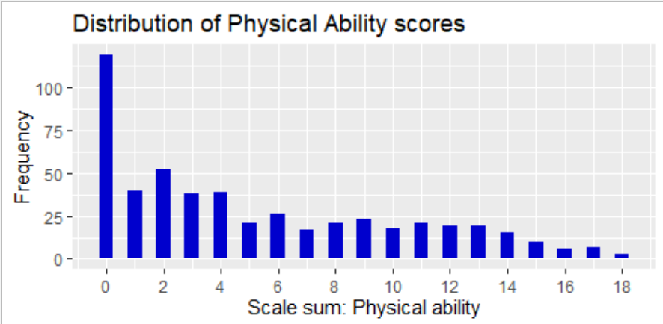
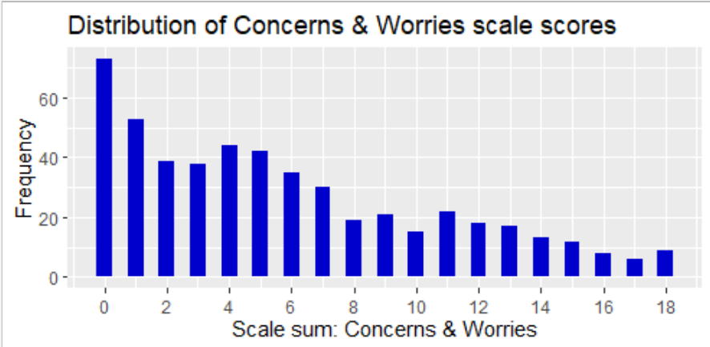
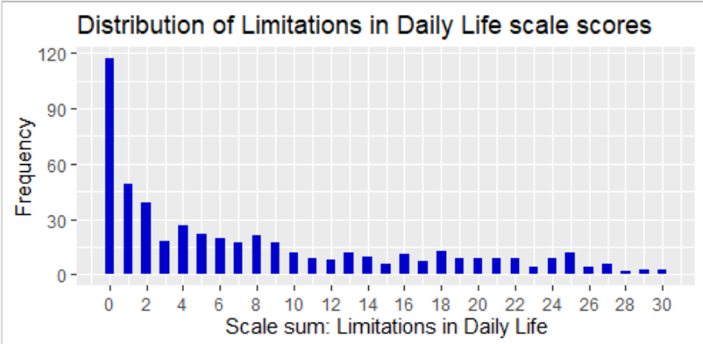
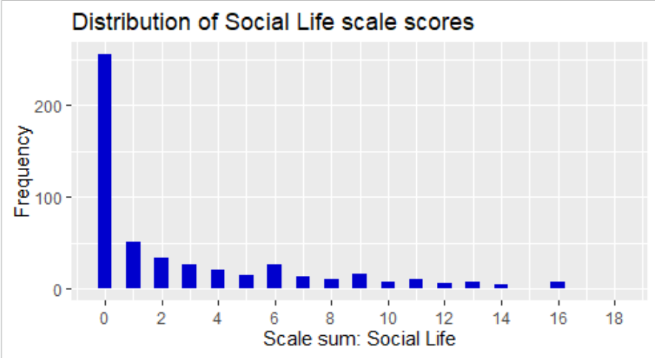
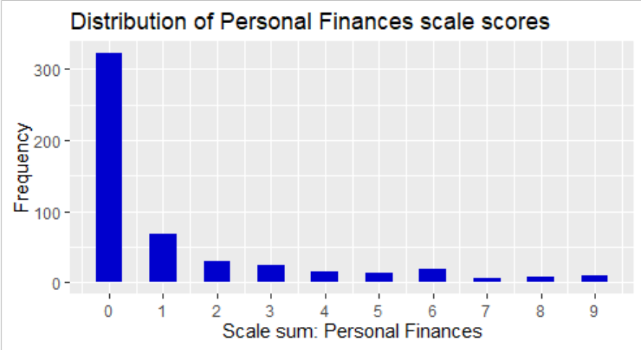
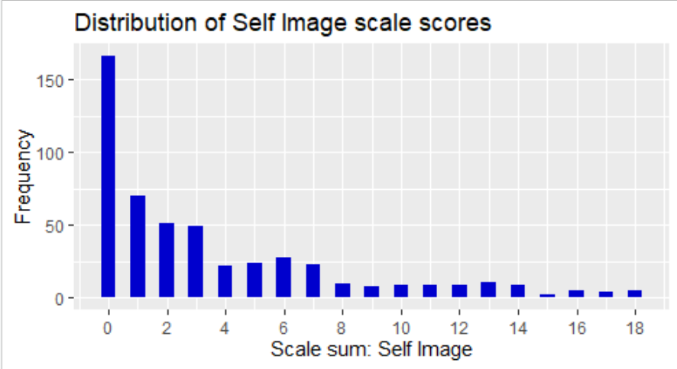

Supplementary Table 1. Inter-item Correlation Matrices
Scale 1 | q1a | q1b | q1c | q1d | q1e | q1f
q1a | 1 | 0.775 | 0.545 | 0.710 | 0.743 | 0.764
q1b | 0.775 | 1 | 0.522 | 0.726 | 0.726 | 0.793
q1c | 0.545 | 0.522 | 1 | 0.632 | 0.529 | 0.483
q1d | 0.710 | 0.726 | 0.632 | 1 | 0.732 | 0.724
q1e | 0.743 | 0.726 | 0.529 | 0.732 | 1 | 0.809
q1f | 0.764 | 0.793 | 0.483 | 0.724 | 0.809 | 1
Scale 2 | q2a | q2b | q2c | q2d | q2e | q2f
q2a | 1 | 0.604 | 0.787 | 0.716 | 0.659 | 0.657
q2b | 0.604 | 1 | 0.659 | 0.639 | 0.524 | 0.517
q2c | 0.787 | 0.659 | 1 | 0.751 | 0.657 | 0.633
q2d | 0.716 | 0.639 | 0.751 | 1 | 0.670 | 0.686
q2e | 0.659 | 0.524 | 0.657 | 0.670 | 1 | 0.657
q2f | 0.657 | 0.517 | 0.633 | 0.686 | 0.657 | 1
Scale 3 | q3a | q3b | q3c | q3d | q3e | q3f | q3g | q3h | q3i | q3j
q3a | 1 | 0.828 | 0.757 | 0.805 | 0.745 | 0.742 | 0.762 | 0.575 | 0.664 | 0.764
q3b | 0.828 | 1 | 0.785 | 0.802 | 0.821 | 0.784 | 0.78 | 0.617 | 0.697 | 0.762
q3c | 0.757 | 0.785 | 1 | 0.716 | 0.752 | 0.746 | 0.789 | 0.688 | 0.721 | 0.681
q3d | 0.805 | 0.802 | 0.716 | 1 | 0.743 | 0.725 | 0.730 | 0.590 | 0.692 | 0.787
q3e | 0.745 | 0.821 | 0.752 | 0.743 | 1 | 0.781 | 0.723 | 0.571 | 0.634 | 0.670
q3f | 0.742 | 0.784 | 0.746 | 0.725 | 0.781 | 1 | 0.723 | 0.612 | 0.689 | 0.707
q3g | 0.762 | 0.780 | 0.789 | 0.730 | 0.723 | 0.723 | 1 | 0.656 | 0.713 | 0.684
q3h | 0.575 | 0.617 | 0.688 | 0.590 | 0.571 | 0.612 | 0.656 | 1 | 0.612 | 0.563
q3i | 0.664 | 0.697 | 0.721 | 0.692 | 0.634 | 0.689 | 0.713 | 0.612 | 1 | 0.696
q3j | 0.764 | 0.762 | 0.681 | 0.787 | 0.670 | 0.707 | 0.684 | 0.563 | 0.696 | 1
Scale 4 | q4a | q4b | q4c | q4d | q4e | q4f
q4a | 1 | 0.723 | 0.571 | 0.631 | 0.748 | 0.643
q4b | 0.723 | 1 | 0.581 | 0.653 | 0.666 | 0.690
q4c | 0.571 | 0.581 | 1 | 0.587 | 0.526 | 0.583
q4d | 0.631 | 0.653 | 0.587 | 1 | 0.607 | 0.595
q4e | 0.748 | 0.666 | 0.526 | 0.607 | 1 | 0.652
q4f | 0.643 | 0.690 | 0.583 | 0.595 | 0.652 | 1
Scale 5 | q5a | q5b | q5c
q5a | 1 | 0.797 | 0.777
q5b | 0.797 | 1 | 0.752
q5c | 0.777 | 0.752 | 1
Scale 6 | q6a | q6b | q6c | q6d | q6e | q6f
q6a | 1 | 0.831 | 0.731 | 0.678 | 0.502 | 0.424
q6b | 0.831 | 1 | 0.740 | 0.679 | 0.537 | 0.468
q6c | 0.731 | 0.740 | 1 | 0.714 | 0.454 | 0.392
q6d | 0.678 | 0.679 | 0.714 | 1 | 0.469 | 0.384
q6e | 0.502 | 0.537 | 0.454 | 0.469 | 1 | 0.682
q6f | 0.424 | 0.468 | 0.392 | 0.384 | 0.682 | 1

Supplementary Figure 3. Illustrative quotes from cognitive interviews

Importance and relevance
You can go from someone like me, with few restrictions, to someone who is totally reliant on help - and the questions stay relevant. I would say it’s totally valid for, probably, 90 per cent of older folk. There will be people around here that could write a book on some of this stuff. (P5)

You need to ask this because poverty is probably one of the major contributing factors to peoples’ state of mind. (P5)
The questions are straight to the point. Am I a burden to others? I think that’s quite a good one in particular. (P4)
Do I feel guilty in relation to my lifestyle? It’s a good question but it’s a tough one to answer – I do feel guilty but also I feel proud to have stopped drinking. (P6)
Clarity and comprehensibility
That was pretty straightforward to understand. I felt comfortable with the wording. (P1)
I didn’t really have any issues understanding the questions. Each of them made me think a little bit, so they’re there for a reason. (P2)
I feel the questions are clear, the way they’re phrased and the way they’re laid out. It’s very easy to follow. (P4)
Coverage
That section [MMQ1] seems bang on in terms of what it covers. (P2)
You are certainly asking the right questions. I think the whole study – these questions – are really good. Really worthwhile. Not only now but in the future with ageing getting longer. (P4)
To me it felt like one or two of these questions are the ultimate questions. But then the others are giving more reasons why somebody feels that way. So I think you’ve got to ask them all. (P3)
Burden
Q: If you were given this as a research participant would you have any issues with it?
A: It’s too big an assessment. (P1)
Maybe there could be fewer questions. I personally think so. Some of them don’t need to be there. It’s like when you’re doing an online course at work and it takes, like, two years to complete. You can shorten it, surely. (P2)
Q: Did you feel like it was a burdensome thing to fill out?
A: Not really. In certain sections it was repetitive, but for other people those sections might be important. (P5)

Supplementary Table 2. Concurrent validity with EQ-5D-5L and ICE-CAP

Correlation (Spearman coefficients) between MMQ1 scale scores and comparator measures
 |  | ICE-CAP
 |  | Item A | Item B | Item C | Item D | Item E | Total
MMQ | Scale1 | 0.595 | 0.345 | 0.724 | 0.707 | 0.618 | 0.756
MMQ | Scale 2 | 0.666 | 0.383 | 0.607 | 0.632 | 0.626 | 0.731
MMQ | Scale 3 | 0.603 | 0.349 | 0.726 | 0.707 | 0.634 | 0.760
MMQ | Scale4 | 0.613 | 0.420 | 0.705 | 0.689 | 0.668 | 0.767
MMQ | Scale5 | 0.510 | 0.361 | 0.450 | 0.465 | 0.513 | 0.559
MMQ | Scale6 | 0.583 | 0.421 | 0.556 | 0.579 | 0.595 | 0.673
MMQ | Total | 0.677 | 0.413 | 0.728 | 0.729 | 0.682 | 0.813
 |  | EQ-5D-5L
 |  | Item A | Item B | Item C | Item D | Item E | Total
MMQ | Scale 1 | 0.758 | 0.652 | 0.820 | 0.635 | 0.482 | 0.847
MMQ | Scale 2 | 0.585 | 0.530 | 0.706 | 0.592 | 0.623 | 0.765
MMQ | Scale 3 | 0.735 | 0.645 | 0.817 | 0.616 | 0.509 | 0.842
MMQ | Scale 4 | 0.633 | 0.644 | 0.724 | 0.527 | 0.557 | 0.756
MMQ | Scale 5 | 0.367 | 0.457 | 0.486 | 0.415 | 0.440 | 0.520
MMQ | Scale 6 | 0.504 | 0.504 | 0.612 | 0.493 | 0.590 | 0.666
MMQ | Total | 0.710 | 0.638 | 0.818 | 0.631 | 0.600 | 0.860

 |  | Single-item QOL rating
MMQ | Scale1 | 0.711
MMQ | Scale 2 | 0.717
MMQ | Scale 3 | 0.727
MMQ | Scale4 | 0.718
MMQ | Scale5 | 0.507
MMQ | Scale6 | 0.662
MMQ | Total | 0.771

Supplementary Table 3. Convergent and discriminant validity

Item-total correlations (Spearman coefficients) between scale items and scale sum scores, showing that for all items, correlation is highest with the native scale.
 | Items from Scale 1
 | Item A |  | Item B |  | Item C |  |  | Item D | Item E | Item F
Scale 1 sum | 0.831 |  | 0.834 |  | 0.602 |  |  | 0.817 | 0.833 | 0.848
Scale 2 sum | 0.686 |  | 0.652 |  | 0.469 |  |  | 0.612 | 0.745 | 0.740
Scale 3 sum | 0.787 |  | 0.789 |  | 0.563 |  |  | 0.767 | 0.803 | 0.861
Scale 4 sum | 0.721 |  | 0.699 |  | 0.576 |  |  | 0.727 | 0.705 | 0.732
Scale 5 sum | 0.474 |  | 0.432 |  | 0.454 |  |  | 0.474 | 0.454 | 0.430
Scale 6 sum | 0.622 |  | 0.583 |  | 0.451 |  |  | 0.560 | 0.640 | 0.650
 | Items from Scale 2
 | Item A |  | Item B |  | Item C |  |  | Item D | Item E | Item F
Scale 1 sum | 0.615 |  | 0.464 |  | 0.587 |  |  | 0.807 | 0.642 | 0.676
Scale 2 sum | 0.812 |  | 0.678 |  | 0.827 |  |  | 0.823 | 0.743 | 0.738
Scale 3 sum | 0.637 |  | 0.498 |  | 0.616 |  |  | 0.782 | 0.664 | 0.725
Scale 4 sum | 0.629 |  | 0.484 |  | 0.596 |  |  | 0.696 | 0.663 | 0.707
Scale 5 sum | 0.492 |  | 0.393 |  | 0.466 |  |  | 0.488 | 0.470 | 0.468
Scale 6 sum | 0.659 |  | 0.538 |  | 0.642 |  |  | 0.678 | 0.676 | 0.649
 | Items from Scale 3
 | Item A |  | Item B |  | Item C |  |  | Item D | Item E | Item F | Item G |  | Item H |  |  |  | Item I |  |  | Item J
Scale 1 sum | 0.798 |  | 0.809 |  | 0.719 |  |  | 0.836 | 0.758 | 0.747 | 0.757 |  | 0.579 |  |  |  | 0.715 |  |  | 0.789
Scale 2 sum | 0.698 |  | 0.746 |  | 0.617 |  |  | 0.725 | 0.680 | 0.687 | 0.651 |  | 0.569 |  |  |  | 0.635 |  |  | 0.674
Scale 3 sum | 0.862 |  | 0.895 |  | 0.855 |  |  | 0.854 | 0.831 | 0.840 | 0.845 |  | 0.694 |  |  |  | 0.783 |  |  | 0.813
Scale 4 sum | 0.754 |  | 0.800 |  | 0.769 |  |  | 0.759 | 0.765 | 0.764 | 0.777 |  | 0.629 |  |  |  | 0.741 |  |  | 0.703
Scale 5 sum | 0.404 |  | 0.485 |  | 0.494 |  |  | 0.449 | 0.471 | 0.474 | 0.469 |  | 0.462 |  |  |  | 0.534 |  |  | 0.472
Scale 6 sum | 0.623 |  | 0.662 |  | 0.570 |  |  | 0.654 | 0.637 | 0.616 | 0.567 |  | 0.537 |  |  |  | 0.616 |  |  | 0.620
 | Items from Scale 4
 | Item A |  | Item B |  | Item C |  |  | Item D | Item E | Item F
Scale 1 sum | 0.698 |  | 0.716 |  | 0.450 |  |  | 0.580 | 0.635 | 0.601
Scale 2 sum | 0.630 |  | 0.702 |  | 0.506 |  |  | 0.532 | 0.601 | 0.568
Scale 3 sum | 0.752 |  | 0.770 |  | 0.492 |  |  | 0.613 | 0.686 | 0.639
Scale 4 sum | 0.804 |  | 0.798 |  | 0.664 |  |  | 0.727 | 0.770 | 0.755
Scale 5 sum | 0.472 |  | 0.505 |  | 0.425 |  |  | 0.492 | 0.507 | 0.498
Scale 6 sum | 0.610 |  | 0.661 |  | 0.479 |  |  | 0.550 | 0.641 | 0.549
 | Items from Scale 5
 | Item A |  | Item B |  | Item C
Scale 1 sum | 0.509 |  | 0.449 |  | 0.426
Scale 2 sum | 0.536 |  | 0.503 |  | 0.460
Scale 3 sum | 0.553 |  | 0.451 |  | 0.438
Scale 4 sum | 0.580 |  | 0.489 |  | 0.481
Scale 5 sum | 0.841 |  | 0.823 |  | 0.806
Scale 6 sum | 0.527 |  | 0.490 |  | 0.466
 | Items from Scale 6
 | Item A |  | Item B |  | Item C |  |  | Item D | Item E | Item F
Scale 1 sum | 0.677 |  | 0.666 |  | 0.537 |  |  | 0.539 | 0.373 | 0.308
Scale 2 sum | 0.693 |  | 0.747 |  | 0.585 |  |  | 0.568 | 0.506 | 0.409
Scale 3 sum | 0.735 |  | 0.709 |  | 0.562 |  |  | 0.587 | 0.410 | 0.303
Scale 4 sum | 0.740 |  | 0.742 |  | 0.605 |  |  | 0.625 | 0.452 | 0.364
Scale 5 sum | 0.542 |  | 0.504 |  | 0.506 |  |  | 0.506 | 0.343 | 0.290
Scale 6 sum | 0.795 |  | 0.820 |  | 0.753 |  |  | 0.722 | 0.636 | 0.560

Supplementary Table 4. Comparison of factor loadings for two CFA models used for scale six (Self-image)

Item and content |  | Model 1  Factor loadings (SE) | Model 2*  Factor loadings (SE)
6a | I feel embarrassed about the impact and limitations my health conditions cause | 0.935 (0.011) | 0.939 (0.011)
6b | My health conditions lower my self-esteem | 0.947 (0.010) | 0.956 (0.010)
6c | It is unpleasant being seen as a patient by others | 0.886 (0.015) | 0.897 (0.015)
6d | I feel people judge me because of my health conditions | 0.854 (0.018) | 0.868 (0.018)
6e | I blame myself for my health conditions | 0.802 (0.024) | 0.657 (0.035)
6f | I often feel guilty about my lifestyle (e.g. smoking, alcohol, diet, exercise) in relation to my health conditions | 0.754 (0.026) | 0.558 (0.040)
*Model 2 includes correlation term: 6e ~~ 6f

Supplementary Table 5. Inter-scale correlation
Correlation (Spearman coefficients) between sum scores for each of the six scales in MMQ1

 | sum_q1 | sum_q2 | sum_q3 | sum_q4 | sum_q5 | sum_q6
sum_q1 | 1.000 | 0.767 | 0.898 | 0.787 | 0.502 | 0.674
sum_q2 | 0.767 | 1.000 | 0.789 | 0.748 | 0.543 | 0.765
sum_q3 | 0.898 | 0.789 | 1.000 | 0.848 | 0.517 | 0.712
sum_q4 | 0.787 | 0.748 | 0.848 | 1.000 | 0.555 | 0.736
sum_q5 | 0.502 | 0.543 | 0.517 | 0.555 | 1.000 | 0.532
sum_q6 | 0.674 | 0.765 | 0.712 | 0.736 | 0.532 | 1.000

Sampling strategy

Cognitive interview sampling
Criteria: Adult patients living with MLTC, where the GP felt the health conditions were likely to be impacting on quality of life.
Sampling aimed for a balance of genders, and with good representation of those from more deprived areas and/or with mental-physical multimorbidity. Sampling was facilitated by two GP practices, one in an area of mixed deprivation, the other in an area of high deprivation. Potentially suitable patients were identified by their GP, either opportunistically or from clinical familiarity, and contacted by their GP by telephone.
9 patients were approached by their GP and consented to be contacted by the research team

6 patient responded to contact and agreed to interview

Survey sampling
Criteria: Adult patients living with MLTC, who would be able to complete a short paper-based survey.
Search strategy on practice records: Patients on two or more chronic disease registers, or four or more repeat prescriptions, who had not been recently invited to another research study.
Chronic disease registers included: coronary heart disease, heart failure, stroke, diabetes, severe mental illness, dementia, chronic kidney disease, atrial fibrillation, peripheral arterial disease, chronic obstructive pulmonary disease, asthma, rheumatoid arthritis, hypertension, cancer.
Eight practice supported sampling. These practices were recruited by volunteering in response to an advert circulated by NHS Research Scotland Primary Care Network.
A sample list for screening was identified randomly from all patients meeting the search criteria on practice records. The size of the screening list was either 200 or 400 based on participation GP discretion. Patients deemed unsuitable for inclusion by their GP (e.g., learning disability, dementia, recent distressing life event, approaching end-of-life).
11,860 potentially eligible patients identified based on search of 8 practice lists

2,800 patients randomly sampled from those eligible

47 deemed unsuitable

2753 retained for invitation after screening by GP for suitability

597 responses received at closure of data collection

Survey changes following cognitive interviews

The following changes (in underlined italics) were made to the wording of MMQ1 following first round of cognitive interviews
- Item 2e
“I have to make an effort to stay mentally strong”
- Item 6f
“I often feel guilty about my lifestyle (e.g. smoking, alcohol, diet, exercise) in relation to my health conditions”

