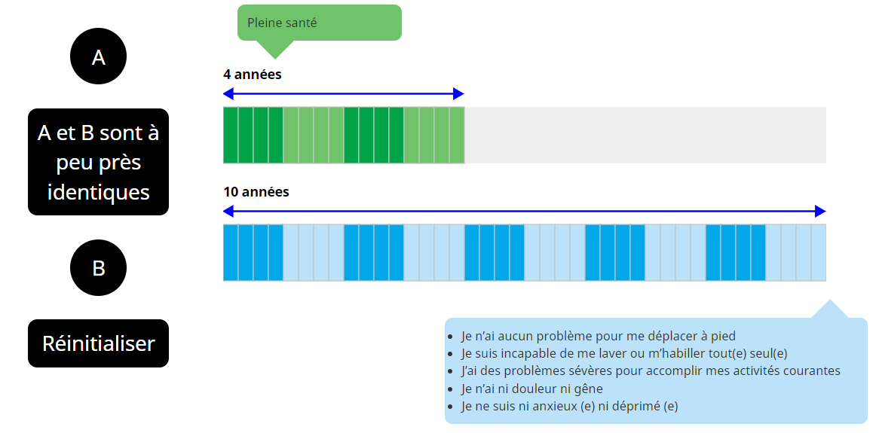
Supplementary Fig. 1 Example of BTD health state of cTTO task

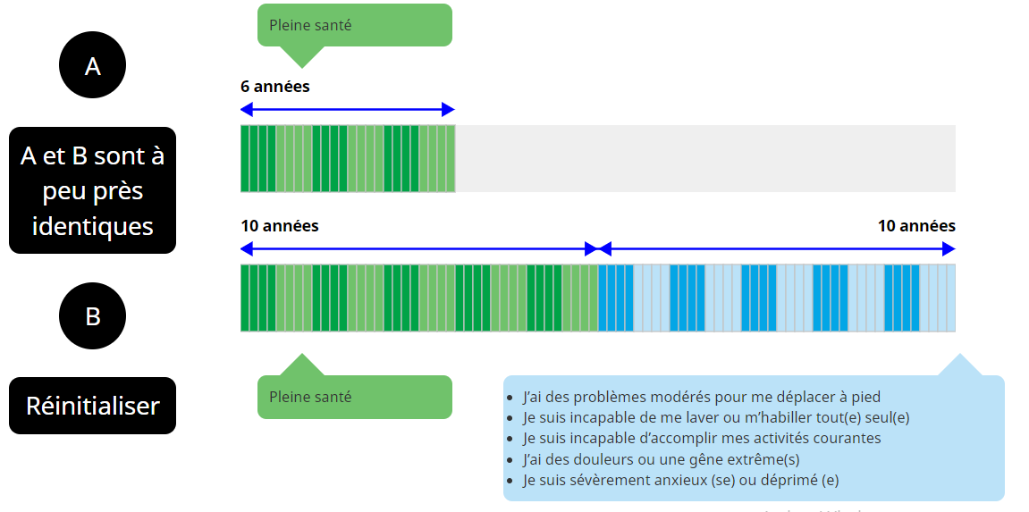
Supplementary Fig. 2 Example of WTD health state of cTTO task

