Microbiome Impacts Quality of Life in Patients with Endometrial Cancer and Benign Gynecological Conditions

Nina J. Gautam¹, Nicole R. Jimenez², Paweł Łaniewski³, Haiyan Cui⁴, Denise J. Roe^{4,5}, Dana M. Chase⁶, Melissa M. Herbst-Kralovetz^{2,3,7,*}

¹ College of Medicine – Phoenix, University of Arizona, Phoenix, AZ 85004, USA
² Department of Obstetrics and Gynecology, College of Medicine – Phoenix, University of Arizona. Phoenix, AZ 85004, USA
³ Department of Basic Medical Sciences, College of Medicine – Phoenix, University of Arizona, Phoenix, AZ 85004, USA
⁴ University of Arizona Cancer Center, University of Arizona, Tucson, AZ 85719, USA
⁵ Department of Epidemiology and Biostatistics, Mel and Enid Zuckerman College of Public Health, University of Arizona, Tucson, AZ 85719, USA
⁶ Division of Gynecologic Oncology, Department of Obstetrics and Gynecology, David Geffen School of Medicine, UCLA, Los Angeles, CA 90095, USA
⁷ Lead contact
*Correspondence: mherbst1@arizona.edu

Online Resource 1

Survey | Benign | EC | Total
Gas/Bloating | 83 | 39 | 122
Diarrhea | 79 | 30 | 109
Mental | 89 | 47 | 136
Physical | 89 | 47 | 136
PSS10 | 85 | 43 | 128
Sexual Int. | 76 | 29 | 105
VAS | 73 | 26 | 99
VuAS | 72 | 25 | 97

Supplemental Table 1 Survey response rates by diagnosis group Breakdown of participants who answered each survey from each cohort is displayed here. Fewer participants completed sexual interest, VAS, and VuAS surveys than non-sexual health related QOL surveys.

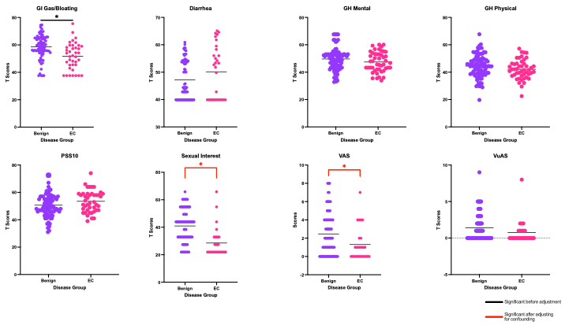

Supplemental Fig. 1 Patients with EC had lower sexual interest and vaginal atrophy symptoms than patients with benign gynecological conditions. Welch’s t-tests were performed to assess differences between diagnosis groups. After adjusting for BMI and menopausal status using a multiple linear regression, VAS and sexual interest were significantly lower in patients with EC than benign gynecological conditions, while the difference in gas and bloating symptoms diminished. No significant differences were identified, before or after adjustment, between diarrhea, mental and physical health, stress, and vulvar symptoms. * = p≤0.05, ** = p≤0.01, *** = p≤0.001, **** = p≤0.0001. Black coloring indicates significant differences in Welch’s t-tests before adjustment, red coloring indicates significant differences after adjustment, using multiple linear regression.
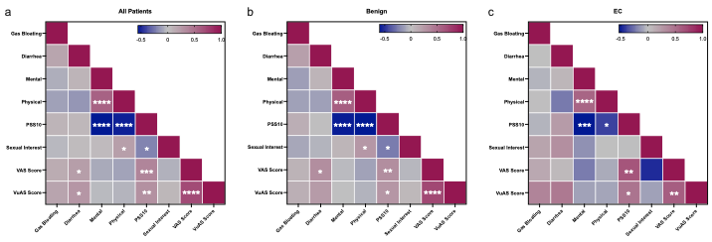
Supplemental Fig. 2 High stress positively correlated to poor mental and physical health, and worse vaginal symptoms in both diagnosis groups Spearman correlations between T-score surveys were performed after adjustment for BMI and menopausal status in each group. a) In the entire study cohort, high stress levels strongly correlated to poor physical and mental health, and worse vaginal symptoms. Significant correlations between diarrhea and vaginal/vulvar symptoms were also observed. b) In the benign group, the correlation between poor physical and mental health and high stress persisted, as well as the correlation between high stress and poor sexual interest and worse vaginal symptoms. Some association between vaginal symptoms and diarrhea was observed. b). In the EC group, the correlation between poor physical and mental health and high stress again remained strong, although less so between physical health and high stress than mental health. Less of an association between high stress and sexual interest was observed, but the correlation between high stress and worse vaginal symptoms remained. There were no correlations observed between diarrhea and other QOL measures in the EC group. * = p≤0.05, ** = p≤0.01, *** = p≤0.001, **** = p≤0.0001. Blue coloring indicates a negative spearman correlation approaching -0.5, grey indicates a spearman correlation near or at 0, and red coloring indicates a positive spearman correlation approaching 1.

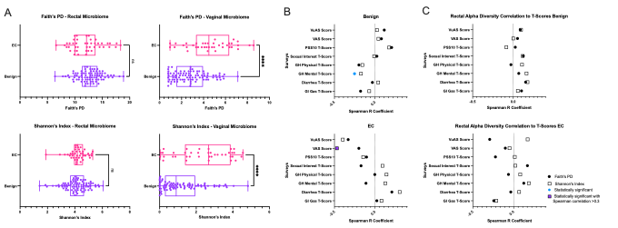
Supplemental Fig. 3 Patients with EC had significantly greater vaginal alpha diversity than patients with benign gynecological conditions, and decreased vaginal alpha diversity was correlated with worse vaginal symptoms A) Mann-Whitney U tests were performed between two alpha diversity metrics, Shannon’s Index and Faith’s Phylogenetic Diversity (PD) on vaginal and rectal microbiota of patients in both diagnosis groups. While vaginal alpha diversity was greater in patients with EC by both metrics (p≤0.0001), rectal alpha diversity was not significantly different between diagnosis groups. B) Vaginal microbial diversity, measured by Faith’s phylogenetic diversity and Shannon’s Index, correlated to survey T-scores of patients with EC using a Spearman rank correlation. Higher vaginal symptoms were significantly correlated to less vaginal microbial diversity in patients with EC. C) Rectal microbial diversity does not correlate significantly to survey T-scores of patients with EC or benign diagnoses using spearman rank correlation. * = p≤0.05, ** = p≤0.01, *** = p≤0.001, **** = p≤0.0001.

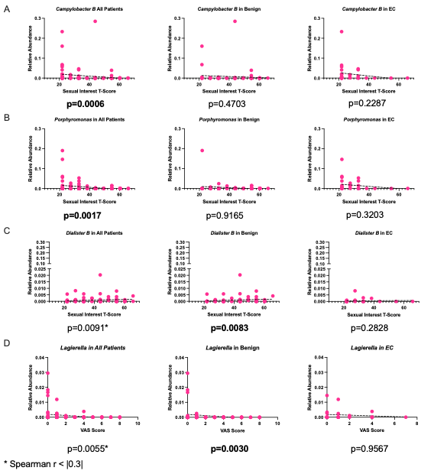

Supplemental Fig. 4 Microbial correlations with sexual interest T-scores in the vaginal microbiome Spearman rank was used to evaluate all correlations. Higher sexual interest and mental health scores indicate better QOL in each category. A) Campylobacter B was negatively correlated to sexual interest in all diagnosis groups, though only significantly in the entire study cohort. B) Porphyromonas was negatively correlated to sexual interest in all diagnosis groups, though only significantly in the entire study cohort. C) Dialister B was positively correlated to sexual interest in the benign group. D) Lagierella was negatively correlated to VAS in the benign group.

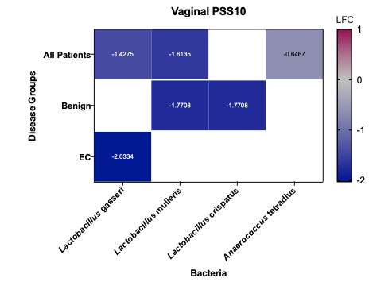

Supplemental Fig. 5 Lactobacillus species were enriched in patients experiencing high levels of perceived stress PSS10 T-scores were dichotomized into high and low groups based on the median of the cohort, and ANCOM-BC was utilized to perform a differential abundance analysis. Lactobacillus gasseri, Lactobacillus mulieris, and Anaerococcus tetradius were depleted in patients with low perceived stress levels in the entire study cohort. In patients with benign gynecological conditions, L. mulieris and L. crispatus were depleted in the low stress group. In patients with EC, L. gasseri was depleted in patients with low perceived stress, as compared to patients with high perceived stress. Blue coloring indicates a negative LFC approaching -2, grey indicates a LFC near or at 0, and red coloring indicates a positive LFC approaching 1.
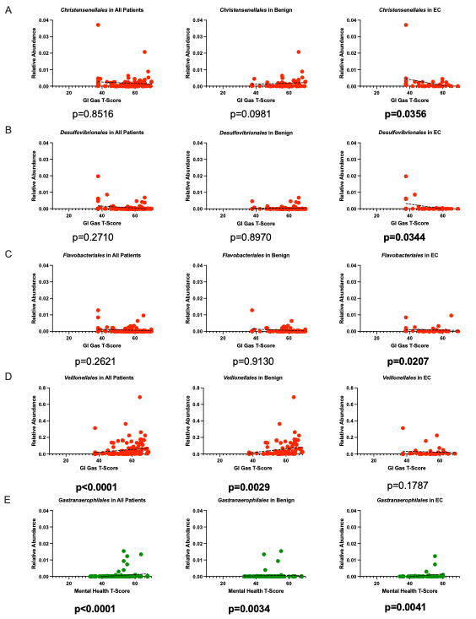
Supplemental Fig. 6 Microbial correlations to gas and bloating and mental health in the rectal microbiome Spearman rank correlation was used to evaluate all correlations. Higher gas and bloating scores indicate worse QOL. A) Christensenellales was negatively correlated to gas and bloating in the EC group and entire study cohort, but positively correlated in the benign group. B) Desulfovibrionales was negatively correlated to gas and bloating in all diagnosis groups, though only significantly in the EC group. C) Flavobacteriales was negatively correlated to gas and bloating in all diagnosis groups, though only significantly in the EC group. D) Veillonellales was positively correlated to gas and bloating in the benign group and entire study cohort, but negatively in the EC group. E) Gastranaerophilales in the rectal microbiome was positively correlated to mental health in all diagnosis groups.

