Appendix
Table A1. Frequencies of ethnic groups in the dataset and comparison with census data
 | Census data |  | Original Dataset¹ |  | Analysis Dataset²
Ethnic Group | 2011  (%) | 2021  (%) | Simple (%) | Weighted (%) | Simple (%) | Weighted (%)
Asian | 7.51 | 9.25 | 6.00 | 6.33 | 6.15 | 6.32
Black | 3.33 | 4.04 | 2.68 | 2.65 | 2.65 | 2.59
Mixed or Multiple Background | 2.18 | 2.88 | 0.73 | 0.90 | 0.78 | 0.95
White | 85.97 | 81.71 | 87.97 | 87.35 | 88.18 | 87.82
Other | 1.01 | 2.11 | 2.62 | 2.76 | 2.24 | 2.32
Note. Source: Office for National Statistics – Census 2021 and own elaboration based on GPPS survey. The ethnic groups in are defined as follows: "White" includes English, Welsh, Scottish, Northern Irish, British, Gypsy or Irish Traveler, and Any other White background. "Mixed or Multiple Ethnic Groups" consist of White and Black Caribbean, White and Asian, White and Black African, or Any other Mixed/Multiple ethnic background. "Asian" comprises Indian, Pakistani, Bangladeshi, Chinese, or Any other Asian ethnicity. "Black" includes African, Caribbean, or Any other Black/African/Caribbean background. "Other Ethnic Groups" include Arab or Any other ethnic group.
¹Percentages from the original datasets are based on all available data from waves "Y7W1", "Y7W2", "Y8W1", "Y8W2", "Y9W1", "Y9W2", "Y10W1", "Y10W2", and "Y11" (n = 4,207,283). 2.02% didn’t have ethnic group information.
²Based on dataset used in the descriptive statistics and estimations (n = 2,642,805).

Table A2 (Part 1 of 3). Standardized coefficients for health conditions: main effects and interactions (Main Model)
Condition | Mobility | Self-care | Usual Activities | Pain / Discomfort | Anxiety / Depression
Alzheimer’s disease or dementia | 0.046 | 0.13 | 0.104 | -0.015 | 0.093
Angina or long-term heart problem | 0.077 | 0.051 | 0.076 | 0.052 | 0.055
Arthritis or long-term joint problem | 0.198 | 0.131 | 0.162 | 0.252 | 0.057
Asthma or long-term chest problem | 0.038 | 0.024 | 0.036 | 0.016 | 0.024
Blindness or severe visual impairment | 0.098 | 0.09 | 0.097 | 0.03 | 0.056
Cancer in the last 5 years | 0.056 | 0.061 | 0.076 | 0.059 | 0.06
Deafness or severe hearing impairment | 0.032 | 0.025 | 0.028 | 0.028 | 0.036
Diabetes | 0.059 | 0.046 | 0.043 | 0.038 | 0.035
Epilepsy | 0.08 | 0.101 | 0.075 | 0.021 | 0.049
High blood pressure | 0.021 | -0.004 | 0.01 | 0.012 | 0.022
Kidney or liver disease | 0.053 | 0.044 | 0.048 | 0.058 | 0.045
Long-term back problem | 0.16 | 0.121 | 0.158 | 0.257 | 0.074
Long-term mental health problem | 0.077 | 0.124 | 0.151 | 0.055 | 0.35
Long-term neurological problem | 0.182 | 0.159 | 0.161 | 0.176 | 0.11
Another long-term condition | 0.099 | 0.093 | 0.106 | 0.124 | 0.086
Recent Illness/Injury Limitations¹: Severe (Baseline: None) | 0.069 | 0.036 | 0.074 | 0.104 | 0.06
Recent Illness/Injury Limitations¹: Moderate (Baseline: None) | 0.156 | 0.132 | 0.161 | 0.184 | 0.12
Note. The coefficients from the model are standardized so that the highest latent variable value equals 1 and the lowest equals 0. Survey weights were used for the estimation of the HOPIT model.
¹Respondents were instructed to consider injuries or health problems lasting "a few days or weeks."

Table A2 (Part 2 of 3). Standardized coefficients for health conditions: main effects and interactions (Main Model)
Condition | Mobility | Self-care | Usual Activities | Pain / Discomfort | Anxiety / Depression
Angina or long-term heart problem and Arthritis or long-term joint problem | -0.051 | -0.027 | -0.049 | -0.034 | -0.018
Angina or long-term heart problem and Diabetes | -0.002 | -0.007 | -0.006 | 0.003 | -0.013
Angina or long-term heart problem and High blood pressure | -0.005 | 0.001 | -0.004 | 0.003 | -0.003
Arthritis or long-term joint problem and Asthma or long-term chest problem | -0.003 | 0.012 | -0.003 | 0.008 | 0.01
Arthritis or long-term joint problem and Deafness or severe hearing impairment | -0.034 | -0.023 | -0.031 | -0.027 | -0.017
Arthritis or long-term joint problem and Diabetes | -0.014 | -0.004 | -0.01 | -0.002 | 0.008
Arthritis or long-term joint problem and High blood pressure | 0.002 | 0.014 | 0.005 | 0.006 | 0.003
Arthritis or long-term joint problem and Long-term back problem | -0.088 | -0.038 | -0.072 | -0.143 | 0.006
Arthritis or long-term joint problem and Long-term mental health problem | -0.034 | -0.05 | -0.073 | -0.009 | -0.04
Arthritis or long-term joint problem and Another long-term condition | -0.049 | -0.035 | -0.046 | -0.059 | -0.017
Asthma or long-term chest problem and Diabetes | -0.001 | -0.005 | -0.005 | 0.005 | -0.003
Asthma or long-term chest problem and High blood pressure | 0.02 | 0.024 | 0.019 | 0.023 | 0.01
Asthma or long-term chest problem and Long-term back problem | -0.016 | -0.015 | -0.022 | -0.011 | -0.007
Asthma or long-term chest problem and Another long-term condition | -0.013 | -0.01 | -0.016 | 0.001 | -0.011
Cancer in the last 5 years and High blood pressure | -0.032 | -0.038 | -0.04 | -0.029 | -0.035
Deafness or severe hearing impairment and High blood pressure | -0.006 | -0.006 | -0.004 | 0.002 | -0.012
Diabetes and High blood pressure | 0.004 | 0.009 | 0.007 | 0.009 | -0.002
Diabetes and Long-term back problem | -0.007 | -0.008 | -0.013 | -0.004 | 0.001
Diabetes and Another long-term condition | 0.007 | 0.004 | -0.001 | 0.001 | -0.004
Note. The coefficients from the model are standardized so that the highest latent variable value equals 1 and the lowest equals 0. Survey weights were used for the estimation of the HOPIT model.
¹Respondents were instructed to consider injuries or health problems lasting "a few days or weeks."

Table A2 (Part 3 of 3). Standardized coefficients for health conditions: main effects and interactions (Main Model)
Condition | Mobility | Self-care | Usual Activities | Pain / Discomfort | Anxiety / Depression
High blood pressure and Long-term back problem | -0.011 | 0.005 | -0.011 | -0.01 | 0.006
High blood pressure and Another long-term condition | -0.008 | -0.001 | -0.01 | -0.013 | -0.018
Long-term back problem and Long-term mental health problem | -0.024 | -0.046 | -0.074 | -0.004 | -0.054
Long-term back problem and Another long-term condition | -0.037 | -0.035 | -0.045 | -0.053 | -0.02
Arthritis, Asthma, and High blood pressure | -0.028 | -0.031 | -0.025 | -0.031 | -0.019
Arthritis, Diabetes, and High blood pressure | -0.016 | -0.018 | -0.012 | -0.022 | -0.014
Arthritis, High blood pressure, and Long-term back problem | 0.013 | -0.004 | 0.012 | 0.016 | -0.009
Note. The coefficients from the model are standardized so that the highest latent variable value equals 1 and the lowest equals 0. Survey weights were used for the estimation of the HOPIT model.
¹Respondents were instructed to consider injuries or health problems lasting "a few days or weeks."

Table A3. Sensitivity Analysis – Differences in Thresholds Between Ethnic Groups and the White Ethnic Group Baseline (Omission of interactions of long-term conditions in latent equation, and area deprivation and health care use variables in the threshold equations ¹)
Dimension | Threshold
Dimension | 1|2 | 2|3 | 3|4 | 4|5
Asian
Mobility | 0.016* (0.004) | 0.031* (0.006) | 0.036* (0.008) | 0.121* (0.018)
Self-Care | -0.057* (0.006) | -0.056* (0.008) | -0.168* (0.011) | -0.133* (0.017)
Usual Activities | 0.118* (0.004) | 0.119* (0.006) | 0.07* (0.009) | 0.093* (0.014)
Pain/Discomfort | -0.037* (0.003) | -0.023* (0.005) | -0.102* (0.007) | -0.073* (0.013)
Anxiety/Depression | 0.16* (0.004) | 0.191* (0.005) | -0.026* (0.008) | -0.078* (0.012)
Black
Mobility | 0.003 (0.007) | -0.027* (0.009) | -0.04* (0.013) | -0.068* (0.026)
Self-Care | -0.032* (0.009) | -0.065* (0.012) | -0.129* (0.017) | -0.106* (0.026)
Usual Activities | 0.151* (0.007) | 0.09* (0.009) | 0.032* (0.012) | 0.062* (0.021)
Pain/Discomfort | -0.036* (0.005) | -0.087* (0.007) | -0.17* (0.01) | -0.075* (0.021)
Anxiety/Depression | 0.277* (0.006) | 0.209* (0.008) | 0.019 (0.012) | -0.011 (0.02)
Mixed or multiple ethnic background
Mobility | -0.025* (0.011) | -0.022 (0.015) | -0.024 (0.021) | 0.149* (0.048)
Self-Care | -0.071* (0.014) | -0.079* (0.018) | -0.061* (0.028) | -0.055 (0.043)
Usual Activities | -0.021* (0.01) | 0.012 (0.014) | 0.004 (0.02) | 0.02 (0.032)
Pain/Discomfort | -0.063* (0.009) | -0.048* (0.012) | -0.077* (0.018) | -0.085* (0.032)
Anxiety/Depression | -0.054* (0.009) | -0.026* (0.011) | -0.071* (0.017) | -0.09* (0.025)
Other ethnic background
Mobility | -0.073* (0.007) | -0.079* (0.009) | -0.133* (0.011) | -0.12* (0.022)
Self-Care | -0.162* (0.008) | -0.151* (0.01) | -0.313* (0.013) | -0.294* (0.02)
Usual Activities | 0.097* (0.007) | 0.068* (0.009) | -0.034* (0.012) | -0.036 (0.018)
Pain/Discomfort | -0.041* (0.006) | -0.103* (0.007) | -0.26* (0.01) | -0.217* (0.016)
Anxiety/Depression | 0.1* (0.006) | 0.085* (0.007) | -0.216* (0.011) | -0.248* (0.015)
Note. Bootstrap standard deviations are shown in parentheses. *Indicates statistical significance at the 95% confidence level (all results were significant using both parametric bootstrap standard deviations and the 2.5th and 97.5th percentiles). Survey weights were used for the estimation of the HOPIT model. The ethnic groups in are defined as follows: "White" includes English, Welsh, Scottish, Northern Irish, British, Gypsy or Irish Traveler, and Any other White background. "Mixed or Multiple Ethnic Groups" consist of White and Black Caribbean, White and Asian, White and Black African, or Any other Mixed/Multiple ethnic background. "Asian" comprises Indian, Pakistani, Bangladeshi, Chinese, or Any other Asian ethnicity. "Black" includes African, Caribbean, or Any other Black/African/Caribbean background. "Other Ethnic Groups" include Arab or Any other ethnic group.).
¹Included the following explanatory variables: ethnic group, main effects of health conditions, interactions between sex and age groups and wave fixed effects. All coefficients available in the supplementary material.

Table A4. Differences in thresholds between each ethnic group and the White ethnic group baseline (Omission of area deprivation and health care utilisation variables in the threshold equations¹)
Dimension | Threshold
Dimension | 1|2 | 2|3 | 3|4 | 4|5
Asian
Mobility | 0.007 (0.005) | 0.024* (0.006) | 0.033* (0.009) | 0.116* (0.019)
Self-Care | -0.069* (0.006) | -0.063* (0.008) | -0.17* (0.011) | -0.133* (0.017)
Usual Activities | 0.109* (0.004) | 0.113* (0.006) | 0.069* (0.008) | 0.094* (0.014)
Pain/Discomfort | -0.043* (0.003) | -0.03* (0.005) | -0.102* (0.007) | -0.063* (0.013)
Anxiety/Depression | 0.159* (0.003) | 0.19* (0.005) | -0.027* (0.008) | -0.079* (0.012)
Black
Mobility | -0.005 (0.007) | -0.032* (0.009) | -0.039* (0.012) | -0.053* (0.024)
Self-Care | -0.041* (0.009) | -0.069* (0.012) | -0.128* (0.017) | -0.105* (0.025)
Usual Activities | 0.147* (0.007) | 0.09* (0.009) | 0.04* (0.012) | 0.073* (0.022)
Pain/Discomfort | -0.041* (0.005) | -0.094* (0.007) | -0.169* (0.01) | -0.063* (0.02)
Anxiety/Depression | 0.279* (0.006) | 0.211* (0.008) | 0.022 (0.012) | -0.007 (0.019)
Mixed or multiple ethnic background
Mobility | -0.027* (0.011) | -0.026 (0.015) | -0.027 (0.021) | 0.135* (0.047)
Self-Care | -0.072* (0.014) | -0.08* (0.018) | -0.061* (0.027) | -0.056 (0.04)
Usual Activities | -0.021* (0.01) | 0.01 (0.015) | 0.005 (0.02) | 0.021 (0.032)
Pain/Discomfort | -0.064* (0.009) | -0.052* (0.012) | -0.078* (0.017) | -0.081* (0.032)
Anxiety/Depression | -0.054* (0.009) | -0.026* (0.011) | -0.069* (0.018) | -0.088* (0.026)
Other ethnic background
Mobility | -0.078* (0.007) | -0.086* (0.008) | -0.139* (0.011) | -0.13* (0.021)
Self-Care | -0.173* (0.008) | -0.16* (0.01) | -0.32* (0.013) | -0.303* (0.02)
Usual Activities | 0.094* (0.007) | 0.06* (0.009) | -0.041* (0.012) | -0.047* (0.017)
Pain/Discomfort | -0.042* (0.006) | -0.107* (0.007) | -0.261* (0.01) | -0.213* (0.016)
Anxiety/Depression | 0.099* (0.006) | 0.083* (0.008) | -0.218* (0.011) | -0.253* (0.015)
Note. Bootstrap standard deviations are shown in parentheses. *Indicates statistical significance at the 95% confidence level (all results were significant using both parametric bootstrap standard deviations and the 2.5th and 97.5th percentiles). Survey weights were used for the estimation of the HOPIT model. The ethnic groups in are defined as follows: "White" includes English, Welsh, Scottish, Northern Irish, British, Gypsy or Irish Traveler, and Any other White background. "Mixed or Multiple Ethnic Groups" consist of White and Black Caribbean, White and Asian, White and Black African, or Any other Mixed/Multiple ethnic background. "Asian" comprises Indian, Pakistani, Bangladeshi, Chinese, or Any other Asian ethnicity. "Black" includes African, Caribbean, or Any other Black/African/Caribbean background. "Other Ethnic Groups" include Arab or Any other ethnic group.
¹Included the following explanatory variables: ethnic group, main effects of health conditions, interactions between sex and age groups, wave fixed effects and two-way and three-way interactions for long-term conditions that were prevalent in at least 1% of the data. All coefficients available in the supplementary material.

Table A4. Differences in thresholds between each ethnic group and the White ethnic group baseline (age-bands and sex variables in latent equation ¹)
Dimension | Threshold
Dimension | 1|2 | 2|3 | 3|4 | 4|5
Asian
Mobility | 0.104* (0.005) | 0.093* (0.007) | 0.059* (0.01) | -0.014 (0.019)
Self-Care | 0.031* (0.008) | 0.004 (0.01) | -0.125* (0.013) | -0.155* (0.02)
Usual Activities | 0.202* (0.005) | 0.181* (0.007) | 0.115* (0.01) | 0.062* (0.016)
Pain/Discomfort | 0.044* (0.004) | 0.043* (0.005) | -0.068* (0.008) | -0.093* (0.016)
Anxiety/Depression | 0.213* (0.004) | 0.243* (0.006) | 0.038* (0.01) | -0.019 (0.016)
Black
Mobility | 0.08* (0.01) | 0.014 (0.013) | -0.083* (0.019) | -0.245* (0.031)
Self-Care | 0.023 (0.015) | -0.041* (0.019) | -0.147* (0.025) | -0.105* (0.039)
Usual Activities | 0.221* (0.01) | 0.138* (0.014) | 0.018 (0.02) | 0.028 (0.031)
Pain/Discomfort | 0.025* (0.007) | -0.06* (0.01) | -0.173* (0.016) | -0.202* (0.029)
Anxiety/Depression | 0.328* (0.008) | 0.268* (0.012) | 0.088* (0.019) | -0.018 (0.031)
Mixed or multiple ethnic background
Mobility | 0.045* (0.012) | 0.02 (0.016) | -0.065* (0.024) | -0.048 (0.051)
Self-Care | 0.008 (0.017) | -0.028 (0.021) | -0.084* (0.032) | -0.105* (0.046)
Usual Activities | 0.034* (0.011) | 0.036* (0.015) | -0.017 (0.023) | -0.014 (0.035)
Pain/Discomfort | -0.006 (0.01) | -0.041* (0.012) | -0.117* (0.02) | -0.24* (0.034)
Anxiety/Depression | -0.019* (0.009) | 0 (0.011) | -0.05* (0.019) | -0.085* (0.029)
Other ethnic background
Mobility | 0.035* (0.009) | -0.008 (0.011) | -0.082* (0.015) | -0.267* (0.024)
Self-Care | -0.046* (0.012) | -0.068* (0.015) | -0.247* (0.018) | -0.275* (0.026)
Usual Activities | 0.185* (0.009) | 0.124* (0.011) | 0.000 (0.015) | -0.012 (0.022)
Pain/Discomfort | 0.036* (0.007) | -0.046* (0.009) | -0.226* (0.012) | -0.214* (0.022)
Anxiety/Depression | 0.147* (0.007) | 0.124* (0.009) | -0.149* (0.013) | -0.202* (0.022)
Note. Bootstrap standard deviations are shown in parentheses. *Indicates statistical significance at the 95% confidence level (all results were significant using both parametric bootstrap standard deviations and the 2.5th and 97.5th percentiles). Survey weights were used for the estimation of the HOPIT model. The ethnic groups in are defined as follows: "White" includes English, Welsh, Scottish, Northern Irish, British, Gypsy or Irish Traveler, and Any other White background. "Mixed or Multiple Ethnic Groups" consist of White and Black Caribbean, White and Asian, White and Black African, or Any other Mixed/Multiple ethnic background. "Asian" comprises Indian, Pakistani, Bangladeshi, Chinese, or Any other Asian ethnicity. "Black" includes African, Caribbean, or Any other Black/African/Caribbean background. "Other Ethnic Groups" include Arab or Any other ethnic group.
¹Included the following explanatory variables: ethnic group, main effects of health conditions, interactions between sex and age groups, wave fixed effects and two-way and three-way interactions for long-term conditions that were prevalent in at least 1% of the data. All coefficients available in the supplementary material.

Table A4. Differences in thresholds between each ethnic group and the White ethnic group baseline (area deprivation in latent equation ¹)
Dimension | Threshold
Dimension | 1|2 | 2|3 | 3|4 | 4|5
Asian
Mobility | 0.098* (0.005) | 0.118* (0.006) | 0.108* (0.008) | 0.109* (0.016)
Self-Care | 0.038* (0.006) | 0.032* (0.007) | -0.093* (0.01) | -0.106* (0.015)
Usual Activities | 0.196* (0.004) | 0.199* (0.006) | 0.142* (0.008) | 0.13* (0.013)
Pain/Discomfort | 0.029* (0.004) | 0.067* (0.005) | -0.008 (0.008) | 0.002 (0.012)
Anxiety/Depression | 0.22* (0.004) | 0.259* (0.005) | 0.048* (0.008) | -0.014 (0.012)
Black
Mobility | 0.125* (0.007) | 0.091* (0.009) | 0.068* (0.012) | 0.003 (0.022)
Self-Care | 0.107* (0.01) | 0.065* (0.012) | -0.011 (0.016) | -0.021 (0.023)
Usual Activities | 0.264* (0.007) | 0.2* (0.009) | 0.136* (0.012) | 0.141* (0.019)
Pain/Discomfort | 0.061* (0.005) | 0.016* (0.007) | -0.072* (0.011) | 0.006 (0.019)
Anxiety/Depression | 0.363* (0.006) | 0.295* (0.008) | 0.102* (0.013) | 0.061* (0.02)
Mixed or multiple ethnic background
Mobility | 0.025* (0.011) | 0.027 (0.015) | 0.019 (0.021) | 0.137* (0.04)
Self-Care | -0.011 (0.015) | -0.022 (0.018) | -0.012 (0.027) | -0.01 (0.038)
Usual Activities | 0.025* (0.011) | 0.056* (0.014) | 0.046* (0.019) | 0.055. (0.029)
Pain/Discomfort | -0.026* (0.009) | -0.009 (0.013) | -0.039* (0.018) | -0.05 (0.03)
Anxiety/Depression | -0.022* (0.009) | 0.007 (0.011) | -0.033 (0.018) | -0.055* (0.025)
Other ethnic background
Mobility | 0.027* (0.007) | 0.017 (0.009) | -0.05* (0.012) | -0.085* (0.019)
Self-Care | -0.05* (0.009) | -0.048* (0.011) | -0.215* (0.013) | -0.23* (0.018)
Usual Activities | 0.191* (0.007) | 0.154* (0.009) | 0.041* (0.011) | 0.015 (0.016)
Pain/Discomfort | 0.039* (0.006) | -0.01 (0.007) | -0.176* (0.01) | -0.148* (0.016)
Anxiety/Depression | 0.168* (0.006) | 0.157* (0.008) | -0.145* (0.011) | -0.193* (0.015)
Note. Bootstrap standard deviations are shown in parentheses. *Indicates statistical significance at the 95% confidence level (all results were significant using both parametric bootstrap standard deviations and the 2.5th and 97.5th percentiles). Survey weights were used for the estimation of the HOPIT model. The ethnic groups in are defined as follows: "White" includes English, Welsh, Scottish, Northern Irish, British, Gypsy or Irish Traveler, and Any other White background. "Mixed or Multiple Ethnic Groups" consist of White and Black Caribbean, White and Asian, White and Black African, or Any other Mixed/Multiple ethnic background. "Asian" comprises Indian, Pakistani, Bangladeshi, Chinese, or Any other Asian ethnicity. "Black" includes African, Caribbean, or Any other Black/African/Caribbean background. "Other Ethnic Groups" include Arab or Any other ethnic group.
¹Included the following explanatory variables: ethnic group, main effects of health conditions, interactions between sex and age groups, wave fixed effects and two-way and three-way interactions for long-term conditions that were prevalent in at least 1% of the data. All coefficients available in the supplementary material.

Table A4. Differences in thresholds between each ethnic group and the White ethnic group baseline (Health care use variables in latent equation ¹)
Dimension | Threshold
Dimension | 1|2 | 2|3 | 3|4 | 4|5
Asian
Mobility | 0.189* (0.005) | 0.17* (0.007) | 0.131* (0.01) | 0.045* (0.022)
Self-Care | 0.056* (0.007) | 0.029* (0.009) | -0.108* (0.014) | -0.136* (0.022)
Usual Activities | 0.24* (0.005) | 0.215* (0.007) | 0.146* (0.01) | 0.091* (0.017)
Pain/Discomfort | 0.109* (0.004) | 0.093* (0.005) | -0.027* (0.008) | -0.06* (0.017)
Anxiety/Depression | 0.181* (0.004) | 0.209* (0.006) | 0.006 (0.009) | -0.049* (0.016)
Black
Mobility | 0.156* (0.01) | 0.095* (0.013) | 0.002 (0.019) | -0.18* (0.035)
Self-Care | 0.049* (0.015) | -0.015 (0.018) | -0.126* (0.027) | -0.064 (0.043)
Usual Activities | 0.254* (0.01) | 0.171* (0.014) | 0.05* (0.02) | 0.07* (0.033)
Pain/Discomfort | 0.064* (0.007) | -0.029* (0.01) | -0.142* (0.015) | -0.168* (0.03)
Anxiety/Depression | 0.291* (0.008) | 0.231* (0.012) | 0.054* (0.019) | -0.053 (0.032)
Mixed or multiple ethnic background
Mobility | 0.154* (0.012) | 0.129* (0.017) | 0.04 (0.024) | 0.054 (0.053)
Self-Care | 0.051* (0.017) | 0.014 (0.022) | -0.053 (0.033) | -0.101* (0.051)
Usual Activities | 0.087* (0.011) | 0.088* (0.016) | 0.029 (0.023) | 0.016 (0.037)
Pain/Discomfort | 0.071* (0.009) | 0.029* (0.012) | -0.053* (0.019) | -0.187* (0.035)
Anxiety/Depression | -0.056* (0.009) | -0.037* (0.011) | -0.085* (0.019) | -0.117* (0.031)
Other ethnic background
Mobility | 0.105* (0.008) | 0.059* (0.011) | -0.022 (0.014) | -0.234* (0.028)
Self-Care | -0.027* (0.011) | -0.05* (0.014) | -0.247* (0.019) | -0.288* (0.029)
Usual Activities | 0.216* (0.009) | 0.15* (0.011) | 0.021 (0.015) | -0.001 (0.024)
Pain/Discomfort | 0.09* (0.007) | -0.005 (0.009) | -0.189* (0.011) | -0.188* (0.022)
Anxiety/Depression | 0.12* (0.007) | 0.094* (0.009) | -0.177* (0.014) | -0.232* (0.022)
Note. Bootstrap standard deviations are shown in parentheses. *Indicates statistical significance at the 95% confidence level (all results were significant using both parametric bootstrap standard deviations and the 2.5th and 97.5th percentiles). Survey weights were used for the estimation of the HOPIT model. The ethnic groups in are defined as follows: "White" includes English, Welsh, Scottish, Northern Irish, British, Gypsy or Irish Traveler, and Any other White background. "Mixed or Multiple Ethnic Groups" consist of White and Black Caribbean, White and Asian, White and Black African, or Any other Mixed/Multiple ethnic background. "Asian" comprises Indian, Pakistani, Bangladeshi, Chinese, or Any other Asian ethnicity. "Black" includes African, Caribbean, or Any other Black/African/Caribbean background. "Other Ethnic Groups" include Arab or Any other ethnic group.
¹Included the following explanatory variables: ethnic group, main effects of health conditions, interactions between sex and age groups, wave fixed effects and two-way and three-way interactions for long-term conditions that were prevalent in at least 1% of the data. All coefficients available in the supplementary material.

Table A5. Number and percentage of missing values by variable
Variable | Count | Percentage
Last GP visit | 19,160 | 0.547
Last nurse visit | 33,360 | 0.952
Get appointment | 124,338 | 3.551
Alzheimer’s disease or dementia | 333,716 | 9.53
Angina or long-term heart problem | 333,714 | 9.53
Arthritis or long-term joint problem | 333,714 | 9.53
Asthma or long-term chest problem | 333,714 | 9.53
Blindness or severe visual impairment | 333,714 | 9.53
Cancer in the last 5 years | 333,714 | 9.53
Deafness or severe hearing impairment | 333,714 | 9.53
Diabetes | 333,714 | 9.53
Epilepsy | 333,714 | 9.53
High blood pressure | 333,714 | 9.53
Kidney or liver disease | 333,714 | 9.53
Long-term back problem | 333,714 | 9.53
Long-term mental health problem | 333,714 | 9.53
Long-term neurological problem | 333,714 | 9.53
Another long-term condition | 333,714 | 9.53
Mobility | 109,696 | 3.132
Self-Care | 120,897 | 3.452
Usual Activities | 114,278 | 3.263
Pain/Discomfort | 113,716 | 3.247
Anxiety/Depression | 149,936 | 4.282
Activities limited today | 111,785 | 3.192
Practice total size | 0 | 0
Age group | 68,856 | 1.966
Sex | 63,238 | 1.806
Deprivation tercile | 2,310 | 0.065
Ethnic group | 76,393 | 2.181
Note. Counts and percentages are calculated based on a final sample of 3,501,404 observations. This sample was obtained after deleting observations for individuals under 25 years of age and those above 74 years of age

Table A6: Linear regression of missing values on demographic and health care use variables
Dependent Variable:  Missing values (1 = Yes, 0 = No)¹ |  |  | Model 1 |  |  |  | Model 2 |  |  |  | Model 3
Age Group (base: 25 to 34)
35 to 44 |  |  | -0.004*** (0.001) |  |  |  | -0.001 (0.001) |  |  |  | 0.004*** (0.001)
45 to 54 |  |  | -0.018*** (0.001) |  |  |  | -0.008*** (0.001) |  |  |  | -0.001 (0.001)
55 to 64 |  |  | -0.035*** (0.001) |  |  |  | -0.020*** (0.001) |  |  |  | -0.010*** (0.001)
65 to 74 |  |  | -0.025*** (0.001) |  |  |  | -0.006*** (0.001) |  |  |  | 0.008*** (0.001)
Sex (base: female)
Male |  |  | -0.000 (0.001) |  |  |  | -0.004*** (0.000) |  |  |  | -0.018*** (0.001)
Deprivation Tercile (base: Least deprived)
Moderately Deprived |  |  |  |  |  |  | 0.016*** (0.001) |  |  |  | 0.016*** (0.001)
Most Deprived |  |  |  |  |  |  | 0.049*** (0.001) |  |  |  | 0.048*** (0.001)
Ethnic Group (base: White)
Mixed/Multiple Ethnicity |  |  |  |  |  |  | 0.031*** (0.002) |  |  |  | 0.029*** (0.002)
Asian |  |  |  |  |  |  | 0.062*** (0.001) |  |  |  | 0.062*** (0.001)
Black |  |  |  |  |  |  | 0.063*** (0.001) |  |  |  | 0.062*** (0.001)
Other Ethnic Group |  |  |  |  |  |  | 0.160*** (0.001) |  |  |  | 0.156*** (0.001)
GP Visit (base: In the past 3 months)
Between 3 and 6 Months Ago |  |  |  |  |  |  |  |  |  |  | 0.002*** (0.001)
Between 6 and 12 Months Ago |  |  |  |  |  |  |  |  |  |  | 0.008*** (0.001)
More Than 12 Months Ago |  |  |  |  |  |  |  |  |  |  | 0.051*** (0.001)
Never Seen a GP |  |  |  |  |  |  |  |  |  |  | 0.302*** (0.002)
Nurse Visit (base: In the past 3 months)
Between 3 and 6 Months Ago |  |  |  |  |  |  |  |  |  |  | 0.003*** (0.001)
Between 6 and 12 Months Ago |  |  |  |  |  |  |  |  |  |  | 0.006*** (0.001)
More Than 12 Months Ago |  |  |  |  |  |  |  |  |  |  | 0.022*** (0.001)
Never Seen a Nurse |  |  |  |  |  |  |  |  |  |  | 0.066*** (0.001)
Constant |  |  | 0.241*** (0.001) |  |  |  | 0.194*** (0.001) |  |  |  | 0.162*** (0.001)
Observations |  |  | 3,416,044 |  |  |  | 3,383,561 |  |  |  | 3,343,609
R-squared |  |  | 0.001 |  |  |  | 0.011 |  |  |  | 0.023
Adjusted R-squared |  |  | 0.001 |  |  |  | 0.011 |  |  |  | 0.022
Residual Std. Error |  |  | 0.420 (df=3,416,038) |  |  |  | 0.413 (df=3,383,549) |  |  |  | 0.405 (df=3,343,589)
F Statistic |  |  | 668.1***  (df=5; 3,416,038) |  |  |  | 3,273.8***  (df=11;3,383,549) |  |  |  | 4,051.3***  (df=19; 3,343,589)
Note: *p < 0.1; **p < 0.05; ***p < 0.01. Standard error in parentheses. Model fitted using weighted ordinary least squares with survey weights applied. Original dataset contained 4,377,614 observations, which were reduced to 3,501,404 after excluding individuals under 25 and above 74. Abbreviations: GP = General Practitioner.
¹An observation was considered to have missing values if it had at least one missing entry in the variables used in the model, excluding those used in the missing analysis model.

Figure A1. Differences in thresholds between each ethnic group and the White ethnic group for each severity level and EQ-5D domain (Omission of interactions of long-term conditions in latent equation, and area deprivation and health care use variables in the threshold equations¹)
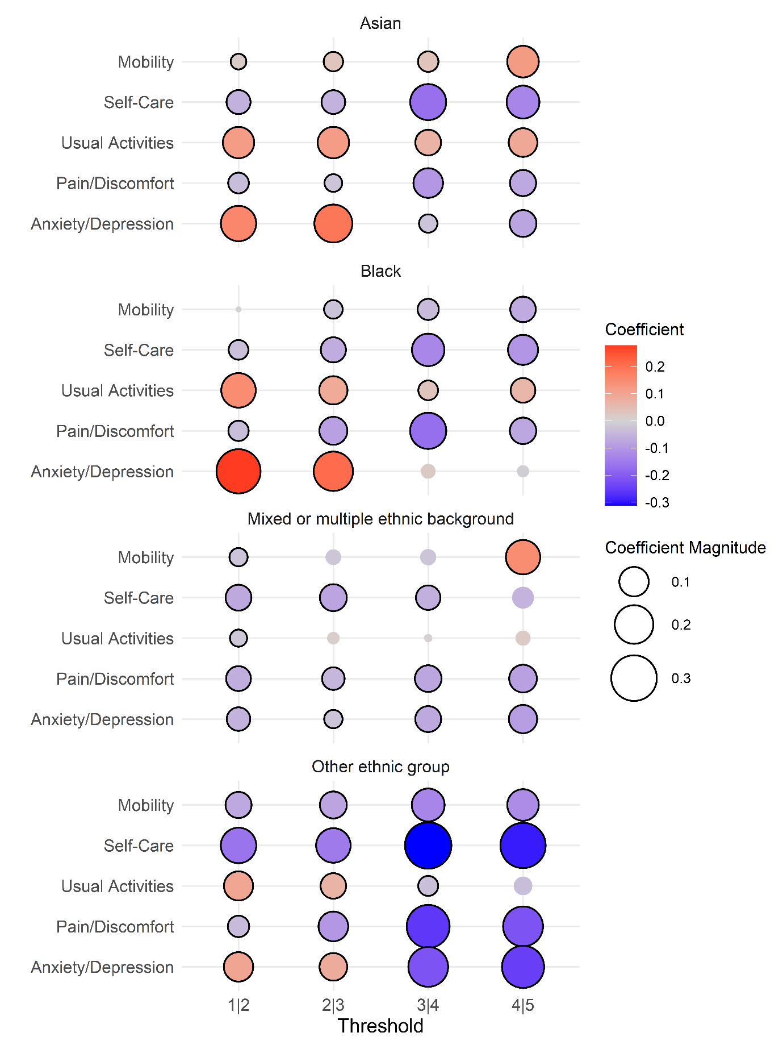
Note. A positive value indicates greater likelihood of reporting the less severe category for the same value of the latent health index. Solid black border indicates statistical significance using percentile bootstrapping (95% CI). Survey weights were used for the estimation of the HOPIT model.
¹Included the following explanatory variables: ethnic group, main effects of health conditions, interactions between sex and age groups and wave fixed effects. All coefficients available in the supplementary material.
Figure A2. Differences in thresholds between each ethnic group and the White ethnic group for each severity level and EQ-5D domain (Omission of area deprivation and health care utilisation variables in the threshold equations¹)
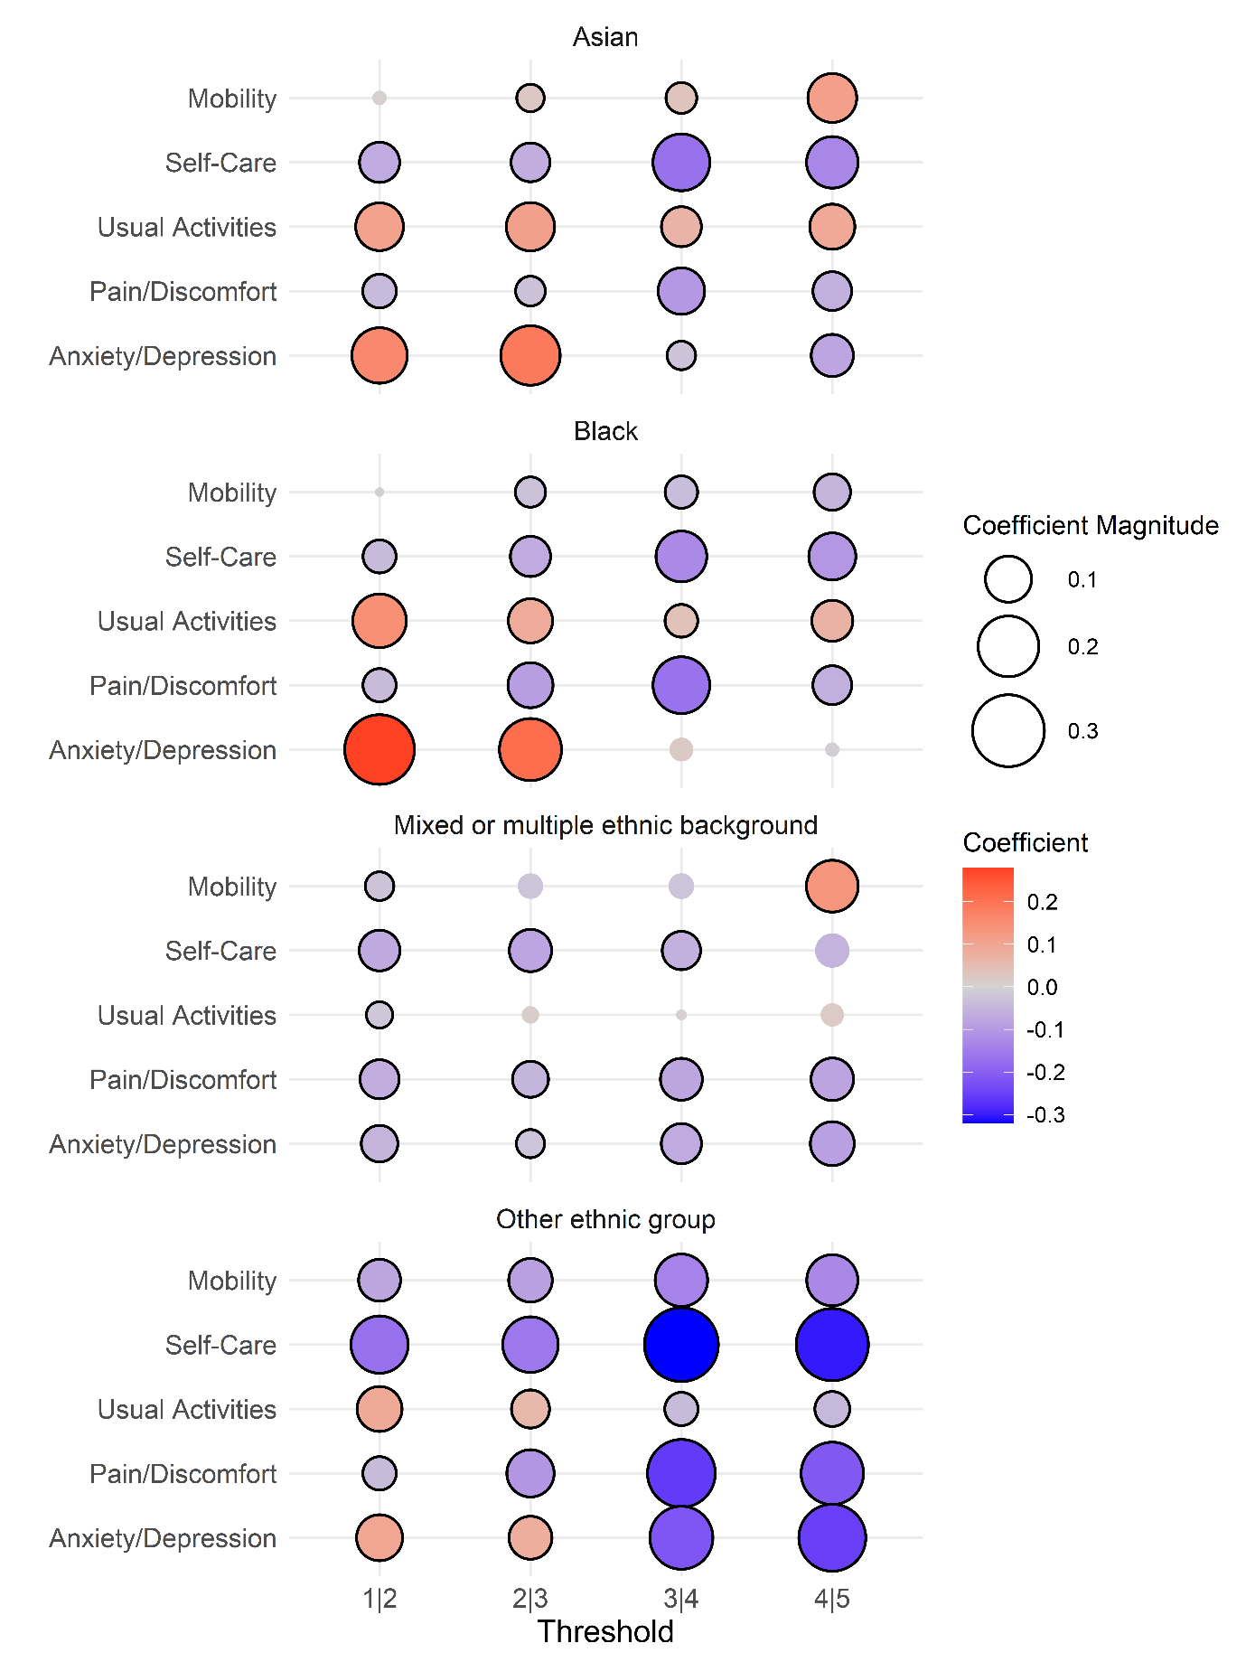
Note. A positive value indicates greater likelihood of reporting the less severe category for the same value of the latent health index. Solid black border indicates statistical significance using percentile bootstrapping (95% CI). Survey weights were used for the estimation of the HOPIT model.
¹Included the following explanatory variables: ethnic group, main effects of health conditions, interactions between sex and age groups, wave fixed effects and two-way and three-way interactions for long-term conditions that were prevalent in at least 1% of the data. All coefficients available in the supplementary material.
Figure A3. Differences in thresholds between each ethnic group and the White ethnic group for each severity level and EQ-5D domain (age-bands and sex variables in latent equation¹)
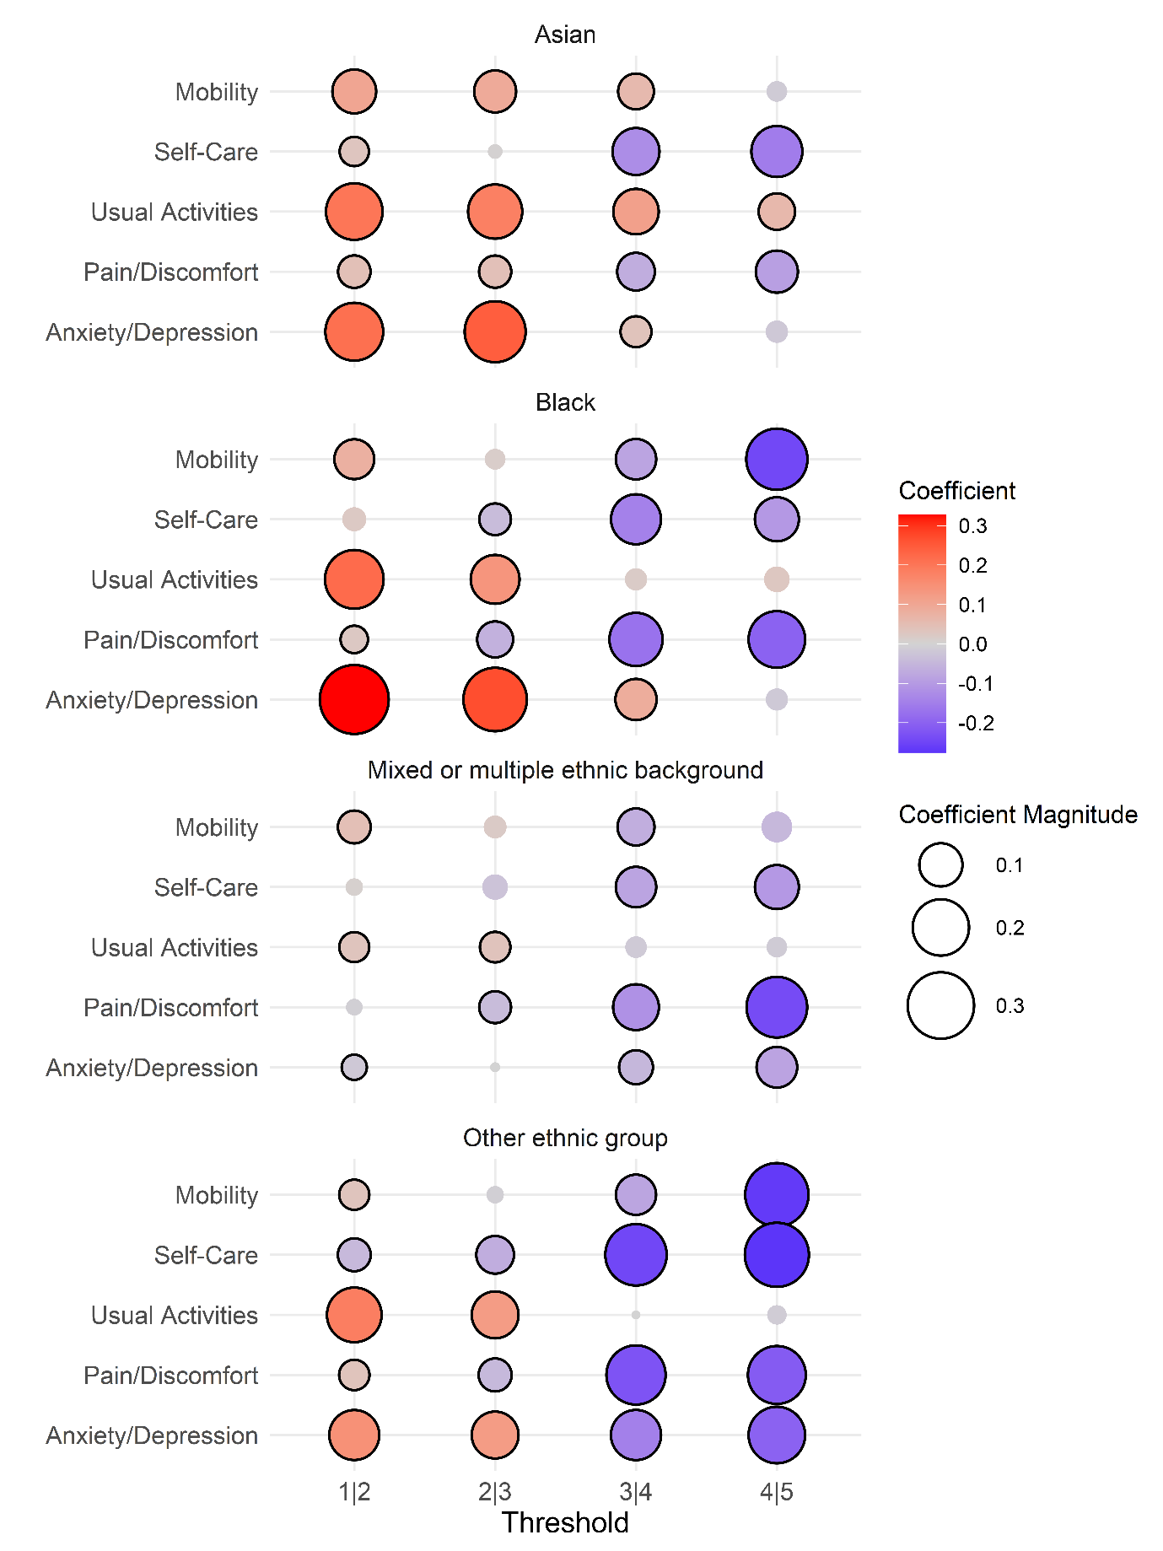
Note. A positive value indicates greater likelihood of reporting the less severe category for the same value of the latent health index. Solid black border indicates statistical significance using percentile bootstrapping (95% CI). Survey weights were used for the estimation of the HOPIT model.
¹Included the following explanatory variables: ethnic group, main effects of health conditions, interactions between sex and age groups, wave fixed effects and two-way and three-way interactions for long-term conditions that were prevalent in at least 1% of the data. All coefficients available in the supplementary material.

Figure A4. Differences in thresholds between each ethnic group and the White ethnic group for each severity level and EQ-5D domain (area deprivation in latent equation¹)
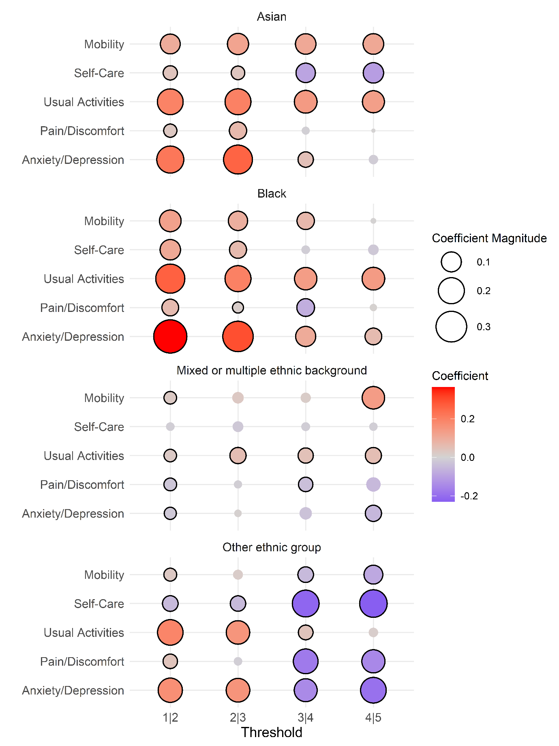
Note. A positive value indicates greater likelihood of reporting the less severe category for the same value of the latent health index. Solid black border indicates statistical significance using percentile bootstrapping (95% CI). Survey weights were used for the estimation of the HOPIT model.
¹Included the following explanatory variables: ethnic group, main effects of health conditions, interactions between sex and age groups, wave fixed effects and two-way and three-way interactions for long-term conditions that were prevalent in at least 1% of the data. All coefficients available in the supplementary material.
Figure A5. Differences in thresholds between each ethnic group and the White ethnic group for each severity level and EQ-5D domain (Health care use variables in latent equation¹)
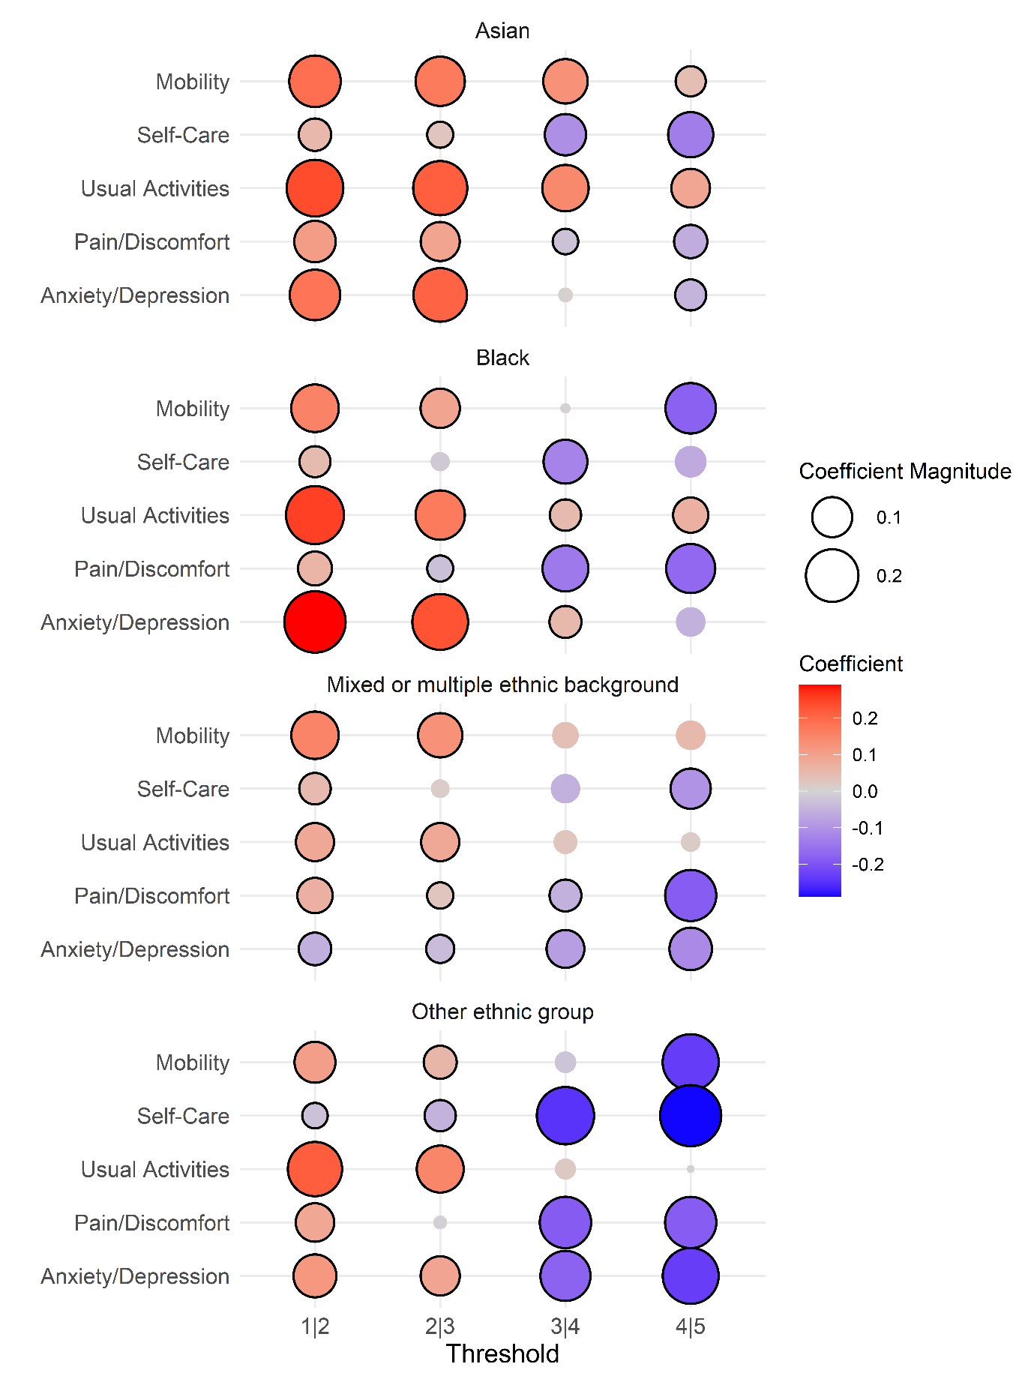
Note. A positive value indicates greater likelihood of reporting the less severe category for the same value of the latent health index. Solid black border indicates statistical significance using percentile bootstrapping (95% CI). Survey weights were used for the estimation of the HOPIT model.

Table A7. Differences in thresholds between each ethnic group within the White ethnic group and English/Welsh/Scottish/Nothern/Irish/British group baseline
Dimension | Thresholds between each of the levels
Dimension | 1|2 | 2|3 | 3|4 | 4|5
Irish
Mobility | 0.091* (0.012) | 0.024 (0.014) | -0.004 (0.018) | 0.008 (0.032)
Self-Care | -0.026 (0.014) | -0.047* (0.017) | -0.058* (0.024) | 0.011 (0.037)
Usual Activities | 0.099* (0.011) | 0.002 (0.014) | -0.008 (0.018) | -0.025 (0.024)
Pain/Discomfort | 0.109* (0.01) | -0.001 (0.011) | -0.019 (0.017) | 0.017 (0.03)
Anxiety/Depression | 0.042* (0.01) | 0.017 (0.013) | 0.021 (0.021) | 0.039 (0.03)
Gypsy or Irish Traveler
Mobility | -0.274* (0.054) | -0.432* (0.06) | -0.342* (0.072) | -0.055 (0.115)
Self-Care | -0.508* (0.058) | -0.506* (0.063) | -0.383* (0.081) | -0.241~ (0.113)
Usual Activities | -0.36* (0.053) | -0.408* (0.06) | -0.326* (0.068) | -0.161 (0.094)
Pain/Discomfort | -0.162* (0.052) | -0.465* (0.054) | -0.592* (0.065) | -0.464* (0.092)
Anxiety/Depression | -0.124* (0.049) | -0.388* (0.055) | -0.623* (0.067) | -0.557* (0.083)
Any other White background
Mobility | 0.174* (0.005) | 0.164* (0.007) | 0.109* (0.01) | -0.041* (0.016)
Self-Care | 0.171* (0.007) | 0.151* (0.009) | -0.033* (0.012) | -0.118* (0.016)
Usual Activities | 0.172* (0.005) | 0.198* (0.007) | 0.144* (0.009) | 0.059* (0.013)
Pain/Discomfort | -0.025* (0.004) | 0.046* (0.005) | 0.018* (0.008) | 0.048* (0.014)
Anxiety/Depression | 0.13* (0.004) | 0.17* (0.005) | 0.05* (0.008) | 0.058* (0.013)
Note. Bootstrap standard deviations are shown in parentheses. *Indicates statistical significance at the 95% confidence level using both parametric bootstrap standard deviations and the 2.5th and 97.5th percentiles). ~Indicates statistical significance at the 95% confidence level using standard deviations).

Table A8. Differences in thresholds between each ethnic group within the Mixed or multiple ethnic background group and English/Welsh/Scottish/Nothern/Irish/British group baseline
Dimension | Thresholds between each of the levels
Dimension | 1|2 | 2|3 | 3|4 | 4|5
White and Black Caribbean
Mobility | -0.067* (0.02) | -0.072* (0.027) | -0.036 (0.037) | -0.017 (0.066)
Self-Care | -0.047 (0.027) | -0.025 (0.033) | -0.046 (0.045) | -0.076 (0.063)
Usual Activities | -0.034 (0.019) | 0.011 (0.027) | -0.015 (0.035) | -0.058 (0.05)
Pain/Discomfort | -0.073* (0.017) | -0.044 (0.024) | -0.144* (0.031) | -0.112* (0.053)
Anxiety/Depression | -0.041* (0.016) | -0.022 (0.022) | -0.02 (0.033) | 0.032 (0.046)
White and Asian
Mobility | 0.111* (0.022) | 0.145* (0.031) | 0.036 (0.04) | 0.005 (0.069)
Self-Care | 0.02 (0.03) | 0.037 (0.036) | -0.031 (0.048) | -0.035 (0.076)
Usual Activities | 0.1* (0.02) | 0.126* (0.027) | 0.149* (0.04) | 0.153* (0.059)
Pain/Discomfort | 0.007 (0.017) | 0.073* (0.024) | 0.055 (0.037) | -0.016 (0.059)
Anxiety/Depression | 0.003 (0.016) | 0.096* (0.023) | 0.094* (0.036) | 0.052 (0.052)
White and Black African
Mobility | 0.143* (0.03) | 0.057 (0.038) | 0.086 (0.054) | 0.255* (0.11)
Self-Care | 0.051 (0.037) | -0.023 (0.043) | 0.026 (0.063) | -0.085 (0.082)
Usual Activities | 0.173* (0.027) | 0.14* (0.038) | 0.159* (0.051) | 0.18* (0.08)
Pain/Discomfort | 0.043. (0.022) | 0.015 (0.03) | -0.043 (0.045) | 0.214* (0.086)
Anxiety/Depression | 0.079* (0.022) | 0.087* (0.03) | 0.004 (0.047) | 0.018 (0.065)
Any other Mixed/Multiple ethnic background
Mobility | 0.034 (0.021) | 0.076* (0.028) | 0.051 (0.04) | 0.173* (0.073)
Self-Care | 0.018 (0.027) | -0.03 (0.032) | -0.028 (0.045) | -0.042 (0.06)
Usual Activities | -0.009 (0.019) | 0.068* (0.026) | 0.01 (0.033) | 0.001 (0.047)
Pain/Discomfort | -0.082* (0.016) | -0.019 (0.022) | 0.039 (0.034) | -0.094 (0.05)
Anxiety/Depression | -0.047* (0.016) | -0.012 (0.021) | -0.099* (0.031) | -0.187* (0.042)
Note. Bootstrap standard deviations are shown in parentheses. *Indicates statistical significance at the 95% confidence level using both parametric bootstrap standard deviations and the 2.5th and 97.5th percentiles). ~Indicates statistical significance at the 95% confidence level using standard deviations).

Table A9. Differences in thresholds between each ethnic group within the Asian ethnic group and English/Welsh/Scottish/Nothern/Irish/British group baseline
Dimension | Thresholds between each of the levels
Dimension | 1|2 | 2|3 | 3|4 | 4|5
Indian
Mobility | 0.142* (0.008) | 0.122* (0.01) | 0.101* (0.013) | 0.065* (0.024)
Self-Care | 0.099* (0.01) | 0.057* (0.012) | -0.062* (0.016) | -0.123* (0.022)
Usual Activities | 0.26* (0.007) | 0.238* (0.01) | 0.192* (0.014) | 0.138* (0.021)
Pain/Discomfort | 0.101* (0.006) | 0.1* (0.008) | 0.068* (0.012) | 0.063* (0.021)
Anxiety/Depression | 0.306* (0.006) | 0.321* (0.009) | 0.157* (0.015) | 0.095* (0.022)
Pakistani
Mobility | 0.03* (0.009) | 0.049* (0.012) | 0.058* (0.015) | 0.021 (0.026)
Self-Care | -0.065* (0.012) | -0.043* (0.014) | -0.182* (0.017) | -0.199* (0.023)
Usual Activities | 0.087* (0.008) | 0.105* (0.012) | 0.07* (0.015) | 0.055* (0.021)
Pain/Discomfort | -0.037* (0.007) | -0.029* (0.01) | -0.087* (0.013) | -0.044~ (0.022)
Anxiety/Depression | 0.197* (0.007) | 0.229* (0.01) | 0.004 (0.015) | -0.082* (0.021)
Bangladeshi
Mobility | -0.007 (0.015) | 0.136* (0.021) | 0.198* (0.027) | 0.236* (0.053)
Self-Care | -0.043* (0.018) | 0.031 (0.022) | -0.136* (0.027) | -0.185* (0.037)
Usual Activities | 0.061* (0.014) | 0.173* (0.019) | 0.136* (0.026) | 0.178* (0.038)
Pain/Discomfort | -0.179* (0.012) | -0.009 (0.017) | -0.036 (0.023) | -0.006 (0.036)
Anxiety/Depression | 0.145* (0.012) | 0.261* (0.017) | -0.003 (0.024) | -0.074* (0.034)
Chinese
Mobility | 0.384* (0.017) | 0.472* (0.027) | 0.394* (0.041) | -0.014 (0.065)
Self-Care | 0.441* (0.029) | 0.403* (0.039) | 0.181* (0.055) | 0.112 (0.084)
Usual Activities | 0.514* (0.016) | 0.582* (0.027) | 0.448* (0.043) | 0.373* (0.069)
Pain/Discomfort | 0.034* (0.011) | 0.315* (0.019) | 0.335* (0.034) | 0.138* (0.06)
Anxiety/Depression | 0.093* (0.011) | 0.321* (0.018) | 0.235* (0.034) | 0.362* (0.066)
Any other Asian background
Mobility | 0.121* (0.01) | 0.174* (0.013) | 0.111* (0.017) | 0.078* (0.03)
Self-Care | 0.077* (0.013) | 0.057* (0.016) | -0.082* (0.021) | -0.126* (0.027)
Usual Activities | 0.228* (0.009) | 0.255* (0.013) | 0.13* (0.017) | 0.096* (0.025)
Pain/Discomfort | -0.004 (0.008) | 0.125* (0.011) | -0.037* (0.015) | -0.051~ (0.025)
Anxiety/Depression | 0.233* (0.007) | 0.275* (0.011) | -0.003 (0.016) | -0.055* (0.024)
Note. Bootstrap standard deviations are shown in parentheses. *Indicates statistical significance at the 95% confidence level using both parametric bootstrap standard deviations and the 2.5th and 97.5th percentiles). ~Indicates statistical significance at the 95% confidence level using standard deviations).

Table A10. Differences in thresholds between each ethnic group within the Black ethnic group and English/Welsh/Scottish/Nothern/Irish/British group baseline
Dimension | Thresholds between each of the levels
Dimension | 1|2 | 2|3 | 3|4 | 4|5
African
Mobility | 0.244* (0.009) | 0.155* (0.014) | 0.061* (0.017) | -0.05 (0.03)
Self-Care | 0.22* (0.013) | 0.132* (0.017) | -0.041~ (0.02) | -0.099* (0.029)
Usual Activities | 0.387* (0.01) | 0.3* (0.014) | 0.164* (0.018) | 0.113* (0.028)
Pain/Discomfort | 0.106* (0.007) | 0.097* (0.01) | -0.057* (0.015) | 0.036 (0.027)
Anxiety/Depression | 0.476* (0.008) | 0.424* (0.012) | 0.186* (0.018) | 0.15* (0.028)
Caribbean
Mobility | 0.035* (0.012) | 0.084* (0.016) | 0.116* (0.021) | -0.07* (0.032)
Self-Care | 0.054* (0.016) | 0.051* (0.019) | 0.027 (0.026) | -0.081* (0.035)
Usual Activities | 0.155* (0.012) | 0.156* (0.015) | 0.138* (0.021) | 0.107* (0.032)
Pain/Discomfort | -0.068* (0.01) | -0.011 (0.013) | 0.024 (0.018) | 0.046 (0.031)
Anxiety/Depression | 0.229* (0.01) | 0.234* (0.014) | 0.148* (0.023) | 0.102* (0.032)
Any other Black/African/Caribbean background
Mobility | 0.021 (0.016) | 0.033 (0.021) | 0.012 (0.028) | -0.06 (0.044)
Self-Care | -0.004 (0.022) | -0.03 (0.026) | -0.093* (0.034) | -0.041 (0.049)
Usual Activities | 0.166* (0.017) | 0.141* (0.022) | 0.098* (0.028) | 0.131* (0.041)
Pain/Discomfort | -0.029* (0.014) | -0.057* (0.018) | -0.119* (0.025) | -0.104* (0.04)
Anxiety/Depression | 0.238* (0.015) | 0.163* (0.018) | -0.029 (0.028) | -0.088* (0.039)
Note. Bootstrap standard deviations are shown in parentheses. *Indicates statistical significance at the 95% confidence level using both parametric bootstrap standard deviations and the 2.5th and 97.5th percentiles). ~Indicates statistical significance at the 95% confidence level using standard deviations).

Table A11. Differences in thresholds between each ethnic group within the Other ethnic group and English/Welsh/Scottish/Nothern/Irish/British group baseline
Dimension | Thresholds between each of the levels
Dimension | 1|2 | 2|3 | 3|4 | 4|5
Arab
Mobility | 0 (0.023) | 0.045 (0.03) | 0.031 (0.04) | 0.057 (0.063)
Self-Care | -0.066* (0.028) | -0.099* (0.032) | -0.244* (0.039) | -0.175* (0.056)
Usual Activities | 0.1* (0.022) | 0.08* (0.028) | 0.014 (0.037) | 0.138* (0.052)
Pain/Discomfort | -0.032 (0.02) | -0.146* (0.024) | -0.088* (0.035) | -0.079 (0.048)
Anxiety/Depression | 0.049* (0.019) | 0.017 (0.024) | -0.233* (0.033) | -0.146* (0.048)
Any other ethnic group
Mobility | 0.049* (0.007) | 0.038* (0.009) | -0.047* (0.012) | -0.151* (0.018)
Self-Care | -0.029* (0.009) | -0.03* (0.011) | -0.218* (0.013) | -0.279* (0.017)
Usual Activities | 0.216* (0.007) | 0.188* (0.01) | 0.058* (0.012) | -0.014 (0.015)
Pain/Discomfort | 0.028* (0.006) | 0.022* (0.008) | -0.162* (0.01) | -0.152* (0.016)
Anxiety/Depression | 0.188* (0.006) | 0.2* (0.008) | -0.11* (0.011) | -0.181* (0.016)
Note. Bootstrap standard deviations are shown in parentheses. *Indicates statistical significance at the 95% confidence level using both parametric bootstrap standard deviations and the 2.5th and 97.5th percentiles). ~Indicates statistical significance at the 95% confidence level using standard deviations).

