Estimating the Minimal Clinically Important Difference for the Myasthenia Gravis Quality of Life revised scale (MG-QOL15R)
Quality of Life Research
Ângela Jornada Ben MD, PhD¹; Febe Brackx MSc¹; Glenn Phillips, PhD²; Carolina Barnett-Tapia, MD, PhD³; Cynthia Qi, PhD²; Fanni Rencz DSc⁴, Sarah Dewilde PhD¹
¹ Services in Health Economics, Brussels, Belgium
² argenX Ghent, Belgium
³ Division of Neurology, Department of Medicine, University Health Network, University of Toronto, Toronto, Ontario, Canada.
⁴ Department of Health Policy, Corvinus University of Budapest, Budapest, Hungary
Corresponding author: Ângela Jornada Ben. angela@she-consulting.be
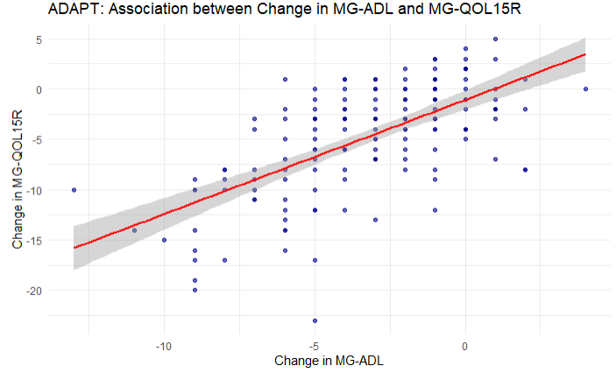 | 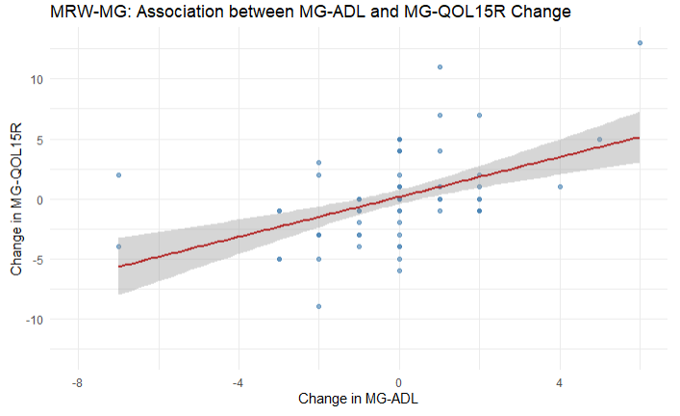
Supplementary Fig 1 Association between changes in MG-ADL and MG-QOL15R scores in the MRW-MG study. Each point represents an individual participant. Negative values on both axes indicate clinical improvement. The red regression line with a 95% confidence band (shaded area) suggests a positive association: participants who improved in MG-ADL tended to show improvement in MG-QOL15R.

