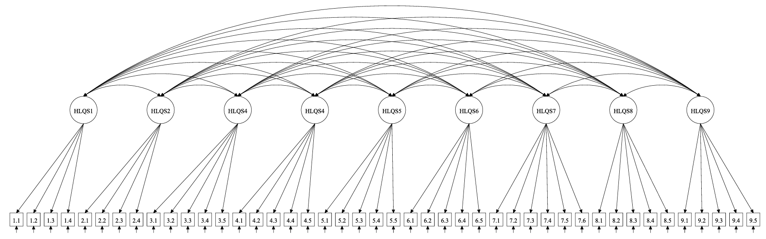

Supplementary Figure 1: The nine-scale a prior HLQ conceptual structure.
Note: HLQS1 = 1. Feeling understood and supported by healthcare providers; HLQS2 = 2. Having sufficient information to manage my health; HLQS3 = 3. Actively managing my health; HLQS4 = 4. Social support for health; HLQS5 = 5. Appraisal of health information; HLQS6 = 6. Ability to actively engage with healthcare providers; HLQS7 = 7. Navigating the healthcare system; HLQS8 = 8. Ability to find good health information; HLQS9 = 9. Understanding health information well enough to know what to do.

