Explaining inequalities in quality of life: A longitudinal study of health disparities in Norway

Supplementary Material - revised

Table A1 Unadjusted mean EQ-5D-5L, EQ VAS and SWLS-3, and percentage reporting Good or Very good Self-Rated Health (SRH) at t₂₁, by categories of BMI and physical activity. The Tromsø Study 1994-2016.
Characteristic | N=11,313ª | EQ-5D-5L | EQ VAS | SRH: Good / Very good | SWLS-3
BMI
Persistent normal | 3,163 (28%) | 0.946 | 0.795 | 77% | 0.724
New normal | 332 (3.0%) | 0.938 | 0.776 | 70% | 0.732
Overweight at t₂₁ | 5,036 (45%) | 0.941 | 0.773 | 70% | 0.729
30-35 at t₂₁ | 2,030 (18%) | 0.927 | 0.735 | 59% | 0.716
Increase to 35+ at t₂₁ | 302 (2.7%) | 0.889 | 0.686 | 41% | 0.669
Persistent obese, 30+ at t₀ & 35+ at t₂₁ | 353 (3.1%) | 0.877 | 0.678 | 43% | 0.645
Physical Activity
Persistent active | 1,801 (17%) | 0.950 | 0.809 | 84% | 0.745
Newly active | 2,394 (22%) | 0.943 | 0.786 | 74% | 0.728
Moderate t₂₁ | 3,260 (31%) | 0.942 | 0.771 | 70% | 0.724
Newly inactive | 1,976 (19%) | 0.926 | 0.742 | 61% | 0.710
Persistent inactive | 1,229 (12%) | 0.920 | 0.727 | 54% | 0.702
ª n (%)

Table A2 Logistic regression results for Good or Very good Self-Rated Health at t₂₁. The Tromsø Study 1994-95 (t₀) and 2015-16 (t₂₁).
 | Model 0 | I | II | III
Characteristic | OR | OR | OR | OR
Own education (ref. Primary)
Secondary | 1.467*** | 1.418*** | 1.334*** | 1.281***
Tertiary low | 2.152*** | 2.014*** | 1.729*** | 1.582***
Tertiary high | 2.944*** | 2.632*** | 2.021*** | 1.843***
Height (ref. Tallest 80%)
Shortest 20% |  | 0.955 | 1.017 | 1.011
Childhood living standard (ref. Good)
Difficult |  | 0.682*** | 0.699*** | 0.768***
Spouse education (ref. No Spouse)
Non-tertiary |  | 1.215*** | 1.244*** | 1.226**
Tertiary |  | 1.480*** | 1.376*** | 1.307***
Smoking status (ref. Never smoker)
Quitter |  |  | 0.732*** | 0.790***
Smoker |  |  | 0.568*** | 0.629***
BMI (ref. Persistent normal)
New normal |  |  | 0.683** | 0.726*
Overweight t21 |  |  | 0.743*** | 0.762***
30-35 at t21 |  |  | 0.504*** | 0.525***
Increase to 35+ |  |  | 0.256*** | 0.262***
Persistent obese, >35 at t21 |  |  | 0.289*** | 0.297***
Physical activity (ref. Persistent active)
Newly active |  |  | 0.623*** | 0.706***
Moderate t21 |  |  | 0.520*** | 0.560***
Newly inactive |  |  | 0.398*** | 0.423***
Persistent inactive |  |  | 0.344*** | 0.404***
Self-Rated Health_t₀ (ref. Good)
Not good |  |  |  | 0.320***
Very good |  |  |  | 3.051***
Odds Ratios (ORs) are reported. *p<0.05; **p<0.01; ***p<0.001. All models were adjusted for age and sex.
Model-0 is a reference case; Model-I includes the three socioeconomic predictors; Model-II further includes three health behaviours; Model-III further adjusts for differences in self-rated health at baseline.

Table A3 Linear regression results for SWLS-3 at t₂₁. The Tromsø Study 1994-95 (t₀) and 2015-16 (t₂₁).

 | Model 0 | I | II | III
Characteristic | Beta | Beta | Beta | Beta
(Intercept) | 0.718*** | 0.672*** | 0.715*** | 0.705***
Own education (ref. Primary)
Secondary | 0.002 | 0.000 | -0.005 | -0.008
Tertiary low | -0.002 | -0.007 | -0.019** | -0.026***
Tertiary high | 0.019** | 0.011 | -0.004 | -0.013*
Childhood living standard (ref. Good)
Difficult |  | -0.034*** | -0.031*** | -0.025***
Spouse education (ref. No Spouse)
Non-tertiary |  | 0.065*** | 0.064*** | 0.062***
Tertiary |  | 0.077*** | 0.070*** | 0.066***
Smoking status (ref. Never smoker)
Quitter |  |  | -0.027*** | -0.022***
Smoker |  |  | -0.050*** | -0.042***
BMI (ref. Persistent normal)
New normal |  |  | 0.001 | 0.006
Overweight t21 |  |  | 0.004 | 0.007
30-35 at t21 |  |  | -0.001 | 0.005
Increase to 35+ |  |  | -0.037** | -0.027*
Persistent obese, >35 at t21 |  |  | -0.063*** | -0.056***
Physical activity (ref. Persistent active)
Newly active |  |  | -0.013* | -0.004
Moderate t21 |  |  | -0.017** | -0.009
Newly inactive |  |  | -0.023*** | -0.015*
Persistent inactive |  |  | -0.030*** | -0.016*
Self-Rated Health_t₀ (ref. Good)
Not good |  |  |  | -0.061***
Very good |  |  |  | 0.058***
R² | 0.006 | 0.029 | 0.043 | 0.073
β-coefficients are reported. *p<0.05; **p<0.01; ***p<0.001. All models were adjusted for age and sex.
Model-0 is a reference case; Model-I includes the three socioeconomic predictors; Model-II further includes three health behaviours; Model-III further adjusts for differences in self-rated health at baseline.

Table A4 Linear regression results split by level of Self-Rated Health (SRH) at baseline. The Tromsø Study 1994-2016.
 | EQ-5D-5L |  | EQ-VAS
 | Baseline SRH:  Good | Baseline SRH:  Very good | Baseline SRH:  Good | Baseline SRH:  Very good
(Intercept) | 0.953*** | 0.964*** | 0.798*** | 0.861***
Childhood living standard
Good | — | — | — | —
Difficult | -0.009*** | -0.007* | -0.010* | -0.020**
Own education
Primary | — | — | — | —
Secondary | 0.002 | -0.001 | 0.015** | -0.002
Tertiary low | 0.002 | 0.003 | 0.014* | 0.011
Tertiary high | 0.002 | 0.010* | 0.021*** | 0.016
Spouse education
No Spouse | — | — | — | —
Non-tertiary | 0.005 | 0.010* | 0.006 | 0.009
Tertiary | 0.003 | 0.008 | 0.007 | 0.010
Smoking status
Never smoker | — | — | — | —
Quitter | -0.005* | -0.003 | -0.016*** | -0.007
Smoker | -0.016*** | -0.010* | -0.027*** | -0.039***
BMI
Persistent normal | — | — | — | —
New normal | -0.007 | -0.017* | -0.021 | -0.018
Overweight t21 | -0.007** | -0.005 | -0.015** | -0.010
30-35 at t21 | -0.017*** | -0.008 | -0.050*** | -0.028**
Increase to 35+ | -0.034*** | -0.037*** | -0.076*** | -0.061**
Persistent obese, >35 at t21 | -0.055*** | -0.019* | -0.072*** | -0.093***
Physical activity
Persistent active | — | — | — | —
Newly active | 0.001 | 0.002 | -0.001 | 0.008
Moderate t21 | 0.001 | 0.002 | -0.013* | -0.019*
Newly inactive | -0.010** | -0.012** | -0.033*** | -0.040***
Persistent inactive | -0.007 | 0.002 | -0.028*** | -0.025
R² | 0.044 | 0.041 | 0.047 | 0.064
β-coefficients are reported. *p<0.05; **p<0.01; ***p<0.001. All models were adjusted for age and sex.

Table A5 Linear regression results (cf Model-II) for EQ-5D-5L and EQ-VAS at t₂₁ by age groups. The Tromsø Study 1994-2016.
 | EQ-5D-5L |  |  | EQ-VAS
Characteristic | 46-55 yrs | 55-65 yrs | 66-75 yrs | 46-55 yrs | 55-65 yrs | 66-75 yrs
(Intercept) | 0.933*** | 0.946*** | 0.975*** | 0.805*** | 0.797*** | 0.815***
Childhood living standard
Good | — | — | — | — | — | —
Difficult | -0.010* | -0.016*** | -0.011*** | -0.027*** | -0.014* | -0.031***
Own education
Primary | — | — | — | — | — | —
Secondary | 0.015** | 0.001 | -0.003 | 0.010 | 0.014* | 0.030***
Tertiary low | 0.013* | 0.007 | -0.006 | 0.017 | 0.020* | 0.030***
Tertiary high | 0.021*** | 0.009* | -0.004 | 0.027** | 0.025*** | 0.045***
Spouse education
No Spouse | — | — | — | — | — | —
Non-tertiary | 0.014*** | 0.010* | 0.000 | 0.021** | 0.009 | 0.009
Tertiary | 0.013** | 0.010* | -0.003 | 0.023** | 0.017* | 0.006
Smoking status
Never smoker | — | — | — | — | — | —
Quitter | -0.004 | -0.015*** | -0.008* | -0.013* | -0.021*** | -0.030***
Smoker | -0.021*** | -0.020*** | -0.015** | -0.040*** | -0.038*** | -0.029**
BMI
Persistent normal | — | — | — | — | — | —
New normal | -0.011 | -0.013 | -0.004 | -0.023 | -0.031 | -0.004
Overweight t₂₁ | -0.005 | -0.004 | -0.013*** | -0.010 | -0.018** | -0.025***
30-35 at t₂₁ | -0.017*** | -0.020*** | -0.015** | -0.048*** | -0.051*** | -0.044***
Increase to 35+ | -0.037*** | -0.039*** | -0.039** | -0.104*** | -0.068*** | -0.054*
Persistent obese, >35 at t₂₁ | -0.051*** | -0.066*** | -0.051*** | -0.084*** | -0.106*** | -0.084***
Physical activity
Persistent active | — | — | — | — | — | —
Newly active | -0.002 | 0.000 | -0.004 | -0.018* | 0.000 | -0.017
Moderate t₂₁ | -0.002 | 0.003 | -0.009* | -0.028*** | -0.015* | -0.030***
Newly inactive | -0.015** | -0.011* | -0.022*** | -0.058*** | -0.024** | -0.053***
Persistent inactive | -0.017** | -0.013* | -0.022*** | -0.052*** | -0.044*** | -0.056***
R² | 0.063 | 0.058 | 0.049 | 0.086 | 0.060 | 0.078
β-coefficients are reported. ¹*p<0.05; **p<0.01; ***p<0.001. All models were adjusted for sex.

Table A6 Linear regression results (cf Model-II) for EQ-5D-5L and EQ-VAS at t₂₁ by sex. The Tromsø Study 1994-2016.
 | EQ-5D-5L |  | EQ-VAS
Characteristic | Women | Men | Women | Men
(Intercept) | 0.950*** | 0.948*** | 0.794*** | 0.803***
Childhood living standard
Good | — | — | — | —
Difficult | -0.017*** | -0.009** | -0.029*** | -0.018***
Own education
Primary | — | — | — | —
Secondary | 0.000 | 0.005 | 0.025*** | 0.010
Tertiary low | 0.004 | 0.003 | 0.035*** | 0.010
Tertiary high | 0.008* | 0.007 | 0.043*** | 0.020**
Spouse education
No Spouse | — | — | — | —
Non-tertiary | 0.007* | 0.013*** | 0.009 | 0.023***
Tertiary | 0.006 | 0.012** | 0.013* | 0.025***
Smoking status
Never smoker | — | — | — | —
Quitter | -0.009** | -0.010*** | -0.017** | -0.025***
Smoker | -0.019*** | -0.020*** | -0.036*** | -0.036***
BMI
Persistent normal | — | — | — | —
New normal | -0.010 | -0.009 | -0.016 | -0.024
Overweight t₂₁ | -0.007** | -0.005 | -0.019*** | -0.013*
30-35 at t₂₁ | -0.021*** | -0.012** | -0.060*** | -0.034***
Increase to 35+ | -0.050*** | -0.013 | -0.085*** | -0.080***
Persistent obese, >35 at t₂₁ | -0.053*** | -0.061*** | -0.087*** | -0.095***
Physical activity
Persistent active | — | — | — | —
Newly active | -0.004 | -0.001 | -0.007 | -0.017*
Moderate t₂₁ | -0.005 | 0.001 | -0.020** | -0.028***
Newly inactive | -0.025*** | -0.007 | -0.045*** | -0.043***
Persistent inactive | -0.018*** | -0.017*** | -0.053*** | -0.047***
R² | 0.055 | 0.042 | 0.081 | 0.061
β-coefficients are reported. ¹*p<0.05; **p<0.01; ***p<0.001. All models were adjusted for age.

Table A7 Linear regression results (cf Model-II) for EQ-5D-5L and EQ-VAS at t₂₁ when excluding subjects who reported level 4 or level 5 on at least one of the first four dimensions in the EQ-5D-5L (i.e. those who might have health issues that restrict physical activity). The Tromsø Study 1994-2016.
 | EQ-5D-5L | EQ-VAS
(Intercept) | 0.961*** | 0.809***
Childhood living standard
Good | — | —
Difficult | -0.009*** | -0.022***
Own education
Primary | — | —
Secondary | 0.002 | 0.020***
Tertiary low | 0.004* | 0.027***
Tertiary high | 0.006** | 0.034***
Smoking status
Never smoker | — | —
Quitter | -0.005*** | -0.019***
Smoker | -0.013*** | -0.031***
Spouse education
No Spouse | — | —
Non-tertiary | 0.004* | 0.010*
Tertiary | 0.004* | 0.013**
BMI
Persistent normal | — | —
New normal | -0.005 | -0.012
Overweight t21 | -0.003* | -0.016***
30-35 at t21 | -0.012*** | -0.045***
Increase to 35+ | -0.028*** | -0.080***
Persistent obese, >35 at t21 | -0.029*** | -0.080***
Physical activity
Persistent active | — | —
Newly active | -0.005* | -0.014**
Moderate t21 | -0.005** | -0.027***
Newly inactive | -0.011*** | -0.041***
Persistent inactive | -0.012*** | -0.048***
R² | 0.039 | 0.066
β-coefficients are reported. *p<0.05; **p<0.01; ***p<0.001. All models were adjusted for age and sex.

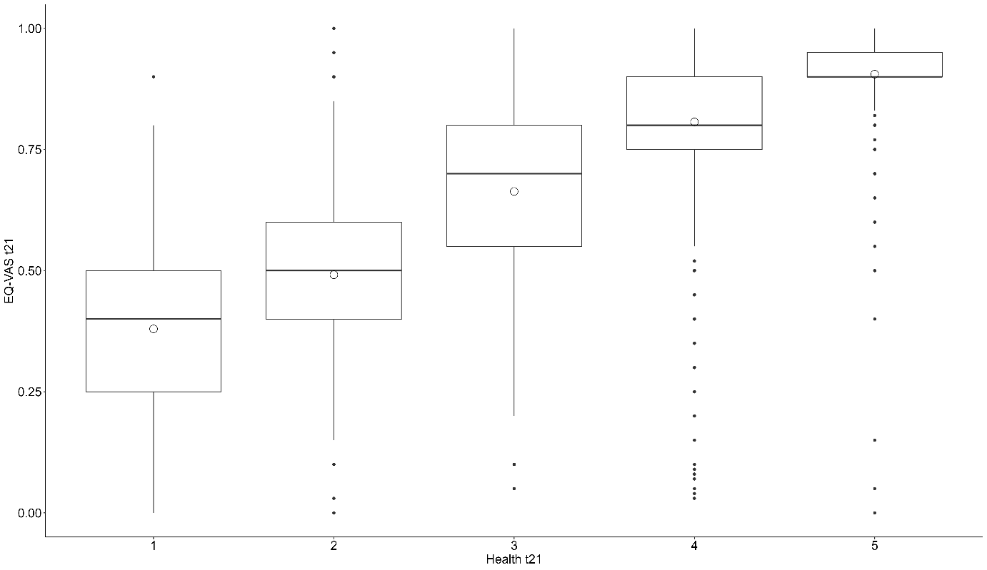
Figure A1. The association between Self-Rated Health at t₂₁ with EQ-VAS at t₂₁
Pearson correlation coefficient ρ=0.62

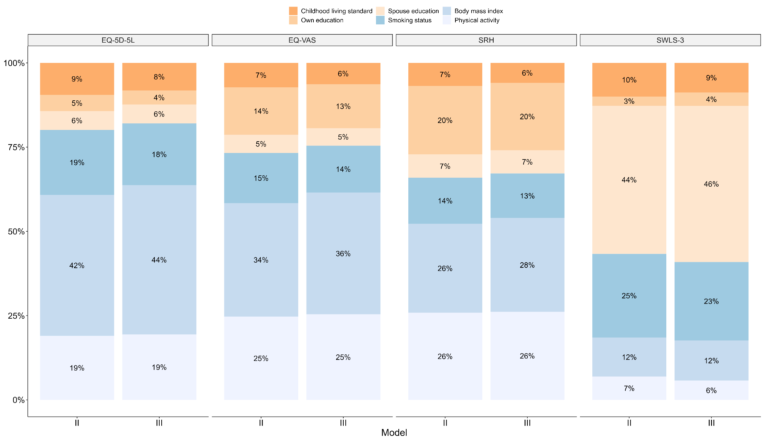
Figure A2. Shapley value decomposition of the relative importance of main set of predictors to the explained variances in health and wellbeing. The Tromsø Study1994-2016. Removing Shapley % for Self-reported health at baseline and rescaling provide similar results as in Model-II.
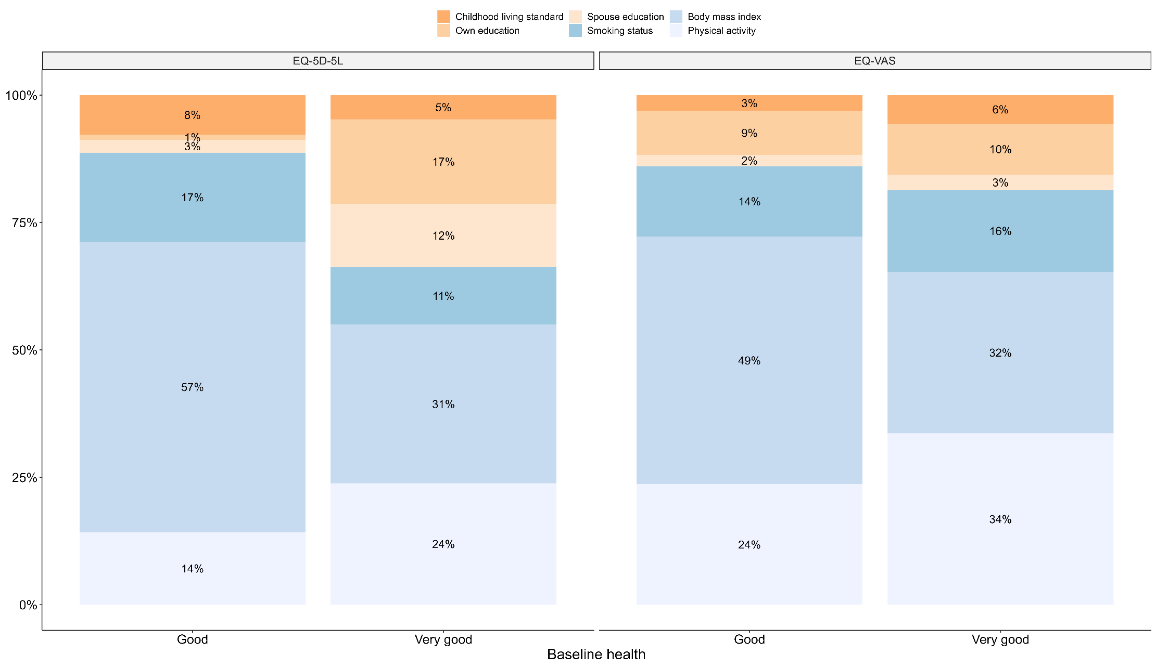
Figure A3. Shapley value decomposition of the relative importance of main set of predictors to the explained variances in EQ-5D-5L and EQ-VAS split by baseline Self-reported health; Good or Very good. The Tromsø Study 1994-2016.

