Title Page
Health Related Quality of Life of Breast Cancer Patients in Malaysia: Evidence from EQ-5D-5L and EORTC QLQ-C30
Journal Name
Quality of Life Research
Authors and affiliations
Siew Chin Ong*¹, Sook Pin Goh¹, Siew Wei Yeong¹, Chow Kyn Ng¹, Yi Jing Tan², Muhammad Daoud Butt¹, Kian Keong Kong³, Sin Dee Cheah⁴, Boon Seang Tan⁴, Jen Ven Lee⁵, Ros Suzanna Ahmad Bustamam⁵, Wei Wern Khor⁶, Liyana Ahamad Fouzi⁷, Aina Shafiza Abd Aziz⁸, Su Yiu Chieng⁹, Sarahfarina Abd Rahim¹⁰
*Corresponding author: siewchinong@usm.my
¹Discipline of Social and Administrative Pharmacy, School of Pharmaceutical Sciences, Universiti Sains Malaysia, Georgetown, Penang, Malaysia.
²Jempol Hospital, Ministry of Health Malaysia, Negeri Sembilan, Malaysia.
³Duchess of Kent Hospital, Ministry of Health Malaysia, Sandakan, Sabah, Malaysia.
⁴Penang General Hospital, Ministry of Health Malaysia, Penang, Malayia.
⁵Kuala Lumpur Hospital, Ministry of Health Malaysia, Kuala Lumpur, Malaysia.
⁶Sarawak General Hospital, Ministry of Health Malaysia, Kuching, Sarawak, Malaysia.
⁷Sultanah Nur Zahirah Hospital, Ministry of Health Malaysia, Kuala Terengganu, Terengganu, Malaysia.
⁸Sultanah Aminah Hospital, Ministry of Health Malaysia, Johor Bahru, Johor, Malaysia.
⁹Sibu Hospital, Ministry of Health Malaysia, Sibu, Sarawak, Malaysia.
¹⁰National Cancer Institute, Ministry of Health Malaysia, Putrajaya, Malaysia.

Supplemental Information
Section 1: Recruitment details of health-related quality of life (HRQoL) study among breast cancer (BC) patients in public hospitals Malaysia
Figure S1.1 Flow chart of patient recruitment

Table S1.2 Regional Distribution of Participating Public Hospitals in Malaysia.
Name of Public Hospitals involved | Level | Region
Institut Kanser Negara (IKN), Putrajaya | National tertiary and referral centre | West Coast (Peninsular Malaysia)
Kuala Lumpur Hospital (HKL), Kuala Lumpur | National tertiary and referral centre | West Coast (Peninsular Malaysia)
Pulau Pinang Hospital (HPP), Penang | State tertiary and referral centre | West Coast (Peninsular Malaysia)
Sultanah Aminah Hospital (HSA), Johor Bahru, Johor | State tertiary and referral centre | West Coast (Peninsular Malaysia)
Sultanah Nur Zahirah Hospital (HSNZ), Kuala Terengganu, Terengganu | State tertiary and referral centre | East Coast (Peninsular Malaysia)
Sarawak General Hospital (HUS), Kuching, Sarawak | State tertiary and referral centre | East Malaysia
Sibu Hospital, Sibu, Sarawak | Regional referral centre | East Malaysia
Duchess of Kent Hospital, Sandakan, Sabah | District general hospital | East Malaysia

Table S1.3 Missing data summary
Variable | Missing Count | Missing Percentage (%)
Lumpectomy | 3 | 1.09
Mastectomy | 2 | 0.73
Breast Reconstruction | 2 | 0.73
Chemotherapy | 2 | 0.73
Hormonal Therapy | 2 | 0.73
VAS | 2 | 0.73
Menopause | 1 | 0.36
Radiation | 1 | 0.36
Mobility | 1 | 0.36
Self-Care | 1 | 0.36
Usual Activities | 1 | 0.36
Pain / Discomfort | 1 | 0.36
EORTC-QLQC30 Question 10 | 1 | 0.36
EORTC-QLQC30 Question 26 | 1 | 0.36

Section 2: Distribution and Inter-relationships of HRQoL Measures.
Table S2.1 Frequency distribution and summary statistics of the EQ-5D-5L dimensions (N = 275).
Dimension | No Problem (%) | Slight Problem (%) | Moderate Problem (%) | Severe Problem (%) | Unable/ Extreme Problem (%)
Mobility | 73.45 | 14.55 | 8.36 | 2.18 | 1.45
Self-Care | 88.00 | 6.55 | 3.64 | 1.09 | 0.73
Usual Activities | 69.45 | 19.27 | 7.27 | 1.82 | 2.18
Pain/ Discomfort | 48.36 | 39.27 | 10.18 | 2.18 | 0.00
Anxiety/ Depression | 57.09 | 30.91 | 10.91 | 0.73 | 0.36

Figure S2.2 Distribution and boxplots of EQ-5D-5L HSUV and EQ-VAS scores.
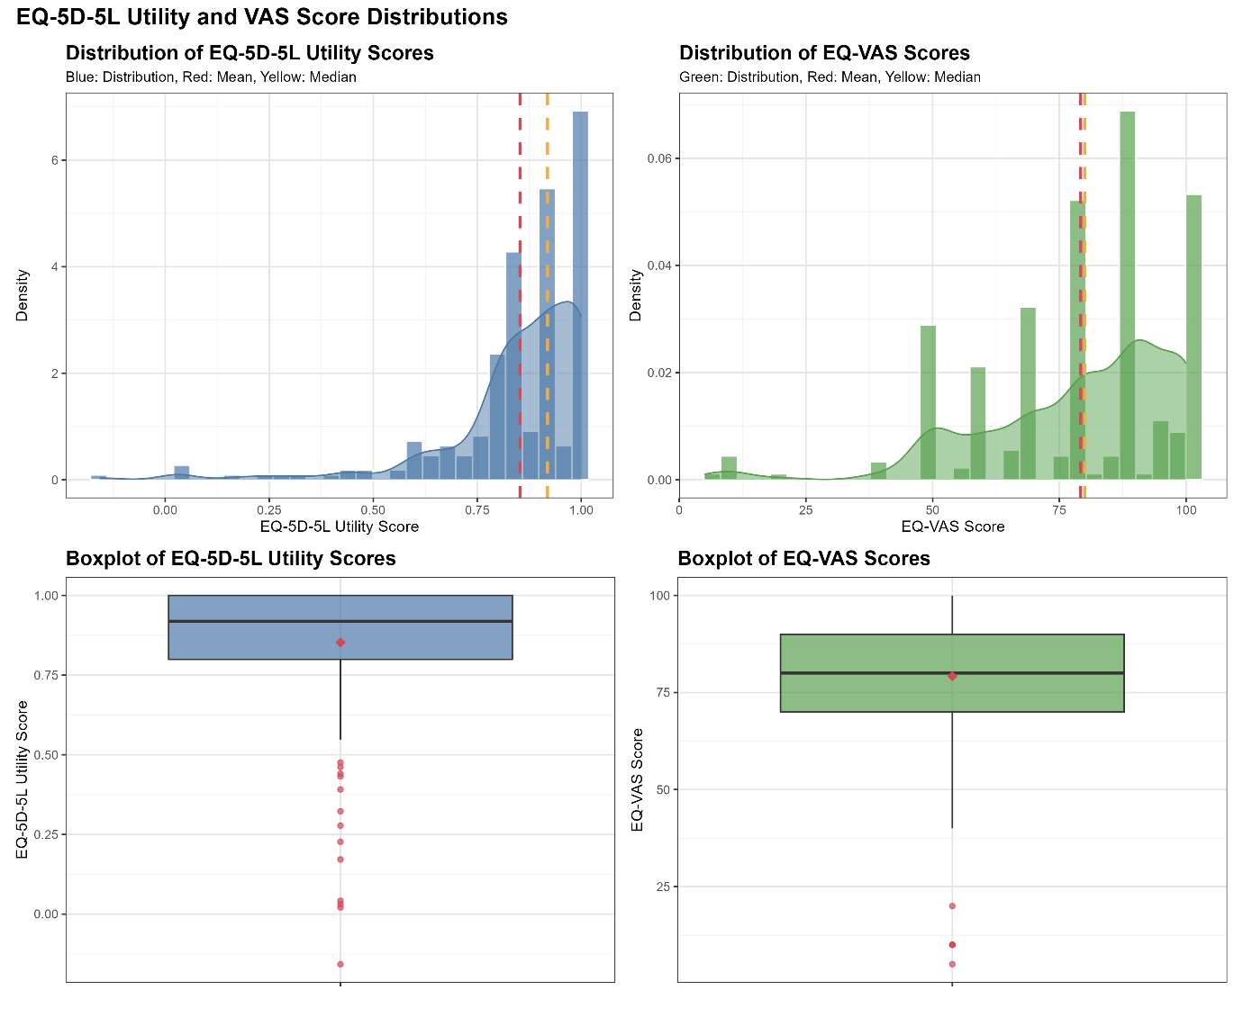
Note: The term "EQ-5D-5L utility" used in this figure refers to the EQ-5D-5L Health State Utility Value (HSUV)
Table S2.3 Correlations among EQ-5D-5L HSUV, EQ-VAS and EORTC QLQ-C30 summary scores
Spearman's rank correlation coefficient (ρ) | EQ-5D-5L HSUV | EQ VAS score | EORTC QLQ-C30 summary scores
EQ-5D-5L HSUV | 1.000 | 0.503 | 0.672
EQ VAS score | 0.503 | 1.000 | 0.509
EORTC QLQ-C30 summary scores | 0.672 | 0.509 | 1.000
EQ-5D-5L HSUV: EuroQol-5 Dimensions-5 Levels health state utility values; EQ-VAS: EuroQol Visual Analog Scale; EORTC QLQ-C30: European Organisation for Research and Treatment of Cancer Quality of Life Questionnaire - Core 30.

Section 3: Unadjusted EQ-5D-5L HSUV, EQ-VAS scores and EORTC QLQ-C30 summary scores by sociodemographic and clinical characteristics.
Patient characteristics | EQ-5D-5L HSUV |  |  |  | EQ-VAS Score |  |  |  | EORTC Summary Score
Patient characteristics | Mean | SD | P | Effect Size | Mean | SD | P | Effect Size | Mean | SD | P | Effect Size
Region
West Coast | 0.850 | 0.192 | 0.137# | Ref | 78.4 | 18.9 | 0.062# | Ref | 84.0 | 15.6 | 0.007# | Ref
East Coast | 0.794 | 0.157 |  | 0.291 | 74.7 | 18.1 |  | 0.198 | 74.7 | 12.3 |  | 0.606
East Malaysia | 0.872 | 0.142 |  | -0.125 | 82.1 | 19.9 |  | -0.194 | 83.3 | 14.7 |  | 0.042
Data form language
Malay | 0.844 | 0.191 | 0.070# | Ref | 78.4 | 20.0 | 0.277# | Ref | 82.7 | 15.9 | 0.338# | Ref
Chinese | 0.858 | 0.117 |  | -0.076 | 78.4 | 16.4 |  | 0.001 | 85.1 | 10.5 |  | -0.159
English | 0.894 | 0.141 |  | -0.268 | 83.8 | 15.6 |  | -0.278 | 85.2 | 15.0 |  | -0.16
Ethnicity
Malay | 0.825 | 0.217 | 0.123# | Ref | 80.1 | 18.4 | 0.147# | Ref | 80.6 | 17.3 | 0.006# | Ref
Chinese | 0.894 | 0.120 |  | -0.371 | 80.6 | 16.6 |  | -0.030 | 88.0 | 10.9 |  | -0.491
Indian | 0.850 | 0.131 |  | -0.120 | 70.2 | 22.9 |  | 0.517 | 80.2 | 17.0 |  | 0.020
Others | 0.862 | 0.152 |  | -0.183 | 79.4 | 22.8 |  | 0.037 | 84.7 | 11.8 |  | -0.252
Marital status
Married | 0.850 | 0.184 | 0.926# | Ref | 79.3 | 19.8 | 0.251# | Ref | 82.6 | 16.0 | 0.394# | Ref
Divorced/Widow | 0.851 | 0.214 |  | -0.007 | 82.4 | 17.4 |  | -0.156 | 86.2 | 14.3 |  | -0.224
Single | 0.874 | 0.113 |  | -0.137 | 76.4 | 15.4 |  | 0.151 | 85.9 | 9.9 |  | -0.215
Education level
No Formal Education/Primary Education | 0.821 | 0.210 | 0.129† | Ref | 75.9 | 20.7 | 0.069† | Ref | 82.0 | 17.2 | 0.823† | Ref
Secondary/Tertiary | 0.868 | 0.159 |  | -0.265 | 80.8 | 18.2 |  | -0.257 | 83.9 | 14.3 |  | -0.122
Employment status
Unemployed | 0.849 | 0.177 | 0.649† | Ref | 77.4 | 20.1 | 0.013† | Ref | 83.4 | 15.5 | 0.600† | Ref
Employed | 0.862 | 0.185 |  | -0.071 | 84.0 | 15.5 |  | -0.346 | 83.1 | 14.7 |  | 0.013
Monthly household income (RM)
≤2500 | 0.851 | 0.170 | 0.371† | Ref | 77.5 | 19.7 | 0.050†# | Ref | 83.7 | 15.2 | 0.434† | Ref
>2500 | 0.856 | 0.194 |  | -0.03 | 82.2 | 17.7 |  | -0.245 | 82.5 | 15.4 |  | 0.078
Number of children
No child | 0.885 | 0.111 | 0.502† | Ref | 76.7 | 14.5 | 0.070† | Ref | 86.2 | 10.6 | 0.411† | Ref
One or more children | 0.847 | 0.188 |  | 0.211 | 79.7 | 19.9 |  | -0.155 | 82.8 | 15.9 |  | 0.223
Menopause status
Yes | 0.858 | 0.170 | 0.306† | Ref | 78.7 | 18.8 | 0.264† | Ref | 84.3 | 15.3 | 0.011† | Ref
No | 0.838 | 0.199 |  | 0.115 | 80.5 | 20.2 |  | -0.096 | 80.6 | 14.9 |  | 0.245
Family History
No | 0.863 | 0.167 | 0.105† | Ref | 79.9 | 18.6 | 0.418† | Ref | 84.5 | 14.6 | 0.023† | Ref
Yes | 0.824 | 0.205 |  | 0.220 | 77.4 | 20.6 |  | 0.130 | 80.0 | 16.5 |  | 0.294
Relationship to affected family member
Not Related | 0.863 | 0.167 | 0.135# | Ref | 79.9 | 18.6 | 0.717# | Ref | 84.5 | 14.6 | 0.069# | Ref
First-Degree relatives | 0.827 | 0.228 |  | 0.201 | 76.8 | 22.2 |  | 0.156 | 79.2 | 17.2 |  | 0.349
Second/Third-degree relatives | 0.818 | 0.141 |  | 0.275 | 78.6 | 16.7 |  | 0.066 | 82.0 | 15.0 |  | 0.167
Time since diagnosis
≤ 6 months | 0.849 | 0.191 | 0.533# | Ref | 79.7 | 17.3 | 0.011# | Ref | 83.0 | 15.3 | 0.420# | Ref
> 6 - 12 months | 0.854 | 0.140 |  | -0.029 | 75.2 | 21.0 |  | 0.237 | 82.7 | 15.3 |  | 0.019
12–18 months | 0.868 | 0.162 |  | -0.101 | 79.9 | 22.0 |  | -0.012 | 84.2 | 14.2 |  | -0.085
18–24 months | 0.848 | 0.236 |  | 0.004 | 87.1 | 15.2 |  | -0.439 | 85.3 | 16.6 |  | -0.152
Cancer Stage
Stage 0-I | 0.891 | 0.158 | <0.001# | Ref | 80.2 | 15.8 | 0.710# | Ref | 86.8 | 12.4 | 0.004# | Ref
Stage II | 0.885 | 0.130 |  | 0.044 | 80.6 | 18.1 |  | -0.026 | 85.9 | 12.7 |  | 0.073
Stage III-IV | 0.807 | 0.212 |  | 0.427 | 77.5 | 21.4 |  | 0.138 | 79.4 | 17.6 |  | 0.455
Mastectomy
Yes | 0.869 | 0.162 | 0.083† | Ref | 79.1 | 19.0 | 0.946† | Ref | 84.3 | 14.7 | 0.185† | Ref
No | 0.831 | 0.197 |  | 0.217 | 79.3 | 19.4 |  | -0.008 | 81.9 | 16.0 |  | 0.155
Breast Reconstruction
No | 0.851 | 0.180 | 0.666† | Ref | 79.4 | 19.1 | 0.288† | Ref | 83.4 | 15.3 | 0.402† | Ref
Yes | 0.905 | 0.071 |  | -0.303 | 71.4 | 21.2 |  | 0.416 | 81.1 | 14.4 |  | 0.145
Lumpectomy
No | 0.852 | 0.186 | 0.589† | Ref | 78.6 | 19.2 | 0.340† | Ref | 83.2 | 15.1 | 0.802† | Ref
Yes | 0.854 | 0.163 |  | -0.009 | 80.5 | 19.0 |  | -0.101 | 83.5 | 15.6 |  | -0.021
Radiation
No | 0.847 | 0.181 | 0.288† | Ref | 78.1 | 19.9 | 0.166† | Ref | 82.9 | 15.4 | 0.303† | Ref
Yes | 0.868 | 0.171 |  | -0.117 | 82.1 | 16.6 |  | -0.206 | 84.5 | 14.8 |  | -0.110
Chemotherapy
No | 0.859 | 0.185 | 0.255† | Ref | 79.8 | 18.9 | 0.508† | Ref | 84.7 | 14.6 | 0.065† | Ref
Yes | 0.846 | 0.171 |  | 0.072 | 78.4 | 19.4 |  | 0.074 | 81.6 | 16.0 |  | 0.205
Hormonal Therapy
No | 0.855 | 0.163 | 0.483† | Ref | 78.6 | 20.0 | 0.617† | Ref | 83.3 | 14.8 | 0.629† | Ref
Yes | 0.847 | 0.209 |  | 0.045 | 80.5 | 17.5 |  | -0.100 | 83.2 | 16.3 |  | 0.006
*Effect sizes and corresponding Cohen’s d values: small effect (0.2 - 0.39), moderate effect (0.4 - 0.79), and large effect (≥0.8).
# p-values obtained using Kruskal-Wallis H test: bold values represent statistically significant differences (p < 0.05).
†p-values obtained using Mann-Whitney U test: bold values represent statistically significant differences (p < 0.05)
EQ-5D-5L HSUV: EuroQol-5 Dimensions-5 Levels health state utility values; EQ-VAS: EuroQol -Visual Analog Scale; EORTC QLQ-C30: European Organisation for Research and Treatment of Cancer Quality of Life Questionnaire - Core 30.

Section 4: Univariable and multivariable regression analysis of EORTC QLQ-C30 Summary Score.
Patient characteristic | Univariable analysis |  |  |  | Multivariable analysis
Patient characteristic | Crude B | Robust SE | 95% CI | p-value | Adj. B | Robust SE | 95% CI | p-value
Age (years) | 0.113 | 0.081 | -0.047 to 0.273 | 0.166 | -0.104 | 0.119 | -0.339 to 0.131 | 0.383
Region (Ref: West Coast)
East Coast | -9.117 | 4.022 | -17.036 to -1.198 | 0.024 | -3.387 | 4.175 | -11.608 to 4.835 | 0.418
East Malaysia | 0.053 | 2.079 | -4.040 to 4.146 | 0.980 | - | - | - | -
Data form language (Ref: Malay)
Chinese | 2.042 | 2.955 | -3.776 to 7.859 | 0.490 | - | - | - | -
English | 2.207 | 2.640 | -2.989 to 7.403 | 0.404 | - | - | - | -
Ethnicity (Ref: Malay)
Chinese | 6.725 | 1.981 | 2.824 to 10.625 | 0.001 | 5.621 | 2.346 | 1.002 to 10.241 | 0.017
Indian | -3.386 | 3.092 | -9.473 to 2.701 | 0.274 | -1.996 | 3.214 | -8.325 to 4.334 | 0.535
Others | 1.599 | 2.700 | -3.716 to 6.915 | 0.554 | 4.448 | 2.897 | -1.257 to 10.153 | 0.126
Marital status (Ref: Married)
Single | 2.973 | 2.795 | -2.530 to 8.476 | 0.289 | - | - | - | -
Divorced/Widow | 3.115 | 3.393 | -3.566 to 9.795 | 0.360 | - | - | - | -
Education level (Ref: No Formal/Primary Education)
Secondary/Tertiary | 1.867 | 1.962 | -1.995 to 5.729 | 0.342 | - | - | - | -
Employment status (Ref: Unemployed)
Employed | -0.204 | 2.070 | -4.280 to 3.871 | 0.921 | 1.532 | 2.349 | -3.095 to 6.158 | 0.515
Monthly household income (RM) (Ref: ≤2500)
>2500 | -1.196 | 1.928 | -4.992 to 2.600 | 0.536 | - | - | - | -
Number of children (Ref: None)
One or more children | -3.398 | 2.530 | -8.379 to 1.584 | 0.180 | -1.061 | 2.560 | -6.102 to 3.981 | 0.679
Menopause status (Ref: Yes)
No | -3.728 | 2.049 | -7.762 to 0.307 | 0.070 | -4.555 | 2.923 | -10.312 to 1.202 | 0.120
Family History (Ref: No)
Yes | -4.456 | 2.061 | -8.515 to -0.398 | 0.032 | -1.464 | 3.410 | -8.179 to 5.251 | 0.668
Relationship to affected family member (Ref: Not Related)
First-degree relatives | -5.062 | 2.335 | -9.658 to -0.466 | 0.031 | -3.007 | 3.865 | -10.619 to 4.605 | 0.437
Second/Third-degree relatives | -1.362 | 3.398 | -8.050 to 5.327 | 0.689 | - | - | - | -
Time since diagnosis (Ref: ≤ 6 months)
> 6 - 12 months | -0.901 | 2.008 | -4.854 to 3.051 | 0.654 | - | - | - | -
12-18 months | 1.071 | 2.766 | -4.374 to 6.516 | 0.699 | - | - | - | -
18-24 months | 2.273 | 2.912 | -3.460 to 8.006 | 0.436 | - | - | - | -
Cancer stage (Ref: Stage 0-I)
Stage II | 4.125 | 1.889 | 0.407 to 7.843 | 0.030 | -0.224 | 2.562 | -5.270 to 4.821 | 0.930
Stage III-IV | -6.746 | 1.818 | -10.324 to -3.167 | <0.001 | -5.234 | 2.577 | -10.309 to -0.159 | 0.043
Mastectomy (Ref: Yes)
No | -2.367 | 1.857 | -6.023 to 1.290 | 0.204 | -2.029 | 2.000 | -5.968 to 1.910 | 0.311
Breast Reconstruction (Ref: No)
Yes | -2.219 | 5.853 | -13.741 to 9.302 | 0.705 | -2.303 | 5.936 | -13.993 to 9.387 | 0.698
Lumpectomy (Ref: No)
Yes | 0.327 | 1.971 | -3.553 to 4.206 | 0.868 | 1.087 | 2.061 | -2.971 to 5.145 | 0.598
Radiation (Ref: No)
Yes | 1.687 | 2.104 | -2.456 to 5.830 | 0.423 | 2.182 | 2.451 | -2.644 to 7.009 | 0.374
Chemotherapy (Ref: No)
Yes | -3.118 | 1.843 | -6.747 to 0.511 | 0.092 | -3.989 | 2.160 | -8.242 to 0.264 | 0.066
Hormonal Therapy (Ref: No)
Yes | -0.085 | 1.977 | -3.977 to 3.806 | 0.966 | -1.464 | 2.122 | -5.643 to 2.714 | 0.491
EQ-5D-5L HSUV: EuroQol-5 Dimensions-5 Levels health state utility values; EQ-VAS: EuroQol -Visual Analog Scale; EORTC QLQ-C30: European Organisation for Research and Treatment of Cancer Quality of Life Questionnaire - Core 30.

Section 5: Model performance statistics for multivariable regression analyses of HRQoL outcomes.
Outcome measure | R² | Adjusted R² | F statistic | F-test p-value | AIC | BIC | Residual SD
EORTC QLQ-C30 Summary Score | 0.131 | 0.070 | 2.145 | 0.005 | 2279.734 | 2352.070 | 14.718
EQ-5D-5L Utility Score (HSUV) | 0.122 | 0.056 | 1.860 | 0.018 | -161.693 | -85.741 | 0.174
EQ-VAS Score | 0.119 | 0.053 | 1.808 | 0.022 | 2410.054 | 2486.007 | 18.622
Note: R² and adjusted R² indicate the proportion of variance explained by each model. AIC = Akaike Information Criterion; BIC = Bayesian Information Criterion. All models were statistically significant based on the overall F-test (p < 0.001). EQ-5D-5L HSUV: EuroQol-5 Dimensions-5 Levels health state utility values; EQ-VAS: EuroQol -Visual Analog Scale; EORTC QLQ-C30: European Organisation for Research and Treatment of Cancer Quality of Life Questionnaire - Core 30.

Section 6: Model Diagnostics for Linear Regression Models.
- Multivariable model for EQ-5D-5L Utility Score (HSUV)
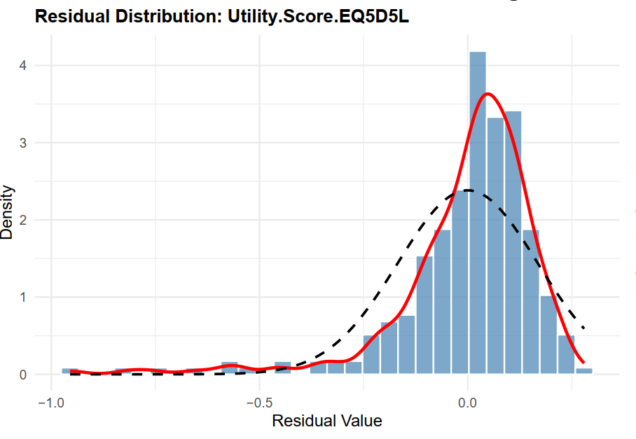
- Multivariable model for EQ-VAS Score
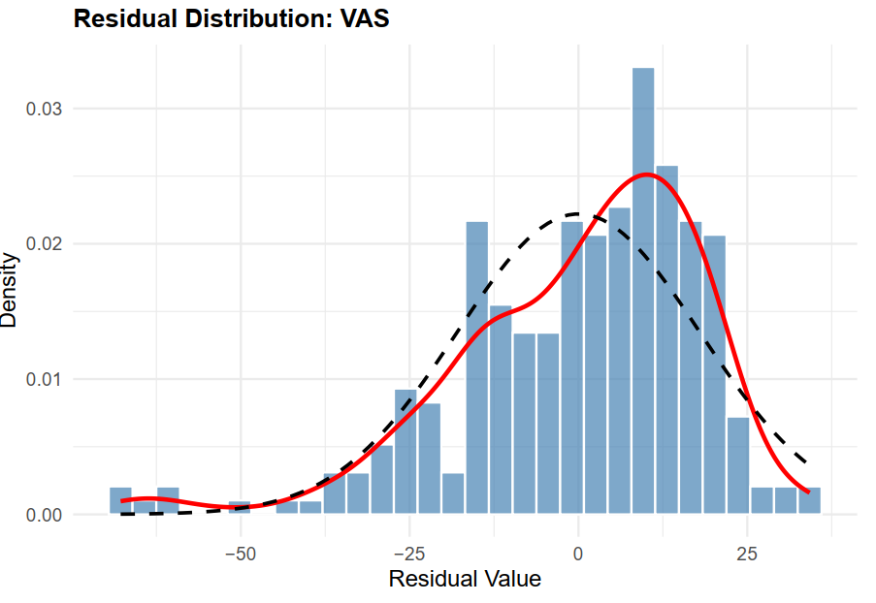

- Multivariable model for EORTC QLQ-C30 Summary Score
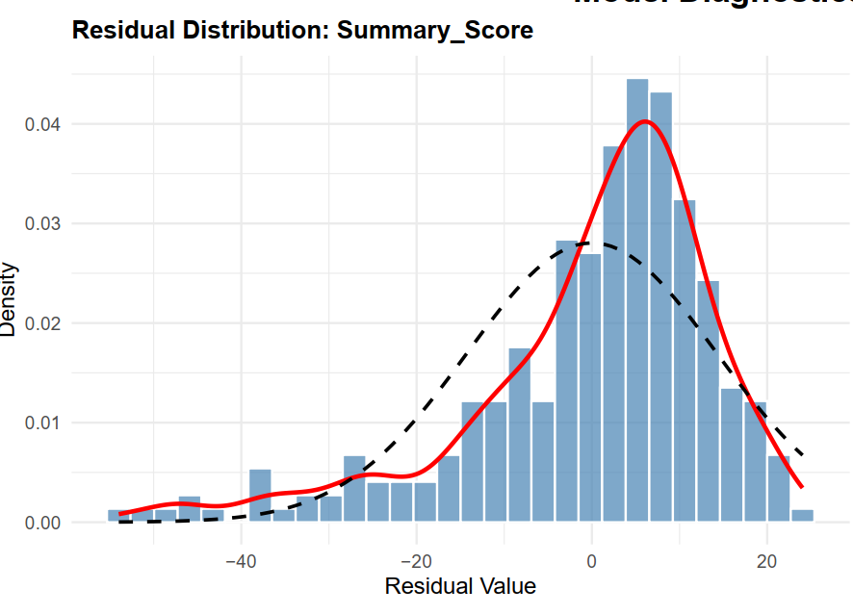
EQ-5D-5L HSUV: EuroQol-5 Dimensions-5 Levels health state utility values; EQ-VAS: EuroQol -Visual Analog Scale; EORTC QLQ-C30: European Organisation for Research and Treatment of Cancer Quality of Life Questionnaire - Core 30.
Diagnostic plots were generated to assess the validity of the regression models for (A) EQ-5D-5L HSUV, (B) EQ-VAS Score, and (C) EORTC QLQ-C30 Summary Score. Kernel density estimates of the residuals (solid red line) were overlaid with the theoretical normal distribution (dashed black line). The residuals were approximately normally distributed for the EORTC QLQ-C30 Summary Score and EQ-VAS Score models, closely aligning the theoretical normal distribution. However, the EQ-5D-5L HSUV model exhibited a leptokurtic distribution (highly peaked), which is characteristic of utility data where a significant proportion of respondents report full health (ceiling effect). Despite this deviation from normality, the Central Limit Theorem supports the robustness of Ordinary Least Squares (OLS) regression estimates when the sample size is sufficiently large, as was the case in this study (N=275). To further ensure valid inference and account for potential heteroskedasticity, robust regression techniques (e.g., OLS with robust standard errors) were subsequently applied to all three models.

