Online Resource 1

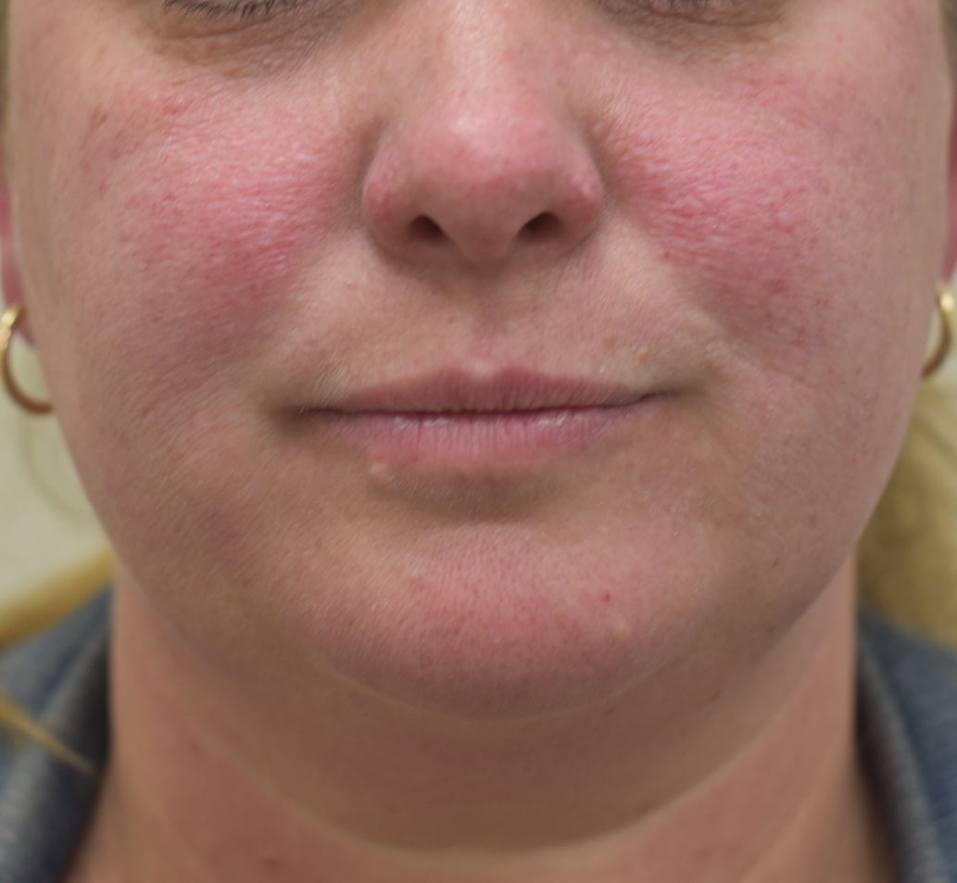
Figure S1: Almost-clear TSC-associated FA health state


Figure S2: Moderate TSC-associated FA health state

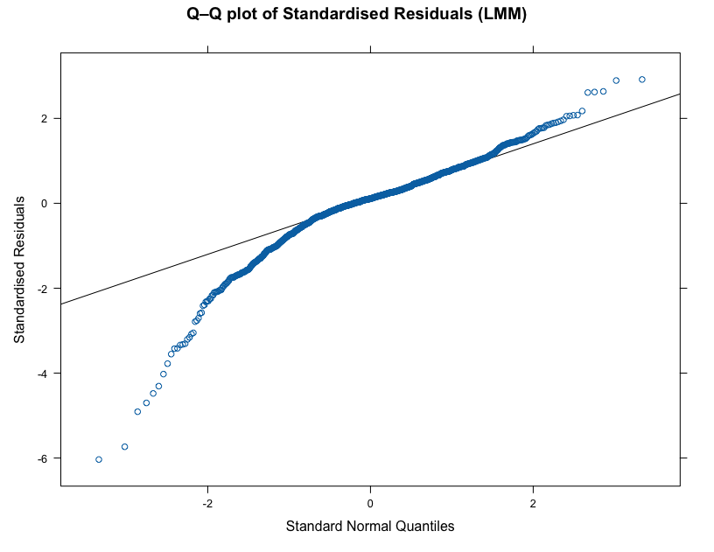
Figure S3: Q-Q plot of residuals, used for assessment of normality
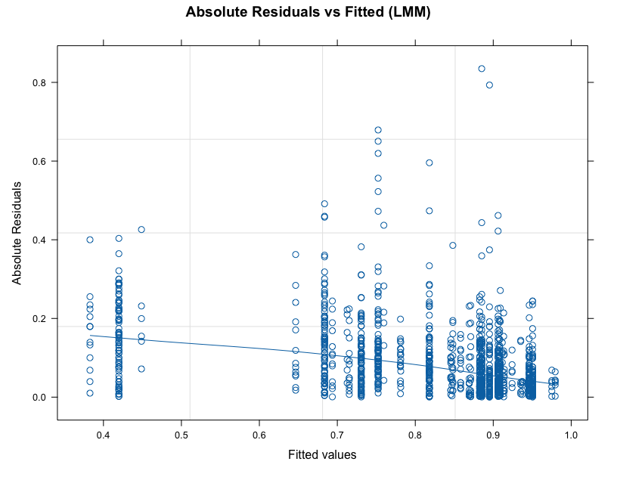
Figure S4: Absolute residuals plotted against fitted values, used for assessment of heteroscedasticity

