Supplementary Material: Comparison of Nine VAS Versions
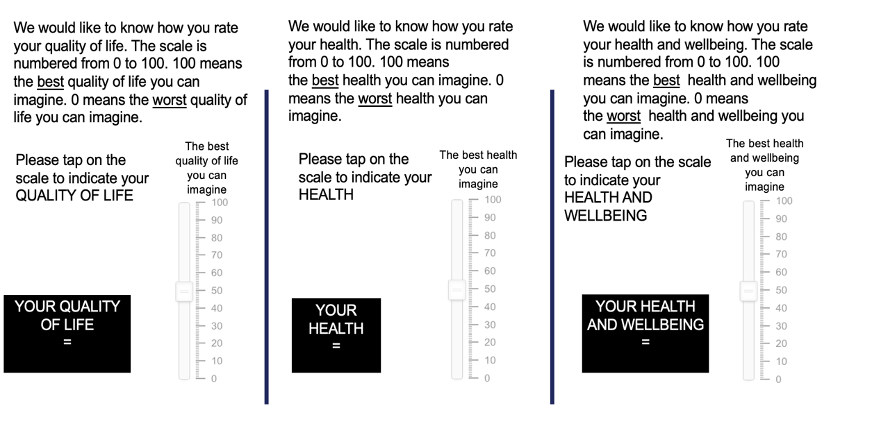

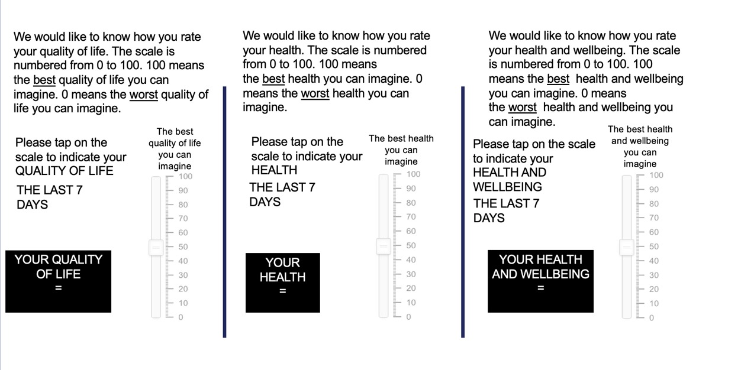
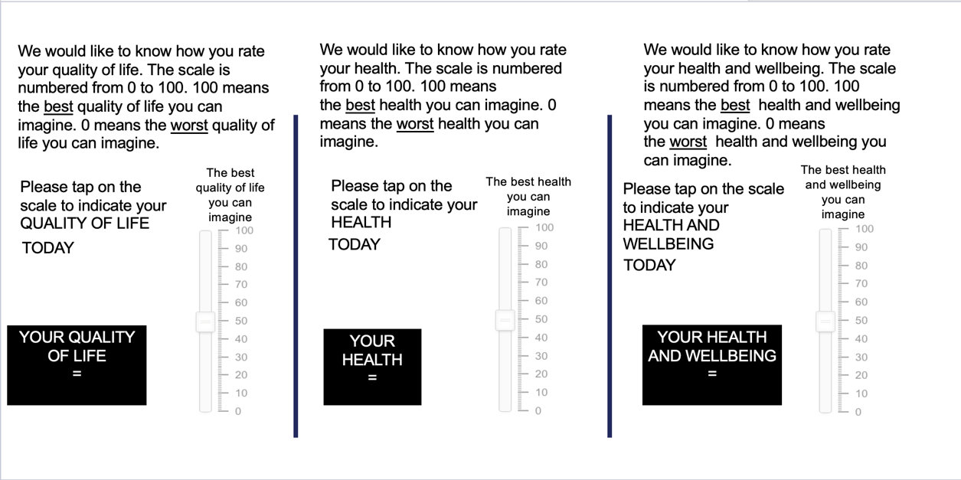

Note that in the online survey, only one VAS version from the first row was presented at a time, in a random order. In the interview, VAS versions were covered and uncovered during the conversation, so a maximum of three versions (one complete row) was shown at one time.

