Online appendix
OA1 Additional empirical design and results
While the adoption of the environmental policy is plausibly exogenous to both creators and backers because Kickstarter determines the timing and specific project categories covered by the policy, the choice to adopt an environmental commitment within treated categories may still be endogenous. Creators self-select into disclosure, and their decisions may correlate with unobservable characteristics, such as motivation, project quality, or past reputation, all of which could also affect funding outcomes. Aside from our main specification, which uses a two-stage least squares fuzzy difference-in-differences approach, we also provide tests to examine the descriptive relationship and intent-to-treat effects of an environmental commitment and the environmental policy on funding outcomes.
We first assess the association between an environmental commitment and funding outcomes using OLS; then we investigate the intention-to-treat effect which provides the estimate of policy exposure.
OA1.1 OLS association between environmental commitment and funding outcomes
We run the following regression to directly estimate the association between environmental commitment and funding outcomes:
$${Funding Success}_{i,t}=β_{0}+β_{1}\left({E-Commitment}_{i,t}\right)+γ_{i}X_{i,t}+Fixed Effects+ε_{i,t},$$ | (OA1)
where i, c, and t are project, project category, and time indices, respectively. Our main variable of interest is E-commitment, an indicator equal to one if project i, has implemented an environmental policy in t and zero otherwise. $X_{i,t}$ is the vector of control variables discussed in the paper that captures characteristics of a project and its creator. Finally, in all regression models, we include three sets of fixed effects absorbing time-invariant variables at the project category, location, and time levels. Standard errors are clustered at the category, location, and year-month level.
We measure funding outcomes with two variables. The first is an indicator variable, Success, which is equal to one if the project is successfully funded and zero otherwise. The second is a continuous variable, Pledges, which is calculated as the total amount pledged to the project, scaled by the project funding goal.
We present the results of this exercise in Panel A of Table OA.13. The estimated coefficients on E-commitment are 0.049 for Success (column 1) and 0.027 for Pledges (column 2). Both coefficients are positive and significant at the 5% level. In terms of economic magnitude, E-commitment is positively associated with a 4.9 percentage point increase in the probability of project success, which corresponds to approximately 18% (i.e., 4.9%/27.2%) of the average success rate of 27.2%. With respect to the pledged amount, E-commitment is associated with a 2.7 percentage point increase in Pledges, which is roughly 5.3% of the sample average of 50.6%. It is evident that adoption of the platform’s going-green disclosure policy has a positive association with funding outcomes and that this association represents a sizeable magnitude in the aggregate.
The coefficients on control variables also have the expected signs. For instance, the negative coefficient on Goal indicates that larger projects seeking more funding tend to have a lower success rate. Consistent with Cascino, Correia and Tamayo (2019) and Lai, Lo and Hwang (2017), the coefficients on Updates and Comments are both positive and significant, which suggests that projects for which creators provide more disclosure or backers and creators have communicated more through comments tend to succeed.
To examine the multidimensional nature of environmental commitments, we leverage Kickstarter’s own structured classification of the Environmental Commitment section, which organizes disclosures into six predefined subcategories: long-lasting design, reusability and recyclability, sustainable materials, environmentally friendly factories, sustainable fulfillment and distribution, and other. Importantly, these categories are defined and displayed by Kickstarter itself. We replace our baseline E-commitment dummy (which equals one if the section is nonempty) with six separate dummy variables—Design, Recycle, Material, Factory, Distribution, and Other—each indicating whether the corresponding Kickstarter-defined subcategory contains content.
We report the results of this test in Table OA.9. The results show that commitments in each of the five primary Kickstarter-defined subcategories are positively associated with crowdfunding success and the amount pledged relative to the funding goal. Among them, Design, Material, and Distribution exhibit somewhat stronger in association than Factory and Recycle, while Other becomes statistically insignificant in the pledge regression. This pattern suggests that backers respond particularly favorably to environmental commitments that are concrete and more readily assessable upon product delivery—such as durability, material choice, or distribution practices that directly shape the product experience. In contrast, commitments that are less directly observable or more residual in nature (captured by the Other category) appear to carry a weaker association. Overall, these findings suggest that backers place greater weight on dimensions that are product-centered and more easily verifiable.
The results of Table OA.13, Panel A, should be interpreted as descriptive correlations rather than causal effects. Because the adoption of an environmental commitment is endogenous at the project level, creators who choose to adopt such a commitment may differ systematically from other creators along unobservable dimensions, such as project quality or intrinsic motivation. To address this concern, we leverage the implementation of the environmental policy to assess the causal effect of an environmental commitment.
OA1.2 Intent-to-Treat effect of Environmental Policy
We next estimate the intention-to-treat effect using category-level exposure to the environmental policy. Because the environmental disclosure policy was introduced at the category level in a staggered fashion, as discussed in Section 2.2 of the study, variation in policy exposure provides plausibly exogenous treatment assignment across categories over time.
To this end, we directly estimate Equation (OA2):
$${Funding Success}_{i,t}=β_{0}+β_{1}\left({E-Policy}_{c,t}\right)+γ_{i}X_{i,t}+Fixed Effects+ε_{i,t}.$$ | (OA2)
Equation (OA2) is a reduced form regression with E-policy as the main independent variable. In theory, the intent-to-treat coefficient captures the average effect of being exposed to the environmental disclosure policy, regardless of whether a project ultimately adopts an environmental commitment. Economically speaking, the intent-to-treat reflects a weighted average of zero effects for noncompliers (projects that do not adopt an environmental commitment after the policy introduction) and hypothesized positive effects for compliers (projects that are exposed to the environmental policy and subsequently adopt an environmental commitment). Table OA.13 Panel B reports the regression results. The estimated coefficients show that policy exposure increases success probability by 4.4 percentage points (col. 1) and total pledges by 2.9 percentage points (col. 2). Relative to OLS, the intent-to-treat mitigates project-level selection into disclosure but continues to average over both compliers and noncompliers within treated categories.
OA2. Discussion of additional analysis
OA2.1 Do creators’ environmental preferences matter?
Based on the catering argument, a rational creator would adopt an environmental commitment aligned with the preferences of that person’s backers rather than with the creators’ own preferences. This conjecture predicts that E-commitment should not vary with creators’ own environmental preferences. To examine this hypothesis, we analyze the number of new creators and the number of high environmental-awareness creators using the classification methods described in Section 4.1.
We assess the impact of an environmental commitment among creators with varying levels of experience and preferences by testing the effect of instrumented E-commitment on new creators and the number of creators from high environmental-awareness areas. The results of these analyses are presented in Table OA.16. In both cases, the instrumented E-commitment is associated with neither the New Creator indicator (column 1) nor the High E-Awareness Creator indicator (column 2). This evidence collectively suggests that creators’ environmental commitment is unlikely to reflect their personal green preferences. Their decisions are driven primarily by strategic considerations rather than their environmental values.
OA2.2 Do creators voluntarily disclose environmental engagement before the environmental policy?
In this section, we compare two types of environmental disclosure: environmental storytelling and structured environmental commitment to see how backers respond to each. Before the introduction of the environmental policy, creators could mention their environmental efforts in the project description (i.e., an environmental story). However, the story was part of the broader narrative about the project and may be less visible to potential backers. (Figure 2 in the main paper and Table OA.7 present the 40 most prevalent environment bigrams in the “story” section.) In contrast, an environmental commitment provides a dedicated, platform-guided section that allows creators to clarify their environmental engagement. As shown in Table OA.14, E-commitment is consistently associated with stronger funding outcomes, while ereas E-story shows weaker and less consistent patterns. Overall, the results suggest that backers respond more strongly to disclosures that are standardized, more visible, and easier to verify.
OA2.3 Robustness to staggered policy adoption and heterogeneous treatment effects
Because Kickstarter introduced the environmental policy at different times across project categories, a natural concern is that our results could be influenced by differences in treatment timing rather than the policy itself. To address this, we implement a project-level semiparametric difference-in-differences approach following Callaway and Sant’Anna (2021), which allows for heterogeneous treatment timing and dynamic effects.
The results, reported in Table OA.15, are consistent with our baseline estimates in Table 3. In particular, the estimated treatment effects remain positive and stable across specifications, suggesting that staggered adoption or timing-related biases do not drive our findings.
OA2.4 Does the Environmental Resources Center drive our findings?
To reduce the costs of implementing green initiatives for creators, Kickstarter launched an information hub—the Environmental Resources Center—along with the environmental policy. The center acts as an information hub where creators can find resources and information on guidelines, best practices, and case studies on adopting and communicating their environmental commitment efforts. Unlike the staggered rollout of environmental policy, the launch of the center was a one-time shock to the information environment for creators. This information shock from the ERC could improve product quality, which may in turn explain our results. To rule out this possibility, we conduct further analysis.
First, we test whether the launch of the Environmental Resources Center leads to changes in project quality using disclosure length, tone, readability, and quantitative language as proxies (Cascino et al. 2019). Table OA.2 reports these results. We find that project and disclosure quality do not differ significantly between the pre- and post-periods, which suggests that our findings are unlikely to be driven by improvements in product quality due to the ERC’s implementation. Additionally, Figure OA.1 shows that funding outcomes before October 2018 across the 13 categories do not display differential trends prior to the introduction of the center, and Table OA.5 shows that, within each project category, the pre- and post-center funding outcomes do not exhibit significant differences. This additional evidence strengthens the argument that our findings are driven by the implementation of the environmental policy rather than the center.

Figure OA.1: Success rate and pledges before the environmental resources center

This figure presents the category-level success rate, average pledged proportion, and the proportion of each category’s pledged amount relative to the platform’s total pledged amount before October 2018.

Figure OA.2: E-backers by year

This figure presents the average number and percentage of high E-awareness backers per project by year. The horizontal axis is the project launch year. The E-Awareness backers are only available when a project garners 10 or more backers to activate the disclosure of backer locations. The classification of E-Awareness backers applies only for U.S. backers. The E-Awareness backers are backers from states with a higher than median percentage of adults worried about global warming (Yale Climate Opinion Maps, https://climatecommunication.yale.edu/visualizations-data/ycom-us/).

Figure OA.3 Time trend of environmental commitment effect

Year | Success | Pledges
2019 | 0.108*** | 0.029
 | (3.54) | (0.90)
2020 | 0.121*** | 0.074***
 | (6.36) | (3.72)
2021 | 0.136*** | 0.087***
 | (7.12) | (4.40)

This figure presents the trend and the coefficients on two-stage least squares instrumented E-commitment when estimating Equation (2) and the dependent variables are Success and Pledges for subsamples of projects with a launch date that is before December 31, 2019, December 31, 2020, and December 31, 2021. The number of projects is cumulative and represents an increasing sample with the inclusion of later calendar years.

Figure OA.4 Example of national and local projects

Panel A: National project, internal project ID: 447780155


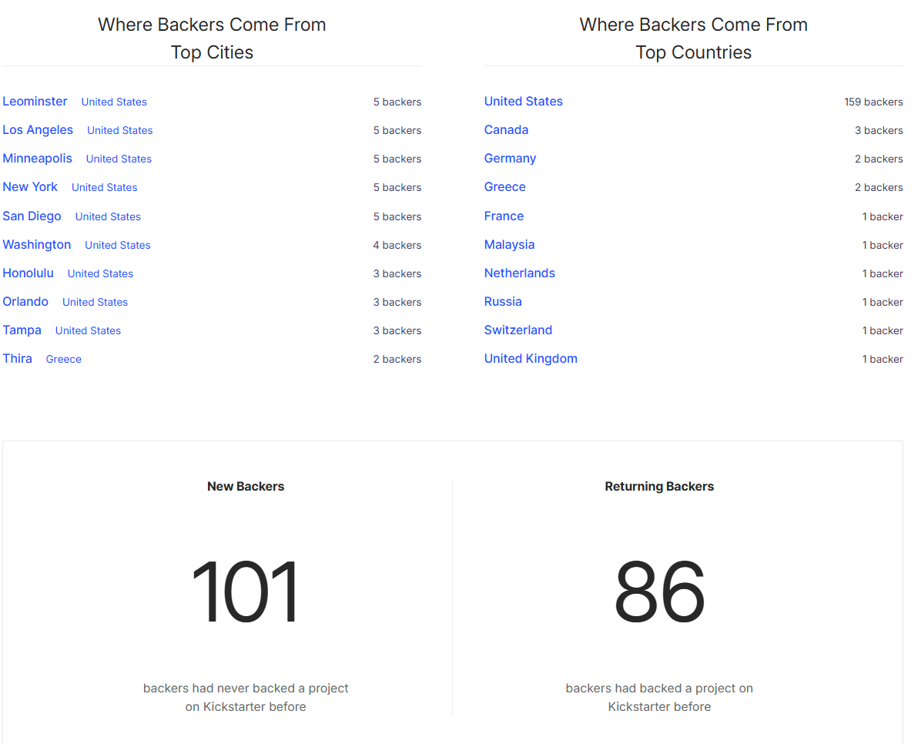

Panel B: Local project, internal project ID: 1236824472



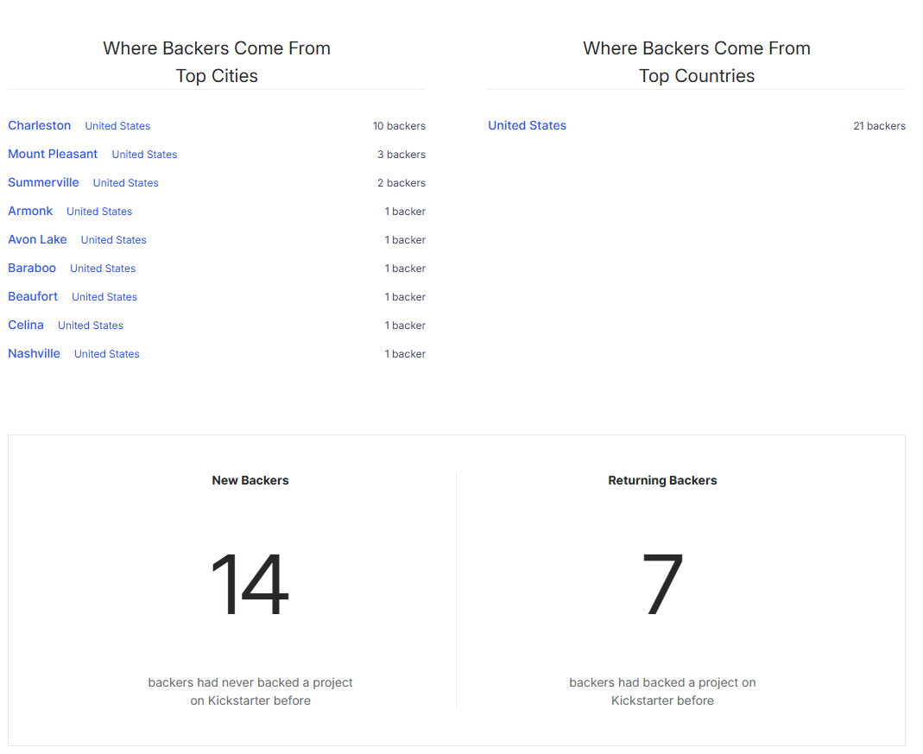
This figure shows two projects that are identified as national and local projects using our machine-learning based method as well as the backers’ geographical distribution. Fifteen out of 21 backers are from cities within 50 miles of the local project’s location.

Figure OA.5 Proportional changes of pledges pre and post environmental policy for top three categories

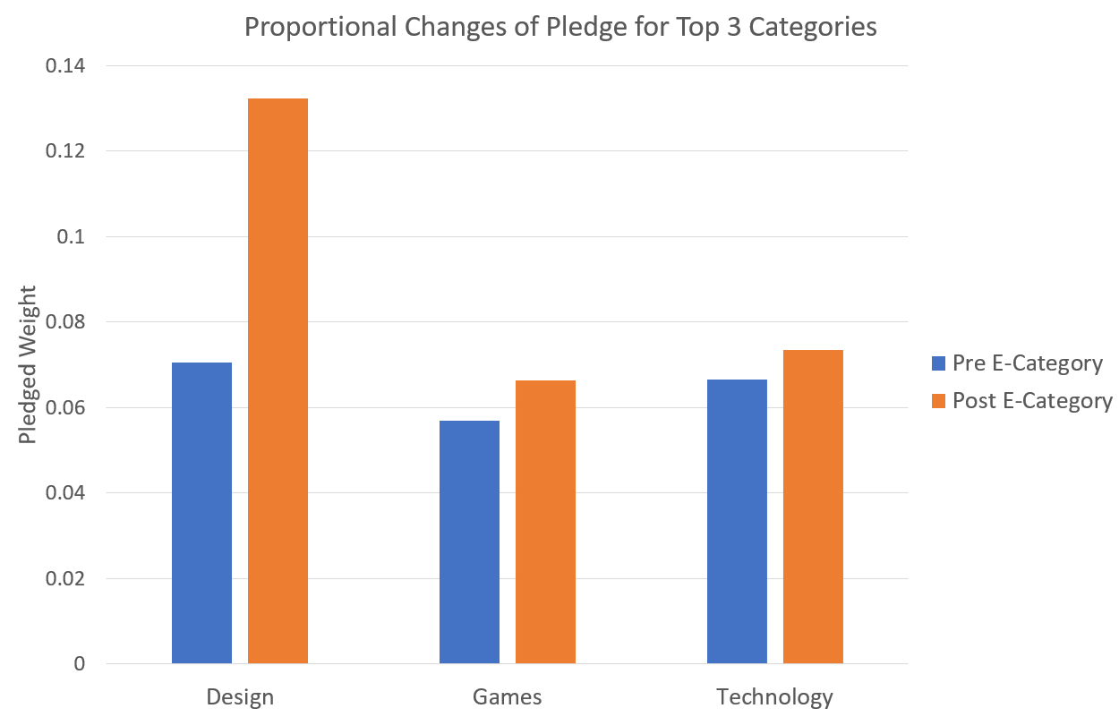

This figure reports the difference in the weight of the pledged amount for the top three categories of projects pre and post Kickstarter’s environmental engagement policy. The top three categories of projects (design, games, and technology) represent 72.5% of the total pledged amounts over our sample period.

Table OA.1 Environmental commitment and funding success – robustness test

Panel A: Excluding design category
 | (1) | (2)
VARIABLES | Success | Pledges
$$\hat{E-commitment}$$ | 0.134*** | 0.126***
 | (3.21) | (3.08)
Goal (in log) | -0.073*** | -0.108***
 | (-15.41) | (-19.14)
Minimum Reward (in log) | 0.009*** | 0.010***
 | (5.96) | (5.56)
Blurb Length (in log) | -0.013*** | -0.021***
 | (-4.50) | (-7.08)
Horizon (in log) | -0.156*** | -0.183***
 | (-23.75) | (-32.04)
Self-Mention | 0.030*** | 0.057***
 | (8.26) | (13.49)
Staff Pick | 0.088*** | 0.140***
 | (4.33) | (6.31)
FAQ | 0.002 | -0.002
 | (0.41) | (-0.42)
Updates | 0.078*** | 0.111***
 | (27.08) | (50.98)
Comments | 0.089*** | 0.173***
 | (13.30) | (25.37)
Previous Success | 0.098*** | 0.121***
 | (14.55) | (14.42)
Other Projects | -0.030*** | -0.043***
 | (-4.67) | (-6.45)
Gender | 0.004 | 0.009***
 | (1.59) | (2.68)
Category, Year-month, and Location FE | Yes | Yes
Category, Year-month, and Location Clustering | Yes | Yes
Observations | 135,619 | 135,619
Adj. R² | 0.432 | 0.631

Panel B: Only product design and technology
 | (1) | (2)
VARIABLES | Success | Pledges
$$\hat{E-commitment}$$ | 0.454*** | 0.335***
 | (6.88) | (2.84)
Goal (in log) | -0.055*** | -0.088***
 | (-5.16) | (-5.94)
Minimum Reward (in log) | 0.007*** | 0.010***
 | (5.20) | (6.68)
Blurb Length (in log) | -0.012*** | -0.012***
 | (-4.78) | (-4.22)
Horizon (in log) | -0.080*** | -0.107***
 | (-4.01) | (-5.06)
Self-Mention | 0.009 | 0.029***
 | (1.12) | (4.04)
Staff Pick | 0.098*** | 0.133***
 | (12.36) | (17.53)
FAQ | -0.004 | 0.003
 | (-1.13) | (1.17)
Updates | 0.095*** | 0.137***
 | (22.70) | (48.29)
Comments | 0.061*** | 0.129***
 | (12.72) | (21.17)
Previous Success | 0.107*** | 0.131***
 | (9.59) | (7.45)
Other Projects | -0.024 | -0.025
 | (-1.37) | (-1.48)
Gender | 0.008 | 0.002
 | (1.53) | (0.35)
Category, Year-month, and Location FE | Yes | Yes
Category, Year-month, and Location Clustering | Yes | Yes
Observations | 38,255 | 38,255
Adj. R² | 0.522 | 0.715
This table presents the effect of two-stage least squares instrumented E-commitment on the main funding outcomes with estimation of equation (2) while focusing on certain categories of Kickstarter projects. Panel A presents the results excluding projects from the design category, and Panel B presents the results keeping only projects from product design and technology categories. This specification controls for the project category and launch year-month and the creator’s location fixed effects, and the standard errors are clustered by category, year-month, and the creator’s location. The t values are reported in parentheses. *, **, and *** indicate significance at the 10%, 5%, and 1% levels, respectively.

Table OA.2 Environmental resources center and project quality implications – linguistic features

 | (1) | (2) | (3) | (4) | (5) | (6)
VARIABLES | Story tone | Story length | Story readability | Quantitative  words in Story | Comment tone | Fraud-related mentions  in backer comments
Post ERC | 0.007 | 0.029 | 0.003 | -0.013 | 0.006 | -0.003
 | (1.71) | (1.57) | (0.37) | (-0.66) | (0.53) | (-0.84)
Other Controls | Yes | Yes | Yes | Yes | Yes | Yes
Category, Year-month, and Location FE | Yes | Yes | Yes | Yes | Yes | Yes
Category, Year-month, and Location Clustering | Yes | Yes | Yes | Yes | Yes | Yes
Observations | 46,563 | 46,563 | 46,563 | 46,563 | 23,081 | 46,563
Adj. R² | 0.014 | 0.258 | 0.124 | 0.066 | 0.230 | 0.385
This table presents the effect of the Environmental Resources Center on the linguistic features of the story section of Kickstarter projects. The center was launched on November 28, 2018, and we include projects that launched one year before and one year after its establishment to conduct the pre versus post test. Post ERC is an indicator variable that equals one if the project’s launch date is after November 28, 2018, and zero otherwise. This specification controls for the project category, launch year-month, and the creator’s location fixed effects, and the standard errors are clustered by category, year-month, and the creator’s location. The t values are reported in parentheses. *, **, and *** indicate significance at the 10%, 5%, and 1% levels, respectively.

Table OA.3 Environmental commitment effect – control for risk and challenges disclosure
 | (1) | (2)
VARIABLES | Success | Pledges
$$\hat{E-commitment}$$ | 0.086** | 0.062**
 | (2.65) | (2.39)
Goal (in log) | -0.069*** | -0.104***
 | (-13.97) | (-16.99)
Minimum Reward (in log) | 0.009*** | 0.010***
 | (6.11) | (5.84)
Blurb Length (in log) | -0.012*** | -0.019***
 | (-6.77) | (-7.96)
Horizon (in log) | -0.142*** | -0.168***
 | (-12.34) | (-15.46)
Self-Mention | 0.027*** | 0.053***
 | (4.84) | (8.93)
Staff Pick | 0.087*** | 0.135***
 | (4.80) | (6.32)
FAQ | 0.003 | 0.002
 | (0.68) | (0.49)
Updates | 0.083*** | 0.118***
 | (22.25) | (28.27)
Comments | 0.084*** | 0.166***
 | (9.34) | (15.98)
Previous Success | 0.100*** | 0.123***
 | (14.39) | (16.13)
Other Projects | -0.028*** | -0.039***
 | (-3.26) | (-3.81)
Gender | 0.005 | 0.008*
 | (1.43) | (2.19)
Risk Disclosure | 0.046** | 0.025
 | (2.29) | (1.20)
Category, Year-month, and Location FE | Yes | Yes
Category, Year-month, and Location Clustering | Yes | Yes
Observations | 173,874 | 173,874
Adj. R² | 0.449 | 0.648
This table presents the effect of two-stage least squares instrumented E-commitment on the main funding outcomes with estimation of equation (2) controlling for the presence of risk and challenges in the disclosure. This specification controls for the project category, launch year-month, and the creator’s location fixed effects, and the standard errors are clustered by category year-month, and the creator’s location. The t values are reported in parentheses. *, **, and *** indicate significance at the 10%, 5%, and 1% levels, respectively.

Table OA.4 Environmental commitment, project disclosure quality, and perceived project quality

 | (1) | (2) | (3)
VARIABLES | Story tone | Quantitative words in Story | Fraud-related mentions in backer comments
$$\hat{E-commitment}$$ | 0.014 | -0.004 | 0.026
 | (0.53) | (-0.52) | (1.09)
Goal (in log) | 0.007*** | -0.003* | 0.004
 | (3.51) | (-1.81) | (0.78)
Minimum Reward (in log) | -0.010*** | 0.003*** | -0.000
 | (-4.86) | (4.11) | (-0.34)
Blurb Length (in log) | 0.018*** | -0.002 | 0.001
 | (5.24) | (-0.85) | (0.37)
Horizon (in log) | -0.028*** | -0.008** | 0.009
 | (-4.14) | (-2.75) | (1.69)
Self-Mention | 0.011** | 0.008** | -0.001
 | (2.19) | (2.58) | (-0.09)
Staff Pick | 0.043*** | 0.003 | -0.016**
 | (3.46) | (0.56) | (-2.34)
FAQ | 0.001 | -0.005*** | 0.013***
 | (0.32) | (-3.47) | (3.06)
Updates | 0.005*** | 0.000 | 0.148***
 | (3.76) | (0.37) | (11.96)
Comments | 0.029*** | 0.012*** | -0.033***
 | (13.82) | (8.76) | (-5.70)
Previous Success | -0.008* | 0.023*** | -0.014***
 | (-2.10) | (9.68) | (-3.11)
Other Projects | -0.008 | 0.014*** | 0.007
 | (-1.02) | (4.69) | (1.05)
Gender | 0.028*** | -0.011*** | 0.001
 | (7.07) | (-3.39) | (0.18)
Category, Year-month, and Location FE | Yes | Yes | Yes
Category, Year-month, and Location Clustering | Yes | Yes | Yes
Observations | 170,756 | 168,741 | 83,569
Adj. R² | 0.081 | 0.054 | 0.393
This table presents the effect of instrumented E-commitment (Equation 2) on project disclosure quality and the perceived likelihood of fraud. This specification controls for the project category, launch year-month, and the creator’s location fixed effects, and the standard errors are clustered by category, year-month, and the creator’s location. The t values are reported in parentheses. *, **, and *** indicate significance at the 10%, 5%, and 1% levels, respectively.

Table OA.5 Success rate and pledges around the Environmental Resources Center (ERC)
Category | Success Pre ERC | Success Post ERC | Post - Pre | Pledges Pre ERC | Pledges Post ERC |  | Post - Pre
Art | 0.322 | 0.393 | 0.071 | 0.602 | 0.708 | 0.107
Comics | 0.410 | 0.404 | -0.006 | 0.776 | 0.766 | -0.010
Crafts | 0.180 | 0.194 | 0.015 | 0.369 | 0.369 | 0.000
Dance | 0.183 | 0.137 | -0.047 | 0.404 | 0.373 | -0.030
Design | 0.363 | 0.351 | -0.012 | 0.659 | 0.612 | -0.048
Fashion | 0.253 | 0.293 | 0.041 | 0.494 | 0.541 | 0.048
Food | 0.108 | 0.123 | 0.015 | 0.257 | 0.275 | 0.018
Games | 0.413 | 0.381 | -0.031 | 0.730 | 0.684 | -0.046
Journalism | 0.105 | 0.143 | 0.037 | 0.256 | 0.270 | 0.014
Music | 0.187 | 0.178 | -0.009 | 0.447 | 0.432 | -0.015
Photography | 0.196 | 0.191 | -0.005 | 0.426 | 0.431 | 0.005
Publishing | 0.217 | 0.234 | 0.017 | 0.461 | 0.475 | 0.014
Technology | 0.175 | 0.174 | -0.001 | 0.334 | 0.309 | -0.026
Overall | 0.239 | 0.246 | 0.006 | 0.478 | 0.480 | 0.002
t-stat |  |  | 0.75 |  |  | 0.21
This table presents the percentage of successfully funded projects and the average pledged proportion by category before and after the launch of the Environmental Resources Center, along with the statistical significance of the differences.
Table OA.6 Difference of average number of backers for local and national projects
Group | Average Number of Backers
Local | 43.921
National | 125.946
Difference | 82.025
t-stat | 22.366
This table presents the average number of backers attracted by projects with local or national appeal, along with the statistical significance of the difference between the two groups.

Table OA.7 Environmental-related bigrams
Rank | Bigram | Relative Importance
1 | recycle material | 0.072
2 | carbon footprint | 0.066
3 | make recycle | 0.055
4 | last long | 0.052
5 | 100 recyclable | 0.052
6 | environmental impact | 0.048
7 | recyclable material | 0.040
8 | last lifetime | 0.039
9 | recycle paper | 0.038
10 | 100 recycle | 0.034
11 | recycle plastic | 0.033
12 | impact environment | 0.029
13 | sustainable material | 0.028
14 | packaging make | 0.027
15 | reduce carbon | 0.025
16 | durable material | 0.025
17 | fully recyclable | 0.020
18 | reduce waste | 0.019
19 | organic cotton | 0.018
20 | make durable | 0.018
21 | material recycle | 0.017
22 | carbon emission | 0.016
23 | eco friendly | 0.015
24 | make recyclable | 0.015
25 | recycle cardboard | 0.014
26 | fsc certify | 0.014
27 | material recyclable | 0.014
28 | low impact | 0.013
29 | carbon neutral | 0.013
30 | recyclable paper | 0.013
31 | recyclable packaging | 0.013
32 | recycle recyclable | 0.013
33 | plastic waste | 0.012
34 | package recyclable | 0.012
35 | reduce environmental | 0.011
36 | biodegradable material | 0.011
37 | renewable energy | 0.011
38 | recyclable biodegradable | 0.011
39 | recyclable cardboard | 0.011
40 | co2 emission | 0.011
This table reports the full list of the top 40 bigrams we use to identify the environmental story in the story section of the Kickstarter page. We also report the relative importance, which is calculated as the frequency of the bigram among all bigrams in the environmental commitment of the Kickstarter project page.

Table OA.8 Robustness test – different fixed-effects specification
Panel A: Intent-to-Treat estimation
 | (1) | (2)
VARIABLES | Success | Pledges
E-policy | 0.012*** | 0.072***
 | (3.05) | (6.54)
Goal (in log) | -0.069*** | -0.103***
 | (-15.27) | (-18.48)
Minimum Reward (in log) | 0.010*** | 0.011***
 | (8.60) | (7.60)
Blurb Length (in log) | -0.009*** | -0.016***
 | (-4.52) | (-7.52)
Horizon (in log) | -0.142*** | -0.168***
 | (-20.45) | (-27.00)
Self-Mention | 0.027*** | 0.054***
 | (7.94) | (12.57)
Staff Pick | 0.083*** | 0.132***
 | (4.67) | (7.08)
FAQ | 0.006 | 0.004
 | (1.62) | (1.16)
Updates | 0.083*** | 0.118***
 | (25.34) | (34.23)
Comments | 0.082*** | 0.164***
 | (13.63) | (25.50)
Previous Success | 0.098*** | 0.122***
 | (14.61) | (14.51)
Other Projects | -0.031*** | -0.041***
 | (-4.61) | (-5.92)
Gender | 0.005* | 0.008**
 | (1.92) | (2.18)
Category×Year-month, and Location FE | Yes | Yes
Category, Year-month, and Location Clustering | Yes | Yes
Observations | 173,874 | 173,874
Adj. R² | 0.453 | 0.651

Panel B: OLS estimation
 | (1) | (2)
VARIABLES | Success | Pledges
E-commitment | 0.143*** | 0.113***
 | (8.01) | (6.83)
Goal (in log) | -0.069*** | -0.103***
 | (-15.50) | (-18.68)
Minimum Reward (in log) | 0.009*** | 0.011***
 | (8.76) | (7.60)
Blurb Length (in log) | -0.011*** | -0.018***
 | (-4.85) | (-7.69)
Horizon (in log) | -0.142*** | -0.168***
 | (-20.71) | (-27.20)
Self-Mention | 0.027*** | 0.054***
 | (8.03) | (12.53)
Staff Pick | 0.084*** | 0.132***
 | (4.78) | (7.20)
FAQ | 0.005 | 0.003
 | (1.32) | (0.90)
Updates | 0.082*** | 0.118***
 | (25.41) | (34.08)
Comments | 0.082*** | 0.164***
 | (13.62) | (25.39)
Previous Success | 0.099*** | 0.123***
 | (15.15) | (14.97)
Other Projects | -0.029*** | -0.041***
 | (-4.62) | (-6.21)
Gender | 0.005** | 0.009***
 | (2.09) | (2.75)
Category×Year-month, and Location FE | Yes | Yes
Category, Year-month, and Location Clustering | Yes | Yes
Observations | 173,874 | 173,874
Adj. R² | 0.456 | 0.652

This table examines the effect of E-commitment and E-policy on the main funding outcomes based on the estimation of Equations 1 and 2 and the two-stage least squares fuzzy difference-in-differences estimation based on Equations 3 and 4. Panel A presents the results with E-policy as the independent variable, and Panel B presents the results with E-commitment as the independent variable. This specification controls for the project category×launch year-month and the creator’s location fixed effects, and the standard errors are clustered by category, year-month, and creator’s location. The t values are reported in parentheses. *, **, and *** indicate significance at the 10%, 5%, and 1% levels, respectively.

Table OA.9 Robustness test – dimensions of environmental commitment

 | (1) | (2) | (3) | (4) | (5) | (6) | (7) | (8) | (9) | (10) | (11) | (12)
 | Success | Success | Success | Success | Success | Success | Pledges | Pledges | Pledges | Pledges | Pledges | Pledges
Design | 0.042*** |  |  |  |  |  | 0.025**
 | (3.91) |  |  |  |  |  | (2.39)
Recycle |  | 0.034*** |  |  |  |  |  | 0.018*
 |  | (4.28) |  |  |  |  |  | (1.82)
Material |  |  | 0.041*** |  |  |  |  |  | 0.029***
 |  |  | (4.89) |  |  |  |  |  | (2.92)
Factory |  |  |  | 0.037*** |  |  |  |  |  | 0.024***
 |  |  |  | (5.74) |  |  |  |  |  | (2.75)
Distribution |  |  |  |  | 0.040*** |  |  |  |  |  | 0.026**
 |  |  |  |  | (4.21) |  |  |  |  |  | (2.45)
Other |  |  |  |  |  | 0.029*** |  |  |  |  |  | 0.009
 |  |  |  |  |  | (5.06) |  |  |  |  |  | (1.42)
Other Ctrl. Var. | Yes | Yes | Yes | Yes | Yes | Yes | Yes | Yes | Yes | Yes | Yes | Yes
Baseline FE | Yes | Yes | Yes | Yes | Yes | Yes | Yes | Yes | Yes | Yes | Yes | Yes
Baseline Clustering | Yes | Yes | Yes | Yes | Yes | Yes | Yes | Yes | Yes | Yes | Yes | Yes
Observations | 173,874 | 173,874 | 173,874 | 173,874 | 173,874 | 173,874 | 173,874 | 173,874 | 173,874 | 173,874 | 173,874 | 173,874
Adj. R² | 0.449 | 0.448 | 0.448 | 0.448 | 0.448 | 0.448 | 0.648 | 0.648 | 0.648 | 0.648 | 0.648 | 0.648
This table examines the effect of different categories of environmental commitment implementation mentioned on the Kickstarter project page on the main funding outcomes based on the estimation of Equations (OA1). The five implementation categories and the other category are identified by Kickstarter’s own structured classification of the Environmental Commitment section, which organizes disclosures into six predefined subcategories: long-lasting design, reusability and recyclability, sustainable materials, environmentally friendly factories, sustainable fulfillment and distribution, and other. This specification controls for the project category, launch year-month, and the creator’s location fixed effects, and the standard errors are clustered by category, year-month, and the creator’s location. The t values are reported in parentheses. *, **, and *** indicate significance at the 10%, 5%, and 1% levels, respectively.

Table OA.10 Robustness test – environmental commitment by category
 | (1) | (2) | (3) | (4)
Category | Success | Pledges | Environmental commitment % | # Projects
Design | 0.192*** | 0.146*** | 76.53% | 19,125
Technology | 0.072*** | 0.056*** | 63.68% | 19,130
Fashion | 0.127*** | 0.082*** | 53.13% | 15,365
Games | 0.177*** | 0.156*** | 44.21% | 26,402
Food | 0.077 | 0.087 | 1.07% | 12,181
Dance, Crafts and Art | 0.007 | 0.006 | 1.92% | 25,304
Publishing, Journalism, Photography, Comics and Music | 0.098** | 0.015 | 1.90% | 56,367
This table examines the category-level effects of an environmental commitment on the main funding outcomes based on the estimation of Equation (1). This specification controls for the launch year-month and the creator’s location fixed effects, and the standard errors are clustered by year-month and the creator’s location. All other controls are included in the specification. The t values are reported in parentheses. *, **, and *** indicate significance at the 10%, 5%, and 1% levels, respectively.

Table OA.11 Early versus late adopters
 | Early Adopters |  | Late Adopters
 | (1) | (2) | (1) | (2)
VARIABLES | Success | Pledges | Success | Pledges
E-commitment | 0.040** | 0.012 | 0.164*** | 0.133***
 | (2.81) | (1.46) | (8.82) | (7.64)
Goal (in log) | -0.085*** | -0.121*** | -0.065*** | -0.103***
 | (-17.25) | (-23.71) | (-8.86) | (-11.28)
Minimum Reward (in log) | 0.011*** | 0.012*** | 0.004 | 0.009**
 | (4.50) | (3.93) | (1.51) | (2.60)
Blurb Length (in log) | -0.015*** | -0.017*** | -0.003 | -0.005
 | (-3.05) | (-4.52) | (-0.40) | (-0.64)
Horizon (in log) | -0.166*** | -0.209*** | -0.134*** | -0.169***
 | (-14.00) | (-19.66) | (-13.28) | (-17.15)
Self-Mention | 0.060*** | 0.085*** | 0.029*** | 0.059***
 | (5.06) | (8.22) | (4.40) | (4.72)
Staff Pick | 0.126*** | 0.175*** | 0.110*** | 0.159***
 | (8.27) | (12.65) | (3.81) | (4.96)
FAQ | 0.007 | 0.004 | 0.004 | 0.006
 | (1.60) | (0.67) | (0.69) | (1.07)
Updates | 0.075*** | 0.104*** | 0.079*** | 0.115***
 | (28.94) | (27.81) | (11.47) | (15.32)
Comments | 0.108*** | 0.192*** | 0.085*** | 0.162***
 | (13.24) | (24.84) | (6.80) | (12.43)
Previous Success | 0.096*** | 0.118*** | 0.112*** | 0.127***
 | (13.73) | (14.84) | (12.57) | (11.45)
Other Projects | -0.063*** | -0.090*** | -0.030 | -0.037
 | (-4.73) | (-5.45) | (-1.56) | (-1.47)
Gender | 0.002 | 0.007 | 0.003 | 0.006
 | (0.27) | (1.25) | (0.52) | (0.88)
Category, Year-month, and Location FE | Yes | Yes | Yes | Yes
Category, Year-month, and Location Clustering | Yes | Yes | Yes | Yes
Observations | 20,574 | 20,574 | 20,418 | 20,418
Adj. R² | 0.482 | 0.663 | 0.554 | 0.716
This table examines the effect of an environmental commitment on the main funding outcomes for the early and late adopters based on the estimation of Equation (1). We keep all projects after the environmental policy and calculate the difference in days between the project’s launch date and the category-specific environmental policy date. We identify the early adopters as projects launched within 469 days (sample median) of the category-specific environmental policy and late adopters as projects launched more than 469 days after the policy date. This specification controls for the project category, launch year-month, and the creator’s location fixed effects, and the standard errors are clustered by category, year-month and creator’s location. The t values are reported in parentheses. *, **, and *** indicate significance at the 10%, 5%, and 1% levels, respectively.

Table OA.12 Benefit analysis of environmental commitment

 | (1) | (2)
VARIABLES | Success | Pledges
$\hat{E-commitment}$× National-Proj | 0.030* | 0.051**
 | (1.71) | (2.56)
$$\hat{E-commitment}$$ | 0.278*** | 0.288***
 | (4.15) | (3.94)
National-Proj | -0.009** | -0.011**
 | (-2.07) | (-2.11)
Other controls | Yes | Yes
Category, Year-month, and Location FE | Yes | Yes
Category, Year-month, and Location Clustering | Yes | Yes
Observations | 158,788 | 158,788
Adj R² | 0.412 | 0.604
This table presents the effect of two-stage least squares instrumented E-commitment and its interaction with National-Proj on the funding success and pledges. To appraise a project’s national appeal (or lack of that), we train BERT (Bidirectional Encoder Representations from Transformers) from Google to classify whether a Kickstarter project is likely to mainly attract local backers (i.e., backers from the creator’s state) or tend to be national by drawing support from multiple states. Our training sample includes all projects that aere launched during the period of 2010–2016 and have 50 or more backers to better discern the geographical dispersion of a project’s backers. Specifically, in the training sample, projects that attract 5% or fewer backers from the creator’s state are classified as being national, and those with 50% or more backers from the creator’s state are classified as being local. This customized BERT classifier is applied to each project in our sample period to predict whether it is likely to attract national support. National-Proj is an indicator variable that takes the value of 1 for predicted national projects and 0 for predicted local projects. This specification controls for the project category, launch year-month, and the creator’s location fixed effects, and the standard errors are clustered by category, year-month, and the creator’s location. The t values are reported in parentheses. *, **, and *** indicate significance at the 10%, 5%, and 1% levels, respectively.

Table OA.13 Environmental commitment and funding success
Panel A: OLS estimation
 | (1) | (2)
VARIABLES | Success | Pledges
E-commitment | 0.049*** | 0.027**
 | (3.63) | (2.04)
Goal (in log) | -0.069*** | -0.104***
 | (-15.67) | (-18.77)
Minimum Reward (in log) | 0.009*** | 0.011***
 | (8.50) | (7.62)
Blurb Length (in log) | -0.011*** | -0.018***
 | (-4.57) | (-7.15)
Horizon (in log) | -0.142*** | -0.169***
 | (-20.44) | (-27.24)
Self-Mention | 0.026*** | 0.053***
 | (8.24) | (13.25)
Staff Pick | 0.085*** | 0.133***
 | (4.75) | (7.18)
FAQ | 0.004 | 0.003
 | (1.24) | (0.88)
Updates | 0.083*** | 0.118***
 | (25.93) | (34.72)
Comments | 0.084*** | 0.165***
 | (13.86) | (25.81)
Previous Success | 0.100*** | 0.123***
 | (14.11) | (14.11)
Other Projects | -0.029*** | -0.040***
 | (-4.47) | (-6.01)
Gender | 0.005** | 0.009***
 | (2.01) | (2.65)
Category, Year-month, and Location FE | Yes | Yes
Category, Year-month, and Location Clustering | Yes | Yes
Observations | 173,874 | 173,874
Adj. R² | 0.449 | 0.648

Panel B: Intent-to-Treat estimation
 | (1) | (2)
VARIABLES | Success | Pledges
E-policy | 0.044*** | 0.029***
 | (4.21) | (3.08)
Goal (in log) | -0.069*** | -0.104***
 | (-15.56) | (-18.70)
Minimum Reward (in log) | 0.010*** | 0.011***
 | (8.64) | (7.56)
Blurb Length (in log) | -0.010*** | -0.017***
 | (-4.48) | (-6.79)
Horizon (in log) | -0.143*** | -0.169***
 | (-20.37) | (-26.99)
Self-Mention | 0.026*** | 0.053***
 | (7.96) | (12.94)
Staff Pick | 0.084*** | 0.133***
 | (4.70) | (7.13)
FAQ | 0.005 | 0.004
 | (1.44) | (0.99)
Updates | 0.083*** | 0.118***
 | (25.68) | (34.59)
Comments | 0.084*** | 0.165***
 | (13.83) | (25.77)
Previous Success | 0.099*** | 0.123***
 | (14.06) | (14.01)
Other Projects | -0.030*** | -0.040***
 | (-4.53) | (-6.00)
Gender | 0.005* | 0.009**
 | (1.94) | (2.63)
Category, Year-month, and Location FE | Yes | Yes
Category, Year-month, and Location Clustering | Yes | Yes
Observations | 173,874 | 173,874
Adj. R² | 0.448 | 0.648
This table examines the effect of E-commitment and E-policy on the main funding outcomes. Panel A presents the results with E-commitment as the independent variable when estimating equation
${Funding Success}_{i,t}=β_{0}+β_{1}\left({E-Commitment}_{c,t}\right)+γ_{i}X_{i,t}+Fixed Effects+ε_{i,t}$. Panel B presents the results with E-policy as the independent variable when estimating equation
${Funding Success}_{i,t}=β_{0}+β_{1}\left({E-Policy}_{c,t}\right)+γ_{i}X_{i,t}+Fixed Effects+ε_{i,t}$. This specification controls for the project category, launch year-month, and the creator’s location fixed effects, and the standard errors are clustered by category, year-month, and the creator’s location. The t values are reported in parentheses. *, **, and *** indicate significance at the 10%, 5%, and 1% levels, respectively.

Table OA.14. Comparison between voluntary environmental story and environmental commitment

 | (1) | (2)
VARIABLES | Success | Pledges
E-commitment | 0.220*** | 0.175***
 | (10.58) | (10.16)
E-story | 0.010 | 0.001
 | (1.24) | (0.11)
Other controls | Yes | Yes
Category, Year-month, and Location FE | Yes | Yes
Category, Year-month, and Location Clustering | Yes | Yes
Observations | 26,345 | 26,345
Adj. R² | 0.402 | 0.524
This table presents the comparison between the effects of an environmental commitment and an environmental story on the funding outcomes. This specification controls for the project category, launch year-month, and the creator’s location fixed effects, and the standard errors are clustered by category, year-month, and the creator’s location. The t values are reported in parentheses. *, **, and *** indicate significance at the 10%, 5%, and 1% levels, respectively.

Table OA.15 Robustness test – semiparametric difference-in-differences

Panel A: Parallel trend

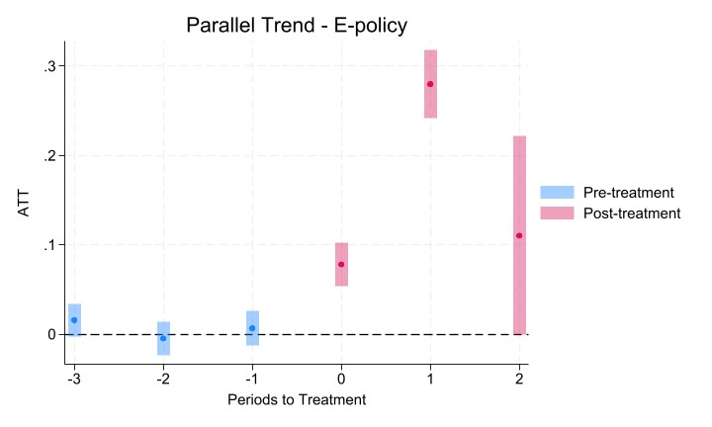

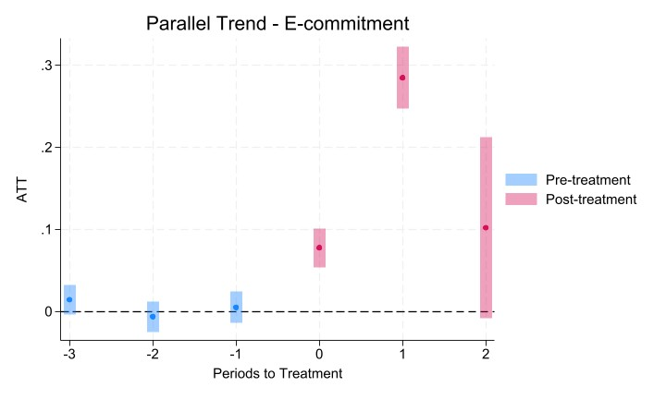

Panel B: Overall average treatment effect on the treated (ATT, Callaway and Sant’Anna 2021)
Average Treatment Effect on Treated: Success | ATT | Std. Err. | z-stat | p-value | N
E-policy | 0.073 | 0.016 | 4.56 | 0.000 | 144,361
E-commitment | 0.076 | 0.015 | 4.97 | 0.000 | 144,361

Average Treatment Effect on Treated: Pledges | ATT | Std. Err. | z-stat | p-value | N
E-policy | 0.088 | 0.020 | 4.48 | 0.000 | 144,361
E-commitment | 0.092 | 0.019 | 4.83 | 0.000 | 144,361
This table reports robustness tests of the parallel trend assumption and the project-level Callaway and Sant’Anna (2021) difference-in-differences design to account for heterogeneous treatment effects. Panel A reports plots of event-study estimates of the average treatment effect on the treated relative to the quarter of policy adoption, using the staggered difference-in-differences estimator of Callaway and Sant’Anna (2021) with Success is the outcome variable. Panel B reports the overall the average treatment effect on the treated using E-policy or E-commitment to define the treatment group over a window of three quarters before and after treatment using Success and Pledges as outcome variables.

Table OA.16 Creators’ preferences in environmental commitment

 | (1) | (2)
VARIABLES | New Creator | High E-Awareness Creator
$$\hat{E-commitment}$$ | -0.008 | -0.005
 | (-0.870) | (-0.142)
Goal (in log) | -0.027*** | 0.002*
 | (-13.344) | (1.799)
Minimum Reward (in log) | 0.011*** | 0.002
 | (5.147) | (1.465)
Blurb Length (in log) | -0.008*** | 0.010**
 | (-2.944) | (2.233)
Horizon (in log) | -0.135*** | -0.016
 | (-8.828) | (-1.415)
Self-Mention | -0.008 | 0.005
 | (-1.287) | (0.682)
Staff Pick | 0.020 | 0.033***
 | (1.371) | (4.636)
FAQ | -0.043*** | 0.003
 | (-10.224) | (1.058)
Comments | 0.061*** | 0.000
 | (12.560) | (0.200)
Updates | 0.042*** | 0.006***
 | (9.455) | (2.977)
Other Projects | 0.324*** | -0.024**
 | (29.533) | (-2.639)
Gender | -0.015*** | 0.002
 | (-4.159) | (0.529)
Category, Year-month, Location FE | Yes | Yes
Category, Year-month, Location clustering | Yes | Yes
Observations | 173,874 | 105,000
Adj. R² | 0.280 | 0.118
This table presents the effect of two-stage least squares instrumented E-commitment on the attributes of creators. This specification controls for the project category, launch year-month, and the creator’s location fixed effects, and the standard errors are clustered by category, year-month, and the creator’s location. The t values are reported in parentheses. *, **, and *** indicate significance at the 10%, 5%, and 1% levels, respectively.

In Table OA.8, we estimate all three different specifications in Table 3 but with a more stringent set of fixed effects, including category × month-year.
We also repeat this specification by subsamples of categories (i.e., design, technology and fashion, etc.) and report the results in Table OA.10. Our results are broadly consistent in that environmental commitments have a stronger association with funding outcomes when they are more concrete. We further examine whether this association varies by calendar time and whether a creator adopts an environmental commitment earlier or later. As the results reported in Figure OA.3 and Online Appendix Table OA.11 show, the association increases from 2019 to 2021 and strengthens for later adopters.
See TriplePundit • Kickstarter’s New Features Put Sustainability Top-of-Mind for Creators for details.

