Supplementary Information

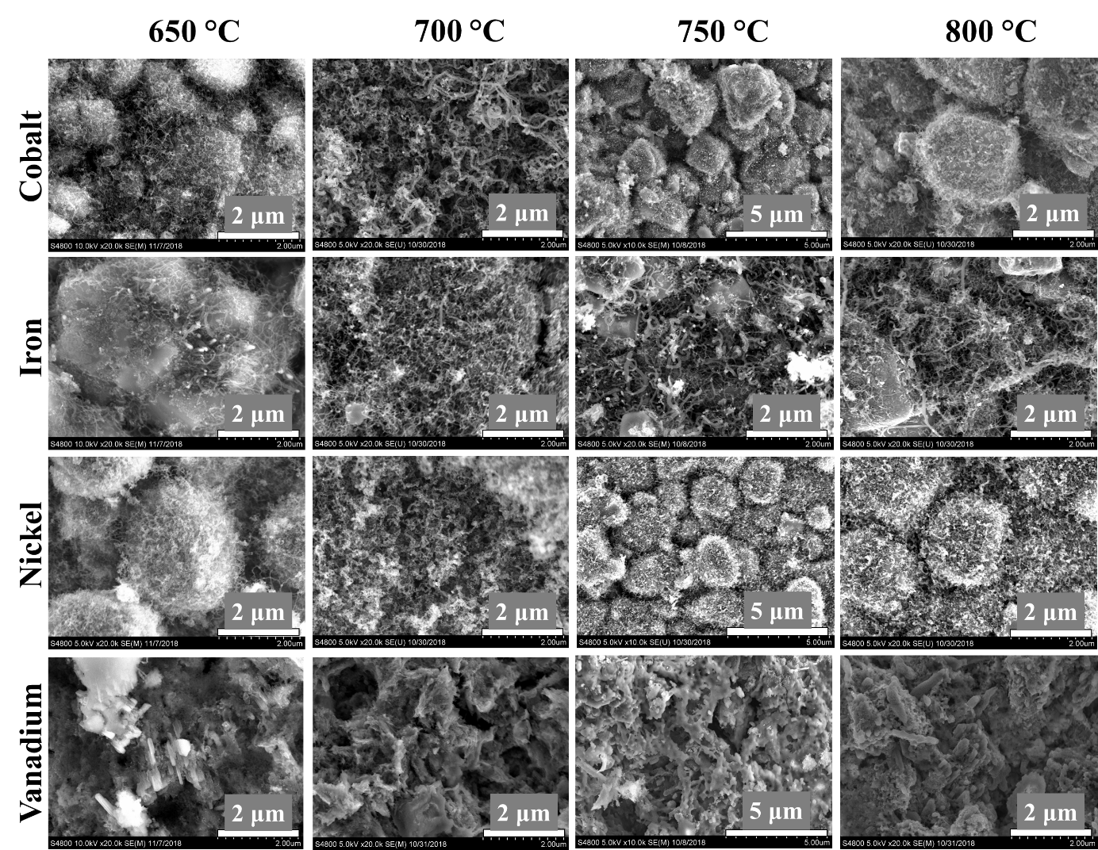
Fig. S1: Scanning electron microscopy (SEM) pictures of the Co, Fe, Ni and V containing zeolite beads used in N-BCNT synthesis at different temperature.
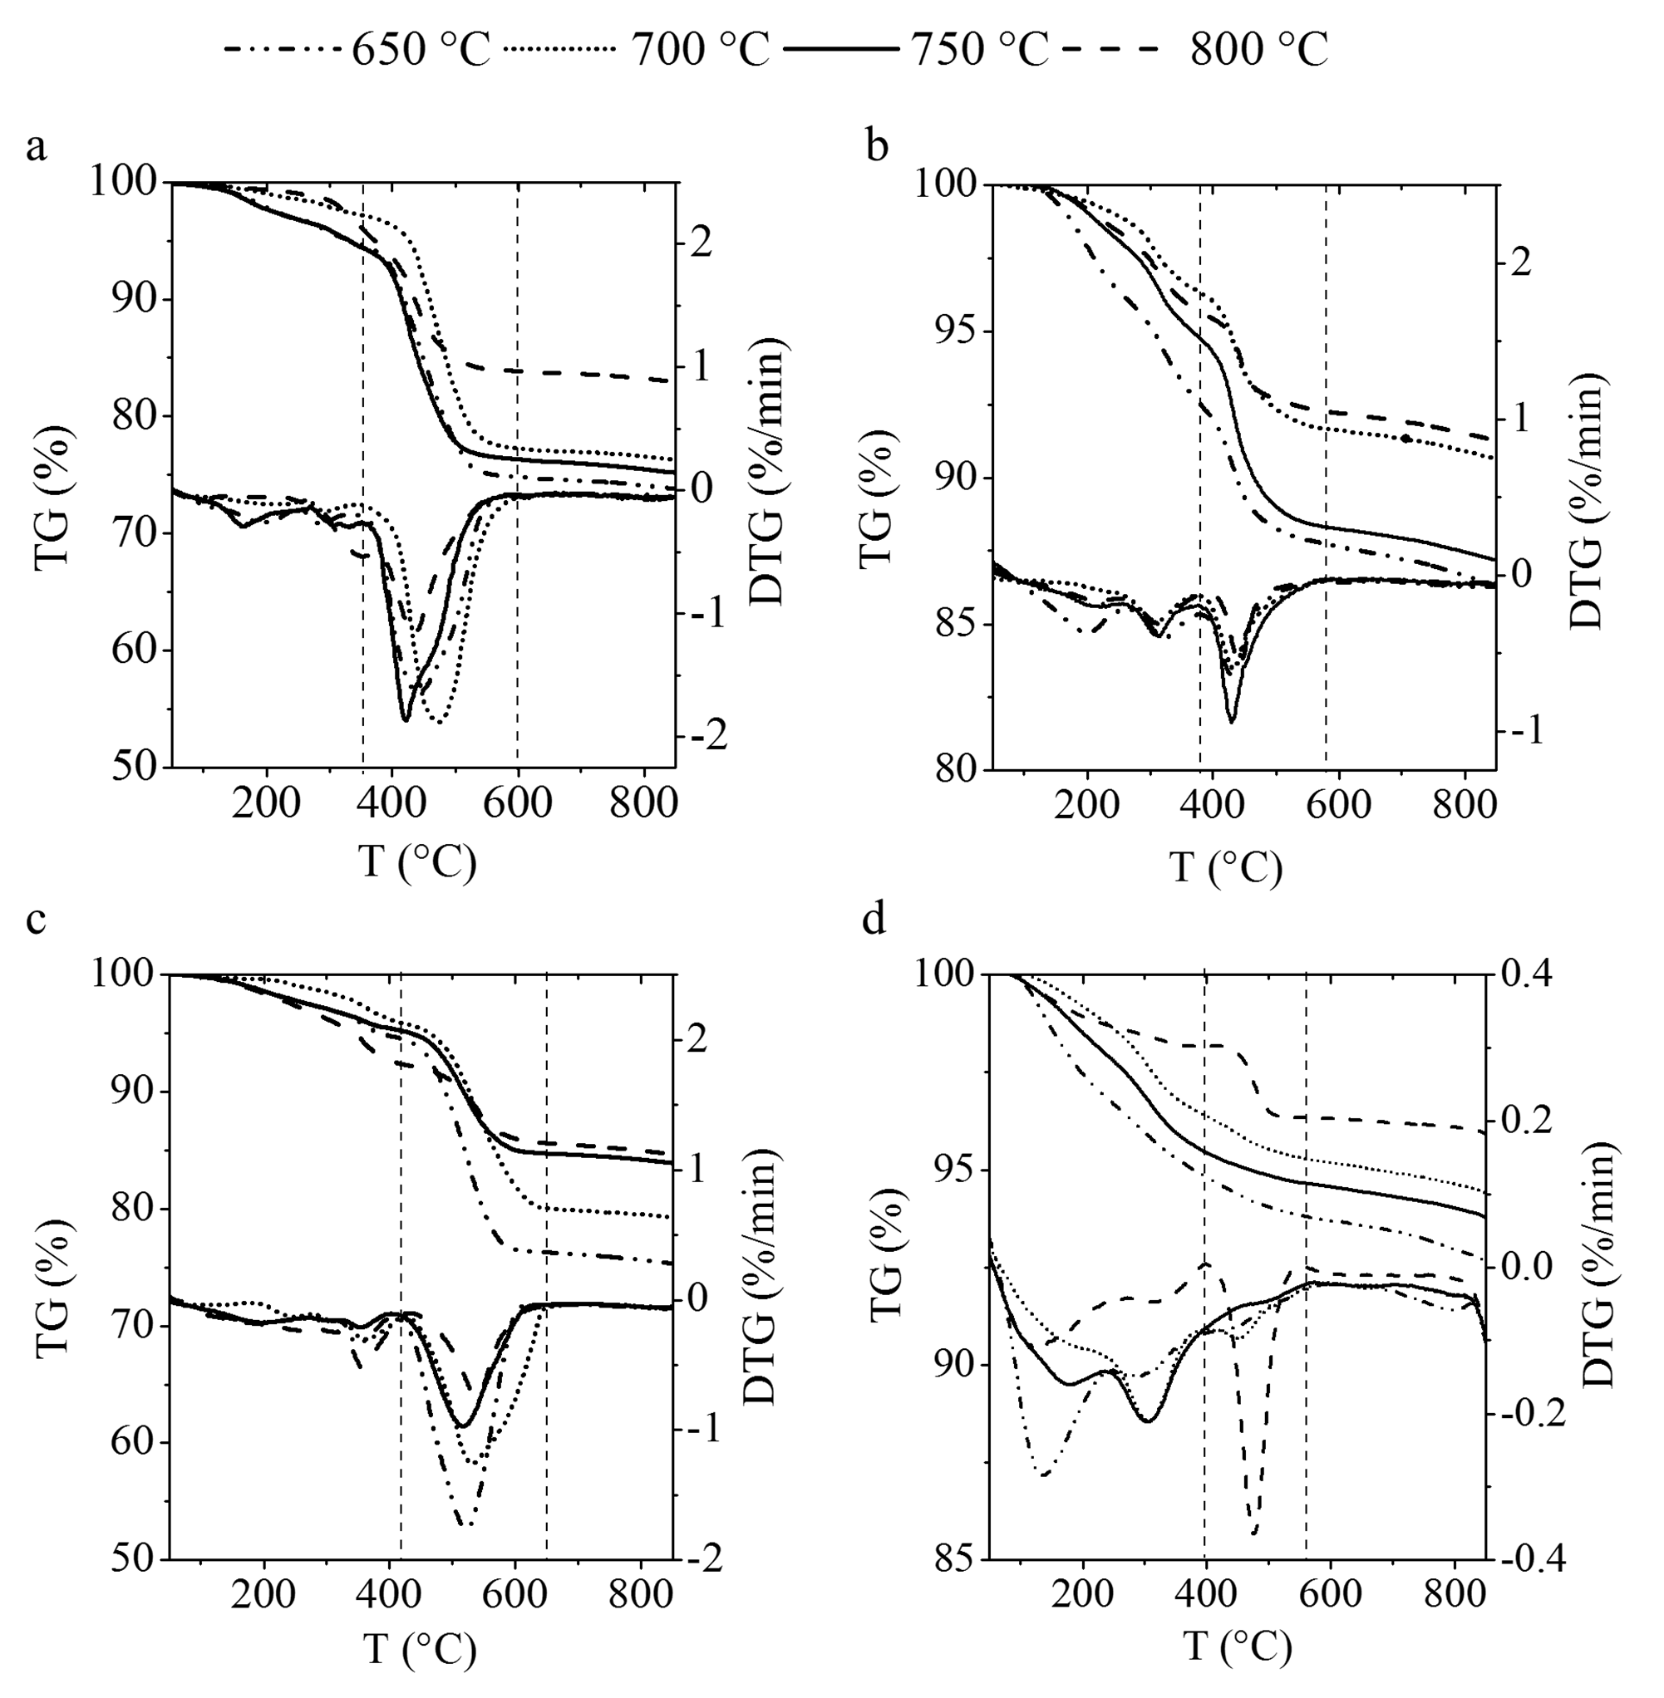
Fig. S2.: TG and DTG curves of the N-BCNT coated Co/zeolite (a), Fe/zeolite (b), Ni/zeolite (c) and V/zeolite beads at 600, 700, 750 and 800 °C.

