Supplementary Information

Nanodisperse gold catalysts in oxidation of benzyl alcohol: comparison of various supports under different conditions

Gergely Nagy¹, Andrea Beck¹, György Sáfrán², Zoltán Schay¹, Shaofeng Liu^{3,4}, Tianbao Li³, Botao Qiao³, Junhu Wang^{3,4}, Károly Lázár⁵*
¹Department of Surface Chemistry and Catalysis, Centre for Energy Research, HAS, Konkoly Thege M. út 29-33, Budapest, 1121, Hungary
² Laboratory of Thin Layer Physics, Institute of Materials Science, Centre for Energy Research, HAS, Konkoly Thege M. út 29-33, 1121, Budapest, 1121, Hungary
³ State Key Laboratory of Catalysis, Dalian Institute of Chemical Physics, Chinese Academy of Sciences, 457 Zhongshan Road, Dalian 116023, China
⁴ Mössbauer Effect Data Center, Dalian Institute of Chemical Physics, Chinese Academy of Sciences, 457 Zhongshan Road, Dalian 116023, China
⁵ Department of Nuclear Analysis and Radiography, Centre for Energy Research, HAS, Konkoly Thege M. út 29-33, Budapest, 1121, Hungary

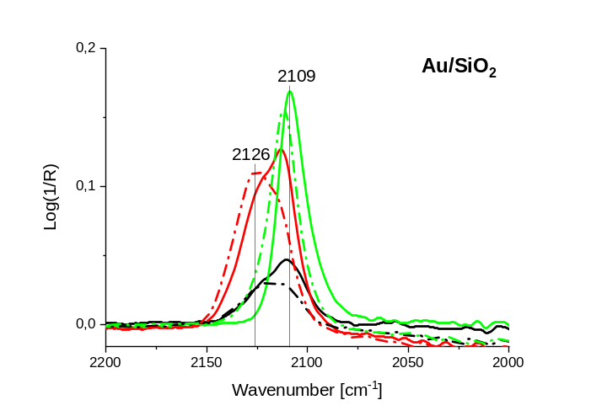 | 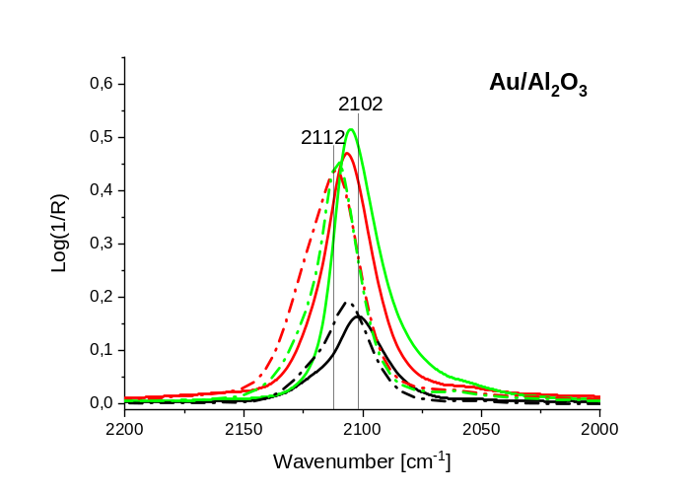
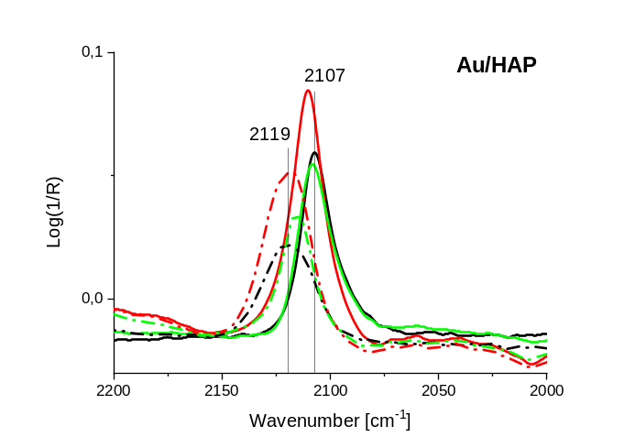 | 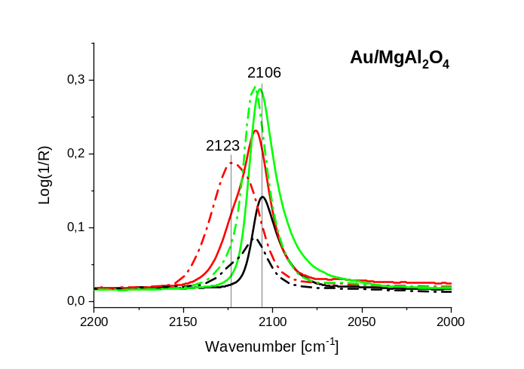
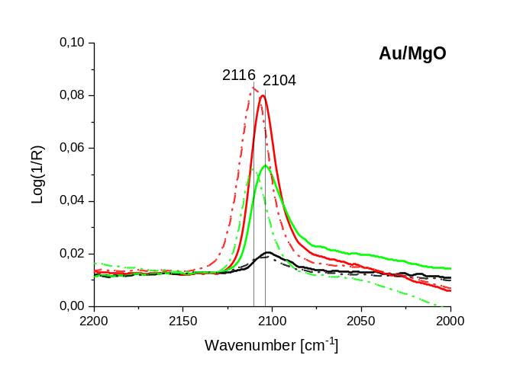 | 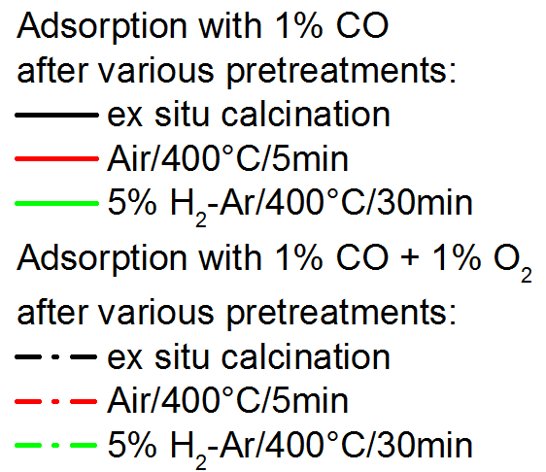

Fig. S1 DRIFT spectra of CO adsorbed at 35 ºC in presence of 1%CO/Ar or 1% CO+1%O₂/He on the different ex situ calcined (400 ºC/synthetic air/1h) catalysts and after various consecutive in situ pretreatments (i) calcination in synthetic air/400 ºC/ 5min, (ii) reduction in 5% H₂ in Ar/400ºC/30min. (1.8 wt % Au on SiO₂, on all the other supports 3 wt % Au )

