Supplementary Information

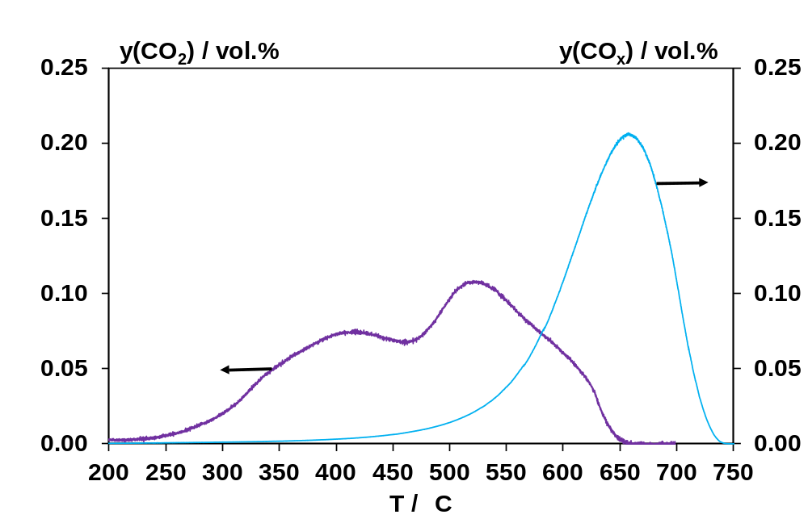
Fig. S1. CO₂ formation during TPO of loose contact catalyst/soot mixture (—) and corresponding CO_{x} formation of bare soot (—), each without SO₂ exposure. TPO conditions: y(O₂) = 1 V%, y(H₂O) = 2 V%, N₂ balance, F = 500 ml/min (STP), m = 0.53 g (blend) or 0.033 g (bare soot), ΔT/Δt = 3 K/min.

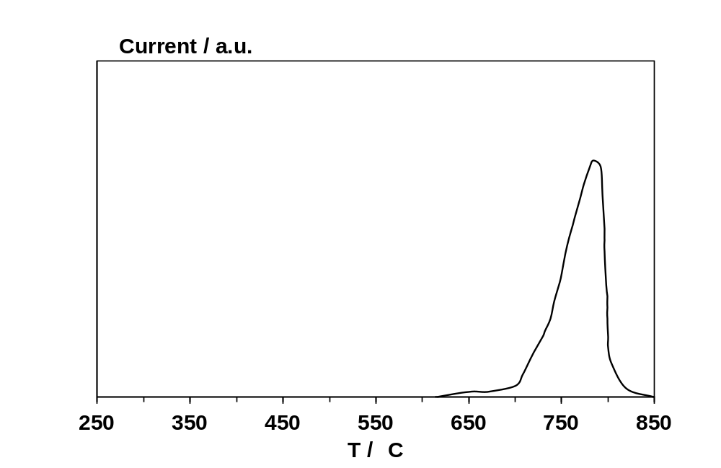
Fig. S2. O₂-TPD profile of the sample after 30 ppm SO₂ exposure and treatment at 705 °C in gasoline model exhaust. TPD conditions: F(He) = 100 ml/min (STP), m ≈ 20 mg, ΔT/Δt = 10 K/min.

