Limonene oxide isomerization – a broad study of acid catalyst effects
Anna Rejzková, Eliška Vyskočilová
Department of Organic Technology, University of Chemistry and Technology Prague, Technická 5, Praha 6, Czech Republic
anna.rejzkova@vscht.cz, eliska.vyskocilova@vscht.cz

Fig. S1. Chromatogram of reaction mixture using tungstophosphoric acid after 1 h
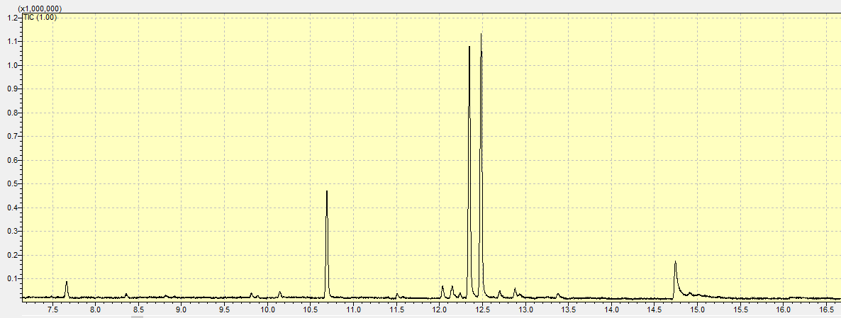
Fig. S2. Chromatogram of reaction mixture using Amberlyst-15 dry after 1 h
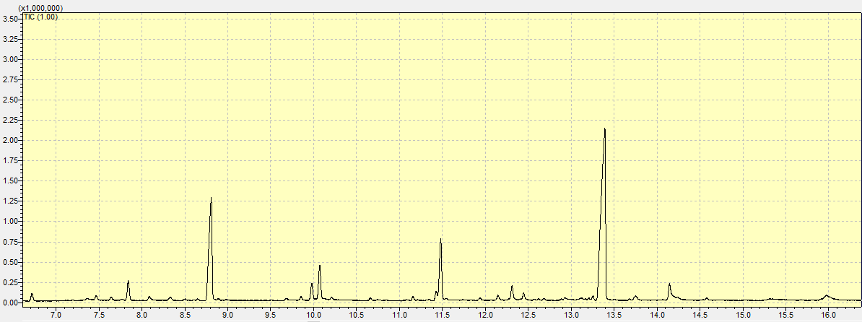

Fig. S3. MS spectra of cis-limonene oxide
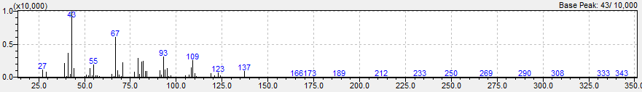
Fig. S4. MS spectra of trans-limonene oxide
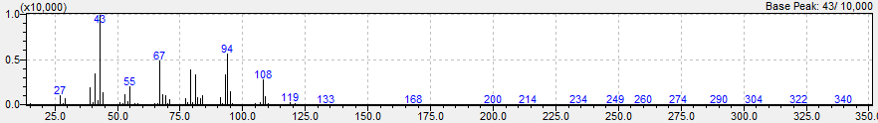
Fig. S5. MS spectra of p-cymene
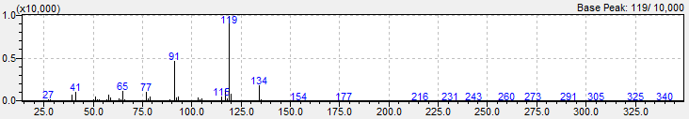
Fig. S6. MS spectra of aldehyd
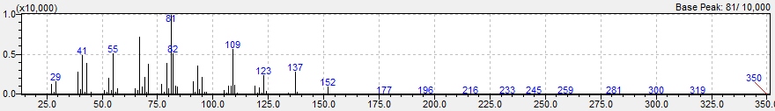
Fig. S7. MS spectra of cis-dihydrocarvone
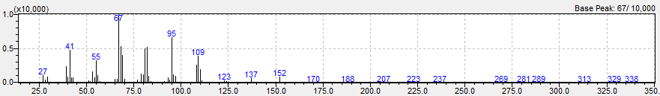
Fig. S8. MS spectra of trans-dihydrocarvone
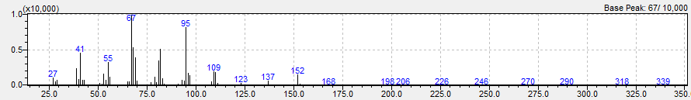
Fig. S9. MS spectra of endo-carveol
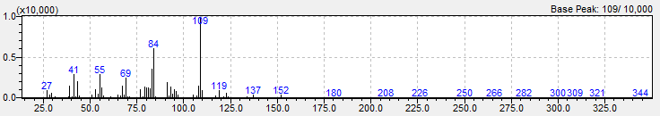
Fig. S10. MS spectra of exo-carveol
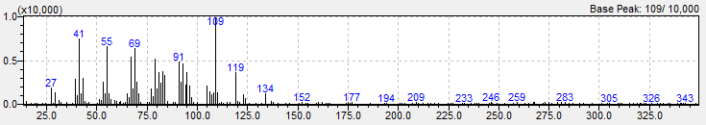

Fig. S11. MS spectra of carvone
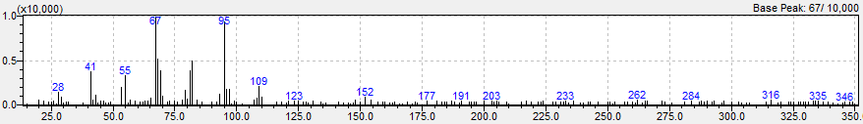
Fig. S12. MS spectra of carvenone
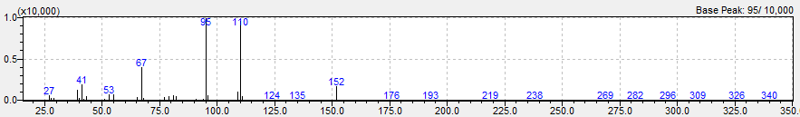
Fig. S13. MS spectra of limonene diol
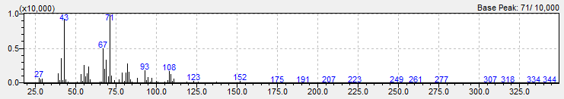

Tab. S1. Temperature program of GC-FID
Temperature of injector | 250 °C
Initial temperature | 80 °C
Hold of initial temperature | 5 min
First temperature ramp | 7 °C/min
End temperature of first ramp | 150 °C
Second temperature ramp | 20 °C/min
End temperature | 250 °C
Hold of end temperature | 5 min
Temperature of detector | 250 °C

Tab. S2: Parameters of column for GC-FID
Column | HP-5
Length | 30 m
Inner diameter | 0.35 mm
Thin of layer | 0.25 µm
Carrying gas | hydrogen
Pressure | 51 kPa
Flow in column | 4 ml/min

Tab. S3: Temperature program of GC-MS (GC part)
Initial temperature | 80 °C
Hold of initial temperature | 5 min
Temperature ramp | 10 °C/min
End temperature | 250 °C
Hold of end temperature | 5 min

Tab. S4: Temperature program of GC-MS (MS part)
MS detector | quadrupol
Interface temperature | 250 °C
Temperature of ion source | 220 °C
End temperature | 250 °C
Voltage (sensitivity) | 0.9 kV

Tab. S5: Parameters of column for GC-MS
Column | DBH-5
Length | 35 m
Inner diameter | 0.2 mm
Thin of layer | 0.35 µm
Carrying gas | helium
Pressure | 198.2 kPa
Flow in column | 1.11 ml/min

