Supplementary information
Transfer Hydrogenation of Butyl Sorbate: Optimization of Reaction Conditions
Kateřina Oplováª, Maria Kotovaª, Eliška Vyskočilová^{a*}
ª Department of Organic Technology, University of Chemistry and Technology, Prague, Czech Republic
*Corresponding author
E-mail address: leitmane@vscht.cz
Preparation of butyl sorbate
Sorbic acid (0.14 mol), butanol (0.40 mol), and p-toluenesulfonic acid (PTSA, 4.5 mmol) were introduced into a 100 mL three-necked flask equipped with an Dean-Stark apparatus and refluxed until no more water was collected. The mixture was neutralized with 5% Na₂CO₃ solution, extracted with water (3 × 10 ml) and hexane (1 × 10 ml), dried over MgSO₄, and concentrated under reduced pressure. The crude ester was purified by vacuum distillation (3.5 kPa, 137 °C) to afford pure butyl sorbate. Sorbic acid was successfully esterified affording butyl sorbate in 83% yield (52 g) with a purity of 97% (Figure 1).
Figure 1
Fisher esterification of sorbic acid
Materials
All chemicals were used as received, namely p-toluensulfonic acid monohydrate (PTSA, p.a.) was purchased from Lachema, butanol (p.a.), sorbic acid (pure), sodium carbonate (p.a.) was obtained from Penta and n-hexane (p.a.) was purchased from Lach-ner.
¹H NMR assignment
butyl (E)-hex-2-enoate (II)
¹H NMR (400 MHz, CDCl₃) δ ppm 0.85-0.92 (m, 6H, CH3),1.30-1.51 (m, 4H, CH2), 1.55-1.62 (m, 2H, CH2), 2.30-2.39 (m, 2H, CH2-CH=), 4.12 (t, J = 6.6 Hz, 2H, OCH2), 5.84 (dt, J = 15.7, 1.4 Hz, 1H, =CH), 6.90-7.03 (d, J = 15.6 Hz 1H, CH=).
¹³C NMR (101 MHz, CDCl₃) δ ppm 13.5, 14.0, 21.2, 22.1, 28.2, 35.0, 64.6, 121.5, 140.8, 173.0.
butyl (E)-hex-4-enoate (III)
¹H NMR (400 MHz, CDCl₃) δ ppm 0.88 (t, J = 7.2 Hz, 3H, alkohol-CH3), 1.35-1.49 (m, 4H, CH2), 1.65 (d, J = 6.4 Hz, 3H, acid-CH3), 2.31-2.42 (m, 4H, CH2), 4.12 (t, J = 6.7 Hz, 2H, OCH2), 5.34-5.46 (m, 2H, CH=CH).
¹³C NMR (101 MHz, CDCl₃) δ ppm 13.7, 17.9, 21.2, 28.1, 31.2, 34.8, 64.2, 126.6, 130.8, 173.2.
butyl (E)-hex-3-enoate (IV)
¹H NMR (400 MHz, CDCl₃) δ ppm 0.90-0.99 (m, 6H, CH3), 1.33-1.52 (m, 4H, CH2), 1.99-2.09 (m, 2H, CH2-CH=), 2.80-3.13 (m, 2H, CH2CO), 4.15 (t, J = 6.7 Hz, 2H, OCH2), 5.41-5.75 (m, 2H, CH=CH).
¹³C NMR (101 MHz, CDCl₃) δ ppm 13.8, 13.9, 19.1, 25.8, 30.8, 35.9, 64.2, 120.8, 135.8, 171.9.
butyl (Z)-hex-3-enoate (V)
¹H NMR (400 MHz, CDCl₃) δ ppm 0.90-0.98 (m, 6H, CH3), 1.31-1.51 (m, 4H, CH2), 1.99-2.09 (m, 2H, CH2-CH=), 2.80-3.12 (m, 2H, CH2CO), 4.17 (t, J = 6.7 Hz, 2H, OCH2), 5.52-5.59 (dt, J = 10.9, 6.2 Hz, 1H, CH=), 5.73-5.84 (dt, J = 10.9, 6.4 Hz, 1H, =CH).
¹³C NMR (101 MHz, CDCl₃) δ ppm 13.8, 13.9, 19.1, 25.9, 30.8, 35.8, 64.2, 121.0, 135.1, 171.9.
butyl hexanoate (VI)
¹H NMR (400 MHz, CDCl₃) δ ppm 0.82-0.88 (m, 6H, CH3), 1.20-1.42 (m, 6H, CH2), 1.59-1.68 (m, 4H, CH2), 2.22-2.27 (m, 2H, CH2CO), 4.01-4.08 (m, 2H, OCH2).
¹³C NMR (101 MHz, CDCl₃) δ ppm 13.9, 14.0, 18.9, 22.1, 27.9, 30.8, 31.5, 34.8, 64.3, 174.0.
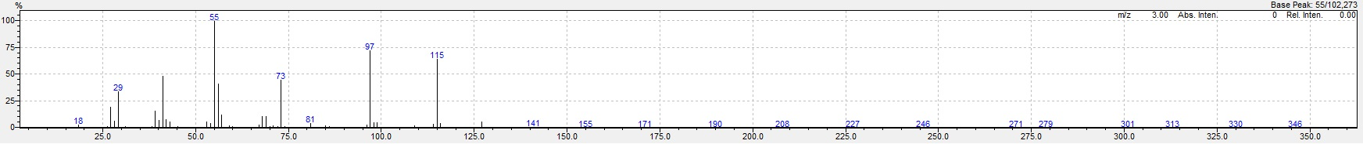
GC-MS spectra
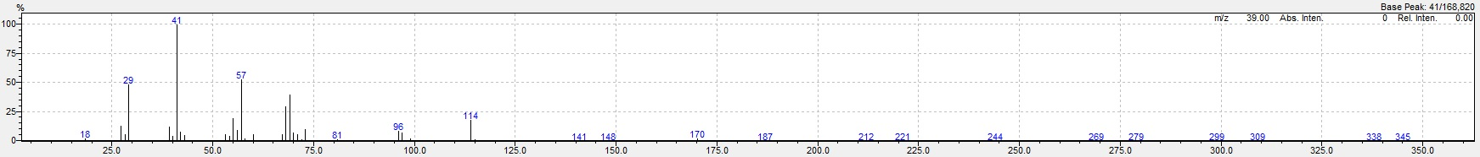
Fig. S1: GC-MS spectrum of butyl (E)-hex-2-enoate
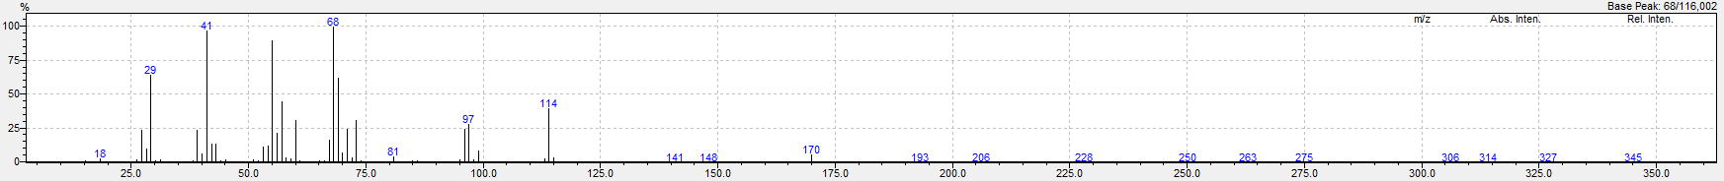
Fig. S2: GC-MS spectrum of butyl (E)-hex-3-enoate
Fig. S3: GC-MS spectrum of butyl (Z)-hex-3-enoate
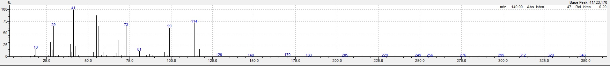
Fig. S4: GC-MS spectrum of butyl hexanoate
Butyl (E)-hex-4-enoate was identified only by NMR.
Reaction courses
Fig. S5: Effect of catalyst and ligand loading on the transfer hydrogenation of butyl sorbate
Fig. S6: Effect of solvent type on the transfer hydrogenation of butyl sorbate
Fig. S7: Effect of temperature on the transfer hydrogenation of butyl sorbate
Fig. S8: Effect of hydrogen donor type on the transfer hydrogenation of butyl sorbate
Fig. S9: Effect of hydrogen donor type on the transfer hydrogenation of butyl sorbate

