Appendix A1: Probe Composition Task Scoring
Table A1 presents the scoring rubric used by when rating texts produced in response to progress monitoring probe tasks. The rubric was developed as follows. First raters selected a random sample of 100 texts and grouped them into four categories (good, average, bad, unreadable / no text) based on their overall impression of text quality. The average and bad groups where then subdivided into upper and lower quality groups. Raters then separately listed features that the identified as being typical of texts in each group. These features were then discussed and agreed to produce the final rubric.

Table A1. Text quality assessment criteria for the regular progress-monitoring tasks.
0 | -There is no text or it’s illegible.  - The text does not respond to the topic.  -The text is a list of words without clauses.
1 | -Certain progression of ideas: the child mentions 1 or 2 clauses without clarifying or descriptive details.  -Frequent digressions.  -Handwriting is difficult to understand and there are frequent spelling mistakes.  -Grammar complexity: simple sentences.  -No connectors or very repetitive ones.  -Basic and simple vocabulary.
2 | - Certain progression of ideas with one of the following:  - 1 or 2 ideas mentioned with descriptive or clarifying details.  - More than 2 ideas with very few or no descriptive or clarifying details.  -Repetitive and irrelevant details.  -Legible handwriting with common spelling mistakes.  -Grammar complexity: mostly simple sentences but there are some compound ones formed by juxtaposition (connector “and”).  -Basic and repetitive connectors.  - Vocabulary according to students’ age.
3 | -Logical progression/sequence of ideas, linked to a common topic and with descriptive and clarifying details.  -Some irrelevant or repetitive details.  -Correct handwriting with some spelling mistakes.  -Grammar complexity: combination of simple and compound sentences (mostly juxtaposition but some formed by subordination).  -Basic and repetitive connectors, although they might include a complex one.  - Appropriate vocabulary.
4 | -Logical progression/sequence of ideas, linked to a common topic and with a variety of descriptive and clarifying details.  - No irrelevant details although there might be some repetitions.  -Correct handwriting with some spelling mistakes.  -Grammar complexity: mostly compound sentences (juxtaposition, coordination and subordination)  - Repetitive connectors although some complex ones.  - Appropriate vocabulary with a few unusual expressions/words.
5 | -Logical progression/sequence of ideas, linked to a common topic and with a variety of descriptive and clarifying details.  -Variety of relevant and non-repetitive details.  -Correct handwriting with very few spelling mistakes.  -Grammar complexity: mostly compound sentences.  -Varied connectors.  -Advanced vocabulary.  -Certain textual structure: introduction, development and conclusion.

Appendix A2: Example compositions
In these sample compositions, text quality is rated as low, middle and high. Texts are presented in Spanish to preserve the errors made, but also transcribed into English. For readability, we have inserted spaces between words were these were missing or not clear in the handwritten originals. Underlining indicated spelling errors or the omission of capitalization. The English translation represents these errors with plausible English spelling mistakes.
Text 1. Score = 1
oi me ido a casa i me peso un susuto i me fi a casa
tody I went home and i gott scare and I wet home

Text 2. Score = 3
Fui a casa Bi el patido por telebision en el canal Gol cene lei un cuento de cuatro abenturas i Fui pa la cama con mama a mi cama llo sola.
I went home Wtched the mathc in telebision in Gol channel had dinner read a tale of four adbentures and i Went too bed with mommy to my bed my alone.

Text 3. Score = 5
Ayer fui a la catequesis ayi hablamos de jesus y de dios y benieron mas niños cuando estabamos leñendo. cuando termine la cataquesis me fui a nadar primero con churro luego con tabla y luego sin ningun material. estaba muy cansado. me fui a casa y tome un vuenco de cereales. estaba muy bueno. me tunve en el sofa lei y me dormi. cuando me dormi mi madre me conto el cuento del principito.
Yesterday I went to catechesis ther we talked about jesus and god and more children cam when we were reading. when catachesis finished I went swimming first with a flot then with a table and then without any material. i was very tired. i went home and had a bolw of cereals. it was very tasty. i lied down on the sofa read and fall asleep. when I felt asleep my mother told me the tale of the little prince.

Appendix B: Handwriting Assessment Criteria for Phase-End Narrative

Score | Indicators
0 | The majority of the marks in the paper do not resemble letters. They can be pictures or random strokes. There might be some strokes that resemble letters but most of them don’t.
1 | The majority of the marks on the first line can be identified as specific letters (independent of context). However nearly all of these are very badly formed in one or more ways: they are inaccurate (i.e you can hardly tell which letter the strokes correspond to) and irregular (i.e shaky strokes, different sizes, same size for capitals and non capitals, oscillations, slant letters and letters overlapped).
2 | The majority of the marks on the first can be identified as specific letters (independent of context). The majority of these are accurately formed but are irregular. Irregularity can include (see above).  Letter size is consistent throughout the text but they are so small it’s difficult to know whether they are accurate or not.
3 | The majority of the marks on the first line can be identified as specific letters (independent of context). At least half of the letters are accurate and regular.
4 | All the marks on the first line can be identified as specific letters (there can be 1 mark not identified as a letter). The great majority of letters are accurate and regular. There might be some irregularities.

Appendix C: Interview Schedule for Teacher Interviews
The interviews conducted with teachers contained the following questions:
- When we first approached you to introduce the program, how did you feel? What aspects about it motivated you to put it in practice and which worries did you have?
- Could you tell us what the students’ experience throughout the program have been? How they felt, if they expressed any opinion about the program…could you tell us about any particular case that caught your attention?
- We provided you with different materials to teach spelling, handwriting and text planning. Could you tell us your experience with these materials? Which are their positive aspects, how have you felt using them, which difficulties you have found (if any)…?
- One of the principles of the program was student progress monitoring and we did this through the writing tasks students completed once or twice a week. What has it been you experience with these tasks? Why do you think that occurs?
- We would like to know how this program has influenced your professional development. Do you think you will include some aspects from it in your future teaching practice?
- Would you recommend this program, or some aspects of it, to colleagues that teach in first and second grade? Why?
- To finish, we would like you to summarize the strong and weak points of your experience with the program.

Appendix D: Tier 1 instruction
Tier 1 instruction comprised 123 sessions delivered by classroom teachers. The normal literacy curriculum continued alongside Tier 1 sessions. Tier 1 instruction addressed four writing processes, as follows.
Spelling instruction comprised 23 sessions. During Phases 1 and 2 (14 sessions) three Spanish spelling rules were taught, each in two stages. First, students analysed 6 words to infer the rule, which the teacher then explained (2 sessions). Second, students practice the rule through the “Writing Goose” game, in which they move around a game board, spelling words at regular intervals (2 sessions). At the end of Phase 2, rules were briefly revisited (2 sessions). During Phase 3, the same spelling rules were revisited (9 sessions). The spelling rules were extracted from the regional educational curricula for 1st and 2nd grade.
Handwriting instruction comprised 41 sessions, the same as the total number of spelling and sentence-combining sessions. During Phases 1 and 2 (28 sessions) sessions were divided in 4 sets, each one focused on 7 letters. Each set began with students learning the name of these letters following the alphabet sequence (2 sessions). A typical task involved singing an alphabet song in which they named each letter and said a word starting by it. Then, they traced the letters first following numbered arrows and then without help (2 sessions). Third, students practiced handwriting speed through time-limited activities focused on writing as many letters as possible (1 session). Fourth, students completed a copy-through-dictation task (1 session). At the end of Phase 2, the contents were revisited (4 sessions). During Phase 3 instruction followed the same sequence (9 sessions).
Sentence-combining training comprised 18 sessions. In Phases 1 and 2 (12 sessions) sentence-combining was taught in two stages. Students learned to use connectors to make complex sentences (2 sessions) and how to use three punctuation rules (2 sessions). This content was revisited during Phase 3, and then new connectors were added.
Text-planning instruction focused on learning to compose narratives and it comprised 41 sessions. In Phases 1 and 2 (28 sessions) planning was taught in 3 stages, according to previous strategy-focused programs. First, direct instruction (12 sessions) focused on providing students with metacognitive understanding of text planning processes and of the structural elements of narratives: introduction (when and where the story happens and who the characters are), development (what happens and how the characters feel) and conclusion (how the story ends). Instruction was based around a mnemonic device called La Montaña de los Cuentos (Story Mountain). Students were encouraged to think of writing a story as a journey up the mounting, visiting villages representing introduction, development and conclusion. Villages contained houses representing when, where, who, and so forth. Students finished by evaluating high and low quality texts, explaining their evaluation in terms of the Story Mountain text features.
The second stage (9 sessions) involved the teacher modelling the Story Mountain strategy. The teacher composed a story in front of the class while “thinking aloud”. Think-aloud was scripted and included frequent reference for the Story Mountain (The first village is called Introduction so I need to write the introduction of my story, and so forth). After the teacher modelled each part of the narrative (introduction, development and conclusion), students wrote down that part of their own story.
In a third stage, individual practice (6 sessions), students wrote a whole story with some teacher feedback. This sequence extended across Phases 1 and 2. At the end of Phase 2, one session was devoted to revisit the learning.
During Phase 3 (13 sessions), the same instructional sequence was followed, using different stories as examples. Two changes were made: modelling was followed by a group reflection on the model’s thoughts, and students wrote their stories alone and also in pairs.

Appendix E: Lesson plan for text planning (English and Spanish)
SESSION 24. DIRECT INSTRUCTION (Story introduction: when and where)

Session development | Materials
(If students complete any worksheets in this session, these must be stored in the blue folder).  At the beginning of the session the teacher reminds the students that, during this year, they will learn to write perfect stories. Then, the teacher asks then whether they remember what is the first thing to do before writing a story. Then, the teacher shows the Story Mountain poster and reminds the students that they will need to climb it for their stories to be perfect. We suggest a possible speech for the teacher: “Guys, as we said the other day, this year we are learning to write perfect stories with all their parts. But, do you remember what is the first thing to do before writing a story? (the teacher lets the students answer). There you go! We have to plan, that is, to think a lot about what we are going to write! So today we are going to start studying which things we should write in a story and for that I took with me…the Story Mountain! (the teacher points to the poster in the wall. For this sessions, the poster will have only three stickers stuck to it: introduction, when and where). Shall we climb the mountain to see what it teaches us?  Then, the teacher explains the first part of a story (the introduction) as well as two of the three elements that should be mentioned in the introduction: when and where the story happens (the third element “who the characters are”) will be explained in the next session). It is important to emphasize that, the same way we climb a mountain starting from the bottom, we also start a story from the instruction. we suggest the following speech: “Let’s start climbing the mountain (the teacher and the students make gestures as if they were actually climbing) and suddenly…what is that we see far away? It looks like a village! It is called Introduction! Remember it, Introduction starting with I (this serves to make students familiar with the IDC rule: introduction, development and conclusion). Introduction is the first part of a story. So, the same way we always start from the bottom when we climb a mountain, we also start from the introduction when we write a story. But, what do we have to write in the introduction? Let’s see what is in the village…there are two houses. The first one is called When. When might a story happen? (the teacher lets the students make suggestions like: a long time ago, a dark night, etc. the teacher congratulates the students who correctly answered the question When?). Well, so the first thing we have to write in a story is when it happens, for example, a pring day. But there is another house in the introduction and it is called Where. Where might a story happen? (again, the teacher lets the students suggest places where a story might happen: in a cave, in the forest, in the park, etc.). So, the second thing I have to write in the introduction is where my story happens, for example, in a far away country. Have you understood? Let’s try to remember it. How do you call the first part of a story? And what is the first thing I have to write in that part? And the second thing?” | Poster: the Story Mountain

SESIÓN 24. INSTRUCCIÓN DIRECTA (Introducción de un cuento: cuándo y dónde)

Desarrollo de la sesión | Materiales
(Las posibles fichas que se realicen en esta sesión se guardarán en la carpeta azul).  Se inicia la sesión recordando a los alumnos que, durante este curso, van a aprender a escribir cuentos perfectos y se les pregunta si recuerdan lo que hay que hacer antes de empezar a escribir un cuento. A continuación, se muestra la montaña de los cuentos y se recuerda que tendrán que escalarla para que sus cuentos sean perfectos. Se sugiere una posible transcripción: “Chicos, como dijimos el otro día, este año vamos a aprender a escribir unos cuentos perfectos, con todas sus partes. Pero ¿recordáis que es lo que hay que hacer antes de escribir un cuento? (se deja un momento para que los alumnos respondan). ¡Eso es! ¡Tenemos que planificar, es decir, pensar mucho en lo que vamos a poner! Pues hoy vamos a empezar a ver qué cosas tenemos que poner en un cuento y para eso he traído…¡la Montaña de los Cuentos! (se señala el mural en la pared, en el que solo estarán dos de los adhesivos correspondientes a la Introducción, el Cuándo y el Dónde). ¿La escalamos entre todos a ver qué nos enseña?  Posteriormente, el docente explicará la primera parte de los cuentos (la introducción), así como dos de los tres elementos que han de mencionarse en ella: cuándo y dónde ocurre el cuento (el tercer elemento, “quién”, se explicará en la siguiente sesión). Es importante enfatizar que, al igual que cuando escalamos una montaña empezamos por la parte de abajo, también al escribir un cuento empezamos siempre por la introducción. Se sugiere la siguiente transcripción: “Empezamos a escalar la montaña (los niños y el docente hacen el gesto de escalar con los brazos) y de pronto…¿Qué es aquello que vemos a lo lejos? ¡Parece un pueblo! ¡Se llama Introducción! Acordaos, Introducción con la I (poner el énfasis en la letra inicial para ir familiarizando a los alumnos con la regla IDC: introducción, desarrollo y conclusión). La introducción es la primera parte de los cuentos. Por eso, igual que cuando escalamos una montaña siempre empezamos por la parte de abajo, cuando escribimos un cuento siempre empezamos por la introducción. Pero ¿qué tenemos que escribir en la introducción? Veamos qué hay en el pueblo…Hay dos casas. La primera se llama Cuándo. ¿Cuándo puede ocurrir un cuento? (se permite a los alumnos hacer sugerencias del tipo: hace mucho tiempo, una noche oscura, etc. Se felicita a los alumnos que responde a la pregunta ¿cuándo?). Pues bien, lo primero que tenemos que poner en un cuento es cuándo ocurre, por ejemplo, un día de primavera. Pero en la introducción hay otra casa y se llama Dónde. ¿Dónde puede ocurrir un cuento? (de nuevo se permiten sugerencias que indiquen lugar, del tipo: en una cueva, en el bosque, en un parque, etc.). Pues bien, lo segundo que tengo que poner en la introducción de mi cuento es dónde ocurre, por ejemplo, en un país muy lejano. ¿Lo habéis aprendido bien? Vamos a intentar recordarlo. ¿Cómo se llama la primera parte de los cuentos? ¿Y qué es lo primero que tengo que escribir en ella? ¿Y lo segundo?” | Mural: la montaña de los cuentos.

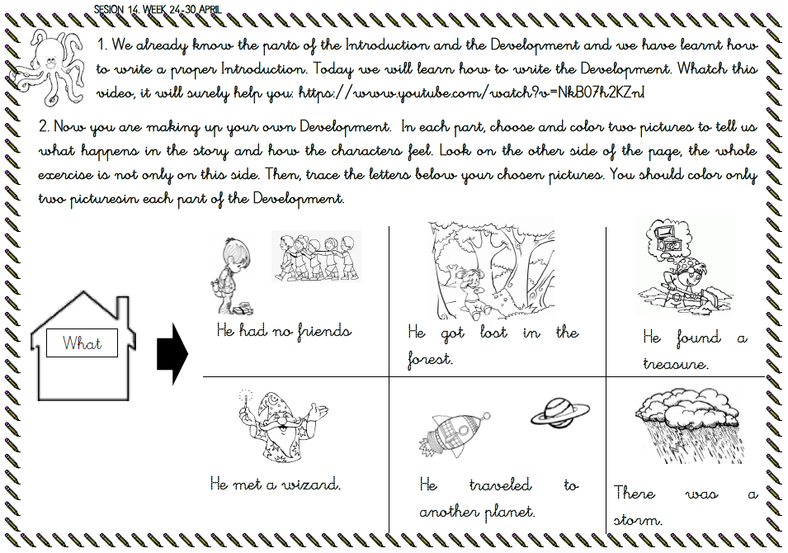
Appendix F: Planning worksheet (English and Spanish)

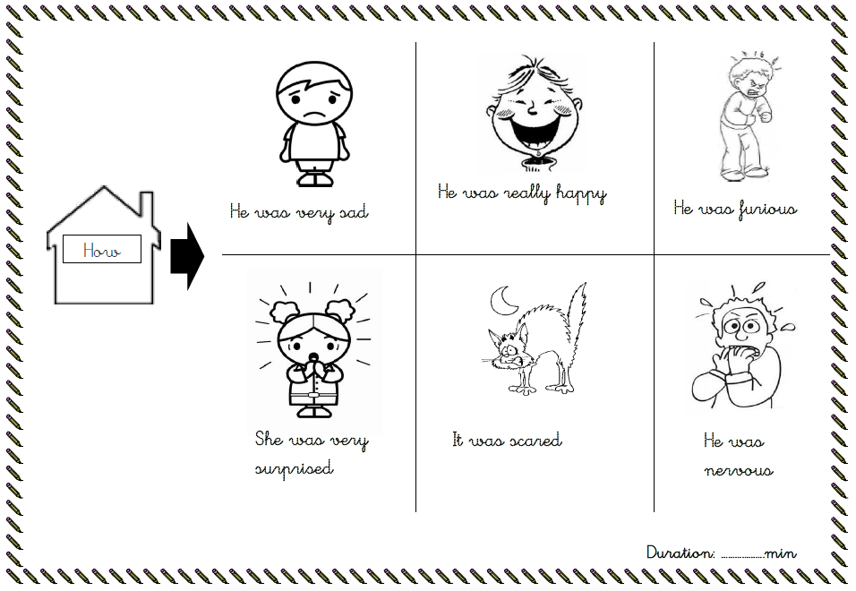

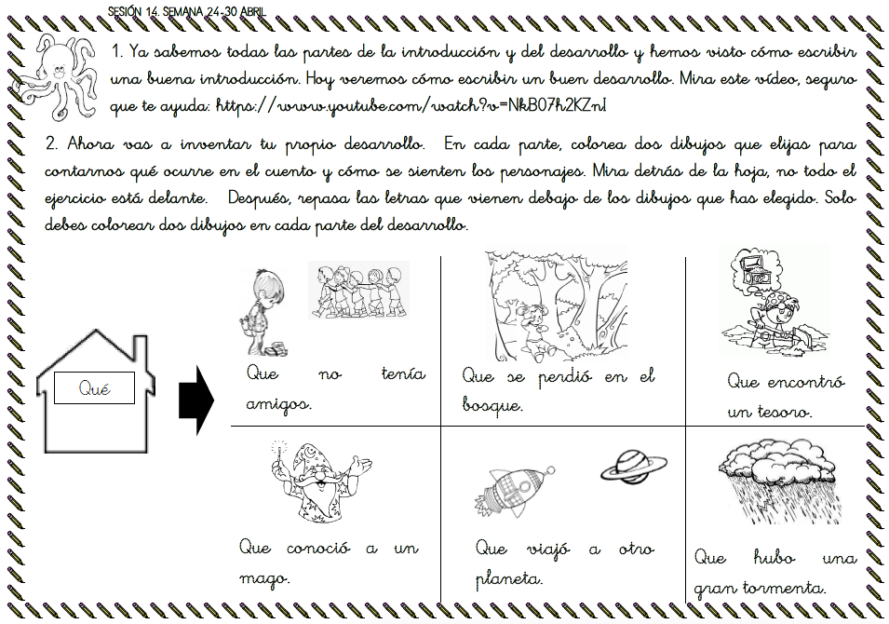

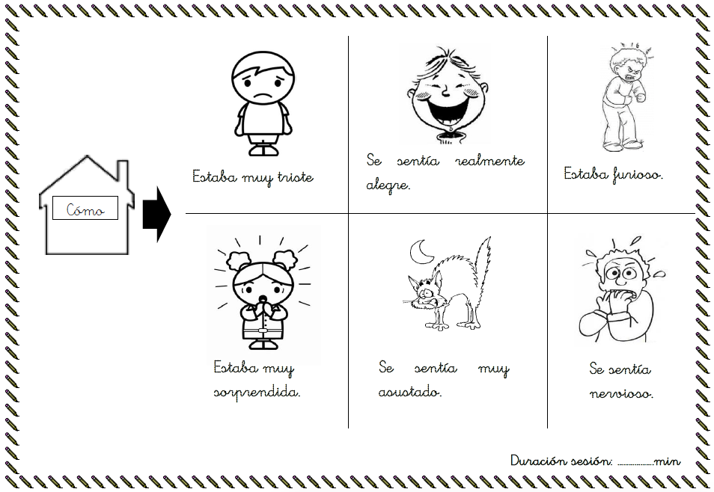

Appendix G: Supplementary statistical analyses

Table G1. Probe writing tasks: Parameter estimates from final model (Model 2) estimating performance on probe tasks as a function of phase, time of probe from start of phase, and group.
Effect | Estimated effect (standard error) | t, df, p
Intercept | 2.13 (.090) | 24, 12, < .001
Group | -.62 (.065) | -9.5, 166, < .001
Phase: 2 vs. 1 | 1.01 (.103) | 9.8, 8, < .001
Phase: 3 vs. 2 | .336 (.069) | 4.9, 9, < .001
Time | .041 (.006) | 6.5, 9, < .001
Phase 1: Group x Time | -.013 (.004) | -3.6, 192, < .001
Phase 2: Group x Time | .038 (.005) | 7.3, 351, < .001
Phase 3: Group x Time | .022 (.004) | 5.3, 256, < .001
Note. Group was sum-coded, comparison group = -1, students with writing difficulties = 1; Phase main effect dummy coded to represent difference from previous Phase. Time is time in weeks of probe from start of Phase.

 | Table G2. Phase-end composition task: Parameter estimates for fixed effects from final model (Model 2) estimating performance on as a function of time of task and group (students with writing difficulties vs. others)
Effect |  | Estimated effect (standard error) | t, df, p
Composition quality
 | Intercept | 5.12 (.137) | 37, 160, < .001
 | Group: Students with writing difficulties | -.964 (.137) | -7, 160, < .001
 | Time: End of Phase 1 vs. Pre Phase 1 | 2.27 (.252) | 9, 21, < .001
 | Time: End of Phase 1 vs. End of Phase 2 | 2.24 (.225) | 10, 60, < .001
 | Time: End of Phase 2 vs. End of Phase 3 | .370 (.219) | 1.7, 196, ns
 | Group x Time (End of Phase 1 vs. Pre Phase 1) | .196 (.137) | 1.4, 439, ns
 | Group x Time (End of Phase 1 vs. End of Phase 2) | .653 (.157) | 4.1, 433, < .001
 | Group x Time (End of Phase 2 vs. End of Phase 3) | .446 (.136) | 3.3, 425, .001
Text length (words)
 | Intercept | 61.3 (1.98) | 31, 149, < .001
 | Group: Students with writing difficulties | -20.2 (4.2) | -4.8, 149, < .001
 | Time: End of Phase 1 vs. Pre Phase 1 | 27.2 (3.64) | 7.5, 18, < .001
 | Time: End of Phase 1 vs. End of Phase 2 | 24.4 (3.88) | 6.3, 12, < .001
 | Time: End of Phase 2 vs. End of Phase 3 | 16.4 (4.95) | 3.3, 11, .007
 | Group x Time (End of Phase 1 vs. Pre Phase 1) | -2.73 (2.02) | -1.4, 433, ns
 | Group x Time (End of Phase 1 vs. End of Phase 2) | 4.86 (2.38) | 2, 426, .042
 | Group x Time (End of Phase 2 vs. End of Phase 3) | 3.51 (2.12) | 1.7, 457, ns
Percent correctly spelled words
 | Intercept | .781 (.009) | 84, 25, < .001
 | Group: Students with writing difficulties | -.057 (.008) | -6.9, 147, < .001
 | Time: End of Phase 1 vs. Pre Phase 1 | .211 (.026) | 8.1, 14, < .001
 | Time: End of Phase 1 vs. End of Phase 2 | .062 (.014) | 4.5, 299, < .001
 | Time: End of Phase 2 vs. End of Phase 3 | .002 (.013) | .15, 339, ns
 | Group x Time (End of Phase 1 vs. Pre Phase 1) | .036 (.012) | 3.1, 447, .002
 | Group x Time (End of Phase 1 vs. End of Phase 2) | .023 (.011) | 2, 420, .042
 | Group x Time (End of Phase 2 vs. End of Phase 3) | 0000 (.009) | .01, 402, ns
Handwriting quality
 | Intercept | 3.14 (.062) | 51, 14, < .001
 | Group: Students with writing difficulties | -.403 (.048) | -8.5, 163, < .001
 | Time: End of Phase 1 vs. Pre Phase 1 | .330 (.127) | 2.6, 10, .027
 | Time: End of Phase 1 vs. End of Phase 2 | .159 (.086) | 1.8, 12, ns
 | Time: End of Phase 2 vs. End of Phase 3 | .197 (.087) | 2.3, 12, .042
 | Group x Time (End of Phase 1 vs. Pre Phase 1) | .076 (.043) | 1.7, 458, ns
 | Group x Time (End of Phase 1 vs. End of Phase 2) | .179 (.049) | 3.6, 388, < .001
 | Group x Time (End of Phase 2 vs. End of Phase 3) | .139 (.043) | 3.2, 379, .001
 | Note. Group was sum-coded, comparison = -1, students with writing difficulties = 1; Time main effect dummy coded to represent difference from previous task, as indicated.

Table G3. Correlations among parent questionnaire item scores.
 | 1 | 2 | 3 | 4 | 5 | 6 | 7 | 8 | 9 | 10 | 11 | 12 | 13 | 14 | 15 | 16 | 17 | 18 | 19 | 20 | 21
Writing motivation
1. My child is now more motivated towards writing
2. My child enjoyed the activities | .35
Parents Feelings
3. My child was happy when selected to participate | .27 | .41
4. I was surprised when my child was selected | .09 | .36 | .49
5. I was happy for my child to receive extra help | .09 | .36 | .45 | .45
6. I was worried for my child to show lower achievement | .04 | .38 | .12 | .26 | .20
7. I was worried about the work I had to do (e.g I lacked time or experience) | .04 | -.16 | -.07 | .03 | .01 | .19
8. I was happy for my child to have an opportunity to reinforce classroom practice | .17 | .24 | .54 | .40 | .78 | .13 | .14
9. I thought the program was completely unnecessary for my child | .08 | -.12 | -.32 | -.13 | -.35 | -.10 | .32 | -.27
10. I was worried about my child’s reactions. | .47 | .14 | .09 | -.16 | .16 | .08 | .36 | .28 | .26
Interaction child-parent during the program
11. Interaction with my child was frequent | -.40 | -.21 | -.13 | -.44 | .23 | -.17 | -.24 | .16 | -.20 | -.25
12. Interaction with my child was positive | .17 | .51 | .33 | .19 | .31 | .25 | -.32 | .39 | -.38 | -.01 | .07
13. I found it difficult to keep my child’s attention | -.45 | -.41 | -.35 | -.14 | .07 | -.45 | .12 | -.13 | .23 | .00 | .21 | -.54
14. I found it difficult to explain the activities to my child | -.11 | -.06 | -.38 | -.10 | -.04 | -.29 | .07 | -.32 | .17 | .19 | -.17 | -.40 | .63
Interaction parent-child after the program
15. The program improved my relationship with my child | .27 | .37 | .42 | -.03 | .24 | -.08 | .02 | .23 | -.19 | .39 | -.02 | .36 | -.13 | -.00
16. The program increased my relationships with the school | .27 | .40 | .71 | .30 | .45 | .09 | -.11 | .53 | -.14 | .23 | -.04 | .26 | -.31 | -.25 | .28
17. I now help my child more often with school tasks | .25 | -.06 | .41 | .27 | .22 | -.08 | .06 | .26 | -.22 | .11 | .01 | -.18 | -.07 | .00 | .05 | .26
18. I now feel more confident to help my child with writing tasks. | .16 | .37 | .57 | .18 | .45 | .16 | .16 | .53 | -.12 | .27 | .07 | .29 | -.20 | -.17 | .53 | .70 | .30
General view of the program
19. It was useful for my child to complete the activities | .28 | .29 | .17 | .14 | .25 | .29 | .04 | .37 | -.44 | .17 | -.13 | .51 | -.47 | -.18 | .24 | .22 | .00 | .34
20. Activities proposed were adequate to my child’s level | -.10 | .25 | .20 | .23 | .35 | .25 | -.05 | .35 | .05 | -.13 | .10 | .34 | -.34 | -.44 | -.17 | .08 | .02 | .13 | .08
21. I will participate again in the program | -.02 | .11 | .27 | .07 | .36 | .09 | -.15 | .54 | -.38 | .11 | .25 | .57 | -.23 | -.30 | .15 | .23 | .13 | .24 | .42 | .33
22. I had a positive experience with the program | .04 | .43 | .44 | .10 | .61 | .11 | -.09 | .56 | -.30 | .10 | .21 | .45 | -.20 | -.09 | .44 | .54 | .08 | .57 | .43 | .31 | .29

