Online Resource: Vocabulary Limitations Undermine Bilingual Children’s Reading Comprehension despite Bilingual Cognitive Strengths

Novel-word learning task

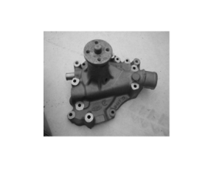
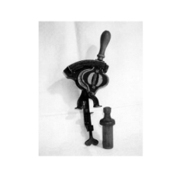
Silbato ………Oruga
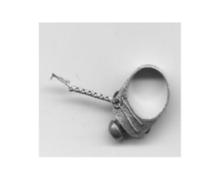
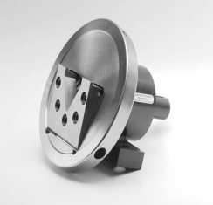
Mapache …….Flauta

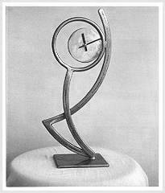
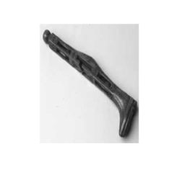
Escoba………Cincel

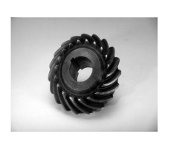
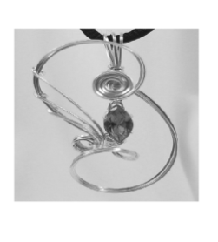
Cangreho………Alicates

ANCOVA with Age and Expressive Vocabulary as Covariates:
Mean Group Differences Between Monolingual and Bilingual Groups
Measure | F | η_{p} ²
Reading comprehension | 16.285 (15.054) | .075 (.069)**
Text reading accuracy | 0.081 (.168) | .000 (.001)
Single word reading accuracy | 0.128 (.047) | .001 (.000)
Receptive vocabulary | 26.414 (24.171) | .116 (.107)**
Novel-word learning | 23.110 (24.279) | .103 (.107)**
Working memory | 31.875 (31.142) | .137 (.134)**
N-Back | .972 (.923) | .005 (.005)
Letter fluency | 8.959 (9.114) | .042 (.043)*
Simon Task | 2.044 (2.005) | .010 (010)
Nonverbal IQ ^{b} | 2.499(2.834) | .012 (.014)
Note. The results are based on raw expressive vocabulary scores and those in parentheses are based on T- scores. The η_{p} ² values of .01, .09 and .25 are defined as small, medium and large effect size, respectively (Cohen, 1988).
* p < .01. ** p< .001.

Simple reaction time task
Children were administered a simple reaction time task in which they responded as quickly as possible with a button press in response to a stimulus indicated by a picture. On each trial participants saw the word “Ready” followed by the presentation of the response stimulus after a delay of either 1000, 3000 or 5000ms and consisted of 45 trials (15 trials per delay). The order of trial presentation was randomised for each participant and the test trial was preceded by practice trials. Prior to analysis erroneous responses and response latencies outside the range of 200-2000ms were excluded. The task was run using the DMDX software (Forster & Forster, 2003).

