English Version of the Text

The Physiology of Sexuality
forskning.no
Research reporter Anniken Hauge
Published November 27th, 2020

Sex is often described as a drive with biological reproduction as its goal, but in reality people also have sex for pleasure. The desire to have sex is influenced by sex hormones. Male sex hormones are mainly produced in the testicles, but can to some extent also be produced in the ovaries and the adrenal cortex. Female sex hormones are primarily formed in the ovaries, but are also produced in the adrenal cortex. In the adrenal cortex, small amounts of female sex hormones are produced in men and small amounts of male sex hormones in women. Figure 1 shows how sex hormones are produced in the body of men and women, respectively.

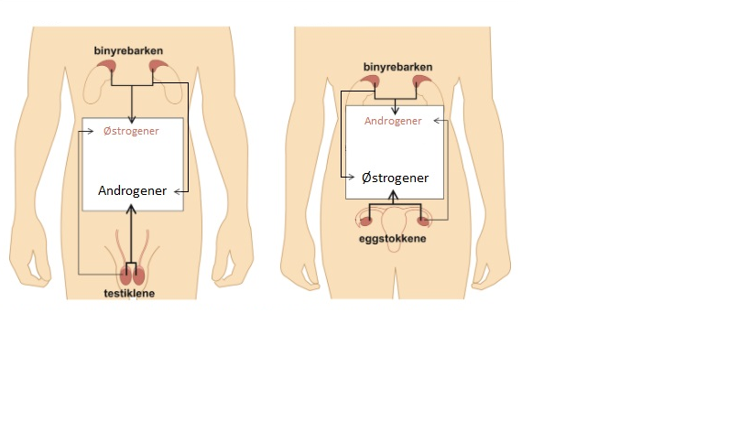

Figure 1. Production of male sex hormones (androgens) and female sex hormones (estrogens) in men and women.

In both men and women, it is male sex hormones and not female sex hormones that affect sexual desire the most. In men, a lack of male sex hormones, for example because of surgical removal of the testicles, can lead to a lack of sexual desire and inability to have an orgasm. In women, a lack of male sex hormones, for example because of less supply of such hormones from the ovaries, can lead to less sexual desire and less pleasure. Sex hormones thus form an important basis for achieving orgasm in both men and women.

Much of what we know about human sexual reactions today originates from a classic study conducted by the American researchers William Masters and Virginia Johnson more than 50 years ago. This study was reported in the book Human Sexual Response, which they published in 1966. In this book, Masters and Johnson described the sexual response cycle by means of four stages of physiological changes that occur during sexual activity. These four phases are called the excitement phase, the plateau phase, the orgasm phase, and the resolution phase.

The arousal phase is the first phase of the sexual response cycle, which occurs after mental or physical erotic stimulation. It is primarily a vasocongestive response, which means that the blood flow to the external genitalia increases. Increased blood flow causes the genitals to increase in size. This reaction slows down as one gets older.

The plateau phase is the phase that occurs just before the orgasm, when the heart rate increases and the vasocongestive response continues. In some people, the skin of the external genitalia may undergo a temporary change of color during the plateau phase.
During the orgasm phase, breathing becomes faster, and rapid cycles of muscle contractions occur in the lower pelvic muscles, which surround both the anus and the primary genitals. Not everyone reaches orgasm; for them, the plateau phase is the highest point of sexual pleasure.

In the resolution phase, which is the last phase of the sexual response cycle, the muscles relax, blood pressure and heart rate decrease, and the body returns from aroused to normal state.

According to Master and Johnson, the sexual response cycle in females is varied and may have alternative patterns (see Figure 2).

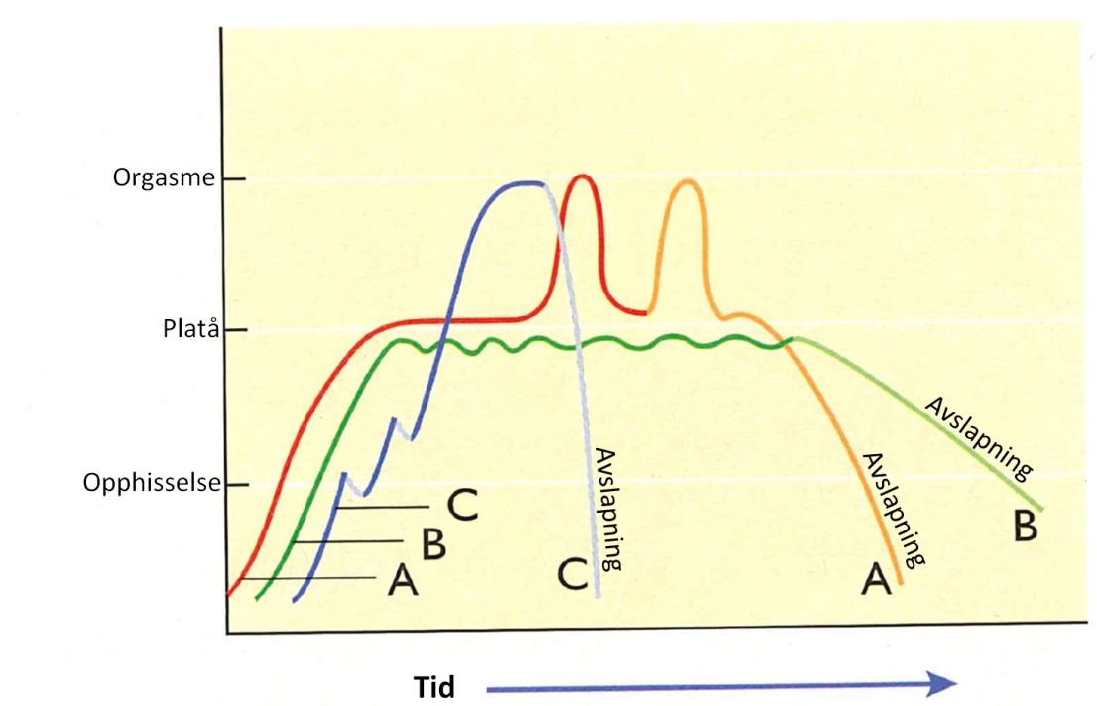

Figure 2. Sexual response cycle in females. Profile A shows one or more orgasms followed by resolution, profile B shows a plateau phase without any orgasm, and profile C shows an orgasm without any preceding plateau phase.

Men's sexual response cycle is often easy to activate and researchers describe this as a general "preparedness" for sexual arousal. In men, the arousal in the plateau phase increases until the muscle tension in the body becomes so strong that it triggers an orgasm that typically lasts between 3-10 seconds. The orgasm is then followed by a resolution phase in which the arousal decreases rapidly and the genitals return to normal. The temperature in the genitals also drops rapidly, and men report little sexual desire immediately after an orgasm. In the resolution phase immediately after the orgasm, men are temporarily unable to achieve a new orgasm. This period in men's sexual response cycle is called a refractory period.

Recent studies of what happens in the body during an orgasm have, among other things, used brain scanning, which show images of the brain’s activity. It has been shown that there is activity in more than 30 different regions during sexual arousal. Especially the anterior part of the brain, which is called the orbitofrontal cortex, is switched off during orgasm. This area controls self-evaluation, reason, and self-control. Switching this off prevents that one experiences fear and anxiety, which is considered important to be able to achieve orgasm. In the pleasure center of the brain, the neurotransmitter dopamine is released and gives a drug-like feeling that makes one want to achieve the same feeling again. The love hormone oxytocin is also released in the brain, and this hormone can contribute to creating emotional connection between partners.

According to Norwegian Health Informatics, 24% of Norwegian women report that they for a longer period of time have a sexual response cycle corresponding to pattern B. Studies have shown that lack of sexual desire can make women despair and lead to depression, reduced self-esteem, frustration, and worry about the relationship. Many women who seek help seem to think that there is a connection between lack of interest in sex and hormone deficiency. Lack of sexual desire and inability to achieve orgasm in women can accordingly be treated with androgenic hormones, either alone or in combination with estrogenic hormones. Such treatment has been shown to restore sex desire and increase the incidence of orgasm. Moreover, Masters and Johnson reported that relatively few women experience profile A. In women, however, the temperature in the genitals is relatively high in the period after an orgasm, and sexual arousal and desire can still remain at a fairly high level in women during this period. This may be one reason that women want to achieve more orgasms after the first one. In women, the muscle contractions during orgasm can last 20 seconds or more.

In women, the pain threshold is more than twice as high during orgasm. In addition, brain scanning has shown activity in areas that are also activated during painful stimulation. This may indicate that there exists a connection between pleasure and pain, a kind of common, intense emotional expression that manifests itself in typical facial expressions during both pain and imminent orgasm. Women's orgasm can thus dampen the pain experience itself, but at the same time be characterized by the arousal that also characterizes pain. According to some researchers, this may possibly explain why painful stimulation in a sexually stimulating context apparently can intensify the pleasure.

Whereas many women seem to view hormonal therapy as a miracle cure, studies have shown that men who were dissatisfied with their sex lives most often reported that their partner's lack of sexual desire was the cause. However, in men with deficient testosterone production who have difficulty achieving orgasm, androgen therapy, that is, the supply of androgens, is an effective standard treatment.

A common method to study sexual arousal is to show participants in research videos with sexual content. However, the videos used in such studies are often monotonous and have a content that is primarily aimed at heterosexual men. There is less knowledge about how sexual arousal can vary when videos with different types of sexual content are shown, and in particular little is known about how women respond to such videos.

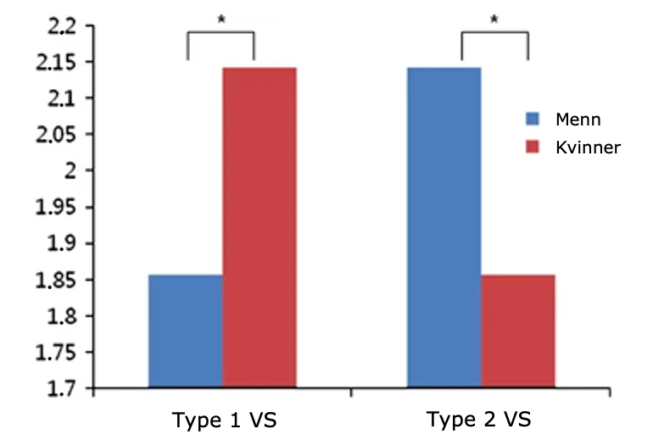

Figure 3. The degree of self-reported sexual arousal in men and women by two types of visual stimuli (VS). Type 1 = video with erotic storytelling, Type 2 = video with focus on physical contact

A research group in South Korea therefore investigated whether there were differences in the types of sexual videos that created arousal in heterosexual women and men. In one type of video, the sexual situation was part of an erotic narrative that focused on what the actors felt and on the development of the relationship between them. In the other type of video, the focus was only on the sexual contact between the actors, with direct filming of the genitals during the act. This latter type corresponded to what is considered classic, commercial pornography. Ten men and ten women aged 20-29, who all were sexually active and without any form of sexual problems, participated in this study. Each participant watched both videos in random order, with the researchers recording their brain activity while they watched the videos. In addition, the participants themselves reported how sexually aroused they were when they saw each of the videos on a scale from 1 to 5.

Both the recorded brain activity and the self-reports showed that men were most sexually aroused by the classic type of pornographic video, whereas women were most sexually aroused by the video in which the sexual act was presented in an emotional and relational context. The results from the self-reports are shown in Figure 3. Possible explanations for these results are that women's arousal to a greater extent depends on whether they can imagine that they themselves could have been the woman in a sex film, whereas men to a greater extent think of the actors as objects. According to the researchers, it is important to find out more about the types of sexual stimuli that create arousal in women because this could benefit women who struggle with different types of sexual dysfunction. There is, for example, reason to believe that this could help women who have a sexual response cycle that corresponds to profile B.

Of course, sex concerns more than sex hormones and physiological reactions. Psychological, social, and cultural factors contribute to shaping human sexuality. In brief, sexuality, in all its diversity, is a central part of being human in the world throughout all stages of life.

Coding System for Scoring Integrated Text Understanding

Idea unit 1: Males primarily produce androgens (male sex hormones) in the testicles and females primarily produce estrogens (female sex hormones) in the ovaries but both males and females produce both androgens and estrogens
Concerns difference and similarity.

Score | Definition | Example
0 | Participants gave no response or described irrelevant or incorrect information. | Both sexes have male and female hormones produced in the body, but the proportion of hormones is different.
1 | Participants correctly described the production of sex hormones in either males or females. | Women mainly produce sex hormones in the ovaries, but can also produce them in the adrenal glands.
2 | Participants correctly described the production of sex hormones in both males and females. | Estrogen is regarded as the female sex hormone, and testosterone is regarded as the male. In women, sex hormones are produced in the ovaries, while in men it is produced in the testicles. However, both also produce sex hormones in the adrenal glands.
Idea unit 2: Androgens (male sex hormones) or the lack of androgens influence the sexual desire the most for both males and females.
Concerns similarity.

Score | Definition | Example
0 | Participants gave no response or described irrelevant or incorrect information. | Androgens are the gene that dominates in both sexes.
1 | Participants correctly described the influence of male and female sex hormones. | In both sexes, testosterone will influence the sexual desire, as this hormone produces the desire to be intimate.
2 | Participants elaborated the description of the influence of male and female sex hormones by also describing the effects of lack of androgens and/or that sex hormones form an important basis for achieving orgasm in both males and females. | Both men and women's sexual desire depends on the male sex hormone androgen. The higher the level of androgen, the higher the sexual desire. Damages to the ovaries or testicles can cause lack of sexual desire in men and women.
Idea unit 3: Males and females experience four phases during sexual activity.
Concerns similarity.

Score | Definition | Example
0 | Participants gave no response or described irrelevant or incorrect information. | It is also explained how women and men respond to sexual pleasure, with different phases of arousal. These occur differently in women and men, with men starting in another phase than women.
1 | Participants correctly mentioned that the same phases exist for males and females. | Men and women go through 4 phases when they get stimulated.
2 | Participants correctly mentioned that the same phases exist for males and females and named all four phases correctly. | Master and Johnson have mapped the sexual response cycle. They found that the human sexual response cycle can be divided into an arousal phase, a plateau phase, an orgasm phase, and a resolution phase.
Idea unit 4: Some females may experience multiple successive orgasms whereas males are temporarily unable to achieve a new orgasm.
Concerns difference.

Score | Definition | Example
0 | Participants gave no response or described irrelevant or incorrect information. | Women have a long resolution phase and a long phase in which the temperature of the genitals is lowered. In men, this goes faster. After orgasm, they are in a resolution phase that lasts between 2 and 10 seconds and the temperature in the genitals drops.
1 | Participants correctly described that females may experience multiple successive orgasms or that males are temporarily unable to achieve a second orgasm (experience a refractory period). | After a resolution phase, men are not able to have sex right away.
2 | Participants correctly compared females to males regarding the ability to experience multiple successive orgasms. | In a period after the orgasm, men cannot achieve a new orgasm, this is called the refractory period. Women, to the contrary, can achieve orgasm several times in a row.
Idea unit 5: The duration of orgasms differs for males and females.
Concerns difference.

Score | Definition | Example
0 | Participants gave no response or described irrelevant or incorrect information. | No examples of incorrect or irrelevant responses in the data - only missing responses coded as 0.
1 | Participants correctly described the duration of orgasm in either males or females or correctly described that females experience longer orgasms than do males. | The orgasm phase is shorter for men than for women.
2 | Participants correctly described the duration (in seconds) of an orgasm for both males and females according to the text | The orgasm phase can last for 3-10 seconds for men, while it can last as long as 20 seconds or more for women.
Idea unit 6: Females may more seldom experience orgasm
Concerns difference.

Score | Definition | Example
0 | Participants gave no response or described irrelevant or incorrect information. | For men, often less is required to enter the arousal phase.
1 | Participants correctly described that females may not experience orgasm. | Still, there are several women who report a lack of sexual desire who are only in the plateau phase and don’t reach orgasm.
2 | Participants correctly compared females to males. | For others [women], waves in the plateau phase can last for some time without triggering an orgasm, and where the plateau phase is followed directly by the resolution phase […] For men, it is most common that a plateau phase culminates in muscle tensions that become so strong that they trigger an orgasm, followed by a relaxation phase.
Idea unit 7: During orgasm bodily reactions include activity in many different brain regions, deactivation of the orbitofrontal cortex, and release of dopamine and oxytocin
Concerns similarity

Score | Definition | Example
0 | Participants gave no response or described irrelevant or incorrect information. | For men and women, the orgasm phase is characterized by a fearless state where the hormones create relaxation and contraction.
1 | Participants correctly described the brain activity during orgasm or orbitofrontal cortex deactivation or release of dopamine/oxytocin. | In addition, one can see that the orbitofrontal cortex is turned off in women and men, such that they don’t experience fear in a sexually aroused state.
2 | Participants correctly described at least two of the following bodily reactions: the brain activity during orgasm, the orbitofrontal cortex deactivation, and release of dopamine/oxytocin. | In both men and women, sex influences the activation in the brain. In the frontal part of the brain that concerns reason, there is less activation. In both sexes, more of the ‘happiness hormone’ dopamine and oxytocin, which is called the ‘love hormone’, is produced.
Idea unit 8: In females the threshold of pain increases during orgasm and brain scanning indicates an association between pleasure and pain.
Concerns difference.

Score | Definition | Example
0 | Participants gave no response or described irrelevant or incorrect information. | In addition, a study has shown that women experience becoming sexually aroused by pain.
1 | Participants correctly described either the increased pain threshold during orgasm or the association between pain and pleasure in a sexually stimulating context, with specific reference to females. | [For women,] brain scanner […] [has] shown that both centers of pain and pleasure are activated during sex.
2 | Participants correctly described both the increased pain threshold during orgasm and the association between pain and pleasure in a sexually stimulating context, with specific reference to females. | It was also noted that women have a higher pain threshold during the orgasm phase, and that pain/pleasure seems to be closely related. This may for example explain increased pleasure by S&M for some women. How this works for men was not mentioned in the text.
Idea unit 9: Although many females perceive that lack of sexual desire is due to hormone deficiency and males dissatisfied with their sex lives often attribute this to their partner’s lack of sexual desire, both males and females have been shown to profit from androgen therapy.
Concerns difference and similarity.

Score | Definition | Example
0 | Participants gave no response or described irrelevant or incorrect information. | It is possible to get treatment when one has a reduced sex drive, which is a problem in some relationships according to the article. Many women who have undergone such a treatment regard it as a miracle cure. It is also mentioned in the article that such treatments can lead to less sexual desire, and possibly loss of the ability to have an orgasm, in both sexes.
1 | Participants correctly described perceived causes or treatment for lack of sexual desire for males and/or females. | It was also mentioned that there were many men with problems in their relationship who believed that this problem was due to a lack of sexual desire on the part of the women.
2 | Participants correctly described both perceived causes and treatment for lack of sexual desire for both males and females. | If the sexual desire of women is low, they can get supplement of the male sex hormone, so that the sexual desire increases. This works well, as women themselves often regard this as a hormonal problem. Men, on the other hand, more often think that a lack of sexual desire comes from partners’ lack of sexual desire. That being said, a similarity is that both sexes respond well to supplement of the male hormone to increase sexual desire.
Idea unit 10: Males and females got sexually aroused by videos with different types of sexual content.
Concerns difference

Score | Definition | Example
0 | Participants gave no response or described irrelevant or incorrect information. | It is also shown in a South Korean study that women get more aroused when they have an emotional relation with the person. While men on the other hand do not necessarily need the emotional affirmation.
1 | Participants correctly described that males became most aroused by a classic pornographic video or that females became most aroused by a video where sex was presented in an emotional and relational context. | [The difference] is that men and women are aroused by different things. The text described a project where it was found that men are often attracted to classic pornography.
2 | Participant correctly described what type of sexual content aroused males and females, respectively, the most. | Research shows that men and women aren’t turned on by the same pornography. Men’s brain activity shows greater sexual arousal when they watch ‘classic porn’ where for example filming of the genitals is in focus. Women on the other hand are more turned on by porn that shows a relationship between people.
Idea unit 11: Males and females may become most aroused by different types of sexual content because males think of the actors as objects whereas females will imagine themselves being the woman in the film.
Concerns difference.
Score | Definition | Example
0 | Participants gave no response or described irrelevant or incorrect information. | No examples of incorrect or irrelevant responses in the data - only missing responses coded as 0.
1 | Participants correctly described why either males or females may become aroused by certain types of videos. | It was found that women reacted more to erotic stories, because they could relate to them and imagine being part of the story.
2 | Participants correctly described why males and females, respectively, may become aroused by certain types of videos | This could be because women need to identify more with the role, concerning that they themselves are the woman in the film, while men regard the roles in the pornography as ‘objects’.
Note. In translating the examples used in this table, we tried to retain participants’ original expressions rather than transforming them into (more) correct grammar.

