SUPPLEMENTARY MATERIAL
Alternative models accounting for each of the reading fluency outcomes (pseudoword, text, and silent reading) by phonological awareness and vocabulary as mediated by the three MA measures and RAN (as control variable).
The model indices suggested that the three models (Fig. S1) did not fit the data well for any of the reading fluency outcomes, χ² = 61.401, χ²/df = 5.36, p < .001, CFI (oral pseudoword = .790, oral text = .803, silent word = .791), TLI (pseudoword = .509, text = .540, silent = .511), RMSEA = .205, AIC = 128.401, and BCC = 134.464. Moreover, the initial recommended models had significantly better fit than the alternative models in terms of CFI, TLI, RMSEA, and substantially lower AIC and BCC values.
As shown in Figure S1 and Table S1, PA and vocabulary affected only directly oral pseudoword, text, and silent reading fluency, without emerging any significant indirect effect through MA measures. Specifically, in the model of oral pseudoword reading fluency, PA had significant unique direct effect, β = .330 [.169, .477]. Also, the total effect size from PA was .377 [.247, .495]. In the model of oral text reading fluency, a significant total effect emerged both from PA, β = .285 [.142, .421] and vocabulary, β = .236 [.095, .371]. Also, PA had a significant direct contribution to oral text reading fluency, β = .234 [.060, .396]. In the silent word reading fluency model, vocabulary had significant direct effect, β = .236 [.046, .421], as well as derivational morphology at metalinguistic level, β = .239 [.025, .411]. The total effect size from vocabulary to silent word reading fluency was .194 [.039, .337]. In addition, path coefficients displayed that PA and vocabulary had significant and unique contribution to all measures of MA.
In sum, the path analysis results showed that inflectional and derivational at epilinguistic and metalinguistic role had limited mediating role in the relation of vocabulary and PA with oral pseudoword, oral text, and silent word reading fluency, since only significant total effect sizes emerged. Vocabulary and PA displayed significant direct effect to all three reading fluency measures. Once again, derivational morphology at metalinguistic level exhibited significant direct effect on silent word reading fluency.

(a) Oral pseudoword reading fluency
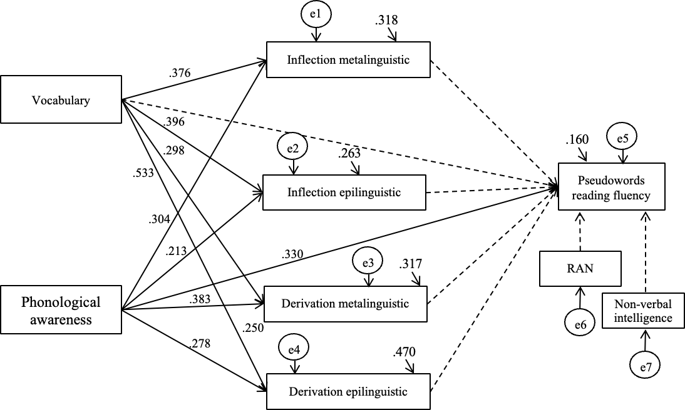

(b) Oral text reading fluency

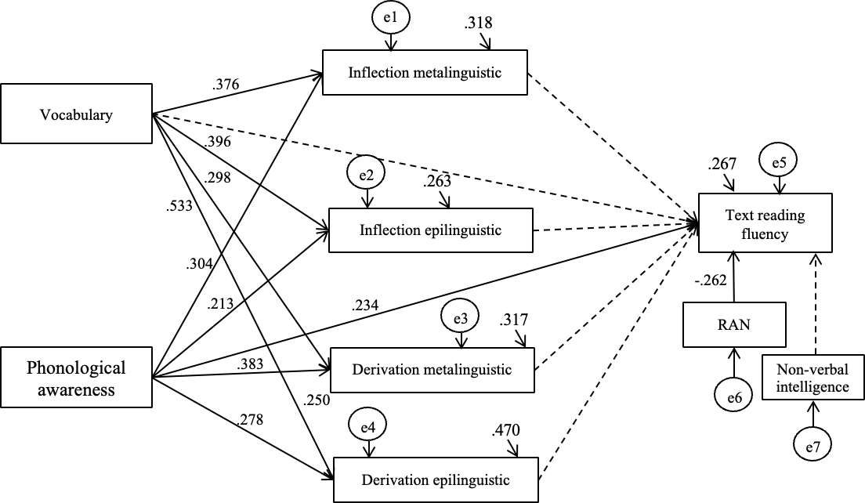

(c) Silent word reading fluency
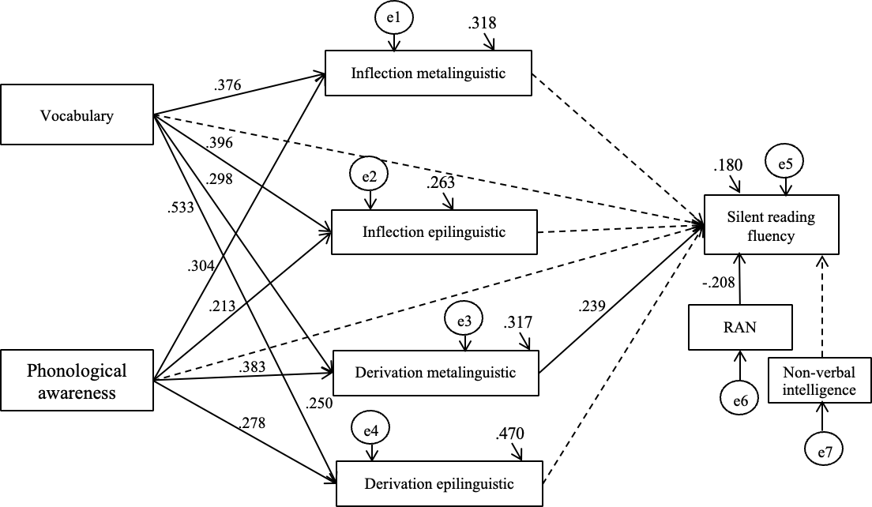
Figure S1
Path Analysis Model between Phonological Awareness, Vocabulary, and Reading Fluency with the mediation of Morphological Awareness, controlling for RAN.

Table S1
Direct, Indirect, and Total Effects of Phonological Awareness and Vocabulary on Reading Fluency
Effects | β | psRF |  |  | β | tRF |  |  | β |  | SRF
Effects | β | 95% CI |  |  | β | 95% CI |  |  |  |  | 95% CI
Total effect
PA | .377 | (.247, .495) |  |  | .285 | (.142, .421) |  |  | .141 |  | (-.023, .308)
Voc. | -.102 | (-.252, .053) |  |  | .236 | (.095, .371) |  |  | .194 |  | (.039, .337)
Direct effect
PA | .330 | (.169, .477) |  |  | .234 | (.060, .396) |  |  | .111 |  | (-.088, .300)
Voc. | -.181 | (-.388, .027) |  |  | .191 | (-.009, .380) |  |  | .236 |  | (.046, .421)
Inf. meta. | .072 | (-.129, .305) |  |  | .079 | (-.120, .278) |  |  | -.015 |  | (-.196, .208)
Inf. epi. | .061 | (-.117, .254) |  |  | -.063 | (-.242, .132) |  |  | -.144 |  | (-.334, .059)
Der.meta. | -.012 | (-.206, .170) |  |  | .086 | (-.113, .291) |  |  | .239 |  | (.025, .411)
Der. epi. | .060 | (-.158, .267) |  |  | .028 | (-.179, .242) |  |  | -.144 |  | (-.310, .121)
Indirect effect
PA | .047 | (-.030, .136) |  |  | .051 | (-.026, .146) |  |  | .029 |  | (-.067, .149)
Voc. | .080 | (-.048, .219) |  |  | .045 | (-.076, .186) |  |  | -.043 |  | (-.173, .100)
Direct effect | β | Inflectional  metalinguistic | β | Inflectional  epilinguistic |  |  | β | Derivational  metalinguistic |  | β |  | Derivational  epilinguistic
Direct effect | β | 95% CI | β | 95% CI |  |  | β | 95% CI |  |  |  | 95% CI
PA | .304 | (.154, .453) | .213 | (.126, .421) |  |  | .383 | (.218, .539) |  | .278 |  | (.065, .350)
Voc. | .376 | (.243, .499) | .396 | (.260, .519) |  |  | .298 | (.161, .431) |  | .533 |  | (.412, .659)
Note. psRF = pseudoword reading fluency, tRF = text reading fluency, SRF = silent reading fluency, PA = phonological awareness, Voc. = Vocabulary, Inf. = inflection, Dr. = derivation, met. = metalinguistic, ep. = epilinguistic

