Supporting Information File

Latent Profile Analysis with Morphological and Orthographic Awareness for Dyslexia Patterns
To further explore the potential impact of morphological and orthographic awareness for the profiles of phonological deficits, we also conducted a supplementary LPA with all 9 assessments (RAN pictures, RAN digits, RAN color, Phoneme Deletion, Onset and Rime Deletion, Spoonerism, Digit Span, Morphological Awareness and Orthographic Awareness) including both phonological measures and morphological and orthographic measures. Fit statistics for latent profile models are shown in Table S2. The BIC decreased until the three-profile model. AIC value decreased from one up to six classes, the BLRT between three-class and four- class models were statistically significant. The three-profile and four-profile solution both had relative high entropy (> 0.80). However, the smallest class in the 4-class solution only contained 7.8% of the sample (N = 8), whereas the smallest class in the 3-class solution contained 16.7% of the sample (N = 17). Thus, the 3-class solution had a more conceptually meaningful smallest profile compared to the 4-class solution. Additionally, the three-profile pattern was the most theoretically tenable when we also took into account the profile solution's theoretical interpretability. Thus, a 3-class solution was the optimal solution. Figure S2 depicted the estimated parameters for each of the three profiles.
The first profile in the three-profile pattern (n=17, 16.7%) was named as severe PA deficits, as these children showed the lowest PA performance (Phoneme Deletion, Onset and Rime Deletion). The second profile (n = 59, 57.8%) was characterized by children who displayed RAN and OA comorbid deficits, with PA, VSTM, and MA scores higher than the other groups. The third profile, comprising 26 students (25.5%), exhibited VSTM and MA comorbid deficits, as evidenced by poor performance on VSTM and MA performance tests and higher scores on RAN and PA tests compared to the other groups.

Table S1
Bivariate Correlations of All Variables in All Participants (N = 263).
Variables | CR | WR | RANpicture | RANdigit | RANcolor | PD | ORD | Spoonerism | DS | MP | OJ
Character Recognition (CR) | -
Wordlist Reading (WR) | 0.68*** | -
Rapid Automatized Naming-Picture (RANpicture) | 0.50*** | 0.58*** | -
Rapid Automatized Naming-Digit (RANdigit) | 0.51*** | 0.64*** | 0.58*** | -
Rapid Automatized Naming-Color (RANcolor) | 0.48*** | 0.50*** | 0.64*** | 0.54*** | -
Phoneme Deletion (PD) | 0.55*** | 0.48*** | 0.43*** | 0.39*** | 0.33*** | -
Onset and Rime Deletion (ORD) | 0.41*** | 0.38*** | 0.29*** | 0.26** | 0.15* | 0.63*** | -
Spoonerism | 0.43*** | 0.40*** | 0.30*** | 0.32*** | 0.29*** | 0.37*** | 0.32*** | -
Digit Span (DS) | 0.37*** | 0.39*** | 0.33*** | 0.32*** | 0.29*** | 0.32*** | 0.32*** | 0.34*** | -
Morphological Production (MP) | 0.56*** | 0.43*** | 0.31*** | 0.33*** | 0.27*** | 0.51*** | 0.41*** | 0.37*** | 0.34*** | -
Orthographic Judgment (OJ) | 0.16* | 0.13* | 0.12 | 0.12 | 0.15* | 0.05 | 0.10 | 0.06 | <0.001 | 0.04 | -

Table S2
Model Fit Statistics for Latent Profile Analyses
Model | AIC | BIC | SABIC | BLRT(p) | Entropy | Class count
1 profile | 2812.73 | 2859.98 | 2803.12 | - | 1 | 102
2 profiles | 2692.02 | 2789.14 | 2672.27 | 0.01 | 0.92 | 21, 81
3 profiles | 2678.05 | 2825.04 | 2648.16 | 0.03 | 0.84 | 17, 59, 26
4 profiles | 2662.75 | 2859.62 | 2622.72 | 0.04 | 0.82 | 8, 29, 16, 49
5 profiles | 2631.46 | 2878.21 | 2581.29 | 0.01 | 0.90 | 10, 34, 39, 16, 3
6 profiles | 2636.56 | 2933.18 | 2576.26 | 0.32 | 0.92 | 10, 19, 36, 18, 5, 14

Figure S1
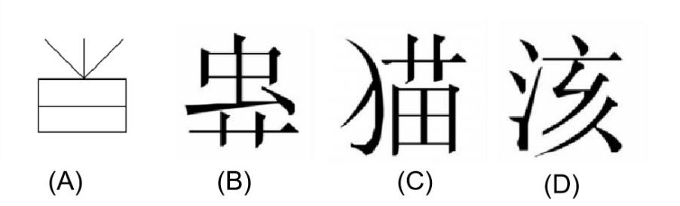
Note: Examples of the orthographic judgment test, black-and-white drawing (A), illegal position (B), ill-formed component (C), and pseudo characters (D).

Figure S2
Latent Profile Analysis Model for the Identification of Subtypes in Chinese Dyslexic Children: Optimal Solution.
