Appendix A: Picture prompt (example)
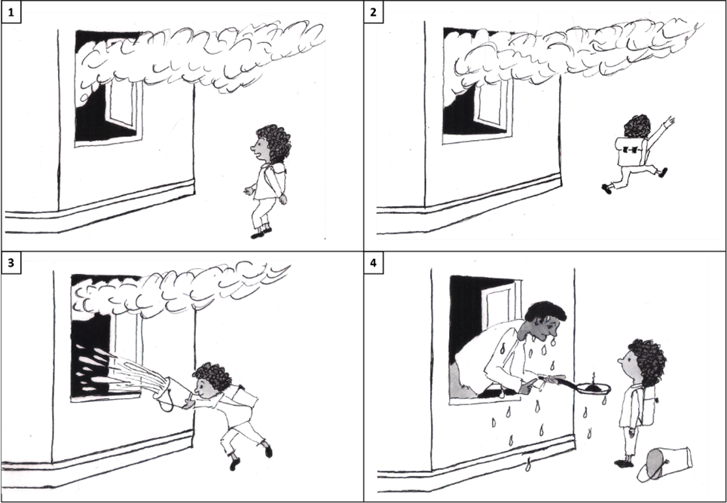
Fig. 3 Picture prompt based on 'father and son stories' (e.o. plauen), adapted by Tanne Stephens, 2023

