Supplementary Information
Online Resource 1: Regular Session Tapping
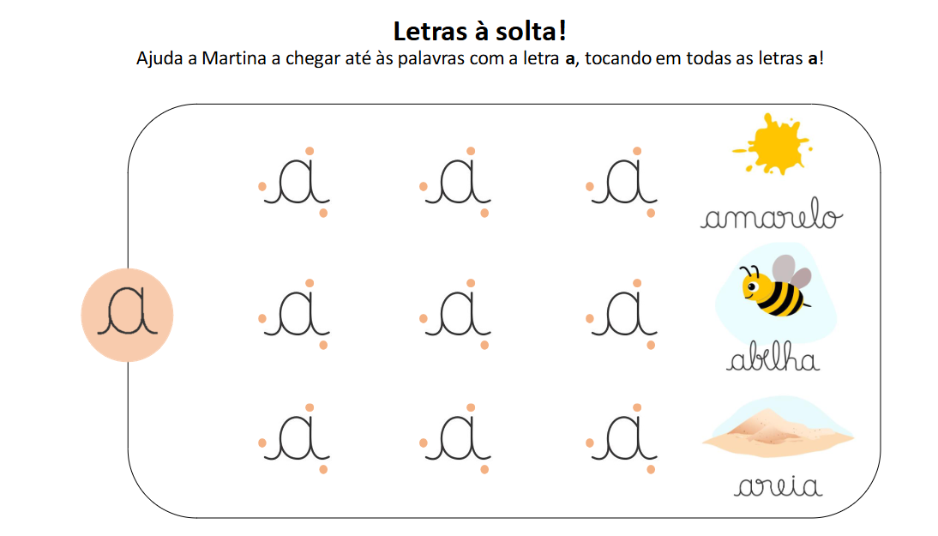

Online Resource 2: Regular Session Handwriting
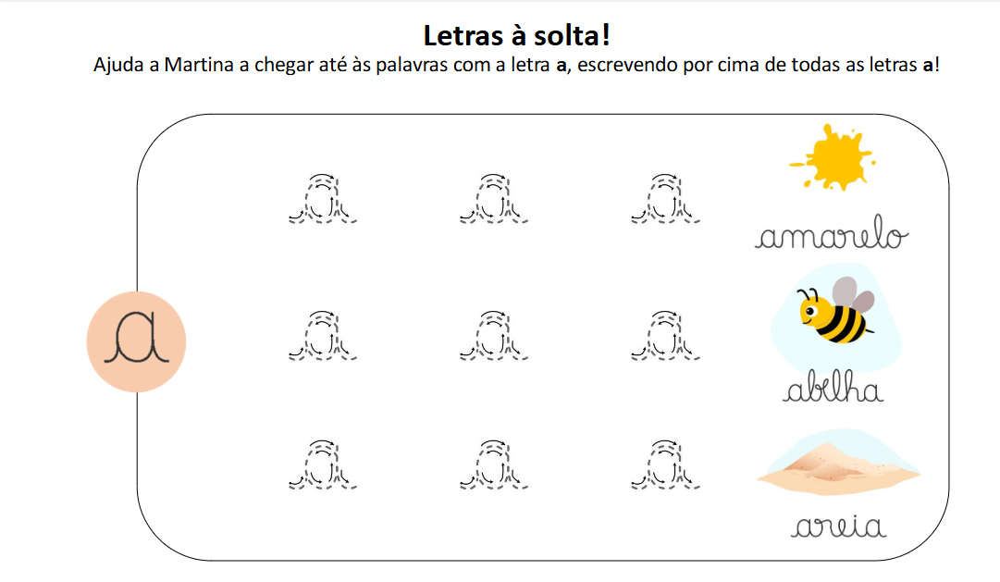

Online Resource 3: Revision Session Tapping
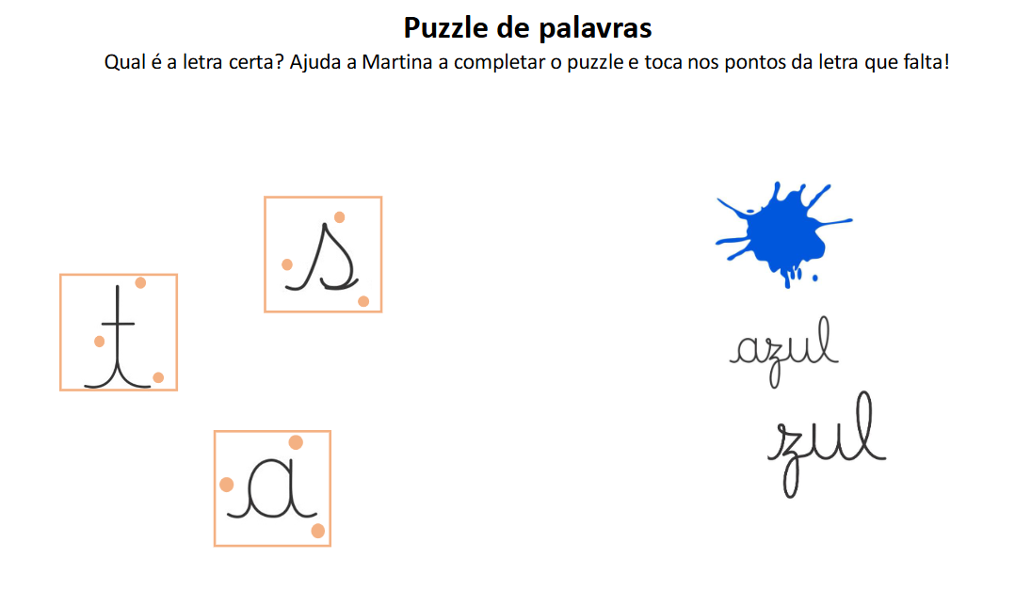

Online Resource 4: Revision Session Handwriting


