Appendix A: Theoretical Model Derivation
The mother’s utility maximisation problem is formally defined below.
$max U\left(m_{i}\right)=U\left(X_{m}, Q, t_{L}\right)$ (A.1)
subject to,
$Q= Q(t_{Q}, t_{cc}q_{cc}; N, A)$ (A.2)
$Q_{1}, Q_{2} > 0$; $Q_{11}, Q_{22} < 0$ (A.3)
$q_{cc}=q_{cc}\left(q_{a,cc}, q_{p,cc}\right)= q_{a,cc} \left(a\right)* q_{p,cc}\left(ga,x\right)$ (A.4)
$q_{cc}∈ R^{+} ; cc ∈[fc, ic]$ ; $0 > \frac{∂q_{ic}}{∂ga} ; 0> \frac{∂q_{fc}}{∂ga}$ (A.5)
$t_{m}W +V= X_{m}+ P_{cc}t_{cc}$ (A.6)
$t_{m}+ t_{Q}+ t_{L} = 1$ (A.7)
$t_{Q}+ t_{cc} < 1$ (A.8)
where, $m_{i}$ is a mother with young children; $X_{m}$ is a composite market good; $Q$is child quality; $t_{L}, t_{m}, t_{Q}, t_{cc}$are the proportions of total time spent in leisure, market work, maternal care, all other forms of childcare, respectively; $q_{cc}$ is a scalar factor representing the quality of childcare compared to the quality of maternal childcare; $q_{a,cc}$ and $q_{p,cc}$ are actual and perceived quality of childcare; $a$ is a vector of inputs which influence actual quality of childcare; $ga$ are the attitudes to gender norms of the mother and her partner; $x$ is a vector containing non-attitudinal elements influencing the perception of the quality of childcare; $cc$ represents the set of childcare that consists of formal care, $fc$, and informal care, $ic$; $N, A$ are the number of children in the household and their age structure; $W$ is the mother’s market wage; $V$ is all household income, excluding maternal market earnings; and $P_{cc}$is the hourly expenditure on childcare.
To obtain the optimal values for the mother’s choice variables, we conduct a constrained optimisation. Thus, we first form a Lagrangian function of the form,
$$L=U\left(∙\right)+ λ(C)$$
where $U\left(∙\right)$is the utility function; $λ$ is the Lagrangian multiplier, and $C$ is the problem constraint. To obtain $U\left(∙\right)$ we rearrange A.2 – A.6 and substitute into A.1, as below.
$U\left(X_{m}, Q, t_{L}\right)=U\left\{\begin{aligned}\left(t_{m}W +V- P_{ic}t_{ic}- P_{fc}t_{fc}\right), \\ Q\left[t_{Q},\left( t_{ic}q_{a,ic} \left(a\right)* q_{p,ic}\left(ga,x_{ic}\right)\right), \left( t_{fc}q_{a,fc} \left(a\right)* q_{p,fc}\left(ga,x_{fc}\right)\right); N, A\right], \\ \left(1- t_{m}- t_{Q}\right)\end{aligned}\right\}$ (A.9)
To obtain $C$ we rearrange and combine A.7 – A.8, as below.
$$C=1- t_{Q}- t_{ic}- t_{fc}$$
(A.10)

So, the complete Lagrangian function is formed by combining A.9 and A.11 into the form specified above.
$$L=U\left\{\begin{aligned}\left(t_{m}W +V- P_{ic}t_{ic}- P_{fc}t_{fc}\right), \\ Q\left[t_{Q},\left( t_{ic}q_{a,ic} \left(a\right)* q_{p,ic}\left(ga,x_{ic}\right)\right), \left( t_{fc}q_{a,fc} \left(a\right)* q_{p,fc}\left(ga,x_{fc}\right)\right); N, A\right], \\ \left(1- t_{m}- t_{Q}\right)\end{aligned}\right\}$$
$$+ λ (1- t_{Q}- t_{ic}- t_{fc})$$
(A.11)
A.11 reveals that the choice variables for this problem are $t_{m}$, $t_{Q}$, $t_{ic}$, $t_{fc}$, that is, the mother maximises her utility by selecting some value of these variables. To solve for these values, we first obtain the first order conditions (FOC) of the problem by setting the partial derivate of the Lagrangian function with respect to each of the choice variables to zero, as follows.
$$FOC\left(i\right): \frac{∂L}{∂t_{m}}= 0$$
$$\frac{∂L}{∂t_{m}}=\frac{∂U}{∂X_{m}}∙\frac{∂X_{m}}{∂t_{m}} + \frac{∂U}{∂\left(1- t_{m}- t_{Q}\right)}∙\frac{∂\left(1- t_{m}- t_{Q}\right)}{∂t_{m}}=0$$
$$Let \frac{∂X_{m}}{∂t_{m}}=W$$
$$∴FOC\left(i\right): W= \frac{U_{L}}{U_{X}}$$
(A.12)
$$FOC\left(ii\right): \frac{∂L}{∂t_{Q}}= 0$$
$$\frac{∂L}{∂t_{Q}}=\frac{∂U}{∂Q}∙\frac{∂Q}{∂t_{Q}} + \frac{∂U}{∂\left(1- t_{m}- t_{Q}\right)}∙\frac{∂\left(1- t_{m}- t_{Q}\right)}{∂t_{Q}}+ λ (\frac{∂C}{∂t_{Q}})=0$$
$$FOC\left(ii\right): λ= U_{Q}Q_{1}-U_{L}$$
(A.13)
$$FOC\left(iii\right): \frac{∂L}{∂t_{ic}}= 0$$
$$\frac{∂L}{∂t_{ic}}=\frac{∂U}{∂X_{m}}∙\frac{∂X_{m}}{∂t_{ic}}+ \frac{∂U}{∂Q}∙\frac{∂Q}{∂\left(t_{ic}∙t_{fc}\right)}∙\frac{∂\left(t_{ic}∙t_{fc}\right)}{∂t_{ic}}+ λ \left(\frac{∂C}{∂t_{ic}}\right)=0$$
$$Let \frac{∂X_{m}}{∂t_{ic}}=P_{ic}$$
$$∴FOC\left(iii\right): U_{X}P_{ic}=U_{Q}Q_{2}q_{ic}-λ$$
(A.14)
$$FOC\left(iv\right): \frac{∂L}{∂t_{fc}}= 0$$
$$By symmetry of FOC\left(iii\right)$$
$$FOC\left(iv\right): U_{X}P_{fc}=U_{Q}Q_{3}q_{fc}-λ$$
(A.15)
A.12 – A.15 represent the relationships between the choice and outcome variables at the optimal levels of consumption, that is, where the mother’s utility is maximised. Note that this problem is constructed such that it is ‘well-behaved’, and so, the first order conditions are guaranteed to correspond to a local maximum.
Since we do not have more information about the problem, we are unable to obtain Marshallian demand functions, however, comparative statics are derived below.
$$FOC\left(ii\right)= FOC\left(iii\right)$$
$$U_{Q}Q_{1}-U_{L}=U_{Q}Q_{2}q_{ic}- U_{X}P_{ic}$$
$$U_{Q}= \frac{U_{L}- U_{X}P_{ic}}{Q_{1}-Q_{2}q_{ic}}$$
$$Q_{2}= \frac{U_{L}- U_{X}P_{ic}-U_{Q}Q_{1}}{U_{Q}(-q_{ic})}$$
$$⇒U_{Q}∝q_{ic} ; U_{Q}∝Q_{2} ; Q_{2}∝q_{ic}$$
(A.16)
$$FOC\left(ii\right)= FOC\left(iv\right)$$
$$By symmetry of FOC\left(ii\right)= FOC\left(iii\right)$$
$$⇒U_{Q}∝q_{fc} ; U_{Q}∝Q_{3} ; Q_{3}∝q_{fc}$$
(A.17)

Appendix B: Histograms showing Gender Attitudes Index Distribution
Figure B1: Gender Attitudes Index Component Distributions for Focal Woman
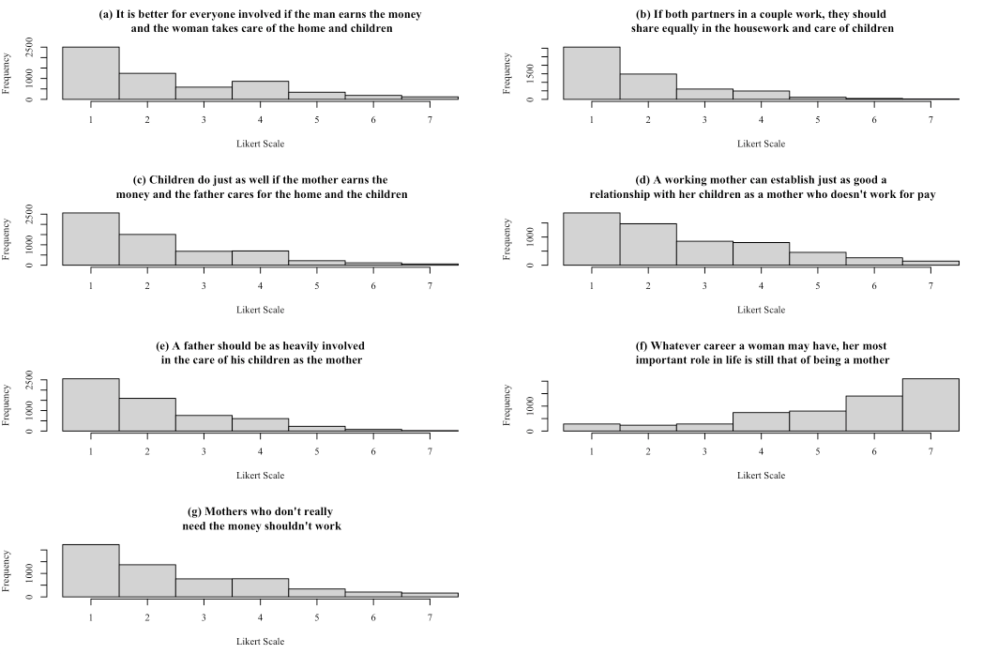
Notes: [a] Charts show how much focal women ranked their agreement with the statements in bold. [b] Data is pooled across all waves. [c] The values have been reversed for some questions, to ensure that a higher number corresponds with more traditional attitudes. A higher number indicates agreement with the statement for panels (a), (f) and (g), and disagreement for panels (b), (c), (d) and (e).
Figure B2: Gender Attitudes Index Component Distributions for Focal Woman’s Partner
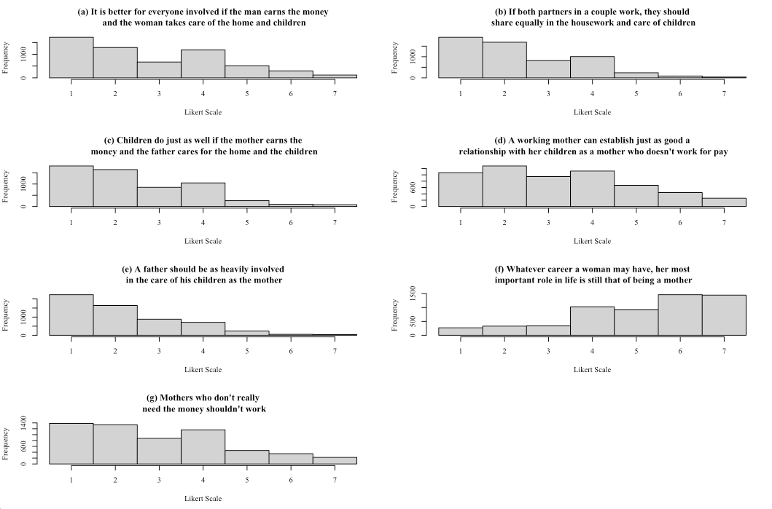
Notes: [a] Charts show how much the focal woman’s partners ranked their agreement with the statements in bold. [b] Data is pooled across all waves. [c] The values have been reversed for some questions, to ensure that a higher number corresponds with more traditional attitudes. A higher number indicates agreement with the statement for panels (a), (f) and (g), and disagreement for panels (b), (c), (d) and (e).
Figure B3: Distribution of Gender Attitudes Index for Woman, her Partner and their Differences
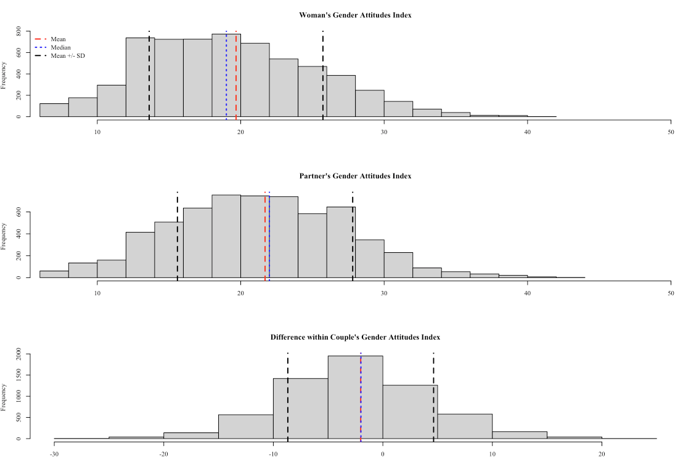
Notes: [a] Charts showing raw gender attitudes index distribution are formed such that a higher number corresponds to more traditional attitudes. [b] Chart showing difference in couple’s attitudes is calculated as the woman’s attitudes, minus her partner’s, thus a positive number indicates that the woman’s attitudes are more traditional than her partner’s and vice versa.

Appendix C: Complete Tables for Structural and Reduced-Form Models

Table C1: Structural Model Complete Regression Table

 | Extensive Margin  Formal Care Utilisation Flag |  |  | Absolute-Intensive Margin  Weekly Formal Childcare Hours |  |  | Relative-Intensive Margin  Proportion of Formal Childcare Hours
 | 1a | 1b |  | 2a | 2b |  | 3a | 3b
Woman’s Standardised Gender Attitudes | -0.0357***  (0.0062) | -0.0409***  (0.0062) |  | -0.2869  (0.2633) | -0.5349**  (0.2664) |  | 0.0033  (0.0041) | 0.0037  (0.0041)
Partner’s Standardised Gender Attitudes | -0.0173***  (0.0062) | -0.023***  (0.0062) |  | -0.8837***  (0.2577) | -1.1187***  (0.2609) |  | -0.0028  (0.004) | -0.0022  (0.004)
Woman's Labour Market Controls
ln(Real Wage) | 0.0125***  (0.0034) | 0.0123***  (0.0034) |  | 0.7006***  (0.1418) | 0.6561***  (0.1437) |  | 0.0032  (0.0022) | 0.0034  (0.0022)
Weekly Hours Worked | 0.0057***  (0.0005) |  |  | 0.5197***  (0.0209) |  |  | -0.0004  (0.0003)
Regular Night Work | -0.1244***  (0.0324) | -0.1376***  (0.0326) |  | -5.2649***  (1.4908) | -6.3494***  (1.5082) |  | 0.0097  (0.0235) | 0.0146  (0.0234)
Irregular Schedule | -0.0396  (0.0256) | -0.0284  (0.0257) |  | -5.1755***  (1.053) | -4.2453***  (1.0677) |  | -0.0132  (0.0165) | -0.0131  (0.0165)
Employed Full-time |  | 0.0942***  (0.0136) |  |  | 11.7005***  (0.5363) |  |  | -0.0011  (0.0083)
Unemployed | 0.1106**  (0.0486) | -0.0115  (0.0472) |  | 8.6817***  (2.1046) | -1.7789  (2.0596) |  | 0.0478  (0.033) | 0.0629**  (0.0319)
Not in Labour Force | -0.0526**  (0.0231) | -0.1727***  (0.0195) |  | 7.8613***  (1.0396) | -2.5457***  (0.8977) |  | 0.0164  (0.0163) | 0.0296**  (0.0139)
Partner's Labour Market Controls
ln(Real Wage) | 0.0004  (0.0026) | -0.001  (0.0027) |  | 0.1277  (0.1083) | 0.0808  (0.1103) |  | -0.0016  (0.0017) | -0.001  (0.0017)
Weekly Hours Worked | -0.0008  (0.0005) |  |  | 0.0075  (0.0228) |  |  | -0.0008**  (0.0003)
Regular Night Work | -0.1411***  (0.0401) | -0.1292***  (0.0405) |  | -3.0429  (1.8617) | -2.9962  (1.8919) |  | -0.0275  (0.0292) | -0.0296  (0.0293)
Irregular Schedule | -0.0724***  (0.0213) | -0.0751***  (0.0215) |  | -0.7338  (0.9105) | -0.96  (0.9231) |  | -0.0038  (0.0143) | -0.0044  (0.0143)
Employed Full-time |  | 0.071***  (0.0217) |  |  | 2.7463***  (0.924) |  |  | -0.0353**  (0.0143)
Unemployed | -0.139***  (0.0519) | -0.0356  (0.0506) |  | -0.4338  (2.2778) | 1.7905  (2.2356) |  | -0.0136  (0.0357) | -0.0083  (0.0346)
Not in Labour Force | -0.2078***  (0.0402) | -0.1072***  (0.0382) |  | -0.4929  (1.8309) | 1.7402  (1.7578) |  | -0.1151***  (0.0288) | -0.1085***  (0.0273)
Woman's Characteristics
Age | 0.0074***  (0.0015) | 0.0071***  (0.0015) |  | 0.033  (0.0634) | 0.0221  (0.0643) |  | -0.0012  (0.0009) | -0.0012  (0.0009)
Non-English COB | -0.0552**  (0.0222) | -0.0511**  (0.0223) |  | 2.2083**  (0.9366) | 1.6519*  (0.9519) |  | 0.0177  (0.0147) | 0.0167  (0.0147)
University | -0.0311  (0.0232) | -0.0232  (0.0234) |  | -1.8291*  (0.9902) | -1.5215  (1.0042) |  | -0.0487***  (0.0155) | -0.0499***  (0.0155)
VET/TAFE | -0.0069  (0.0226) | -0.0018  (0.0227) |  | 0.5945  (0.965) | 0.6629  (0.9789) |  | -0.0479***  (0.0151) | -0.0498***  (0.0151)
High School Diploma | -0.0239  (0.0246) | -0.0183  (0.0247) |  | 0.1728  (1.0545) | 0.3786  (1.0694) |  | -0.0408**  (0.0165) | -0.0418**  (0.0165)
Partner's Characteristics
Age | 0.0004  (0.0013) | 0.0009  (0.0013) |  | 0.106*  (0.0556) | 0.1206**  (0.0564) |  | 0.0032***  (0.0008) | 0.0032***  (0.0008)
Non-English COB | 0.0139  (0.0233) | 0.0237  (0.0235) |  | 1.0915  (0.9795) | 1.2359  (0.9936) |  | -0.0187  (0.0153) | -0.0201  (0.0154)
University | 0.0283  (0.0225) | 0.0262  (0.0226) |  | -0.5531  (0.9556) | -0.4386  (0.9693) |  | 0.04***  (0.015) | 0.041***  (0.015)
VET/TAFE | 0.0364*  (0.0201) | 0.0332  (0.0203) |  | -0.1509  (0.8605) | -0.1869  (0.8728) |  | 0.0351***  (0.0135) | 0.0356***  (0.0135)
High School Diploma | 0.0112  (0.0238) | 0.0115  (0.0239) |  | 0.3528  (1.0122) | 0.2657  (1.0267) |  | 0.0212  (0.0159) | 0.0217  (0.0159)
Household Characteristics
Regional | 0.0354***  (0.0136) | 0.0343**  (0.0136) |  | 1.0521*  (0.5513) | 1.1209**  (0.559) |  | 0.0265***  (0.0086) | 0.0262***  (0.0086)
Remote | -0.0132  (0.0515) | -0.0196  (0.0517) |  | 3.0018  (2.2756) | 2.4669  (2.3043) |  | 0.0429  (0.0357) | 0.0393  (0.0357)
SEIFA Decile | 0.0037  (0.0024) | 0.0034  (0.0024) |  | -0.0208  (0.0991) | 0.0123  (0.1003) |  | -0.0012  (0.0015) | -0.0013  (0.0015)
Married | 0.038**  (0.015) | 0.029*  (0.0151) |  | 0.5674  (0.6215) | 0.4638  (0.63) |  | -0.0085  (0.0097) | -0.0084  (0.0097)
No. Children 0-4 | 0.0484***  (0.0097) | 0.0425***  (0.0098) |  | 7.8981***  (0.3976) | 7.4869***  (0.4017) |  | -0.0232***  (0.0062) | -0.0222***  (0.0062)
Year Fixed Effects
2005 | -0.0279  (0.0305) | -0.0307  (0.0307) |  | -3.966***  (1.247) | -4.2974***  (1.2645) |  | -0.0026  (0.0195) | -0.0024  (0.0195)
2006 | -0.0541*  (0.0311) | -0.0552*  (0.0313) |  | -2.4961*  (1.2797) | -2.7223**  (1.2976) |  | 0.0221  (0.0201) | 0.0209  (0.0201)
2007 | -0.0564*  (0.0315) | -0.0615*  (0.0317) |  | 0.3058  (1.307) | -0.553  (1.3257) |  | 0.0131  (0.0205) | 0.0128  (0.0205)
2008 | -0.0614**  (0.0307) | -0.0679**  (0.0309) |  | -1.5162  (1.2817) | -2.3661*  (1.3001) |  | 0.0257  (0.0201) | 0.0258  (0.0201)
2009 | -0.0252  (0.0306) | -0.0318  (0.0308) |  | -1.6133  (1.2508) | -2.4421*  (1.2681) |  | -0.0157  (0.0197) | -0.0144  (0.0197)
2010 | -0.0536*  (0.031) | -0.0566*  (0.0311) |  | -2.1207*  (1.285) | -2.7665**  (1.3031) |  | -0.012  (0.0201) | -0.0114  (0.0201)
2011 | -0.0376  (0.0276) | -0.0412  (0.0278) |  | -1.8851*  (1.1367) | -2.2791**  (1.1522) |  | 0.0011  (0.0178) | 0.0011  (0.0178)
2012 | 0.0076  (0.0282) | 0.0045  (0.0284) |  | -1.1908  (1.1399) | -1.6533  (1.1558) |  | 0.0311*  (0.0179) | 0.0319*  (0.0179)
2013 | 0.0041  (0.0281) | 0.0012  (0.0283) |  | -2.2685**  (1.1328) | -2.8587**  (1.1483) |  | 0.0065  (0.0178) | 0.0071  (0.0177)
2014 | -0.0074  (0.0278) | -0.0084  (0.0279) |  | -0.506  (1.1224) | -0.7801  (1.1385) |  | 0.0166  (0.0176) | 0.0171  (0.0176)
2015 | 0.0219  (0.0265) | 0.024  (0.0267) |  | -0.2237  (1.0532) | -0.233  (1.0681) |  | 0.0168  (0.0165) | 0.0163  (0.0165)
2016 | -0.0031  (0.0268) | -0.0035  (0.027) |  | -0.7102  (1.0757) | -0.7123  (1.0909) |  | 0.0224  (0.0169) | 0.0221  (0.0169)
2017 | 0.0031  (0.0262) | 0.0031  (0.0264) |  | -1.3417  (1.0439) | -1.6267  (1.0588) |  | 0.0064  (0.0164) | 0.0066  (0.0164)
2018 | 0.0137  (0.0262) | 0.0125  (0.0264) |  | 0.3216  (1.0359) | 0.2376  (1.0506) |  | -0.0052  (0.0162) | -0.0051  (0.0162)
N | 6161 | 6161 |  | 4314 | 4314 |  | 4310 | 4310
Adj. R² | 0.1055 | 0.0939 |  | 0.2149 | 0.1925 |  | 0.0153 | 0.0149
Notes: [a] ⏊ p<0.15; *p<0.1; **p<0.05, ***p<0.01; [b] Standard errors reported in brackets.

Table C2: Second Stage Reduced Form Model Complete Regression Table
 | Extensive Margin  Formal Care Utilisation Flag |  |  | Absolute-Intensive Margin  Weekly Formal Childcare Hours
 | 1a | 1b |  | 2a | 2b
Woman's Explained Gender Attitudes | -0.0883***  (0.0257) | -0.1031***  (0.0259) |  | 0.4281  (0.8766) | -0.3082  (0.889)
Woman's Unexplained Gender Attitudes | -0.0306***  (0.0077) | -0.0354***  (0.0078) |  | -0.8915***  (0.3232) | -1.076***  (0.3279)
Partner's Explained Gender Attitudes | -0.0377⏊  (0.025) | -0.0529**  (0.0251) |  | -1.4712*  (0.8622) | -2.053**  (0.8733)
Partner's Unexplained Gender Attitudes | -0.0192**  (0.0078) | -0.0247***  (0.0078) |  | -1.2061***  (0.3201) | -1.3025***  (0.3251)
Woman's Labour Market Controls
ln(Real Wage) | 0.008*  (0.0043) | 0.007⏊  (0.0043) |  | 0.7018***  (0.1693) | 0.6067***  (0.1719)
Weekly Hours Worked | 0.0058***  (0.0006) |  |  | 0.5216***  (0.0248)
Regular Night Work | -0.1071***  (0.0409) | -0.1215***  (0.0412) |  | -4.4958**  (1.7921) | -5.0608***  (1.8194)
Irregular Schedule | -0.051⏊  (0.0315) | -0.0384  (0.0317) |  | -5.0526***  (1.2704) | -3.7871***  (1.29)
Employed Full-time |  | 0.0881***  (0.0171) |  |  | 12.1504***  (0.6516)
Unemployed | 0.1039*  (0.0608) | -0.0241  (0.0594) |  | 7.9263***  (2.5478) | -2.7226  (2.5063)
Not in Labour Force | -0.0758***  (0.0284) | -0.201***  (0.0242) |  | 6.2918***  (1.2419) | -4.2296***  (1.0861)
Partner's Labour Market Controls
ln(Real Wage) | -0.0004  (0.0031) | -0.0018  (0.0031) |  | 0.1218  (0.1248) | 0.0699  (0.1273)
Weekly Hours Worked | -0.0014**  (0.0006) |  |  | -0.0248  (0.0275)
Regular Night Work | -0.14**  (0.0577) | -0.1308**  (0.0582) |  | -5.4713**  (2.5478) | -4.9509*  (2.5897)
Irregular Schedule | -0.0813***  (0.0249) | -0.0853***  (0.0251) |  | -1.6122⏊  (1.0424) | -1.766*  (1.0589)
Employed Full-time |  | 0.0704**  (0.0295) |  |  | 2.8949**  (1.2174)
Unemployed | -0.2336***  (0.0683) | -0.0976  (0.0678) |  | -1.4695  (3.01) | 2.3163  (3.0127)
Not in Labour Force | -0.2573***  (0.0521) | -0.1221**  (0.0508) |  | -3.9007*  (2.3127) | 0.3278  (2.2811)
Woman's Characteristics
Age | 0.0108***  (0.002) | 0.0103***  (0.0021) |  | 0.174**  (0.0828) | 0.1473*  (0.0841)
Non-English COB | -0.0161  (0.0467) | -0.0133  (0.0471) |  | -0.3883  (1.9724) | -1.336  (2.0046)
University | -0.0757***  (0.0293) | -0.0656**  (0.0296) |  | -1.536  (1.2028) | -1.1729  (1.2219)
VET/TAFE | -0.0122  (0.0285) | -0.0063  (0.0287) |  | 1.3017  (1.1729) | 1.2869  (1.1918)
High School Diploma | -0.0382  (0.0307) | -0.0305  (0.031) |  | 1.9345⏊  (1.2759) | 2.205*  (1.2957)
Partner's Characteristics
Age | -0.0009  (0.0018) | -0.0003  (0.0018) |  | 0.0749  (0.0724) | 0.0986  (0.0735)
Non-English COB | -0.0974**  (0.0477) | -0.0785⏊  (0.0481) |  | 2.5085  (2.088) | 3.3485⏊  (2.1191)
University | 0.0457⏊  (0.0284) | 0.0387  (0.0287) |  | -1.1003  (1.1765) | -1.0578  (1.1955)
VET/TAFE | 0.0455*  (0.0251) | 0.0413⏊  (0.0253) |  | 0.2885  (1.052) | 0.3221  (1.0689)
High School Diploma | 0.028  (0.0293) | 0.0272  (0.0295) |  | 0.4741  (1.221) | 0.337  (1.2404)
Household Characteristics
Regional | 0.0469***  (0.0159) | 0.0454***  (0.016) |  | 1.9852***  (0.628) | 2.2001***  (0.6379)
Remote | 0.0678  (0.0632) | 0.0457  (0.0636) |  | 6.5053**  (2.6001) | 4.8782*  (2.6345)
SEIFA Decile | 0.0032  (0.0029) | 0.0026  (0.0029) |  | 0.1034  (0.1177) | 0.1408  (0.1193)
Married | 0.0246  (0.0191) | 0.0164  (0.0192) |  | 0.0012  (0.7755) | -0.051  (0.7866)
No. Children 0-4 | 0.0512***  (0.0117) | 0.0455***  (0.0117) |  | 8.3446***  (0.4639) | 7.9435***  (0.4694)
Year Fixed Effects
2005 | -0.0171  (0.0372) | -0.0154  (0.0376) |  | -3.2703**  (1.4719) | -3.4775**  (1.4954)
2006 | -0.0493  (0.0382) | -0.0491  (0.0385) |  | -2.7248*  (1.5191) | -2.9217*  (1.5431)
2007 | -0.0672*  (0.0381) | -0.0663*  (0.0384) |  | 1.2161  (1.5482) | 0.5244  (1.5726)
2008 | -0.0726*  (0.0379) | -0.0747*  (0.0383) |  | -1.9632  (1.541) | -2.6891*  (1.566)
2009 | 0.0058  (0.0383) | -0.0012  (0.0386) |  | -1.8767  (1.5069) | -2.7331*  (1.5307)
2010 | -0.0636*  (0.0374) | -0.0658*  (0.0377) |  | -0.8056  (1.526) | -1.5171  (1.5502)
2011 | -0.0307  (0.034) | -0.0329  (0.0343) |  | -2.2838*  (1.3611) | -2.6196*  (1.3822)
2012 | 0.026  (0.0344) | 0.0255  (0.0347) |  | -0.7839  (1.3451) | -1.0527  (1.3664)
2013 | 0.023  (0.0349) | 0.0236  (0.0352) |  | -0.5204  (1.3576) | -0.8325  (1.3789)
2014 | -0.012  (0.035) | -0.0105  (0.0352) |  | -0.9033  (1.3792) | -1.0125  (1.4016)
2015 | 0.0187  (0.0323) | 0.0216  (0.0326) |  | 0.9258  (1.2423) | 0.7457  (1.2624)
2016 | -0.0202  (0.0323) | -0.0187  (0.0326) |  | -0.0061  (1.2588) | 0.1759  (1.2787)
2017 | -0.0242  (0.0312) | -0.0228  (0.0315) |  | -0.5466  (1.2118) | -0.702  (1.2314)
2018 | -0.0225  (0.0313) | -0.0209  (0.0315) |  | 1.1087  (1.2095) | 1.3628  (1.2286)
N | 4085 | 4085 |  | 2903 | 2903
Adj. R² | 0.1175 | 0.103 |  | 0.2446 | 0.2204
Notes: [a] ⏊ p<0.15; *p<0.1; **p<0.05, ***p<0.01; [b] Standard errors reported in brackets.

Table C3: Mediated Effects Bootstrap Sampling Results
 | (a) |  | (b)
Extensive Margin
Woman's Mother's Norms | 0.1019***  (0.0393) |  | 0.1024***  (0.0388)
Woman's Father's Norms | 0.1377***  (0.038) |  | 0.1384***  (0.0369)
Woman's Peers' Norms | 0.4945***  (0.0653) |  | 0.4975***  (0.0568)
Woman's Internal Learnings | 0.266***  (0.088) |  | 0.2616***  (0.0733)
Partner's Mother's Norms | 0.0241  (0.0188) |  | 0.0251  (0.0186)
Partner's Father's Norms | 0.1485**  (0.0589) |  | 0.1539***  (0.0531)
Partner's Peers' Norms | 0.4553***  (0.1464) |  | 0.4736***  (0.1214)
Partner's Internal Learnings | 0.3721*  (0.198) |  | 0.3474**  (0.1624)
Absolute-Intensive Margin
Woman's Mother's Norms | 0.0358  (0.0292) |  | 0.0324  (0.0263)
Woman's Father's Norms | 0.086*  (0.0489) |  | 0.0778*  (0.0442)
Woman's Peers' Norms | 0.2861**  (0.1449) |  | 0.2583**  (0.1313)
Woman's Internal Learnings | 0.5921***  (0.2057) |  | 0.6314***  (0.1867)
Partner's Mother's Norms | 0.0397*  (0.0214) |  | 0.0456**  (0.0221)
Partner's Father's Norms | 0.0996**  (0.0405) |  | 0.1143***  (0.0391)
Partner's Peers' Norms | 0.3642***  (0.1264) |  | 0.4158***  (0.1091)
Partner's Internal Learnings | 0.4965***  (0.1681) |  | 0.4243***  (0.1429)
Notes: [a] ⏊ p<0.15; *p<0.1; **p<0.05, ***p<0.01; [b] Standard errors reported in brackets; [c] Results in column (a) are derived from specification that controls weekly hours worked and real wage; Results in (b) control for labour supply with weekly hours worked and fulltime status; [d] Both specifications control for: employment status, work schedule, age, country of birth, highest educational attainment, marital status, SEIFA decile, remoteness structure, number of children aged 0-4 and year fixed effects.

Appendix D: Results for Robustness Checks and Heterogeneity Analyses
Table D1: First Stage Reduced Form Model Estimated where Peer Groups are Larger than 10 Peers
 | Extensive Margin |  |  | Absolute-Intensive Margin
 | $${ga}_{i}$$ | $${ga}_{p}$$ |  | $${ga}_{i}$$ | $${ga}_{p}$$
$$z({osm}_{i,p})$$ | -0.0635***  (0.0182) | 0.0127  (0.019) |  | -0.0477**  (0.0209) | 0.0445**  (0.0217)
$$z({osf}_{i,p})$$ | -0.1003***  (0.0186) | -0.1125***  (0.0192) |  | -0.1313***  (0.0205) | -0.116***  (0.0219)
$$z({ga}_{-i,-p})$$ | 0.2492***  (0.0629) | 0.2559***  (0.0399) |  | 0.2557***  (0.0704) | 0.2935***  (0.0423)
Intercept | -0.0138  (0.0168) | -0.0167  (0.0169) |  | -0.0846***  (0.0203) | -0.0803***  (0.0196)
Weak Instruments | 241.396***  [0.0000] | 713.265***  [0.0000] |  | 184.873***  [0.0000] | 601.146***  [0.0000]
Wu-Hausman | 3.2411*  [0.0719] | 6.0245**  [0.0142] |  | 2.6111⏊  [0.1063] | 3.2174*  [0.073]
Controls
N | 3050 | 3050 |  | 2148 | 2148
Adj. R² | 0.14 | 0.1298 |  | 0.1556 | 0.1531
Notes: [a] ⏊ p<0.15; *p<0.1; **p<0.05, ***p<0.01; [b] $z( )$ refers to standardised score, $osm$ is the occupational status score of the individual’s mother, $osf$ is the occupational status score of the individual’s father, ${ga}_{-i,-p}$ refers to the peers’ gender attitudes and the subscripts $i$ and $p$ refer to the woman and her partner, respectively; [c] Standard errors reported in rounded brackets; [d] Instrumental variable diagnostic test p-values reported in squared brackets; [e] Weak instruments test assesses the strength of the relationship between an endogenous variable and the instrumental variable/s; [f] The null hypothesis for the Wu-Hausman tests is that the OLS and the instrumental variable estimators are consistent.
Table D2: Second Stage Reduced Form Model Estimated where Peer Groups are Larger than 10 Peers
 | Extensive Margin  Formal Care Utilisation Flag |  |  | Absolute-Intensive Margin  Weekly Formal Childcare Hours
 | 1a | 1b |  | 2a | 2b
$\hat{{ga}_{i}}$ | -0.1361***  (0.0351) | -0.1544***  (0.0354) |  | 1.4817  (1.3153) | 0.4669  (1.336)
$${ga}_{i}-\hat{{ga}_{i}}$$ | -0.0321***  (0.0089) | -0.039***  (0.009) |  | -0.9462**  (0.3756) | -1.1499***  (0.3816)
$\hat{{ga}_{p}}$ | 0.007  (0.0313) | -0.0041  (0.0316) |  | 0.6054  (1.1114) | -0.1009  (1.1286)
$${ga}_{p}-\hat{{ga}_{p}}$$ | -0.0163*  (0.0089) | -0.0225**  (0.009) |  | -1.0788***  (0.3663) | -1.1805***  (0.3727)
Controls
N | 3050 | 3050 |  | 2148 | 2148
Adj. R² | 0.129 | 0.1103 |  | 0.245 | 0.218
Notes: [a] ⏊ p<0.15; *p<0.1; **p<0.05, ***p<0.01; [b] $ga$ is the actual value of the individual’s gender attitudes index, $\hat{ga}$ is the predicted value (representing the explained component), the difference between them are the residuals (representing the unexplained component), and the subscripts $i$ and $p$ refer to the woman and her partner, respectively; [c] Standard errors reported in brackets; [d] Specifications with suffix (a) control for labour supply with weekly hours worked and real wage; specifications with suffix (b) control for labour supply with weekly hours worked and fulltime status; [e] Both specifications control for: employment status, work schedule, age, country of birth, highest educational attainment, marital status, SEIFA decile, remoteness structure, number of children aged 0-4 and year fixed effects; [f] Full regression results available upon author request.
Table D3: Structural Model Estimated with Non-Imputed Gender Attitudes Dataset
 | Extensive Margin  Formal Care Utilisation Flag |  |  | Absolute-Intensive Margin  Weekly Formal Childcare Hours |  |  | Relative-Intensive Margin  Proportion of Formal Childcare Hours
 | 1a | 1b |  | 2a | 2b |  | 3a | 3b
$$z({ga}_{i})$$ | -0.036***  (0.0106) | -0.0407***  (0.0106) |  | -0.3812  (0.4347) | -0.6413  (0.4379) |  | -0.0006  (0.007) | -0.0007  (0.007)
$$z({ga}_{p})$$ | -0.0129  (0.0105) | -0.0179*  (0.0106) |  | -1.9459***  (0.4324) | -2.1362***  (0.4361) |  | -0.0111  (0.0069) | -0.0101  (0.0069)
Controls
N | 2160 | 2160 |  | 1511 | 1511 |  | 1511 | 1511
Adj. R² | 0.1114 | 0.0989 |  | 0.2505 | 0.2348 |  | 0.0089 | 0.0093
Notes: [a] ⏊ p<0.15; *p<0.1; **p<0.05, ***p<0.01; [b] $z({ga}_{i})$ is the woman’s standardised gender attitudes index and $z({ga}_{p})$ is the partner’s standardised gender attitudes index; [c] Standard errors reported in brackets; [d] Specifications with suffix (a) control for labour supply using weekly hours worked; specifications with suffix (b) control for labour supply using full-time status; [e] Both specifications control for: real hourly wages; employment status, work schedule, age, country of birth, highest educational attainment, marital status, SEIFA decile, remoteness structure, number of children aged 0-4 and year fixed effects; [f] Full regression results available upon author request.
Table D4: First Stage Reduced Form Model Estimated with Non-Imputed Gender Attitudes Dataset
 | Extensive Margin |  |  | Absolute-Intensive Margin
 | $${ga}_{i}$$ | $${ga}_{p}$$ |  | $${ga}_{i}$$ | $${ga}_{p}$$
$$z({osm}_{i,p})$$ | -0.0473⏊  (0.0321) | -0.0003  (0.0348) |  | -0.0188  (0.0359) | 0.015  (0.0387)
$$z({osf}_{i,p})$$ | -0.0928***  (0.0323) | -0.1014***  (0.0322) |  | -0.1046***  (0.0354) | -0.1157***  (0.0356)
$$z({ga}_{-i,-p})$$ | 0.314**  (0.141) | 0.2504**  (0.1042) |  | 0.4059***  (0.1418) | 0.2924***  (0.0995)
Intercept | -0.0165  (0.0294) | -0.0208  (0.0296) |  | -0.0679*  (0.0377) | -0.075**  (0.0341)
Weak Instruments | 44.6864***  [0.0000] | 87.7699***  [0.0000] |  | 42.1361***  [0.0000] | 95.4036***  [0.0000]
Wu-Hausman | 0.2151  [0.6429] | 2.7699*  [0.0964] |  | 0.125  [0.7238] | 1.6067  [0.2054]
Controls
N | 986 | 986 |  | 708 | 708
Adj. R² | 0.1571 | 0.1542 |  | 0.1519 | 0.174
Notes: [a] ⏊ p<0.15; *p<0.1; **p<0.05, ***p<0.01; [b] $z( )$ refers to standardised score, $osm$ is the occupational status score of the individual’s mother, $osf$ is the occupational status score of the individual’s father, ${ga}_{-i,-p}$ refers to the peers’ gender attitudes and the subscripts $i$ and $p$ refer to the woman and her partner, respectively; [c] Standard errors reported in rounded brackets; [d] Instrumental variable diagnostic test p-values reported in squared brackets; [e] Weak instruments test assesses the strength of the relationship between an endogenous variable and the instrumental variable/s; [f] The null hypothesis for the Wu-Hausman tests is that the OLS and the instrumental variable estimators are consistent.
Table D5: Second Stage Reduced Form Model Estimated with Non-Imputed Gender Attitudes Dataset
 | Extensive Margin  Formal Care Utilisation Flag |  |  | Absolute-Intensive Margin  Weekly Formal Childcare Hours
 | 1a | 1b |  | 2a | 2b
$\hat{{ga}_{i}}$ | -0.1215**  (0.0508) | -0.146***  (0.0513) |  | -0.5544  (1.6426) | -1.0139  (1.6555)
$${ga}_{i}-\hat{{ga}_{i}}$$ | -0.0278*  (0.0154) | -0.0352**  (0.0156) |  | -1.7472***  (0.6411) | -1.8553***  (0.6457)
$\hat{{ga}_{p}}$ | -0.0622  (0.0564) | -0.094*  (0.0569) |  | -1.0204  (1.9505) | -2.166  (1.9627)
$${ga}_{p}-\hat{{ga}_{p}}$$ | -0.0008  (0.0156) | -0.0091  (0.0158) |  | -2.2776***  (0.6631) | -2.4248***  (0.6673)
Controls
N | 986 | 986 |  | 708 | 708
Adj. R² | 0.1465 | 0.1244 |  | 0.2309 | 0.2169
Notes: [a] ⏊ p<0.15; *p<0.1; **p<0.05, ***p<0.01; [b] $ga$ is the actual value of the individual’s gender attitudes index, $\hat{ga}$ is the predicted value (representing the explained component), the difference between them are the residuals (representing the unexplained component), and the subscripts $i$ and $p$ refer to the woman and her partner, respectively; [c] Standard errors reported in brackets; [d] Specifications with suffix (a) control for labour supply with weekly hours worked and real wage; specifications with suffix (b) control for labour supply with weekly hours worked and fulltime status; [e] Both specifications control for: employment status, work schedule, age, country of birth, highest educational attainment, marital status, SEIFA decile, remoteness structure, number of children aged 0-4 and year fixed effects; [f] Full regression results available upon author request.
Table D6: Structural Model Estimated with Non-Linear Techniques
 | Extensive Margin  Formal Care Utilisation Flag |  |  | Relative-Intensive Margin  Proportion of Formal Childcare Hours
 | 1a | 1b |  | 3a | 3b
$$z({ga}_{i})$$ | -0.0337***  (0.0061) | -0.0392***  (0.0061) |  | 0.0035  (0.0041) | 0.0038  (0.0041)
$$z({ga}_{p})$$ | -0.0179***  (0.0061) | -0.0236***  (0.0062) |  | -0.0028  (0.004) | -0.0022  (0.004)
Controls
N | 6161 | 6161 |  | 4310 | 4310
Pseudo. R² | 0.0870 | 0.0945 |  | 0.0304 | 0.0302
Notes: [a] ⏊ p<0.15; *p<0.1; **p<0.05, ***p<0.01; [b] Extensive margin is modelled using a logit model, average marginal effects are reported; [c] Relative-intensive margin is modelled using a fractional logit model, average marginal effects are reported; [d] Standard errors reported in brackets; [e] Specifications with suffix (a) control for labour supply using weekly hours worked; specifications with suffix (b) control for labour supply using full-time status; [f] Both specifications control for: real hourly wages; employment status, work schedule, age, country of birth, highest educational attainment, marital status, SEIFA decile, remoteness structure, number of children aged 0-4 and year fixed effects; [g] Full regression results available upon author request. [h] McFadden’s R² is reported for logit and tobit model and Nagelkere’s R² is reported for fractional logit model. Both measures are adjusted.
Table D7: Second Stage Reduced Form Model Estimated with Non-Linear Techniques
Extensive Margin
Formal Care Utilisation Flag
 | 1a | 1b
$\hat{{ga}_{i}}$ | -0.0867***  (0.0257) | -0.0865***  (0.0274)
$${ga}_{i}-\hat{{ga}_{i}}$$ | -0.0274***  (0.0075) | -0.0472***  (0.0081)
$\hat{{ga}_{p}}$ | -0.0366⏊  (0.025) | -0.0688**  (0.0268)
$${ga}_{p}-\hat{{ga}_{p}}$$ | -0.0202***  (0.0077) | -0.0316***  (0.0083)
Controls
N | 4085 | 4085
Pseudo. R² | 0.1106 | 0.0835
Notes: [a] ⏊ p<0.15; *p<0.1; **p<0.05, ***p<0.01; [b] $ga$ is the actual value of the individual’s gender attitudes index, $\hat{ga}$ is the predicted value (representing the explained component), the difference between them are the residuals (representing the unexplained component), and the subscripts $i$ and $p$ refer to the woman and her partner, respectively; [c] Extensive margin is modelled using a logit model, average marginal effects are reported; [d] Relative-intensive margin is modelled using a fractional logit model, average marginal effects are reported; [e] Standard errors reported in brackets; [f] Specifications with suffix (a) control for labour supply with weekly hours worked and real wage; specifications with suffix (b) control for labour supply with weekly hours worked and fulltime status; [g] Both specifications control for: employment status, work schedule, age, country of birth, highest educational attainment, marital status, SEIFA decile, remoteness structure, number of children aged 0-4 and year fixed effects; [h] Full regression results available upon author request. [i] McFadden’s R² is reported for logit model and Nagelkere’s R² is reported for fractional logit model. Both measures are adjusted.
Table D8: Structural Model with Alternate Labour Market Controls; Income and Full-time Employment
 | Extensive Margin  Formal Care Utilisation Flag |  | Absolute-Intensive Margin  Weekly Formal Childcare Hours |  | Relative-Intensive Margin  Proportion of Formal Childcare Hours
 | 1a |  | 2a |  | 3a
$$z({ga}_{i})$$ | -0.0398***  (0.0063) |  | -0.4995*  (0.2655) |  | 0.0037  (0.0041)
$$z({ga}_{p})$$ | -0.0228***  (0.0062) |  | -1.0906***  (0.2600) |  | -0.0022  (0.0040)
Controls
N | 6161 |  | 4314 |  | 4310
Adj. R² | 0.0893 |  | 0.1981 |  | 0.0146
Notes: [a] ⏊ p<0.15; *p<0.1; **p<0.05, ***p<0.01; [b] Standard errors reported in brackets; [c] Each model controls for: age, country of birth, highest educational attainment, marital status, SEIFA decile, remoteness structure, number of children aged 0-4 and wave of response for the woman and her partner. [d] Full table available upon author request.
Table D9: Structural Model Estimated for Households with Primary Caregivers Employed
 | Extensive Margin  Formal Care Utilisation Flag |  |  | Absolute-Intensive Margin  Weekly Formal Childcare Hours |  |  | Relative-Intensive Margin  Proportion of Formal Childcare Hours
 | 1a | 1b |  | 2a | 2b |  | 3a | 3b
$$z({ga}_{i})$$ | -0.0333***  (0.0066) | -0.04***  (0.0067) |  | -0.4175  (0.2796) | -0.7177**  (0.2836) |  | -0.0001  (0.0043) | 0.0002  (0.0043)
$$z({ga}_{p})$$ | -0.0158**  (0.0066) | -0.0229***  (0.0067) |  | -0.9452***  (0.275) | -1.2217***  (0.2791) |  | -0.0025  (0.0043) | -0.0019  (0.0043)
Controls
N | 4932 | 4932 |  | 3683 | 3683 |  | 3681 | 3681
Adj. R² | 0.0829 | 0.0657 |  | 0.2352 | 0.2082 |  | 0.0239 | 0.023
Notes: [a] ⏊ p<0.15; *p<0.1; **p<0.05, ***p<0.01; [b] $z({ga}_{i})$ is the woman’s standardised gender attitudes index and $z({ga}_{p})$ is the partner’s standardised gender attitudes index; [c] Standard errors reported in brackets; [d] Specifications with suffix (a) control for labour supply using weekly hours worked; specifications with suffix (b) control for labour supply using full-time status; [e] Both specifications control for: real hourly wages; employment status, work schedule, age, country of birth, highest educational attainment, marital status, SEIFA decile, remoteness structure, number of children aged 0-4 and year fixed effects; [f] Full regression results available upon author request.
Table D10: First Stage Reduced Form Model Estimated with Primary Caregivers Employed
 | Extensive Margin |  |  | Absolute-Intensive Margin
 | $${ga}_{i}$$ | $${ga}_{p}$$ |  | $${ga}_{i}$$ | $${ga}_{p}$$
$$z({osm}_{i,p})$$ | -0.0442**  (0.0181) | 0.0044  (0.0187) |  | -0.0242  (0.02) | 0.0383*  (0.0203)
$$z({osf}_{i,p})$$ | -0.0836***  (0.0171) | -0.1073***  (0.0187) |  | -0.0941***  (0.0187) | -0.1111***  (0.021)
$$z({ga}_{-i,-p})$$ | 0.338***  (0.085) | 0.2926***  (0.0492) |  | 0.3895***  (0.0892) | 0.3381***  (0.0476)
Intercept | -0.0068  (0.0162) | -0.0085  (0.0162) |  | -0.0607***  (0.0187) | -0.0557***  (0.0184)
Weak Instruments | 123.591***  [0.0000] | 404.708***  [0.0000] |  | 105.694***  [0.0000] | 435.437***  [0.0000]
Wu-Hausman | 0.8254  [0.3637] | 6.2349**  [0.0126] |  | 0.0394  [0.8427] | 2.602⏊  [0.1069]
Controls
N | 3161 | 3161 |  | 2399 | 2399
Adj. R² | 0.174 | 0.171 |  | 0.1833 | 0.1853
Notes: [a] ⏊ p<0.15; *p<0.1; **p<0.05, ***p<0.01; [b] $z( )$ refers to standardised score, $osm$ is the occupational status score of the individual’s mother, $osf$ is the occupational status score of the individual’s father, ${ga}_{-i,-p}$ refers to the peers’ gender attitudes and the subscripts $i$ and $p$ refer to the woman and her partner, respectively; [c] Standard errors reported in rounded brackets; [d] Instrumental variable diagnostic test p-values reported in squared brackets; [e] Weak instruments test assesses the strength of the relationship between an endogenous variable and the instrumental variable/s; [f] The null hypothesis for the Wu-Hausman tests is that the OLS and the instrumental variable estimators are consistent.
Table D11: Second Stage Reduced Form Model Estimated with Primary Caregivers Employed
 | Extensive Margin  Formal Care Utilisation Flag |  |  | Absolute-Intensive Margin  Weekly Formal Childcare Hours
 | 1a | 1b |  | 2a | 2b
$\hat{{ga}_{i}}$ | -0.0845***  (0.0242) | -0.1007***  (0.0245) |  | -0.1349  (0.852) | -0.9842  (0.8683)
$${ga}_{i}-\hat{{ga}_{i}}$$ | -0.0228***  (0.0085) | -0.03***  (0.0086) |  | -1.0927***  (0.3546) | -1.3391***  (0.3616)
$\hat{{ga}_{p}}$ | -0.0165  (0.0264) | -0.0321  (0.0267) |  | -0.4452  (0.9253) | -1.1998  (0.9419)
$${ga}_{p}-\hat{{ga}_{p}}$$ | -0.015*  (0.0085) | -0.0221**  (0.0086) |  | -1.2506***  (0.3464) | -1.3534***  (0.3538)
Controls
N | 3161 | 3161 |  | 2399 | 2399
Adj. R² | 0.0916 | 0.0686 |  | 0.2628 | 0.2306
Notes: [a] ⏊ p<0.15; *p<0.1; **p<0.05, ***p<0.01; [b] $ga$ is the actual value of the individual’s gender attitudes index, $\hat{ga}$ is the predicted value (representing the explained component), the difference between them are the residuals (representing the unexplained component), and the subscripts $i$ and $p$ refer to the woman and her partner, respectively; [c] Standard errors reported in brackets; [d] Specifications with suffix (a) control for labour supply with weekly hours worked and real wage; specifications with suffix (b) control for labour supply with weekly hours worked and fulltime status; [e] Both specifications control for: employment status, work schedule, age, country of birth, highest educational attainment, marital status, SEIFA decile, remoteness structure, number of children aged 0-4 and year fixed effects; [f] Full regression results available upon author request.
Table D12: Structural Model Estimated with Grandparent Controls
 | Extensive Margin  Formal Care Utilisation Flag |  |  | Absolute-Intensive Margin  Weekly Formal Childcare Hours |  |  | Relative-Intensive Margin  Proportion of Formal Childcare Hours
 | 1a | 1b |  | 2a | 2b |  | 3a | 3b
$$z({ga}_{i})$$ | -0.0384***  (0.0113) | -0.0433***  (0.0113) |  | -0.4624  (0.4735) | -0.8014*  (0.476) |  | -0.0012  (0.0073) | -0.0005  (0.0073)
$$z({ga}_{p})$$ | -0.0011  (0.0113) | -0.0077  (0.0114) |  | -1.5403***  (0.4719) | -1.8574***  (0.4751) |  | -0.0071  (0.0073) | -0.006  (0.0073)
Controls
N | 1803 | 1803 |  | 1286 | 1286 |  | 1286 | 1286
Adj. R² | 0.1223 | 0.109 |  | 0.2255 | 0.2106 |  | 0.0252 | 0.0239
Notes: [a] ⏊ p<0.15; *p<0.1; **p<0.05, ***p<0.01; [b] $z({ga}_{i})$ is the woman’s standardised gender attitudes index and $z({ga}_{p})$ is the partner’s standardised gender attitudes index; [c] Standard errors reported in brackets; [d] Specifications with suffix (a) control for labour supply using weekly hours worked; specifications with suffix (b) control for labour supply using full-time status; [e] Both specifications control for: real hourly wages; employment status, work schedule, age, country of birth, highest educational attainment, marital status, SEIFA decile, remoteness structure, number of children aged 0-4 and year fixed effects; [f] Note that questions regarding an individual’s grandparents were only asked in Waves 8, 12, 15, 19 [g] Full regression results available upon author request.
Table D13: First Stage Reduced Form Model Estimated Using Parent’s Employment Dummy as Proxy for Revealed Attitudes
 | Extensive Margin |  |  | Absolute-Intensive Margin
 | $${ga}_{i}$$ | $${ga}_{p}$$ |  | $${ga}_{i}$$ | $${ga}_{p}$$
$${mother_work}_{i,p}$$ | -0.1781***  (0.0365) | -0.0291  (0.0348) |  | -0.1179***  (0.042) | 0.0521  (0.0458)
$${father_work}_{i,p}$$ | -0.0318  (0.0848) | -0.1904*  (0.1019) |  | -0.1261  (0.1061) | -0.2401⏊  (0.1492)
$$z({ga}_{-i,-p})$$ | 0.2799***  (0.0771) | 0.426  (0.2985) |  | 0.2983***  (0.0933) | 0.9987⏊  (0.618)
Intercept | 0.1452*  (0.0848) | 0.1835*  (0.1061) |  | 0.1308  (0.1063) | 0.1287  (0.1465)
Weak Instruments | 152.605  [0] | 9.9616  [0.0016] |  | 98.4356  [0] | 2.9808  [0.0844]
Wu-Hausman | 2.1313  [0.1444] | 0.0035  [0.953] |  | 0.7595  [0.3836] | 1.2675  [0.2604]
Controls
N | 3296 | 3296 |  | 2326 | 2326
Adj. R² | 0.1467 | 0.1595 |  | 0.1458 | -0.1699
Notes: [a] ⏊ p<0.15; *p<0.1; **p<0.05, ***p<0.01; [b] ${mother_work}_{i,p}$ and ${father_work}_{i,p}$ are dummy variables which record 1 if the individual’s parent was in paid employment when the individual was 14, ${ga}_{-i,-p}$ refers to the peers’ gender attitudes and the subscripts $i$ and $p$ refer to the woman and her partner, respectively; [c] Standard errors reported in rounded brackets; [d] Instrumental variable diagnostic test p-values reported in squared brackets; [e] Weak instruments test assesses the strength of the relationship between an endogenous variable and the instrumental variable/s; [f] The null hypothesis for the Wu-Hausman tests is that the OLS and the instrumental variable estimators are consistent.
Table D14: Second Stage Reduced Form Model Estimated Using Parent’s Employment Dummy as Proxy for Revealed Attitudes
 | Extensive Margin  Formal Care Utilisation Flag |  |  | Absolute-Intensive Margin  Weekly Formal Childcare Hours
 | 1a | 1b |  | 2a | 2b
$\hat{{ga}_{i}}$ | -0.1054***  (0.0317) | -0.1219***  (0.0318) |  | 1.262  (1.2257) | 0.3498  (1.2407)
$${ga}_{i}-\hat{{ga}_{i}}$$ | -0.0247***  (0.0087) | -0.0282***  (0.0087) |  | -0.8081**  (0.361) | -1.0267***  (0.3655)
$\hat{{ga}_{p}}$ | -0.0301⏊  (0.0208) | -0.0408*  (0.0209) |  | -1.3409***  (0.4235) | -1.629***  (0.4278)
$${ga}_{p}-\hat{{ga}_{p}}$$ | -0.0281***  (0.0088) | -0.0337***  (0.0088) |  | -1.3536***  (0.3609) | -1.5169***  (0.3653)
Controls
N | 3296 | 3296 |  | 2326 | 2326
Adj. R² | 0.1292 | 0.117 |  | 0.2595 | 0.2389
Notes: [a] ⏊ p<0.15; *p<0.1; **p<0.05, ***p<0.01; [b] $ga$ is the actual value of the individual’s gender attitudes index, $\hat{ga}$ is the predicted value (representing the explained component), the difference between them are the residuals (representing the unexplained component), and the subscripts $i$ and $p$ refer to the woman and her partner, respectively; [c] Standard errors reported in brackets; [d] Specifications with suffix (a) control for labour supply with weekly hours worked and real wage; specifications with suffix (b) control for labour supply with weekly hours worked and fulltime status; [e] Both specifications control for: employment status, work schedule, age, country of birth, highest educational attainment, marital status, SEIFA decile, remoteness structure, number of children aged 0-4 and year fixed effects; [f] Full regression results available upon author request.
Table D15: Mediated Effects Bootstrap Sampling Results When Using Parent’s Employment Dummy as Proxy for Revealed Attitudes
 | (a) |  | (b)
Extensive Margin
Woman's Mother's Norms | 0.278***  (0.0803) |  | 0.2801***  (0.0786)
Woman's Father's Norms | 0.1043  (0.0729) |  | 0.1053⏊  (0.073)
Woman's Peers' Norms | 0.4141***  (0.0974) |  | 0.4171***  (0.0936)
Woman's Internal Learnings | 0.2036**  (0.0921) |  | 0.1976***  (0.0749)
Partner's Mother's Norms | 0.03  (0.0362) |  | 0.0321  (0.0369)
Partner's Father's Norms | 0.1477  (0.1204) |  | 0.1588  (0.1197)
Partner's Peers' Norms | 0.2974*  (0.1617) |  | 0.3194**  (0.1532)
Partner's Internal Learnings | 0.525***  (0.1892) |  | 0.4897***  (0.157)
Absolute-Intensive Margin
Woman's Mother's Norms | 0.128⏊  (0.083) |  | 0.1003  (0.0758)
Woman's Father's Norms | 0.1414  (0.1011) |  | 0.1091  (0.0863)
Woman's Peers' Norms | 0.2948**  (0.1379) |  | 0.2265*  (0.1233)
Woman's Internal Learnings | 0.4358*  (0.2319) |  | 0.5641**  (0.2205)
Partner's Mother's Norms | 0.0242  (0.0241) |  | 0.0254  (0.025)
Partner's Father's Norms | 0.109  (0.0979) |  | 0.1127  (0.0952)
Partner's Peers' Norms | 0.3588***  (0.1084) |  | 0.3727***  (0.1052)
Partner's Internal Learnings | 0.508***  (0.1163) |  | 0.4892***  (0.1024)
Notes: [a] ⏊ p<0.15; *p<0.1; **p<0.05, ***p<0.01; [b] Standard errors reported in brackets; [d] Results in column (a) are derived from specification that controls weekly hours worked and real wage; Results in (b) control for labour supply with weekly hours worked and fulltime status.
Table D16: First Stage Reduced Form Model Estimated After Setting Individuals’ Mother’s Occupational Status Score to Zero if Non-Employed
 | Extensive Margin |  |  | Absolute-Intensive Margin
 | $${ga}_{i}$$ | $${ga}_{p}$$ |  | $${ga}_{i}$$ | $${ga}_{p}$$
$$z({osm}_{i,p})$$ | -0.0767***  (0.0163) | -0.0027  (0.0157) |  | -0.0389**  (0.0186) | 0.0414**  (0.018)
$$z({osf}_{i,p})$$ | -0.0747***  (0.0155) | -0.0838***  (0.0171) |  | -0.1028***  (0.0175) | -0.0812***  (0.0198)
$$z({ga}_{-i,-p})$$ | 0.2802***  (0.0562) | 0.3247***  (0.0453) |  | 0.3307***  (0.0649) | 0.3667***  (0.0474)
Intercept | -0.012  (0.015) | -0.0121  (0.015) |  | -0.0708***  (0.0179) | -0.0767***  (0.0175)
Weak Instruments | 293.453  [0] | 497.417  [0] |  | 205.184  [0] | 431.608  [0]
Wu-Hausman | 2.9723  [0.0848] | 3.4155  [0.0647] |  | 0.3217  [0.5706] | 0.9273  [0.3357]
Controls
N | 3709 | 3709 |  | 2612 | 2612
Adj. R² | 0.1509 | 0.1664 |  | 0.1619 | 0.1847
Notes: [a] ⏊ p<0.15; *p<0.1; **p<0.05, ***p<0.01; [b] $z( )$ refers to standardised score, $osm$ is the occupational status score of the individual’s mother, $osf$ is the occupational status score of the individual’s father, ${ga}_{-i,-p}$ refers to the peers’ gender attitudes and the subscripts $i$ and $p$ refer to the woman and her partner, respectively; [c] Standard errors reported in rounded brackets; [d] Instrumental variable diagnostic test p-values reported in squared brackets; [e] Weak instruments test assesses the strength of the relationship between an endogenous variable and the instrumental variable/s; [f] The null hypothesis for the Wu-Hausman tests is that the OLS and the instrumental variable estimators are consistent.
Table D17: Second Stage Reduced Form Model Estimated After Setting Individuals’ Mother’s Occupational Status Score to Zero if Non-Employed
 | Extensive Margin  Formal Care Utilisation Flag |  |  | Absolute-Intensive Margin  Weekly Formal Childcare Hours
 | 1a | 1b |  | 2a | 2b
$\hat{{ga}_{i}}$ | -0.0942***  (0.028) | -0.1096***  (0.0281) |  | 1.0846  (0.9629) | 0.5108  (0.9764)
$${ga}_{i}-\hat{{ga}_{i}}$$ | -0.0276***  (0.0082) | -0.0313***  (0.0082) |  | -0.8446**  (0.3415) | -1.0171***  (0.3461)
$\hat{{ga}_{p}}$ | -0.0204  (0.0239) | -0.0349⏊  (0.024) |  | -1.4609*  (0.8405) | -2.0339**  (0.8501)
$${ga}_{p}-\hat{{ga}_{p}}$$ | -0.0223***  (0.0083) | -0.0278***  (0.0083) |  | -1.5042***  (0.3394) | -1.5929***  (0.3442)
Controls
N | 3709 | 3709 |  | 2612 | 2612
Adj. R² | 0.1231 | 0.1091 |  | 0.2478 | 0.2255
Notes: [a] ⏊ p<0.15; *p<0.1; **p<0.05, ***p<0.01; [b] $ga$ is the actual value of the individual’s gender attitudes index, $\hat{ga}$ is the predicted value (representing the explained component), the difference between them are the residuals (representing the unexplained component), and the subscripts $i$ and $p$ refer to the woman and her partner, respectively; [c] Standard errors reported in brackets; [d] Specifications with suffix (a) control for labour supply with weekly hours worked and real wage; specifications with suffix (b) control for labour supply with weekly hours worked and fulltime status; [e] Both specifications control for: employment status, work schedule, age, country of birth, highest educational attainment, marital status, SEIFA decile, remoteness structure, number of children aged 0-4 and year fixed effects; [f] Full regression results available upon author request.
Table D18: Mediated Effects Bootstrap Sampling Results After Setting Individuals’ Mother’s Occupational Status Score to Zero if Non-Employed
 | (a) |  | (b)
Extensive Margin
Woman's Mother's Norms | 0.1415***  (0.0433) |  | 0.1425***  (0.0427)
Woman's Father's Norms | 0.1332***  (0.0346) |  | 0.1342***  (0.0337)
Woman's Peers' Norms | 0.4959***  (0.0726) |  | 0.4996***  (0.0662)
Woman's Internal Learnings | 0.2295***  (0.0836) |  | 0.2237***  (0.0691)
Partner's Mother's Norms | 0.0147  (0.0137) |  | 0.0161  (0.0138)
Partner's Father's Norms | 0.0955*  (0.0495) |  | 0.1043**  (0.0462)
Partner's Peers' Norms | 0.3659**  (0.1661) |  | 0.4***  (0.149)
Partner's Internal Learnings | 0.5239**  (0.2131) |  | 0.4796**  (0.1897)
Absolute-Intensive Margin
Woman's Mother's Norms | 0.0461  (0.0328) |  | 0.0355  (0.0284)
Woman's Father's Norms | 0.1177**  (0.0567) |  | 0.0892*  (0.0536)
Woman's Peers' Norms | 0.3627**  (0.1491) |  | 0.2744*  (0.1445)
Woman's Internal Learnings | 0.4736**  (0.2146) |  | 0.6008***  (0.2104)
Partner's Mother's Norms | 0.0383*  (0.0213) |  | 0.0442**  (0.0217)
Partner's Father's Norms | 0.0759**  (0.0348) |  | 0.0879**  (0.0342)
Partner's Peers' Norms | 0.3437***  (0.1271) |  | 0.3966***  (0.1109)
Partner's Internal Learnings | 0.5421***  (0.1638) |  | 0.4713***  (0.1404)
Notes: [a] ⏊ p<0.15; *p<0.1; **p<0.05, ***p<0.01; [b] Standard errors reported in brackets; [d] Results in column (a) are derived from specification that controls weekly hours worked and real wage; Results in (b) control for labour supply with weekly hours worked and fulltime status.

Table D19: First Stage Reduced Form Model Estimated After Removing Individuals’ Mother’s if Non-Employed
 | Extensive Margin |  |  | Absolute-Intensive Margin
 | $${ga}_{i}$$ | $${ga}_{p}$$ |  | $${ga}_{i}$$ | $${ga}_{p}$$
$$z({osm}_{i,p})$$ | -0.0207  (0.0262) | 0.0338  (0.0239) |  | -0.0202  (0.0308) | 0.0441⏊  (0.0271)
$$z({osf}_{i,p})$$ | -0.1611***  (0.0268) | -0.0969***  (0.0243) |  | -0.1747***  (0.0295) | -0.0847***  (0.0276)
$$z({ga}_{-i,-p})$$ | 0.1772  (0.2354) | 0.4008***  (0.0739) |  | 0.196  (0.291) | 0.4366***  (0.0776)
Intercept | -0.0173  (0.0221) | -0.0012  (0.0207) |  | -0.0527*  (0.0291) | -0.032  (0.0237)
Weak Instruments | 15.3315  [0.0001] | 154.866  [0] |  | 9.28  [0.0024] | 134.455  [0]
Wu-Hausman | 1.0832  [0.2981] | 3.269  [0.0708] |  | 0.6016  [0.4381] | 3.0901  [0.079]
Controls
N | 1760 | 1760 |  | 1282 | 1282
Adj. R² | 0.1479 | 0.2672 |  | 0.1684 | 0.3055
Notes: [a] ⏊ p<0.15; *p<0.1; **p<0.05, ***p<0.01; [b] $z( )$ refers to standardised score, $osm$ is the occupational status score of the individual’s mother, $osf$ is the occupational status score of the individual’s father, ${ga}_{-i,-p}$ refers to the peers’ gender attitudes and the subscripts $i$ and $p$ refer to the woman and her partner, respectively; [c] Standard errors reported in rounded brackets; [d] Instrumental variable diagnostic test p-values reported in squared brackets; [e] Weak instruments test assesses the strength of the relationship between an endogenous variable and the instrumental variable/s; [f] The null hypothesis for the Wu-Hausman tests is that the OLS and the instrumental variable estimators are consistent.
Table D20: Second Stage Reduced Form Model Estimated After Removing Individuals’ Mother’s if Non-Employed
 | Extensive Margin  Formal Care Utilisation Flag |  |  | Absolute-Intensive Margin  Weekly Formal Childcare Hours
 | 1a | 1b |  | 2a | 2b
$\hat{{ga}_{i}}$ | -0.0358  (0.0456) | -0.0461  (0.0461) |  | 1.7669  (1.6386) | 1.0158  (1.6524)
$${ga}_{i}-\hat{{ga}_{i}}$$ | -0.0051  (0.0119) | -0.0098  (0.012) |  | -1.2018**  (0.4847) | -1.2866***  (0.489)
$\hat{{ga}_{p}}$ | 0.008  (0.0275) | -0.0053  (0.0277) |  | -2.5451**  (1.0054) | -2.9787***  (1.0125)
$${ga}_{p}-\hat{{ga}_{p}}$$ | -0.0113  (0.0124) | -0.0172  (0.0125) |  | -1.4232***  (0.5046) | -1.5314***  (0.5094)
Controls
N | 1760 | 1760 |  | 1282 | 1282
Adj. R² | 0.1105 | 0.0916 |  | 0.2599 | 0.2457
Notes: [a] ⏊ p<0.15; *p<0.1; **p<0.05, ***p<0.01; [b] $ga$ is the actual value of the individual’s gender attitudes index, $\hat{ga}$ is the predicted value (representing the explained component), the difference between them are the residuals (representing the unexplained component), and the subscripts $i$ and $p$ refer to the woman and her partner, respectively; [c] Standard errors reported in brackets; [d] Specifications with suffix (a) control for labour supply with weekly hours worked and real wage; specifications with suffix (b) control for labour supply with weekly hours worked and fulltime status; [e] Both specifications control for: employment status, work schedule, age, country of birth, highest educational attainment, marital status, SEIFA decile, remoteness structure, number of children aged 0-4 and year fixed effects; [f] Full regression results available upon author request.
Table D21: Mediated Effects Bootstrap Sampling Results After Removing Individuals’ Mother’s if Non-Employed
 | (a) |  | (b)
Extensive Margin
Woman's Mother's Norms | 0.0527  (0.0512) |  | 0.0523  (0.0505)
Woman's Father's Norms | 0.3063*  (0.1676) |  | 0.3057*  (0.1681)
Woman's Peers' Norms | 0.3845*  (0.2037) |  | 0.3791*  (0.1999)
Woman's Internal Learnings | 0.2565  (0.2228) |  | 0.2629  (0.2205)
Partner's Mother's Norms | 0.0385⏊  (0.0266) |  | 0.0335  (0.0251)
Partner's Father's Norms | 0.1074*  (0.057) |  | 0.0939*  (0.055)
Partner's Peers' Norms | 0.4368**  (0.1915) |  | 0.3821**  (0.1944)
Partner's Internal Learnings | 0.4173*  (0.2486) |  | 0.4905*  (0.2522)
Absolute-Intensive Margin
Woman's Mother's Norms | 0.0391  (0.0424) |  | 0.035  (0.0395)
Woman's Father's Norms | 0.2203  (0.1558) |  | 0.1963  (0.1519)
Woman's Peers' Norms | 0.2503*  (0.1455) |  | 0.2237⏊  (0.1409)
Woman's Internal Learnings | 0.4902**  (0.2204) |  | 0.5451**  (0.2235)
Partner's Mother's Norms | 0.0498*  (0.0272) |  | 0.0518*  (0.0271)
Partner's Father's Norms | 0.0929**  (0.0386) |  | 0.0977**  (0.0394)
Partner's Peers' Norms | 0.4828***  (0.1262) |  | 0.5022***  (0.1081)
Partner's Internal Learnings | 0.3745**  (0.1489) |  | 0.3484***  (0.1247)
Notes: [a] ⏊ p<0.15; *p<0.1; **p<0.05, ***p<0.01; [b] Standard errors reported in brackets; [d] Results in column (a) are derived from specification that controls weekly hours worked and real wage; Results in (b) control for labour supply with weekly hours worked and fulltime status.

Figure D1: Woman and Partner’s Gender Attitudes Coefficient Point Estimates – Extensive Margin, Specification (a)
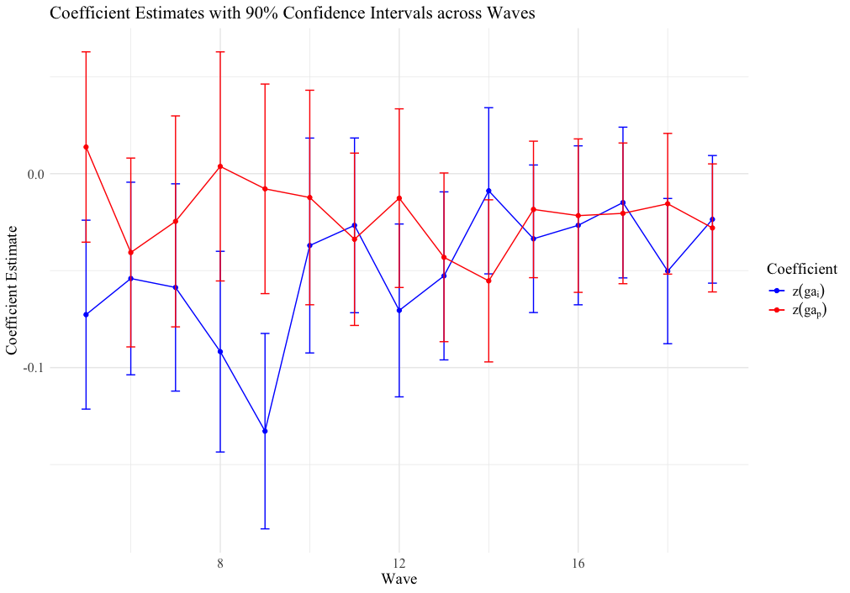
Figure D2: Woman and Partner’s Gender Attitudes Coefficient Point Estimates – Intensive Margin, Specification (b)
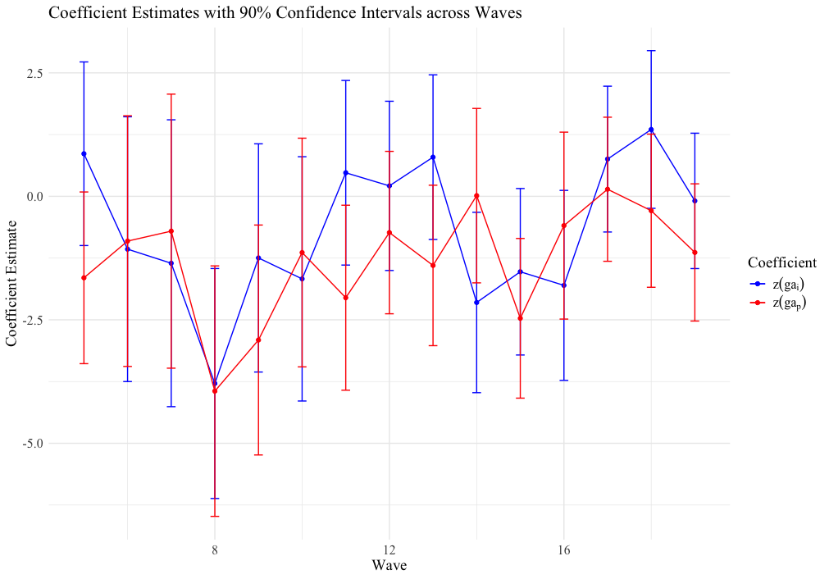

Table D22: Structural Model Estimated After Removing Kindergarten from Formal Care
 | Extensive Margin  Formal Care Utilisation Flag |  |  | Absolute-Intensive Margin  Weekly Formal Childcare Hours |  |  | Relative-Intensive Margin  Proportion of Formal Childcare Hours
 | 1a | 1b |  | 2a | 2b |  | 3a | 3b
$$z({ga}_{i})$$ | -0.0447***  (0.0066) | -0.0505***  (0.0066) |  | 0.0298  (0.2775) | -0.1846  (0.2813) |  | 0.0054  (0.0043) | 0.0056  (0.0043)
$$z({ga}_{p})$$ | -0.0215***  (0.0065) | -0.0278***  (0.0066) |  | -0.8579***  (0.2713) | -1.0821***  (0.275) |  | -0.0015  (0.0042) | -0.0011  (0.0042)
Controls
N | 6161 | 6161 |  | 3893 | 3893 |  | 3887 | 3887
Adj. R² | 0.0984 | 0.0853 |  | 0.2174 | 0.1928 |  | 0.0163 | 0.0163
Notes: [a] ⏊ p<0.15; *p<0.1; **p<0.05, ***p<0.01; [b] $z({ga}_{i})$ is the woman’s standardised gender attitudes index and $z({ga}_{p})$ is the partner’s standardised gender attitudes index; [c] Standard errors reported in brackets; [d] Specifications with suffix (a) control for labour supply using weekly hours worked; specifications with suffix (b) control for labour supply using full-time status; [e] Both specifications control for: real hourly wages; employment status, work schedule, age, country of birth, highest educational attainment, marital status, SEIFA decile, remoteness structure, number of children aged 0-4 and year fixed effects; [f] Note that questions regarding an individual’s grandparents were only asked in Waves [g] Full regression results available upon author request.
Table D23: Structural Model Estimated with Non-English-Speaking Country of Birth Interactions
 | Extensive Margin  Formal Care Utilisation Flag |  |  | Absolute-Intensive Margin  Weekly Formal Childcare Hours |  |  | Relative-Intensive Margin  Proportion of Formal Childcare Hours
 | 1a | 1b |  | 2a | 2b |  | 3a | 3b
$$z({ga}_{i})$$ | -0.0405***  (0.0066) | -0.0461***  (0.0066) |  | -0.7364***  (0.2758) | -0.9934***  (0.279) |  | -0.0019  (0.0043) | -0.0016  (0.0043)
$$z({ga}_{p})$$ | -0.0169***  (0.0065) | -0.0228***  (0.0065) |  | -1.1456***  (0.2691) | -1.3955***  (0.2722) |  | -0.0042  (0.0042) | -0.0035  (0.0042)
$${z\left({ga}_{i}\right)}^{*}{NESB}_{i}$$ | 0.0419**  (0.0181) | 0.0442**  (0.0182) |  | 3.4031***  (0.7985) | 3.4658***  (0.8097) |  | 0.045***  (0.0125) | 0.0456***  (0.0125)
$${z\left({ga}_{p}\right)}^{*}{NESB}_{p}$$ | -0.0091  (0.0191) | -0.0056  (0.0192) |  | 1.7879**  (0.8147) | 1.9608**  (0.8258) |  | 0.0039  (0.0128) | 0.0035  (0.0128)
Controls
N | 6161 | 6161 |  | 4314 | 4314 |  | 4310 | 4310
Adj. R² | 0.106 | 0.0946 |  | 0.2211 | 0.1992 |  | 0.0186 | 0.0183
Notes: [a] ⏊ p<0.15; *p<0.1; **p<0.05, ***p<0.01; [b] $z({ga}_{i})$ is the woman’s standardised gender attitudes index and $z({ga}_{p})$ is the partner’s standardised gender attitudes index; [c] Standard errors reported in brackets; [d] Specifications with suffix (a) control for labour supply using weekly hours worked; specifications with suffix (b) control for labour supply using full-time status; [e] Both specifications control for: real hourly wages; employment status, work schedule, age, country of birth, highest educational attainment, marital status, SEIFA decile, remoteness structure, number of children aged 0-4 and year fixed effects; [f] Note that questions regarding an individual’s grandparents were only asked in Waves [g] Full regression results available upon author request.

