BRIDGING THE GAP: RECOMMENDATIONS TO ACCOMPLISH TRANSITION FROM PEDIATRIC TO ADULT CARE IN ADOLESCENTS LIVING WITH OBESITY
Albert Goday,^{1,2,3,4} Gilberto Pérez,⁵ Amanda Fernández,^{6,7,8} Xavier Díaz-Carrasco,⁹ Rosaura Leis,^{3,10,11,12} Ana de Hollanda,^{3,13,14} Marta Ramon-Krauel¹⁵
¹Endocrinology and Diabetes Unit. Hospital del Mar, Barcelona, Spain
²Unit of Cardiovascular Risk and Nutrition, Institut Hospital del Mar de Investigaciones Médicas Municipal d’Investigació Médica (IMIM), Barcelona, Spain
³CIBER Physiopathology of Obesity and Nutrition (CIBEROBN), Carlos III Health Institute (ISCIII), Madrid, Spain
⁴Department of Medicine and Life Sciences (MELIS), Universitat Pompeu Fabra, Barcelona, Spain
agoday@psmar.cat
⁵EndoPedia Clinic, Madrid, Spain
gperezlopez80@gmail.com
⁶Overweight and Obesity Institute, Fundación Jiménez Díaz, Madrid, Spain
⁷Grupo de Trabajo Obesidad Infantil y en la Adolescencia, Sociedad Española para el Estudio de la Obesidad (SEEDO), Madrid, Spain
⁸Servicio Madrileño de Salud (SERMAS), Madrid, Spain
amanda.fernandezylena@gmail.com
⁹Consultori local Collbató-El Bruc, EAP Esparreguera. Institut Català de la Salut. Barcelona, Spain
dr.x.diaz@gmail.com
¹⁰Research Group of Pediatric Nutrition. Health Research Institute of Santiago (IDIS).-ISCIII.Santiago de Compostela. Spain
¹¹Unit of Investigation in Nutrition, Growth and Human Development of Galicia. University of Santiago de Compostela. Santiago de Compostela. Spain
¹²Pediatric Gastroenterology, Hepatology and Nutrition Unit. University Clinical Hospital of Santiago. Santiago de Compostela. Spain
mariarosaura.leis@usc.es
¹³Department of Endocrinology and Nutrition, Hospital Clínic Barcelona, Barcelona, Spain
¹⁴Fundació Clínic per la Recerca Biomèdica (FCRB)-Institut d’Investigacions Biomèdiques August Pi Sunyer (IDIBAPS), Barcelona, Spain
amdehol@clinic.cat
¹⁵Pediatric Endocrinology Department, Hospital Sant Joan de Déu of Barcelona, Spain; Institut de Recerca Sant Joan de Déu, Barcelona, Spain
marta.ramon@sjd.es

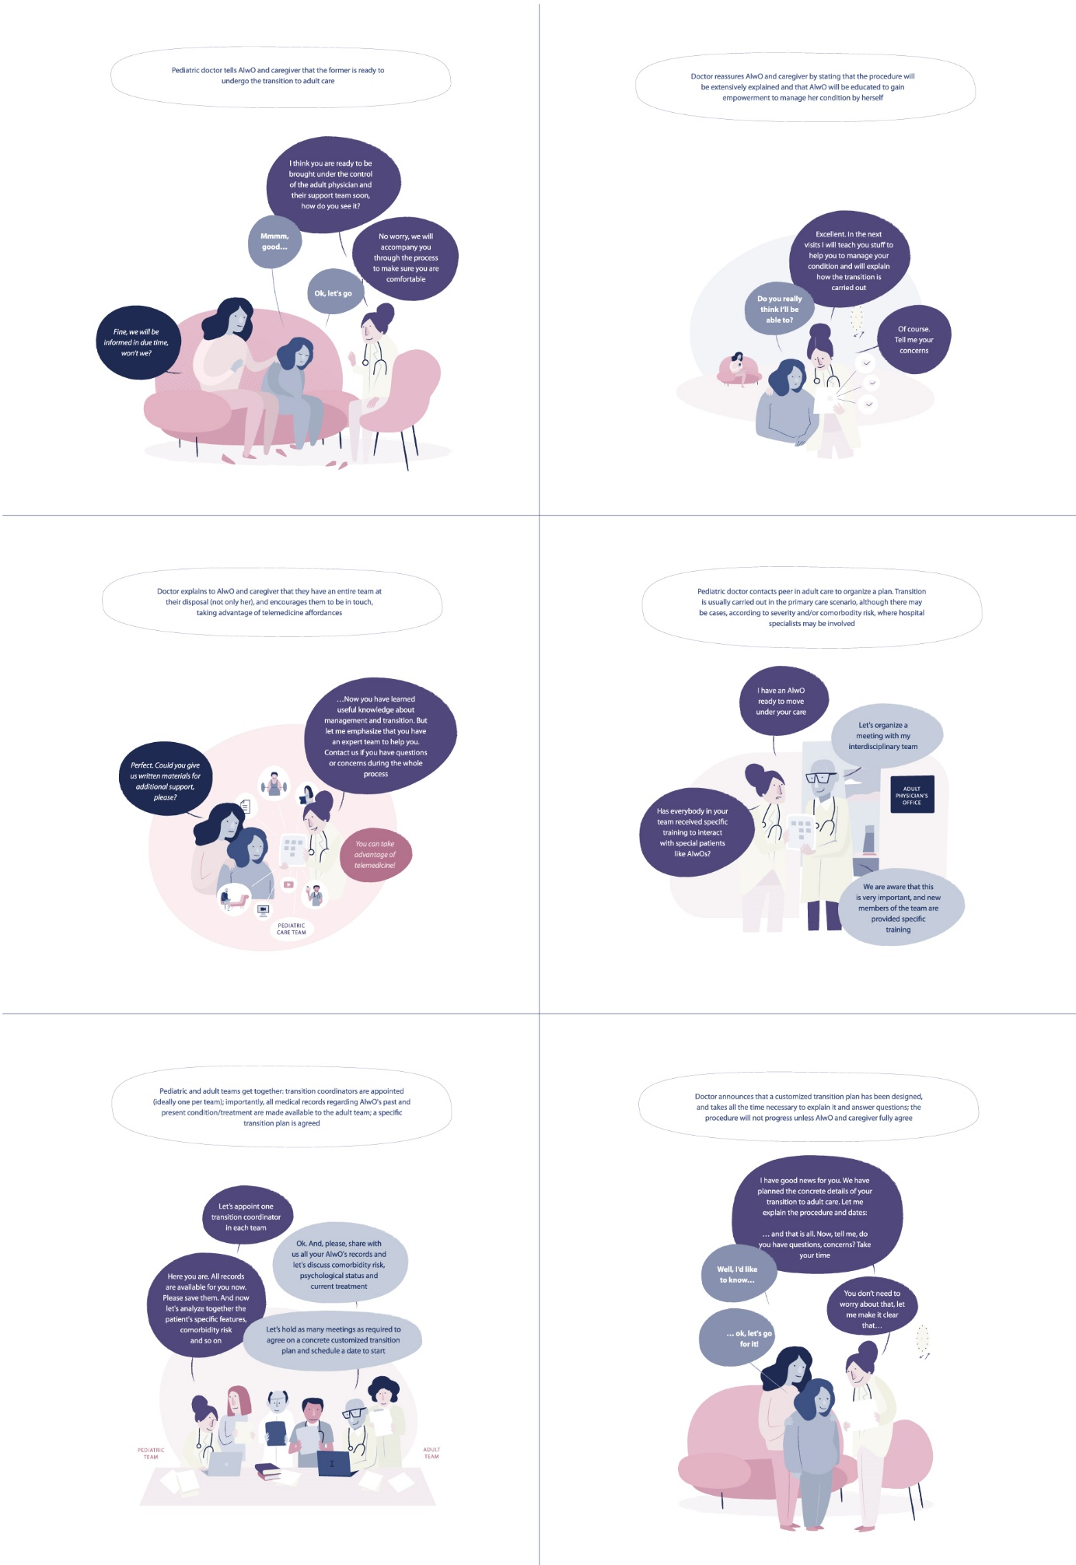
Supplementary Fig. 1 Planning transfer
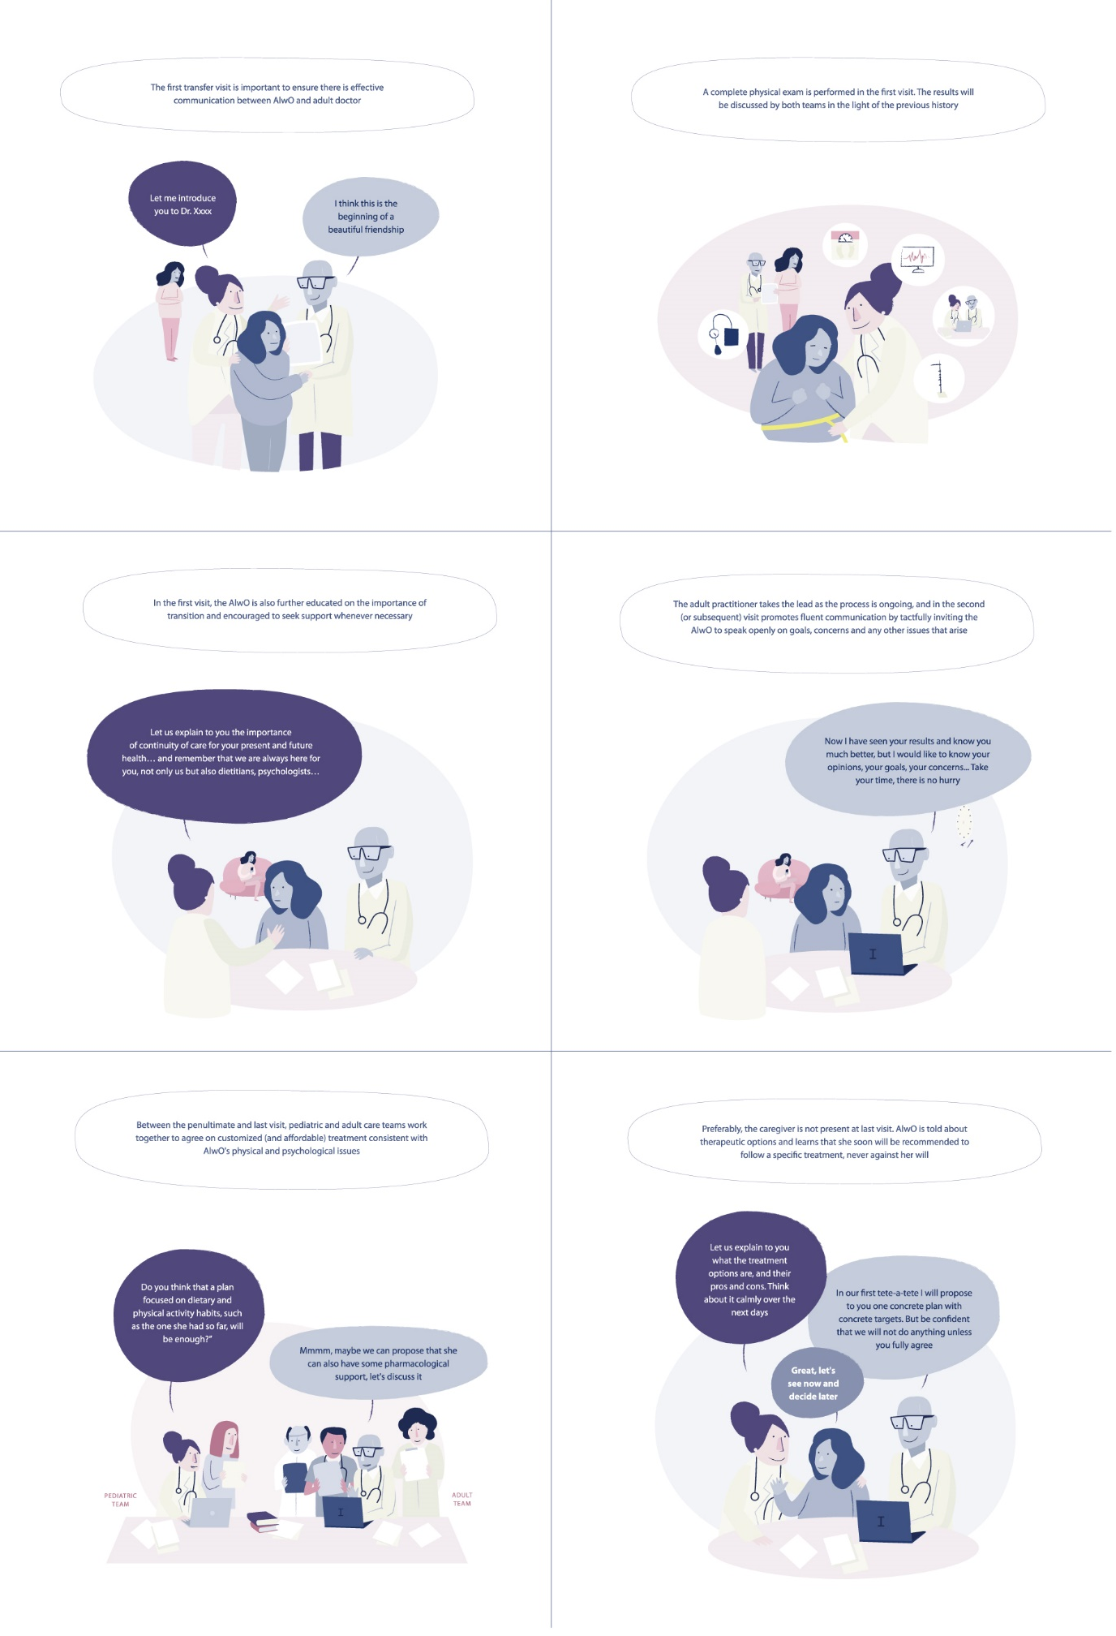
Supplementary Fig. 2 Transfer
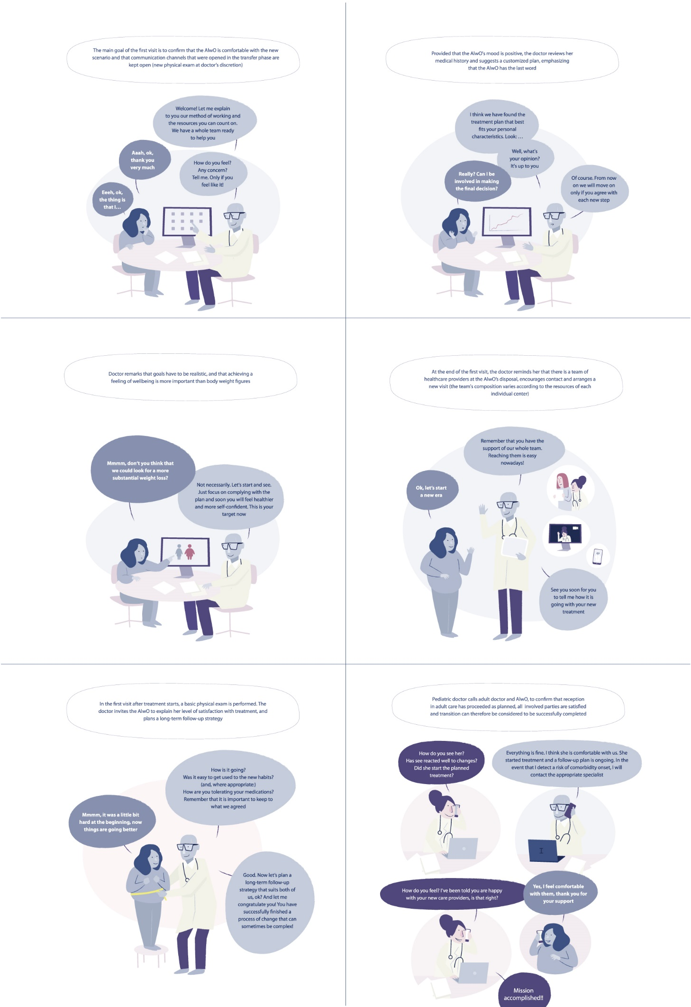
Supplementary Fig. 3 Reception in adult unit, end of the process

Supplementary Table 1. Periods of adolescence
Period | Age (years) | Hallmarks
Early adolescence | 10-14 | Insecurity, desire for intimacy, distrust of parents
Middle adolescence | 15-17 | Breakdown with the parent figure, enhanced self-confidence, risk behavior
Late adolescence | ≥18 | More realistic point of view, acceptance/reconciliation regarding own environment

Supplementary Table 2. Differences between pediatric and adult assistance
Pediatric care | Adult care
Family-orientated | Individual-focused
Developmental aspects considered | Focuses on health specifically
Coordination with schools and social services | Less communication with social services and workplace
More help with treatment regimes | More accepting of treatment refusal
More trainee supervision | Less trainee supervisión
Paternalistic | Shared treatment decisions with patient
Adapted from Robertson et al [53].

Supplementary Table 3. Quality indicators to assess the adequacy of the planned steps to achieve transfer preparation successfully
Pre-transfer
Quality indicator | Level of care | Accomplished?
Proportion of interdisciplinary team staff completing a transition training program | Health system
IT platform is available to host resources, tools, guidelines, and policy documents | Health system
There is a keyworker/clinical nurse specialist coordinating care and liaising with the intra and interdisciplinary team | Health system
There is a coordinated approach to transition for AlwOs with multiple or complex needs. Co-ordination should extend beyond specialty and organizational boundaries to include all services accessed by the young person | Health system
Fluent communication channels allowing all relevant AlwO information to be conveyed to adult providers | Health system
Clear written plan and policy for transition is shared between child and adult teams | Health system
Analyze if access to adult care is available for AlwO in terms of costs and geographic proximity | Health system
Verify that healthcare system is able to provide resources that may be needed during transition (access to nutritionists, support groups and others) | Health system
Readiness for transition is frequently assessed through conversations held during clinic appointments | Provider
Use of relevant documentation/checklists may be used to assess how ready the young person is to move to adult care | Provider
Health professionals take into account what else is happening in a young person’s life and avoid transferring them at difficult times (e.g. during major exams, during a period of illness crisis/instability) | Provider
The general practitioner is involved in the transition plan | Provider
Evidence of local arrangements to ensure that all young people who are moving from children's to adults' services have a named worker to coordinate care and support before, during and after transfer | Provider
Early information about transition and moving to adult care is given to young people and parents with information about what young people/parents can expect. What is expected of each of them throughout the transition process is made clear | Provider
Satisfaction of members of the interdisciplinary healthcare team | Provider
Information about transition is provided through different media (e.g. leaflets, websites) | Provider
The plan for transition is frequently discussed with young people and parents, decisions are shared and they have clear information about the timeline for transfer and when this will happen | Provider
Parents are asked for their opinion and feedback about whether or not the young person is ready for transition | Caregiver
Family satisfaction with preparation for transfer process | Caregiver
Achievement of transition readiness | Patient
Patient has a medical/health home | Patient
The young person and parent(s) know who to contact for transition information | Patient
Patient satisfaction with preparation for transfer process | Patient
Transfer
Quality indicator | Level of care | Accomplished?
Health professionals are aware of how to care effectively for young people regarding their dignity and that many young people are body conscious and easily embarrassed | Provider
Young people are recognized as ‘young person’, not as a child or an adult | Provider
Health professionals have good interpersonal and communication skills, good knowledge of the young person’s condition and the ability to signpost appropriately | Provider
Information given to young people is open and honest and at a level they can understand | Provider
Health professionals ensure the young person understands their health condition | Provider
A point of contact is provided for parents to make enquiries/raise concerns | Caregiver
Opportunities for parents to talk to health professionals without the young person present while maintaining the confidentiality and trust of the young person | Caregiver
Help for parents to gradually ‘take a step back’ but continue to support the young person’s self-management | Caregiver
The young person is helped to gain confidence when talking with health professionals without parent(s) being there | Patient
Patient builds a trusting relationship with adult provider | Patient
Patient understands characteristics of their condition and associated complications | Patient
Reception in adult care and later
Quality indicator | Level of care | Accomplished?
No administrative hurdles to jeopardize continuity of care or scheduling follow-up visits | Health system
Comprehensive clinical assessment at reception (also considering comorbidity risk and psychosocial complications) | Provider
Continuity-of-care ensured: AlwO is managed according to customized plan agreed with pediatric providers (usually initial continuity of pediatric stage treatment followed by gradual adaptation to adulthood peculiarities | Provider
‘Lifestyle’ advice is given (e.g., about healthy diet, alcohol, smoking, recreational drugs, exercise, sexual health, staying well) | Provider
AlwO has received/receives psychological support regarding concerns such as self-esteem, body image and others (where appropriate, access to mental health specialists is provided) | Provider
Customized follow-up plan agreed between provider and patient (follow-up visits and control tests/explorations scheduled) | Provider
Primary care should be informed if young people are failing to engage with secondary and tertiary care | Provider
Family satisfaction with the new dynamics of care | Caregiver
Independent communication with physician/nurse | Patient
Patient has good self-efficacy (i.e., ability to manage their illness day-to-day) | Patient
Patient keeps clinic visits | Patient
Patient remains adherent to treatment and medications | Patient
Disease control | Patient
Patient satisfaction with the new dynamics of care (feels supported; feels treatment makes sense) | Patient
Part of quality indicators taken from Bailey et al [69] and adapted to transition of adolescents living with obesity.

