Supplementary Material
Title: Harnessing green tide Ulva biomass for carbon dioxide sequestration
Journal: Reviews in Environmental Science and Bio/Technology
Authors:
Jihae Park ^{1,2,3}*, Hojun Lee ³*, Jonas De Saeger ^{4,5}, Stephen Depuydt ⁴, Jana Asselman ², Colin Janssen ², Philippe M. Heynderickx ^{1,6}, Di Wu ^{1,6}, Frederik Ronsse ⁶, Filip M. G. Tack ⁶, Masanori Hiraoka ^{1,7}, Lalit K. Pandey⁸, Ondrej Mašek ⁹, Yung Hung ¹⁰, and Taejun Han ^{2,3}**
Affiliations and addresses:
¹ Center for Environmental and Energy Research, Ghent University Global Campus, Songdomunhwa-ro 119-5, 21985 Incheon, Korea
² Department of Animal Sciences and Aquatic Ecology, Faculty of Bioscience Engineering, Ghent University, Wetenschapspark 1, Bluebridge 8400 Oostende, Belgium
³ Bio Environmental Science and Technology (BEST) Lab, Ghent University Global Campus, Songdomunhwa-ro 119-5, 21985 Incheon, Korea
⁴ Department of Plant Biotechnology and Bioinformatics, Ghent University, Technologiepark 71, 9052 Ghent, Belgium
⁵ VIB Center for Plant Systems Biology, Technologiepark 71, 9052 Ghent, Belgium
⁶ Department of Green Chemistry and Technology, Ghent University, 653 Coupure Links, 9000 Ghent, Belgium
⁷ Usa Marine Biological Institute, Kochi University, Inoshiri, Usa, Tosa, Kochi 781-1164, Japan
⁸ Department of Plant Science, Faculty of Applied Sciences, MJP Rohilkhand University, Bareilly, 243006, India
⁹ UK Biochar Research Centre, School of GeoSciences, University of Edinburgh, Edinburgh, EH9 3FF, UK
¹⁰ Department of Agricultural Economics, Ghent University, 9000 Ghent, Belgium
* These authors contributed equally to this work.
** Corresponding author: Taejun.Han@Ghent.ac.kr

Table S1 A comprehensive estimate of CO₂ equivalent emission reductions and economic benefits of biochar and biofertiliser applications from Ulva biomass in China and South Korea (2008–2022)

Country | Year | Total area (km²) | Dry biomass (ton) | CO₂eq (ton) by carbon contents | CO₂eq (ton)  by biochar | CO₂eq (ton)  by biofertilizer  34%–50% | Total CO₂eq (ton) | Total benefit (USD)
China | 2008 | 2,590 | 2,249,100 | 2,434,990 | 1,217,497 | 413,950–608,750 | 4,066,437–4,261,237 | 81,776,048–85,693,476
China | 2009 | 3,700 | 188,300 | 203,865 | 101,934 | 34,659–50,969 | 340,458–356,768 | 6,846,610–7,174,604
China | 2010 | 530 | 12,000 | 12,992 | 6,496 | 2,209–3,248 | 21,697–22,736 | 436,327–457,221
China | 2011 | 560 | 17,200 | 18,622 | 9,311 | 3,167–4,657 | 31,100–32,590 | 625,421–655,385
China | 2012 | 36,267 | 45,274 | 49,017 | 24,508 | 8,335–12,254 | 81,860–85,779 | 1,646,205–1,725,016
China | 2013 | 790 | 496,483 | 537,516 | 268,758 | 91,379–134,381 | 897,653–940,655 | 18,051,802–18,916,572
China | 2014 | 540 | 244,629 | 264,849 | 132,425 | 45,024–66,214 | 442,298–463,488 | 8,894,613–9,320,744
China | 2015 | 594 | 179,100 | 193,904 | 96,954 | 32,964–48,477 | 323,822–339,335 | 6,512,060–6,824,027
China | 2016 | 554 | 117,456 | 127,166 | 63,583 | 21,620–31,793 | 212,369–222,542 | 4,270,741–4,475,320
China | 2017 | 312 | 321 | 349 | 176 | 59–88 | 584–613 | 11,744–12,327
China | 2018 | ND | ND | ND | ND | ND | ND | ND
China | 2019 | ND | ND | ND | ND | ND | ND | ND
China | 2020 | ND | ND | ND | ND | ND | ND | ND
China | Total | 46,437 | 3,549,863 | 3,843,270 | 1,921,642 | 653,366–960,831 | 6,418,278–6,725,743 | 129,071,571–135,254,692
Korea | 2008 | ND | 1,000 | 1,083 | 543 | 184–272 | 1,810–1,898 | 36,399–38,169
Korea | 2011 | 1.38 | 173 | 187 | 95 | 33–48 | 315–330 | 6,335–6,636
Korea | 2012 | 1.38 | 188 | 202 | 103 | 37–51 | 342–356 | 6,878–7,159
Korea | 2013 | 1.38 | 235 | 253 | 128 | 44–66 | 425–447 | 8,547–8,989
Korea | 2014 | 1.38 | 122 | 132 | 66 | 22–33 | 220–231 | 4,424–4,645
Korea | 2015 | 1.38 | 277 | 301 | 150 | 51–77 | 502–528 | 10,095–10,618
Korea | 2016 | 1.38 | 275 | 297 | 150 | 51–77 | 498–524 | 10,015–10,538
Korea | 2017 | 1.38 | 531 | 576 | 290 | 99–147 | 965–1,013 | 19,406–20,371
Korea | 2018 | 3.00 | 330 | 356 | 180 | 62–92 | 598–628 | 12,026–12,629
Korea | 2019 | 3.00 | 694 | 752 | 378 | 128–191 | 1,258–1,321 | 25,298–26,565
Korea | 2020 | 3.00 | 1,334 | 1,446 | 723 | 246–363 | 2,415–2,532 | 48,566–50,919
Korea | 2021 | ND | 511 | 554 | 279 | 95–139 | 928–972 | 18,662–19,547
Korea | 2022 | ND | 889 | 962 | 481 | 165–242 | 1,608–1,685 | 32,337–33,885
Korea | Total | 19 | 6,559 | 7,101 | 3,566 | 1,217–1,798 | 11,884–12,465 | 238,988–250,670
The carbon content of Ulva sp. has been reported in various studies (Untawale and Dhargalkar 1986; Pérez-Lloréns et al. 1996; Altamirano et al. 2000; Kakinuma et al. 2004; Nielsen et al. 2012; Malta and de Nys 2016; Hu et al. 2017; Gao et al. 2018; Wu et al. 2018; Samanta et al. 2019; Yan et al. 2019; Hiraoka et al. 2020; Lee and Kang 2020; Lawton et al. 2021), with an average value of 29.5%. This percentage is multiplied by the dry biomass to predict the carbon content. As approximately half of the carbon in the feedstock is incorporated into the biochar (Lehmann et al. 2006), this value is multiplied by 50% to estimate the amount of carbon stored as biochar. The total CO₂ sequestered by the biochar is calculated by multiplying the carbon content by 3.67 (the ratio of the molecular weights of carbon dioxide and carbon, i.e., 44 ÷ 12 = 3.67). Based on the conversion rate (34–50%) of biochar applied to agricultural land (Sohi et al. 2009), the carbon content in the biochar is multiplied by 34% to 50% to determine the amount of carbon contributed. The total amount of CO₂ sequestered by biochar used in agriculture is then calculated by multiplying the carbon content by 3.67. Finally, the amount of CO₂ sequestered by biochar is multiplied by the average carbon market price of $20.11 per tonne of CO₂e in 2019 (World Bank) to estimate its monetary value.

Fig. S1 A literature-based hypothetical techno-economic analysis (TEA) example of Ulva biomass and biochar production in land-based aquaculture with carbon trading revenues.
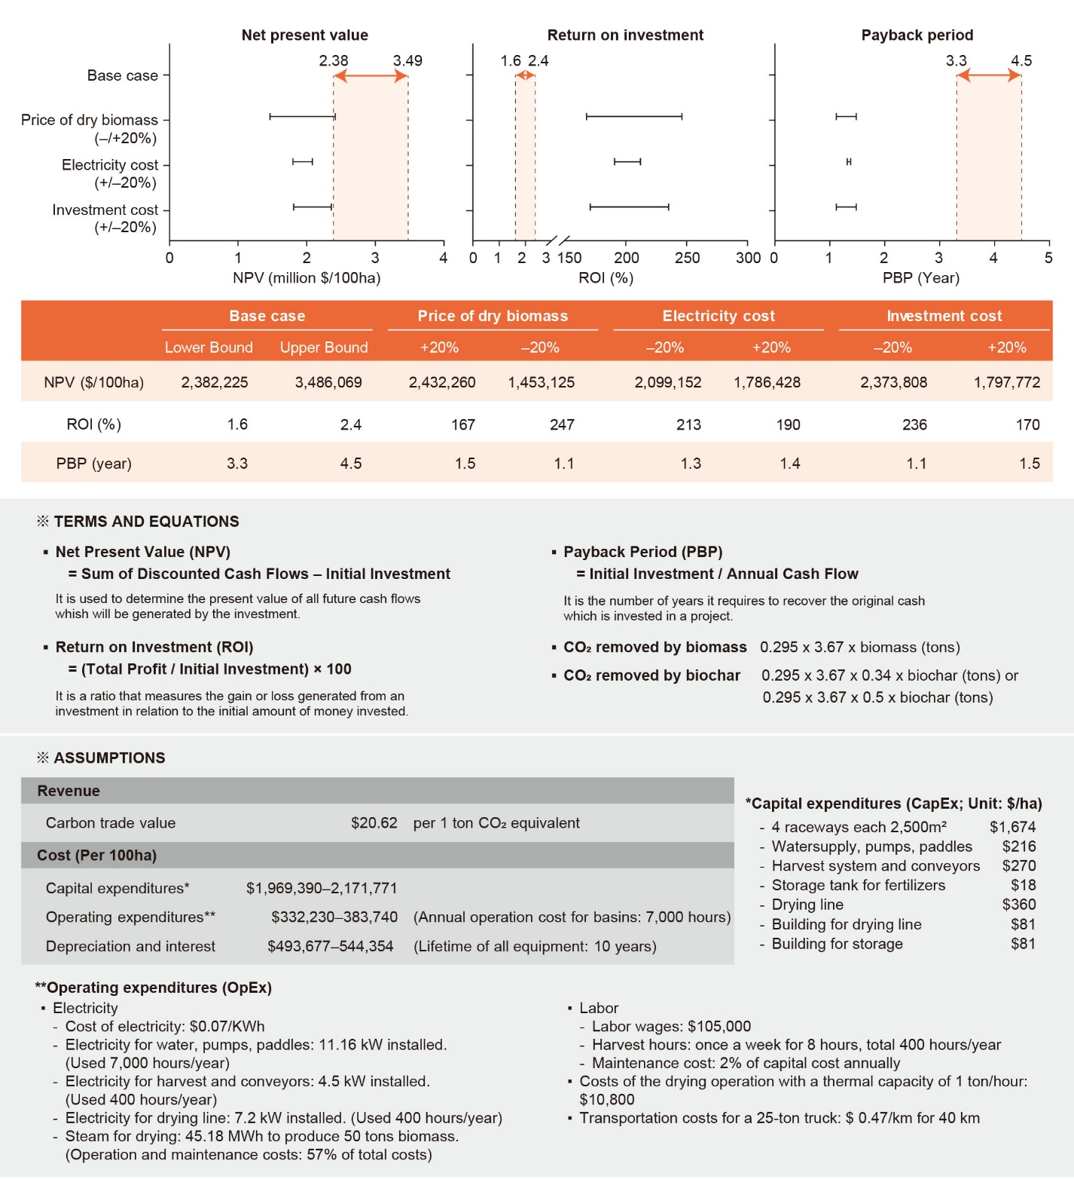

References
Altamirano M, Flores-Moya A, Conde F, Figueroa FL (2000) Growth seasonality, photosynthetic pigments, and carbon and nitrogen content in relation to environmental factors: a field study of Ulva olivascens (Ulvales, Chlorophyta). Phycologia 39:50–58. https://doi.org/10.2216/i0031-8884-39-1-50.1
Gao G, Clare AS, Rose C, Caldwell GS (2018) Ulva rigida in the future ocean: potential for carbon capture, bioremediation and biomethane production. GCB Bioenergy 10:39–51. https://doi.org/10.1111/gcbb.12465
Hiraoka M, Kinoshita Y, Higa M, Tsubaki S, Monotilla AP, Onda A, Dan A (2020) Fourfold daily growth rate in multicellular marine alga Ulva meridionalis. Sci Rep 10:12606. https://doi.org/10.1038/s41598-020-69536-4
Hu L, Hu C, Ming-Xia HE (2017) Remote estimation of biomass of Ulva prolifera macroalgae in the Yellow Sea. Remote Sens Environ 192:217–227. https://doi.org/10.1016/j.rse.2017.01.037
Kakinuma M, Kuno Y, Amano H (2004) Salinity stress responses of a sterile mutant of Ulva pertusa (Ulvales, Chlorophyta). Fisheries Sci 70:1177–1179. https://doi.org/10.1111/j.1444-2906.2004.00921.x
Lawton RJ, Sutherland JE, Glasson CR, Magnusson ME (2021) Selection of temperate Ulva species and cultivars for land-based cultivation and biomass applications. Algal Res 56:102320. https://doi.org/10.1016/j.algal.2021.102320
Lee JE, Kang JW (2020) The interactive effects of elevated temperature and nutrient concentrations on the physiological responses of Ulva linza Linnaeus (Ulvales, Chlorophyta). J Appl Phycol 32:2459–2467. https://doi.org/10.1007/s10811-019-02031-0
Lehmann J, Gaunt J, Rondon M (2006) Bio-char sequestration in terrestrial ecosystems – a review. Mitig Adapt Strat Glob Change 11:403–427. https://doi.org/10.1007/s11027-005-9006-5

Malta E, de Nys R (2016) The effect of short-term preharvest strategies on the carbon constituents of Ulva ohnoi M. Hiraoka et S. Shimada. J Appl Phycol 28:555–565. https://doi.org/10.1007/s10811-015-0543-3
Nielsen MM, Bruhn A, Rasmussen MB, Olesen B, Larsen MM, Møller HB (2012) Cultivation of Ulva lactuca with manure for simultaneous bioremediation and biomass production. J Appl Phycol 24:449–458. https://doi.org/10.1007/s10811-011-9767-z
Pérez-Lloréns JL, Vergara JJ, Pino RR, Hernández I, Peralta G, Niell FX (1996) The effect of photoacclimation on the photosynthetic physiology of Ulva curvata and Ulva rotundata (Ulvales, Chlorophyta). Eur J Phycol 31:349–359. https://doi.org/10.1080/09670269600651581
Samanta P, Shin S, Jang S, Song YC, Oh S, Kim JK (2019) Stable carbon and nitrogen isotopic characterization and tracing nutrient sources of Ulva blooms around Jeju coastal areas. Environ Pollut 254:113033. https://doi.org/10.1016/j.envpol.2019.113033
Sohi S, Shackley S, Meikel M, Pratt K, Lopez-Capel E, Haszeldine S, Gaunt J, Mašek O, Manning D, Carter S (2009) Biochar: An emerging technology for climate change mitigation?, UK Biochar Research Centre Workshop proceedings, UKBRC Working Paper 1, 1st April 2009, University of Edinburgh. https://www.biochar.ac.uk/abstract.php?id=12
Untawale AG, Dhargalkar VK (1986) Ecological studies of Ulva reticulata Forsskal in Chapora bay (Goa). Mahasagar. http://drs.nio.org/drs/handle/2264/6184
Wu H, Shin SK, Jang S, Yarish C, Kim JK (2018) Growth and nutrient bioextraction of Gracilaria chorda, G. vermiculophylla, Ulva prolifera, and U. compressa under hypo-and hyper-osmotic conditions. Algae 33:329–340. https://doi.org/10.4490/algae.2018.33.11.13
Yan L, Wang Y, Li J, Zhang Y, Ma L, Fu F, Chen B, Liu H (2019) Hydrothermal liquefaction of Ulva prolifera macroalgae and the influence of base catalysts on products. Bioresour Technol 292:121286. https://doi.org/10.1016/j.biortech.2019.03.125

