Supporting Information

TITLE: General patterns of sexual dimorphism in graylings (Thymallus), with a comparison to other salmonid species

AUTHORS: Gernot K. ENGLMAIER*, Alexander ANTONOV and Steven J. WEISS
*Corresponding author: gernot.englmaier@uni-graz.at

Table S1. Definitions of morphometric character states used in the present study following Svetovidov (1936), Pravdin (1966), and Knizhin et al. (2004). If not otherwise indicated, abbreviations follow those used by Knizhin (2009). A graphical illustration of morphometric characters is given in Fig. 2.

Morphometric  characters | Definition | Pravdin  (1966) | Knizhin  (2009)
Fork length | Distance between the anteriormost point of the head to the midpoint of the caudal fin | ac | Lsm
Trunk length | Distance between the posterior point of the head to posterior end of the last midline scale | od | l2
Snout length | Distance between the anteriormost point of the head to the anterior rim (skin fold) of the eye | an | ao
Horizontal eye diameter | Measured as the outside opening between the anterior and posterior rims of the eye (skin folds) | np | o
Postorbital length | Measured from the posterior rim of the eye (skin fold) to the most posterior point of the operculum without skin fold | po | f
Head length | Measured from the anteriormost point of the head to the posteriormost edge of the operculum without skin fold | ao | c
Head depth at nape | Measured as a vertical line from nape to the ventral side (same as head depth at occiput) | lm | ch2
Head depth through the eye | Measured as a vertical line from above the middle of the eye to the ventral side |  | ch
Forehead width | Distance between the skin folds of the eyes (interorbital distance (width)) |  | k
Upper jaw length | Distance between the anteriormost extremity to the posteriormost extremity of the upper jaw | aa6 | lmx
Upper jaw depth | Distance between the uppermost extremity to the lowermost extremity (where maximum) |  | i/lmx
Lower jaw length | Distance between the anteriormost extremity to the posteriormost extremity | k1l1 | lmd
Maximum body depth | Vertical distance from the visible base of the anteriormost unbranched dorsal fin ray (origin of dorsal fin) to ventral midline of the belly | qh | H
Minimal caudal peduncle depth | Minimum caudal-peduncle depth at any point where minimum | ik | h
Maximum width of body | Maximum body width at any point where maximum |  | w
Predorsal length | Distance between the origin of dorsal fin to anteriormost point of head | aq | aD
Postdorsal length | Measured as a distance between the projection of the dorsal fin insertion (projection to midline) to posterior end of the last midline scale | rd | pD
Preanal length | Distance between the anteriormost point of the head and the origin of anal fin | ay | aA
Prepelvic length | Distance between the anteriormost point of the head and the origin of pelvic fin | az | aV
Caudal peduncle length | Measured as a distance between the projection of the anal fin insertion (projection to midline) to posterior end of the last midline scale | fd | lp
Pectoral-pelvic distance | Distance between the pectoral-fin origin and the pelvic-fin origin | vz | PV
Pelvic-anal distance | Distance between the pelvic-fin origin and the anal-fin origin | zy | vA
Length of dorsal fin base | Distance between the origin of the dorsal fin to its insertion | qs | lD
Height of anterior part of dorsal fin | Measured along the last unbranched ray (see Svetovidov 1936) |  | hD1
Height of posterior part of dorsal fin | Measured along the fourth, counted from the fin end, branched ray (see Svetovidov 1936) |  | hD2
Length of anal fin base | Distance between the origin of the anal fin to its insertion | yy1 | lA
Height of anal fin | Measured along the length of the longest anal fin ray | ej | hA
Length of pelvic fin | Distance between the origin of the pelvic fin to the most extremity of the fin | zz1 | lV
Length of pectoral fin | Distance between the origin of the pectoral fin to the most extremity of the fin | vx | lP

Table S2. P-values from pairwise comparison of reduced major axis regressions of principal component one (PC1) on log-transformed fork length. Bold numbers represent P-values that remained significant after table-wide Bonferroni correction (significance level at α = 0.05/55 = 0.00091).

 | arcticus | baicalensis | baicalolenensis | brevirostris | burejensis | flavomaculatus | grubii | nigrescens | svetovidovi | thymallus | tugarinae
arcticus |  | 0.00000 | 0.00000 | 0.00000 | 0.00194 | 0.66162 | 0.04516 | 0.54574 | 0.12975 | 0.01580 | 0.69083
baicalensis |  |  | 0.00000 | 0.00005 | 0.00000 | 0.00000 | 0.00000 | 0.00308 | 0.68043 | 0.00000 | 0.00000
baicalolenensis |  |  |  | 0.17190 | 0.08291 | 0.00137 | 0.00021 | 0.25484 | 0.31338 | 0.02539 | 0.00408
brevirostris |  |  |  |  | 0.00861 | 0.00019 | 0.00004 | 0.11195 | 0.39192 | 0.00244 | 0.00050
burejensis |  |  |  |  |  | 0.03249 | 0.16358 | 0.61139 | 0.23412 | 0.61234 | 0.10687
flavomaculatus |  |  |  |  |  |  | 0.15803 | 0.44416 | 0.11598 | 0.07434 | 0.52762
grubii |  |  |  |  |  |  |  | 0.99982 | 0.17965 | 0.43829 | 0.45607
nigrescens |  |  |  |  |  |  |  |  | 0.19569 | 0.76979 | 0.71563
svetovidovi |  |  |  |  |  |  |  |  |  | 0.21036 | 0.14848
thymallus |  |  |  |  |  |  |  |  |  |  | 0.22681

Table S3. One-way ANOVA results of fork length (Lsm) and 28 standardized morphometric characters. Significant P-values highlighted.

Species |  | Lsm | l2 | ao | o | f | c | ch2 | ch | k | lmx
T. arcticus | SS | 0.11 | 0.00 | 0.02 | 0.01 | 0.01 | 0.01 | 0.01 | 0.02 | 0.01 | 0.03
 | MS | 0.11 | 0.00 | 0.02 | 0.01 | 0.01 | 0.01 | 0.01 | 0.02 | 0.01 | 0.03
 | F | 13.52 | 2.66 | 16.78 | 9.80 | 13.82 | 33.87 | 22.10 | 21.91 | 3.70 | 17.11
 | P-value | 0.00 | 0.11 | 0.00 | 0.00 | 0.00 | 0.00 | 0.00 | 0.00 | 0.06 | 0.00
T. baicalensis | SS | 0.11 | 0.00 | 0.02 | 0.00 | 0.02 | 0.01 | 0.01 | 0.01 | 0.03 | 0.01
 | MS | 0.11 | 0.00 | 0.02 | 0.00 | 0.02 | 0.01 | 0.01 | 0.01 | 0.03 | 0.01
 | F | 9.06 | 22.88 | 17.76 | 0.04 | 30.28 | 20.22 | 13.89 | 15.62 | 21.37 | 4.26
 | P-value | 0.00 | 0.00 | 0.00 | 0.84 | 0.00 | 0.00 | 0.00 | 0.00 | 0.00 | 0.04
T. baicalolenensis | SS | 0.14 | 0.00 | 0.00 | 0.01 | 0.00 | 0.00 | 0.00 | 0.00 | 0.00 | 0.01
 | MS | 0.14 | 0.00 | 0.00 | 0.01 | 0.00 | 0.00 | 0.00 | 0.00 | 0.00 | 0.01
 | F | 22.58 | 0.85 | 0.34 | 10.53 | 0.34 | 0.20 | 0.08 | 0.67 | 0.48 | 7.65
 | P-value | 0.00 | 0.36 | 0.56 | 0.00 | 0.56 | 0.66 | 0.78 | 0.41 | 0.49 | 0.01
T. brevirostris | SS | 0.01 | 0.00 | 0.00 | 0.00 | 0.01 | 0.00 | 0.00 | 0.00 | 0.00 | 0.01
 | MS | 0.01 | 0.00 | 0.00 | 0.00 | 0.01 | 0.00 | 0.00 | 0.00 | 0.00 | 0.01
 | F | 0.57 | 1.68 | 0.91 | 0.16 | 3.01 | 1.46 | 0.65 | 0.85 | 0.88 | 2.35
 | P-value | 0.46 | 0.20 | 0.35 | 0.69 | 0.09 | 0.23 | 0.42 | 0.36 | 0.35 | 0.13
T. burejensis | SS | 0.00 | 0.00 | 0.01 | 0.00 | 0.00 | 0.00 | 0.00 | 0.00 | 0.00 | 0.00
 | MS | 0.00 | 0.00 | 0.01 | 0.00 | 0.00 | 0.00 | 0.00 | 0.00 | 0.00 | 0.00
 | F | 0.58 | 0.34 | 23.27 | 0.46 | 0.35 | 3.32 | 2.44 | 1.42 | 1.73 | 0.52
 | P-value | 0.45 | 0.56 | 0.00 | 0.50 | 0.56 | 0.07 | 0.12 | 0.24 | 0.19 | 0.48
T. flavomaculatus | SS | 0.01 | 0.00 | 0.00 | 0.00 | 0.00 | 0.00 | 0.00 | 0.00 | 0.00 | 0.00
 | MS | 0.01 | 0.00 | 0.00 | 0.00 | 0.00 | 0.00 | 0.00 | 0.00 | 0.00 | 0.00
 | F | 2.00 | 3.93 | 0.01 | 0.76 | 1.10 | 0.21 | 1.14 | 0.37 | 2.70 | 3.18
 | P-value | 0.16 | 0.05 | 0.93 | 0.39 | 0.30 | 0.65 | 0.29 | 0.54 | 0.11 | 0.08
T. grubii | SS | 0.09 | 0.00 | 0.00 | 0.00 | 0.00 | 0.00 | 0.00 | 0.00 | 0.00 | 0.01
 | MS | 0.09 | 0.00 | 0.00 | 0.00 | 0.00 | 0.00 | 0.00 | 0.00 | 0.00 | 0.01
 | F | 16.27 | 1.01 | 3.94 | 1.26 | 2.95 | 1.62 | 0.43 | 1.62 | 0.10 | 9.10
 | P-value | 0.00 | 0.32 | 0.05 | 0.26 | 0.09 | 0.21 | 0.51 | 0.20 | 0.75 | 0.00
T. nigrescens | SS | 0.00 | 0.00 | 0.00 | 0.00 | 0.00 | 0.00 | 0.00 | 0.00 | 0.00 | 0.00
 | MS | 0.00 | 0.00 | 0.00 | 0.00 | 0.00 | 0.00 | 0.00 | 0.00 | 0.00 | 0.00
 | F | 2.06 | 0.61 | 1.46 | 0.20 | 0.54 | 2.31 | 0.05 | 0.42 | 4.91 | 1.39
 | P-value | 0.16 | 0.44 | 0.24 | 0.66 | 0.47 | 0.14 | 0.83 | 0.52 | 0.04 | 0.25
T. svetovidovi | SS | 0.00 | 0.00 | 0.00 | 0.00 | 0.00 | 0.00 | 0.00 | 0.00 | 0.00 | 0.00
 | MS | 0.00 | 0.00 | 0.00 | 0.00 | 0.00 | 0.00 | 0.00 | 0.00 | 0.00 | 0.00
 | F | 0.21 | 1.40 | 3.80 | 0.36 | 2.67 | 1.86 | 1.58 | 2.26 | 0.58 | 0.03
 | P-value | 0.65 | 0.25 | 0.06 | 0.55 | 0.12 | 0.19 | 0.22 | 0.15 | 0.46 | 0.87
T. thymallus | SS | 0.05 | 0.00 | 0.00 | 0.00 | 0.00 | 0.00 | 0.00 | 0.00 | 0.01 | 0.00
 | MS | 0.05 | 0.00 | 0.00 | 0.00 | 0.00 | 0.00 | 0.00 | 0.00 | 0.01 | 0.00
 | F | 15.00 | 0.29 | 3.93 | 0.02 | 0.51 | 1.44 | 0.01 | 4.43 | 6.52 | 2.60
 | P-value | 0.00 | 0.59 | 0.05 | 0.90 | 0.48 | 0.23 | 0.94 | 0.04 | 0.01 | 0.11
T. tugarinae | SS | 0.01 | 0.00 | 0.00 | 0.00 | 0.00 | 0.00 | 0.00 | 0.00 | 0.00 | 0.00
 | MS | 0.01 | 0.00 | 0.00 | 0.00 | 0.00 | 0.00 | 0.00 | 0.00 | 0.00 | 0.00
 | F | 3.69 | 0.14 | 0.03 | 11.21 | 0.29 | 0.06 | 1.84 | 1.99 | 0.01 | 0.18
 | P-value | 0.06 | 0.71 | 0.85 | 0.00 | 0.59 | 0.81 | 0.18 | 0.16 | 0.93 | 0.67

Table S3. Continued

Species |  | i/lmx | lmd | H | h | w | А-D | P-D | A-A | A-V | lp
T. arcticus | SS | 0.01 | 0.02 | 0.00 | 0.00 | 0.00 | 0.00 | 0.00 | 0.00 | 0.00 | 0.00
 | MS | 0.01 | 0.02 | 0.00 | 0.00 | 0.00 | 0.00 | 0.00 | 0.00 | 0.00 | 0.00
 | F | 3.28 | 21.97 | 0.04 | 0.97 | 1.30 | 0.43 | 0.79 | 19.05 | 5.51 | 0.11
 | P-value | 0.07 | 0.00 | 0.85 | 0.33 | 0.26 | 0.51 | 0.38 | 0.00 | 0.02 | 0.74
T. baicalensis | SS | 0.05 | 0.01 | 0.00 | 0.01 | 0.00 | 0.00 | 0.01 | 0.00 | 0.00 | 0.00
 | MS | 0.05 | 0.01 | 0.00 | 0.01 | 0.00 | 0.00 | 0.01 | 0.00 | 0.00 | 0.00
 | F | 23.43 | 10.74 | 0.25 | 14.06 | 1.32 | 13.86 | 43.29 | 17.07 | 0.01 | 0.09
 | P-value | 0.00 | 0.00 | 0.62 | 0.00 | 0.25 | 0.00 | 0.00 | 0.00 | 0.93 | 0.76
T. baicalolenensis | SS | 0.00 | 0.00 | 0.00 | 0.00 | 0.00 | 0.02 | 0.00 | 0.00 | 0.00 | 0.00
 | MS | 0.00 | 0.00 | 0.00 | 0.00 | 0.00 | 0.02 | 0.00 | 0.00 | 0.00 | 0.00
 | F | 0.14 | 3.29 | 0.26 | 5.10 | 0.20 | 45.60 | 14.50 | 61.81 | 23.93 | 2.17
 | P-value | 0.70 | 0.07 | 0.61 | 0.02 | 0.65 | 0.00 | 0.00 | 0.00 | 0.00 | 0.14
T. brevirostris | SS | 0.01 | 0.00 | 0.00 | 0.00 | 0.00 | 0.00 | 0.00 | 0.00 | 0.00 | 0.00
 | MS | 0.01 | 0.00 | 0.00 | 0.00 | 0.00 | 0.00 | 0.00 | 0.00 | 0.00 | 0.00
 | F | 3.06 | 0.89 | 0.20 | 0.00 | 1.07 | 5.39 | 2.42 | 0.65 | 0.53 | 0.06
 | P-value | 0.09 | 0.35 | 0.66 | 0.96 | 0.31 | 0.02 | 0.13 | 0.43 | 0.47 | 0.81
T. burejensis | SS | 0.00 | 0.00 | 0.00 | 0.00 | 0.01 | 0.00 | 0.00 | 0.00 | 0.00 | 0.00
 | MS | 0.00 | 0.00 | 0.00 | 0.00 | 0.01 | 0.00 | 0.00 | 0.00 | 0.00 | 0.00
 | F | 0.44 | 0.11 | 3.62 | 0.13 | 12.10 | 0.90 | 0.52 | 0.57 | 0.01 | 0.19
 | P-value | 0.51 | 0.74 | 0.06 | 0.72 | 0.00 | 0.35 | 0.47 | 0.45 | 0.94 | 0.67
T. flavomaculatus | SS | 0.00 | 0.00 | 0.00 | 0.00 | 0.00 | 0.00 | 0.00 | 0.00 | 0.00 | 0.00
 | MS | 0.00 | 0.00 | 0.00 | 0.00 | 0.00 | 0.00 | 0.00 | 0.00 | 0.00 | 0.00
 | F | 3.55 | 0.04 | 0.26 | 5.35 | 0.04 | 0.55 | 0.08 | 0.00 | 0.15 | 0.10
 | P-value | 0.07 | 0.83 | 0.62 | 0.03 | 0.84 | 0.46 | 0.78 | 0.96 | 0.70 | 0.75
T. grubii | SS | 0.00 | 0.00 | 0.00 | 0.00 | 0.08 | 0.01 | 0.00 | 0.00 | 0.00 | 0.00
 | MS | 0.00 | 0.00 | 0.00 | 0.00 | 0.08 | 0.01 | 0.00 | 0.00 | 0.00 | 0.00
 | F | 0.16 | 2.72 | 3.36 | 7.90 | 5.76 | 18.72 | 8.26 | 19.20 | 8.80 | 2.13
 | P-value | 0.69 | 0.10 | 0.07 | 0.01 | 0.02 | 0.00 | 0.00 | 0.00 | 0.00 | 0.15
T. nigrescens | SS | 0.01 | 0.00 | 0.00 | 0.00 | 0.00 | 0.00 | 0.00 | 0.00 | 0.00 | 0.00
 | MS | 0.01 | 0.00 | 0.00 | 0.00 | 0.00 | 0.00 | 0.00 | 0.00 | 0.00 | 0.00
 | F | 9.17 | 3.69 | 0.14 | 5.52 | 1.16 | 0.63 | 0.01 | 6.20 | 2.45 | 0.07
 | P-value | 0.01 | 0.06 | 0.71 | 0.03 | 0.29 | 0.43 | 0.91 | 0.02 | 0.13 | 0.79
T. svetovidovi | SS | 0.00 | 0.00 | 0.00 | 0.00 | 0.00 | 0.00 | 0.00 | 0.00 | 0.00 | 0.00
 | MS | 0.00 | 0.00 | 0.00 | 0.00 | 0.00 | 0.00 | 0.00 | 0.00 | 0.00 | 0.00
 | F | 0.02 | 0.07 | 0.16 | 1.03 | 0.28 | 2.53 | 2.58 | 1.09 | 1.29 | 0.54
 | P-value | 0.89 | 0.79 | 0.69 | 0.32 | 0.60 | 0.13 | 0.12 | 0.31 | 0.27 | 0.47
T. thymallus | SS | 0.00 | 0.00 | 0.00 | 0.00 | 0.02 | 0.00 | 0.00 | 0.00 | 0.00 | 0.00
 | MS | 0.00 | 0.00 | 0.00 | 0.00 | 0.02 | 0.00 | 0.00 | 0.00 | 0.00 | 0.00
 | F | 1.22 | 4.60 | 1.74 | 6.43 | 12.24 | 6.36 | 20.04 | 10.81 | 4.79 | 0.00
 | P-value | 0.27 | 0.03 | 0.19 | 0.01 | 0.00 | 0.01 | 0.00 | 0.00 | 0.03 | 0.97
T. tugarinae | SS | 0.00 | 0.00 | 0.00 | 0.00 | 0.00 | 0.00 | 0.00 | 0.00 | 0.00 | 0.00
 | MS | 0.00 | 0.00 | 0.00 | 0.00 | 0.00 | 0.00 | 0.00 | 0.00 | 0.00 | 0.00
 | F | 0.37 | 0.13 | 1.45 | 0.08 | 0.29 | 15.75 | 2.97 | 5.66 | 1.78 | 0.08
 | P-value | 0.54 | 0.72 | 0.23 | 0.77 | 0.59 | 0.00 | 0.09 | 0.02 | 0.19 | 0.78

Table S3. Continued

Species |  | pV | vA | lD | hD1 | hD2 | lA | hA | lV | lP
T. arcticus | SS | 0.01 | 0.01 | 0.01 | 0.02 | 0.49 | 0.03 | 0.02 | 0.13 | 0.02
 | MS | 0.01 | 0.01 | 0.01 | 0.02 | 0.49 | 0.03 | 0.02 | 0.13 | 0.02
 | F | 13.28 | 14.77 | 8.95 | 9.14 | 38.39 | 27.26 | 8.73 | 23.64 | 19.43
 | P-value | 0.00 | 0.00 | 0.00 | 0.00 | 0.00 | 0.00 | 0.00 | 0.00 | 0.00
T. baicalensis | SS | 0.01 | 0.01 | 0.09 | 0.17 | 3.27 | 0.07 | 0.24 | 0.24 | 0.03
 | MS | 0.01 | 0.01 | 0.09 | 0.17 | 3.27 | 0.07 | 0.24 | 0.24 | 0.03
 | F | 27.09 | 15.94 | 85.93 | 90.35 | 265.19 | 50.04 | 154.40 | 155.40 | 24.34
 | P-value | 0.00 | 0.00 | 0.00 | 0.00 | 0.00 | 0.00 | 0.00 | 0.00 | 0.00
T. baicalolenensis | SS | 0.01 | 0.00 | 0.10 | 0.19 | 2.87 | 0.05 | 0.20 | 0.19 | 0.01
 | MS | 0.01 | 0.00 | 0.10 | 0.19 | 2.87 | 0.05 | 0.20 | 0.19 | 0.01
 | F | 33.17 | 6.80 | 82.58 | 69.65 | 536.79 | 47.70 | 170.63 | 228.19 | 20.81
 | P-value | 0.00 | 0.01 | 0.00 | 0.00 | 0.00 | 0.00 | 0.00 | 0.00 | 0.00
T. brevirostris | SS | 0.00 | 0.00 | 0.00 | 0.00 | 0.01 | 0.00 | 0.03 | 0.00 | 0.00
 | MS | 0.00 | 0.00 | 0.00 | 0.00 | 0.01 | 0.00 | 0.03 | 0.00 | 0.00
 | F | 0.28 | 0.25 | 1.92 | 4.66 | 2.62 | 0.01 | 13.14 | 4.33 | 0.50
 | P-value | 0.60 | 0.62 | 0.17 | 0.04 | 0.11 | 0.93 | 0.00 | 0.04 | 0.48
T. burejensis | SS | 0.00 | 0.00 | 0.00 | 0.00 | 0.02 | 0.00 | 0.00 | 0.01 | 0.00
 | MS | 0.00 | 0.00 | 0.00 | 0.00 | 0.02 | 0.00 | 0.00 | 0.01 | 0.00
 | F | 3.51 | 0.45 | 4.37 | 1.91 | 4.42 | 0.81 | 1.69 | 11.81 | 4.44
 | P-value | 0.07 | 0.50 | 0.04 | 0.17 | 0.04 | 0.37 | 0.20 | 0.00 | 0.04
T. flavomaculatus | SS | 0.00 | 0.00 | 0.00 | 0.01 | 0.14 | 0.00 | 0.00 | 0.01 | 0.00
 | MS | 0.00 | 0.00 | 0.00 | 0.01 | 0.14 | 0.00 | 0.00 | 0.01 | 0.00
 | F | 0.00 | 0.36 | 2.02 | 4.47 | 30.11 | 1.02 | 3.31 | 7.75 | 0.66
 | P-value | 0.99 | 0.55 | 0.16 | 0.04 | 0.00 | 0.32 | 0.08 | 0.01 | 0.42
T. grubii | SS | 0.00 | 0.00 | 0.03 | 0.07 | 1.03 | 0.05 | 0.12 | 0.06 | 0.00
 | MS | 0.00 | 0.00 | 0.03 | 0.07 | 1.03 | 0.05 | 0.12 | 0.06 | 0.00
 | F | 7.99 | 0.56 | 41.80 | 31.25 | 178.59 | 38.84 | 117.29 | 69.93 | 8.87
 | P-value | 0.01 | 0.46 | 0.00 | 0.00 | 0.00 | 0.00 | 0.00 | 0.00 | 0.00
T. nigrescens | SS | 0.00 | 0.00 | 0.00 | 0.02 | 0.08 | 0.01 | 0.04 | 0.01 | 0.00
 | MS | 0.00 | 0.00 | 0.00 | 0.02 | 0.08 | 0.01 | 0.04 | 0.01 | 0.00
 | F | 10.44 | 0.97 | 1.11 | 31.86 | 59.13 | 1.87 | 45.64 | 26.49 | 4.23
 | P-value | 0.00 | 0.33 | 0.30 | 0.00 | 0.00 | 0.18 | 0.00 | 0.00 | 0.05
T. svetovidovi | SS | 0.00 | 0.00 | 0.00 | 0.01 | 0.03 | 0.00 | 0.01 | 0.00 | 0.00
 | MS | 0.00 | 0.00 | 0.00 | 0.01 | 0.03 | 0.00 | 0.01 | 0.00 | 0.00
 | F | 0.23 | 2.71 | 5.84 | 4.03 | 39.12 | 3.40 | 15.24 | 5.12 | 0.39
 | P-value | 0.63 | 0.11 | 0.02 | 0.06 | 0.00 | 0.08 | 0.00 | 0.03 | 0.54
T. thymallus | SS | 0.00 | 0.00 | 0.02 | 0.02 | 0.55 | 0.02 | 0.01 | 0.02 | 0.00
 | MS | 0.00 | 0.00 | 0.02 | 0.02 | 0.55 | 0.02 | 0.01 | 0.02 | 0.00
 | F | 2.33 | 1.49 | 26.62 | 15.96 | 134.86 | 21.86 | 17.86 | 51.38 | 2.15
 | P-value | 0.13 | 0.22 | 0.00 | 0.00 | 0.00 | 0.00 | 0.00 | 0.00 | 0.15
T. tugarinae | SS | 0.00 | 0.00 | 0.00 | 0.02 | 0.14 | 0.01 | 0.04 | 0.04 | 0.00
 | MS | 0.00 | 0.00 | 0.00 | 0.02 | 0.14 | 0.01 | 0.04 | 0.04 | 0.00
 | F | 2.20 | 0.02 | 5.79 | 17.89 | 37.18 | 11.10 | 47.13 | 33.91 | 1.01
 | P-value | 0.14 | 0.88 | 0.02 | 0.00 | 0.00 | 0.00 | 0.00 | 0.00 | 0.32

Table S4. Blomberg’s K (P-values based on 1000 randomizations) and Pagel's λ (P-values based on LR tests).

 | Blomberg's K |  | Pagel's λ
 | K | P-value | λ | logL(λ) | LR(λ=0) | P-value
Trunk length (l2) | 0.481 | 0.487 | 0.00007 | 49.7332 | -0.00021 | 1
Snout length (ao) | 0.487 | 0.452 | 0.00007 | 31.207 | -0.00031 | 1
Horizontal eye diameter (o) | 0.765 | 0.161 | 0.00007 | 36.2158 | -0.00007 | 1
Postorbital length (f) | 0.394 | 0.691 | 0.00007 | 35.2449 | -0.00038 | 1
Head length (c) | 0.546 | 0.414 | 0.00007 | 37.4834 | -0.00026 | 1
Head depth at nape (ch2) | 0.436 | 0.564 | 0.00007 | 38.2544 | -0.00024 | 1
Head depth through the eye (ch) | 0.536 | 0.409 | 0.00007 | 35.062 | -0.00027 | 1
Forehead width (k) | 0.51 | 0.387 | 0.00007 | 35.6446 | -0.00034 | 1
Upper jaw length (lmx) | 0.622 | 0.292 | 0.00007 | 30.0929 | -0.00022 | 1
Upper jaw depth (i/lmx) | 0.495 | 0.435 | 0.00007 | 29.8849 | -0.00033 | 1
Lower jaw length (lmd) | 0.633 | 0.243 | 0.00007 | 34.1626 | -0.00023 | 1
Maximum body depth (H) | 0.582 | 0.304 | 0.00007 | 43.4853 | -0.0001 | 1
Minimal caudal peduncle depth (h) | 0.597 | 0.242 | 0.00007 | 41.4663 | -0.00011 | 1
Maximum width of body (w) | 0.394 | 0.693 | 0.00007 | 31.0226 | -0.00018 | 1
Predorsal length (aD) | 0.547 | 0.362 | 0.00007 | 42.1979 | -0.00029 | 1
Postdorsal length (pD) | 0.259 | 0.877 | 0.00007 | 40.985 | -0.00043 | 1
Preanal length (aA) | 0.529 | 0.419 | 0.00007 | 50.29 | -0.00018 | 1
Prepelvic length (aV) | 0.33 | 0.809 | 0.00007 | 45.6038 | -0.00027 | 1
Caudal peduncle length (lp) | 0.531 | 0.405 | 0.00007 | 47.7228 | -0.00005 | 1
Pectoral-pelvic distance (pV) | 0.342 | 0.732 | 0.00007 | 39.9498 | -0.0003 | 1
Pelvic-anal distance (vA) | 0.49 | 0.486 | 0.00007 | 39.5822 | -0.00015 | 1
Length of the dorsal fin base (lD) | 0.285 | 0.826 | 0.00007 | 37.4866 | -0.00037 | 1
Height of anterior part of dorsal fin (hD1) | 0.483 | 0.476 | 0.00007 | 34.6178 | -0.00026 | 1
Height of posterior part of dorsal fin (hD2) | 0.508 | 0.394 | 0.00007 | 17.3397 | -0.00016 | 1
Length of anal fin base (lA) | 0.433 | 0.595 | 0.00007 | 30.6154 | -0.00029 | 1
Height of anal fin (hA) | 0.343 | 0.758 | 0.00007 | 27.3049 | -0.00016 | 1
Length of pelvic fin (lV) | 0.788 | 0.087 | 0.95082 | 31.8867 | 0.36949 | 0.543
Length of pectoral fin (lP) | 0.781 | 0.169 | 0.00007 | 40.8743 | -0.0001 | 1

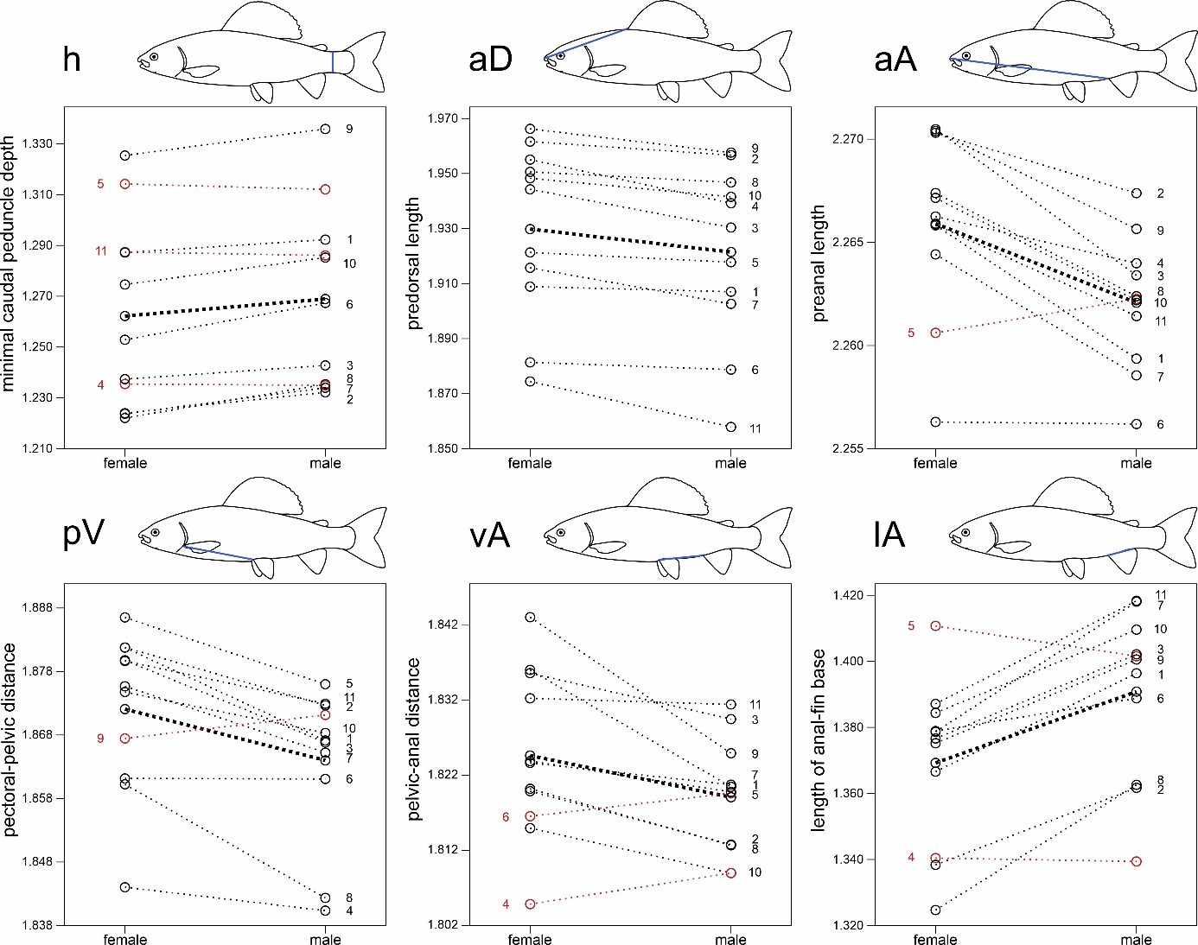
Fig. S1. Comparison of pairwise differences (least square means) for significant (two-way ANOVA, significant after table-wide Bonferroni correction) sexually dimorphic traits of the caudal peduncle, abdomen and anal fin. Bold lines represent mean values for all species. In red (and labelled on the left side) are species with a divergent trend from the mean. 1 = T. arcticus, 2 = T. baicalensis, 3 = T. baicalolenensis, 4 = T. brevirostris, 5 = T. burejensis, 6 = T. flavomaculatus, 7 = T. grubii, 8 = T. nigrescens, 9 = T. svetovidovi, 10 = T. thymallus, 11 = T. tugarinae.

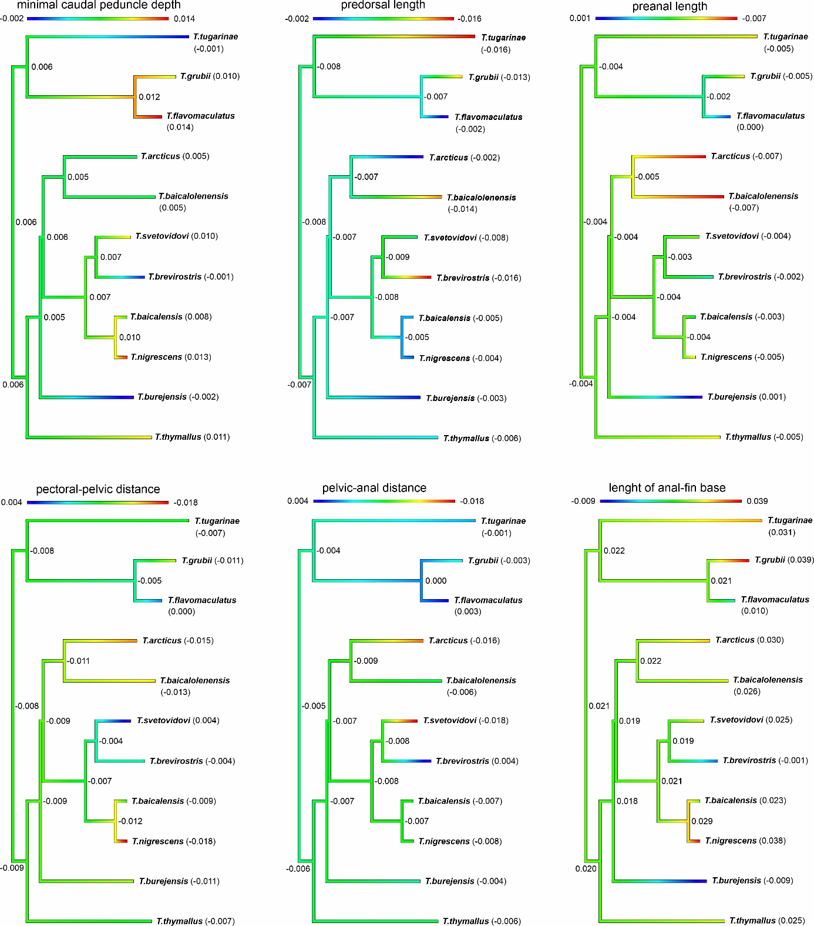

Fig. S2. Ancestral state reconstruction of the degree of sexual dimorphism for significant sexually dimorphic traits of the caudal peduncle, abdomen and anal fin (red = most dimorphic, blue = least dimorphic). Thymallus aeliani, T. brevicephalus, T. ligericus, and T. nikolskyi were excluded from ancestral state reconstruction due to missing morphological data. Negative values indicate a female-biased trait.

