A review of marine stressors impacting Atlantic salmon Salmo salar, with an assessment of the major threats to English stocks
Supplementary Information

Jonathan P. Gillson^{1*}, Tea Bašić¹, Phil I. Davison¹, William D. Riley¹, Lawrence Talks², Alan Walker¹ and Ian C. Russell¹

¹The Centre for Environment, Fisheries and Aquaculture Science, Pakefield Road, Lowestoft, Suffolk, NR33 0HT, UK
²Environment Agency, Romsey Depot, Canal Walk, Romsey, Hampshire, SO51 7LP, UK
*Corresponding author: Jonathan Gillson (jonathan.gillson@cefas.co.uk)
Target journal: Reviews in Fish Biology and Fisheries

Supplementary methods 1
Climate change 1
Fig. S1 Central estimates (50% probability level) of future UK mean annual air temperature projections (UKCP09) in the marine environment under three greenhouse gas emission scenarios (low, medium, and high) for the 2020s, 2050s and 2080s 1
Fig. S2 Central estimates (50% probability level) of future UK mean annual air temperature anomaly projections (UKCP18) at 1.5 m across land relative to the baseline period from 1981 to 2010 under three greenhouse gas emission scenarios (low, medium, and high) for the 2020s, 2050s and 2080s 2
Predation 3
Water quality 3
Fig. S3 Percentage of transitional and coastal water bodies affected by point source or diffuse pollution pressures in the UK and the Republic of Ireland 3
Bycatch 3
Fig. S4 Distribution of pelagic fishing effort around estuarine and nearshore waters in England 4
Artificial light at night 4
Fig. S5 Artificial light at night (ALAN) radiance levels in the UK in 2018 5
Tidal barrages 5
Power station impingement and thermal discharge 5
Fig. S6 Location of (a) nuclear, (b) coal, and (c) gas power stations in the UK 6
Noise pollution from pile-driving 6
Fig. S7 Location of impact pile-driving sounds below 10 kHz in the North Sea, English Channel, and Irish Sea between 2015 and 2017 7
Invasive non-native species 7
Electromagnetic fields 7
Fig. S8 Location of subsea cables laid around nearshore waters in England 8
Fisheries exploitation 8
Salmon mariculture 8
Tidal lagoons 8
Fig. S9 Location of tidal lease areas available in England 9
Supplementary results 10
Table S1 Classification of the different marine stressors along the (a) effects and (b) development axes for Atlantic salmon in the North East marine plan area 10
Table S2 Classification of the different marine stressors along the (a) effects and (b) development axes for Atlantic salmon in the South marine plan area 12
Table S3 Classification of the different marine stressors along the (a) effects and (b) development axes for Atlantic salmon in the South West marine plan area 14
Table S4 Classification of the different marine stressors along the (a) effects and (b) development axes for Atlantic salmon in the North West marine plan area 16
Supplementary references 18

Supplementary methods

Climate change
Climate change is a diffuse stressor that has and will continue to have geographically varying effects on the temperature of freshwater, estuarine and marine ecosystems around the UK (Murphy et al. 2009; Lowe et al. 2019). Future UK climate change projections indicate a north-south warming gradient, with higher increases in mean annual air temperature expected in the south due to the closer proximity of continental Europe (Fig. S1 and S2).
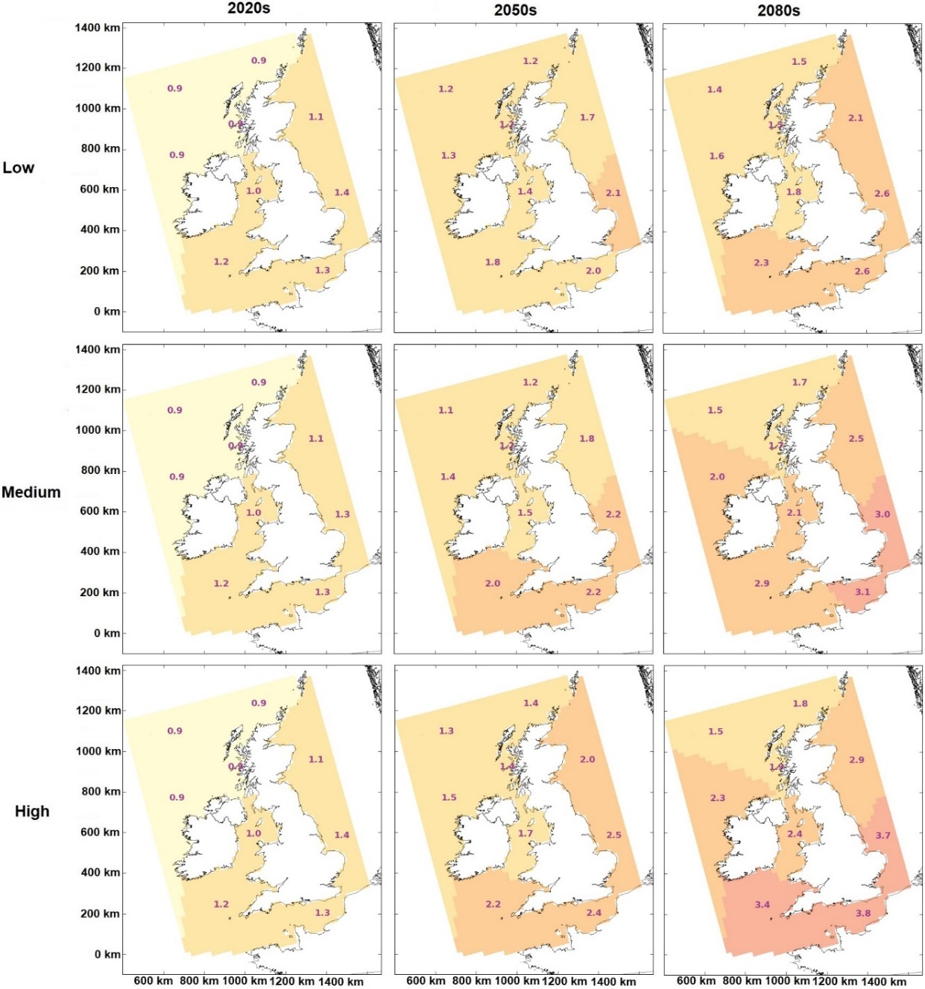
Fig. S1 Central estimates (50% probability level) of future UK mean annual air temperature projections (UKCP09) in the marine environment under three greenhouse gas emission scenarios (low, medium, and high) for the 2020s, 2050s and 2080s. Figure reproduced from Murphy et al. (2009)
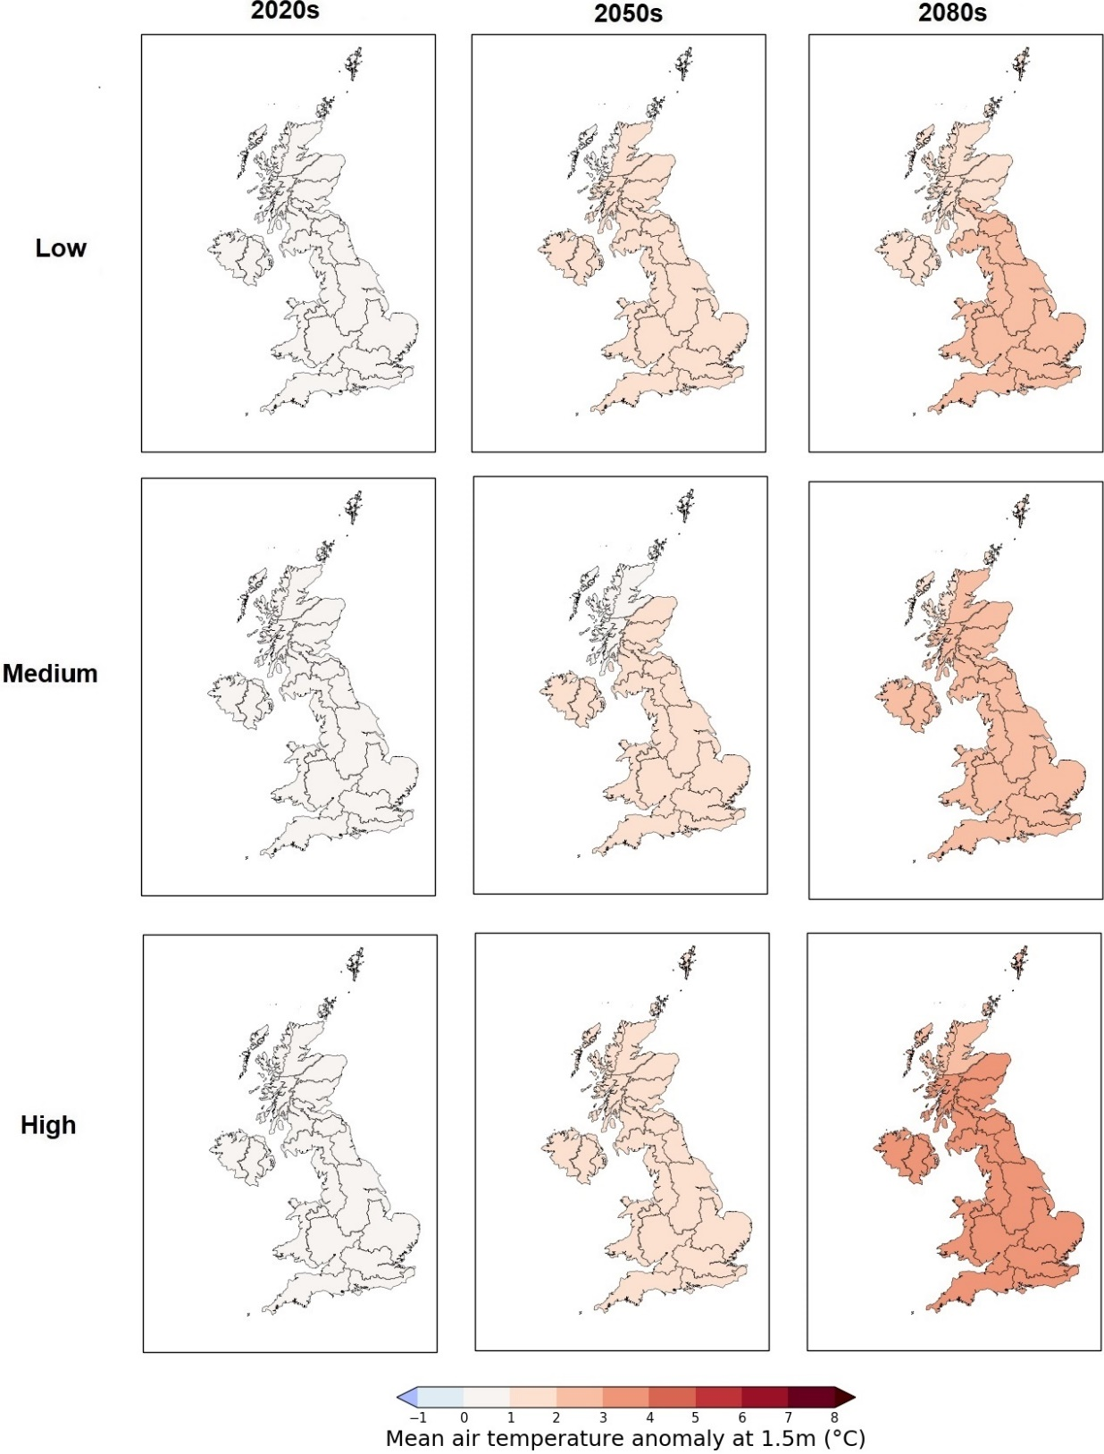
Fig. S2 Central estimates (50% probability level) of future UK mean annual air temperature anomaly projections (UKCP18) at 1.5 m across land relative to the baseline period from 1981 to 2010 under three greenhouse gas emission scenarios (low, medium, and high) for the 2020s, 2050s and 2080s. Figure reproduced from Lowe et al. (2019)

Predation
Predation is a diffuse and point source stressor with the potential to affect Atlantic salmon throughout the life cycle. Potential impacts are more likely to occur in estuaries and nearshore areas when fish are undertaking freshwater and marine migrations. There is relatively scant information about predation on the high seas. Predator species are distributed widely around estuaries and nearshore waters in England. Information on the distribution and abundance of grey Halichoerus grypus and harbour Phoca vitulina seal colonies around the UK are available from the Sea Mammal Research Unit (SCOS 2017). Balmer et al. (2013) and BTO (2014) provide detailed information on the distribution and abundance of piscivorous birds.

Water quality
Fluctuations in water quality due to human activities are a diffuse and point source stressor likely to primarily affect Atlantic salmon in estuarine and nearshore waters. Pollution pressures in estuaries and nearshore waters exist in all regions of England but are less prevalent in the South West region (Fig. S3).
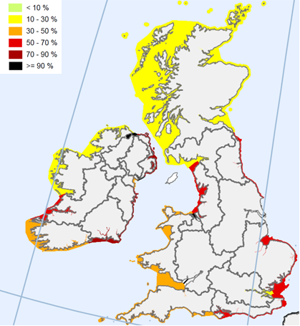
Fig. S3 Percentage of transitional and coastal water bodies affected by point source or diffuse pollution pressures in the UK and the Republic of Ireland. Figure reproduced from the European Commission’s Directorate-General for Environment (2012)

Bycatch
Bycatch is a diffuse stressor that has the potential to impact Atlantic salmon in pelagic fisheries targeting other species. The principal concerns have been raised about pelagic fisheries operating on the high seas (e.g., the Norwegian Sea and North Atlantic). Pelagic fisheries are distributed widely around estuarine and nearshore waters in the UK (Fig. S4). However, bycatches of Atlantic salmon in these fisheries considered to be very low (Sumner 2015).
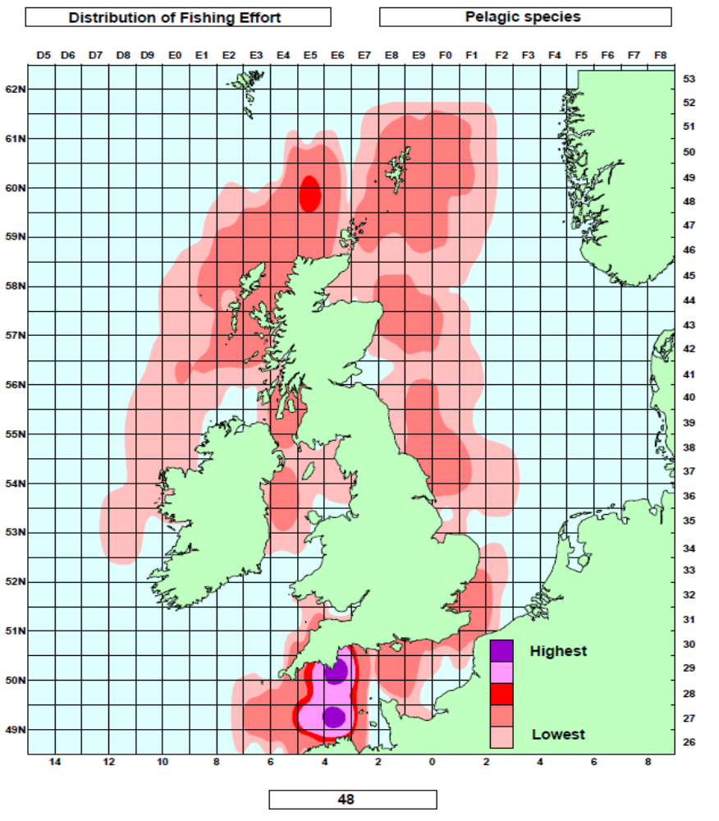
Fig. S4 Distribution of pelagic fishing effort around estuarine and nearshore waters in England. Figure reproduced from Coull et al. (1998)

Artificial light at night
Artificial light at night (ALAN) is a point-source stressor with the potential to affect Atlantic salmon in estuaries and nearshore waters (Fig. S5). In England, the most affected regions adjacent to estuaries and nearshore waters are the North East and North West.
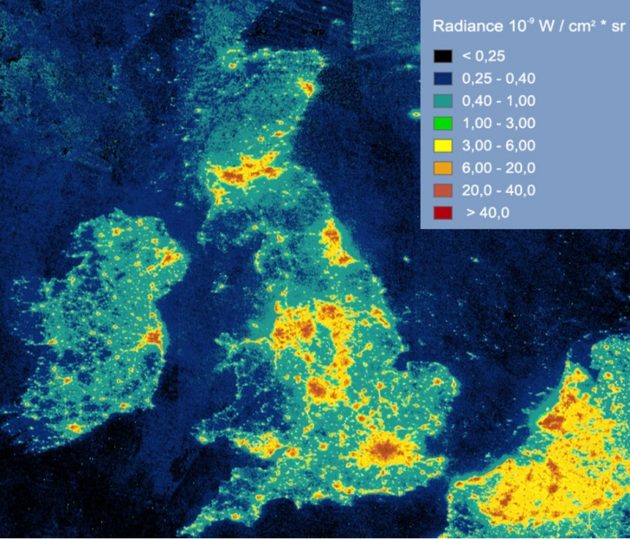
Fig. S5 Artificial light at night (ALAN) radiance levels in the UK in 2018 based on visible infrared imaging radiometer suite observations. Figure reproduced from Stare (2016)

Tidal barrages
Tidal barrages are a point-source stressor that affect Atlantic salmon in estuaries and nearshore waters. Only one tidal barrage currently exists in England, which is located on the River Tees in the North East region (Gough 1996). However, several future developments have been planned in the North East, South West and North West regions (Hooper and Austen 2013).

Power station impingement and thermal discharge
Power stations are a point-source stressor with the potential to affect Atlantic salmon in estuaries and nearshore waters. Although power stations are located throughout England, they are most prevalent in the South West and North West regions (Fig. S6).
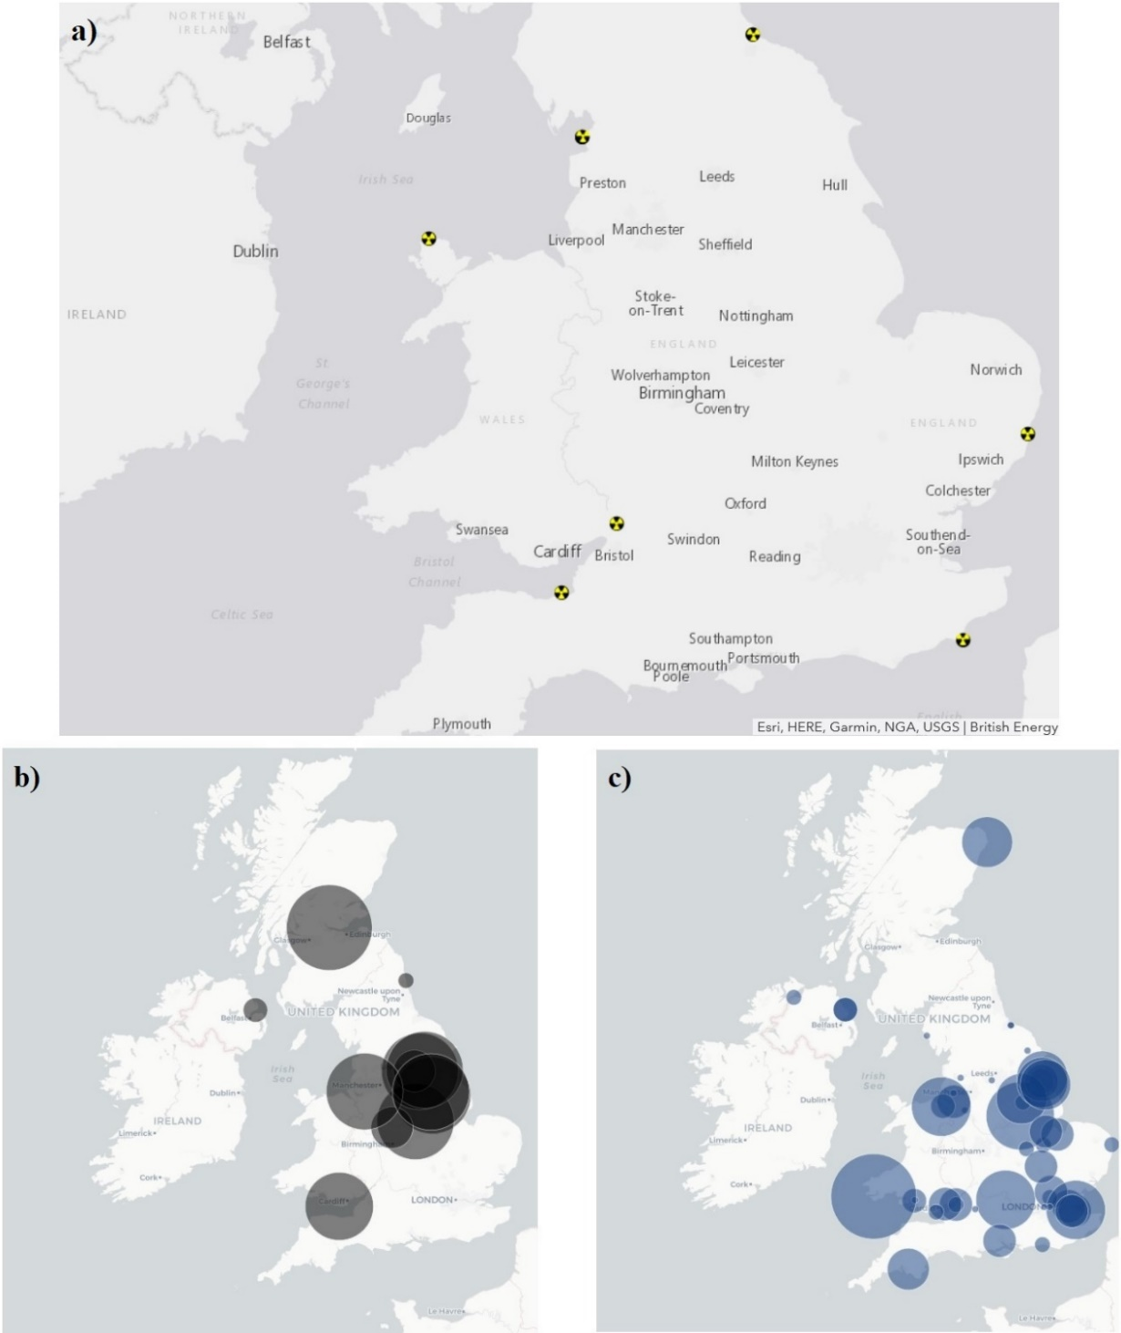
Fig. S6 Location of (a) nuclear, (b) coal, and (c) gas power stations in the UK based on the marine planning evidence base terrestrial energy data. Figures reproduced from DEFRA and MMO (2019) (a) and (b and c) Pearce and Evans (2015). Circle sizes in figures (b) and (c) indicate power station capacity in megawatts

Noise pollution from pile-driving
Underwater pile-driving sounds generated by construction activities are a point-source stressor that can impact Atlantic salmon in estuaries, nearshore waters, and the open ocean (Thomsen et al. 2006). Pile-driving sounds are expected to be of greatest concern within the confines of estuaries. Available information indicates that impact pile-driving sounds outside estuaries are most prevalent in the South and North West regions of England, and in the southern North Sea (Fig. S7).
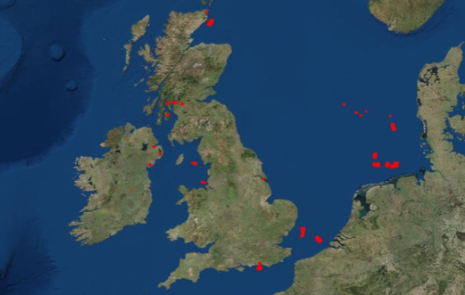
Fig. S7 Location of impact pile-driving sounds below 10 kHz in the North Sea, English Channel, and Irish Sea between 2015 and 2017. Figures reproduced from ICES (2016)

Invasive non-native species
Invasive non-native species are a point source and diffuse stressor that could affect Atlantic salmon in estuaries, nearshore waters, and the open ocean. However, the potential effects of inter-specific competition are probably more likely to occur in freshwater habitats where space is more constrained. The recent capture of pink salmon around the UK has raised concerns about their potential impact on Atlantic salmon should they occur in larger numbers and/or become established in UK rivers.

Electromagnetic fields
Artificial electromagnetic fields generated by subsea cables laid beneath the seabed are a point-source stressor that could mainly affect Atlantic salmon in estuaries and nearshore waters (Gill et al. 2012). The highest concentration of subsea cables laid around the nearshore waters of England is in the South West region, while the lowest concentration is in the North East region (Fig. S8).
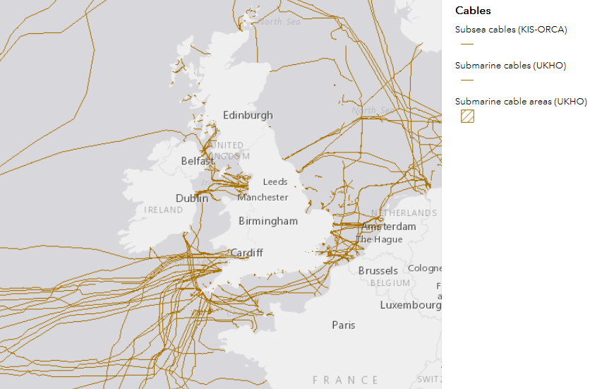
Fig. S8 Location of subsea cables laid around nearshore waters in England based on the marine planning evidence base cables data. Figures reproduced from DEFRA and MMO (2019)

Fisheries exploitation
Net and fixed engine fisheries for Atlantic salmon in estuaries and nearshore waters downstream of rivers designated as ‘at risk’ and ‘probably at risk’ of poor stock status were closed in England in 2019 following the introduction of National Salmon and Sea Trout Protection Byelaws (Cefas et al. 2020). Nearly all (92% in 2018) of the catches of Atlantic salmon in net and fixed engine fisheries were historically taken in the North East region. In contrast, far fewer catches were taken in the North West (5%) and South West (2%) regions. The introduction of these byelaws has reduced the exploitation of Atlantic salmon by nets and fixed engine fisheries to negligible levels.

Salmon mariculture
Salmon mariculture is a potential point-source stressor, mainly located in nearshore waters. No salmon mariculture facilities exist around the nearshore waters of England. However, there is extensive salmon farming in lochs and nearshore waters along the west coast of Scotland and in Norway.

Tidal lagoons
Tidal lagoons are a point-source stressor that have the potential to impact Atlantic salmon in nearshore waters with large tidal ranges, typically over 4 m, and the high seas (Rajgor 2016). No tidal lagoon developments currently exist in England, although there has been extended discussion around a proposal to develop a scheme in the Severn Estuary (Swansea Bay) and other proposals are under consideration in the North West and South West regions. Two tidal lease areas have been identified as sites for possible future development in the South and South West regions (Fig. S9).

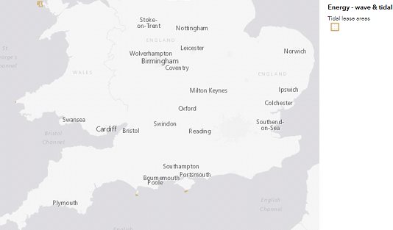
Fig. S9 Location of tidal lease areas available in England based on the marine planning evidence base tidal lease areas data Figures reproduced from DEFRA and MMO (2019)

Supplementary results
Table S1 Classification of the different marine stressors along the (a) effects and (b) development axes for Atlantic salmon in the North East marine plan area
 | Criteria and scoring | Climate change | Predation | Water quality | Bycatch | ALAN |  | Tidal barrages | Power stations | Noise pollution | Invasive species | EMF |  | Fisheries exploitation | Salmon mariculture | Tidal lagoons
(a) Effects axis characteristics considered
1. Percentage of affected river stocks | 0: 0%, 1: 1-25%, 2: 26-50%, 3: >50% | 3.0 | 3.0 | 3.0 | 0.0 | 3.0 |  | 1.0 | 0.0 | 0.0 | 0.0 | 1.0 |  | 3.0 | 0.0 | 0.0
2. Habitat zone | 1: Offshore | 4.0 | 3.0 | 3.0 | 2.0 | 3.0 |  | 3.0 | 3.0 | 3.0 | 3.0 | 2.0 |  | 3.0 | 2.0 | 2.0
Area where stressor effect likely to be most pronounced | 2: Nearshore  3: Estuarine  4: All
3. Spatial extent of stressor | 0: None | 3.0 | 3.0 | 3.0 | 2.0 | 1.0 |  | 1.0 | 1.0 | 1.0 | 1.0 | 1.0 |  | 2.0 | 0.0 | 0.0
 | 1: Small
 | 2: Moderate
 | 3: Large
4. Impact on smolts | 0: None | 3.0 | 3.0 | 2.0 | 1.0 | 1.0 |  | 2.0 | 2.0 | 1.0 | 0.0 | 1.0 |  | 0.0 | 3.0 | 1.0
Evidence from literature review | 1. Low
 | 2: Moderate
 | 3: High
5. Impact on adults | 0: None | 3.0 | 2.0 | 2.0 | 1.0 | 1.0 |  | 2.0 | 1.0 | 1.0 | 0.0 | 1.0 |  | 2.0 | 2.0 | 1.0
Evidence from literature review | 1. Low
 | 2: Moderate
 | 3: High
6. Impact on smolts | 0: No impact | 3.0 | 1.0 | 2.0 | 0.0 | 3.0 |  | 2.0 | 0.0 | 0.0 | 0.0 | 1.0 |  | 1.0 | 0.0 | 0.0
Local knowledge | 1. Low
 | 2: Moderate
 | 3: High
7. Impact on adults | 0: No impact | 1.0 | 3.0 | 2.0 | 0.0 | 1.0 |  | 1.0 | 0.0 | 0.0 | 0.0 | 0.0 |  | 2.0 | 0.0 | 0.0
Local knowledge | 1. Low
 | 2: Moderate
 | 3: High
8. Implemented mitigation measures  That have reduced the effects or likelihood of losing populations | 1: Extensive, with large effects  2: Many, with good effects  3: Few, or measures with small effects  4: Very few/none, or measures without net effect | 3.0 | 3.0 | 2.0 | 3.0 | 4.0 |  | 3.0 | 2.0 | 2.0 | 3.0 | 1.0 |  | 1.0 | 3.0 | 3.0
Sum (maximum 26) |  | 23.0 | 21.0 | 19.0 | 9.0 | 17.0 |  | 15.0 | 9.0 | 8.0 | 7.0 | 8.0 |  | 14.0 | 0.0 | 0.0
Compiled relative effect (0–1) |  | 0.9 | 0.8 | 0.7 | 0.3 | 0.7 |  | 0.6 | 0.3 | 0.3 | 0.3 | 0.3 |  | 0.5 | 0.0 | 0.0
Knowledge | 1: Extensive, 2: Moderate, 3: Poor | 1.0 | 1.0 | 1.0 | 3.0 | 3.0 |  | 2.0 | 3.0 | 2.0 | 3.0 | 2.0 |  | 1.0 | 3.0 | 3.0
(b) Development axis characteristics considered
1. Main area for likely development Area where stressor effect likely to be most pronounced | 1: Offshore  2: Nearshore  3: Estuarine  4: All | 4.0 | 3.0 | 3.0 | 2.0 | 3.0 | 3.0 |  | 2.0 | 3.0 | 3.0 | 3.0 | 3.0 |  | 2.0 | 2.0
2. Likelihood of stressor becoming more prevalent in next 10 years | 0: Nil  1. Low  2: Moderate  3: High | 3.0 | 3.0 | 2.0 | 2.0 | 3.0 | 2.0 |  | 3.0 | 3.0 | 2.0 | 2.0 | 1.0 |  | 1.0 | 1.0
3. Potential for effective measures | 1: Extensive and very effective measures planned | 3.0 | 3.0 | 2.0 | 3.0 | 3.0 | 3.0 |  | 2.0 | 1.0 | 2.0 | 1.0 | 1.0 |  | 2.0 | 2.0
Projection of present situation | 2: Several and effective measures planned
 | 3: Some effective measures, all measures with small effects planned
 | 4: Few/no effective measures planned
Sum (maximum 11) |  | 10.0 | 9.0 | 7.0 | 7.0 | 9.0 | 8.0 |  | 7.0 | 7.0 | 7.0 | 6.0 | 5.0 |  | 5.0 | 5.0
Compiled development (0–1) |  | 0.9 | 0.8 | 0.6 | 0.6 | 0.8 | 0.7 |  | 0.6 | 0.6 | 0.6 | 0.6 | 0.5 |  | 0.5 | 0.5
Uncertainty of projected development | 1: Small, 2: Moderate, 3: Large | 3.0 | 3.0 | 1.0 | 2.0 | 2.0 | 3.0 |  | 1.0 | 2.0 | 3.0 | 1.0 | 1.0 |  | 2.0 | 2.0
Stressors include modified oceanic conditions linked to the changing climate (climate change), mortality due to consumption by predators (predation), poor water quality in the marine environment (water quality), incidental capture in non-target fisheries (bycatch), emissions of artificial light at night (ALAN), tidal barrages for renewable energy generation (tidal barrages), power station impingement and thermal discharge (power stations), noise pollution from pile-driving (noise pollution), invasive non-native species (invasive species), electromagnetic fields (EMF) from subsea cables, commercial and recreational exploitation by targeted salmon fisheries and illegal, unreported and unregulated fishing (fisheries exploitation), salmon mariculture in nearshore waters (salmon mariculture), and tidal lagoons for renewable energy generation (tidal lagoons).

Table S2 Classification of the different marine stressors along the (a) effects and (b) development axes for Atlantic salmon in the South marine plan area
 | Criteria and scoring | Climate change | Predation | Water quality | Bycatch | ALAN | Tidal barrages | Power stations | Noise pollution | Invasive species | EMF | Fisheries exploitation | Salmon mariculture | Tidal lagoons
(a) Effects axis characteristics considered
1. Percentage of affected river stocks | 0: 0%, 1: 1-25%, 2: 26-50%, 3: >50% | 3.0 | 3.0 | 3.0 | 3.0 | 0.0 | 0.0 | 1.0 | 2.0 | 1.0 | 0.0 | 2.0 | 0.0 | 0.0
2. Habitat zone | 1: Offshore | 4.0 | 3.0 | 3.0 | 2.0 | 3.0 | 3.0 | 3.0 | 3.0 | 3.0 | 2.0 | 3.0 | 2.0 | 2.0
Area where stressor effect likely to be most pronounced | 2: Nearshore  3: Estuarine  4: All
3. Spatial extent of stressor | 0: None | 3.0 | 2.0 | 3.0 | 3.0 | 1.0 | 0.0 | 1.0 | 2.0 | 1.0 | 2.0 | 1.0 | 0.0 | 0.0
 | 1: Small
 | 2: Moderate
 | 3: Large
4. Impact on smolts | 0: None | 3.0 | 3.0 | 2.0 | 1.0 | 1.0 | 2.0 | 2.0 | 1.0 | 0.0 | 1.0 | 0.0 | 3.0 | 1.0
Evidence from literature review | 1. Low
 | 2: Moderate
 | 3: High
5. Impact on adults | 0: None | 3.0 | 2.0 | 2.0 | 1.0 | 1.0 | 2.0 | 1.0 | 1.0 | 0.0 | 1.0 | 2.0 | 2.0 | 1.0
Evidence from literature review | 1. Low
 | 2: Moderate
 | 3: High
6. Impact on smolts | 0: No impact | 3.0 | 3.0 | 2.0 | 1.0 | 0.0 | 0.0 | 1.0 | 1.0 | 1.0 | 0.0 | 1.0 | 0.0 | 0.0
Local knowledge | 1. Low
 | 2: Moderate
 | 3: High
7. Impact on adults | 0: No impact | 3.0 | 0.0 | 1.0 | 3.0 | 0.0 | 0.0 | 1.0 | 1.0 | 0.0 | 0.0 | 1.0 | 0.0 | 0.0
Local knowledge | 1. Low
 | 2: Moderate
 | 3: High
8. Implemented mitigation measures  That have reduced the effects or likelihood of losing populations | 1: Extensive, with large effects  2: Many, with good effects  3: Few, or measures with small effects  4: Very few/none, or measures without net effect | 3.0 | 3.0 | 2.0 | 3.0 | 3.0 | 3.0 | 2.0 | 2.0 | 3.0 | 1.0 | 1.0 | 3.0 | 3.0
Sum (maximum 26) |  | 25.0 | 19.0 | 18.0 | 17.0 | 9.0 | 0.0 | 12.0 | 13.0 | 9.0 | 7.0 | 11.0 | 0.0 | 0.0
Compiled relative effect (0–1) |  | 1.0 | 0.7 | 0.7 | 0.7 | 0.3 | 0.0 | 0.5 | 0.5 | 0.3 | 0.3 | 0.4 | 0.0 | 0.0
Knowledge | 1: Extensive, 2: Moderate, 3: Poor | 2.0 | 2.0 | 1.0 | 2.0 | 3.0 | 3.0 | 3.0 | 2.0 | 3.0 | 2.0 | 1.0 | 3.0 | 3.0
(b) Development axis characteristics considered
1. Main area for likely development Area where stressor effect likely to be most pronounced | 1: Offshore  2: Nearshore  3: Estuarine  4: All | 4.0 | 3.0 | 3.0 | 2.0 | 3.0 | 3.0 | 3.0 | 3.0 | 3.0 | 3.0 | 3.0 | 2.0 | 2.0
2. Likelihood of stressor becoming more prevalent in next 10 years | 0: Nil  1. Low  2: Moderate  3: High | 3.0 | 2.0 | 2.0 | 2.0 | 2.0 | 1.0 | 1.0 | 3.0 | 2.0 | 3.0 | 1.0 | 1.0 | 1.0
3. Potential for effective measures Projection of present situation | 1: Extensive and very effective measures planned | 3.0 | 3.0 | 2.0 | 3.0 | 3.0 | 3.0 | 2.0 | 1.0 | 2.0 | 1.0 | 1.0 | 2.0 | 2.0
 | 2: Several and effective measures planned
 | 3: Some effective measures, all measures with small effects planned
 | 4: Few/no effective measures planned
Sum (maximum 11) |  | 10.0 | 8.0 | 7.0 | 7.0 | 8.0 | 7.0 | 6.0 | 7.0 | 7.0 | 7.0 | 5.0 | 5.0 | 5.0
Compiled development (0–1) |  | 0.9 | 0.7 | 0.6 | 0.6 | 0.7 | 0.6 | 0.6 | 0.6 | 0.6 | 0.6 | 0.5 | 0.5 | 0.5
Uncertainty of projected development | 1: Small, 2: Moderate, 3: Large | 3.0 | 3.0 | 1.0 | 2.0 | 2.0 | 2.0 | 1.0 | 1.0 | 3.0 | 2.0 | 1.0 | 2.0 | 2.0
Stressors include modified oceanic conditions linked to the changing climate (climate change), mortality due to consumption by predators (predation), poor water quality in the marine environment (water quality), incidental capture in non-target fisheries (bycatch), emissions of artificial light at night (ALAN), tidal barrages for renewable energy generation (tidal barrages), power station impingement and thermal discharge (power stations), noise pollution from pile-driving (noise pollution), invasive non-native species (invasive species), electromagnetic fields (EMF) from subsea cables, commercial and recreational exploitation by targeted salmon fisheries and illegal, unreported and unregulated fishing (fisheries exploitation), salmon mariculture in nearshore waters (salmon mariculture), and tidal lagoons for renewable energy generation (tidal lagoons).

Table S3 Classification of the different marine stressors along the (a) effects and (b) development axes for Atlantic salmon in the South West marine plan area
 | Criteria and scoring | Climate change | Predation | Water quality | Bycatch | ALAN | Tidal barrages | Power stations | Noise pollution | Invasive species | EMF | Fisheries exploitation | Salmon mariculture | Tidal lagoons
(a) Effects axis characteristics considered
1. Percentage of affected river stocks | 0: 0%, 1: 1-25%, 2: 26-50%, 3: >50% | 3.0 | 1.0 | 1.0 | 3.0 | 1.0 | 0.0 | 1.0 | 2.0 | 0.0 | 0.0 | 2.0 | 0.0 | 0.0
2. Habitat zone | 1: Offshore | 4.0 | 3.0 | 3.0 | 2.0 | 3.0 | 3.0 | 3.0 | 3.0 | 3.0 | 2.0 | 3.0 | 2.0 | 2.0
Area where stressor effect likely to be most pronounced | 2: Nearshore  3: Estuarine  4: All
3. Spatial extent of stressor | 0: None | 3.0 | 2.0 | 3.0 | 2.0 | 1.0 | 0.0 | 2.0 | 1.0 | 1.0 | 3.0 | 1.0 | 0.0 | 0.0
 | 1: Small
 | 2: Moderate
 | 3: Large
4. Impact on smolts | 0: None | 3.0 | 3.0 | 2.0 | 1.0 | 1.0 | 2.0 | 2.0 | 1.0 | 0.0 | 1.0 | 0.0 | 3.0 | 1.0
Evidence from literature review | 1. Low
 | 2: Moderate
 | 3: High
5. Impact on adults | 0: None | 3.0 | 2.0 | 2.0 | 1.0 | 1.0 | 2.0 | 1.0 | 1.0 | 0.0 | 1.0 | 2.0 | 2.0 | 1.0
Evidence from literature review | 1. Low
 | 2: Moderate
 | 3: High
6. Impact on smolts | 0: No impact | 0.0 | 1.0 | 1.0 | 2.0 | 1.0 | 0.0 | 1.0 | 0.0 | 0.0 | 0.0 | 1.0 | 0.0 | 0.0
Local knowledge | 1. Low
 | 2: Moderate
 | 3: High
7. Impact on adults | 0: No impact | 1.0 | 1.0 | 1.0 | 3.0 | 1.0 | 0.0 | 1.0 | 0.0 | 0.0 | 0.0 | 1.0 | 0.0 | 0.0
Local knowledge | 1. Low
 | 2: Moderate
 | 3: High
8. Implemented mitigation measures | 1: Extensive, with large effects | 3.0 | 3.0 | 2.0 | 3.0 | 3.0 | 3.0 | 2.0 | 2.0 | 3.0 | 1.0 | 1.0 | 3.0 | 3.0
That have reduced the effects or likelihood of losing populations | 2: Many, with good effects
 | 3: Few, or measures with small effects
 | 4: Very few/none, or measures without net effect
Sum (maximum 26) |  | 20.0 | 16.0 | 15.0 | 17.0 | 12.0 | 0.0 | 13.0 | 10.0 | 7.0 | 8.0 | 11.0 | 0.0 | 0.0
Compiled relative effect (0–1) |  | 0.8 | 0.6 | 0.6 | 0.7 | 0.5 | 0.0 | 0.5 | 0.4 | 0.3 | 0.3 | 0.4 | 0.0 | 0.0
Knowledge | 1: Extensive, 2: Moderate, 3: Poor | 2.0 | 2.0 | 1.0 | 2.0 | 3.0 | 3.0 | 3.0 | 2.0 | 3.0 | 2.0 | 1.0 | 3.0 | 3.0
(b) Development axis characteristics considered
1. Main area for likely development | 1: Offshore | 4.0 | 3.0 | 3.0 | 2.0 | 3.0 | 3.0 | 3.0 | 3.0 | 3.0 | 3.0 | 3.0 | 2.0 | 2.0
Area where stressor effect likely to be most pronounced | 2: Nearshore  3: Estuarine  4: All
2. Likelihood of stressor becoming more prevalent in next 10 years | 0: Nil  1. Low  2: Moderate  3: High | 3.0 | 2.0 | 2.0 | 2.0 | 3.0 | 2.0 | 2.0 | 3.0 | 2.0 | 3.0 | 1.0 | 1.0 | 1.0
3. Potential for effective measures Projection of present situation | 1: Extensive and very effective measures planned | 3.0 | 3.0 | 2.0 | 3.0 | 3.0 | 3.0 | 2.0 | 1.0 | 2.0 | 1.0 | 1.0 | 2.0 | 2.0
 | 2: Several and effective measures planned
 | 3: Some effective measures, all measures with small effects planned
 | 4: Few/no effective measures planned
Sum (maximum 11) |  | 10.0 | 8.0 | 7.0 | 7.0 | 9.0 | 8.0 | 7.0 | 7.0 | 7.0 | 7.0 | 5.0 | 5.0 | 5.0
Compiled development (0–1) |  | 0.9 | 0.7 | 0.6 | 0.6 | 0.8 | 0.7 | 0.6 | 0.6 | 0.6 | 0.6 | 0.5 | 0.5 | 0.5
Uncertainty of projected development | 1: Small, 2: Moderate, 3: Large | 3.0 | 3.0 | 1.0 | 2.0 | 2.0 | 3.0 | 1.0 | 1.0 | 3.0 | 2.0 | 1.0 | 2.0 | 2.0
Stressors include modified oceanic conditions linked to the changing climate (climate change), mortality due to consumption by predators (predation), poor water quality in the marine environment (water quality), incidental capture in non-target fisheries (bycatch), emissions of artificial light at night (ALAN), tidal barrages for renewable energy generation (tidal barrages), power station impingement and thermal discharge (power stations), noise pollution from pile-driving (noise pollution), invasive non-native species (invasive species), electromagnetic fields (EMF) from subsea cables, commercial and recreational exploitation by targeted salmon fisheries and illegal, unreported and unregulated fishing (fisheries exploitation), salmon mariculture in nearshore waters (salmon mariculture), and tidal lagoons for renewable energy generation (tidal lagoons).

Table S4 Classification of the different marine stressors along the (a) effects and (b) development axes for Atlantic salmon in the North West marine plan area
 | Criteria and scoring | Climate change | Predation | Water quality | Bycatch | ALAN | Tidal barrages | Power stations | Noise pollution | Invasive species | EMF | Fisheries exploitation | Salmon mariculture | Tidal lagoons
(a) Effects axis characteristics considered
1. Percentage of affected river stocks | 0: 0%, 1: 1-25%, 2: 26-50%, 3: >50% | 1.0 | 3.0 | 1.0 | 3.0 | 0.0 | 0.0 | 0.0 | 0.0 | 0.0 | 0.0 | 3.0 | 0.0 | 0.0
2. Habitat zone | 1: Offshore | 4.0 | 3.0 | 3.0 | 2.0 | 3.0 | 3.0 | 3.0 | 3.0 | 3.0 | 2.0 | 3.0 | 2.0 | 2.0
Area where stressor effect likely to be most pronounced | 2: Nearshore  3: Estuarine  4: All
3. Spatial extent of stressor | 0: None | 3.0 | 3.0 | 3.0 | 2.0 | 1.0 | 0.0 | 2.0 | 2.0 | 1.0 | 2.0 | 1.0 | 1.0 | 0.0
 | 1: Small
 | 2: Moderate
 | 3: Large
4. Impact on smolts | 0: None | 3.0 | 3.0 | 2.0 | 1.0 | 1.0 | 2.0 | 2.0 | 1.0 | 0.0 | 1.0 | 0.0 | 3.0 | 1.0
Evidence from literature review | 1. Low
 | 2: Moderate
 | 3: High
5. Impact on adults | 0: None | 3.0 | 2.0 | 2.0 | 1.0 | 1.0 | 2.0 | 1.0 | 1.0 | 0.0 | 1.0 | 2.0 | 2.0 | 1.0
Evidence from literature review | 1. Low
 | 2: Moderate
 | 3: High
6. Impact on smolts | 0: No impact | 1.0 | 2.0 | 0.0 | 1.0 | 0.0 | 0.0 | 0.0 | 0.0 | 0.0 | 0.0 | 1.0 | 0.0 | 0.0
Local knowledge | 1. Low
 | 2: Moderate
 | 3: High
7. Impact on adults | 0: No impact | 1.0 | 1.0 | 1.0 | 1.0 | 0.0 | 0.0 | 0.0 | 0.0 | 0.0 | 0.0 | 2.0 | 0.0 | 0.0
Local knowledge | 1. Low
 | 2: Moderate
 | 3: High
8. Implemented mitigation measures | 1: Extensive, with large effects | 3.0 | 3.0 | 2.0 | 3.0 | 4.0 | 3.0 | 2.0 | 2.0 | 3.0 | 1.0 | 1.0 | 3.0 | 3.0
That have reduced the effects or likelihood of losing populations | 2: Many, with good effects
 | 3: Few, or measures with small effects
 | 4: Very few/none, or measures without net effect
Sum (maximum 26) |  | 19.0 | 20.0 | 14.0 | 14.0 | 10.0 | 0.0 | 10.0 | 9.0 | 7.0 | 7.0 | 13.0 | 11.0 | 0.0
Compiled relative effect (0–1) |  | 0.7 | 0.8 | 0.5 | 0.5 | 0.4 | 0.0 | 0.4 | 0.3 | 0.3 | 0.3 | 0.5 | 0.4 | 0.0
Knowledge | 1: Extensive, 2: Moderate, 3: Poor | 1.0 | 1.0 | 1.0 | 2.0 | 3.0 | 3.0 | 3.0 | 2.0 | 3.0 | 2.0 | 1.0 | 3.0 | 3.0
(b) Development axis characteristics considered
1. Main area for likely development | 1: Offshore | 4.0 | 3.0 | 3.0 | 2.0 | 3.0 | 3.0 | 3.0 | 3.0 | 3.0 | 3.0 | 3.0 | 2.0 | 2.0
Area where stressor effect likely to be most pronounced | 2: Nearshore  3: Estuarine  4: All
2. Likelihood of stressor becoming more prevalent in next 10 years | 0: Nil  1. Low  2: Moderate  3: High | 3.0 | 3.0 | 2.0 | 2.0 | 3.0 | 2.0 | 2.0 | 3.0 | 2.0 | 2.0 | 1.0 | 2.0 | 1.0
3. Potential for effective measures Projection of present situation | 1: Extensive and very effective measures planned | 3.0 | 3.0 | 2.0 | 3.0 | 3.0 | 3.0 | 2.0 | 1.0 | 2.0 | 1.0 | 1.0 | 2.0 | 2.0
 | 2: Several and effective measures planned
 | 3: Some effective measures, all measures with small effects planned
 | 4: Few/no effective measures planned
Sum (maximum 11) |  | 10.0 | 9.0 | 7.0 | 7.0 | 9.0 | 8.0 | 7.0 | 7.0 | 7.0 | 6.0 | 5.0 | 6.0 | 5.0
Compiled development (0–1) |  | 0.9 | 0.8 | 0.6 | 0.6 | 0.8 | 0.7 | 0.6 | 0.6 | 0.6 | 0.6 | 0.5 | 0.6 | 0.5
Uncertainty of projected development | 1: Small, 2: Moderate, 3: Large | 3.0 | 3.0 | 1.0 | 2.0 | 2.0 | 3.0 | 1.0 | 2.0 | 3.0 | 1.0 | 1.0 | 2.0 | 2.0
Stressors include modified oceanic conditions linked to the changing climate (climate change), mortality due to consumption by predators (predation), poor water quality in the marine environment (water quality), incidental capture in non-target fisheries (bycatch), emissions of artificial light at night (ALAN), tidal barrages for renewable energy generation (tidal barrages), power station impingement and thermal discharge (power stations) , noise pollution from pile-driving (noise pollution), invasive non-native species (invasive species), electromagnetic fields (EMF) from subsea cables, commercial and recreational exploitation by targeted salmon fisheries and illegal, unreported and unregulated fishing (fisheries exploitation), salmon mariculture in nearshore waters (salmon mariculture), and tidal lagoons for renewable energy generation (tidal lagoons).

Supplementary references
Balmer DE, Gillings S, Caffrey BJ, Swann RL, Downie IS, Fuller RJ (2013) Bird Atlas 2007-11: the breeding and wintering birds of Britain and Ireland. BTO Books, Thetford
Cefas, Environment Agency, and Natural Resources Wales (2020) Salmon stocks and fisheries in England and Wales in 2019. Preliminary assessment prepared for ICES, 89 pp
Coull KA, Johnstone R, Rogers SI (1998) Fisheries sensitivity maps in British waters. UKOOA Ltd. https://www.cefas.co.uk/media/o0fgfobd/sensi_maps.pdf. Accessed 1 March 2019
Department for Environment, Food & Rural Affairs (DEFRA) and Marine Management Organisation (MMO) (2019) Explore Marine Plans. https://www.gov.uk/guidance/explore-marine-plans#history. Accessed 1 December 2019
European Commission’s Directorate-General for Environment (2012) Map of transitional water bodies and coastal water bodies affected by point source or diffuse source pollution pressures. https://ec.europa.eu/environment/water/water-framework/facts_figures/pdf/Point-diffuse%20pollution-coastal-transitional-2012.pdf. Accessed 1 March 2019
Gill AB, Bartlett M, Thomsen F (2012) Potential interactions between diadromous fishes of UK conservation importance and the electromagnetic fields and subsea noise from marine renewable energy developments. J Fish Biol 81:664–695
Gough PJ (1996) Potential impacts of Estuarine Barrages on Migratory Fish in England and Wales. In: Burt N and Watts J (eds) Barrages: Engineering Design and Environmental Impacts. International Conference, 10-13/09/1996, John Wiley and Sons Ltd, Cardiff, UK
Hooper T, Austen M (2013) Tidal barrages in the UK: Ecological and social impacts, potential mitigation, and tools to support barrage planning. Renewable Sustainable Energy Rev 23:289–298
International Council for the Exploration of the Sea (ICES) (2016) Impulsive noise register. https://underwaternoise.ices.dk/impulsive/map.aspx. Accessed 1 March 2019
Lowe JA, Bernie D, Bett P, Bricheno L, Brown S, Calvert D, Clark R, Eagle K el al (2019) UKCP18 Science Overview Report. November 2018 (Updated March 2019). Met Office UK. https://www.metoffice.gov.uk/pub/data/weather/uk/ukcp18/science-reports/UKCP18-Overview-report.pdf. Accessed 15 August 2019
Murphy J, Sexton D, Jenkins G, Booth B, Brown C, Clark R et al (2009) UK Climate Projections Science Report: Climate change projections. Met Office Hadley Centre. http://cedadocs.ceda.ac.uk/1320/1/climate_projections_full_report.pdf. Accessed: 20 August 2019
Pearce R, Evans S (2015) CarbonBrief Clear on climate, mapped: How the UK generates its electricity. https://www.carbonbrief.org/mapped-how-the-uk-generates-its-electricity. Accessed 1 March 2019
Rajgor G (2016) Time for tidal lagoons? Renew Energy Focus 17:202–204
Special Committee on Seals (SCOS) (2017) Scientific advice on matters related to the management of seal populations: 2017. Sea Mammal Research Unit, University of St Andrews. http://www.smru.st-andrews.ac.uk/files/2018/01/SCOS-2017.pdf. Accessed 20 February 2020
Stare J (2016) Light Pollution map info (v2.8.0). https://www.lightpollutionmap.info/#zoom=4.00&lat=45.8720&lon=14.5470&layers=B0FFFFFFTFFFFFFFFFF. Accessed 1 March 2019
Sumner K (2015) Review of protection measures for Atlantic salmon and sea trout in inshore waters. Environment Agency evidence report, 31 pp
The British Trust for Ornithology (BTO) (2014) Bird Atlas Mapstore. https://app.bto.org/mapstore/StoreServlet. Accessed 1 March 2019
Thomsen F, Lüdemann K, Kafemann R, Piper W (2006) Effects of offshore wind farm noise on marine mammals and fish. Biola on behalf of COWRIE Ltd, Hamburg, Germany, 62 pp

