Unravelling the phylogenetic and ecological drivers of beak shape variability in cephalopods
Reviews in Fish Biology and Fisheries

Antoni Sánchez-Márquez¹, Joan Navarro¹, Antigoni Kaliontzopoulou², Marc Farré³, Morag Taite^{4, 5}, Oscar Escolar¹, Roger Villanueva¹, Louise Allcock⁴ and Fernando Á. Fernández-Álvarez^{1,4, *}

¹Institut de Ciències del Mar (ICM-CSIC), Passeig Marítim de la Barceloneta 37-49, 08003 Barcelona, Spain.
²Facultat de Biologia, Universitat de Barcelona, Diagonal 643, 08014 Barcelona, Spain.
³Centro Oceanográfico de Baleares (IEO-CSIC), Moll de Ponent s/n, 07015 Palma, Mallorca, Spain.
⁴Ryan Institute and School of Natural Sciences, National University of Ireland Galway, University Road, H91 TK33 Galway, Ireland.
⁵Institute of Biological, Environmental and Rural Sciences, Aberystwyth University, Aberystwyth, United Kingdom.

*Corresponding author:
f.a.fernandez.alvarez@gmail.com

Supplementary Information
Table S1. ANOVA test between both landmark sets replicates for the upper beak. Abbreviation are indicated as follows: Df = Degrees of freedom; F = statistic from the F test; Ind = individual; MS = Mean of the sum of Squares; Pr(>F) = p-values of the F-statistic; Rep = replicate; Rsq = R-squared; SS = Sum of Squares; Z = Z or standard score.
 | Df | SS | MS | Rsq | F | Z | Pr(>F)
Ind | 201 | 9.1792 | 0.045668 | 0.98774 | 87.593 | 20.5038 | 0.001
Rep | 1 | 0.0091 | 0.009118 | 0.00098 | 17.489 | 3.8855 | 0.001
Residual | 201 | 0.1048 | 0.000521 | 0.01128
Total | 403 | 9.2931

Table S2. ANOVA test between both landmark sets replicates for the lower beak. Abbreviation are indicated as follows: Df = Degrees of freedom; F = statistic from the F test; Ind = individual; MS = Mean of the sum of Squares; Pr(>F) = p-values of the F-statistic; Rep = replicate; Rsq = R-squared; SS = Sum of Squares; Z = Z or standard score.
 | Df | SS | MS | Rsq | F | Z |  | Pr(>F)
Ind | 204 | 8.9707 | 0.043974 | 0.97131 | 34.1950 | 19.891 |  | 0.001
Rep | 1 | 0.0027 | 0.002654 | 0.00029 | 2.0641 | 1.185 |  | 0.133
Residual | 204 | 0.2623 | 0.001286 | 0.02840
Total | 409 | 9.2357

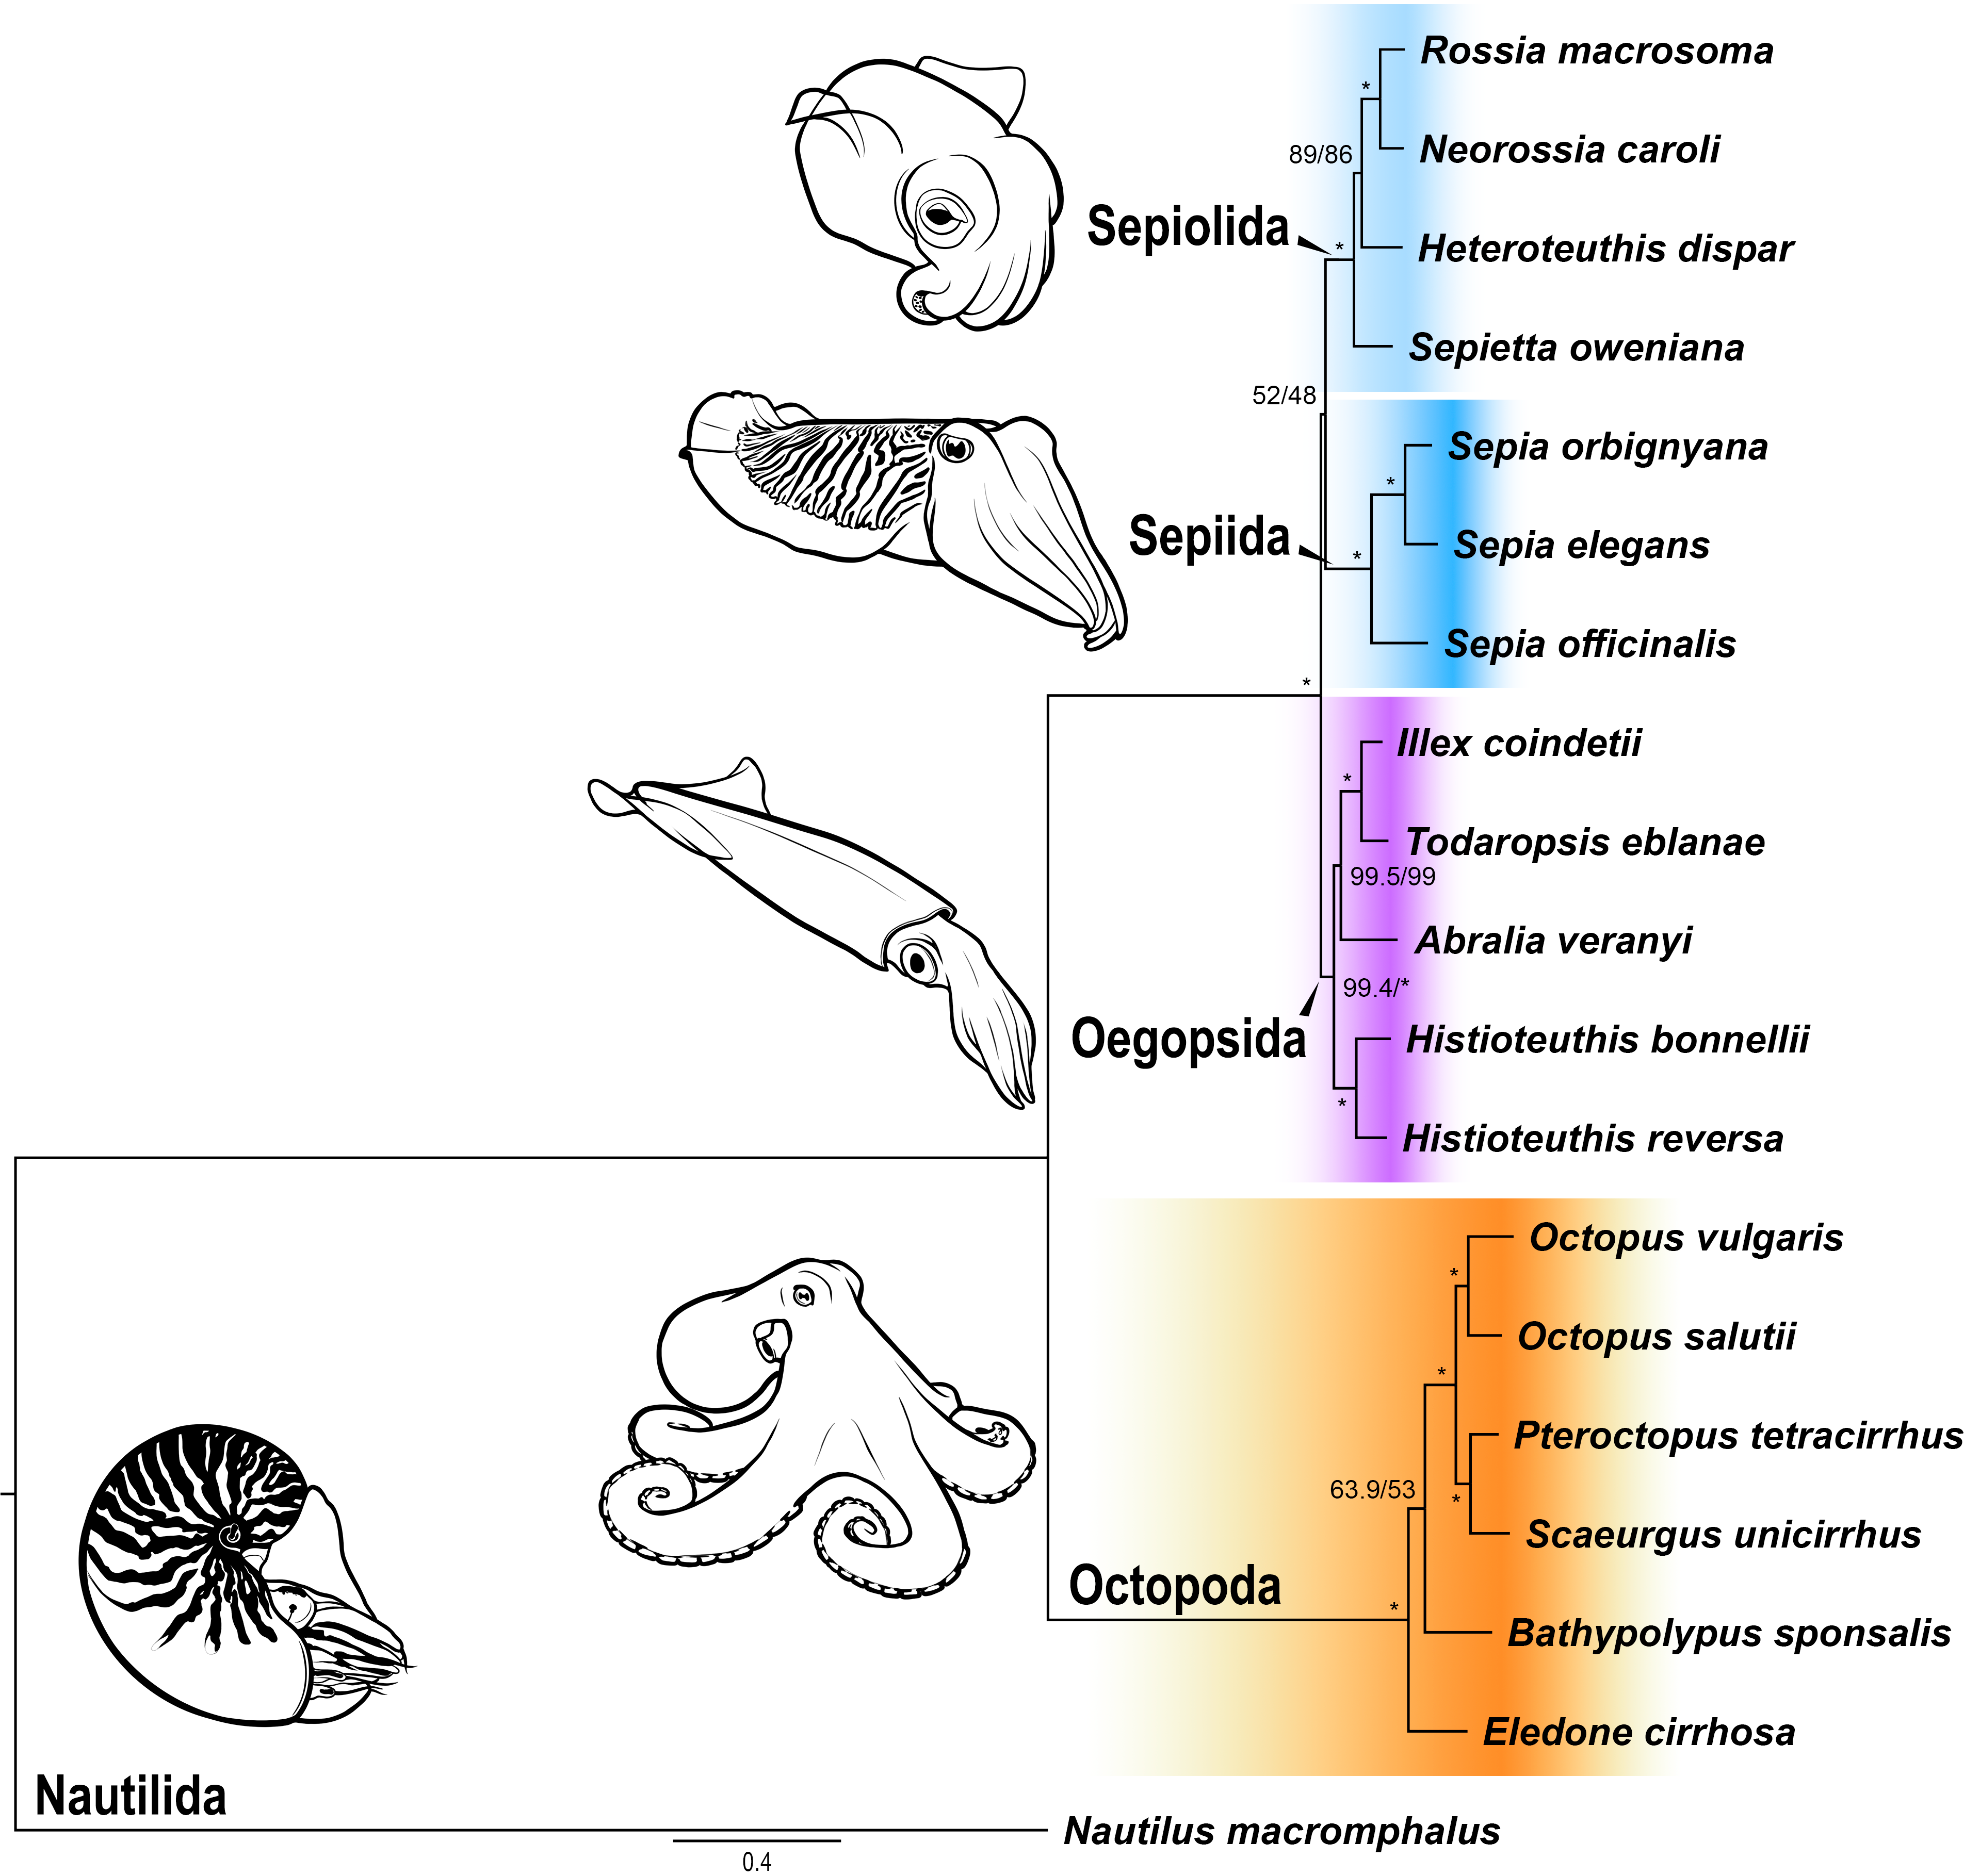
Fig. S1 Maximum likelihood phylogenetic tree obtained with IQTREE. Values on nodes indicate SH-aLRT support (%) and ultrafast bootstrap support (%), respectively. Asterisks indicates the maximum support value. The four main orders of the study and Nautilida (outgroup) are indicated. Illustrations correspond to each order represented in the tree and are based on Euprymna scolopes, Sepia officinalis, Illex sp., Octopus vulgaris and Nautilus macromphalus, from top to bottom

