Supplementary material for Size-dependent thermal limits in Australian hybrid abalone: implications for productivity shifts with ocean warming
FIGURE S1 Schematic drawing of experimental design and process. (a) Animals are separated by farm of origin (provenance; JTA and SOM) and size class. (b) Animals are placed on to the side of the experimental aquarium (Figure 1), randomly allocated across an even spread of size classes and provenance for each tank. (c) Starting at 14˚C, animals are subjected to two different experiments; acute, where the temperature is increased by 1˚C/hour, and chronic, where the temperature is increased by 1˚C/12 hours. When an animal falls off the side of the tank and is unable to self right, it has reached it’s critical thermal maximum (CT_{max}), where the temperature is recorded. (d) Following an animal reaching it’s CT_{max} endpoint, sex and allometric data are recorded, and tissues (gonad, digestive gland, foot side wall and foot sole) are excised and fixed in 10% formalin for histological analysis.

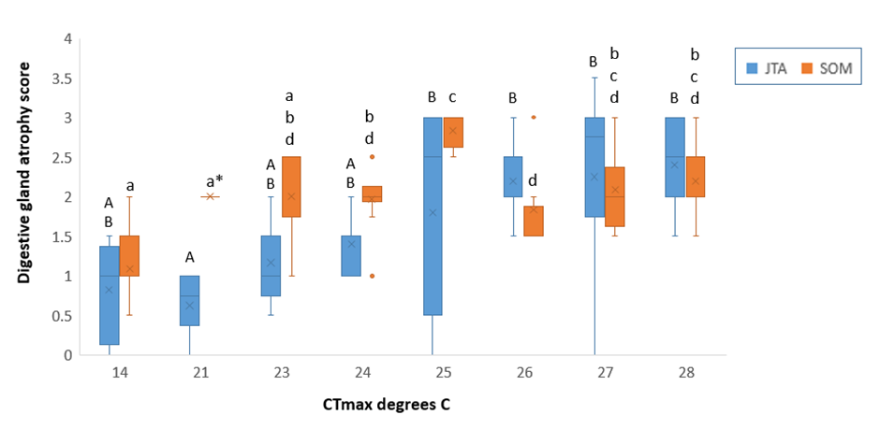

FIGURE S2 Boxplots comparing digestive tubule atrophy scores – CT_{max} x Provenance. Index score 0 = nil – 5% atrophy, index score 4 = 95%- 100% atrophy. Provenance - Jade Tiger Abalone (JTA), Southern Ocean Mariculture (SOM). Upper case letters indicate statistical differences between digestive gland atrophy score and CT_{max} in JTA abalone (p=0.0008), lower case letters indicate statistical differences between digestive gland atrophy score and CT_{max} in SOM abalone (p<0.0001). Asterisk indicates a single data point.

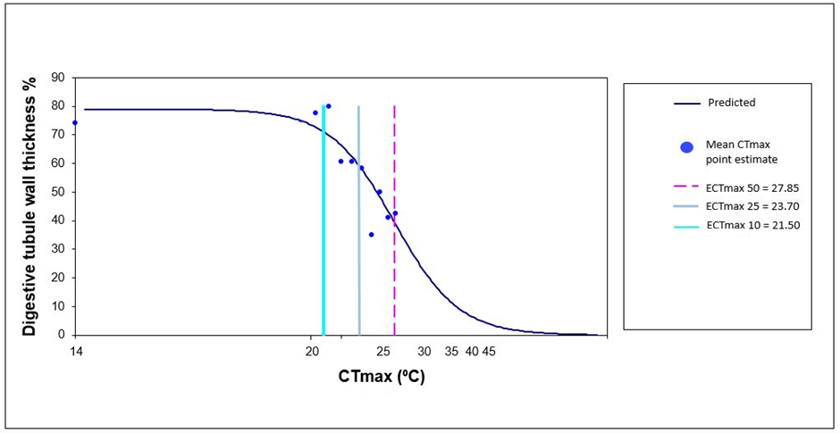
FIGURE S3 Probit analysis using Logistic (Sigmoidal) curve to identify the predicted Effect Critical Temperature maximum (ECT_{max}) estimate indicating a predicted % reduction in digestive tubule wall thickness at CT_{max} degree Celsius (e.g. ECT_{max} 50 indicates a 50% reduction in tubule wall thickness). Decrease in digestive tubule thickness indicates relative decrease in the tubule digestive cell volume for nutrient uptake and metabolism.

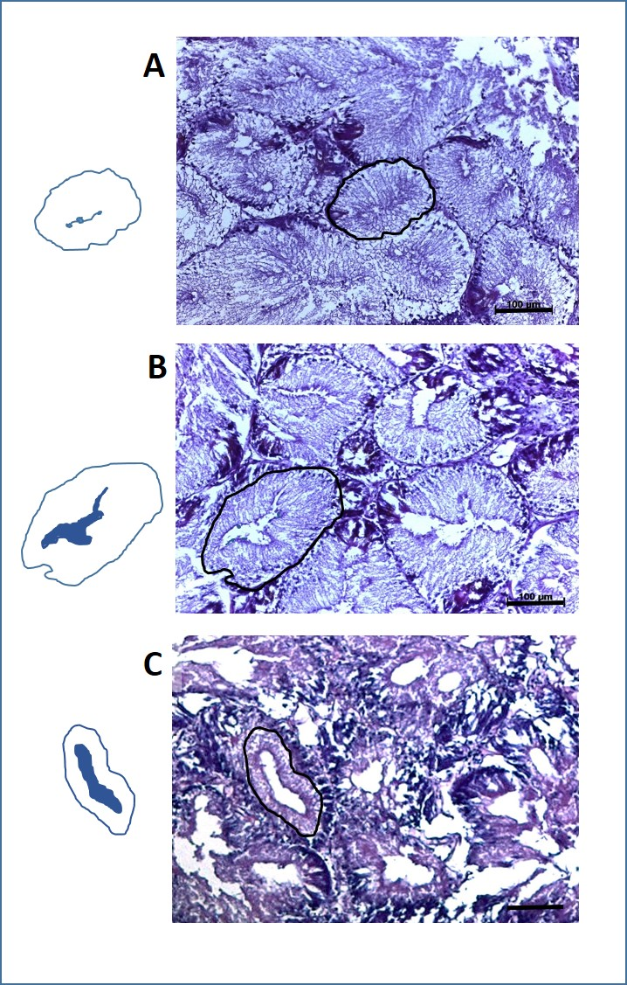
FIGURE S4 Comparison of tubule atrophy categories in digestive glands of abalone. Photomicrograph and corresponding stencil images depicting the central lumen area (shaded) and digestive cell tubule wall perimeter representative of: A. normal digestive tubule wall thickness with the central lumen comprising 0 % – 5% of the digestive tubule; B. tubule wall thickness significantly less than normal, but greater than one-half normal thickness with central lumen area representing up to 25% digestive wall atrophy; C. tubule wall thickness averaging approximately one-half normal thickness with central lumen representing up to 50% digestive wall atrophy. Scale bar represents µ100 m.

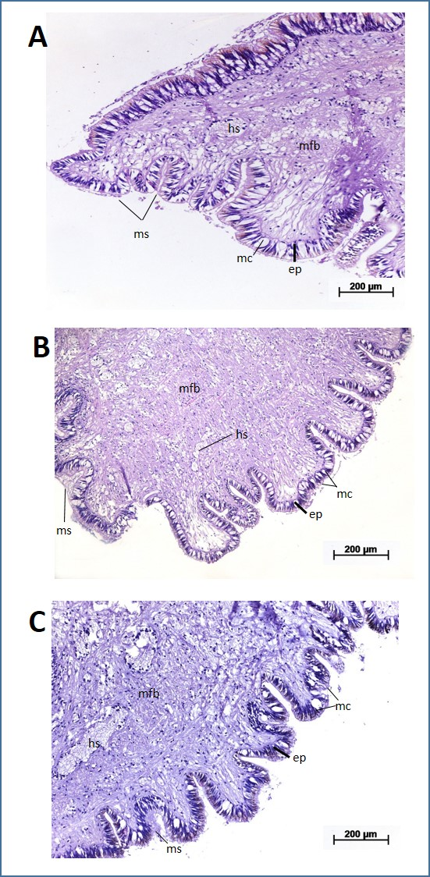
FIGURE S5 Photomicrographs of pedal foot section of abalone representative of: A. pedal sole and pedal side wall section of Control treatment at 14⁰C, B. pedal sole section of CTmax at 21⁰C, and C. pedal sole section of CTmax at 28⁰C, all showing intact epithelial layer (ep) comprising ciliated epithelial mucous cells (mc), mucus secretion (ms), pedal musculature comprising muscle fibre bundles (mfb) and haemocoelic sinuses (hs) providing contractile and hydrostatic support for pedal contraction.

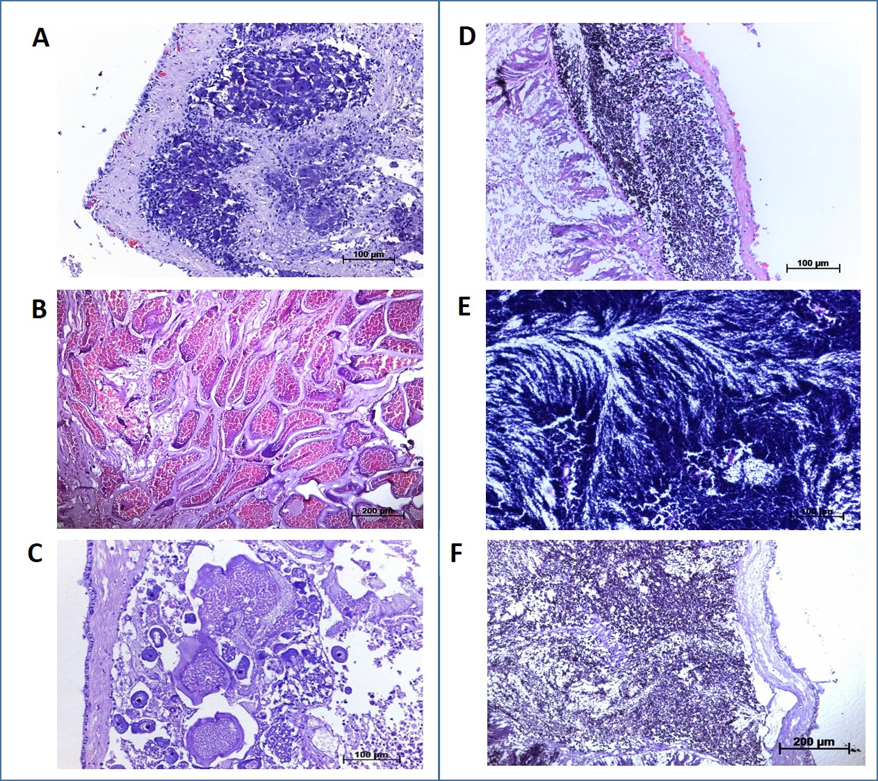
FIGURE S6 Photomicrographs of selected representative abalone gonad developmental stages of: A. ovarian immature phase predominantly comprising primary oocytes; B. late maturation to mature phase comprising densely packed elongate and hexagonal vitellogenic oocytes with thick gelatinous coating; C. spent and degenerative phase comprising degenerating large non-nucleated, irregular shaped oocytes; D. testis immature to early active phase predominantly comprising spermatogonia and strongly basophilic spermatocytes; E. mature ripe phase comprising densely packed spermatozoa; F. spent phase comprising a marked decrease in density of residual spermatozoa.

FIGURE S7 Scatterplot demonstrating the relationship between animal body mass and gonadal development. Experimental systems (System 1 = tanks 1 and 2, System 2 = tanks 3 and 4) are shown due to significant effect of system as a random factor in mixed model ANOVA (P < 0.001; Table 5).

FIGURE S8 Boxplot depicting CT_{max} values for each size class, separated by experimental tank where the animal was housed for the duration of the chronic (1˚C/12 hours) experiment.

TABLE S1 Non-parametric correlation between size category and digestive gland atrophy index within each abalone CT_{max} gradient.
CT_{max} range (°C) | Spearman’s Rho
21.0 – 21.9 | 0.4535 | P=0.3743
23.0 – 23.9 | 0.3337 | P=0.5243
24.0 – 24.9 | 0.1064 | P=0.7300
25.0 – 25.9 | 0.0882 | P=0.7852
26.0 – 26.9 | 0.2064 | P=0.5387
27.0 – 27.9 | 0.0616 | P=0.8572
28.0 – 28.9 | 0.4310 | P=0.2130

