Supplementary materials
Management strategy evaluation operating model conditioning: a swordfish case study
Daniela Rosa^{1,2,*}, Iago Mosqueira³, Dan Fu⁴, Rui Coelho^{1,2}.

1: IPMA – Instituto Português do Mar e da Atmosfera, I.P., Av. 5 de Outubro s/n, 8700-305 Olhão, Portugal.
2: CCMAR – Centro de Ciências do Mar da Universidade do Algarve, Universidade do Algarve, Campus de Gambelas, 8005-139 Faro, Portugal.
3: WMR – Wageningen Marine Research, Haringkade 1, 1976 CP IJmuiden. The Netherlands
4: IOTC – Indian Ocean Tuna Commission, Blend building, Providence, Seychelles
*corresponding author: daniela.rosa@ipma.pt

A set of model diagnostics is presented as an example for one model (i1) from the model grid with the following specifications:
- M=0.2
- h=0.75
- sigmaR=0.2
- ess=2
- llq=1.00
- Growth & maturity= Farley et al., 2022
- CPUE=jappt
- Scaling= area
- LLsel= Double normal
Diagnostics were based on convergence, retrospective analysis, runs test and hindcast cross validation. These diagnostics were run in R (R Core Team, 2022) using the R package “ss3diags” (Winker et al., 2021).

Convergence level
Convergence is assessed by the inversion of the Hessian matrix, and the value of final gradient of the objective function at the solution, from here forward mentioned as convergence level. Carvalho et al. (2021) suggested 0.0001 as a threshold for the convergence level, noting that a small gradient might not be an absolute requirement. In the case of model i1, the convergence level was below this threshold.

Retrospective analysis
The retrospective pattern for the estimated SSB from the i1 model is shown in Figure S1. This plot also includes a one-step ahead projection of SSB based on the known total catches. Retrospective analysis is a form of hindcasting commonly used to assess the stability of a model formulation to updates in the data. Mohn’s rho (Mohn, 1999) is then used to quantify the strength of the retrospective pattern. Hurtado-Ferro et al. (2015) proposed that values outside the -0.15 to 0.20 range, should indicate an undesirable retrospective pattern for longer lived species. In the case of i1 Monh's rho is within the proposed range.
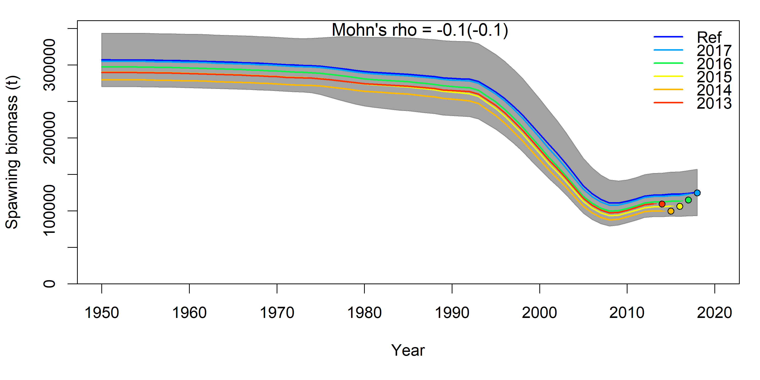
Figure S1 - Five-year retrospective runs with a one step ahead forecast of spawning stock biomass according to total catch for Indian Ocean swordfish.

Runs test
Runs tests on the CPUE and length-frequency data sources are common diagnostics of goodness of fit (Carvalho et al., 2017). The Wald-Wolfowitz runs test, a non-parametric statistical test that checks the randomness hypothesis for a data sequence, can be used to identify residuals patterns that should not be considered random. The runs test for the CPUEs (Figure S2) indicate that the model fit to the CPUE data series do not present significant patterns for all CPUE series except in the case of the SW Japanese series, however it should be noted that for this area two series (UJPLL_SW and UPOR_SW) are being fitted for the year 2000 up to 2003.
The runs test for the length-frequency (LF) data sources indicate that some series present significant patterns in the residuals (Figures S3-S4), this is particularly noted in the SW region where none of the LF “passed” the runs test.
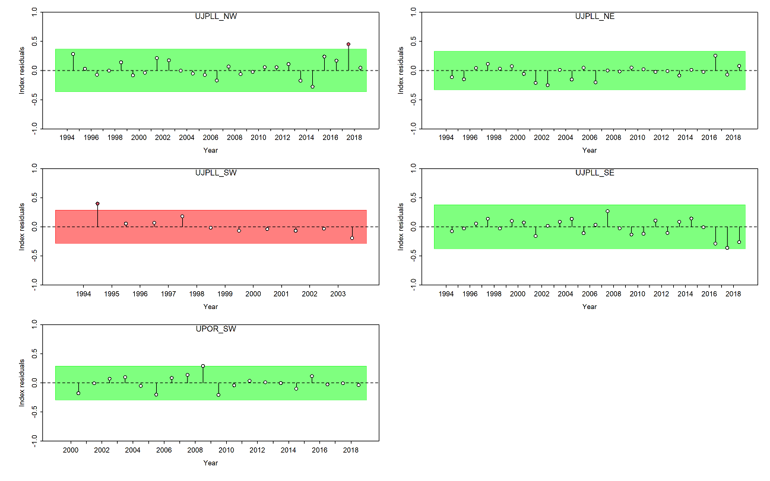
Figure S2 - Runs tests of the CPUE series for Indian Ocean swordfish.
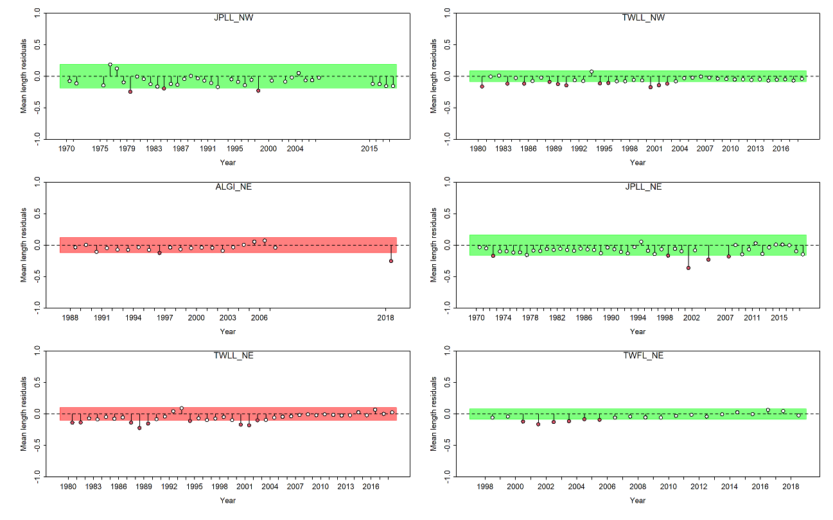Figure S3 - Runs tests for the various sources of length frequency data for the Northern Indian Ocean swordfish.
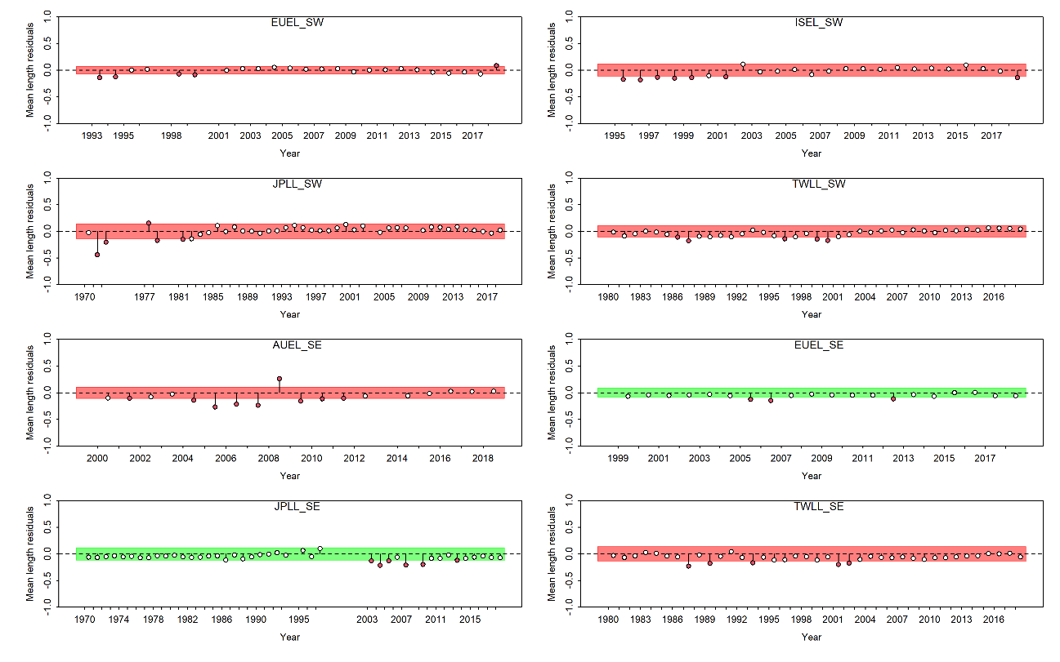
Figure S4 - Runs tests for the various sources of length frequency data for the Southern Indian Ocean swordfish.

Hindcasting cross validation
A proposed model-free hindcasting technique (HCXval) uses cross-validation to compare observations to their predicted future values (Kell et al., 2016). The prediction skill of a model is then computed from the prediction residuals. A robust statistic for evaluating the prediction skill can be constructed using the mean absolute scaled error (MASE) of Hyndman et al. (2006).
The prediction skills of the indices for each area are presented in Figure S5. A MASE score larger than 1 indicates the model does only as well as a random walk at predicting the quantity, while a value of 0.5 indicates the model is twice as good as a random walk. The model prediction skill appears to be better for the Northwest area.
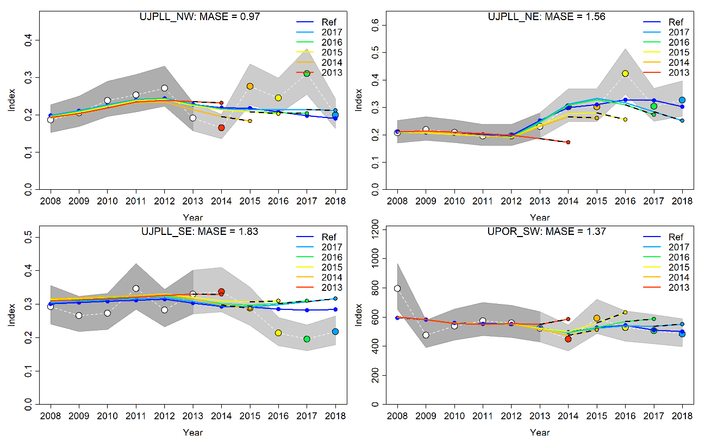
Figure S5 - Hindcasting cross-validation results for the four area CPUEs for Indian Ocean swordfish.

References
Carvalho F, Punt AE, Chang YJ, Maunder MN, Piner KR (2017) Can Diagnostic Tests Help Identify Model Misspecification in Integrated Stock Assessments? Fish Res 192: 28–40.
Carvalho F, Winker H, Courtney D, Kapur M, Kell L, Cardinale M, Schirripa M, Kitakado T, Yemane D, Piner KR, Maunder MN, Taylor I, Wetzel CR, Doering K, Johnson KF, Methot RD (2021) A cookbook for using model diagnostics in integrated stock assessments. Fish Res 240: 105959.
Farley JH, Clear NP, Krusic-Golub K, Evenson P, Young JW (2022) A bone to pick with age estimation using hard parts: A case study of swordfish, Xiphias gladius, in the southwest Pacific Ocean. Fish Res 254: 106413.
Hurtado-Ferro F, Szuwalski CS, Valero JL, Anderson SC, Cunningham CJ, Johnson KF, Licandeo R, McGilliard CR, Monnahan CC, Muradian ML, Ono K, Vert-Pre KA, Whitten AR, Punt AE (2015) Looking in the Rear-View Mirror: Bias and Retrospective Patterns in Integrated, Age-Structured Stock Assessment Models. ICES J Mar Sci 72 (1): 99–110.
Hyndman R J, Koehler AB, Methot RD, Wetzel CR (2006) Another Look at Measures of Forecast Accuracy. Int J Forecast 22 (4): 679–88.
Kell LT, Kimoto A, Kitakado T (2016) Evaluation of the Prediction Skill of Stock Assessment Using Hind-casting. Fish Res 183: 119–27.
Mohn R (1999) The Retrospective Problem in Sequential Population Analysis: An Investigation Using Cod Fishery and Simulated Data. ICES J Mar Sci 56 (4): 473–78.
R Core Team (2022) R: A language and environment for statistical computing. R Foundation for Statistical Computing, Vienna, Austria. URL https://www.R-project.org/.
Winker H, Carvalho F, Cardinale M., Kell L (2021) ss3diags: Cookbook for Model Diagnostics in Stock Synthesis. R package version 1.0.8.

