Supplementary information

Multi-disciplinary approach identifies pelagic nutrient linkage by sawsharks

Patrick J. Burke¹, Lauren Meyer², Vincent Raoult^{1,3}, Charlie Huveneers², Jane E. Williamson^{1, 4}

¹ School of Natural Sciences, Macquarie University, North Ryde, NSW, Australia
² College of Science and Engineering, Flinders University, Bedford, SA, Australia
³ School of Environmental and Life Sciences, University of Newcastle, Ourimbah, NSW, Australia
⁴ Sydney Institute of Marine Science, 19 Chowder Bay Road, Mosman, NSW, Australia
Corresponding author: patrick.burke@mq.edu.au

Additional methods information
Fishing information
We obtained sawshark samples using demersal gillnets and trawls, from fishing cooperatives within the Southern and Eastern Scalefish and Shark Fishery.

Demersal gillnets
Demersal gillnets are long rectangular panels of netting with diamond-shaped mesh that are held vertically in the water column and anchored to the ocean floor at either end. Under the Australian Fisheries Management Authority, gillnets must not exceed a total combined length of 6 km. Gillnets were set off the back of a commercial fishing vessel of 18 meters and were deployed for a period of 3 to 4 hours then hauled. Catch was processed, sawsharks were kept or tagged and released, and net was deployed again. This process was repeated across multiple days.

Demersal Trawl
Samples sourced from commercial trawlers were from the the Southern and Eastern Scalefish and Shark Fishery. Nets were demersal otter trawls with mesh size in the wings and the net mouth (shoulders, belly and veranda) not less than 115mm. A mesh size of: at least 90mm single twine mesh; or double twine mesh of at least 102mm or greater; or at least 90mm double twine mesh with one or more bycatch reduction devices. Trawl times were minimum 30 minutes and up to several hours in duration.
Fisheries-independent demersal trawls were carried out on board the TV Bluefin. A series of short, deep demersal trawls between 60m and 100m using a 70mm demersal mesh fish net were carried out. Trawls were conducted for 30 minutes at a speed of approximately 3.1kts

Table S1: Location and biological data of common and southern sawsharks collected in this study. Latitude and longitude are presented in decimal degrees and total length is measured in centimetres.
Species | Latitude  (decimal degrees) | Longitude  (decimal degrees) | Sex | Total length (cm) | Capture Date
P cirratus | -37.5055 | 150.0206 | M | 80.5 | 04-Oct-2018
P cirratus | -37.5055 | 150.0206 | M | 65 | 04-Oct-2018
P cirratus | -37.5055 | 150.0206 | M | 61.7 | 04-Oct-2018
P cirratus | -37.5055 | 150.0206 | F | 64.8 | 04-Oct-2018
P cirratus | -37.5055 | 150.0206 | F | 57.1 | 04-Oct-2018
P cirratus | -37.5055 | 150.0206 | F | 76.1 | 04-Oct-2018
P cirratus | -37.5055 | 150.0206 | F | 65.2 | 04-Oct-2018
P cirratus | -37.5055 | 150.0206 | M | 69.1 | 04-Oct-2018
P cirratus | -37.5055 | 150.0206 | F | 74.0 | 04-Oct-2018
P cirratus | -37.5055 | 150.0206 | M | 80.0 | 04-Oct-2018
P cirratus | -37.5055 | 150.0206 | M | 83.6 | 04-Oct-2018
P cirratus | -37.5055 | 150.0206 | F | 75.7 | 04-Oct-2018
P cirratus | -38.8605 | 143.1336 | F | 124.5 | 01-Sep-2019
P cirratus | -38.8605 | 143.1336 | F | 128.6 | 01-Sep-2019
P cirratus | -38.8605 | 143.1336 | F | 137.9 | 01-Sep-2019
P cirratus | -38.8605 | 143.1336 | F | 119.0 | 01-Sep-2019
P cirratus | -38.8605 | 143.1336 | F | 127.6 | 01-Sep-2019
P cirratus | -38.8605 | 143.1336 | F | 80.0 | 01-Sep-2019
P cirratus | -38.8605 | 143.1336 | F | 133.7 | 01-Sep-2019
P cirratus | -38.9247 | 144.8323 | M | 100.0 | 01-Jul-2020
P nudipinnis | -37.6718 | 138.7355 | F | 96.1 | 01-Nov-2020
P nudipinnis | -37.6718 | 138.7355 | F | 95.3 | 01-Nov-2020
P nudipinnis | -37.6718 | 138.7355 | M | 82.6 | 01-Nov-2020
P nudipinnis | -37.6718 | 138.7355 | M | 98.8 | 01-Nov-2020
P nudipinnis | -37.6718 | 138.7355 | M | 100.0 | 01-Nov-2020
P nudipinnis | -37.6718 | 138.7355 | M | 79.9 | 01-Nov-2020
P nudipinnis | -37.6718 | 138.7355 | M | 97.1 | 01-Nov-2020
P nudipinnis | -37.6718 | 138.7355 | M | 105.2 | 01-Nov-2020
P nudipinnis | -37.2362 | 138.9351 | M | 99.1 | 02-Nov-2020
P nudipinnis | -37.2362 | 138.9351 | M | 94.6 | 02-Nov-2020
P nudipinnis | -37.2362 | 138.9351 | M | 96.4 | 02-Nov-2020
P nudipinnis | -37.2362 | 138.9351 | M | 91.2 | 02-Nov-2020
P nudipinnis | -37.2362 | 138.9351 | M | 102.1 | 02-Nov-2020
P nudipinnis | -37.2362 | 138.9351 | M | 94.4 | 02-Nov-2020
P nudipinnis | -37.2362 | 138.9351 | F | 91.1 | 02-Nov-2020
P nudipinnis | -37.2362 | 138.9351 | M | 91.2 | 02-Nov-2020
P nudipinnis | -40.1229 | 147.8082 | M | 95.0 | 27-Nov-2018
P nudipinnis | -40.1229 | 147.8082 | M | 67.5 | 27-Nov-2018
P nudipinnis | -40.1229 | 147.8082 | F | 65.0 | 27-Nov-2018
P nudipinnis | -40.1229 | 147.8082 | M | 96.0 | 27-Nov-2018
P nudipinnis | -40.1229 | 147.8082 | M | 88.0 | 27-Nov-2018
P nudipinnis | -38.9247 | 144.8323 | M | 98.0 | 01-Jul-2020
P nudipinnis | -38.9247 | 144.8323 | F | 100.0 | 01-Jul-2020
P nudipinnis | -38.9247 | 144.8323 | M | 101.0 | 01-Jul-2020
P nudipinnis | -38.9247 | 144.8323 | M | 92.0 | 01-Jul-2020
P nudipinnis | -38.9247 | 144.8323 | M | 99.0 | 01-Jul-2020
P nudipinnis | -38.9247 | 144.8323 | M | 98.0 | 01-Jul-2020
P nudipinnis | -38.9247 | 144.8323 | F | 106.0 | 01-Jul-2020
P nudipinnis | -38.9247 | 144.8323 | M | 91.0 | 01-Jul-2020

Table S2: Stable isotope values of different prey species used to inform the mixing model in this study.
Species | Total Length (cm) | d15N | d13C | d34S
Chrysophyrus auratus | 38.1 | 15.2 | -16.5 | 15.5
Chrysophyrus auratus | 41.0 | 14.2 | -19.1 | 18.7
Chrysophyrus auratus | 43.1 | 15.2 | -17.6 | 18.6
Chrysophyrus auratus | 34.0 | 15.7 | -16.9 | 17
Chrysophyrus auratus | 37.0 | 15.4 | -18 | 18.4
Melicertus latisulcatus | 17.0 | 8.7 | -17 | 13.5
Melicertus latisulcatus | 17.0 | 8.8 | -18.8 | 16.1
Melicertus latisulcatus | 15.0 | 7.8 | -18.2 | 15.6
Melicertus latisulcatus | 17.5 | 8.6 | -17.4 | 13.6
Melicertus latisulcatus | 18.5 | 8.4 | -17.7 | 11.5
Melicertus latisulcatus | 15.0 | 8.9 | -17.3 | 11.7
Sillaginodes punctatus | 34.0 | 9.1 | -14.2 | 4.6
Sillaginodes punctatus | 36.0 | 8.8 | -14.8 | 2.1
Sillaginodes punctatus | 35.5 | 9.6 | -16.3 | 5.7
Sillaginodes punctatus | 34.5 | 8.4 | -14.7 | 5.1
Sillaginodes punctatus | 33.0 | 8.5 | -14.3 | 2.8
Sardinops sagax | 16.0 | 10.3 | -20.5 | 19.9
Sardinops sagax | 17.0 | 12.1 | -20.2 | 19.5
Sardinops sagax | 21.0 | 11.3 | -20.2 | 19.4
Sardinops sagax | 20.0 | 10.3 | -20.5 | 19.2
Sardinops sagax | 19.0 | 10.2 | -20.3 | 19.5
Sardinops sagax | 19.0 | 9.9 | -20.6 | 20.3
Sardinops sagax | 16.0 | 9.4 | -20.2 | 19.7
Sardinops sagax | 16.5 | 9.4 | -20.4 | 19.6

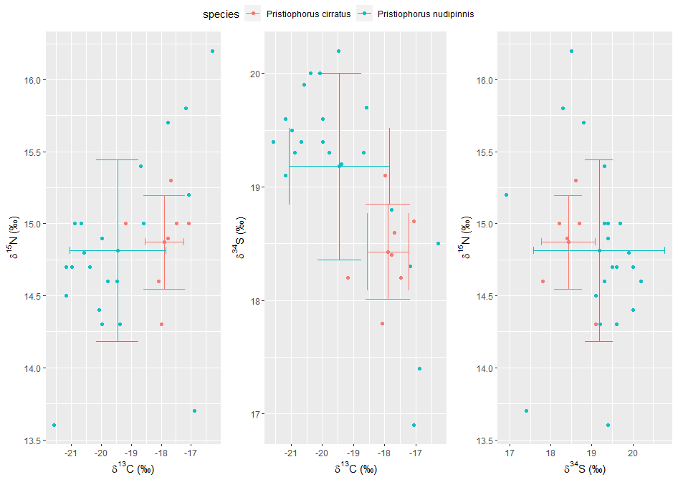
Supplementary Figure 1: Stable isotope biplots of Pristiophorus cirratus and Pristiophorus nudipinnis liver tissue including δ¹⁵N v δ¹³C, δ³⁴S v δ¹³C, and δ¹⁵N v δ³⁴S.

