Supplementary material for ‘Otolith growth chronologies reveal distinct environmental sensitivities between and within shallow- and deep-water snappers.’
Joseph B. Widdrington¹* Patrick Reis-Santos¹, John R. Morrongiello³, Jed I. Macdonald⁴, Corey B. Wakefield², Stephen J. Newman², Simon J. Nicol⁴, Bronwyn M. Gillanders¹
1 Southern Seas Ecology Laboratories, School of Biological Sciences, University of Adelaide, Adelaide, SA, Australia.
2 Western Australian Fisheries and Marine Research Laboratories, Department of Primary Industries and Regional Development, Government of Western Australia, Perth, WA, Australia.
3 School of BioSciences, University of Melbourne, Melbourne, Victoria, Australia.
4 Oceanic Fisheries Programme, The Pacific Community, Noumea, New Caledonia.
* Corresponding author: Joseph B Widdrington
Appendix A – FishID, age and otolith increment measurements.
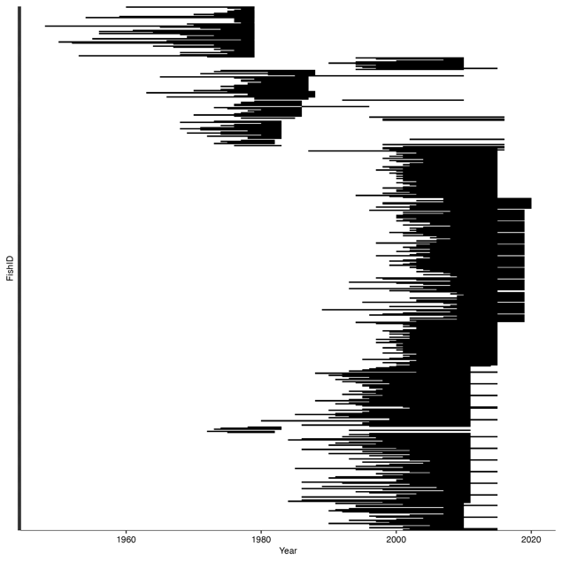

Figure S1. Figure showing the spread of data by FishID for Lutjanus sebae (1950 – 2020).

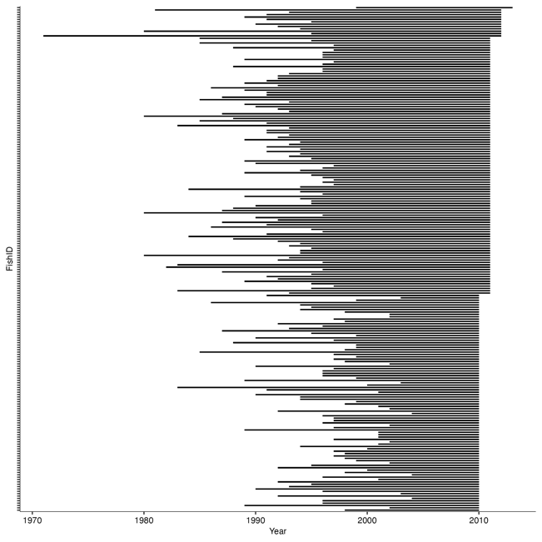

Figure S2. Figure showing the spread of data by FishID for Etelis boweni (1973 – 2013).

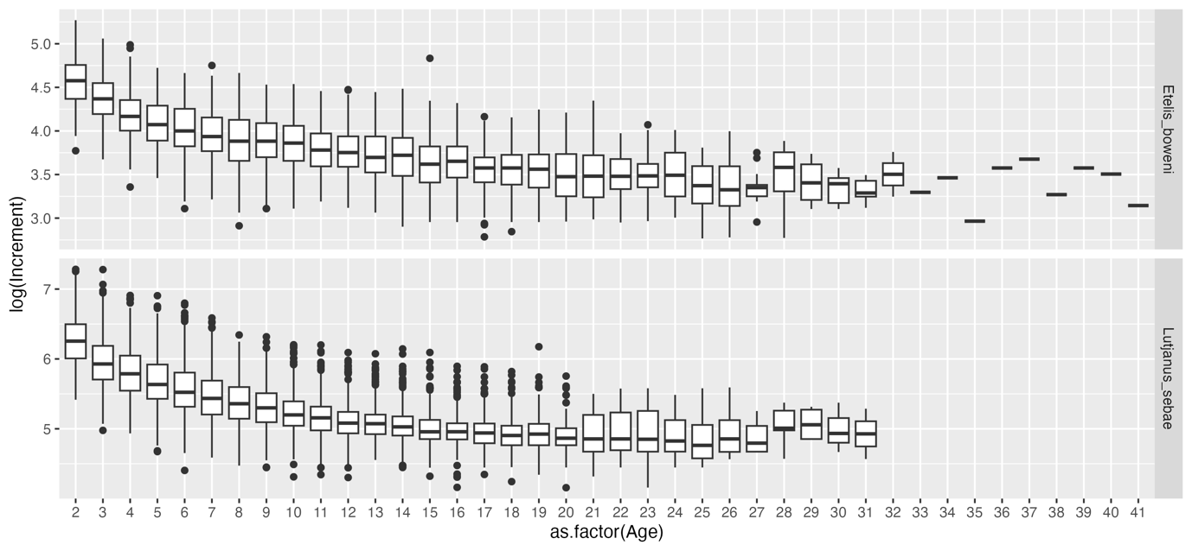
Figure S3. Boxplots showing increment width distances (growth) per age for each species. Y axis indicates length of increment and the X axis indicates different age classes. Black circles indicate outliers, the extent of the straight line for each age class shows the maximum and minimum growth value, the black line in each age class box indicates the mean increment width, whereas the box indicates the first (lower) and third (upper) quartile.

Appendix B – Data analysis workflow.

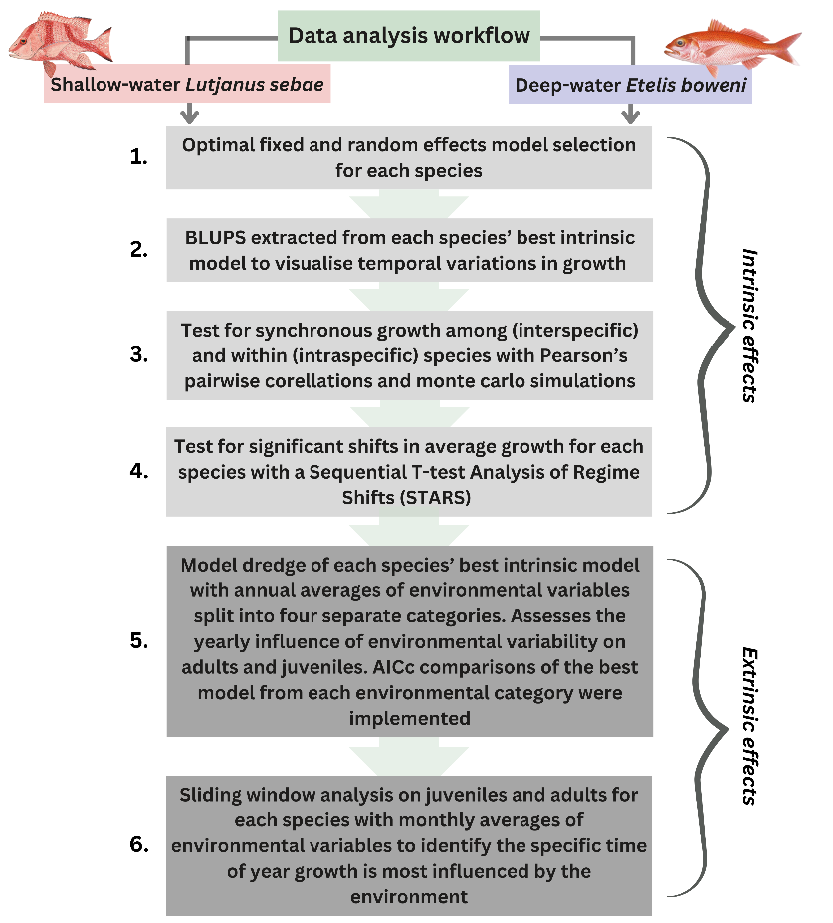

Figure S4. Conceptual diagram showing the workflow of data analyses techniques used in the manuscript.

Appendix C – Intrinsic growth modelling.

Table S1. Results of Lutjanus sebae random effects structure model selection.
Model | Random effects structure | AIcc
M1 | (Age))|FishID) + (1|Maturity:Year) + (1|Cohort) | 0.0
M2 | (Age))|FishID) + (1|Year) + (1|Cohort) | 8.8
M3 | (Age))|FishID) + (1|Maturity:Year) | 83.5
M4 | (Age))|FishID) + (1|Year) | 219.9

Table S2. Results of Lutjanus sebae fixed effects structure model selection.
Model | Fixed effects structure | AIcc
M1a | Age + AAC | 0.0
M1b | AAC | 1265.1
M1c | Age | 31.8

Table S3. Results of Etelis boweni random effects structure model selection.
Model | Random effects structure | AIcc
B1 | (Age))|FishID) + (1|Maturity:Year) + (1|Cohort) | 0.0
B2 | (Age))|FishID) + (1|Year) + (1|Cohort) | 1.9
B3 | (Age))|FishID) + (1|Maturity:Year) | 2.5
B4 | (Age))|FishID) + (1|Year) | 4.6

Table S4. Results of Etelis boweni fixed effects structure model selection.
Model | Fixed effects structure | AIcc
B1a | Age*Sex + AAC*Sex | 0.0
B1b | Age*Sex + AAC | 2.0
B1c | Age + AAC*Sex | 4.9
B1d | Age + AAC + Sex | 5.5
B1e | Age + AAC | 7.5

Table S5. Results of Pearson’s correlation analysis.
Test | R value | P value
L. sebae adl vs E. boweni adl | 0.308 | 0.060
L. sebae juv vs E. boweni juv | -0.109 | 0.589
E. boweni adl vs E. boweni juv | -0.283 | 0.185
L. sebae adl vs L. sebae juv | -0.088 | 0.494

Appendix D – Extrinsic growth modelling.

Lutjanus sebae:

Table S6. Results of Lutjanus sebae growth model dredge with large-scale environmental variables averaged over a year. IM represents the intrinsic growth model.
Model | AICc score
a) IM + ENSO*Maturity + PDO*Maturity + IOD*Maturity | 0.0
b) IM + ENSO*Maturity + PDO*Maturity | 24.4
c) IM + ENSO*Maturity + IOD*Maturity | 15.6
d) IM + IOD*Maturity + PDO*Maturity | 17.5
e) IM + PDO*Maturity | 36.4
f) IM + IOD*Maturity | 31.4
g) IM + ENSO*Maturity | 35.1
h) IM + ENSO + PDO + IOD | 31.3
i) IM + ENSO + PDO | 42.6
j) IM + ENSO + IOD | 36.8
k) IM + IOD + PDO | 42.5
l) IM + PDO | 48.9
m) IM + IOD | 47.2
n) IM + ENSO | 46.7
o) IM | 54.2

Table S7. Results of Lutjanus sebae growth model dredge with 1-year lagged large-scale environmental variables averaged over a year. IM represents the intrinsic growth model.
Model | AICc score
a) IM + ENSO_lag*Maturity + PDO_lag*Maturity + IOD_lag*Maturity | 0.0
b) IM + ENSO_lag*Maturity + PDO_lag*Maturity | 25.8
c) IM + ENSO_lag*Maturity + IOD_lag*Maturity | 16.3
d) IM + IOD_lag*Maturity + PDO_lag*Maturity | 15.2
e) IM + PDO_lag*Maturity | 35.7
f) IM + IOD_lag*Maturity | 31.4
g) IM + ENSO_lag*Maturity | 38.2
h) IM + ENSO_lag + PDO_lag + IOD_lag | 31.9
i) IM + ENSO_lag + PDO_lag | 45.1
j) IM + ENSO_lag + IOD_lag | 36.4
k) IM + IOD_lag + PDO_lag | 41.0
l) IM + PDO_lag | 49.6
m) IM + IOD_lag | 46.3
n) IM + ENSO_lag | 49.6
o) IM | 56.1

Table S8. Results of Lutjanus sebae growth model dredge with local-scale environmental variables averaged over a year. IM represents the intrinsic growth model.
Model | AICc score
a) IM + SST*Maturity + Rain*Maturity + Lcurrent*Maturity | 0.0
b) IM + SST*Maturity + Rain*Maturity | 18.8
c) IM + SST*Maturity + Lcurrent*Maturity | 10.2
d) IM + Rain*Maturity + Lcurrent*Maturity | 22.1
e) IM + SST*Maturity | 29.9
f) IM + Lcurrent*Maturity | 31.4
g) IM + Rain*Maturity | 41.2
h) IM + SST + Rain + Lcurrent | 36.8
i) IM + SST + Rain | 48.9
j) IM + SST + Lcurrent | 40.6
k) IM + Rain + Lcurrent | 41.9
l) IM + SST | 54.0
m) IM + Rain | 52.8
n) IM + Lcurrent | 45.9
o) IM | 57.8

Table S9. Results of Lutjanus sebae growth model dredge with 1-year lagged local-scale environmental variables averaged over a year. IM represents the intrinsic growth model.
Model | AICc score
a) IM + SST_lag*Maturity + Rain_lag*Maturity + Lcurrent_lag*Maturity | 0.0
b) IM + SST_lag*Maturity + Rain_lag*Maturity | 21.3
c) IM + SST_lag*Maturity + Lcurrent_lag*Maturity | 10.2
d) IM + Rain_lag*Maturity + Lcurrent_lag*Maturity | 21.4
e) IM + SST_lag*Maturity | 33.2
f) IM + Lcurrent_lag*Maturity | 30.7
g) IM + Rain_lag*Maturity | 41.5
h) IM + SST_lag + Rain_lag + Lcurrent_lag | 34.2
i) IM + SST_lag + Rain_lag | 48.3
j) IM + SST_lag + Lcurrent_lag | 38.1
k) IM + Rain_lag + Lcurrent_lag | 39.5
l) IM + SST_lag | 54.5
m) IM + Rain_lag | 52.3
n) IM + Lcurrent_lag | 43.8
o) IM | 58.3

Etelis boweni:

Table S10. Results of Etelis boweni growth model dredge with large-scale environmental variables averaged over a year. IM represents the intrinsic growth model.
Model | AICc score
a) IM + ENSO*Maturity + PDO*Maturity + IOD*Maturity | 0.5
b) IM + ENSO*Maturity + PDO*Maturity | 0.0
c) IM + ENSO*Maturity + IOD*Maturity | 4.3
d) IM + IOD*Maturity + PDO*Maturity | 2.9
e) IM + PDO*Maturity | 3.1
f) IM + IOD*Maturity | 6.4
g) IM + ENSO*Maturity | 4.8
h) IM + ENSO + PDO + IOD | 23.6
i) IM + ENSO + PDO | 23.7
j) IM + ENSO + IOD | 27.0
k) IM + IOD + PDO | 24.4
l) IM + PDO | 25.4
m) IM + IOD | 26.8
n) IM + ENSO | 28.7
o) IM | 28.3

Table S11. Results of Etelis boweni growth model dredge with 1-year lagged large-scale environmental variables averaged over a year. IM represents the intrinsic growth model.
Model | AICc score
a) IM + ENSO_lag*Maturity + PDO_lag*Maturity + IOD_lag*Maturity | 0.0
b) IM + ENSO_lag*Maturity + PDO_lag*Maturity | 1.9
c) IM + ENSO_lag*Maturity + IOD_lag*Maturity | 3.8
d) IM + IOD_lag*Maturity + PDO_lag*Maturity | 2.8
e) IM + PDO_lag*Maturity | 2.2
f) IM + IOD_lag*Maturity | 8.4
g) IM + ENSO_lag*Maturity | 6.6
h) IM + ENSO_lag + PDO_lag + IOD_lag | 26.2
i) IM + ENSO_lag + PDO_lag | 25.8
j) IM + ENSO_lag + IOD_lag | 30.0
k) IM + IOD_lag + PDO_lag | 26.6
l) IM + PDO_lag | 26.1
m) IM + IOD_lag | 30.1
n) IM + ENSO_lag | 30.1
o) IM | 29.8

Table S12. Results of Etelis boweni growth model dredge with local-scale environmental variables averaged over a year. IM represents the intrinsic growth model.
Model | AICc score
a) IM + SST*Maturity + Rain*Maturity + Lcurrent*Maturity | 0.0
b) IM + SST*Maturity + Rain*Maturity | 11.3
c) IM + SST*Maturity + Lcurrent*Maturity | 1.4
d) IM + Rain*Maturity + Lcurrent*Maturity | 3.3
e) IM + SST*Maturity | 10.8
f) IM + Lcurrent*Maturity | 3.2
g) IM + Rain*Maturity | 10.4
h) IM + SST + Rain + Lcurrent | 28.9
i) IM + SST + Rain | 30.7
j) IM + SST + Lcurrent | 29.0
k) IM + Rain + Lcurrent | 29.3
l) IM + SST | 30.2
m) IM + Rain | 29.6
n) IM + Lcurrent | 31.6
o) IM | 31.0

Table S13. Result of Etelis boweni growth model dredge with 1-year lagged local-scale environmental variables averaged over a year. IM represents the intrinsic growth model.
Model | AICc score
a) IM + SST_lag*Maturity + Rain_lag*Maturity + Lcurrent_lag*Maturity | 0.0
b) IM + SST_lag*Maturity + Rain_lag*Maturity | 6.4
c) IM + SST_lag*Maturity + Lcurrent_lag*Maturity | 1.8
d) IM + Rain_lag*Maturity + Lcurrent_lag*Maturity | 2.3
e) IM + SST_lag*Maturity | 5.3
f) IM + Lcurrent_lag*Maturity | 3.8
g) IM + Rain_lag*Maturity | 9.9
h) IM + SST_lag + Rain_lag + Lcurrent_lag | 26.9
i) IM + SST_lag + Rain_lag | 31.2
j) IM + SST_lag + Lcurrent_lag | 27.0
k) IM + Rain_lag + Lcurrent_lag | 28.3
l) IM + SST_lag | 30.6
m) IM + Rain_lag | 27.9
n) IM + Lcurrent_lag | 30.7
o) IM | 30.1

Appendix E – Sliding window analysis.
E1 Lutjanus sebae juvenile sliding windows:

Large-scale environment
Table S14. Results of the large-scale exploratory sliding window for L. sebae juveniles. A randomisation test confirmed the identification of a linear PDO signal influencing growth in May did not occur by chance. Window open/close values relate to the number of months away from the reference month used in the analysis (based on peak spawning), counting backwards. 0 = October, 1 = September, 2 = August, 3 = July, 4 = June, 5 = May, 6 = April, 7 = March, 8 = February, 9 = January, 10 = December, 11 = November, 12 = October.
Stage One:
Climate | Function | AICc | Window Open | Window Close | P-value
ENSO | lin | -3.86 | 12 | 0 | -
PDO | lin | -10.95 | 5 | 5 | 0.04
IOD | lin | -6.58 | 9 | 9 | -
ENSO | quad | -7.92 | 12 | 0 | -
PDO | quad | -13.01 | 5 | 5 | 0.22
IOD | quad | -12.40 | 3 | 3 | -

Stage Two:
Climate | Function | AICc | Window Open | Window Close | P-value
ENSO | lin | -4.03 | 2 | 2 | -
IOD | lin | -8.00 | 9 | 9 | 0.28
ENSO | quad | -7.94 | 12 | 0 | -
IOD | quad | -13.12 | 10 | 0 | 0.59

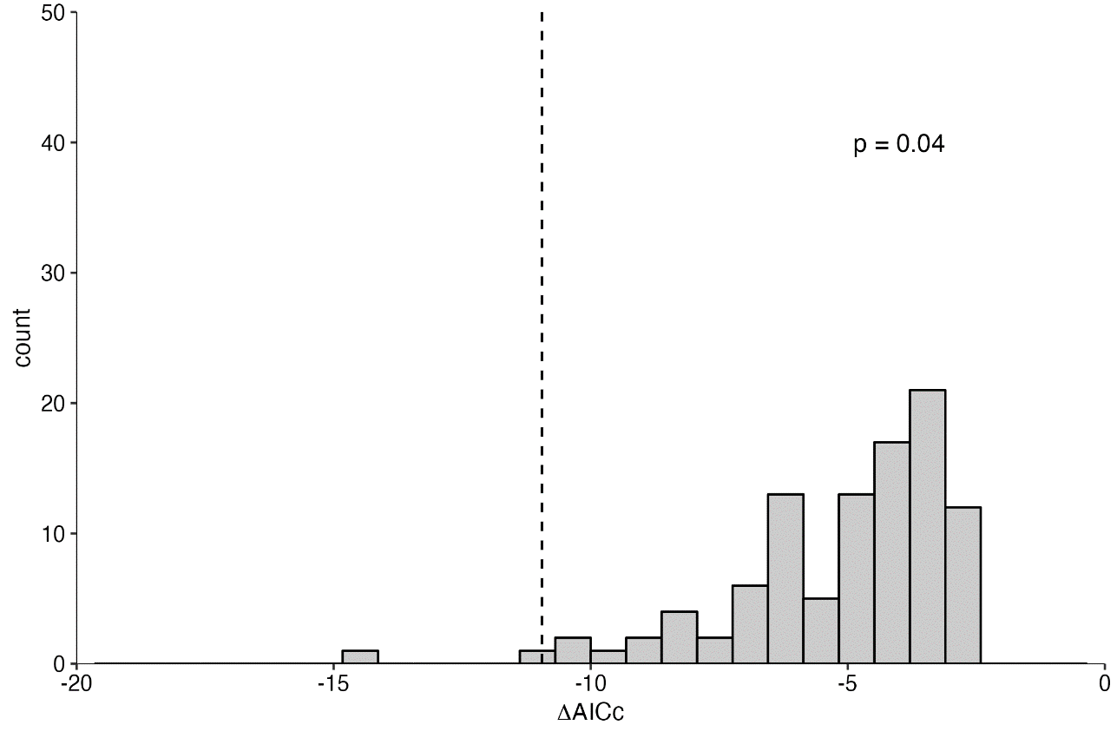

Figure S5. A plot comparing the likelihood of the AICc of the best supported large-scale model against the distribution of AICc values from 100 randomisation tests of the environmental data (PDO linear) for L. sebae juveniles. Dashed line represents the AICc of the time window identified (-10.95). A p-value <0.05 indicates the best time window was not selected by chance.

1-year lagged large-scale environment
Table S15. Results of the 1-year lagged large-scale exploratory sliding window for L. sebae juveniles. A randomisation test confirmed the identification of a signal of the previous year’s PDO (linear) influencing growth from March to May did not occur by chance. Window open/close values relate to the number of months away from the reference month used in the analysis (based on peak spawning), counting backwards. 0 = October, 1 = September, 2 = August, 3 = July, 4 = June, 5 = May, 6 = April, 7 = March, 8 = February, 9 = January, 10 = December, 11 = November, 12 = October.
Climate | Function | AICc | Window Open | Window Close | P-value
ENSO_lag | lin | -7.42 | 12 | 12 | -
PDO_lag | lin | -11.90 | 7 | 5 | 0.02
IOD_lag | lin | -6.91 | 12 | 12 | -
ENSO_lag | quad | -11.73 | 8 | 1 | -
PDO_lag | quad | -15.98 | 7 | 5 | -
IOD_lag | quad | -18.69 | 8 | 5 | 0.14
Stage One:

Stage Two:
Climate | Function | AICc | Window Open | Window Close | P-value
ENSO_lag | lin | -4.28 | 12 | 0 | -
IOD_lag | lin | -6.11 | 9 | 5 | 0.5
ENSO_lag | quad | -11.58 | 4 | 3 | -
IOD_lag | quad | -15.42 | 7 | 5 | 0.35

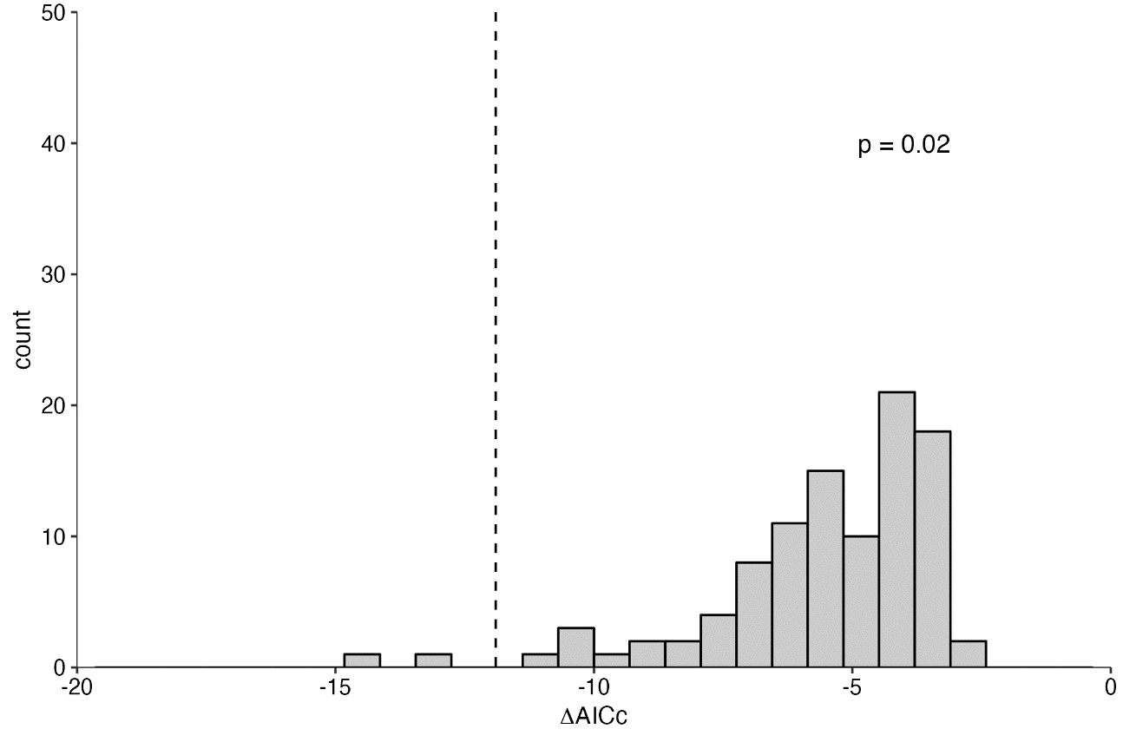

Figure S6. A plot comparing the likelihood of the AICc of the best supported 1-year lagged large-scale model against the distribution of AICc values from 100 randomisation tests of the environmental data (1-year lagged PDO linear) for L. sebae juveniles. Dashed line represents the AICc of the time window identified (-11.90). A p-value <0.05 indicates the best time window was not selected by chance.

Local-scale environment
Table S16. Results of the local-scale exploratory sliding window for L. sebae juveniles. A randomisation test confirmed the identification of a linear SST signal influencing growth from April to July did not occur by chance. Window open/close values relate to the number of months away from the reference month used in the analysis (based on peak spawning), counting backwards. 0 = October, 1 = September, 2 = August, 3 = July, 4 = June, 5 = May, 6 = April, 7 = March, 8 = February, 9 = January, 10 = December, 11 = November, 12 = October.
Stage One:
Climate | Function | AICc | Window Open | Window Close | P-value
SST | lin | -15.26 | 6 | 3 | 0.02
Rain | lin | -12.36 | 12 | 12 | -
LCurrent | lin | -5.72 | 7 | 6 | -
SST | quad | -25.79 | 6 | 0 | -
Rain | quad | -32.10 | 12 | 12 | 0.1
LCurrent | quad | -12.41 | 7 | 6 | -

Climate | Function | AICc | Window Open | Window Close | P-value
Rain | lin | -14.09 | 2 | 0 | -
LCurrent | lin | -16.20 | 11 | 9 | 0.07
Rain | quad | -37.08 | 2 | 0 | 0.33
LCurrent | quad | -22.71 | 11 | 11 | -
Stage Two:

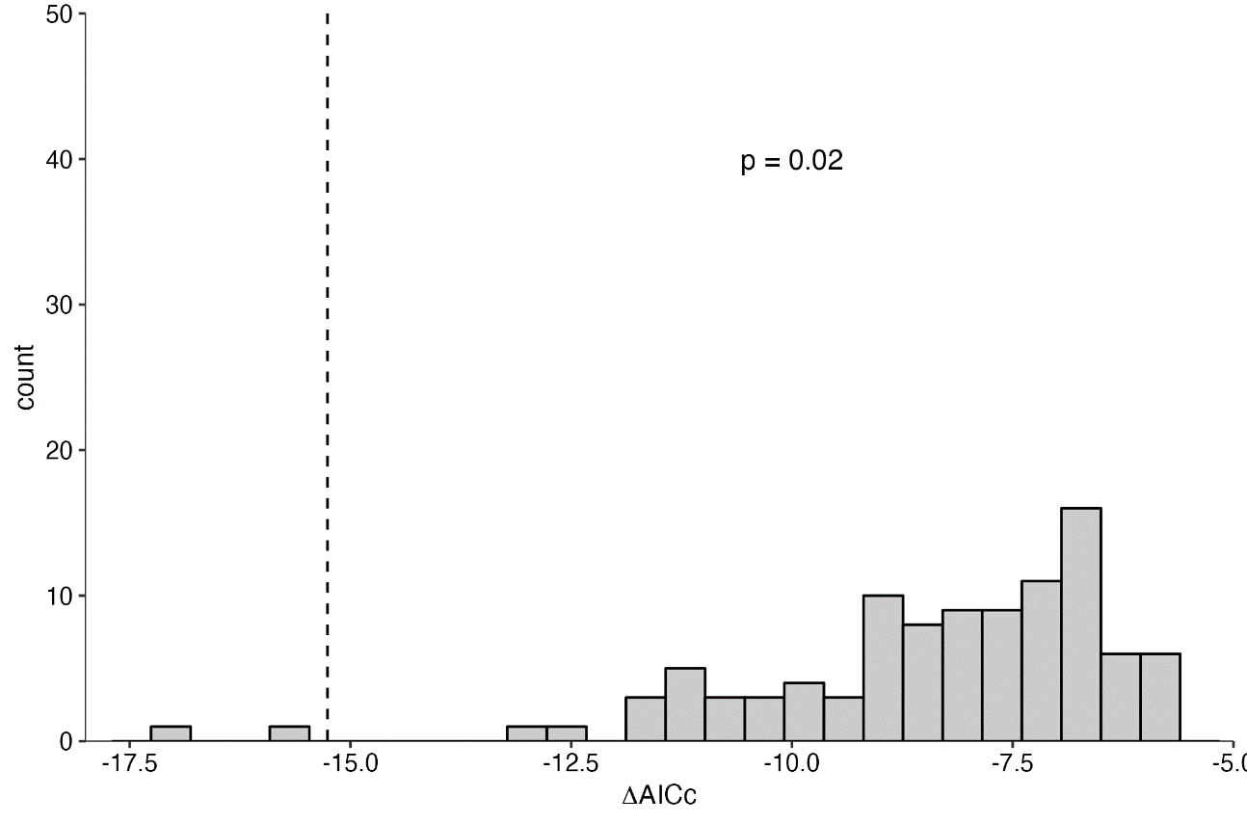

Figure S7. A plot comparing the likelihood of the AICc of the best supported local-scale model against the distribution of AICc values from 100 randomisation tests of the environmental data (SST linear) for L. sebae juveniles. Dashed line represents the AICc of the time window identified (-15.26). A p-value <0.05 indicates the best time window was not selected by chance.

1-year lagged local-scale environment
Table S17. Results of the 1-year lagged local-scale exploratory sliding window for L. sebae juveniles. A randomisation test confirmed the identification of a signal of the previous year’s rainfall (linear) influencing growth from October to November did not occur by chance. A randomisation test in the second stage confirmed the identification of a signal of the previous year’s SST (linear) influencing growth from November to July did not occur by chance. Window open/close values relate to the number of months away from the reference month used in the analysis (based on peak spawning), counting backwards. 0 = October, 1 = September, 2 = August, 3 = July, 4 = June, 5 = May, 6 = April, 7 = March, 8 = February, 9 = January, 10 = December, 11 = November, 12 = October.
Stage One:
Climate | Function | AICc | Window Open | Window Close | P-value
SST_lag | lin | -15.48 | 6 | 3 | -
Rain_lag | lin | -22.04 | 12 | 11 | <0.001
LCurrent_lag | lin | -8.24 | 12 | 12 | -
SST_lag | quad | -25.11 | 6 | 3 | -
Rain_lag | quad | -38.68 | 12 | 11 | 0.05
LCurrent_lag | quad | -12.60 | 12 | 11 | -

Stage Two:
Climate | Function | AICc | Window Open | Window Close | P-value
SST_lag | lin | -12.74 | 11 | 3 | 0.02
LCurrent_lag | lin | -5.59 | 12 | 12 | -
SST_lag | quad | -23.53 | 9 | 4 | 0.05
LCurrent_lag | quad | -11.96 | 12 | 11 | -

Stage Three:
Climate | Function | AICc | Window Open | Window Close | P-value
LCurrent_lag | lin | -9.54 | 7 | 7 | 0.78
LCurrent_lag | quad | -16.87 | 11 | 11 | 0.93

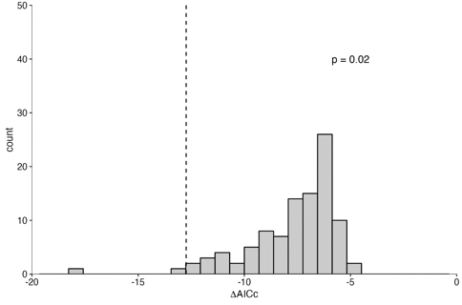
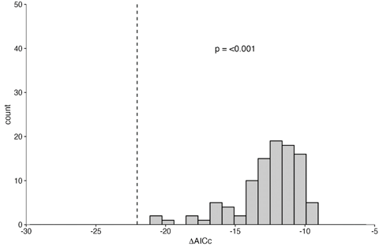

Figure S8. Plots comparing the likelihood of the AICc of the best supported 1-year lagged local-scale models against the distribution of AICc values from 100 randomisation tests of the environmental data (Left: 1-year lagged rainfall linear and right: 1-year lagged SST linear) for L. sebae juveniles. Dashed lines represent the AICc of the time window identified (-22.04 and -12.74 respectively). P-values <0.05 indicate the best time windows were not selected by chance.

Comparison of best sliding window models
Table S18. AICc comparison of all optimal environmental windows to select the extrinsic model that best explains L. sebae juvenile growth. The 1-year lagged local-scale model including temporal windows for the previous years’ rainfall and SST (linear) was identified as the best model. JM represents the intrinsic L. sebae juvenile growth model with adult growth removed.
Model | AICc score
a) JM + PDO | 23.8
b) JM + PDO_lag | 22.9
c) JM + SST | 19.5
d) JM + Rain_lag + SST_lag | 0.0

E2 Lutjanus sebae adult sliding windows:
Large-scale environment
Table S19. Results of the large-scale exploratory sliding window for L. sebae adults. Although IOD was identified as the best quadratic environmental predictor influencing growth from June to July, a randomization test suggests it may have occurred by chance (p-value >0.05). Although ENSO was identified as the best linear environmental predictor influencing growth in May, a randomization test suggests it may have occurred by chance (p-value >0.05). Window open/close values relate to the number of months away from the reference month used in the analysis (based on peak spawning), counting backwards. 0 = October, 1 = September, 2 = August, 3 = July, 4 = June, 5 = May, 6 = April, 7 = March, 8 = February, 9 = January, 10 = December, 11 = November, 12 = October.
Stage One:
Climate | Function | AICc | Window Open | Window Close | P-value
ENSO | lin | -5.66 | 5 | 5 | 0.57
PDO | lin | -5.46 | 1 | 0 | -
IOD | lin | -4.56 | 11 | 4 | -
ENSO | quad | -9.85 | 6 | 5 | -
PDO | quad | -13.96 | 1 | 0 | -
IOD | quad | -14.71 | 4 | 3 | 0.45

1-year lagged large-scale environment
Table S20. Results of the 1-year lagged large-scale exploratory sliding window for L. sebae adults. Although the previous year’s IOD was identified as the best quadratic environmental predictor influencing growth from January to May, a randomization test suggests it may have occurred by chance (p-value >0.05). Although the previous year’s ENSO was identified as the best linear environmental predictor influencing growth in May, a randomization test suggests it may have occurred by chance (p-value >0.05). The previous year’s PDO as a quadratic term was also tested as an influence on growth from October to October, however a randomisation test suggests it may have occurred by chance (p-value >0.05). Window open/close values relate to the number of months away from the reference month used in the analysis (based on peak spawning), counting backwards. 0 = October, 1 = September, 2 = August, 3 = July, 4 = June, 5 = May, 6 = April, 7 = March, 8 = February, 9 = January, 10 = December, 11 = November, 12 = October.

Stage One:
Climate | Function | AICc | Window Open | Window Close | P-value
ENSO_lag | lin | -6.40 | 5 | 5 | 0.41
PDO_lag | lin | -3.38 | 9 | 2 | -
IOD_lag | lin | -5.28 | 10 | 4 | -
ENSO_lag | quad | -10.01 | 5 | 5 | -
PDO_lag | quad | -11.35 | 12 | 0 | 0.45
IOD_lag | quad | -11.43 | 9 | 5 | 0.76

Local-scale environment
Table S21. Results of the local-scale exploratory sliding window for L. sebae adults. Although rain was identified as the best quadratic environmental predictor influencing growth from September to October, a randomization test suggests it may have occurred by chance (p-value >0.05). Although Rain was identified as the best linear environmental predictor influencing growth from August to October, a randomization test suggests it may have occurred by chance (p-value >0.05). A randomisation test confirmed the identification of an SST signal influencing growth from May to July did not occur by chance. This signal was checked as the AICc values were close. Window open/close values relate to the number of months away from the reference month used in the analysis (based on peak spawning), counting backwards. 0 = October, 1 = September, 2 = August, 3 = July, 4 = June, 5 = May, 6 = April, 7 = March, 8 = February, 9 = January, 10 = December, 11 = November, 12 = October.
Stage One:
Climate | Function | AICc | Window Open | Window Close | P-value
SST | lin | -13.17 | 5 | 5 | -
Rain | lin | -13.20 | 2 | 0 | 0.26
LCurrent | lin | -8.44 | 6 | 6 | -
SST | quad | -29.48 | 5 | 3 | <0.001
Rain | quad | -31.08 | 1 | 0 | 0.54
LCurrent | quad | -12.09 | 4 | 4 | -

Stage Two:
Climate | Function | AICc | Window Open | Window Close | P-value
Rain | lin | -13.39 | 7 | 0 | 0.24
LCurrent | lin | -7.75 | 7 | 6 | -
Rain | quad | -28.65 | 2 | 0 | 0.89
LCurrent | quad | -12.10 | 11 | 11 | -

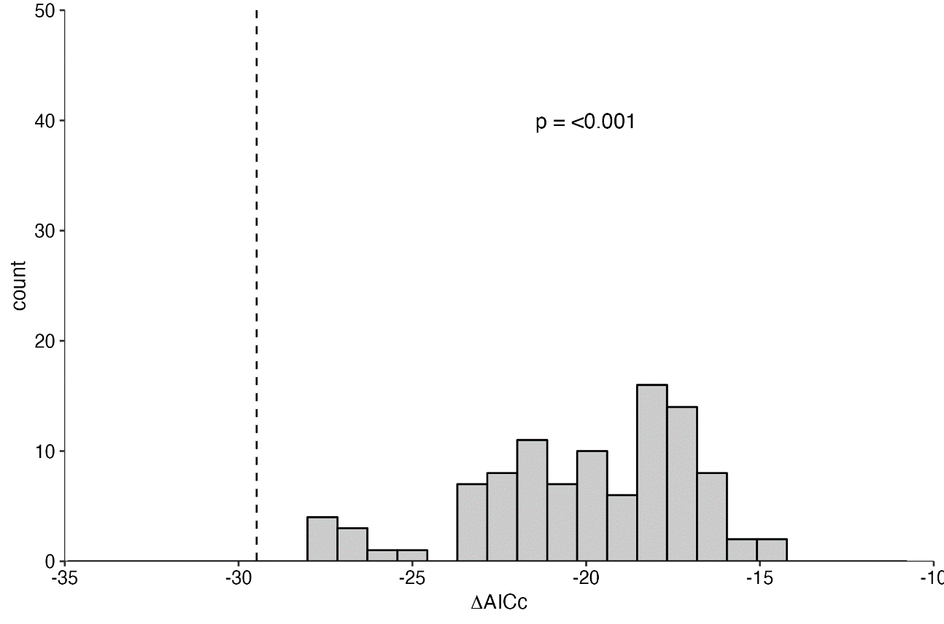

Figure S9. A plot comparing the likelihood of the AICc of the best supported local-scale model against the distribution of AICc values from 100 randomisation tests of the environmental data (SST quadratic) for L. sebae adults. Dashed line represents the AICc of the time window identified (-29.48). A p-value <0.05 indicates the best time window was not selected by chance.
1-year lagged local-scale environment
Table S22. Results of the 1-year lagged local-scale exploratory sliding window for L. sebae adults. Although the previous year’s rain was identified as the best quadratic environmental predictor influencing growth from October to November, a randomization test suggests it may have occurred by chance (p-value >0.05). Although the previous year’s rain was identified as the best linear environmental predictor influencing growth from October to November, a randomization test suggests it may have occurred by chance (p-value >0.05). The previous year’s SST as a linear term was also tested as an influence on growth from May to June, however a randomisation test suggests it may have occurred by chance (p-value >0.05). Window open/close values relate to the number of months away from the reference month used in the analysis (based on peak spawning), counting backwards. 0 = October, 1 = September, 2 = August, 3 = July, 4 = June, 5 = May, 6 = April, 7 = March, 8 = February, 9 = January, 10 = December, 11 = November, 12 = October.
Stage One:
Climate | Function | AICc | Window Open | Window Close | P-value
SST_lag | lin | -14.18 | 5 | 4 | 0.12
Rain_lag | lin | -14.50 | 12 | 11 | 0.14
LCurrent_lag | lin | -6.69 | 12 | 12 | -
SST_lag | quad | -23.39 | 11 | 3 | -
Rain_lag | quad | -32.38 | 12 | 11 | 0.21
LCurrent_lag | quad | -11.14 | 6 | 6 | -

E3 Etelis boweni juvenile sliding windows:

Large-scale environment
Table S23. Results of the large-scale exploratory sliding window for E. boweni juveniles. A randomisation test confirmed the identification of a linear ENSO signal influencing growth in November did not occur by chance. Window open/close values relate to the number of months away from the reference month used in the analysis (based on peak spawning), counting backwards. 0 = January, 1 = December, 2 = November, 3 = October, 4 = September, 5 = August, 6 = July, 7 = June, 8 = May, 9 = April, 10 = March, 11 = February, 12 = January.
Stage One:
Climate | Function | AICc | Window Open | Window Close | P-value
ENSO | lin | -9.61 | 2 | 2 | 0.04
PDO | lin | -2.51 | 12 | 8 | -
IOD | lin | -3.83 | 11 | 11 | -
ENSO | quad | -9.31 | 2 | 2 | 0.16
PDO | quad | -7.36 | 8 | 4 | -
IOD | quad | -7.20 | 8 | 6 | -

Stage Two:
Climate | Function | AICc | Window Open | Window Close | P-value
PDO | lin | -3.47 | 4 | 2 | 0.42
IOD | lin | -3.42 | 11 | 11 | -
PDO | quad | -7.72 | 4 | 4 | 0.39
IOD | quad | -5.08 | 8 | 6 | -

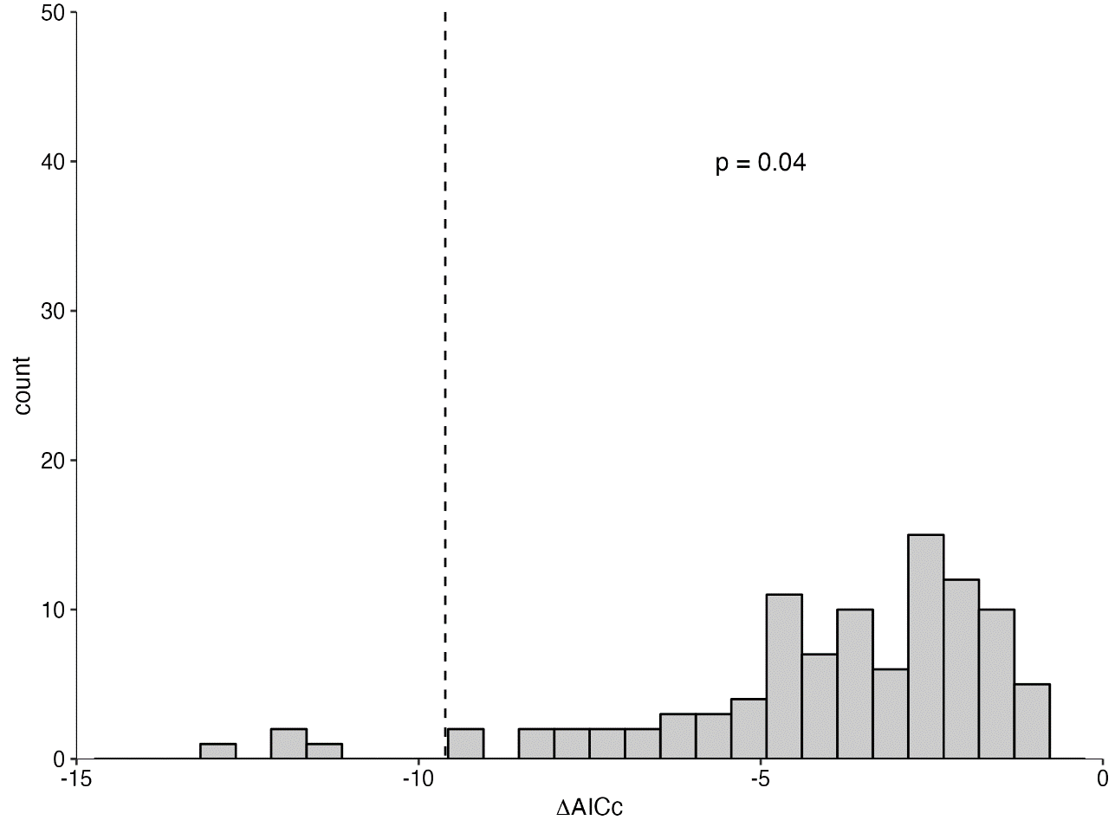

Figure S10. A plot comparing the likelihood of the AICc of the best supported large-scale model against the distribution of AICc values from 100 randomisation tests of the environmental data (ENSO linear) for E. boweni juveniles. Dashed line represents the AICc of the time window identified (-9.61). A p-value <0.05 indicates the best time window was not selected by chance.

1-year lagged large-scale environment
Table S24. Results of the 1-year lagged large-scale exploratory sliding window for E. boweni juveniles. Although the previous year’s PDO was identified as the best quadratic environmental predictor influencing growth from September to October, a randomization test suggests it may have occurred by chance (p-value >0.05). Although the previous year’s IOD was identified as the best linear environmental predictor influencing growth from January to May, a randomization test suggests it may have occurred by chance (p-value >0.05). Window open/close values relate to the number of months away from the reference month used in the analysis (based on peak spawning), counting backwards. 0 = January, 1 = December, 2 = November, 3 = October, 4 = September, 5 = August, 6 = July, 7 = June, 8 = May, 9 = April, 10 = March, 11 = February, 12 = January.
Stage One:
Climate | Function | AICc | Window Open | Window Close | P-value
ENSO_lag | lin | -1.56 | 11 | 4 | -
PDO_lag | lin | -2.48 | 1 | 0 | -
IOD_lag | lin | -3.64 | 12 | 8 | 0.61
ENSO_lag | quad | -8.39 | 12 | 1 | -
PDO_lag | quad | -10.41 | 4 | 3 | 0.15
IOD_lag | quad | -7.74 | 11 | 8 | -

Local-scale environment
Table S25. Results of the local-scale exploratory sliding window for E. boweni juveniles. A randomisation test confirmed the identification of a rainfall signal influencing growth in August did not occur by chance. Window open/close values relate to the number of months away from the reference month used in the analysis (based on peak spawning), counting backwards. 0 = January, 1 = December, 2 = November, 3 = October, 4 = September, 5 = August, 6 = July, 7 = June, 8 = May, 9 = April, 10 = March, 11 = February, 12 = January.
Stage One:
Climate | Function | AICc | Window Open | Window Close | P-value
SST | lin | -9.24 | 3 | 3 | -
Rain | lin | -14.66 | 6 | 1 | -
LCurrent | lin | -6.27 | 0 | 0 | -
SST | quad | -15.21 | 3 | 3 | -
Rain | quad | -30.35 | 5 | 5 | <0.001
LCurrent | quad | -10.82 | 5 | 5 | -

Climate | Function | AICc | Window Open | Window Close | P-value
SST | lin | -8.87 | 4 | 3 | -
LCurrent | lin | -6.34 | 5 | 4 | -
SST | quad | -16.42 | 12 | 9 | 1
LCurrent | quad | -9.71 | 5 | 4 | -
Stage Two:

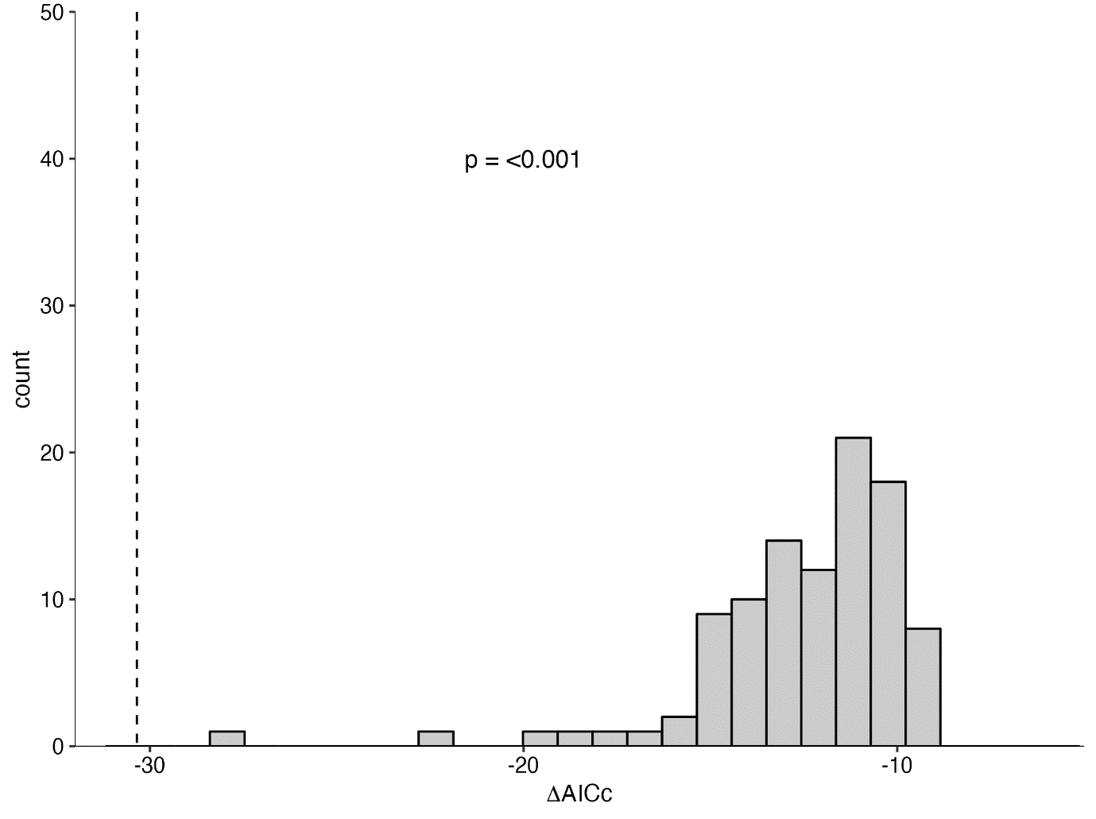

Figure S11. A plot comparing the likelihood of the AICc of the best supported local-scale model against the distribution of AICc values from 100 randomisation tests of the environmental data (rainfall quadratic) for E. boweni juveniles. Dashed line represents the AICc of the time window identified (-30.35). A p-value <0.05 indicates the best time window was not selected by chance.

1-year lagged local-scale environment
Table S26. Results of the 1-year lagged local-scale exploratory sliding window for E. boweni juveniles. Although the previous year’s rain was identified as the best quadratic environmental predictor influencing growth from December to January, a randomization test suggests it may have occurred by chance (p-value >0.05). Although the previous year’s rain was identified as the best linear environmental predictor influencing growth from December to January, a randomization test suggests it may have occurred by chance (p-value >0.05). Window open/close values relate to the number of months away from the reference month used in the analysis (based on peak spawning), counting backwards. 0 = January, 1 = December, 2 = November, 3 = October, 4 = September, 5 = August, 6 = July, 7 = June, 8 = May, 9 = April, 10 = March, 11 = February, 12 = January.

Stage One:
Climate | Function | AICc | Window Open | Window Close | P-value
SST_lag | lin | -9.17 | 4 | 4 | -
Rain_lag | lin | -10.40 | 1 | 0 | 0.8
LCurrent_lag | lin | -4.47 | 4 | 4 | -
SST_lag | quad | -17.96 | 8 | 0 | -
Rain_lag | quad | -26.18 | 1 | 0 | 0.99
LCurrent_lag | quad | -7.81 | 7 | 4 | -

Comparison of best sliding window models
Table S27. AICc comparison of all optimal environmental windows to select the extrinsic model that best explains E. boweni juvenile growth. The local-scale model including a temporal window for rainfall (quadratic) was identified as the best model. JM represents the intrinsic E. boweni juvenile growth model with adult growth removed.
Model | AICc score
a) JM + ENSO | 30.1
b) JM + Rainfall + Rainfall^2 | 0.0

E4 Etelis boweni adult sliding windows:

Large-scale environment

Table S28. Results of the large-scale exploratory sliding window for E. boweni adults. Although IOD was identified as the best quadratic environmental predictor influencing growth from March to April, a randomization test suggests it may have occurred by chance (p-value >0.05). Although PDO was identified as the best linear environmental predictor influencing growth in January, a randomization test suggests it may have occurred by chance (p-value >0.05). Window open/close values relate to the number of months away from the reference month used in the analysis (based on peak spawning), counting backwards. 0 = January, 1 = December, 2 = November, 3 = October, 4 = September, 5 = August, 6 = July, 7 = June, 8 = May, 9 = April, 10 = March, 11 = February, 12 = January.
Stage One:
Climate | Function | AICc | Window Open | Window Close | P-value
ENSO | lin | -0.44 | 9 | 8 | -
PDO | lin | -3.12 | 12 | 12 | 0.3
IOD | lin | 0.15 | 10 | 9 | -
ENSO | quad | -1.24 | 7 | 7 | -
PDO | quad | -2.07 | 12 | 10 | -
IOD | quad | -5.48 | 10 | 9 | 0.37

1-year lagged large-scale environment

Table S29. Results of the 1-year lagged large-scale exploratory sliding window for E. boweni adults. A randomisation test confirmed the identification of a signal of the previous year’s IOD influencing growth from March to April did not occur by chance. A randomisation test in the second stage confirmed the identification of a signal of the previous year’s PDO influencing growth from January to July did not occur by chance. Window open/close values relate to the number of months away from the reference month used in the analysis (based on peak spawning), counting backwards. 0 = January, 1 = December, 2 = November, 3 = October, 4 = September, 5 = August, 6 = July, 7 = June, 8 = May, 9 = April, 10 = March, 11 = February, 12 = January.
Stage One:
Climate | Function | AICc | Window Open | Window Close | P-value
ENSO_lag | lin | -3.04 | 9 | 8 | -
PDO_lag | lin | -9.45 | 12 | 4 | -
IOD_lag | lin | 0.14 | 10 | 9 | -
ENSO_lag | quad | -8.29 | 3 | 1 | -
PDO_lag | quad | -7.86 | 12 | 4 | -
IOD_lag | quad | -19.31 | 10 | 9 | <0.001

Stage Two:
Climate | Function | AICc | Window Open | Window Close | P-value
ENSO_lag | lin | -3.98 | 12 | 4 | -
PDO_lag | lin | -9.59 | 12 | 5 | -
ENSO_lag | quad | -3.38 | 12 | 5 | -
PDO_lag | quad | -7.67 | 12 | 5 | 0.01

Climate | Function | AICc | Window Open | Window Close | P-value
ENSO_lag | lin | 0.34 | 6 | 6 | 0.53
ENSO_lag | quad | 0.61 | 3 | 3 | -
Stage Three:

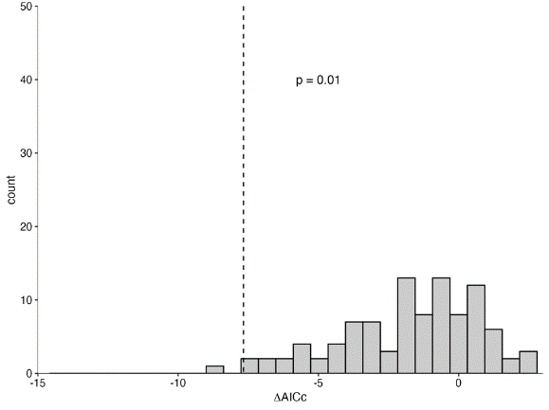
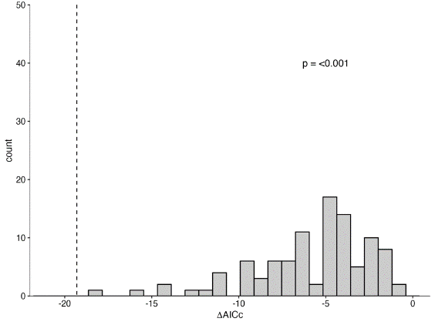

Figure S12. Plots comparing the likelihood of the AICc of the best supported 1-year lagged large-scale models against the distribution of AICc values from 100 randomisation tests of the environmental data (Left: 1-year lagged IOD quadratic and right: 1-year lagged PDO quadratic) for E. boweni adults. Dashed lines represent the AICc of the time window identified (-19.31 and -7.67 respectively). P-values <0.05 indicate the best time windows were not selected by chance.

Local-scale environment

Table S30. Results of the local-scale exploratory sliding window for E. boweni adults. Although the previous year’s rain was identified as the best quadratic environmental predictor influencing growth in September, a randomization test suggests it may have occurred by chance (p-value >0.05). Although the previous year’s rain was identified as the best linear environmental predictor influencing growth from September to October, a randomization test suggests it may have occurred by chance (p-value >0.05). Window open/close values relate to the number of months away from the reference month used in the analysis (based on peak spawning), counting backwards. 0 = January, 1 = December, 2 = November, 3 = October, 4 = September, 5 = August, 6 = July, 7 = June, 8 = May, 9 = April, 10 = March, 11 = February, 12 = January.
Stage One:
Climate | Function | AICc | Window Open | Window Close | P-value
SST | lin | -3.99 | 8 | 6 | -
Rain | lin | -9.06 | 4 | 3 | 0.81
LCurrent | lin | -1.00 | 7 | 7 | -
SST | quad | -10.13 | 12 | 11 | -
Rain | quad | -24.95 | 4 | 4 | 0.82
LCurrent | quad | -9.89 | 12 | 7 | -

1-year lagged local-scale environment
Table S31. Results of the 1-year lagged local-scale exploratory sliding window for E. boweni adults. A randomisation test confirmed the identification of a signal of the previous year’s SST influencing growth in December did not occur by chance. Window open/close values relate to the number of months away from the reference month used in the analysis (based on peak spawning), counting backwards. 0 = January, 1 = December, 2 = November, 3 = October, 4 = September, 5 = August, 6 = July, 7 = June, 8 = May, 9 = April, 10 = March, 11 = February, 12 = January.
Stage One:
Climate | Function | AICc | Window Open | Window Close | P-value
SST_lag | lin | -9.87 | 1 | 1 | <0.001
Rain_lag | lin | -8.21 | 2 | 0 | -
LCurrent_lag | lin | -5.04 | 1 | 1 | -
SST_lag | quad | -12.39 | 1 | 1 | -
Rain_lag | quad | -21.45 | 12 | 11 | 0.96
LCurrent_lag | quad | -6.84 | 1 | 1 | -

Stage Two:
Climate | Function | AICc | Window Open | Window Close | P-value
Rain_lag | lin | -10.21 | 1 | 0 | -
LCurrent_lag | lin | -0.62 | 10 | 10 | -
Rain_lag | quad | -24.70 | 1 | 0 | 0.96
LCurrent_lag | quad | -3.35 | 1 | 1 | -

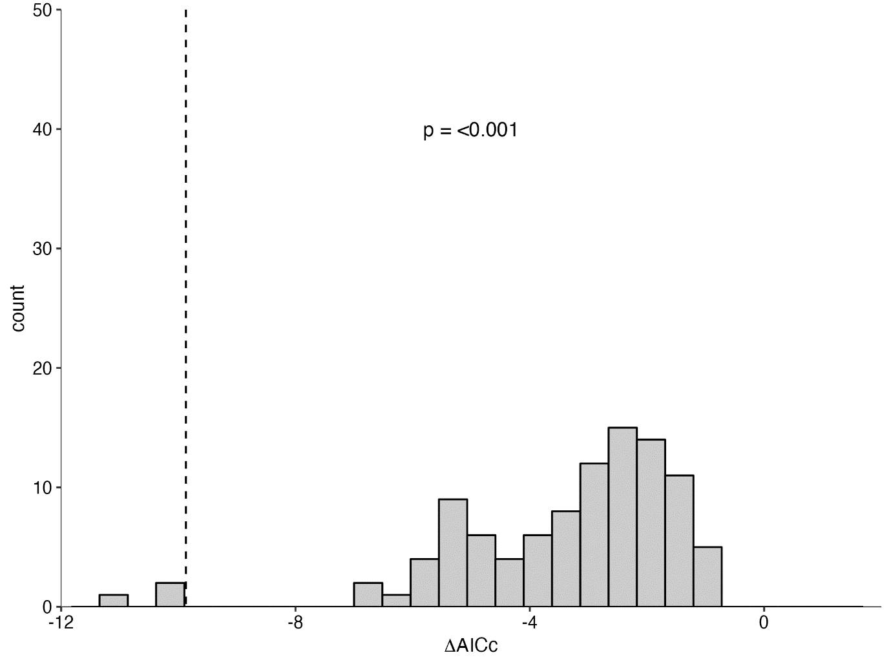

Figure S13. A plot comparing the likelihood of the AICc of the best supported 1-year lagged local-scale model against the distribution of AICc values from 100 randomisation tests of the environmental data (SST linear) for E. boweni adults. Dashed line represents the AICc of the time window identified (-9.87). A p-value <0.05 indicates the best time window was not selected by chance.

Comparison of best sliding window models
Table S32. AICc comparison of all optimal environmental windows to select the extrinsic model that best explains E. boweni adult growth. The 1-year lagged large-scale model including a temporal window for Indian Ocean Dipole (quadratic) and Pacific Decadal Oscillation (quadratic) was identified as the best model. AM represents the intrinsic E. boweni adult growth model with juvenile growth removed.
Model | AICc score
a) AM + IOD + IOD^2 + PDO + PDO^2 | 0.0
b) AM + SST_lag | 17.1

