Supplementary Data
Figure S1. Mean Cq value of treatment on genomic DNA from (a) TGGG, (b) E. awaora, (c) E. bleekeri, (d) E. coioides and (e) E. quoyanus at different level of species-specific blocking primer to Fish16S assay primer ratio (0 to 1, 10 to 1 and 20 to 1) and different annealing temperature (54˚C and 58˚C). Asterisk above each bar represented significant pairwise mean differences between samples indicated from Dunn test.

Figure S2. Mean Cq value of treatment on genomic DNA of different potential prey species, including Bathygobius fuscus, Chaetodon wiebeli, Ostorinchus fasciatus, Parupeneus indicus and Stethojulis terina at different level of species-specific blocking primer to Fish16S assay primer ratio (0 to 1 and 20 to 1).

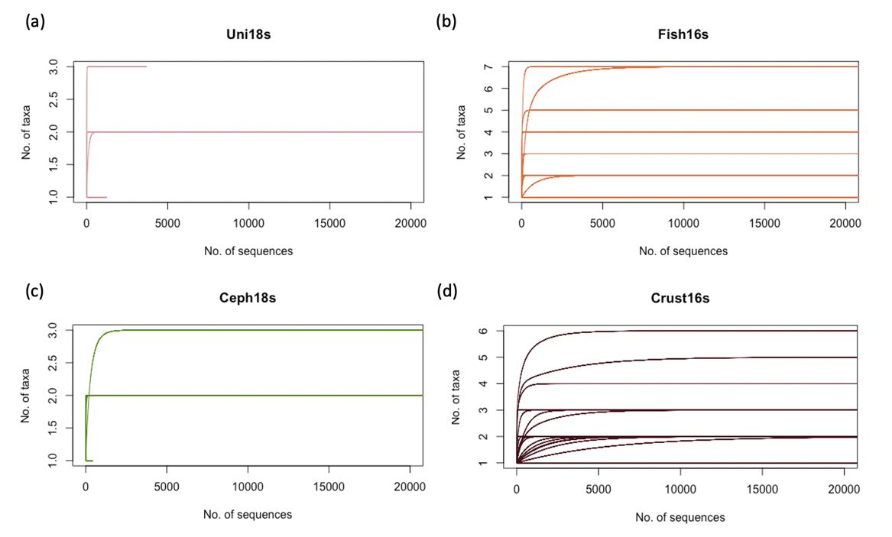
Figure S3. Rarefaction curve of samples from (a) Uni18S assay, (b) Fish16S assay, (c) Ceph18S assay and (d) Crust16S assay.

Figure S4. Accumulation curve showing the cumulative number of taxa being found in each of the host species as a function of number of samples. Error bars represented standard deviation.

Figure S5. Percentage of Occurrence (POO) of prey taxa in each host species. Prey taxa were combined according to their associated Order. Further POO details of each categories can be found in Table S3.

Table S1. The TL, wet weight and digestion level of the collected samples from all five host species
Species | Sample size (n)  (Wet/ dry season) | TL (cm) (± SD) | TL min max | Wet Weight (g) (± SD) | Weight min max | Digestion level (Percentage)
TGGG | 27 (14,13) | 34.1±9.27 | 26.4, 68 | 1108±1527 | 384, 6480 | 1: / (0%)  2: 1 (3.7%)  3: 2 (7.4%)  4: 24 (88.9%))
E. awoara | 13 (0,13) | 25.1±1.87 | 21.6, 27.1 | 282±61.2 | 172, 369 | 1: / (0%)  2: / (0%)  3: 2 (15.4%)  4: 11 (84.6%)
E. bleekeri | 9 (9,0) | 22.8±3.60 | 18.9, 28.5 | 205±110 | 102, 385 | 1: 1 (11.1%)  2: 5 (55.6%)  3: / (0%)  4: 3 (33.3%)
E. coioides | 6 (3,3) | 28.6±10.4 | 19.3, 44.9 | 469±527 | 109, 1483 | 1: / (0%)  2: 1 (16.7%)  3: / (0%)  4: 5 (83.3%)
E. quoyanus | 8 (8,0) | 24.2±1.05 | 22.8, 25.6 | 243±40.4 | 173, 303 | 1: 5 (62.5%)  2: 2 (25%)  3: / (0%)  4: 1 (12.5%)

Table S2. Results of Kruskal-Wallis test to examine TL, wet weight and digestion level difference between the host species
Variable | df | Chi-squared value | p value
TL | 4 | 36.5 | <0.001
Wet weight | 4 | 40.7 | <0.001
Digestion level | 4 | 30.8 | <0.001

Table S3. Percentage of Occurrence (POO) of prey taxa (grouped by Order) in each host species
Order | TGGG | E. awoara | E. bleekeri | E. coioides | E. quoyanus
Acanthuriformes | 3.03 | 0.00 | 10.26 | 8.00 | 4.76
Aulopiformes | 0.00 | 5.56 | 0.00 | 0.00 | 0.00
Balanomorpha | 0.00 | 0.00 | 0.00 | 8.00 | 0.00
Beloniformes | 0.00 | 0.00 | 0.00 | 0.00 | 2.38
Blenniiformes | 42.42 | 0.00 | 2.56 | 0.00 | 0.00
Chaetodontiformes | 0.00 | 0.00 | 5.13 | 12.00 | 0.00
Clupeiformes | 0.00 | 44.45 | 0.00 | 0.00 | 4.76
Decapoda | 24.24 | 22.24 | 35.90 | 24.00 | 66.67
Gobiiformes | 0.00 | 0.00 | 10.26 | 0.00 | 2.38
Gonorynchiformes | 0.00 | 0.00 | 2.56 | 0.00 | 0.00
Lutjaniformes | 15.15 | 0.00 | 12.82 | 12.00 | 9.52
Myopsida | 3.03 | 0.00 | 0.00 | 0.00 | 0.00
Mytilida | 0.00 | 0.00 | 0.00 | 0.00 | 4.76
Ovalentaria incertae sedis | 0.00 | 0.00 | 5.13 | 0.00 | 0.00
Perciformes | 3.03 | 0.00 | 0.00 | 0.00 | 0.00
Pleuronectiformes | 0.00 | 0.00 | 0.00 | 16.00 | 0.00
Sepiida | 6.06 | 22.22 | 5.13 | 20.00 | 0.00
Siluriformes | 0.00 | 5.56 | 0.00 | 0.00 | 0.00
Spariformes | 0.00 | 0.00 | 2.56 | 0.00 | 0.00
Syngnathiformes | 3.03 | 0.00 | 5.13 | 0.00 | 4.76
Tetraodontiformes | 0.00 | 0.00 | 2.56 | 0.00 | 0.00
Total | 100.00 | 100.00 | 100.00 | 100.00 | 100.00

Table S4. Beta diversity between species pairs as calculated by betapart package in R
Simpson dissimilarity
 | TGGG | E. awoara | E. bleekeri | E. coioides
E. awoara | 0.92
E. bleekeri | 0.57 | 0.85
E. coioides | 0.50 | 0.85 | 0.47
E. quoyanus | 0.57 | 0.85 | 0.52 | 0.59
Nestedness-resultant dissimilarity
 | TGGG | E. awoara | E. bleekeri | E. coioides
E. awoara | 0.00
E. bleekeri | 0.13 | 0.05
E. coioides | 0.05 | 0.02 | 0.11
E. quoyanus | 0.12 | 0.05 | 0.01 | 0.08
Sørensen dissimilarity
 | TGGG | E. awoara | E. bleekeri | E. coioides
E. awoara | 0.93
E. bleekeri | 0.70 | 0.90
E. coioides | 0.55 | 0.87 | 0.58
E. quoyanus | 0.69 | 0.89 | 0.53 | 0.67

Table S5. Similarity Percentage (SIMPER) analysis on the contribution of individual taxa (Significance determined by Krustal-Wallis rank-sum test with false discovery rate (FDJ) p-value corrections) on diet partitioning between pairwise comparison of host species

 |  | SIMPER results (%)
Species 1 | Species 2 | Decapoda | Pleuronichthys cornutus | Encrasicholina | Omobranchus | Portunidae | Charybdis hellerii
TGGG | E. awoara |  |  | 8.99 | 17.6
TGGG | E. bleekeri |  |  |  | 14.0 |  | 10.6
TGGG | E. coioides |  | 17.1 |  | 16.4
TGGG | E. quoyanus | 8.80 |  |  | 11.6 | 9.46 | 9.12
E. bleekeri | E. awoara |  |  |  |  |  | 9.67
E. bleekeri | E. coioides |  | 12.0
E. coioides | E. awoara |  | 15.6
E. coioides | E. quoyanus |  | 9.99
E. awoara | E. quoyanus |  |  |  |  | 8.72 | 8.34

