Supplementary information

Distribution and density of larval capelin (Mallotus villosus) around Iceland and associated environmental conditions
Thassya C. dos Santos Schmidt, James Kennedy, Sigurður Þór Jónsson, and Guðmundur Jóhann Óskarsson
Marine and Freshwater Research Institute, Fornubúðir 5, IS-220 Hafnarfjörður, Iceland
Corresponding author: thassya.dos.santos.schmidt@hafogvatn.is

Table S1. Index of concurvity for the GAMs for density and presence/absence of capelin larvae. Note that small variations are found in the presence/absence GAM. No concurvity index is presented on the model Presence/Absence ~ Chlorophyll-a × Year_{i} due to the absence of smooth function.
 | Year | Index first smooth term |  |  | Index second smooth term |  |  | Index third smooth term |  |  | Index forth smooth term
Model |  | Worst | Observed | Estimate | Worst | Observed | Estimate | Worst | Observed | Estimate | Worst | Observed | Estimate
Density ~ te(Longitude ~ Latittude, by = Year_{i}, bs = "gp") | 2017 | 0.57 | 0.12 | 0.02
 | 2018 | 0.63 | 0.04 | 0.06
 | 2019 | 0.72 | 0.05 | 0.02
 | 2020 | 0.71 | 0.02 | 0.02
Density ~ s(Temperature, by = Year_{i}, k = 5) | 2017 | 0.11 | 0.05 | 0.01
Density ~ s(Temperature, by = Year_{i}, k = 5) | 2018 | 0.11 | 0.05 | 0.05
Density ~ s(Temperature, by = Year_{i}, k = 5) | 2019 | 0.22 | 0.01 | 0.01
Density ~ s(Temperature, by = Year_{i}, k = 5) | 2020 | 0.14 | 0.00 | 0.07
Density ~ s(Zooplankton, by = Year_{i}, k = 5) | 2017 | 0.03 | 0.00 | 0.01
Density ~ s(Zooplankton, by = Year_{i}, k = 5) | 2018 | 0.27 | 0.18 | 0.01
Density ~ s(Zooplankton, by = Year_{i}, k = 5) | 2019 | 0.02 | 0.00 | 0.01
Density ~ s(Zooplankton, by = Year_{i}, k = 5) | 2020 | 0.35 | 0.03 | 0.03
Density ~ s(Chlorophyll-a, by = Year_{i}, k = 5) | 2017 | 0.29 | 0.10 | 0.01
Density ~ s(Chlorophyll-a, by = Year_{i}, k = 5) | 2018 | 0.28 | 0.02 | 0.02
Density ~ s(Chlorophyll-a, by = Year_{i}, k = 5) | 2019 | 0.14 | 0.00 | 0.01
Density ~ s(Chlorophyll-a, by = Year_{i}, k = 5) | 2020 | 0.08 | 0.00 | 0.02
Density ~ te(Longitude ~ Latitude, by = Year_{i}, bs = "gp") + s(Temperature, by = Year_{i}, k = 5) | 2017 | 0.99 | 0.65 | 0.26 | 0.99 | 0.99 | 0.98
 | 2018 | 1.00 | 0.88 | 0.43 | 1.00 | 0.98 | 0.99
 | 2019 | 0.99 | 0.67 | 0.29 | 0.99 | 0.98 | 0.90
 | 2020 | 0.99 | 0.48 | 0.38 | 0.99 | 0.98 | 0.97
Density ~ te(Longitude ~ Latitude, by = Year_{i}, bs = "gp") + s(Zooplankton, by = Year_{i}, k = 5) | 2017 | 0.97 | 0.14 | 0.18 | 0.98 | 0.93 | 0.96
 | 2018 | 1.00 | 0.07 | 0.21 | 1.00 | 0.92 | 0.77
 | 2019 | 0.89 | 0.10 | 0.18 | 0.76 | 0.68 | 0.63
 | 2020 | 0.90 | 0.01 | 0.16 | 0.89 | 0.71 | 0.59
Density ~ te(Longitude ~ Latitude, by = Year_{i}, bs = "gp") + s(Chlorophyll-a, by = Year_{i}, k = 5) | 2017 | 0.85 | 0.08 | 0.13 | 0.87 | 0.73 | 0.68
 | 2018 | 0.97 | 0.16 | 0.27 | 0.98 | 0.95 | 0.83
 | 2019 | 0.89 | 0.12 | 0.10 | 0.71 | 0.50 | 0.50
 | 2020 | 0.91 | 0.12 | 0.09 | 0.91 | 0.64 | 0.77
Density ~ te(Longitude ~ Latitude, by = Year_{i}, bs = "gp") + s(Temperature, by = Year_{i}, k = 5) + s(Zooplankton, by = Year_{i}, k = 5) | 2017 | 1.00 | 0.69 | 0.39 | 1.00 | 0.99 | 0.98 | 0.99 | 0.95 | 0.98
 | 2018 | 1.00 | 0.92 | 0.51 | 1.00 | 1.00 | 0.99 | 1.00 | 0.94 | 0.85
 | 2019 | 0.99 | 0.70 | 0.36 | 0.99 | 0.98 | 0.91 | 0.81 | 0.73 | 0.68
 | 2020 | 1.00 | 0.59 | 0.43 | 1.00 | 0.99 | 0.98 | 0.94 | 0.49 | 0.60
Density ~ te(Longitude ~ Latitude, by = Year_{i}, bs = "gp") + s(Temperature, by = Year_{i}, k = 5) + s(Chlorophyll-a, by = Year_{i}, k = 5) | 2017 | 0.99 | 0.66 | 0.36 | 0.99 | 0.99 | 0.98 | 0.93 | 0.77 | 0.77
 | 2018 | 1.00 | 0.80 | 0.55 | 1.00 | 0.99 | 0.99 | 0.99 | 0.96 | 0.85
 | 2019 | 0.99 | 0.71 | 0.35 | 0.99 | 0.98 | 0.91 | 0.74 | 0.53 | 0.53
 | 2020 | 1.00 | 0.48 | 0.43 | 1.00 | 0.99 | 0.98 | 0.93 | 0.67 | 0.80
Density ~ te(Longitude ~ Latitude, by = Year_{i}, bs = "gp") + s(Zooplankton, by = Year_{i}, k = 5) + s(Chlorophyll-a, by = Year_{i}, k = 5) | 2017 | 0.99 | 0.27 | 0.29 | 0.99 | 0.92 | 0.97 | 0.95 | 0.90 | 0.81
 | 2018 | 1.00 | 0.25 | 0.39 | 1.00 | 0.95 | 0.86 | 0.99 | 0.88 | 0.85
 | 2019 | 0.93 | 0.14 | 0.25 | 0.86 | 0.75 | 0.70 | 0.81 | 0.53 | 0.55
 | 2020 | 0.94 | 0.10 | 0.22 | 0.94 | 0.57 | 0.57 | 0.92 | 0.58 | 0.79
Density ~ te(Longitude ~ Latitude, by = Yeari, bs = "gp") + s(Temperature, by = Year_{i}, k = 5) + s(Zooplankton, by = Year_{i}, k = 5) + s(Chlorophyll-a, by = Year_{i}, k = 5) | 2017 | 1.00 | 0.60 | 0.48 | 1.00 | 0.99 | 0.99 | 1.00 | 0.93 | 0.99 | 0.97 | 0.92 | 0.86
 | 2018 | 1.00 | 0.85 | 0.62 | 1.00 | 1.00 | 1.00 | 1.00 | 0.88 | 0.89 | 0.99 | 0.97 | 0.89
 | 2019 | 0.99 | 0.73 | 0.42 | 0.99 | 0.98 | 0.92 | 0.90 | 0.80 | 0.75 | 0.85 | 0.55 | 0.58
 | 2020 | 1.00 | 0.60 | 0.48 | 1.00 | 0.99 | 0.98 | 0.96 | 0.63 | 0.63 | 0.94 | 0.67 | 0.81
Presence/Absence ~ te(Longitude ~ Latittude, by = Year_{i}, bs = "gp") | 2017 | 0.24 | 0.07 | 0.01
 | 2018 | 0.26 | 0.02 | 0.01
 | 2019 | 0.32 | 0.04 | 0.01
 | 2020 | 0.40 | 0.02 | 0.01
Presence/Absence ~ s(Temperature, by = Year_{i}), gamma = 2 | 2017 | 0.26 | 0.00 | 0.00
Presence/Absence ~ s(Temperature, by = Year_{i}), gamma = 2 | 2018 | 0.41 | 0.02 | 0.03
Presence/Absence ~ s(Temperature, by = Year_{i}), gamma = 2 | 2019 | 0.51 | 0.03 | 0.03
Presence/Absence ~ s(Temperature, by = Year_{i}), gamma = 2 | 2020 | 0.36 | 0.08 | 0.08
Presence/Absence ~ s(Zooplankton, by = Year_{i}, k = 5) | 2017 | 0.16 | 0.00 | 0.01
Presence/Absence ~ s(Zooplankton, by = Year_{i}, k = 5) | 2018 | 0.27 | 0.00 | 0.02
Presence/Absence ~ s(Zooplankton, by = Year_{i}, k = 5) | 2019 | 0.06 | 0.00 | 0.00
Presence/Absence ~ s(Zooplankton, by = Year_{i}, k = 5) | 2020 | 0.33 | 0.04 | 0.04
Presence/Absence ~ Chlorophyll-a × Year_{i} | 2017 | - | - | -
Presence/Absence ~ Chlorophyll-a × Year_{i} | 2018 | - | - | -
Presence/Absence ~ Chlorophyll-a × Year_{i} | 2019 | - | - | -
Presence/Absence ~ Chlorophyll-a × Year_{i} | 2020 | - | - | -
Presence/Absence ~ te(Longitude ~ Latitude, by = Year_{i}, bs = "gp") + s(Temperature, by = Year_{i}, k = 5) | 2017 | 0.97 | 0.56 | 0.21 | 0.97 | 0.96 | 0.92
 | 2018 | 0.99 | 0.74 | 0.35 | 0.99 | 0.78 | 0.96
 | 2019 | 0.98 | 0.10 | 0.25 | 0.98 | 0.90 | 0.88
 | 2020 | 0.99 | 0.44 | 0.35 | 0.99 | 0.79 | 0.95
Presence/Absence ~ te(Longitude ~ Latitude, by = Year_{i}, bs = "gp") + s(Zooplankton, by = Year_{i}, k = 5) | 2017 | 0.96 | 0.11 | 0.12 | 0.96 | 0.86 | 0.74
 | 2018 | 0.74 | 0.21 | 0.15 | 0.77 | 0.57 | 0.75
 | 2019 | 0.65 | 0.18 | 0.12 | 0.64 | 0.56 | 0.57
 | 2020 | 0.93 | 0.04 | 0.11 | 0.93 | 0.87 | 0.51
Presence/Absence ~ te(Longitude ~ Latitude, by = Year_{i}, bs = "gp") + s(Chlorophyll-a, by = Year_{i}, k = 5) | 2017 | 0.72 | 0.20 | 0.14 | 0.77 | 0.64 | 0.49
 | 2018 | 0.83 | 0.12 | 0.16 | 0.85 | 0.64 | 0.61
 | 2019 | 0.56 | 0.11 | 0.07 | 0.54 | 0.52 | 0.51
 | 2020 | 0.83 | 0.07 | 0.08 | 0.84 | 0.48 | 0.74
Presence/Absence ~ te(Longitude ~ Latitude, by = Year_{i}, bs = "gp") + s(Temperature, by = Year_{i}, k = 5) + s(Zooplankton, by = Year_{i}, k = 5) | 2017 | 0.99 | 0.48 | 0.31 | 0.98 | 0.97 | 0.93 | 0.97 | 0.79 | 0.78
 | 2018 | 0.99 | 0.68 | 0.43 | 1.00 | 0.79 | 0.96 | 0.89 | 0.60 | 0.61
 | 2019 | 0.98 | 0.16 | 0.30 | 0.98 | 0.92 | 0.91 | 0.67 | 0.60 | 0.54
 | 2020 | 0.99 | 0.65 | 0.39 | 0.99 | 0.97 | 0.95 | 0.94 | 0.51 | 0.50
Presence/Absence ~ te(Longitude ~ Latitude, by = Yeari, bs = "gp") + s(Temperature, by = Yeari) + s(Chlorophyll-a, by = Yeari) | 2017 | 0.98 | 0.61 | 0.32 | 0.97 | 0.99 | 0.93 | 0.87 | 0.82 | 0.64
 | 2018 | 1.00 | 0.69 | 0.45 | 1.00 | 0.72 | 0.96 | 0.93 | 0.77 | 0.69
 | 2019 | 0.98 | 0.33 | 0.30 | 0.98 | 0.93 | 0.91 | 0.55 | 0.54 | 0.53
 | 2020 | 0.99 | 0.60 | 0.39 | 0.99 | 0.97 | 0.95 | 0.86 | 0.55 | 0.75
Presence/Absence ~ te(Longitude ~ Latitude, by = Year_{i}, bs = "gp") + s(Zooplankton, by = Year_{i}, k = 5) + s(Chlorophyll-a, by = Year_{i}, k = 5) | 2017 | 0.97 | 0.25 | 0.23 | 0.97 | 0.84 | 0.77 | 0.80 | 0.73 | 0.67
 | 2018 | 0.83 | 0.22 | 0.25 | 0.99 | 0.63 | 0.63 | 0.99 | 0.79 | 0.74
 | 2019 | 0.74 | 0.25 | 0.17 | 0.68 | 0.59 | 0.52 | 0.53 | 0.51 | 0.51
 | 2020 | 0.97 | 0.12 | 0.18 | 0.97 | 0.95 | 0.52 | 0.92 | 0.52 | 0.80
Presence/Absence ~ te(Longitude ~ Latitude, by = Year_{i}, bs = "gp") + s(Temperature, by = Year_{i}, k = 5) + s(Zooplankton, by = Year_{i}, k = 5) + s(Chlorophyll-a, by = Year_{i}, k = 5) | 2017 | 0.99 | 0.65 | 0.40 | 0.98 | 0.96 | 0.94 | 0.97 | 0.65 | 0.80 | 0.89 | 0.87 | 0.71
 | 2018 | 1.00 | 0.66 | 0.51 | 1.00 | 0.76 | 0.97 | 0.99 | 0.67 | 0.68 | 0.99 | 0.86 | 0.80
 | 2019 | 0.98 | 0.35 | 0.36 | 0.98 | 0.94 | 0.92 | 0.72 | 0.62 | 0.57 | 0.58 | 0.54 | 0.56
 | 2020 | 0.99 | 0.59 | 0.42 | 0.99 | 0.97 | 0.96 | 0.97 | 0.55 | 0.55 | 0.92 | 0.57 | 0.81

Table S2. Autocorrelation at first lag (ACF) for each GAM model specified in Table 2.
Model | Autocorrelation
Density ~ te(Longitude ~ Latittude, by = Year_{i}, bs = "gp") | 0.084
Density ~ s(Temperature, by = Year_{i}, k = 5) | 0.231
Density ~ s(Zooplankton, by = Year_{i}, k = 5) | 0.312
Density ~ s(Chlorophyll-a, by = Year_{i}, k = 5) | 0.241
Presence/Absence ~ te(Longitude ~ Latittude, by = Year_{i}, bs = "gp") | -0.029
Presence/Absence ~ s(Temperature, by = Year_{i}), gamma = 2 | 0.175
Presence/Absence ~ s(Zooplankton, by = Year_{i}, k = 5) | 0.225
Presence/Absence ~ Chlorophyll-a, by = Year_{i} | 0.181

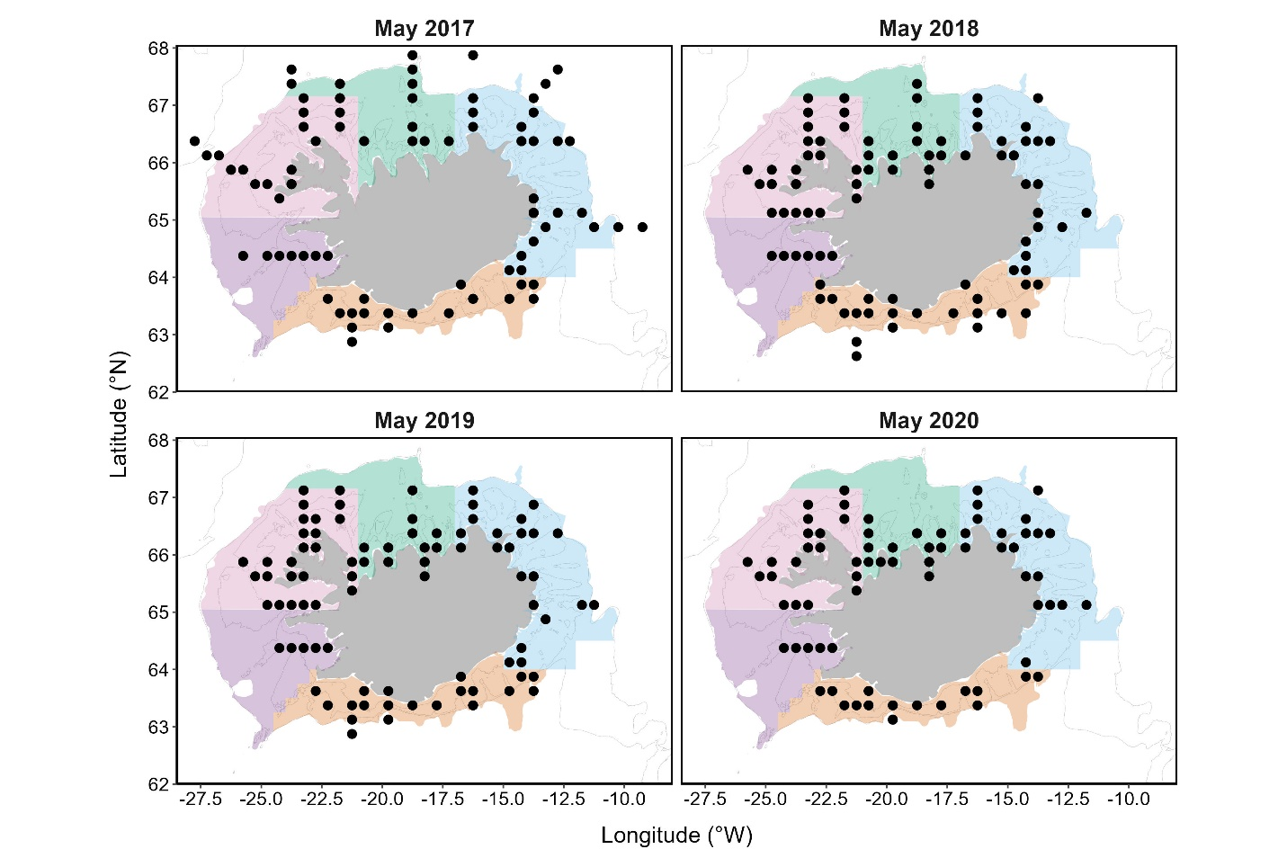
Figure S1. Stations where GULF 7 was deployed per year and area. The Bormicon areas are also represented (southwest in purple, northwest in magenta, north in green, east in blue, and south in orange). Stations located outside the delimited areas were included in the nearest Bormicon area. Depth contour represents 100, 200 and 500 m.

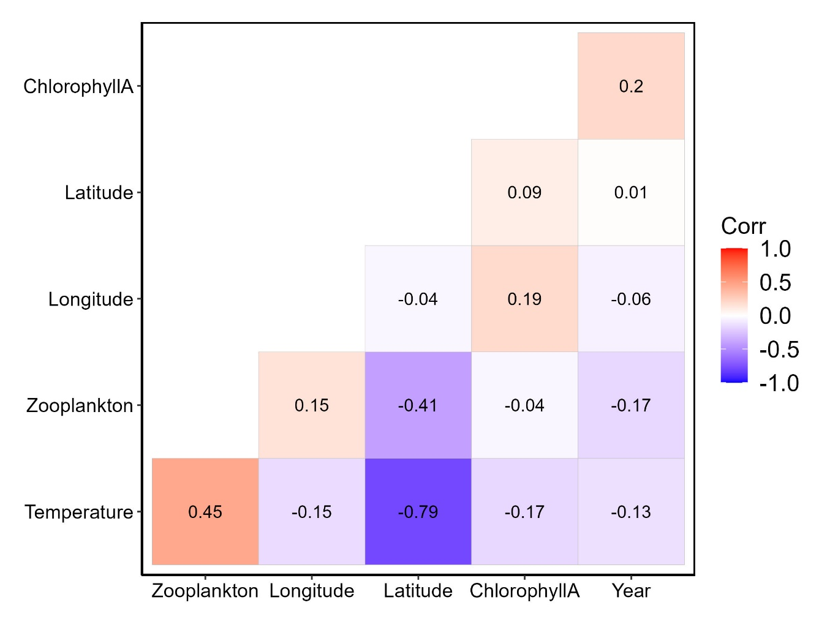
Figure S2. Correlation (Corr) values between explanatory variables.

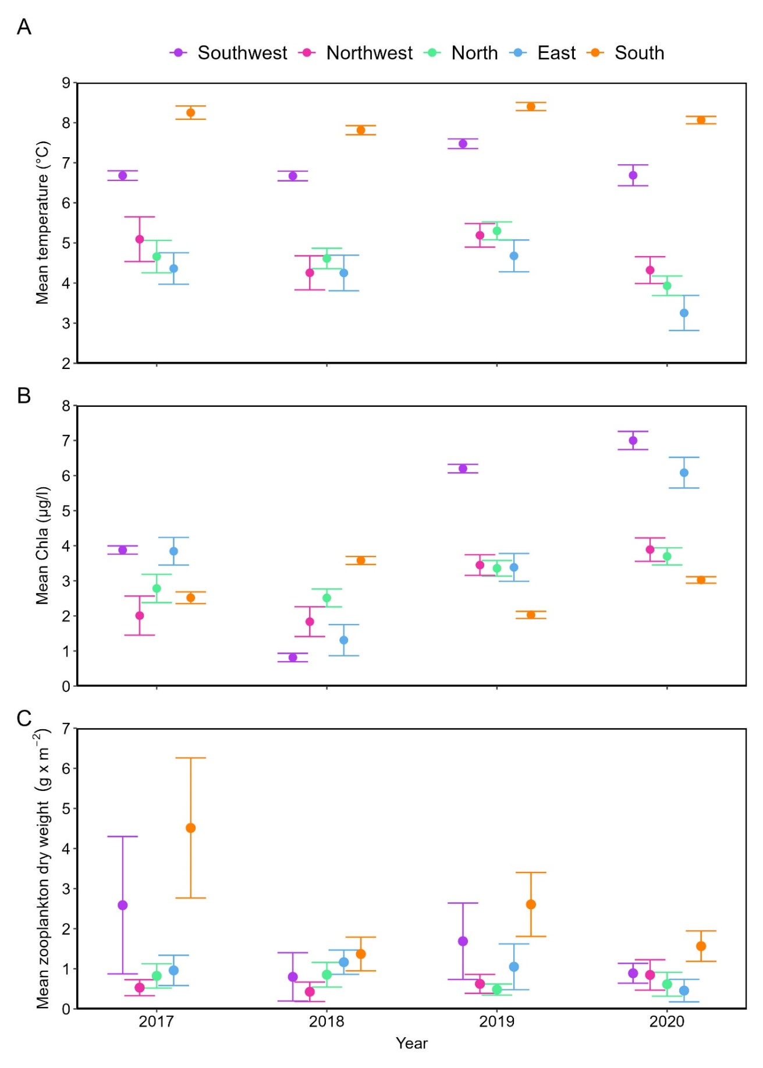
Fig. S3. Mean (± coefficient interval [CI]) in situ sea temperature, chlorophyll-a (Chl-a), and zooplankton dry weight recorded in each Bormicon area in May from 2017 to 2020.

