Supporting information for:
Complex relationships between marine growth and age at maturity in Atlantic salmon
Tim Burton*, Geir H. Bolstad, Peder Fiske, Gunnel Østborg, Gitte Løkeberg and Eva B. Thorstad
Norwegian Institute for Nature Research, PO Box 5685, Torgarden, NO 7485, Trondheim Norway
*corresponding author: tim.burton@nina.no

This file contains:
Supporting figures S1 – S3
Supporting table S1

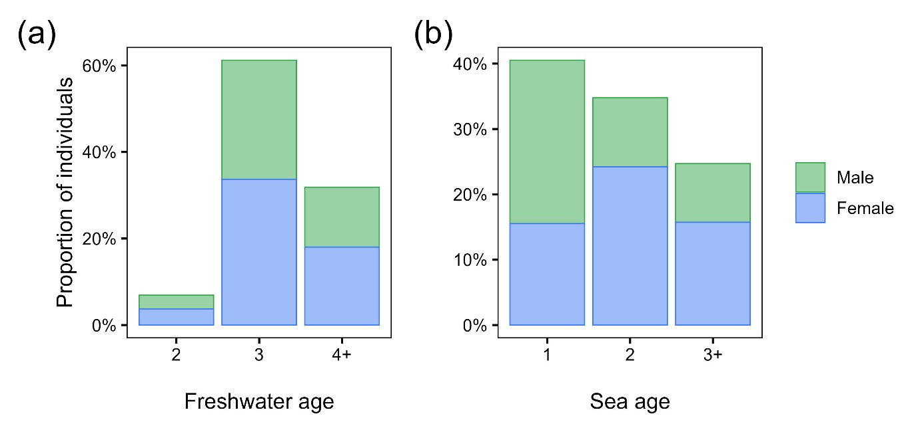
Figure S1. Demographic composition of dataset. (a) bar plot showing proportion of individuals sampled in relation to sex and the number of years spent in freshwater prior to emigration to the sea (‘freshwater age’). Few individuals (n = 61) emigrated after 5 or more years of freshwater residency, so these are included in the freshwater age category ‘4+’. (b) bar plot showing proportion of individuals sampled in relation to sex and the number of years spent in at sea prior to returning to spawn in freshwater (‘sea age’). Few individuals (n = 32) matured after 4 or more years at sea, so these are included in the sea age category ‘3+’. In total 2159 females and 1732 males were sampled.

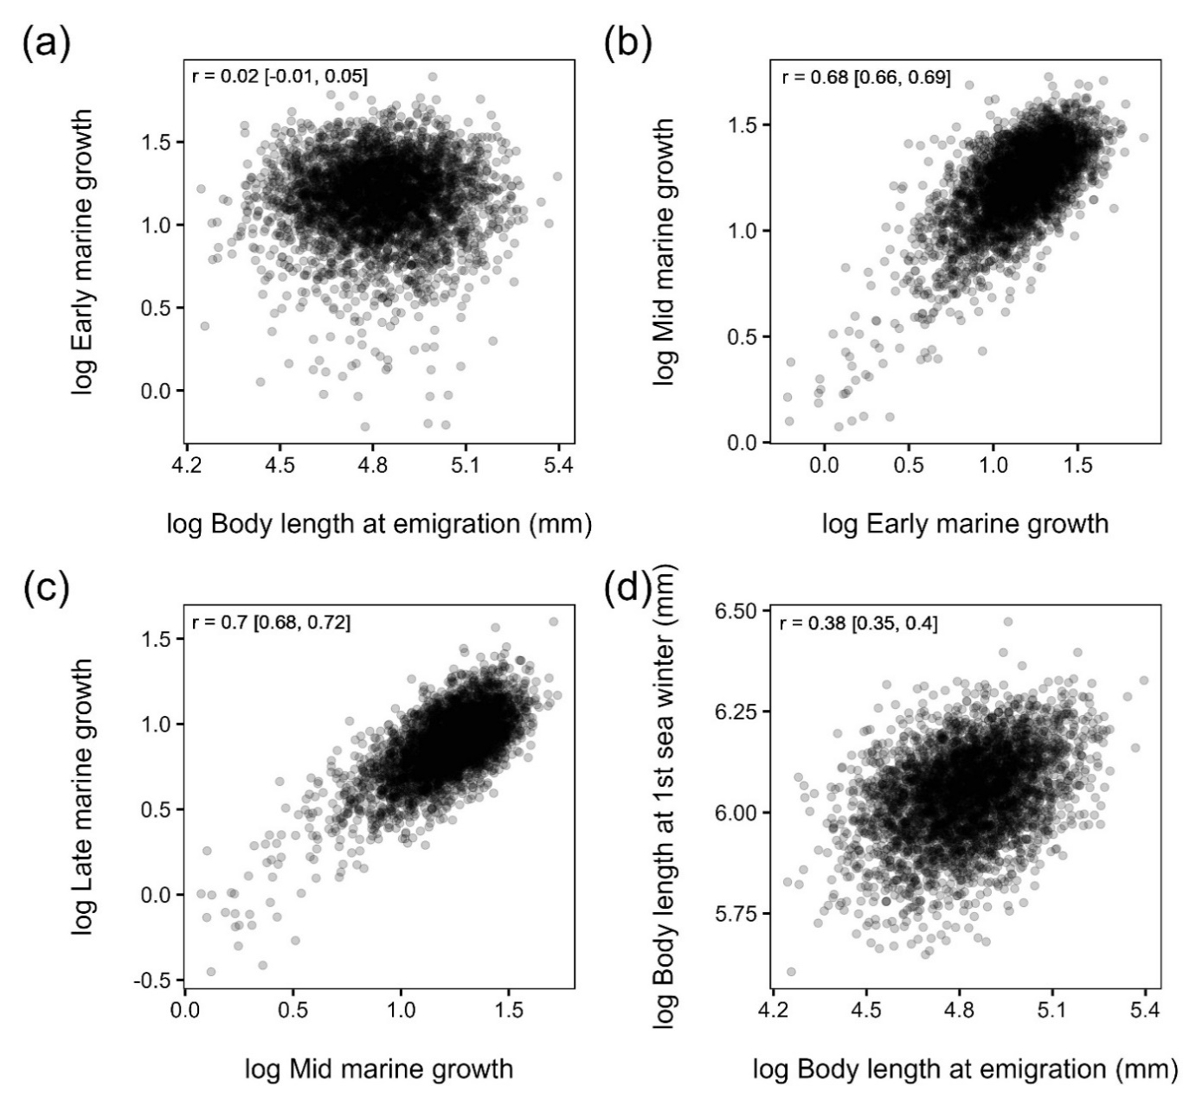
Figure S2. Relationships between (a) body length at emigration from freshwater and early marine growth rate, (b) early marine growth rate and mid marine growth rate, (c) mid marine growth rate and late marine growth rate and (d) body length at emigration from freshwater and body length at the first winter spent at sea for Atlantic salmon from the River Namsen, Norway. Each variable is shown on the natural log scale. Pearson correlations, r, with 95% confidence intervals in parentheses are given for each relationship. Rate of marine growth is the absolute increase in body length (mm) occurring per 1% of the time elapsed during the first year spent at sea when divided into three discrete time periods: ‘early’, ‘mid’ and ‘late’. See main text for full details of growth calculation. Growth was back-calculated from scales sampled from adult Atlantic salmon during their return spawning migration in the river Namsen, Norway between 1977 and 2018.

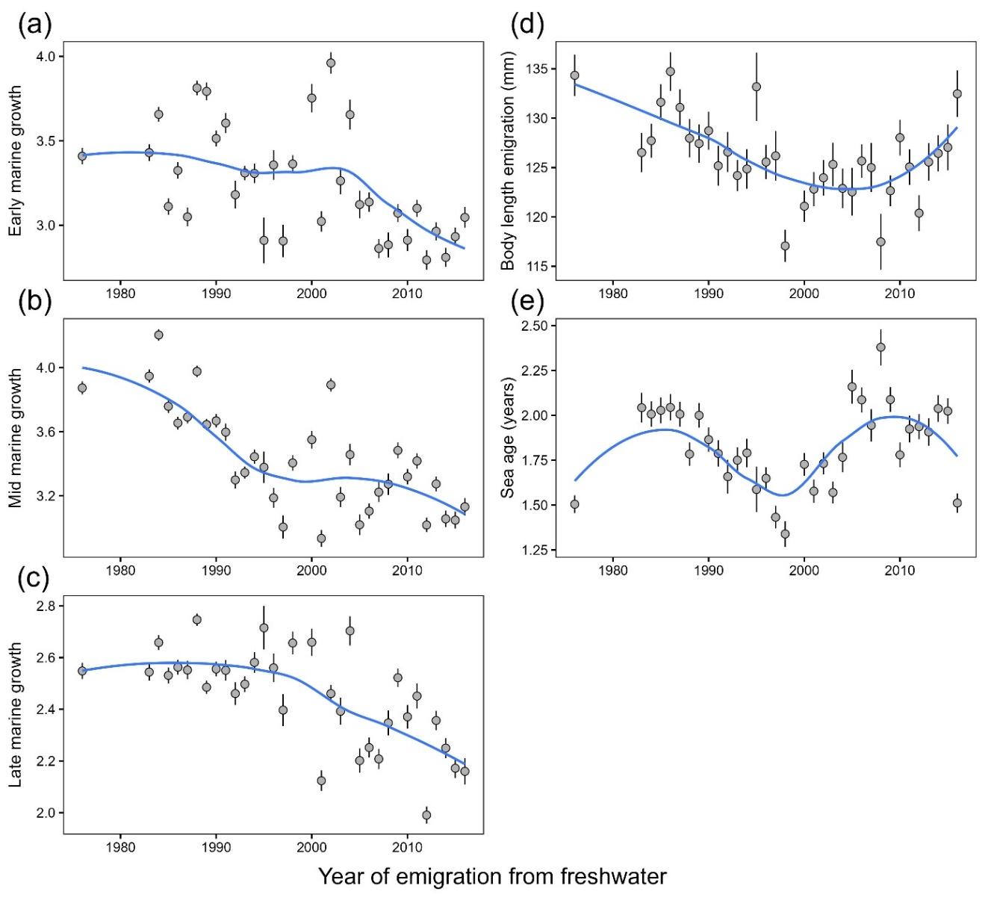
Figure S3. Temporal trends in mean growth rate during the early, mid and late time periods of the first year spent at sea, mean body length at emigration from freshwater and mean sea age. Marine growth rate is the absolute increase in body length (mm) occurring per 1% of the time elapsed during the first growing season at sea when divided into three discrete time periods (‘early’, ‘mid’ and ‘late’). Error bars indicate standard error. Mean values are calculated for a given emigration cohort, i.e. all the individuals that emigrated from freshwater to the marine environment in the same year, not the year of return to freshwater. Smoothed lines do not represent model fits and are included to aid interpretation only. Among cohorts, mean sea age was weakly correlated with mean growth occurring in each time period (Pearson correlations on log transformed data and 95% confidence intervals, ‘early’ growth, r = -0.14 [-0.46, 0.20]; ‘mid’ growth, r = 0.11 [-0.23, 0.44]; ‘late’ growth, r = -0.19 [-0.50, 0.15]). Cohorts that emigrated from freshwater in 1974-1975, 1977-1982, 1999 and 2017 are excluded from the analysis because there was no variation in sea age. Note that variation in mean sea age will be due partly to differences in sampling stochasticity and effort among return years.
Table S1. Parameter estimates and 95% confidence intervals from binomial GLMMs describing the probability of delayed maturation in Atlantic salmon in relation to sex, individual body length at emigration from freshwater (mm), and individual growth during the early, mid and late time periods of the marine migration and sex. Marine growth rate refers to the absolute increase in body length (mm) occurring per 1% of the time elapsed during the first year spent at sea. The parameter estimate for sex is presented so that female fish are set as the intercept. Parameter estimates are shown from separate models where growth was back-calculated from measurements of scale radius made using the assumption that body length was either isometrically or allometrically (scaling exponent, b = 0.95) related to scale radius. Year of emigration from freshwater was fitted as a random intercept term in both analyses with random slope terms for each measurement of marine growth. Standard deviation associated with these random terms is shown. Marginal R² considers the contribution to explained variance from the fixed effects only, whereas conditional R² considers the contribution to explained variance from both the fixed and random effects.
 | isometric  back-calculation |  | allometric  back-calculation
term | estimate | CI | estimate | CI
(intercept) | 1.04 | 0.81 – 1.27 | 1.01 | 0.79 – 1.23
male fish | -1.51 | -1.66 – -1.35 | -1.42 | -1.57 – -1.27
length at emigration | 1.99 | 1.52 – 2.47 | 0.71 | 0.27 – 1.14
early marine growth | 1.05 | 0.45 – 1.66 | 0.93 | 0.36 – 1.50
mid marine growth | 1.65 | 0.84 – 2.46 | 0.87 | 0.16 – 1.59
late marine growth | 1.57 | 0.81 – 2.32 | 0.70 | 0.07 – 1.34
length at emigration:early marine growth | 1.33 | -0.74 – 3.40 | 1.23 | -0.66 – 3.11
early marine growth:mid marine growth | 4.05 | 1.97 – 6.13 | 3.1 | 1.11 – 5.09
mid marine growth:late marine growth | -1.44 | -3.84 – 0.95 | -1.75 | -4.00 – 0.51
random effects
emigration year – (intercept) | 0.61 | – | 0.58 | –
emigration year – early marine growth | 1.09 | – | 1.01 | –
emigration year – mid marine growth | 1.23 | – | 0.74 | –
emigration year – late marine growth | 1.36 | – | 0.82 | –
marginal R² | 0.21 | – | 0.15 | –
conditional R² | 0.29 | – | 0.23 | –

