The biogeographic ignorance in the distribution of South American goliath catfish
Reviews in Fish Biology and Fisheries
Ana Karolina Mendes Morenoª, Geiziane Tessarolo^{b}, José Alexandre Felizola Diniz Filho^{b}, Lisiane Hahn^{c}, Lucas Jardimª, Fabrício Barreto Teresa^{d}, Guilherme Rogie Gonçalves Tavares^{b}, Laura Barreto de Paula-Souza^{e}, Levi Carina Terribile^{f}
ª Laboratório de Macroecologia, Instituto de Biociências, Universidade Federal de Jataí, Jataí, Goiás, Brazil.
^{b} Departamento de Ecologia, Instituto de Ciências Biológicas, Universidade Federal de Goiás, Goiânia, Goiás, Brazil.
^{c} Neotropical Pesquisa e Consultoria Ambiental, São José dos Campos, São Paulo, Brazil.
^{d} Universidade Estadual de Goiás, Campus Central, Anápolis, Goiás, Brazil.
^{e} Departamento de Ecologia, Instituto de Ciências Biológicas, Universidade de Brasília, Brasília, Distrito Federal, Brazil.
^{f} Instituto de Biociências, Universidade Federal de Jataí, Jataí, Goiás, Brazil.

Corresponding author:
Ana Karolina Mendes Moreno
e-mail: akarolinamoreno@gmail.com

Supplementary Material
Table S1. Digital repositories and other sources accessed to build the global Pimelodidae dataset
Source | URL | N° records
Global Biodiversity Information Facility (GBIF) | https://www.gbif.org/pt/ | 3801
speciesLink | https://specieslink.net/ | 3313
NEOTROPICAL FRESHWATER FISHES: A dataset of occurrence and abundance of freshwater fishes in the Neotropics | https://doi.org/10.1002/ecy.3713 | 1691
Fishnet2 | https://fishnet2.net/ | 1498
Sistema da Informação sobre a Biodiversidade Brasileira (SiBBr) | https://www.sibbr.gov.br/ | 1408
Laboratório de Ictiologia e Pesca da Fundação Universidade Federal de Rondônia (UFRO-UNIR) | https://collectory.sibbr.gov.br/collectory/public/showDataResource/dr424 | 873
Portal da Biodiversidade ICMbio (PortalBio) | https://portaldabiodiversidade.icmbio.gov.br | 844
A database of freshwater fish species of the Amazon Basin | https://doi.org/10.6084/m9.figshare.9923762.v3 | 842
Integrated Digitized Biocollections (IDigBio) | https://www.idigbio.org/ | 327
Colección de Ictiología del Instituto de Ciencias Naturales (ICN-MHN-Ic) | http://www.biovirtual.unal.edu.co/es/colecciones/search/fish/ | 315
Projeto Peixara | https://www.peixara.com.br/ | 279
Macaulay Library | https://search.macaulaylibrary.org/catalog | 278
llinois Natural History Survey fish collection | http://www.inhs.illinois.edu/collections/fish/ | 239
Bolivian Amazon lowland fish metacommunity data | http://data.freshwaterbiodiversity.eu/data/BFE_105-Bolivian_fish | 233
iNaturalist | https://www.inaturalist.org/ | 130
VertNet | http://www.vertnet.org/ | 86
Sistema de Autorização e Informação em Biodiversidade (SISBio) | https://www.icmbio.gov.br/sisbio/ | 62
Museu Nacional do Rio de Janeiro (MNRJ) |  | 61
Museo de Historia Natural Gustavo Orcés V |  | 87
Barcode of Life Data Systems (BOLD) | https://portal.boldsystems.org/ | 38
California Academy of Sciences (CAS) | https://www.calacademy.org/scientists/ichthyology-collections | 30
Swedish Museum of Natural History |  | 26
FishBase | https://www.fishbase.se/search.php | 11
Universidade Federal de Sergipe (UFS) |  | 11

Table S2: List of Pimelodidae species. The list comprises 68 valid species retained after geographic, temporal, and taxonomic filtering of occurrence records.
Aguarunichthys inpai
Aguarunichthys tocantinsensis
Aguarunichthys torosus
Brachyplatystoma capapretum
Brachyplatystoma filamentosum
Brachyplatystoma juruense
Brachyplatystoma platynema
Brachyplatystoma rousseauxii
Brachyplatystoma tigrinum
Brachyplatystoma vaillantii
Calophysus macropterus
Cheirocerus eques
Cheirocerus goeldii
Duopalatinus peruanus
Exallodontus aguanai
Hemisorubim platyrhynchos
Hypophthalmus celiae
Hypophthalmus donascimientoi
Hypophthalmus edentatus
Hypophthalmus fimbriatus
Hypophthalmus marginatus
Hypophthalmus oremaculatus
Iheringichthys megalops
Leiarius longibarbis
Leiarius marmoratus
Leiarius pictus
Megalonema amaxanthum
Megalonema orixanthum
Megalonema platycephalum
Megalonema xanthum
Phractocephalus hemioliopterus
Pimelabditus moli
Pimelodina flavipinnis
Pimelodus albofasciatus
Pimelodus altissimus
Pimelodus blochii
Pimelodus garciabarrigai
Pimelodus halisodous
Pimelodus jivaro
Pimelodus joannis
Pimelodus luciae
Pimelodus maculatus
Pimelodus ornatus
Pimelodus pictus
Pimelodus quadratus
Pimelodus speciosus
Pimelodus stewarti
Pimelodus tetramerus
Pinirampus pirinampu
Platynematichthys notatus
Platysilurus malarmo
Platysilurus mucosa
Platysilurus mucosus
Platysilurus olallae
Platystomatichthys sturio
Propimelodus araguayae
Propimelodus caesius
Pseudoplatystoma fasciatum
Pseudoplatystoma metaense
Pseudoplatystoma orinocoense
Pseudoplatystoma punctifer
Pseudoplatystoma tigrinum
Sorubim elongatus
Sorubim lima
Sorubim maniradii
Sorubim trigonocephalus
Sorubimichthys planiceps
Zungaro zungaro

Table S3: Eigenvalues ​​and percentage of variance explained for each factor from a PCA of the freshwater variables. The factors selected with eigenvalues ​​>1 for constructing the models and spatial-environmental matrix are highlighted in bold.
Factors | Eigenvalues | % of Variance | % of Cumulative Variance
1 | 11.73823059 | 40.47665722 | 40.47665722
2 | 9.438618234 | 32.54695943 | 73.02361665
3 | 3.511840339 | 12.10979427 | 85.13341092
4 | 1.593918646 | 5.496271192 | 90.62968211
5 | 0.777135978 | 2.679779234 | 93.30946134
6 | 0.600536284 | 2.070814773 | 95.38027612
7 | 0.452954335 | 1.561911498 | 96.94218762
8 | 0.30179882 | 1.040685587 | 97.9828732
9 | 0.256357777 | 0.883992334 | 98.86686554
10 | 0.117038295 | 0.403580327 | 99.27044586
11 | 0.091746315 | 0.316366604 | 99.58681247
12 | 0.047202165 | 0.162766085 | 99.74957855
13 | 0.038439707 | 0.132550713 | 99.88212927
14 | 0.013042495 | 0.044974122 | 99.92710339
15 | 0.009421815 | 0.032489018 | 99.95959241
16 | 0.004476831 | 0.015437348 | 99.97502975
17 | 0.003038881 | 0.010478902 | 99.98550866
18 | 0.002216513 | 0.007643149 | 99.9931518
19 | 0.00085454 | 0.002946688 | 99.99609849
20 | 0.000555685 | 0.001916154 | 99.99801465
21 | 0.000302555 | 0.001043293 | 99.99905794
22 | 0.000187363 | 0.00064608 | 99.99970402
23 | 7.07E-05 | 0.000243745 | 99.99994776
24 | 1.48E-05 | 5.10E-05 | 99.99999877
25 | 3.17E-07 | 1.09E-06 | 99.99999986
26 | 3.97E-08 | 1.37E-07 | 100
27 | 8.08E-29 | 2.79E-28 | 100
28 | 8.89E-32 | 3.07E-31 | 100
29 | 8.89E-32 | 3.07E-31 | 100

Table S4: Freshwater variables and their loadings for each factor resulting from the PCA. In bold are the most important variables for each PCA factor.
Variable and units | Factor 1 | Factor 2 | Factor 3 | Factor 4
Minimum elevation [m] | 0.250800509 | -0.11235645 | -0.009186714 | -0.196605681
Maximum elevation [m] | 0.263462895 | 0.065917955 | -0.083013518 | 0.230102161
Elevation range [m] | 0.194920896 | 0.14536722 | -0.099961263 | 0.399539346
Average elevation [m] | 0.275198222 | -0.08227377 | -0.058001584 | -0.051708353
Flow length (number of upstream stream grid cells) [count] | 0.070034565 | 0.307796044 | 0.079201327 | -0.061476612
Flow accumulation (total number of upstream grid cells) [count] | 0.070037547 | 0.3079182 | 0.079081756 | -0.063229356
Bioclim 1, average across sub-catchment (Annual Mean Temperature) [°C] * 10 | -0.271528912 | 0.089929086 | 0.019882149 | 0.170189619
Bioclim 2, average across sub-catchment (Mean Diurnal Range) [°C] * 10 | 0.145156394 | -0.08681059 | 0.358951464 | 0.036298489
Bioclim 3, average across sub-catchment (Isothermality) [°C] * 10 | -0.037258846 | 0.074774147 | -0.445052483 | -0.129235758
Bioclim 4, average across sub-catchment (Temperature Seasonality) [°C] * 10 | 0.105280029 | -0.05795916 | 0.292107708 | 0.140058723
Bioclim 5, average across sub-catchment (Max Temperature of Warmest Month) [°C] * 10 | -0.230131424 | 0.044922488 | 0.25073737 | 0.23488736
Bioclim 6, average across sub-catchment (Min Temperature of Coldest Month) [°C] * 10 | -0.245849226 | 0.105314153 | -0.203911321 | 0.090753108
Bioclim 7, average across sub-catchment (Temperature Annual Range) [°C] * 10 | 0.120309846 | -0.09274714 | 0.438947564 | 0.070740641
Bioclim 8, average across sub-catchment (Mean Temperature of Wettest Quarter) [°C] * 10 | -0.263445151 | 0.083785086 | 0.077230726 | 0.178742932
Bioclim 9, average across sub-catchment (Mean Temperature of Driest Quarter) | -0.267379794 | 0.093257002 | -0.065676603 | 0.136248599
Bioclim 10, average across sub-catchment (Mean Temperature of Warmest Quarter) [°C] * 10 | -0.266515499 | 0.084558589 | 0.058153221 | 0.199895806
Bioclim 11, average across sub-catchment (Mean Temperature of Coldest Quarter) [°C] * 10 | -0.269854908 | 0.093025762 | -0.039723993 | 0.131011885
Bioclim 12, average across sub-catchment (Annual Precipitation) [°C] * 10 | 0.067314723 | 0.307970676 | 0.070302457 | -0.075018961
Bioclim 13, average across sub-catchment (Precipitation of Wettest Month) [°C] * 10 | 0.068400697 | 0.311647964 | 0.074080327 | -0.027520048
Bioclim 14, average across sub-catchment (Precipitation of Driest Month) [°C] * 10 | 0.060977645 | 0.296127638 | 0.049485908 | -0.160995515
Bioclim 15, average across sub-catchment (Precipitation Seasonality) [°C] * 10 | 0.032055335 | -0.07793233 | 0.363586571 | 0.162915523
Bioclim 16, average across sub-catchment (Precipitation of Wettest Quarter) [°C] * 10 | 0.067979484 | 0.307986608 | 0.074963035 | -0.032352206
Bioclim 17, average across sub-catchment (Precipitation of Driest Quarter) [°C] * 10 | 0.062252002 | 3.00E-01 | 0.050640535 | -0.148670974
Bioclim 18, average across sub-catchment (Precipitation of Warmest Quarter) [°C] * 10 | 0.067979484 | 3.08E-01 | 7.50E-02 | -0.032352206
Bioclim 19, average across sub-catchment (Precipitation of Coldest Quarter) [°C] * 10 | 0.062252002 | 3.00E-01 | 5.06E-02 | -0.148670974
Minimum slope [°]*100 | 0.224408096 | -8.17E-02 | -1.19E-01 | 0.04055256
Maximum slope [°]*100 | 0.209651759 | 1.04E-01 | -1.47E-01 | 0.414790401
Slope range [°]*100 | 0.204804131 | 1.10E-01 | -1.45E-01 | 0.421702625
Average slope [°]*100 | 0.238845191 | -5.35E-02 | -1.54E-01 | 0.197469137

Table S5: Performance values ​​generated for each ecological niche modeling method for B. filamentosum.
Metric | Bioclim | Gower | SVM | GLM | Maxent
AUC | 0.7169 | 0.6330 | 0.8656 | 0.9188 | 0.9078
TSS | 0.3609 | 0.2801 | 0.6308 | 0.7064 | 0.7250
Kappa | 0.3609 | 0.2801 | 0.6308 | 0.7064 | 0.7250
Sensitivity | 0.6308 | 0.7109 | 0.7692 | 0.8173 | 0.8096
Specificity | 0.7301 | 0.5692 | 0.8615 | 0.8891 | 0.9154
Omission | 0.3692 | 0.2891 | 0.2308 | 0.1827 | 0.1904

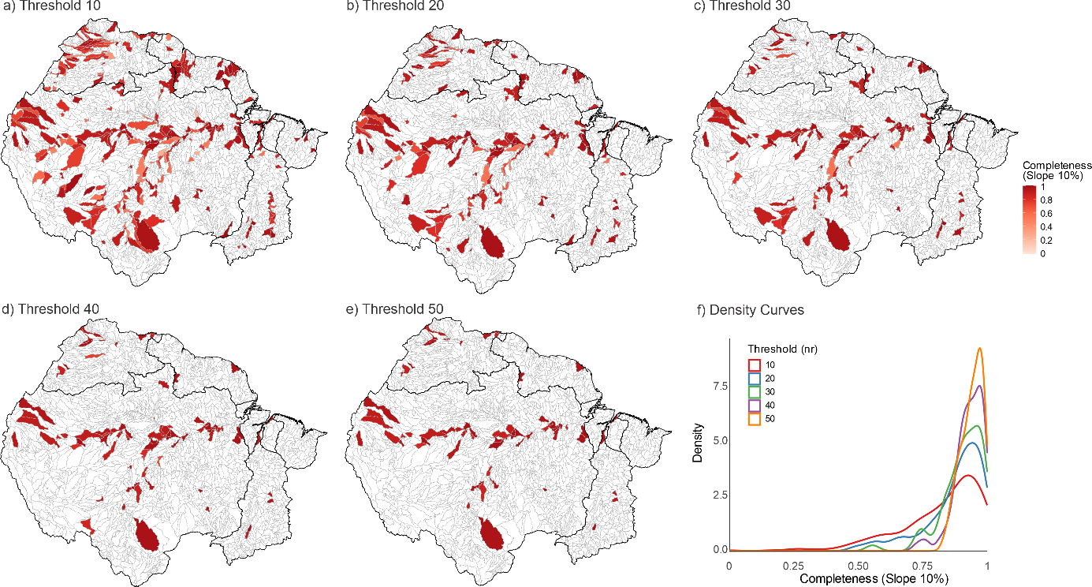
Figure S1. Inventory completeness estimated under different thresholds used to generate species accumulation curves: (a) 10, (b) 20, (c) 30, (d) 40, and (e) 50. Panel (f) presents the density curves of completeness (Slope 10%) for the different thresholds.

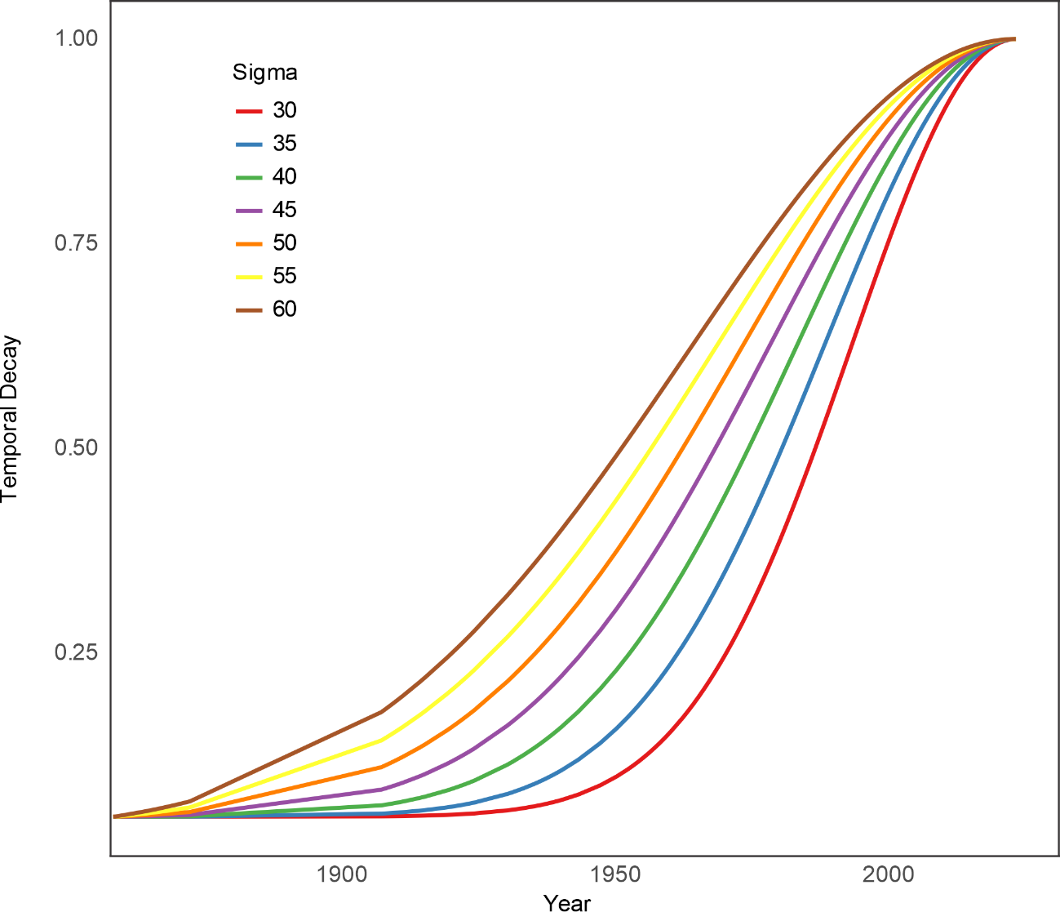
Figure S2. Time decay density curves for different sigmas (σ = 30, 35, 40, 45, 50, 55 and 60).

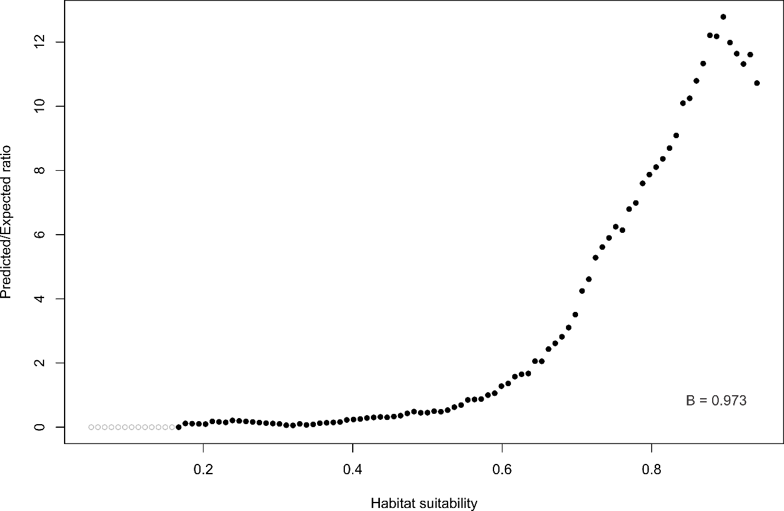
Figure S3. Continuous Boyce index (B = 0.975) of the ensemble of Brachyplatystoma filamentosum.
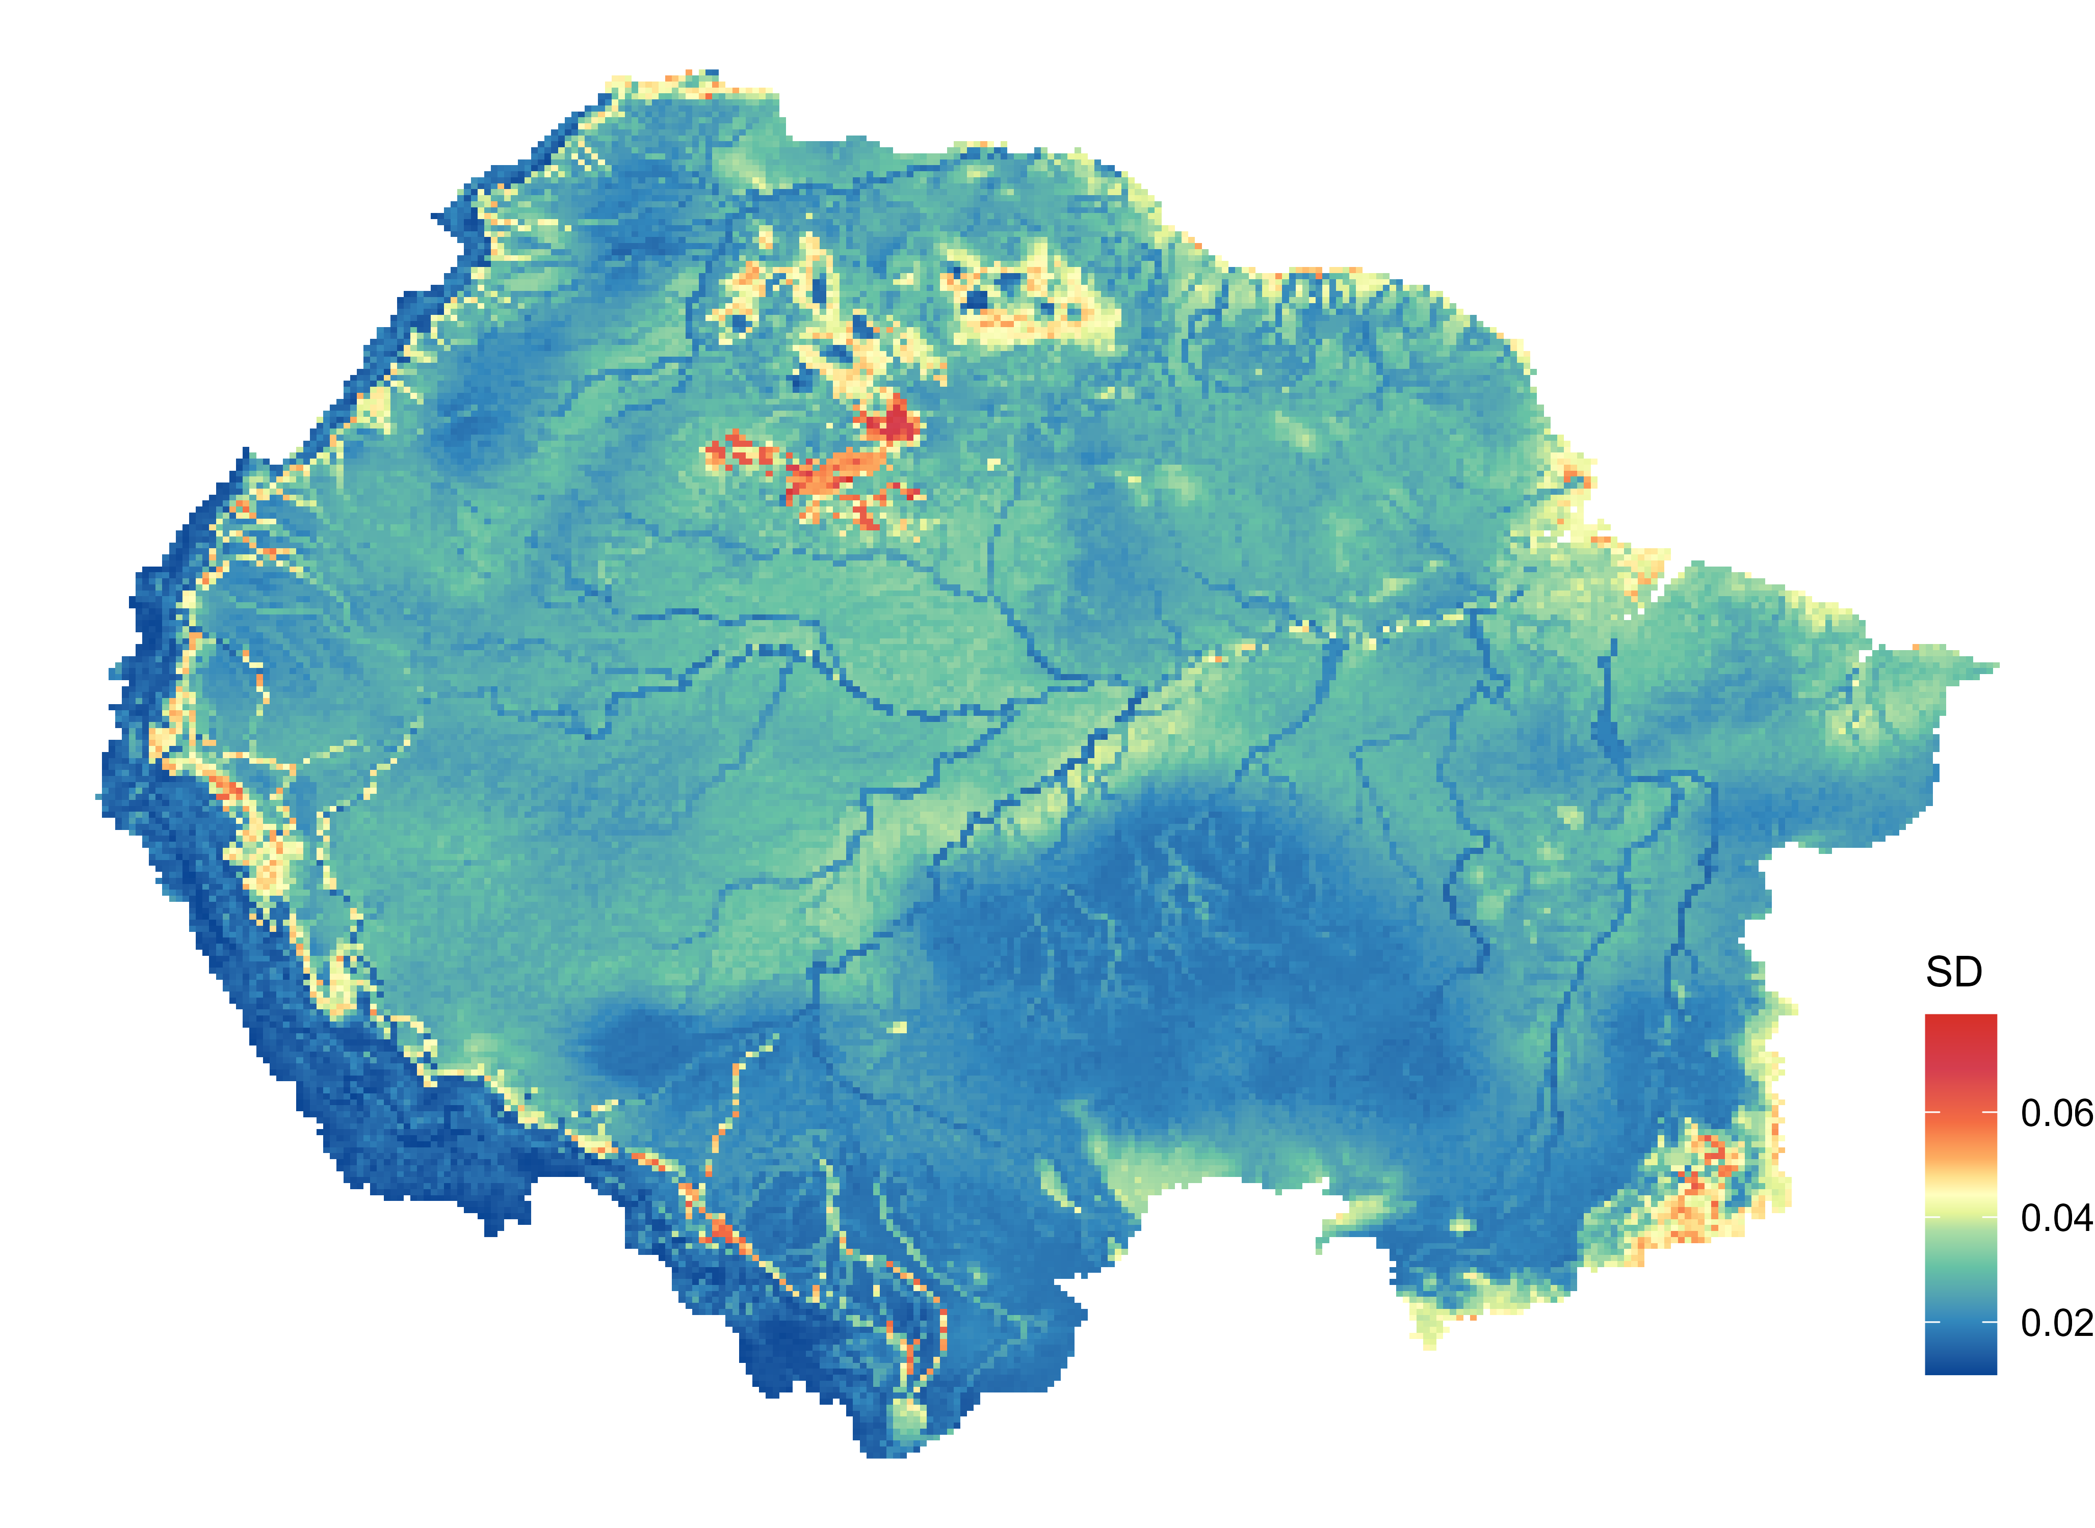
Figure S4. Ensemble disagreement map showing the standard deviation of suitability across the 30 ensemble runs.

