SUPPLEMENTARY MATERIAL

Table S1. List of the species caught during the study period. (see excel attached). *Species for which catch is prohibited; and ** Species with IUCN Conservation Status.

Table S2. Descriptive statistics (minimum, mean, and maximum) of the fishing and environmental predictors used in the XGBoost model.
Dimension | Predictors | Minimum | Mean | Maximum | Units
Fishing | Average fishing depth | 4.35 | 19.2 | 46 | Meters
Fishing | Net height | 1.5 | 2.25 | 4 | Meters
Fishing | Number of nets | 2 | 11 | 40 | Units
Fishing | Net length | 26 | 63 | 70 | Meters
Fishing | Fishing month | 1 | 7 | 12 | Months
Environmental | Maximum chlorophyll concentration | 0.1 | 0.11 | 0.16 | mg m⁻³
Environmental | Mean chlorophyll concentration | 0.03 | 0.04 | 0.05 | mg m⁻³
Environmental | Minimum chlorophyll concentration | 0.02 | 0.02 | 0.03 | mg m⁻³
Environmental | Mean sea surface temperature | 20.5 | 21 | 21.4 | (°C)
Environmental | Minimum sea surface temperature | 17.4 | 17.8 | 18.2 | (°C)
Environmental | Maximum salinity concentration | 36.9 | 37 | 37.2 | PSS
Environmental | Mean salinity concentration | 36.6 | 36.8 | 36.9 | PSS
Environmental | Minimum salinity concentration | 36 | 36.3 | 36.5 | PSS
Environmental | Maximum primary production | 0.0007 | 0.001 | 0.002 | g·m⁻³·day⁻¹
Environmental | Minimum primary production | 0.000081 | 0.000082 | 0.000085 | g·m⁻³·day⁻¹

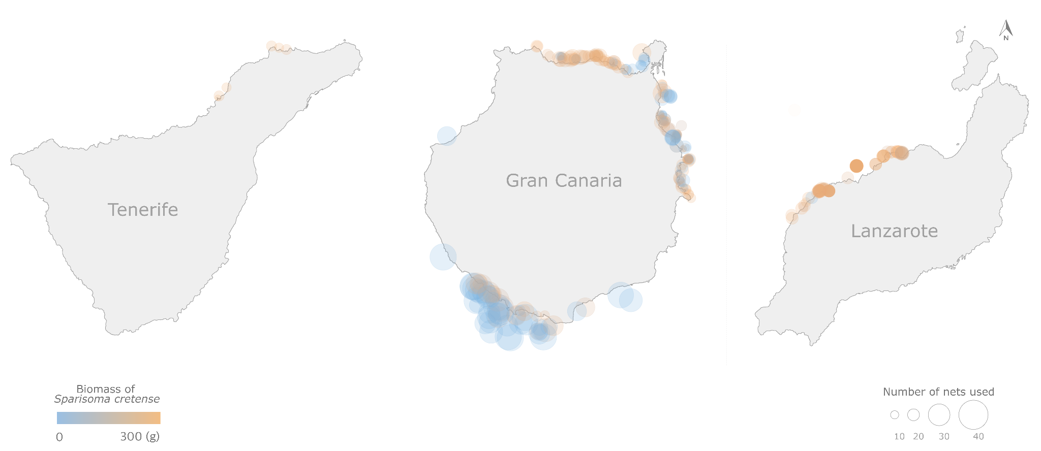

Fig. S1. Map of the three study islands in the Canary Islands: Tenerife, Gran Canaria, and Lanzarote (presented from left to right), where each circle represents a fishing haul (N = 336)

