Paris Agreement can reduce climate change-induced extinction risk fivefold and range shifts by two-thirds in fisheries worldwide
Danielle Gama-Maia¹(0000-0001-7071-8083), Stella Manes^{1,2} (0000-0002-5938-6900), Artur Malecha³(0000-0001-8643-3568), Jemilli Viaggi^{1,4} (0000-0003-2440-3763) , Flávia Lucena-Frédou⁵ (0000-0001-5492-7205), Rodrigo H. Tardin⁶ (0000-0002-0807-6937), Mariana M.Vale⁶ (0000-0003-0734-4925)
¹ Graduate Program in Ecology, Universidade Federal do Rio de Janeiro (UFRJ), Av. Carlos Chagas Filho, 373, Centro de Ciências da Saúde, Bloco A, Rio de Janeiro, RJ 21941-590, Brazil.
² International Institute for Sustainability (IIS), Rio de Janeiro, RJ, Brazil.
³ Graduate Program in Ecology and Evolution, Universidade do Estado do Rio de Janeiro (UERJ).
⁴ Oceanographic Institute, University of São Paulo, São Paulo, Brazil
⁵ Department of Fisheries and Aquaculture (DEPAQ), Federal Rural University of Pernambuco (UFRPE), Rua Dom Manuel de Medeiros, s/n, Recife, PE 52171-900, Brazil
⁶ Ecology Department, Universidade Federal do Rio de Janeiro (UFRJ), Rio de Janeiro, RJ Brazil.
*Corresponding author: Danielle Gama-Maia - danielle.gamaia@gmail.com

Supplementary Material
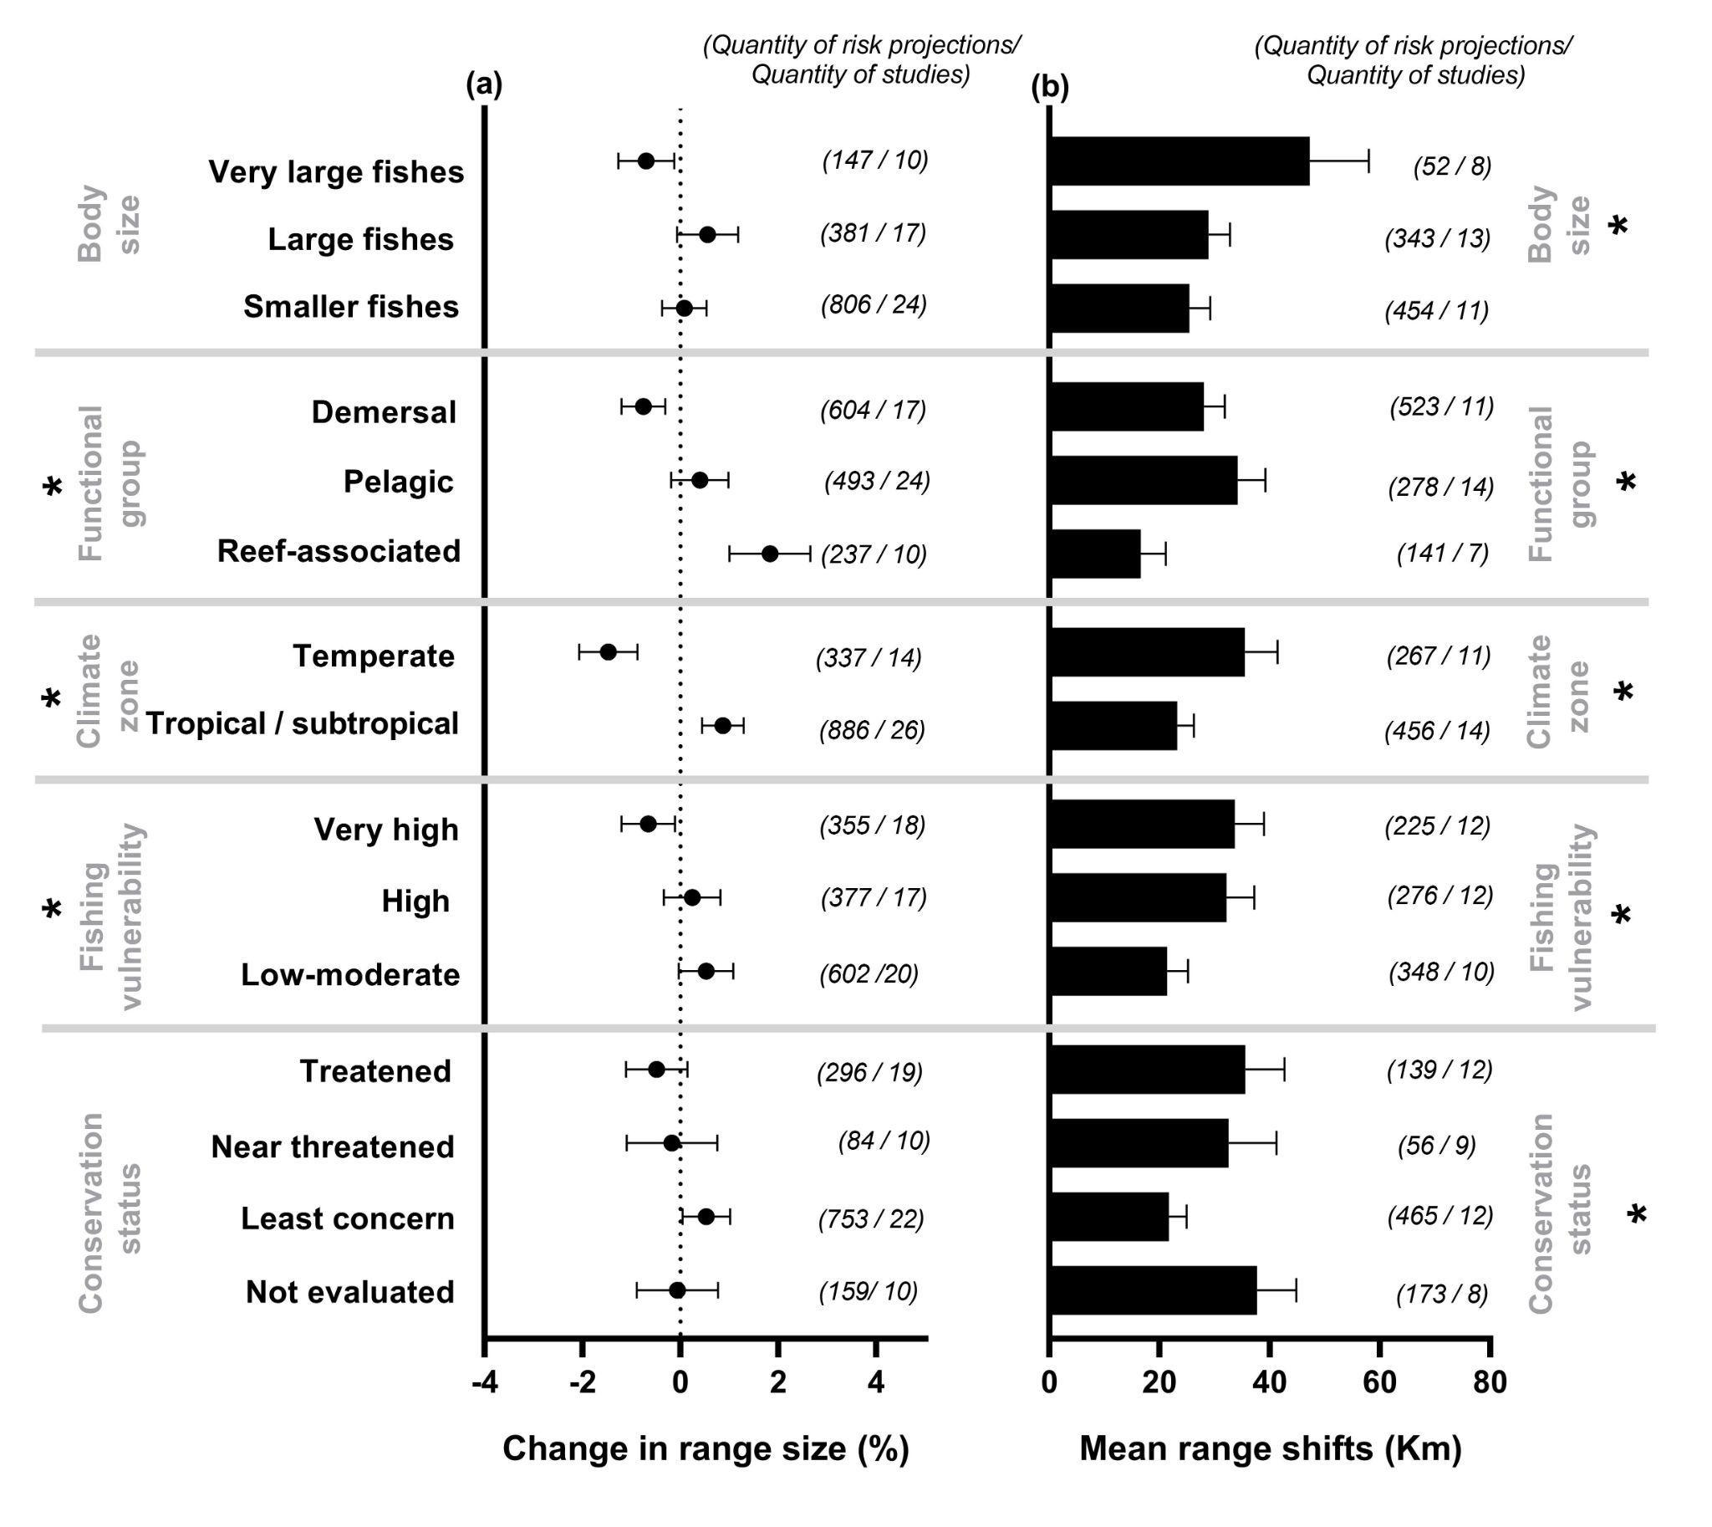
Figure S1. Projected climate change impact on the distribution of different categories of fisheries. (a) Change in range size is measured in percentage change per decade, where positive and negative values (mean ± 95% CI) denote an increase and decrease in values, respectively. (b) Mean range shifts are measured in range displacement per decade (km) (mean ± 95% CI). Black stars show significant deviations from zero (p < 0.05; Table S2). The number of projections and studies for each category is shown in parentheses.
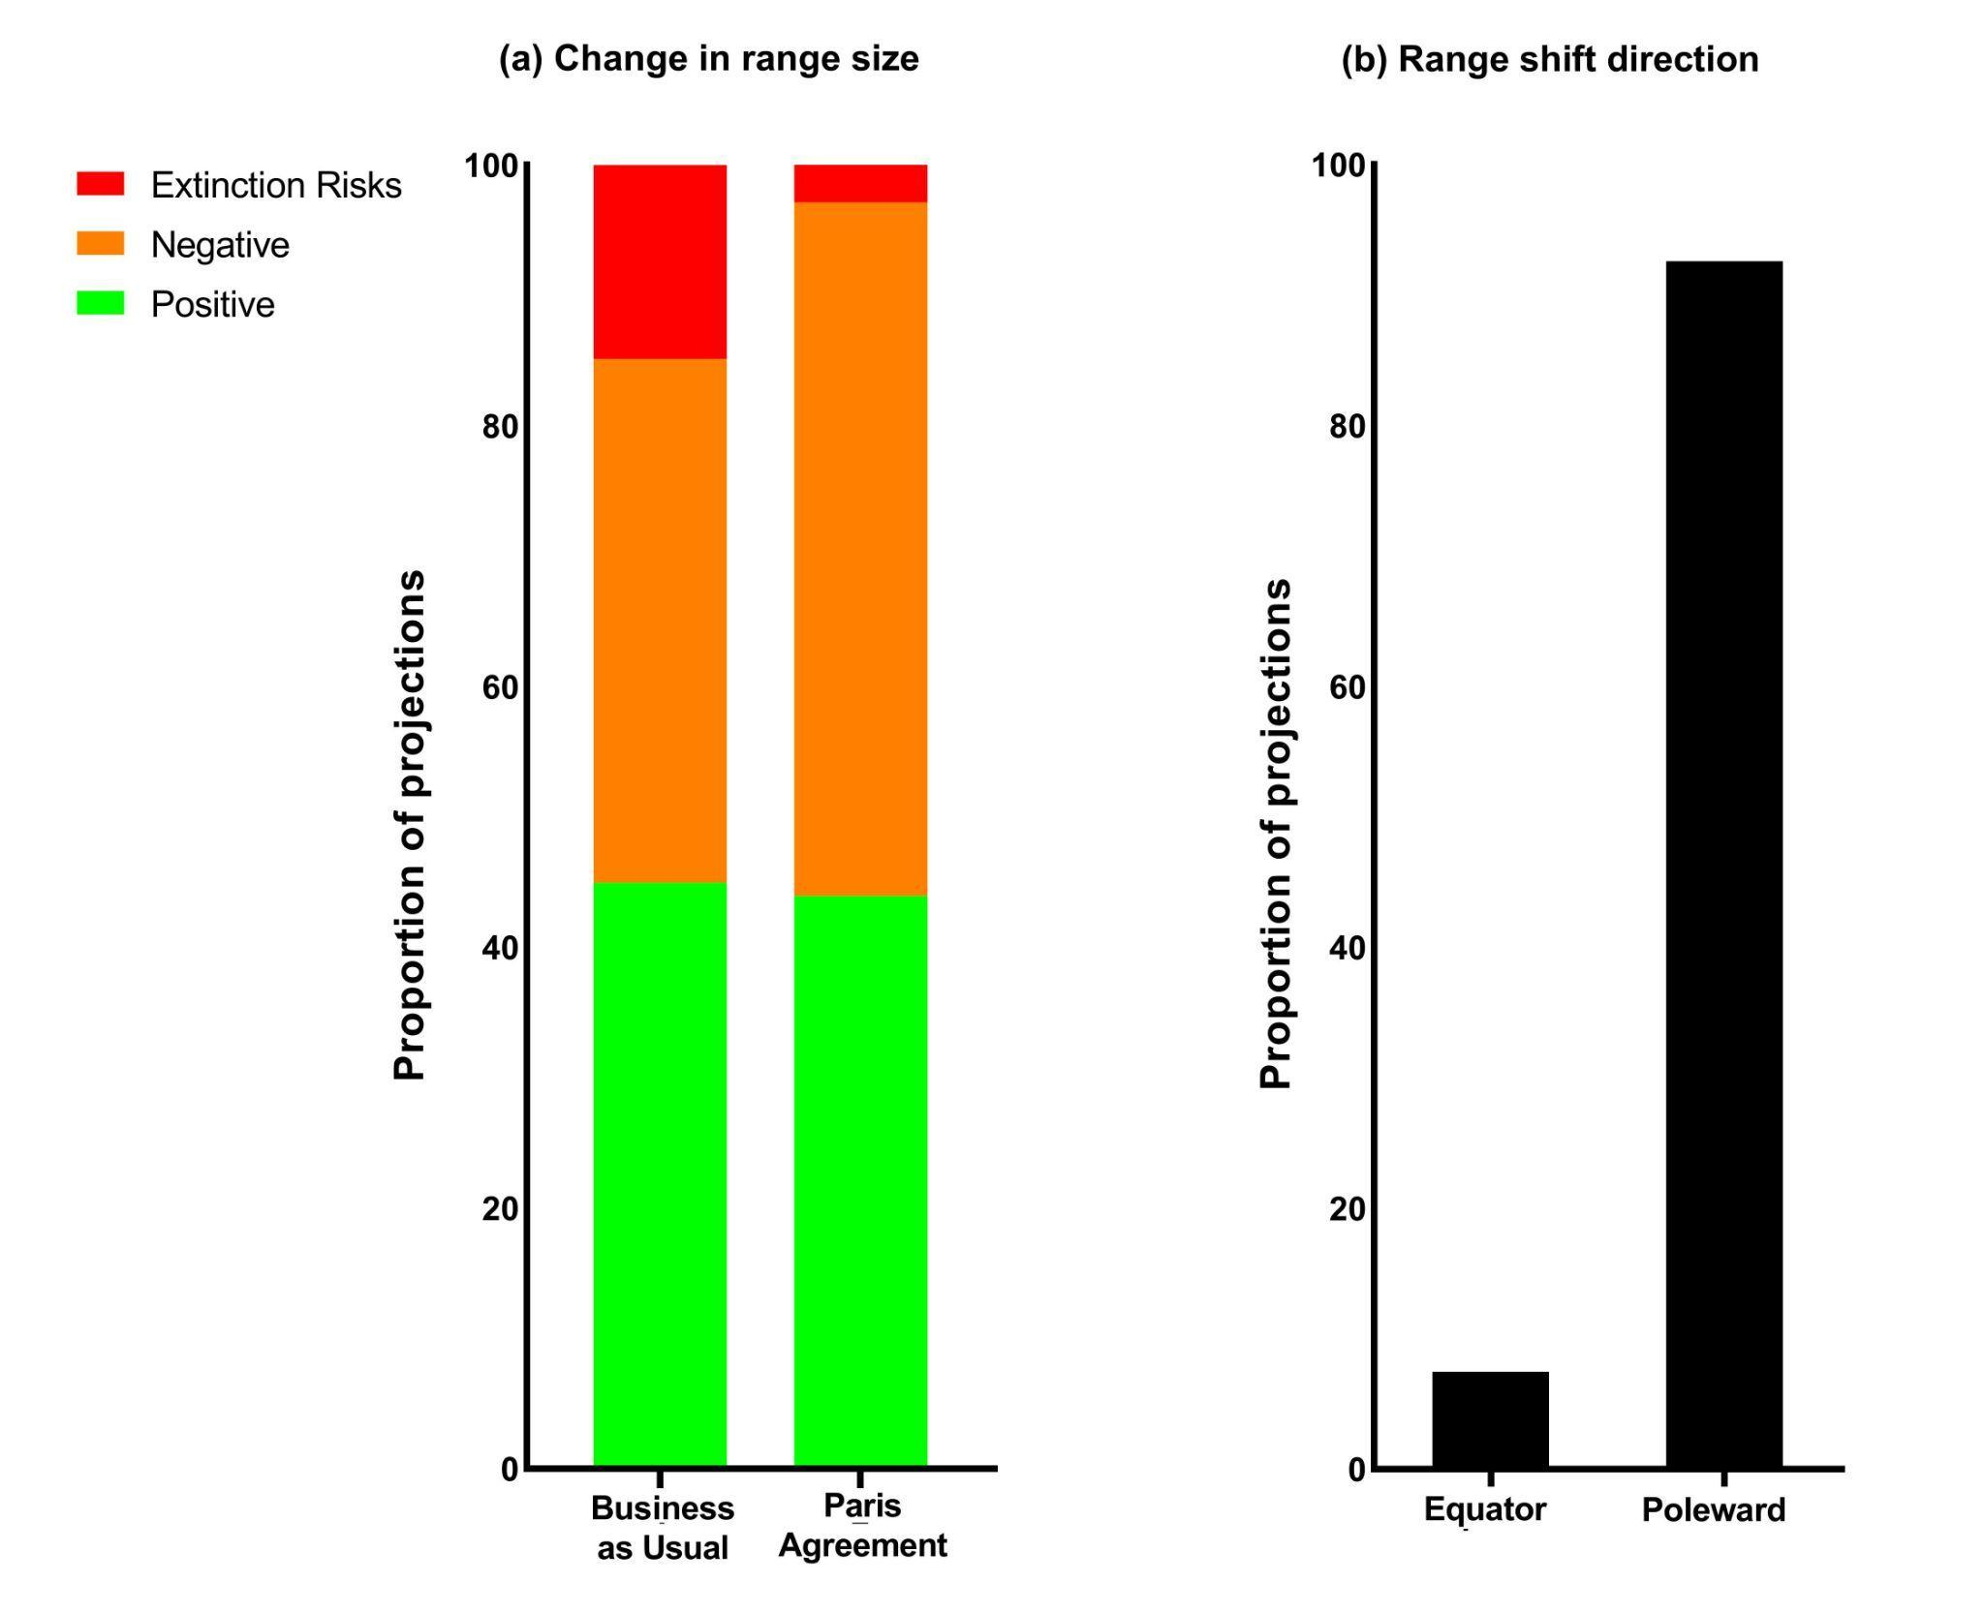
Figure S2. Impact of climate change on fisheries’ extinction risk and direction of range shift. (a) The proportion of projections that impact fish range size positively, negatively, or place the species at risk of extinction under different climate change scenarios; and (b) Fisheries range shift direction in response to climate change.
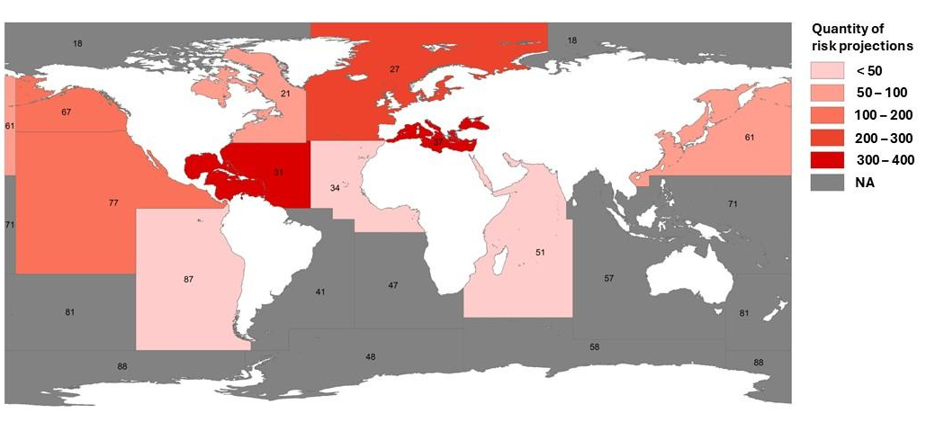
Figure S3. Number of risk projections in Major Fishing Areas. Numbers show FAO’s numeric code for each different major fishing area (see Table S4 for all areas’ names).

Supplementary Table 1. Studies used and respective categorization of scenarios, categories, range sizes and range shifts. “Provided in Excel format (Table S1_Gama-Maia et al.2026.xls)”.

Supplementary Table 2. Estimated marginal means (± 95% confidence intervals) derived from linear mixed-effects models (LMMs) for range size and range shift across categories, with study ID included as a random factor. P-values were obtained from t-tests of fixed effects and from Type III ANOVA applied to the LMMs.

Categories | Predictor variables | Categories | Estimated mean | 95% CI | p-value | dem df | F value | p-value ANOVA
RANGE SIZE
Body size | Categories | Large | -1.28 | -3.04 - 0.488 | 0.1403 | 1300 | 0.488 | 0.6137
Body size | Categories | Small-medium | -1.17 | -2.88 - 0.542 | 0.7762 | 1300 | 0.488 | 0.6137
Body size | Categories | Very large | -1.84 | -3.87 - 0.186 | 0.4129 | 1300 | 0.488 | 0.6137
Functional group | Categories | Demersal | -2.430 | -4.13 - -0.733 | 0.0036 | 1300 | 16.452 | <.0001
Functional group | Categories | Pelagic | -0.944 | -2.61 - 0.723 | 0.0001 | 1300 | 16.452 | <.0001
Functional group | Categories | Reef-associated | 0.138 | -1.68 - 1.956 | 0 | 1300 | 16.452 | <.0001
Climate zone | Categories | Temperate | -3.06 | -4.97 - -1.15 | 0.0011 | 1190 | 33.361 | <.0001
Climate zone | Categories | Tropical-subtropical | -0.51 | -2.33 - 1.31 | 0 | 1190 | 33.361 | <.0001
Fishing Vulnerability | Categories | High | -1.124 | -2.92 - 0.671 | 0.2017 | 1300 | 3.892 | 0.0206
Fishing Vulnerability | Categories | Low-moderate | -0.885 | -2.64 - 0.867 | 0.5622 | 1300 | 3.892 | 0.0206
Fishing Vulnerability | Categories | Very high | -2.110 | -3.91 - -0.307 | 0.0316 | 1300 | 3.892 | 0.0206
Conservation status | Categories | Data deficient (DD) | -1.667 | -4.16 - 0.826 | 0.1729 | 1298 | 1.553 | 0.1845
Conservation status | Categories | Least Concern (LC) | -0.873 | -2.59 - 0.840 | 0.4027 | 1298 | 1.553 | 0.1845
Conservation status | Categories | Near Threatened (NT) | -1.584 | -3.71 - 0.545 | 0.942 | 1298 | 1.553 | 0.1845
Conservation status | Categories | Not Evaluated | -1.893 | -3.83 - 0.041 | 0.8302 | 1298 | 1.553 | 0.1845
Conservation status | Categories | Threatened | -1.723 | -3.52 - 0.069 | 0.9551 | 1298 | 1.553 | 0.1845
RANGE SHIFT
Body size | Categories | Large | 44.2 | 29.7 - 58.6 | 0 | 829 | 4.043 | 0.0179
Body size | Categories | Smaller | 37.1 | 22.7 - 51.6 | 0.0075 | 829 | 4.043 | 0.0179
Body size | Categories | Very large | 47.2 | 29.3 - 65.2 | 0.6486 | 829 | 4.043 | 0.0179
Functional group | Categories | Demersal | 42.7 | 28.3 - 57.2 | 0 | 829 | 5.782 | 0.0032
Functional group | Categories | Pelagic | 44.3 | 29.9 - 58.6 | 0.5995 | 829 | 5.782 | 0.0032
Functional group | Categories | Reef-associated | 32.1 | 16.8 - 47.4 | 0.0025 | 829 | 5.782 | 0.0032
Climate zone | Categories | Temperate | 49.2 | 33.0 - 65.4 | 0 | 704 | 21.309 | <.0001
Climate zone | Categories | Tropical-subtropical | 35.3 | 19.3 - 51.2 | 0 | 704 | 21.309 | <.0001
Fishing Vulnerability | Categories | High | 46.3 | 31.6 - 60.9 | 0 | 829 | 8.946 | 0.0001
Fishing Vulnerability | Categories | Low-moderate | 34.4 | 19.7 - 49.0 | 0.0001 | 829 | 8.946 | 0.0001
Fishing Vulnerability | Categories | Very high | 44.1 | 29.6 - 58.7 | 0.5164 | 829 | 8.946 | 0.0001
Conservation | Categories | Data deficient (DD) | 33.9 | 10.4 - 57.3 | 0.0024 | 827 | 11.732 | <.0001
status |  | Least Concern (LC) | 37.4 | 22.3 - 52.5 | 0.6879
 |  | Near Threatened (NT) | 33.5 | 16.0 - 50.9 | 0.9685
 |  | Not Evaluated | 57.9 | 42.1 - 73.7 | 0.008
 |  | Threatened | 44.1 | 28.4 - 59.7 | 0.2679

Supplementary Table 3. Estimated marginal means (± 95% confidence intervals) derived from linear mixed-effects models (LMMs) with study ID as a random factor. Differences (Δ) between warming scenarios (Business-as-usual vs. Paris Agreement) were obtained from pairwise contrasts of estimated marginal means. Degrees of freedom (df), F-values, and corresponding p-values are based on ANOVA results for each model.

RANGE SIZE | Predictor variables | Scenario | Estimated mean | 95% CI | Difference (Δ) | dem df | F value | p-value
Body size
Very large fishes | warming levels | BAU | -0.68 | -2.07 - 0.71 | -0.26 | 136 | 0.206 | 0.6501
 |  | Paris Agreement | -0.42 | -1.87 - 1.03 |  | 136 | 0.206 | 0.6501
Large fishes | warming levels | BAU | -0.13 | -1.64 - 1.38 | 0.32 | 363 | 0.251 | 0.6164
 |  | Paris Agreement | -0.44 | -1.93 - 1.05 |  | 363 | 0.251 | 0.6164
Smaller fishes | warming levels | BAU | -2.09 | -4.44 - 0.26 | -0.50 | 728 | 1.237 | 0.2663
 |  | Paris Agreement | -1.59 | -3.96 - 0.78 |  | 728 | 1.237 | 0.2663
Funcional group
Demersal | warming levels | BAU | -1.96 | -3.49 - -0.43 | -0.49 | 586 | 1.241 | 0.2657
 |  | Paris Agreement | -1.46 | -2.99 - 0.07 |  | 586 | 1.241 | 0.2657
Pelagic | warming levels | BAU | -1.04 | -3.17 - 1.09 | 0.13 | 468 | 0.053 | 0.8172
 |  | Paris Agreement | -1.17 | -3.31 - 0.98 |  | 468 | 0.053 | 0.8172
Reef-associated | warming levels | BAU | 1.10 | -1.03 - 3.22 | -0.16 | 226 | 0.037 | 0.8469
 |  | Paris Agreement | 1.26 | -0.91 - 3.43 |  | 226 | 0.037 | 0.8469
Climatic zone
Temperate | warming levels | BAU | -2.38 | -4.13 - -0.63 | -1.34 | 322 | 5.594 | 0.0186
 |  | Paris Agreement | -1.05 | -2.79 - 0.70 |  | 322 | 5.594 | 0.0186
Tropical-Subtropical | warming levels | BAU | -0.92 | -3.04 - 1.19 | 0.31 | 859 | 0.531 | 0.4662
 |  | Paris Agreement | -1.23 | -3.37 - 0.90 |  | 859 | 0.531 | 0.4662
Fishing Vulnerability
Very High | warming levels | BAU | -1.31 | -2.90 - 0.29 | -0.21 | 336 | 0.149 | 0.6995
 |  | Paris Agreement | -1.10 | -2.72 - 0.52 |  | 336 | 0.149 | 0.6995
High | warming levels | BAU | -0.53 | -1.73 - 0.67 | -0.6 | 359 | 1.052 | 0.3056
 |  | Paris Agreement | 0.07 | -1.11 - 1.25 |  | 359 | 1.052 | 0.3056
Low-moderate | warming levels | BAU | -1.63 | -4.31 - 1.04 | -0.01 | 581 | 0.0007 | 0.9776
 |  | Paris Agreement | -1.62 | -4.30 -1.06 |  | 581 | 0.0007 | 0.9776
Conservation status
Threatened | warming levels | BAU | -0.84 | -3.08 - 1.41 | -0.80 | 276 | 1.709 | 0.1922
 |  | Paris Agreement | -0.03 | -2.33 - 2.27 |  | 276 | 1.709 | 0.1922
Near Threatened (NT) | warming levels | BAU | -0.53 | -2.27 - 1.21 | -0.47 | 73 | 0.252 | 0.6168
 |  | Paris Agreement | -0.06 | -1.61 - 1.50 |  | 73 | 0.252 | 0.6168
Least Concern (LC) | warming levels | BAU | -1.70 | -4.37 - 0.97 | -0.03 | 730 | 0.005 | 0.9427
 |  | Paris Agreement | -1.67 | -4.34 - 1.01 |  | 730 | 0.005 | 0.9427
Not Evaluated | warming levels | BAU | -0.54 | -2.61 - 1.52 | 0.11 | 148 | 0.016 | 0.8968
 |  | Paris Agreement | -0.65 | -2.70 - 1.40 |  | 148 |  | 0.8968

RANGE SHIFT | Predictor variables | Scenario | Estimated mean (km dec⁻¹) | 95% CI | Difference (Δ) | dem df | F value | p-value
Body size
Very large fishes | warming levels | BAU | 51.6 | 21.5 - 81.8 | 9.56 | 43 | 0.742 | 0.3935
 |  | Paris Agreement | 42.1 | 12.8 - 71.4 |  | 43 | 0.742 | 0.3935
Large fishes | warming levels | BAU | 51.4 | 34.8 - 68.0 | 24.8 | 329 | 48.650 | <.0001
 |  | Paris Agreement | 26.6 | 10.0 - 43.2 |  | 329 | 48.650 | <.0001
Smaller fishes | warming levels | BAU | 45.0 | 21.63 - 68.4 | 28.2 | 442 | 82.901 | <.0001
 |  | Paris Agreement | 16.8 | -6.89 - 40.5 |  | 442 | 82.901 | <.0001
Funcional group
Demersal | warming levels | BAU | 47.6 | 24.11 - 71.1 | 30.7 | 419 | 88.408 | <.0001
 |  | Paris Agreement | 16.9 | -6.83 - 40.7 |  | 419 | 88.408 | <.0001
Pelagic | warming levels | BAU | 60.0 | 38.8 - 81.3 | 25.9 | 263 | 39.406 | <.0001
 |  | Paris Agreement | 34.1 | 12.8 - 55.5 |  | 263 | 39.406 | <.0001
Reef-associated | warming levels | BAU | 41.0 | 19.51 - 62.5 | 12.4 | 133 | 9.321 | 0.0027
 |  | Paris Agreement | 28.6 | 7.07 - 50.2 |  | 133 | 9.321 | 0.0027
Climatic zone
Temperate | warming levels | BAU | 52.9 | 23.9 - 81.8 | 34.4 | 255 | 63.512 | <.0001
 |  | Paris Agreement | 18.5 | -10.6 - 47.6 |  | 255 | 63.512 | <.0001
Tropical-Subtropical | warming levels | BAU | 55.8 | 40.6 - 71.1 | 20 | 441 | 56.032 | <.0001
 |  | Paris Agreement | 35.8 | 20.7 - 50.9 |  | 441 | 56.032 | <.0001
Fishing Vulnerability
Very High | warming levels | BAU | 61.5 | 40.4 - 82.6 | 27.2 | 212 | 36.381 | <.0001
 |  | Paris Agreement | 34.3 | 13.2 - 55.5 |  | 212 | 36.381 | <.0001
High | warming levels | BAU | 47.2 | 26.79 - 67.5 | 31.9 | 263 | 50.908 | <.0001
 |  | Paris Agreement | 15.3 | -5.63 - 36.2 |  | 263 | 50.908 | <.0001
Low-moderate | warming levels | BAU | 52.4 | 20.35 - 84.4 | 20.4 | 337 | 49.163 | <.0001
 |  | Paris Agreement | 32.0 | -0.07 - 64 |  | 337 | 49.163 | <.0001
Conservation status
Threatened | warming levels | BAU | 59.0 | 33.14 - 84.9 | 24.1 | 126 | 20.808 | <.0001
 |  | Paris Agreement | 34.9 | 8.76 - 61.1 |  | 126 | 20.808 | <.0001
Near Threatened (NT) | warming levels | BAU | 55.5 | 35.5 - 75.6 | 26 | 46 | 17.007 | 0.0002
 |  | Paris Agreement | 29.6 | 10.2 - 48-9 |  | 46 | 17.007 | 0.0002
Least Concern (LC) | warming levels | BAU | 47.8 | 24.32 - 71.2 | 21.4 | 452 | 64.401 | <.0001
 |  | Paris Agreement | 26.3 | 2.85 - 49.8 |  | 452 | 64.401 | <.0001
Not Evaluated | warming levels | BAU | 56.3 | 18.3 - 94.2 | 38.4 | 164 | 40.572 | <.0001
 |  | Paris Agreement | 17.9 | -20.8 - 56.7 |  | 164 | 40.572 | <.0001

Supplementary Table 4. Estimated marginal means (± 95% confidence intervals) derived from linear mixed-effects models (LMMs) with study ID as a random factor. Differences (Δ) between warming scenarios (Business-as-usual vs. Paris Agreement) were obtained from pairwise contrasts of estimated marginal means. Degrees of freedom (df), F-values, and corresponding p-values are based on ANOVA results for each model. Data are presented only for the categories “other fisheries” and “fish with fishing importance”.
.

Categories | Predictor variables | Scenario | Estimated mean | 95% CI | Difference (Δ) | dem df | F value | p-value
RANGE SIZE
Other fisheries | warming levels | BAU | -4.71 | -8.18 - -1.24 | -2.23 | 44 | 4.897 | 0.0321
 |  | Paris Agreement | -2.47 | -6.09 - 1.14 |  | 44 | 4.897 | 0.0321
Fish with fishing importance | warming levels | BAU | -1.39 | -3.07 - 0.29 | -0.22 | 1301 | 0.429 | 0.5124
 |  | Paris Agreement | -1.17 | -2.87 - 0.52 |  | 1301 | 0.429 | 0.5124
RANGE SHIFT
Other fisheries | warming levels | BAU | 62.8 | 13.5 - 112 | 6.58 | 60 | 1.389 | 0.2431
 |  | Paris Agreement | 56.2 | 6.83 - 106 |  | 60 | 1.389 | 0.2431
Fish with fishing importance | warming levels | BAU | 53.6 | 37.9 - 69.3 | 26.5 | 830 | 133.615 | <.0001
 |  | Paris Agreement | 27.1 | 11.3 - 42.9 |  | 830 | 133.615 | <.0001

Supplementary Table 5. Name corresponding to the numeric code of each FAO Major Fishing Area. The location of each area can be seen in Figure 3 and S1, with respective impact risk projections for BAU and Paris Agreement scenarios for change in range size and range shifts.models, in which significant values are in bold.

Major fishing areas FAO’s numeric code | Name
Area 18 | Arctic Sea
Area 21 | Northwest Atlantic
Area 27 | Atlantic, Northeast
Area 31 | Atlantic, Western-Central
Area 34 | Atlantic, Eastern Central
Area 37 | Mediterranean and Black Sea
Area 41 | Atlantic, Southwest
Area 47 | Atlantic, Southeast
Area 48 | Atlantic, Antarctic
Area 51 | Indian Ocean, Western
Area 57 | Indian Ocean, Eastern
Area 58 | Antarctic and Southern Indian Ocean
Area 61 | Pacific, Northwest
Area 67 | Pacific, Northeast
Area 71 | Pacific, Western Central
Area 77 | Pacific, Eastern Central
Area 81 | Pacific, Southwest
Area 87 | Pacific, Southeast
Area 88 | Pacific, Antarctic

