Advancing sustainable biofuel additive production via urea-carbonylated mannose over Lanthanum Triflate-supported Aluminium Oxide catalysts

Anisah Sajidah Saud, ª Muhammad Sheraz Ahmad, ^{b} Venkata Rao Madduluri, ^{ac} Gaanty Pragas Maniam, ª Mohd Hasbi Ab Rahim ^{*ac}

ª Faculty of Industrial Sciences and Technology, Universiti Malaysia Pahang Al-Sultan Abdullah, Lebuhraya Persiaran Tun Khalil Yaakob 26300, Kuantan Pahang, Malaysia
^{b} Center for Environmental Sustainability and Human Health, Ming Chi University of Technology, New Taipei City, 24301, Taiwan
^{c} Center for Advanced Intelligent Materials, Universiti Malaysia Pahang Al-Sultan Abdullah, Lebuhraya Persiaran Tun Khalil Yaakob 26300, Kuantan Pahang, Malaysia

*Corresponding author: mohdhasbi@umpsa.edu.my
First author: sajidahsaud@gmail.com
Co-author: drsheraz@mail.mcut.edu.tw
Co-author: mvrjntu@gmail.com
Co-author: gaanty@umpsa.edu.my

Supportive information
Table S1 Technical specifications of the engine.
Type of engine | Horizontal one-cylinder two-stroke gasoline engine
Cylinder bore x stroke | 44 x 35mm
Displacement | 53.2 cm³
Maximum Power | 2.0 kW (2.68hp) / 8500rpm
Maximum torque | 3.0 Nm (2.68 hp)/5000 r pm
Fuel tank capacity (liters) | 1.1 liters
Swirl ratio | 2.20 ± 0.1
Nozzle | 0.33mm, 2 direction injection
Nozzle Injection Angle | 150 °C
Injection timing | 19 °C ± 1 BTDC
Injection valve opening pressure | 19.6~20.1 Mpa (200~205kgf/cm²)
Cooling type | Radiator
Weight | 4.5 kg

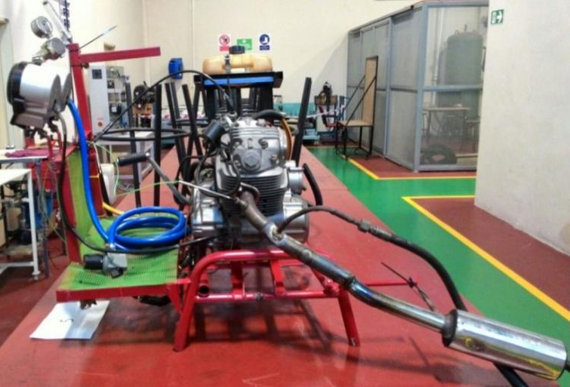
Fig. S1. Engine testing set-up.
Fig. S2. The pore distribution diagram of BJH desorption pore width for LT, Al₂O₃, and LT/Al₂O₃ (et).

Table S2 Mass Fragmentation of compound.
Mass Fragmentation of compound (3)
Mass | Structure | Mass | Structure | Mass | Structure
43 | 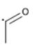 | 74 | 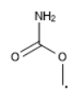 | 87 | 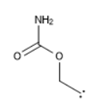
 | C₂H₃O· |  | C₂H₄NO₂· |  | C₃H₅NO₂^{2·}
98 | 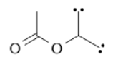 | 102 | 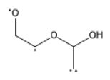 | 114 | 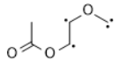
 | C₅H₆O₂^{4·} |  | C₄H₆O₃^{4·} |  | C₅H₆O₃^{4·}
126 | 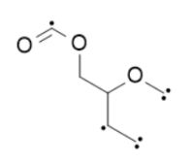 | 139 | 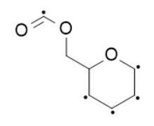 | 145 | 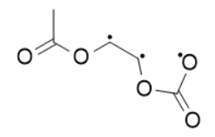
 | C₆H₆O₃^{6·} |  | C₇H₇O₃^{5·} |  | C₅H₅O₅^{3·}
155 | 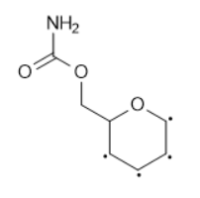 | 170 | 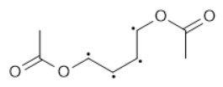 | 187 | 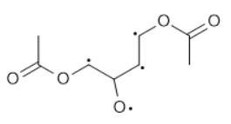
 | C₇H₉NO₃^{4·} |  | C₈H₁₀O₄^{4·} |  | C₈H₁₁O₅^{3·}
215 | 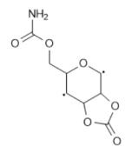 | 230 | 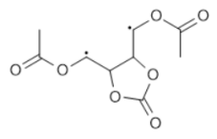 | 259 | 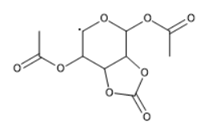
 | C₈H₉NO₆^{2·} |  | C₉H₁₀O₇^{2·} |  | C₁₀H₁₁O₈·

Mass Fragmentation of compound (4)
Mass | Structure | Mass | Structure | Mass | Structure
43 |  | 57 | 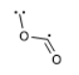 | 72 | 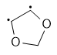
 | C₂H₃O· |  | C₂HO₂^{3·} |  | C₃H₄O₂^{2·}
87 |  | 102 | 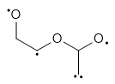 | 114
 | C₃H₅NO₂^{2·} |  | C₄H₆O₃^{4·} |  | C₅H₆O₃^{4·}
126 | 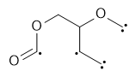 | 139 | 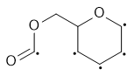 | 172 | 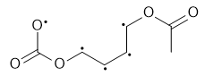
 | C₆H₆O₃^{6·} |  | C₇H₇O₃^{5·} |  | C₇H₈O₅^{4·}
176 | 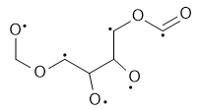 | 199 | 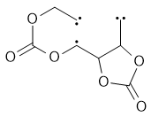 | 215 | 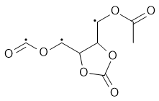
 | C₆H₈NO₆^{4·} |  | C₈H₇NO₆^{5·} |  | C₈H₇O₇^{3·}
230 | 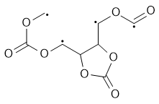 | 243 | 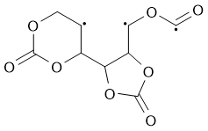 | 258 | 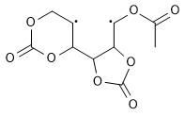
 | C₈H₆O₈^{4·} |  | C₉H₇O₈^{5·} |  | C₁₀H₁₀O₈^{2·}

Mass Fragmentation of compound (5)
Mass | Structure | Mass | Structure | Mass | Structure
43 | 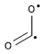 | 60 | 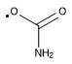 | 87
 | CO₂^{2·} |  | CH₂NO₂· |  | C₃H₅NO₂^{2·}
114 |  | 139 |  | 155 | 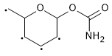
 | C₅H₆O₃^{4·} |  | C₇H₇O₃^{5·} |  | C₇H₈O₅^{4·}
176 |  | 199 | 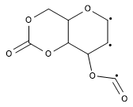 | 215 | 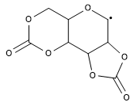
 | C₆H₈NO₆^{4·} |  | C₈H₇NO₆^{3·} |  | C₈H₇O₇·
231 | 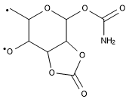 | 259 | 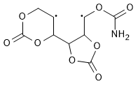
 | C₈H₉NO₇^{2·} |  | C₉H₉NO₈^{2·}

Mass Fragmentation of compound (6)

Mass | Structure | Mass | Structure | Mass | Structure
43 |  | 59 | 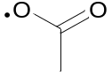 | 86 | 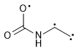
 | CO₂^{2·} |  | C₂H₃O₂· |  | C₃H₄NO₂^{3·}
98 | 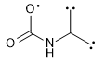 | 139 |  | 173 | 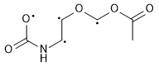
 | C₄H₄NO₂^{5·} |  | C₇H₇O₃^{5·} |  | C₆H₈NO₆^{4·}
214 | 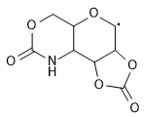 | 245 | 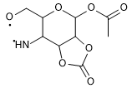
 | C₈H₈NO₆· |  | C₉H₁₁NO₇^{2·}

Mass Fragmentation of compound (7)

Mass | Structure | Mass | Structure | Mass | Structure
43 |  | 57 |  | 72
 | CO₂^{2·} |  | C₂HO₂^{3·} |  | C₃H₄O₂^{2·}
86 | 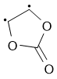 | 115 | 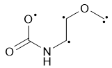 | 139
 | C₃H₂NO₃^{2·} |  | C₄H₅O₃^{4·} |  | C₇H₇O₃^{5·}
145 | 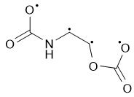 | 175 | 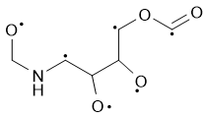 | 198 | 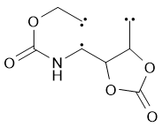
 | C₄H₃O₅^{4·} |  | C₆H₉NO₅^{4·} |  | C₈H₈NO₅^{5·}
214 | 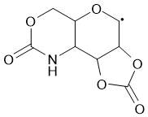 | 242 | 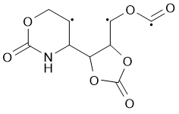 | 258 | 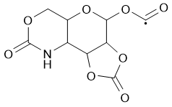
 | C₈H₈O₆· |  | C₉H₈NO₇^{3·} |  | C₉H₈NO₈·
260 | 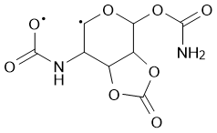
 | C₈H₈N₂O₈^{2·}

Mass Fragmentation of compound (8)

Mass | Structure | Mass | Structure | Mass | Structure
43 |  | 57 |  | 71 | 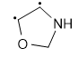
 | C₂H₃O· |  | C₂HO₂^{3·} |  | C₃H₅O^{2·}
85 | 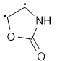 | 102 |  | 144 | 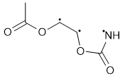
 | C₃H₃NO₂^{2·} |  | C₄H₆O₃^{4·} |  | C₅H₆NO₄^{3·}
170 | 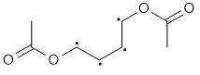 | 187 | 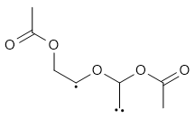 | 213 | 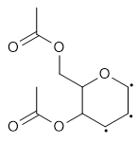
 | C₈H₁₀O₄^{4·} |  | C₈H₁₁O₅^{3·} |  | C₁₀H₁₃O₅^{6·}
229 | 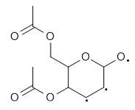 | 272 | 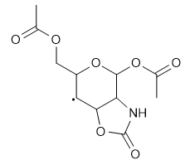 | 288 | 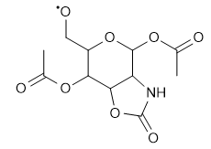
 | C₁₀H₁₃NO₆^{3·} |  | C₁₁H₁₄NO₇· |  | C₁₁H₁₄NO₈·

Mass Fragmentation of compound (9)
Mass | Structure | Mass | Structure | Mass | Structure
43 |  | 60 |  | 85
 | C₂H₃O· |  | CH₂NO₂· |  | C₃H₃NO₂^{2·}
102 |  | 115 |  | 139
 | C₄H₆O₃^{4·} |  | C₄H₅O₃^{4·} |  | C₇H₇O₃^{5·}
185 | 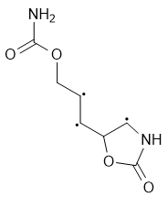 | 198 | 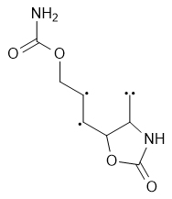 | 214 | 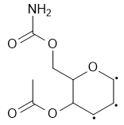
 | C₇H₉N₂O₄^{3·} |  | C₈H₁₀N₂O₄^{4·} |  | C₉H₁₂NO₅^{3·}
230 | 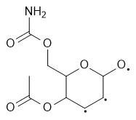 | 257 | 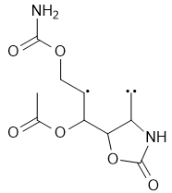 | 273 | 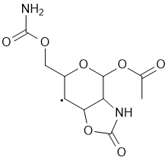
 | C₉H₁₂NO₆^{3·} |  | C₁₀H₁₃N₂O₆^{3·} |  | C₁₀H₁₃N₂O₇·
289 | 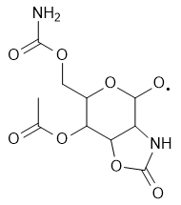 | 317 | 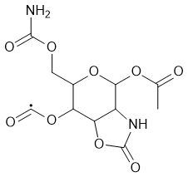
 | C₁₀H₁₃N₂O₈· |  | C₁₀H₁₃N₂O₉·

Mass Fragmentation of compound (10)

Mass | Structure | Mass | Structure | Mass | Structure
43 |  | 59 |  | 85
 | C₂H₃O· |  | C₂H₃O₂· |  | C₃H₃NO₂^{2·}
102 |  | 115 |  | 139
 | C₄H₆O₃^{4·} |  | C₄H₅O₃^{4·} |  | C₇H₇O₃^{5·}
171 | 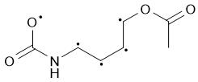 | 184 | 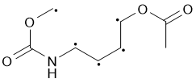 | 213 | 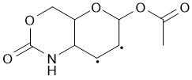
 | C₇H₉NO₄^{4·} |  | C₈H₁₀NO₄^{5·} |  | C₉H₁₁NO₅^{2·}
229 | 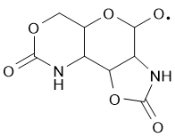 | 257 | 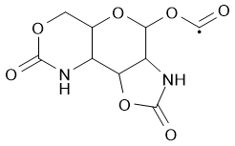
 | C₈H₉N₂O₆· |  | C₉H₉N₂O₇·

Mass Fragmentation of compound (11)

Mass | Structure | Mass | Structure | Mass | Structure
43 |  | 60 |  | 85
 | CO₂^{2·} |  | CH₂NO₂· |  | C₃H₃NO₂^{2·}
102 |  | 139 |  | 144 | 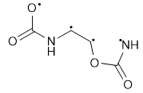
 | C₄H₆O₃^{4·} |  | C₇H₇O₃^{5·} |  | C₄H₄N₂O₄^{4·}
171 | 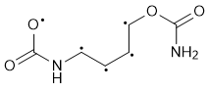 | 185 |  | 197 | 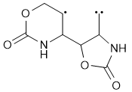
 | C₆H₇N₂O₄^{5·} |  | C₇H₉N₂O₄^{5·} |  | C₈H₉N₂O₄^{3·}
229 |  | 242
 | C₈H₉N₂O₆· |  | C₉H₈NO₇^{3·}

Mass Fragmentation of compound (12)

Mass | Structure | Mass | Structure | Mass | Structure
43 |  | 57 |  | 71 | 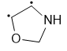
 | CO₂^{2·} |  | C₂HO₂^{3·} |  | C₃H₅NO^{2·}
85 |  | 102 |  | 116 | 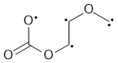
 | C₃H₃NO₂^{2·} |  | C₄H₆O₃^{4·} |  | C₄H₄O₄^{4·}
129 | 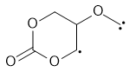 | 154 | 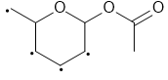 | 198 | 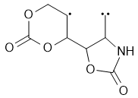
 | C₅H₅O₄^{3·} |  | C₈H₁₀O₃^{4·} |  | C₈H₈NO₅^{3·}
230 | 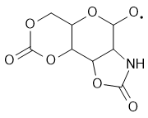
 | C₈H₈NO₇·

Mass Fragmentation of compound (13)

Mass | Structure | Mass | Structure | Mass | Structure
43 |  | 57 |  | 71
 | CO₂^{2·} |  | C₂HO₂^{3·} |  | C₃H₅NO^{2·}
85 |  | 116 |  | 139
 | C₃H₃NO₂^{2·} |  | C₄H₄O₄^{4·} |  | C₇H₇O₃^{5·}
145 | 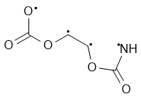 | 155 |  | 176
 | C₄H₃NO₅^{4·} |  | C₇H₈O₅^{4·} |  | C₆H₈NO₆^{4·}
198 | 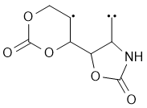 | 214 | 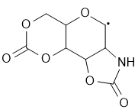 | 242 | 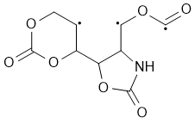
 | C₈H₈NO₅^{3·} |  | C₈H₈NO₆· |  | C₉H₈NO₇^{3·}
258 | 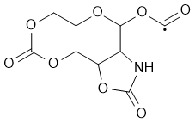
 | C₉H₈NO₈·

Table S3 Comparison of LT/Al₂O₃ (et) efficiency with reported catalysts.
Catalyst | Yield | Chemical Reaction | Conditions | Reference
Sc(OTf)₃ | 4% | CO₂ + Methanol → dimethyl carbonate | 180 °C, 24 h | ¹
[Ph₂NH₂] · OTf | 40% | CO₂ + Methanol → dimethyl carbonate | 180 °C, 24 h | ¹
La₂O₃ | 55% conversion | Ethylene glycol (EG)+ urea → dimethyl carbonate | 150 °C, 3h, | ²
Zn(OTf)₂ | 39% | Propylene glycol + CO₂ → propylene carbonate | 135 °C, 16 h | ³
Montmorillonite  K-10/ La(OTf)₃ | ~94% | Benzimidazoles + o-phenylenediamine → 1-benzyl-2-phenyl-1H-benzo[d]imidazole | 90 °C, 4 h | ⁴
La(OTf)₃ | 85% | Benzimidazoles + o-phenylenediamine →1-benzyl-2-phenyl-1H-benzo[d]imidazole | 90 °C, 8 h | ⁴
Yb(OTf)₃ | 88% | Benzimidazoles + o-phenylenediamine → 1-benzyl-2-phenyl-1H-benzo[d]imidazole | 90 °C, 9 h | ⁴
LT- Al₂O₃ | 96.74% | Mannose + urea → Mannose carbonate | 140 °C, 8 h | Current work

References:

1. J.-C. Choi, K. Kohno, Y. Ohshima, H. Yasuda and T. Sakakura, Catalysis Communications, 2008, 9, 1630-1633.
2. B. M. Bhanage, S.-i. Fujita, Y. Ikushima and M. Arai, Green Chemistry, 2003, 5, 429-432.
3. J. W. Comerford, S. J. Hart, M. North and A. C. Whitwood, Catalysis Science & Technology, 2016, 6, 4824-4831.
4. K. N. Reddy, S. Ramanaiah and N. A. K. Reddy.

