Students’ holistic reading of socio-scientific texts on climate change in a ChatGPT scenario
Appendix 1

After critically examining common claims about climate change in more than 30 research papers related to public understanding of climate science, the research teams had selected two claims that are incorporated into the conversation between the student and ChatGPT, “Is global warming real?” (Brzenk et al., 2000; Kerr, 1989) (Conversation A) and “Most climate scientists say human-caused global warming is happening because that’s how they get government grant money.” (Senthilkumaran et al., 2023) (Conversation C). These conversations were the reading materials that were eventually incorporated in the main study. The first claim elicited ChatGPT-generated text on providing empirical evidence about human-caused climate change, which focuses on nature and source of knowledge; while the second claim elicited texts regarding how scientists’ works are related or unrelated to the political power structures and financial systems of science. To avoid ChatGPT generating a long passage, the research team has restricted ChatGPT to generate socio-scientific texts under 200 words. In a previous study, the research team has designed a reading-in-science test between 210 to 240 words for upper secondary students (Stang Lund et al., 2019). The research team, which consisted of researchers from the field of applied linguistics and science education, came into a consensus that the texts generated by ChatGPT should be limited under 200 words. This limited word count was lower than the number in that study, would be appropriate for lower secondary multilingual learners. Hence, the word count of conversation A generated by ChatGPT is 124 while that of conversation C is 163. Both conversations have similar Flesch-Kincaid Readability (Flesch, 2007). In the two pilot studies, students found it difficult to read texts generated by ChatGPT. As the reading difficulties are higher than students’ grade levels, glossaries on scientific vocabularies were provided to students, and the scaffolded version and questions were further reviewed by three experienced and participating teachers. Readers should note that our pilot studies reveal equity issues such as students who were developing their English proficiency might form a barrier for their equitable access to scientific knowledge generated by ChatGPT, as ChatGPT is not originally designed for education that considers for learners’ linguistic diversity.

After generating socio-scientific texts in responses to two common claims about climate change in the ChatGPT 3.5 interface, the research team designed a set of questions which targeted on different domains of reading scientific texts, namely content-interpretation (CI) domain, genre-reasoning (GR) domain and epistemic-evaluation (EE) domain. The design process follow a construct-driven approach (Wilson, 2023) which consists of three stages: construct map, performance expectation, designing items and coding rubrics. Firstly, in the construct map we layered descriptions about different levels in each domain of reading of socio-scientific texts in ChatGPT outputs (Appendix 1 Table S1). Following that, we set out performance expectation (Appendix 1 Table S2) in each domain within the two conversations, Conversations A and C. Based on the performance expectation, we wrote a detailed outcome spaces which describe each level of performance in each question (Appendix 1 Tables S3 and S4). The descriptions of levels of each domain are explained below.

Table S1 Construct map for disciplinary reading of socio-scientific texts in ChatGPT outputs
Components | Simple reading Disciplinary reading
Components | Level 0 | Level 1 | Level 2 | Level 3 | Level 4
Content-interpretation domain (CI) | CI-0 students cannot detect any key elements of scientific content/concepts in relation to Gen-AI scientific texts. | CI-1 students can detect single key elements of scientific content/concepts in relation to Gen-AI scientific texts. | CI-1 students can detect all key elements of scientific content/concepts in relation to Gen-AI scientific texts | CI-3 students can detect all key elements of scientific content/concepts in Gen-AI scientific texts and partially reason these in relation to the key scientific phenomenon discussed. | CI-4 students can detect all key elements of scientific content/concepts in Gen-AI scientific texts and provide reasoning on how these scientific concepts related to the key scientific phenomenon discussed.
Genre reasoning (GR) | GR-0 students incorrectly identify the genre of Gen-AI scientific texts. | GR-1 students correctly identify the name/description of the genre of Gen-AI scientific texts but do not provide any reasons. | GR-2 students correctly identify the name/description of genre of Gen-AI scientific texts and provide reasons that are related to linguistic features of the text. | GR-3 students correctly identify the name and description of the genre of Gen-AI scientific texts and provide reasons that are either related to linguistic features or purpose of the text. | GR-4 students correctly identify the name and description of genre of Gen-AI scientific texts and provide reasons that are both linguistic features and purpose of the text.
Epistemic Evaluation (EE) | EE-0 students do not provide justification on their chosen stance on the claim. | EE-1 students provide justification on their chosen claim which are not related to the nature of the discipline or information from the Gen-AI scientific texts. | EE-2 students provide justification on their chosen claim which is related to either nature of AI or nature of science. | EE-3 students provide justification on their chosen claim which is related to either nature of AI or nature of science. They also draw connections on their evaluation to the text. | EE-4 students provide justification on their chosen claim which is related to both nature of science and nature of AI, as well as drawing connections to the text.

Table S2 The performance expectation of domains in relation to disciplinary reading of socio-scientific texts in ChatGPT outputs
Domains of scientific literacy | Conversation 1: Is global warming real? | Conversation 3: Is the following claim true? “Most climate scientists say human-caused global warming is happening because that’s government grant money”.
Content-interpretation domain (CI) | Identify and reason how ChatGPT reasons environmental impacts and the causes of global warming. | Identify and reason how ChatGPT rejects the claim that scientists promote human-caused global warming because of government grants.
Genre-reasoning domain (GR) | Identify the explanatory genre of scientific text on the cause of global warming. Relate the genre to the purpose (accounting the underlying causes and processes) and its linguistic features (material processes, casual relations). | Identifying argumentative genre of the text related to the conspiracy theory that scientists attributed human as the cause of global warming. Relate the genre to the purpose (present a claim and support evidence in favour of claim) and language features (processes centring on human).
Epistemic evaluation domain (EE) | Evaluating the claims “global warming is real” (line 1) and “human-induced global warming is a significant threat to our planet, ecosystems and future generations.” (lines 7-8) by considering epistemic nature of science and AI, as well as drawing connections to information in the text. | Evaluating the claim “Climate scientists are driven by their commitment to understanding addressing the complex issue of climate change, not by financial gain.” (lines 6-7) and “While government grants do support climate research, these grants are awarded to advance scientific knowledge and inform evidence-based policy decisions, not to promote a particular agenda” (lines 11-13) by considering epistemic nature of science and AI, as well as drawing connections to information in the text.

Table S3. Coding rubric for Conversation 1: Is global warming real?
Domains of disciplinary reading Gen-AI scientific texts | Questions | Descriptions of coding rubrics
Content-interpretation domain (CI) | CA-CI1: Environmental Impacts of global warming | 4: Select both correct environmental impacts of global warming described by ChatGPT (e.g., rise in sea level and melting of ice caps). Demonstrate some connections to the text by selecting the reason that cutting down forests and burning fossil fuels that results in global warming. Reason how these environmental impacts cause global warming with reference to their knowledge and text information (e.g., mentioning either production of carbon dioxide or increasing global temperature).  3: Select one correct environmental impact of global warming described by ChatGPT (e.g., either rise in sea level or melting of ice caps). Demonstrate some connections to the text by selecting the reason that cutting down forests and burning fossil fuels that results in global warming and fully reason how human activities cause the impacts.  OR  Select two correct environmental impacts of global warming described by ChatGPT (e.g., either rise in sea level and melting of ice caps). Demonstrate some connections to the text by selecting the reason that cutting down forests and burning fossil fuels that results in global warming/Reasoning how human activities cause the impacts.  2: Select one correct environmental impact of global warming described by ChatGPT (e.g., either rise in sea level or melting of ice caps). Demonstrate some connections to the text by selecting the reason that cutting down forests and burning fossil fuels that results in global warming.  OR  Select both correct environmental impacts of global warming described by ChatGPT (e.g., rise in sea level and melting of ice caps).  1: Select one correct environmental impact of global warming described by ChatGPT (e.g., either rise in sea level or melting of ice caps).  0: Select an incorrect environmental impact of global warming described by ChatGPT.  B: No answer or not classifiable.
Content-interpretation domain (CI) | CA-CI2: Specific actions to slow down global warming | 4: Select both correct specific actions mentioned by ChatGPT to tackle global warming (e.g., use more clean energy resources and reduce greenhouse gas emissions). Reason how these specific actions slow down global warming with reference to their knowledge and text information (e.g., reduce greenhouse gas emissions).  3: Select one correct specific action mentioned by ChatGPT to tackle global warming (e.g., use more clean energy resources and reduce greenhouse gas emissions). Fully reason how these specific actions slow down global warming with reference to their knowledge and text information (e.g., reduce greenhouse gas emissions).  OR  Select both correct specific actions mentioned by ChatGPT to tackle global warming (e.g., use more clean energy resources and reduce greenhouse gas emissions). Demonstrate some reasonings of the cause of global warming (e.g., greenhouse gases /human (activities)).  2: Select one correct specific action mentioned by ChatGPT to tackle global warming (e.g., either use more clean energy resources or reduce greenhouse gas emissions). Demonstrate some connection to the text regarding the cause of global warming (e.g., greenhouse gases /human (activities)).  OR  Select both correct specific actions mentioned by ChatGPT to tackle global warming (e.g., use more clean energy resources and reduce greenhouse gas emissions).  1: Select one correct specific action mentioned by ChatGPT to tackle global warming (e.g., either use more clean energy resources or reduce greenhouse gas emissions).  0: Select incorrect action to tackle global warming as mentioned by ChatGPT.  B: No answer or not classifiable.
Genre-reasoning domain (GR) | CA-GR1: Identification and reasoning genre | 4: Select the correct genre (e.g. explaining scientific phenomenon). Reason their choice with reference to both the purpose (e.g., to highlight the causes and effects of climate change) and language features (e.g., high usage of verbs on relationship; high usage of nonhuman objects). Give examples from the texts to justify these language features.  3: Select the correct genre (e.g. explaining scientific phenomenon). Reason their choice with reference to either the purpose (to highlight the causes and effects of climate change) or language features (e.g., high usage of verbs on relationship; high usage of nonhuman objects).  2: Select either the correct genre (e.g. explaining scientific phenomenon) in lines 1-6 or the explanation of genre (e.g., to highlight the causes and effects of climate change). Determine the correct language features of the corresponding genre.  1: Select either the correct genre (e.g. presenting an argument) in lines 1-6 or the explanation of genre (e.g., to highlight the causes and effects of climate change).  0: Select incorrect genre presented in lines 1-6.  B: No answer or not classifiable.
Epistemic evaluation domain (EE) | CA-EE1: To what extent do you agree with the claim about made by ChatGPT on “global warming is real” (line 1)? | 4: Provide some justification of evaluation of the claim that “global warming is real” with reference to nature of science, nature of AI and information of the text.  3: Provide some justification of evaluation of the claim that “global warming is real” with reference to nature of science/AI as well as information of the text.  2: Provide some justification of evaluation of the claim that “global warming is real” with reference to nature of science/AI.  1: Provide some justification of evaluation of the claim that “global warming is real” without reference to nature of discipline or information of the text.  0: Did not provide any justification of evaluation of the claim that “global warming is real”.  B: No answer or not classifiable.
Epistemic evaluation domain (EE) | CA-EE2: To what extent do you agree with the claim about made by ChatGPT “human-induced global warming is a significant threat to our planet, ecosystems and future generations.” (lines 7-8)? | 4: Provide some justification of evaluation of the claim that “human-induced global warming is a significant threat to our planet, ecosystems and future generations.” with reference to nature of science, nature of AI and information of the text.  3: Provide some justification of evaluation of the claim that “human-induced global warming is a significant threat to our planet, ecosystems and future generations.” with reference to nature of science/AI as well as information of the text.  2: Provide some justification of evaluation of the claim that “human-induced global warming is a significant threat to our planet, ecosystems and future generations.” with reference to nature of science/AI.  1: Provide some justification of evaluation of the claim that “human-induced global warming is a significant threat to our planet, ecosystems and future generations.” without reference to nature of discipline or information of the text.  0: Did not provide any justification of evaluation of the claim that “human-induced global warming is a significant threat to our planet, ecosystems and future generations.”.  B: No answer or not classifiable.

Table S4. Coding rubric for Conversation 3: Has climate change paused over the last 8 years?
Domains of disciplinary reading Gen-AI scientific texts | Questions | Descriptions of coding rubrics
Content-interpretation domain (CI) | CC-CI1: Evidence to reject the claim that scientists promote human-caused global warming because of getting government grants | 4: Select all correct evidence that supports the claim that scientists promote human-caused global warming because of getting government grants (e.g., both Grants are awarded based on evidence-based policy decisions and Human-caused global warming is supported by extensive data). Reason how this evidence supports the claim with reference to their knowledge and text information.  3: Select one correct evidence that supports the claim that scientists promote human-caused global warming because of getting government grants (e.g., either Grants are awarded based on evidence-based policy decisions or Human-caused global warming is supported by extensive data). Demonstrate some connections to the claim instead of complete reasoning. Reason how this evidence supports the claim with reference to their knowledge and text information.  OR  Select all correct evidence that supports the claim that scientists promote human-caused global warming because of getting government grants (e.g., both Grants are awarded based on evidence-based policy decisions and Human-caused global warming is supported by extensive data). Demonstrate some connections to the claim instead of complete reasoning/ Reason how this evidence supports the claim with reference to their knowledge and text information.  2: Select one correct evidence that supports the claim that scientists promote human-caused global warming because of getting government grants (e.g., either Grants are awarded based on evidence-based policy decisions or Human-caused global warming is supported by extensive data). Demonstrate some connections to the claim instead of complete reasoning.  OR  Select all correct evidence that supports the claim that scientists promote human-caused global warming because of getting government grants (e.g., both Grants are awarded based on evidence-based policy decisions and Human-caused global warming is supported by extensive data).  1: Select one correct evidence that supports the claim that scientists promote human-caused global warming because of getting government grants (e.g., either Grants are awarded based on evidence-based policy decisions or Human-caused global warming is supported by extensive data).  0: Select incorrect evidence that support the claim that scientists promote human-caused global warming because of getting government grants  B: No answer or not classifiable.
Genre-reasoning domain (GR) | CC-GR1: Identification and reasoning genre | 4: Select the correct genre (e.g. presenting an argument). Reason their choice with reference to both the purpose (rebutting an assertion) and language features (processes centring on human (i.e., “scientists”) or mental processes (i.e., “peer review”)). Give examples from the texts to justify these language features.  3: Select the correct genre (e.g. presenting an argument). Reason their choice with reference to either the purpose (rebutting an assertion) or language features (processes centring on human (i.e., “scientists”) or mental processes (i.e., “peer review”)). Give examples from the texts to justify these language features.  2: Select either the correct genre (e.g. presenting an argument) in lines 1-10 or the explanation of genre (e.g., To highlight claims and arguments about scientists’ claims about human-caused climate change). Determine the correct language features of the corresponding genre.  1: Select either the correct genre (e.g. presenting an argument) in lines 1-10 or the explanation of genre (e.g., To highlight claims and arguments about scientists’ claims about human-caused climate change).  0: Select incorrect genre presented in lines 1-10.  B: No answer or not classifiable.
Epistemic evaluation domain (EE) | CC-EE1: To what extent do you agree with the following claim made by ChatGPT: “Climate scientists are driven by their commitment to understanding addressing the complex issue of climate change, not by financial gain.” (lines 6-7)? | 4: Provide some justification of evaluation of the claim that “Climate scientists are driven by their commitment to understanding addressing the complex issue of climate change, not by financial gain.” with reference to nature of science, nature of AI and information of the text.  3: Provide some justification of evaluation of the claim that “Climate scientists are driven by their commitment to understanding addressing the complex issue of climate change, not by financial gain.” with reference to nature of science/AI as well as information of the text.  2: Provide some justification of evaluation of the claim that “Climate scientists are driven by their commitment to understanding addressing the complex issue of climate change, not by financial gain” with reference to nature of science/AI.  1: Provide some justification of evaluation of the claim that “Climate scientists are driven by their commitment to understanding addressing the complex issue of climate change, not by financial gain.” without reference to nature of discipline or information of the text.  0: Did not provide any justification of evaluation of the claim that “Climate scientists are driven by their commitment to understanding addressing the complex issue of climate change, not by financial gain.”.  B: No answer or not classifiable.
Epistemic evaluation domain (EE) | CC-EE2: To what extent do you agree with the following claim made by ChatGPT: “While government grants do support climate research, these grants are awarded to advance scientific knowledge and inform evidence-based policy decisions, not to promote a particular agenda” (lines 11-13)? | 4: Provide some justification of evaluation of the claim that “While government grants do support climate research, these grants are awarded to advance scientific knowledge and inform evidence-based policy decisions, not to promote a particular agenda” with reference to nature of science, nature of AI and information of the text.  3: Provide some justification of evaluation of the claim that “While government grants do support climate research, these grants are awarded to advance scientific knowledge and inform evidence-based policy decisions, not to promote a particular agenda” with reference to nature of science/AI as well as information of the text.  2: Provide some justification of evaluation of the claim that “While government grants do support climate research, these grants are awarded to advance scientific knowledge and inform evidence-based policy decisions, not to promote a particular agenda” with reference to nature of science/AI.  1: Provide some justification of evaluation of the claim that “While government grants do support climate research, these grants are awarded to advance scientific knowledge and inform evidence-based policy decisions, not to promote a particular agenda” without reference to nature of discipline or information of the text.  0: Did not provide any justification of evaluation of the claim that “While government grants do support climate research, these grants are awarded to advance scientific knowledge and inform evidence-based policy decisions, not to promote a particular agenda.”.  B: No answer or not classifiable.

Document 1. Reading Instrument

Your Background Information
- Please write down your information for Items 1-4.
- Full Name (Chinese name in English): ______________
- Form: ______________ Class: _______________
- Your Class Number: (Example: 3A01) ______________
- Age:______________
- Please circle your options for Questions 5-13.

Example: What is your favourite fruit? (a) apples (b) oranges (c) peaches
- Your Gender: (a) Male (boy) (b) Female (girl)
- What is your cultural background?
(a) Chinese (b) Indian (c) Filipino (d) Pakistani
(e) Hispanic (f) White (g) Two or more races (h) Others: ______________
- Which language do you usually speak? Choose one option only.
(a) Cantonese (b) English (c) Mandarin (d) Others: ______________
- Is English your first language?
(a) Yes (b) No
- My science teacher teaches science in
(a) Chinese language. (b) English language.
- How many bathrooms are in your home?
(a) None (b) One (c) Two (d) More than two
- Does your family own a car, van, or truck?
(a) No (b) One (c) Two (d) Three or more
- Before the Covid-19 pandemic, how many times did you travel away on holiday with your family in a year?
(a) Not at all (b) Once (c) Twice (d) More than twice
- How many computers does your family own?
(a) None (b) One (c) Two (d) More than two

Chris read news about global warming online and would like to find out more about it. He then asked ChatGPT a series of questions. ChatGPT gave him some responses. Please read the following conversation between Chris and ChatGPT, and answer the following questions:
Conversation A
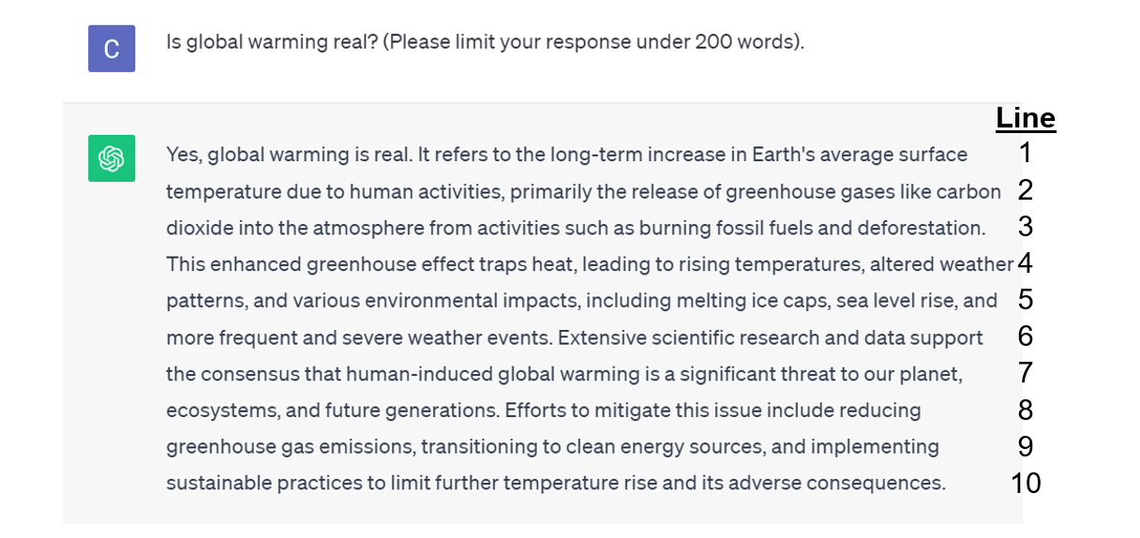
CA-CI1
1. (a) In lines 4-6, what environmental impacts on global warming have been described by ChatGPT? Circle two choice only.
A. Melting of ice caps
B. Decrease in total number of plants
C. Rise in sea level
D. Increasing areas of deserts
E. Decrease in diversity of plants

(b) (i) According to ChatGPT, what are examples of human activities that cause the impacts you stated in (a)? Circle one (the best) choice only.
A. Producing food and burning fossil fuels
B. Cutting down forests and burning fossil fuels
C. Cutting down forests and powering buildings
D. Transportation and producing powering buildings

(ii) Please explain your answer in (b)(i) on how these human activities cause the impacts.
______________________________________________________________________________________________________________________________________________________________

CA-CI2
2. (a) What specific actions suggested by ChatGPT to slow down global warming? Circle two choice only.
A. Using more clean energy resources
B. Adopting more sustainable practices
C. Participating in petitions concerning environmental protection
D. Speaking up to support zero-emissions
E. Cleaning ups of parks and beaches

(b) According to ChatGPT, why these actions you selected in (a) are so important? Explain.
These actions can slow down global warming because global warming is mainly caused by
____________________________. Hence, these actions can ____________________________
_____________________________________________________________________________.
CA-GR1
3. (a) (i) What type of scientific text is in lines 1-6? Circle one choice only.
A. Reporting information
B. Explaining scientific phenomenon
C. Describing an experiment
D. Presenting an argument

(ii) Based on the choice you selected in (a)(i), which of the following correctly describes the main purpose of the text in lines 1-6? Circle one choice only.
A. To highlight trends of climate change
B. To highlight causes and effects of climate change
C. To highlight claims and arguments about whether human causes climate change
D. To highlight procedures of studying climate change

(b) Based on the answer you selected in (a), complete the table below that describes the use of languages of the text in lines 1-6. (1) Circle if the use of each language feature has a high/low frequency and (2) give examples from the text. An example has been done for you.
Use of language features | Frequency | Examples from the text if you selected “high”
(e.g.) Linking words | (High/Low)* | E,g,“due to” (line 2), “leading to” (line 4)
(1) Verbs related to material (i.e., magnet attracts, diver falls) | (High/Low)*
(2) Verbs related to relationship (i.e., is, has, type of) | (High/Low)*
(3) Verbs related to behaviour (i.e., measure, see) | (High/Low)*
(4) Verbs related to thinking (i.e., believe, propose) | (High/Low)*
(5) Focus on nonhuman objects | (High/Low)*
(6) Focus on human objects | (High/Low)*
(7) Use of modal verbs (i.e., could be) | (High/Low)*
* Circle the correct answer.

CA-EE1
4. (a) To what extent do you agree with the claim about made by ChatGPT on “global warming is real” (line 1)? Circle one choice only.
A. Strongly agree
B. Agree
C. Neutral
D. Disagree
E. Strong disagree

(b) According to Conversation A, your knowledge about science and AI, provide as many reasons as possible to justify the choice you made above.
I chose this answer because in Conversation A, it (provides/does not provide)* evidence to support the claim. Examples of evidence is ________________________________________________________
_________________________________________________________________________________.
Scientific knowledge (is/is not)* always true because ______________________________________
_________________________________________________________________________________.
Claims generated by AI/ChatGPT (is/is not)*always true because ____________________________
_________________________________________________________________________________.
* Circle your answer.
CA-EE2
5. (a) To what extent do you agree with the claim about made by ChatGPT “human-induced global warming is a significant threat to our planet, ecosystems and future generations.” (lines 7-8)? Circle one choice only.
A. Strongly agree
B. Agree
C. Neutral
D. Disagree
E. Strong disagree

(b) According to Conversation A, your knowledge about science and AI, provide as many reasons as possible to justify the choice you made above.
I chose this answer because in Conversation A, it (provides/does not provide)* evidence to support the claim. The evidence is _______________________________________________________________
_________________________________________________________________________________.
Scientific knowledge (is/is not)* always true because ______________________________________
_________________________________________________________________________________.
Claims generated by AI/ChatGPT (is/is not)*always true because ____________________________
_________________________________________________________________________________.
* Circle your answer.

Conversation C
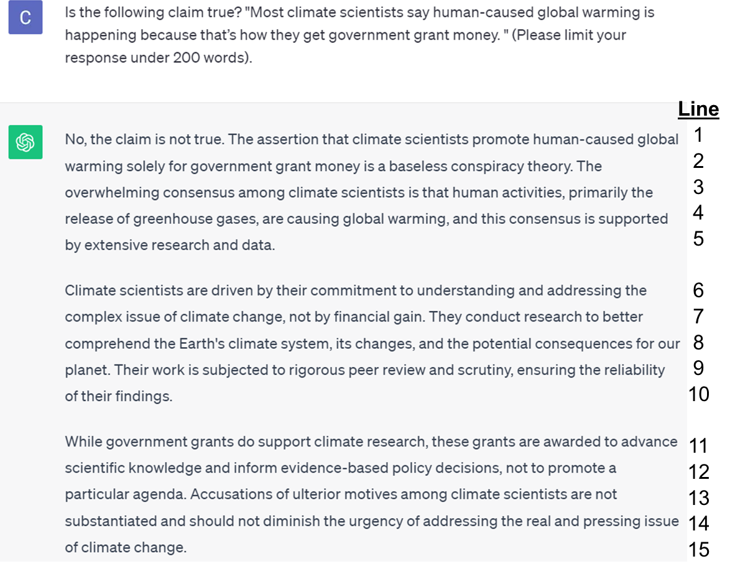
CC-CI1
1. (a) What is the reasons provided by ChatGPT to reject the claim that scientists promote human-caused global warming because of getting government grants? Circle two choice only.
A. Grants are awarded based on evidence-based policy decisions.
B. Human-caused global warming is supported by a lot of data.
C. There are a lot of government grants available to support climate change research.
D. We never know the aims behind the scientists.
E. We should not disagree with scientists because they are a high salary.

(b) According to ChatGPT, scientists address issues of climate change because of their commitment. Such issues are _____________ so it ___________________________________________________.
CC-GR1
2. (a) (i) What type of scientific text is in lines 1-10? Circle one choice only.
A. Reporting information
B. Explaining scientific phenomenon
C. Describing an experiment
D. Presenting an argument

(ii) Based on the choice you selected in (a)(i), which of the following correctly describes the main purpose of the text in lines 1-10? Circle one choice only.
A. To highlight trends of climate change
B. To highlight causes and effects of climate change
C. To highlight claims and arguments about scientists’ claims about human-caused climate change
D. To highlight procedures of studying climate change

(b) Based on the answer you selected in (a), complete the table below that describes the use of languages of the text in lines 1-10. (1) Circle if the use of each language feature has a high/low frequency and (2) give examples from the text. An example has been done for you.
Use of language features | Frequency | Examples from the text if you selected “high”
(e.g.) Linking words | (High/Low)*
(1) Verbs related to material (i.e., magnet attracts, diver falls) | (High/Low)*
(2) Verbs related to relationship (i.e., is, has, type of) | (High/Low)*
(3) Verbs related to behaviour (i.e., measure, see) | (High/Low)*
(4) Verbs related to thinking (i.e., believe, propose) | (High/Low)*
(5) Focus on nonhuman objects | (High/Low)*
(6) Focus on human objects | (High/Low)*
(7) Use of modal verbs (i.e., could be) | (High/Low)*
* Circle the correct answer.

CC-EE1
3. (a) To what extent do you agree with the following claim made by ChatGPT:
“While government grants do support climate research, these grants are awarded to advance scientific knowledge and inform evidence-based policy decisions, not to promote a particular agenda” (lines 11-13)?
Circle one choice only.
A. Strongly agree
B. Agree
C. Neutral
D. Disagree
E. Strong disagree

(b) According to Conversation C, your knowledge about science and AI, provide as many reasons as possible to justify the choice you made above.
I chose this answer because in Conversation C, it (provides/does not provide)* evidence to support the claim. The evidence is ________________________________________________________
_________________________________________________________________________________.
Scientific knowledge (is/is not)* always true because ______________________________________
_________________________________________________________________________________.
Claims generated by AI/ChatGPT (is/is not)* always true because ____________________________
_________________________________________________________________________________.
* Circle your answer.

