Table S1. Inter-rater reliability of each item
Items | Cohen’s α
CA-CI1 | .97***
CA-CI2 | .87***
CA-GR1 | .96***
CA-EE1 | .97***
CA-EE2 | .94***
CC-CI1 | .84***
CC-GR1 | .94***
CC-EE1 | .88***
*** p <.001

Figure 1. Wright map of students’ holistic reading of socio-scientific texts about climate change on ChatGPT outputs
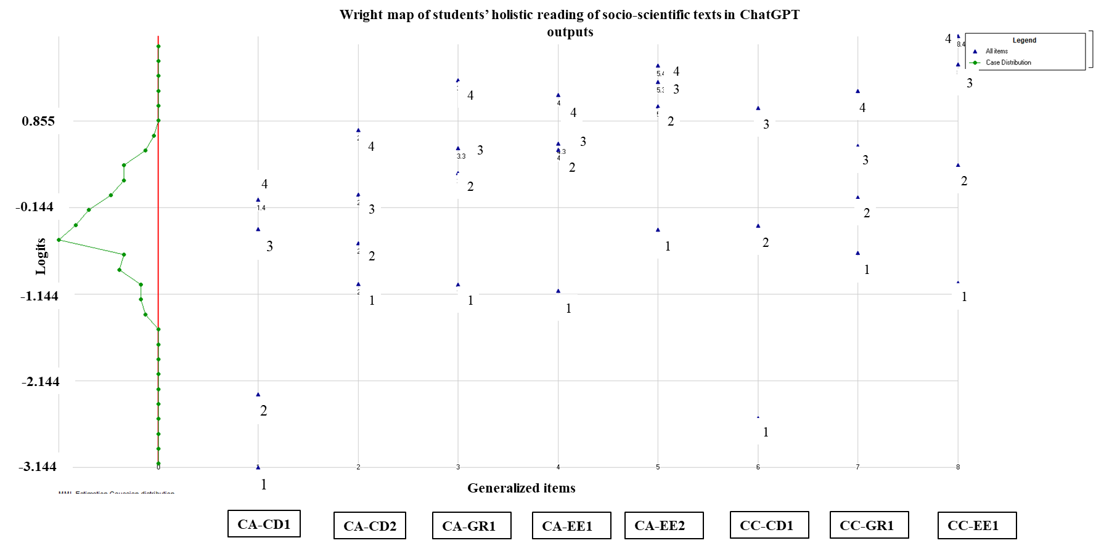

Table S2. Students’ pre- and post- performance in holistic reading of socio-scientific texts on the ChatGPT output (n=55)

Level | Pre-test |  |  |  |  | Post-test
Level | 0 | 1 | 2 | 3 | 4 | 0 | 1 | 2 | 3 | 4
Conversation A: “Is global warming real?”
CA-CI1 | 0 (0%) | 6 (11%) | 47 (86%) | 2 (4%) | 0 (0%) | 0 (0%) | 0 (0%) | 20 (36%) | 26 (47%) | 9 (16%)
CA-CI2 | 4 (7%) | 15 (27%) | 23 (42%) | 11 (20%) | 2 (4%) | 0 (0%) | 5 (9%) | 21 (38%) | 23 (42%) | 6 (11%)
CA-GR1 | 16 (29%) | 29 (53%) | 6 (11%) | 4 (7%) | 0 (0%) | 5 (9%) | 22 (40%) | 23 (42%) | 4 (7%) | 1 (2%)
CA-EE1 | 17 (31%) | 32 (58%) | 1 (2%) | 4 (7%) | 1 (2%) | 8 (15%) | 24 (44%) | 17 (31%) | 5 (9%) | 1 (2%)
CA-EE2 | 25 (46%) | 25 (46%) | 5 (9%) | 0 (0%) | 0 (0%) | 15 (27%) | 26 (47%) | 13 (24%) | 1 (2%) | 0 (0%)
Conversation C: “Most climate scientists say human-caused global warming is happening because that’s how they get government grant money.”
CC-CI1 | 3 (5%) | 26 (47%) | 20 (36%) | 6 (11%) | 0 (0%) | 2 (4%) | 21 (38%) | 21 (38%) | 10 (18%) | 1 (2%)
CC-GR1 | 21 (38%) | 15 (27%) | 15 (27%) | 3 (5%) | 1 (2%) | 5 (9%) | 21 (38%) | 22 (40%) | 5 (9%) | 2 (4%)
CC-EE1 | 19 (35%) | 22 (40%) | 13 (24%) | 1 (2%) | 0 (0%) | 8 (15%) | 24 (44%) | 19 (35%) | 4 (7%) | 0 (0%)

