Supplementary Information for:
Asymmetric behavioural responses to updating caloric information

This file includes:
Appendix Sections A and B
Figures S1 to S18
Tables S1 to S11
Supplementary References
Note: The numbering differs at times from the appearance in the main manuscript. Section A presents details for the four studies; Section B includes supplementary tables and figures in order of appearance.

Appendix A: Methods and Descriptive Statistics

1 Study 1

1.1 Study design
The first page of the study asked participants to provide informed consent, which was obtained in a similar manner across all data collection sessions (see Figure S1). Following our study design, participants were then asked to rate their current hunger level and report the time of their last meal. Thereafter, participants were introduced to the scenario below and asked to select their preferred portion sizes.
“In the following, we ask you to select a preferred portion size for 3 different meals. Imagine you are at the workplace and have to select one of these portion sizes to eat for lunch. Please treat all 3 choices independently, meaning that we do not ask you to eat all 3 portions at once, but rather on different days. In this scenario, you had only a small breakfast and you are hungry.”

The food options were “chicken curry with rice”, “fish, chips and peas”, and “grilled white fish with tomato and bean salad” (see Figure S2). In the standard paradigm (see Figure S3 for a graphical representation), participants were presented with eight portion sizes for three foods. Portion sizes increased by 100 kcal in each image, starting at 300 kcal and progressing to 1000 kcal (see Figure S4, left panel). This first food choice was followed by an estimation task of the kcal for each of the shown portion sizes (see Figure S5). All three 8-portion sizes were presented in random order. Participants were informed that, based on the accuracy of three randomly drawn estimates, the best guesses would receive an additional $5. This tournament-style incentive was implemented to increase effort in the estimation task, a well-known problem in online samples. While this simple “winner-takes-all” approach has been shown to incentivise better results in estimation tasks (Vandegrift et al., 2007), competitive schemes may distort the incentive for truth-telling if people calibrate their estimates to the expectations about other participants.
After completing the 24 portion size estimations, participants were asked to reconsider their preferred portion sizes, now displayed with their actual caloric content in kcal, following this introduction text (see Figure S4, right panel):

“Now imagine you are provided with calorie labels that display the total calories (kcal) for each portion size. Which portion size would you select now that you know their true caloric value? Remember that in this scenario, you had only a small breakfast and you are hungry. Please treat all 3 choices independently.”

Thereafter, participants were asked to rate the familiarity, taste, and health perception of the meals, followed by socio-demographic information and a measure of dietary restraint (Herman & Polivy, 1975). Sample 2 in Study 1 deviated from this standard paradigm in two ways to assess the validity of our approach. First, we randomly assigned participants to a paradigm in which the estimation task was omitted. Second, after the second-choice task, which included the caloric content, we asked participants how surprised they were by the portion sizes' caloric content. This approach aimed at capturing an emotional response to the provided caloric information to assess its novelty. We do not provide an analysis of this data, as little additional insight emerged from this approach.

1.2 Measures
Choices for each of the three meal options were measured in kcal (min. 300 to max. 1000), with the choice difference defined as the difference between the two options. Our measure for caloric misperception is calculated as the difference between the estimated kcal for the selected portion in the first choice and the actual caloric content.
Hunger was measured using a slider scale from 0 (“Not at all”) to 100 (“Extremely”). Familiarity, taste, and health were assessed for each meal option on a 5-point Likert scale ranging from “Extremely familiar/tasty/healthy” to “Not at all familiar/tasty/healthy”. Additional variables in the survey included age (numeric), gender (three categories, including other), body height and weight (numeric entry), ethnicity (six, including other), marital status (five categories), number of people in household below and above age 15 (numeric entry), highest level of education (11 categories), gross household income (17 categorical ranges, including prefer not to answer), state of residency, employment status (eight categories, including prefer not to answer), and seven items to measure dietary restraint (Herman & Polivy, 1975).

1.3 Data & Sample
All data was collected via Amazon’s Mechanical Turk. Requirements were that participants were located in the U.S. and had a 98% prior approval rate. Sample 1 has a raw size of N = 128, which is reduced to N = 85 after data cleaning. Sample 2 has a raw sample size of N = 198, reduced to N = 168 after cleaning. Data cleaning consisted of two attention checks: participants first had to extract instructions from an image and enter adequate text in the box below the image, and then respond to a Likert-scale item according to specific instructions. Sample characteristics are provided in Table S1. The analytical samples may vary due to the exclusion of estimation outliers, defined as portion size estimates lower than 30 kcal or larger than 3000 kcal, and the selective exclusion of missing values in relevant variables. For Study 1 and all further analyses, we used STATA version 18.

1.4 Empirical Approach
To estimate the relationship between calorie information and food choice, we use the kcal portion- size adjustment between the first and second choices as an outcome ${∆choice}_{i,f}$ for each participant i and food option f. We employ two main approaches to model misperception. First, we use a third-order polynomial to allow a flexible relationship that can vary across over- and underestimations. We include a fixed effect for food type and cluster the standard errors at the individual level.

$${∆choice}_{i,f}= β_{0}+β_{1}{misestimation}_{i,f}+β_{2}{misestimation}_{i,f}^{2}+β_{3}{misestimation}_{i,f}^{3}+{food_dummy}_{i,f}+ε_{i,f}$$

Second, we employ a linear specification, allowing the slope to differ between over- and underestimation by interacting the calculated mistestimations with a binary indicator. This approach provides a single test for asymmetric responses.

$${∆choice}_{i,f}= β_{0}+β_{1}{misestimation}_{i,f}+β_{2}{over_under_dummy}_{i,f}^{}+β_{3}{(over_under_dummy}_{i,f}^{}*{misestimation}_{i,f})+{food_dummy}_{i,f}+ε_{i,f}$$

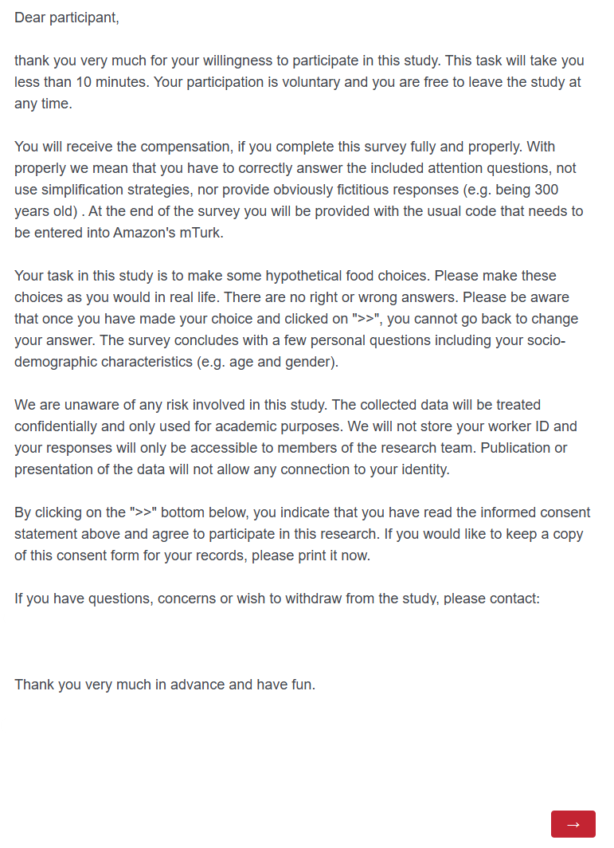

Figure S1 Screenshot of informed consent statement

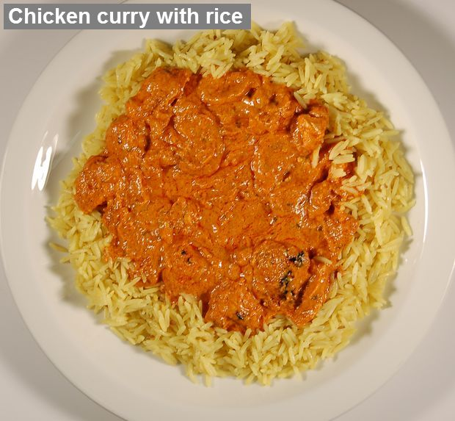 | 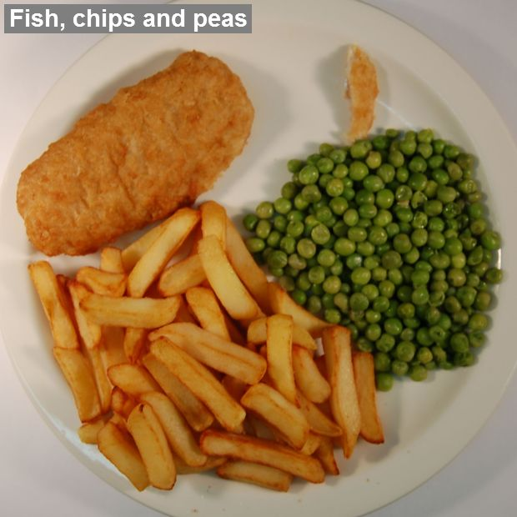 | 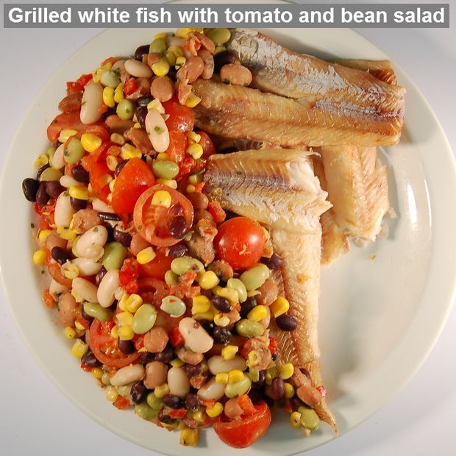
FIGURE S2 Examples of the foodS
Sample 2 validation: no estimate

Estimate kcal for each available portion size for 3 meals.
3 x 8 = 24 estimates

FIGURE S3 STudy 1 Design
Calorie estimates

Estimate kcal for each available portion size for 3 meals.
3 x 8 = 24 estimates

Follow-up survey

Subjective ratings on foods and socio-demographics

Food choice #2

Re-select 1 of 8 different portion sizes for 3 meals. With caloric information provided

Food choice #1

Select 1 of 8 different portion sizes for 3 meals. No caloric information provided

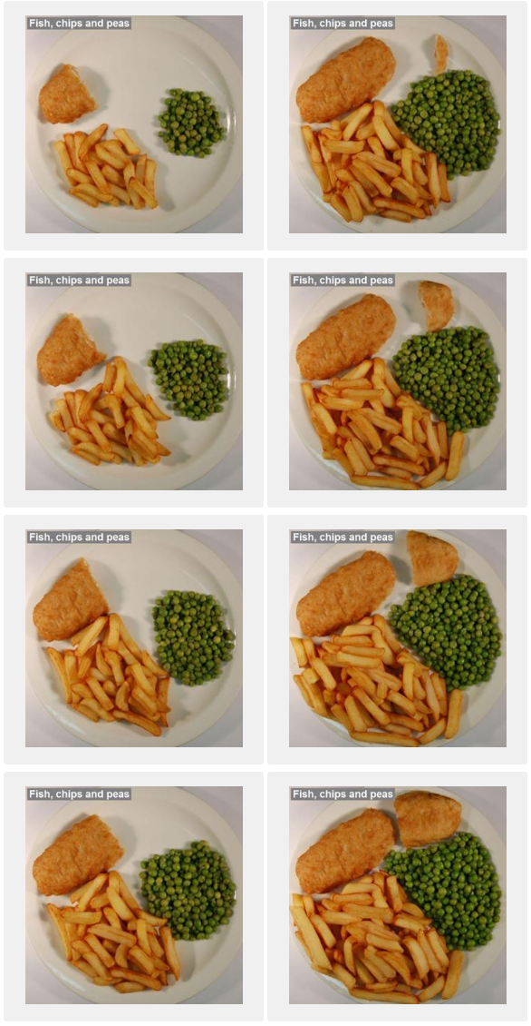 | 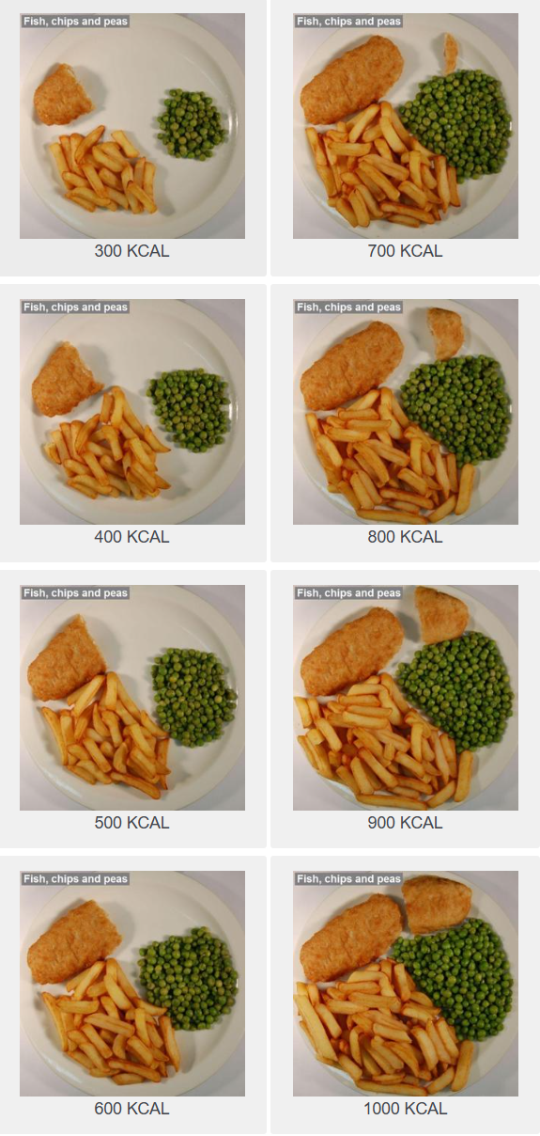
FIGURE S4 Portion size selection TaskS
Notes: The left panel represents the first selection task without calorie information. The right panel shows the second selection task, including calorie information.
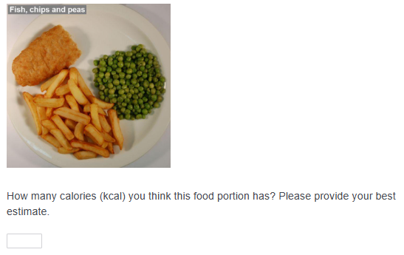
FIGURE S5 Portion size Estimation TAsk
Notes: Participants were asked to enter a numeric value for their estimate in the box below.

TABLE S1 Sample characteristics, Study 1
 | Summary
N | 253.0
Age (years) | 34.9 (10.0)
Sex
Male/other | 135.0 (53.4%)
Female | 118.0 (46.6%)
Body Mass Index | 26.3 (5.9)
Hunger (0 'Not at all'-100 'Extremely') | 48.1 (31.6)
Education Level
Nursery school to 8th grade | 1.0 (0.4%)
Some high school, no diploma | 6.0 (2.4%)
High school graduate (incl. GED) | 35.0 (13.8%)
Some college credit, no degree | 43.0 (17.0%)
Trade/technical/vocational training | 5.0 (2.0%)
Associate degree | 20.0 (7.9%)
Bachelor's degree | 100.0 (39.5%)
Master's degree | 37.0 (14.6%)
Professional degree | 4.0 (1.6%)
Doctorate degree | 2.0 (0.8%)
Ethnicity
White or Caucasian | 202.0 (79.8%)
Black or African American | 24.0 (9.5%)
American Indian or Alaska Native | 4.0 (1.6%)
Asian | 15.0 (5.9%)
Native Hawaiian or Pacific Islander | 1.0 (0.4%)
Other | 7.0 (2.8%)
Marital Status
Single, never married | 104.0 (41.1%)
Married or domestic partnership | 130.0 (51.4%)
Widowed | 5.0 (2.0%)
Divorced | 13.0 (5.1%)
Separated | 1.0 (0.4%)
Household Income
Less than $5,000 | 2.0 (0.8%)
$5,000 to $7,499 | 0 (0%)
$7,500 to $9,999 | 3.0 (1.2%)
$10,000 to $12,499 | 4.0 (1.6%)
$12,500 to $14,999 | 4.0 (1.6%)
$15,000 to $19,999 | 7.0 (2.8%)
$20,000 to $24,999 | 19.0 (7.5%)
$25,000 to $29,999 | 14.0 (5.5%)
$30,000 to $34,999 | 18.0 (7.1%)
$35,000 to $39,999 | 21.0 (8.3%)
$40,000 to $49,999 | 37.0 (14.6%)
$50,000 to $59,999 | 31.0 (12.3%)
$60,000 to $74,999 | 32.0 (12.6%)
$75,000 to $99,999 | 24.0 (9.5%)
$100,000 to $149,999 | 22.0 (8.7%)
$150,000 or more | 11.0 (4.3%)
I prefer not to answer | 4.0 (1.6%)
HH Members ≤15 yrs | 0.9 (1.7)
HH Members >15 yrs | 2.3 (1.4)
Dietary Restraint Score | 14.3 (3.8)

2 Study 2

2.1 Study Design
The study incorporated an experimental manipulation into the paradigm described in Study 1. The experimental manipulation was implemented by randomising participants to one of three conditions: seeing 100 kcal more than the actual caloric content, the correct caloric content, or 100 kcal less than the actual caloric content on the labels for the second-choice task (Figure S6 for a graphical description).

2.2 Measures
As in the previous study, we elicited hunger, portion-size choices, calorie estimates, and ratings of the foods' taste, health, and familiarity. We added a measure of confidence to the design. Before participants made their second portion-size choice, which included the calorie labels, we asked them to report their confidence in the calorie estimates they had just provided. The measure included a financial incentive to avoid overconfidence. The instruction read as follows:
“Now we want to know how well you think you have estimated the calories in the previous task. You express this confidence by indicating a value that you think is slightly larger than the error you might have made in your calorie estimates. The highest level of confidence means that you think your estimates are off by less than ± 50 kcal, while the lowest confidence means that you think you might have under- or overestimated calories by up to 900 (kcal).
As you can see below on the scale: The more you trust your own estimates (i.e. the smaller the error range), the higher your bonus might be [lower value in the scale below]; however, you only receive this bonus if your calorie estimates are within the range you selected. We test this by randomly choosing 3 of your estimates and will award the bonus only, if all 3 estimates are closer to the true calorie content than the value you indicate here.
Hence, please answer the following question using the scale below: "I am confident that my calorie estimates are off by less than [upper value in the scale below] kcal".

The most confidence was an error of +/- 50 kcal, and if realized, would reward participants with 49 cents extra. The least confidence was +/- 900 kcal rewarded with 1 cent extra. See Table S2 for the complete range of options. Further survey measures were similar to those in Study 1.

2.3 Data & Sample
We again collected data via Amazon’s Mechanical Turk, using the same requirements (U.S. location and a 98% prior approval rate). We excluded participants from the previous study. The raw data included N = 302, which was reduced to N = 268 after data cleaning. The same quality criteria were applied as in the previous studies. As before, to increase effort in providing calorie estimates, we incentivized the best performance with a $5 bonus. See details of the sample Table S3.

2.4 Empirical Approach
To estimate the difference between the three labelling groups, we interact the higher-order polynomial of the misestimations with a categorical indicator for each treatment group.

$${∆choice}_{i,f}= β_{0}+\left(β_{1}{misestimation}_{i,f}+β_{2}{misestimation}_{i,f}^{2}+β_{3}{misestimation}_{i,f}^{3}\right)*\sum_{l=1}^{3}{∂ {labelling}_{i}}+{food_dummy}_{i,f}+ε_{i,f}$$

The remainder of the analytical approach is similar to that in Study 1.

3
Food choice #2

Re-select 1 of 8 different portion sizes for 3 meals. With 100kcal lower caloric information provided

Food choice #1

Select 1 of 8 different portion sizes for 3 meals. No caloric information provided

Calorie estimates

Estimate kcal for each available portion size for 3 meals.
3 x 8 = 24 estimates

Follow-up survey

Subjective ratings on foods and socio-demographics

Food choice #2

Re-select 1 of 8 different portion sizes for 3 meals. With correct caloric information provided

Food choice #2

Re-select 1 of 8 different portion sizes for 3 meals. With 100 kcal higher caloric information provided

FIGURE S6 STudy 2 design

TABLE S2 confidence measure
Confidence in KCAL | ±50 49¢ | ±100 41¢ | ±150 36¢ | ±200 32¢ | ±250 28¢ | ±300 25¢ | ±350 21¢ | ±400 18¢ | ±450 15¢ | ±500 13¢ | ±600 8¢ | ±700 5¢ | ±800 2¢ | ±900 1¢

TABLE S3 Study 2 Sample Characteristics
 | Summary
N | 268.0
Age (years) | 37.9 (12.3)
Sex
Male/other | 132.0 (49.3%)
Female | 136.0 (50.7%)
Body Mass Index | 25.6 (5.0)
Hunger (0 'Not at all'-100 'Extremely') | 44.7 (27.8)
Education Level
Some high school, no diploma | 1.0 (0.4%)
High school graduate (incl. GED) | 25.0 (9.3%)
Some college credit, no degree | 59.0 (22.0%)
Trade/technical/vocational training | 4.0 (1.5%)
Associate degree | 38.0 (14.2%)
Bachelor's degree | 102.0 (38.1%)
Master's degree | 34.0 (12.7%)
Professional degree | 4.0 (1.5%)
Doctorate degree | 1.0 (0.4%)
Ethnicity
White or Caucasian | 215.0 (80.2%)
Black or African American | 25.0 (9.3%)
American Indian or Alaska Native | 2.0 (0.7%)
Asian | 17.0 (6.3%)
Other | 9.0 (3.4%)
Marital Status
Single, never married | 110.0 (41.0%)
Married or domestic partnership | 129.0 (48.1%)
Widowed | 5.0 (1.9%)
Divorced | 22.0 (8.2%)
Separated | 2.0 (0.7%)
Household Income
Less than $5,000 | 1.0 (0.4%)
$5,000 to $7,499 | 6.0 (2.2%)
$7,500 to $9,999
$10,000 to $12,499 | 6.0 (2.2%)
$12,500 to $14,999 | 4.0 (1.5%)
$15,000 to $19,999 | 10.0 (3.7%)
$20,000 to $24,999 | 18.0 (6.7%)
$25,000 to $29,999 | 15.0 (5.6%)
$30,000 to $34,999 | 11.0 (4.1%)
$35,000 to $39,999 | 15.0 (5.6%)
$40,000 to $49,999 | 41.0 (15.3%)
$50,000 to $59,999 | 34.0 (12.7%)
$60,000 to $74,999 | 39.0 (14.6%)
$75,000 to $99,999 | 38.0 (14.2%)
$100,000 to $149,999 | 21.0 (7.8%)
$150,000 or more | 8.0 (3.0%)
I prefer not to answer | 1.0 (0.4%)
HH Members ≤15 yrs | 0.6 (1.1)
HH Members >15 yrs | 2.1 (1.0)
Confidence Range in KCAL | 287.9 (153.4)
Dietary Restraint Score | 13.7 (3.6)
Treatment groups
[1]Low -100 | 89.0 (33.2%)
[2]Real +/-0 | 87.0 (32.5%)
[3]High +100 | 92.0 (34.3%)

3 Study 3

3.1 Study Design
For Study 3, we reused the same experimental paradigm and implemented two experimental manipulations, reducing and increasing the labelled caloric value by 100 kcal.

3.2 Measures
As in Study 2, we included the same incentivised measure of confidence, along with most of the additional measures detailed in Study 1. Additionally, we added a measure of self-reported importance when selecting food (36 items) (Pula et al., 2014). We also replace the seven-item dietary restraint measure with the Three Factor Eating Questionnaire (21 items) (Cappelleri et al., 2009).

3.3 Data & Sample
We again collected data via Amazon’s Mechanical Turk (U.S. location, 98% prior approval rate), excluding participants who had participated on previous studies. The raw sample size was N = 603, reduced to N = 525 after data cleaning. Sample details are reported in Table S4.

3.4 Empirical Approach
To estimate the difference between the two labelling groups, we interact the higher-order polynomial of the misestimation with a categorical indicator for each treatment group.

$${∆choice}_{i,f}= β_{0}+\left(β_{1}{misestimation}_{i,f}+β_{2}{misestimation}_{i,f}^{2}+β_{3}{misestimation}_{i,f}^{3}\right)*\sum_{l=1}^{2}{∂ {labelling}_{i}}+{food_dummy}_{i,f}+ε_{i,f}$$

TABLE S4 STUDY 3 Sample characteristics
 | Summary
N | 525.0
Age (years) | 37.5 (10.9)
Sex
Male/other | 256.0 (48.8%)
Female | 269.0 (51.2%)
Body Mass Index | 26.7 (5.8)
Hunger (0 'Not at all'-100 'Extremely') | 48.3 (28.4)
Education Level
Some high school, no diploma | 8.0 (1.5%)
High school graduate (incl. GED) | 61.0 (11.6%)
Some college credit, no degree | 90.0 (17.1%)
Trade/technical/vocational training | 10.0 (1.9%)
Associate degree | 48.0 (9.1%)
Bachelor's degree | 232.0 (44.2%)
Master's degree | 64.0 (12.2%)
Professional degree | 9.0 (1.7%)
Doctorate degree | 3.0 (0.6%)
Ethnicity
White or Caucasian | 418.0 (79.6%)
Black or African American | 51.0 (9.7%)
American Indian or Alaska Native | 2.0 (0.4%)
Asian | 39.0 (7.4%)
Native Hawaiian or Pacific Islander | 1.0 (0.2%)
Other | 14.0 (2.7%)
Marital Status
Single, never married | 185.0 (35.2%)
Married or domestic partnership | 302.0 (57.5%)
Widowed | 3.0 (0.6%)
Divorced | 32.0 (6.1%)
Separated | 3.0 (0.6%)
Household Income
Less than $5,000 | 10.0 (1.9%)
$5,000 to $7,499 | 5.0 (1.0%)
$7,500 to $9,999 | 5.0 (1.0%)
$10,000 to $12,499 | 7.0 (1.4%)
$12,500 to $14,999 | 8.0 (1.6%)
$15,000 to $19,999 | 21.0 (4.1%)
$20,000 to $24,999 | 21.0 (4.1%)
$25,000 to $29,999 | 14.0 (2.7%)
$30,000 to $34,999 | 32.0 (6.2%)
$35,000 to $39,999 | 37.0 (7.2%)
$40,000 to $49,999 | 54.0 (10.5%)
$50,000 to $59,999 | 67.0 (13.0%)
$60,000 to $74,999 | 74.0 (14.3%)
$75,000 to $99,999 | 80.0 (15.5%)
$100,000 to $149,999 | 55.0 (10.7%)
$150,000 or more | 26.0 (5.0%)
Employment status
Working (paid employee) | 375.0 (71.4%)
Working (self-employed) | 67.0 (12.8%)
Not working (temporary layoff) | 1.0 (0.2%)
Not working (looking for work) | 30.0 (5.7%)
Not working (retired) | 12.0 (2.3%)
Not working (disabled) | 5.0 (1.0%)
Not working (other) | 30.0 (5.7%)
Prefer not to answer | 5.0 (1.0%)
HH Members ≤15 yrs | 0.8 (1.1)
HH Members >15 yrs | 2.2 (1.0)
TFEQ Cognitive Restraint | 2.5 (0.7)
TFEQ Emotional Eating | 2.0 (0.8)
TFEQ Uncontrolled Eating | 2.1 (0.6)
Health importance | 5.5 (1.0)
Mental well-being importance | 4.2 (1.5)
Ease/convenience importance | 5.0 (1.2)
Taste importance | 5.3 (0.9)
Naturalness importance | 4.8 (1.5)
Price importance | 5.3 (1.2)
Familiarity importance | 4.3 (1.3)
Environmental importance | 4.3 (1.5)
Social proof importance | 2.9 (1.6)
Confidence Range in KCAL | 299.9 (154.6)
Treatment groups
[1]low | 258.0 (49.1%)
[2]high | 267.0 (50.9%)

4 Study 4

4.1 Study Design
In Study 4, we utilised a large sample from a data provider to obtain a representative sample of the U.S. population. The study design did not include any calorie-label manipulations and was therefore similar to Study 1, including the analysis strategy. We preregistered three hypotheses for this study on OSF (https://osf.io/9fjg7). Based on the previous findings, we hypothesized “a relationship between calorie misestimation and food selection in response to a provided calorie label” (H1) and that this “relation is different depending on whether people over- or underestimate the caloric content of a food portion” (H2). Finally, we preregistered an exploratory hypothesis that “individual estimation errors can be predicted by observable characteristics” (H3).

4.2 Measures
Study 4 repeated most of the measures collected in Study 3. These included ratings of familiarity, taste, and healthiness for the foods; confidence in the estimates; sociodemographic characteristics; important criteria for selecting food (36 items); and the TFEQ. We additionally asked participants about their general health status (5 items, range “bad” to “very good”). Beyond that, we added a measure to elicit relevant attributes when selecting food, right before participants estimated the caloric content of the portion sizes. The question asked: “How important would the following attributes be for your choice in such a scenario?” providing 16 attributes, such as “…tastes good” or “…easy to eat”, with answer categories ranging from “Not at all important” to “Extremely important” on a 7-item scale.

4.3 Data & Sample
TNS KANTAR provided data representative of the U.S. population with regard to gender, age (six age categories), and region (West, Midwest, South, and North). N = 3,888 participants answered the quota questions. The final cleaned sample comprised N = 1,021. Sample details provided in Table S5.

TABLE S5 STUDy 4 Sample characteristics
 | Summary
N | 1021.0
Age (years) | 51.8 (15.5)
Sex
Male/other | 477.0 (46.7%)
Female | 544.0 (53.3%)
Region
West | 210.0 (20.6%)
Midwest | 230.0 (22.5%)
South | 354.0 (34.7%)
North | 226.0 (22.2%)
Body Mass Index | 27.3 (6.3)
Hunger (0 'Not at all'-100 'Extremely') | 40.0 (32.3)
Education Level
No schooling completed | 4.0 (0.4%)
Nursery school to 8th grade | 2.0 (0.2%)
Some high school, no diploma | 17.0 (1.7%)
High school graduate (incl. GED) | 156.0 (15.3%)
Some college credit, no degree | 173.0 (16.9%)
Trade/technical/vocational training | 48.0 (4.7%)
Associate degree | 127.0 (12.4%)
Bachelor's degree | 280.0 (27.4%)
Master's degree | 157.0 (15.4%)
Professional degree | 22.0 (2.2%)
Doctorate degree | 35.0 (3.4%)
Ethnicity
White or Caucasian | 880.0 (86.2%)
Black or African American | 73.0 (7.1%)
American Indian or Alaska Native | 7.0 (0.7%)
Asian | 39.0 (3.8%)
Native Hawaiian or Pacific Islander | 1.0 (0.1%)
Other | 21.0 (2.1%)
Marital Status
Single, never married | 277.0 (27.1%)
Married or domestic partnership | 580.0 (56.8%)
Widowed | 58.0 (5.7%)
Divorced | 97.0 (9.5%)
Separated | 9.0 (0.9%)
Household Income
Less than $5,000 | 24.0 (2.4%)
$5,000 to $7,499 | 10.0 (1.0%)
$7,500 to $9,999 | 14.0 (1.4%)
$10,000 to $12,499 | 21.0 (2.1%)
$12,500 to $14,999 | 18.0 (1.8%)
$15,000 to $19,999 | 52.0 (5.1%)
$20,000 to $24,999 | 52.0 (5.1%)
$25,000 to $29,999 | 44.0 (4.3%)
$30,000 to $34,999 | 40.0 (3.9%)
$35,000 to $39,999 | 53.0 (5.2%)
$40,000 to $49,999 | 87.0 (8.5%)
$50,000 to $59,999 | 84.0 (8.2%)
$60,000 to $74,999 | 100.0 (9.8%)
$75,000 to $99,999 | 182.0 (17.8%)
$100,000 to $149,999 | 119.0 (11.7%)
$150,000 or more | 83.0 (8.1%)
I prefer not to answer | 38.0 (3.7%)
Employment status
Working (paid employee) | 462.0 (45.2%)
Working (self-employed) | 71.0 (7.0%)
Not working (temporary layoff) | 8.0 (0.8%)
Not working (looking for work) | 69.0 (6.8%)
Not working (retired) | 268.0 (26.2%)
Not working (disabled) | 61.0 (6.0%)
Not working (other) | 68.0 (6.7%)
Prefer not to answer | 14.0 (1.4%)
HH Members ≤15 yrs | 0.5 (1.0)
HH Members >15 yrs | 2.0 (1.1)
TFEQ Cognitive Restraint | 2.5 (0.7)
TFEQ Emotional Eating | 1.9 (0.8)
TFEQ Uncontrolled Eating | 2.0 (0.6)
Health importance | 5.7 (1.0)
Mental well-being importance | 4.6 (1.6)
Ease/convenience importance | 5.3 (1.2)
Taste importance | 5.8 (0.9)
Naturalness importance | 5.2 (1.4)
Price importance | 5.3 (1.2)
Familiarity importance | 4.8 (1.2)
Environmental importance | 4.6 (1.5)
Social proof importance | 3.6 (1.8)
Confidence Range in KCAL | 366.7 (220.5)

Appendix B: Supplementary Tables and Figures

Tables
TABLE S6 Determinants of Mean estimation Error
 | (1) | (2) | (3) | (4) | (5) | (6) | (7)
 | Model 1 | Model 2 | Model 3 | Model 4 | Model 5 | Model 6 | Model 7
Body Mass Index |  | 2.12
 |  | (1.94)
Hunger (0 'Not at all'-100 'Extremely') |  | -0.09
 |  | (0.41)
Food ratings
Familiarity (between) |  |  | -6.73
 |  |  | (16.97)
Familiarity (within) |  |  | 14.70***
 |  |  | (4.18)
Taste (between) |  |  | -36.00*
 |  |  | (17.24)
Taste (within) |  |  | 6.97⁺
 |  |  | (4.13)
Health (between) |  |  | 5.53
 |  |  | (17.76)
Health (within) |  |  | -20.34***
 |  |  | (4.40)
Confidence Range in KCAL |  |  |  | 17.42**
 |  |  |  | (6.07)
Importance
Health |  |  |  |  | -9.48
 |  |  |  |  | (18.43)
Well-being |  |  |  |  | -3.32
 |  |  |  |  | (11.99)
Ease/convenience |  |  |  |  | -14.64
 |  |  |  |  | (12.90)
Taste |  |  |  |  | 14.69
 |  |  |  |  | (16.97)
Natural |  |  |  |  | 14.19
 |  |  |  |  | (13.35)
Price |  |  |  |  | 10.65
 |  |  |  |  | (13.43)
Familiarity |  |  |  |  | -17.18
 |  |  |  |  | (14.23)
Environment |  |  |  |  | -15.11
 |  |  |  |  | (11.02)
Social proof |  |  |  |  | -7.08
 |  |  |  |  | (9.64)
TFEQ Cognitive Restraint (z-score) |  |  |  |  |  | 23.19
 |  |  |  |  |  | (18.14)
TFEQ Emotional Eating (z-score) |  |  |  |  |  | -2.85
 |  |  |  |  |  | (19.06)
TFEQ Uncontrolled Eating (z-score) |  |  |  |  |  | -24.44
 |  |  |  |  |  | (22.54)
Food attitude (factor 1) |  |  |  |  |  |  | -30.01*
 |  |  |  |  |  |  | (13.81)
Food attitude (factor 2) |  |  |  |  |  |  | 14.53
 |  |  |  |  |  |  | (13.29)
Food attitude (factor 3) |  |  |  |  |  |  | 12.93
 |  |  |  |  |  |  | (12.29)
Food attitude (factor 4) |  |  |  |  |  |  | -39.04**
 |  |  |  |  |  |  | (12.46)
Female | 45.71⁺ | 37.42 | 35.45 | 50.70⁺ | 36.34 | 40.40 | 35.36
 | (26.34) | (26.82) | (26.94) | (26.13) | (26.38) | (26.50) | (27.04)
Age (years) | 3.33** | 2.85* | 2.96** | 3.15** | 2.52* | 2.96** | 2.29*
 | (1.12) | (1.15) | (1.15) | (1.11) | (1.14) | (1.13) | (1.11)
Marital status
Married or domestic partnership |  |  |  | Reference
Single, never married | 14.97 | 6.69 | 8.42 | 10.32 | 11.15 | 16.33 | 24.53
 | (30.40) | (30.73) | (30.68) | (30.17) | (30.80) | (30.39) | (30.94)
Widowed | 59.95 | 72.73 | 60.97 | 67.81 | 75.57 | 59.47 | 75.15
 | (76.03) | (76.64) | (76.41) | (76.24) | (75.51) | (76.33) | (77.30)
Divorced | 16.40 | 21.72 | 12.64 | 18.16 | 13.19 | 18.11 | 19.53
 | (42.90) | (43.02) | (42.81) | (42.95) | (43.43) | (43.03) | (43.56)
Separated | -77.16 | -62.27 | -72.38 | -55.90 | -85.95 | -75.21 | -120.68
 | (68.62) | (67.97) | (67.06) | (69.10) | (77.94) | (70.48) | (75.95)
Ethnicity
White or Caucasian |  |  |  | Reference
Black or African American | -0.38 | -16.60 | 5.89 | 5.13 | 19.94 | -5.30 | 14.17
 | (50.45) | (49.57) | (50.58) | (50.41) | (51.35) | (50.81) | (51.14)
American Indian or Alaska Native | 82.26 | -7.08 | 73.72 | 51.85 | 76.38 | 86.86 | 86.57
 | (97.92) | (84.04) | (98.28) | (92.76) | (98.40) | (107.32) | (93.82)
Asian | 28.54 | 29.51 | 29.54 | 38.24 | 32.96 | 23.10 | 27.69
 | (65.71) | (65.10) | (65.83) | (66.21) | (64.17) | (64.39) | (69.03)
Native Hawaiian or Pacific Islander | 248.36* | 233.54* | 247.01* | 254.29* | 241.82⁺ | 207.24⁺ | 207.80⁺
 | (116.14) | (117.07) | (113.56) | (108.67) | (132.02) | (115.79) | (120.21)
Other | 100.77 | 43.29 | 86.36 | 91.46 | 92.61 | 79.46 | 93.69
 | (84.96) | (77.16) | (84.69) | (84.64) | (86.64) | (84.24) | (89.96)
Bachelor degree (yes) | 39.21 | 42.27 | 39.93 | 38.70 | 35.91 | 38.44 | 30.27
 | (25.65) | (25.82) | (25.76) | (25.53) | (25.74) | (25.53) | (26.14)
Income
Low |  |  |  | Reference
Middle | -10.22 | -16.34 | -11.26 | -9.27 | -17.01 | -9.46 | -19.09
 | (37.98) | (38.46) | (37.93) | (38.15) | (38.20) | (37.97) | (39.18)
High | -9.29 | -9.27 | -11.99 | -4.07 | -7.37 | -12.25 | -5.78
 | (41.83) | (42.48) | (41.95) | (42.05) | (42.85) | (41.78) | (43.31)
Employment
Working (paid employee) |  |  |  | Reference
Working (self-employed) | -9.45 | -0.68 | -10.63 | -10.52 | -22.65 | -12.32 | -40.87
 | (44.70) | (45.23) | (44.98) | (44.12) | (44.74) | (44.65) | (44.94)
Not working (temporary layoff) | -299.86** | -295.39** | -287.87** | -296.56** | -300.85** | -285.22** | -298.46**
 | (94.98) | (93.58) | (97.43) | (90.94) | (105.64) | (96.09) | (99.23)
Not working (looking for work) | -23.55 | -12.19 | -24.28 | -24.90 | -22.18 | -20.46 | -40.16
 | (50.45) | (51.64) | (50.26) | (50.94) | (49.80) | (50.00) | (51.28)
Not working (retired) | -11.31 | -10.73 | -5.22 | -9.18 | -7.42 | -10.30 | -12.89
 | (42.74) | (42.81) | (43.22) | (42.30) | (42.86) | (42.94) | (43.76)
Not working (disabled) | 69.09 | 63.90 | 77.73 | 68.55 | 61.77 | 67.58 | 60.72
 | (66.25) | (66.71) | (66.33) | (65.79) | (66.75) | (66.41) | (67.51)
Not working (other) | 16.11 | 23.89 | 15.54 | 19.99 | -0.24 | 11.50 | -9.47
 | (46.74) | (47.24) | (47.14) | (46.71) | (48.13) | (47.42) | (46.46)
Prefer not to answer | -227.03* | -211.31⁺ | -217.66* | -251.04* | -224.02⁺ | -232.25* | -197.49⁺
 | (108.31) | (108.43) | (105.11) | (100.54) | (116.21) | (106.88) | (111.84)
Food item
Rice curry |  |  |  | Reference
Chip, peas, and fish | 60.73*** | 61.13*** | 63.42*** | 60.83*** | 60.76*** | 60.74*** | 61.83***
 | (7.38) | (7.43) | (7.51) | (7.38) | (7.38) | (7.38) | (7.53)
Fish and bean salad | 14.60* | 16.65* | 40.97*** | 14.60* | 14.87* | 14.61* | 14.38*
 | (6.79) | (6.85) | (9.71) | (6.80) | (6.78) | (6.78) | (6.96)
Portion size
300 kcal |  |  |  | Reference
400 kcal | -11.59** | -9.24* | -11.45** | -11.67** | -11.40** | -11.60** | -11.02*
 | (4.23) | (4.23) | (4.24) | (4.23) | (4.22) | (4.23) | (4.32)
500 kcal | -54.81*** | -53.94*** | -54.58*** | -54.80*** | -54.59*** | -54.83*** | -54.62***
 | (4.70) | (4.72) | (4.70) | (4.70) | (4.69) | (4.70) | (4.79)
600 kcal | -100.57*** | -99.84*** | -100.31*** | -100.61*** | -100.15*** | -100.55*** | -99.29***
 | (5.74) | (5.76) | (5.74) | (5.74) | (5.73) | (5.74) | (5.86)
700 kcal | -126.52*** | -123.69*** | -126.28*** | -126.47*** | -126.20*** | -126.50*** | -126.18***
 | (7.57) | (7.67) | (7.57) | (7.58) | (7.56) | (7.57) | (7.69)
800 kcal | -160.18*** | -156.40*** | -159.96*** | -159.98*** | -159.83*** | -160.14*** | -159.32***
 | (8.82) | (8.84) | (8.81) | (8.82) | (8.83) | (8.82) | (8.99)
900 kcal | -207.00*** | -204.18*** | -206.77*** | -206.89*** | -206.62*** | -206.95*** | -206.00***
 | (9.77) | (9.88) | (9.77) | (9.77) | (9.76) | (9.77) | (9.95)
1000 kcal | -260.44*** | -256.84*** | -260.02*** | -260.33*** | -260.01*** | -260.39*** | -260.44***
 | (11.14) | (11.23) | (11.15) | (11.15) | (11.14) | (11.14) | (11.33)
Constant | -102.10 | -126.52 | 29.30 | -161.01* | 55.18 | -78.96 | -35.21
 | (67.84) | (94.55) | (96.36) | (71.36) | (123.77) | (68.45) | (69.65)
Obs. | 22610 | 22002 | 22610 | 22610 | 22610 | 22610 | 21891
adj. R² | 0.06 | 0.06 | 0.07 | 0.07 | 0.07 | 0.06 | 0.07
Notes: Standard errors clustered on the individual level in parentheses ⁺ p < 0.1, * p < 0.05, ** p < 0.01, *** p < 0.001

TABLE S7 determinants of absolute estimation errors
 | (1) | (2) | (3) | (4) | (5) | (6) | (7)
 | Model 1 | Model 2 | Model 3 | Model 4 | Model 5 | Model 6 | Model 7
Body Mass Index |  | 0.10
 |  | (1.10)
Hunger (0 'Not at all'-100 'Extremely') |  | 0.12
 |  | (0.25)
Food ratings
Familiarity (between) |  |  | -9.05
 |  |  | (10.61)
Familiarity (within) |  |  | 4.62
 |  |  | (3.41)
Taste (between) |  |  | 12.82
 |  |  | (9.81)
Taste (within) |  |  | 1.64
 |  |  | (3.31)
Health (between) |  |  | -0.66
 |  |  | (10.83)
Health (within) |  |  | -9.61**
 |  |  | (3.58)
Confidence Range in KCAL |  |  |  | 14.67***
 |  |  |  | (3.56)
Importance
Health |  |  |  |  | 0.74
 |  |  |  |  | (9.95)
Well-being |  |  |  |  | -8.80
 |  |  |  |  | (7.68)
Ease/convenience |  |  |  |  | 9.16
 |  |  |  |  | (7.99)
Taste |  |  |  |  | 18.72⁺
 |  |  |  |  | (9.68)
Natural |  |  |  |  | -5.20
 |  |  |  |  | (7.82)
Price |  |  |  |  | -2.19
 |  |  |  |  | (7.88)
Familiarity |  |  |  |  | 9.79
 |  |  |  |  | (8.65)
Environment |  |  |  |  | -2.55
 |  |  |  |  | (6.75)
Social proof |  |  |  |  | 2.47
 |  |  |  |  | (5.86)
TFEQ Cognitive Restraint (z-score) |  |  |  |  |  | -8.42
 |  |  |  |  |  | (10.99)
TFEQ Emotional Eating (z-score) |  |  |  |  |  | 3.49
 |  |  |  |  |  | (12.71)
TFEQ Uncontrolled Eating (z-score) |  |  |  |  |  | -4.82
 |  |  |  |  |  | (10.93)
Food attitude (factor 1) |  |  |  |  |  |  | 8.60
 |  |  |  |  |  |  | (8.96)
Food attitude (factor 2) |  |  |  |  |  |  | 15.07⁺
 |  |  |  |  |  |  | (8.15)
Food attitude (factor 3) |  |  |  |  |  |  | 5.88
 |  |  |  |  |  |  | (6.92)
Food attitude (factor 4) |  |  |  |  |  |  | 1.99
 |  |  |  |  |  |  | (7.51)
Female | -49.78** | -49.38** | -49.91** | -45.58** | -45.64** | -47.06** | -49.03**
 | (16.08) | (16.31) | (16.33) | (15.88) | (16.04) | (16.10) | (16.76)
Age (years) | 0.26 | 0.38 | 0.24 | 0.11 | 0.40 | 0.26 | 0.11
 | (0.68) | (0.70) | (0.70) | (0.67) | (0.70) | (0.69) | (0.68)
Marital status
Married or domestic partnership |  |  |  | Reference
Single, never married | -41.90* | -40.42* | -40.17* | -45.82** | -43.04* | -42.88* | -38.66*
 | (17.91) | (18.17) | (18.11) | (17.66) | (18.29) | (17.94) | (18.25)
Widowed | 75.70 | 84.82⁺ | 76.38 | 82.32⁺ | 67.41 | 73.93 | 76.09
 | (49.78) | (50.25) | (49.81) | (49.71) | (50.10) | (50.04) | (50.95)
Divorced | -39.61 | -35.70 | -37.58 | -38.13 | -42.81 | -39.96 | -37.92
 | (26.21) | (26.44) | (26.35) | (26.10) | (26.76) | (26.20) | (26.84)
Separated | -118.58*** | -112.79*** | -113.56*** | -100.68** | -121.51*** | -117.33*** | -131.09***
 | (31.14) | (31.02) | (31.11) | (36.00) | (32.38) | (31.57) | (32.54)
Ethnicity
White or Caucasian |  |  |  | Reference
Black or African American | 46.12 | 37.41 | 46.76 | 50.76⁺ | 40.08 | 45.19 | 37.26
 | (29.11) | (28.21) | (29.51) | (28.79) | (30.09) | (29.34) | (30.71)
American Indian or Alaska Native | -71.65 | -119.34** | -65.25 | -97.26⁺ | -62.00 | -68.99 | -73.82
 | (50.41) | (36.25) | (50.16) | (49.64) | (55.96) | (49.67) | (47.65)
Asian | 0.23 | 3.51 | 3.05 | 8.39 | 3.74 | -1.33 | -12.98
 | (43.22) | (42.87) | (43.08) | (43.81) | (42.78) | (42.64) | (45.79)
Native Hawaiian or Pacific Islander | -274.80*** | -286.85*** | -282.56*** | -269.80*** | -287.74*** | -273.26*** | -291.84***
 | (56.74) | (55.53) | (56.87) | (63.62) | (60.11) | (56.18) | (54.50)
Other | -36.29 | -76.87⁺ | -31.21 | -44.13 | -43.46 | -33.57 | -26.80
 | (56.68) | (45.55) | (56.10) | (53.90) | (56.12) | (56.70) | (58.39)
Bachelor degree (yes) | -9.06 | -15.14 | -6.68 | -9.50 | -0.86 | -8.41 | -7.66
 | (15.36) | (15.42) | (15.27) | (15.22) | (15.21) | (15.24) | (15.68)
Income
Low |  |  |  | Reference
Middle | -35.32 | -43.52⁺ | -34.97 | -34.52 | -32.26 | -36.38 | -38.46⁺
 | (22.42) | (22.58) | (22.33) | (22.28) | (22.67) | (22.46) | (23.10)
High | -29.66 | -35.10 | -26.94 | -25.27 | -28.47 | -29.48 | -31.27
 | (25.32) | (25.70) | (25.41) | (25.40) | (25.91) | (25.40) | (26.17)
Employment
Working (paid employee) |  |  |  | Reference
Working (self-employed) | -31.74 | -28.00 | -31.87 | -32.64 | -28.88 | -32.58 | -24.88
 | (25.60) | (26.06) | (25.52) | (25.06) | (25.82) | (25.86) | (26.62)
Not working (temporary layoff) | 50.96 | 55.33 | 45.95 | 53.74 | 31.98 | 50.02 | 46.48
 | (50.79) | (52.13) | (50.32) | (47.78) | (52.50) | (47.45) | (55.01)
Not working (looking for work) | 18.63 | 22.05 | 18.42 | 17.49 | 17.51 | 17.94 | 10.35
 | (26.69) | (27.28) | (26.87) | (26.33) | (26.44) | (26.57) | (27.84)
Not working (retired) | -7.48 | -7.13 | -9.13 | -5.69 | -10.34 | -8.35 | -1.32
 | (27.04) | (27.11) | (27.41) | (26.75) | (27.26) | (27.20) | (27.87)
Not working (disabled) | 15.70 | 11.88 | 12.38 | 15.26 | 10.93 | 14.20 | 11.43
 | (43.91) | (44.12) | (44.11) | (43.49) | (45.08) | (43.90) | (45.41)
Not working (other) | -23.46 | -16.60 | -24.12 | -20.19 | -28.59 | -24.81 | -31.01
 | (26.99) | (27.43) | (27.07) | (26.92) | (27.02) | (27.67) | (26.06)
Prefer not to answer | 51.85 | 57.83 | 53.99 | 31.63 | 37.76 | 51.47 | 41.25
 | (52.30) | (50.57) | (51.61) | (59.99) | (47.74) | (50.77) | (49.57)
Food item
Rice curry |  |  |  | Reference
Chip, peas, and fish | 36.91*** | 36.88*** | 38.82*** | 37.00*** | 36.89*** | 36.92*** | 38.22***
 | (6.07) | (6.12) | (6.10) | (6.07) | (6.06) | (6.07) | (6.19)
Fish and bean salad | 27.47*** | 26.81*** | 38.70*** | 27.47*** | 27.45*** | 27.49*** | 27.64***
 | (5.39) | (5.41) | (7.51) | (5.38) | (5.38) | (5.39) | (5.53)
Portion size
300 kcal |  |  |  | Reference
400 kcal | 35.13*** | 36.32*** | 35.15*** | 35.06*** | 35.12*** | 35.13*** | 35.19***
 | (3.74) | (3.74) | (3.74) | (3.75) | (3.74) | (3.74) | (3.85)
500 kcal | 52.00*** | 50.97*** | 51.99*** | 52.01*** | 51.85*** | 52.00*** | 51.29***
 | (4.17) | (4.17) | (4.18) | (4.18) | (4.18) | (4.17) | (4.27)
600 kcal | 78.52*** | 76.38*** | 78.53*** | 78.48*** | 78.36*** | 78.50*** | 78.31***
 | (5.33) | (5.38) | (5.34) | (5.33) | (5.33) | (5.33) | (5.45)
700 kcal | 121.71*** | 120.42*** | 121.70*** | 121.75*** | 121.61*** | 121.69*** | 120.50***
 | (6.48) | (6.56) | (6.48) | (6.48) | (6.48) | (6.48) | (6.60)
800 kcal | 154.17*** | 152.96*** | 154.17*** | 154.34*** | 154.11*** | 154.15*** | 152.79***
 | (7.61) | (7.64) | (7.62) | (7.61) | (7.61) | (7.62) | (7.78)
900 kcal | 194.16*** | 191.34*** | 194.18*** | 194.26*** | 194.14*** | 194.17*** | 192.63***
 | (8.43) | (8.53) | (8.44) | (8.43) | (8.43) | (8.43) | (8.62)
1000 kcal | 230.40*** | 228.17*** | 230.39*** | 230.50*** | 230.31*** | 230.38*** | 228.42***
 | (9.52) | (9.58) | (9.52) | (9.52) | (9.51) | (9.52) | (9.72)
Constant | 257.19*** | 250.03*** | 236.84*** | 207.59*** | 119.65⁺ | 256.92*** | 266.97***
 | (39.19) | (58.87) | (56.43) | (41.40) | (70.67) | (40.39) | (40.94)
N | 22610 | 22002 | 22610 | 22610 | 22610 | 22610 | 21891
adj. R2 | 0.07 | 0.08 | 0.08 | 0.08 | 0.08 | 0.07 | 0.08
Notes: Standard errors clustered on the individual level in parentheses ⁺ p < 0.1, * p < 0.05, ** p < 0.01, *** p < 0.001

TABLE S8 Predicted portion-size adjustment by MIsestimation using a Polynomial model
 | (1) | (2) | (3) | (4) | (5) | (6) | (7) | (8)
 | Study 1 | Study 2 |  |  | Study 3 |  | Study 4
Label | Accurate | -100 kcal | Accurate | +100 kcal | -100 kcal | +100 kcal | Accurate | Accurate  (weighted)
-500 | -183.69*** | -185.87*** | -169.29*** | -156.18* | -112.14*** | -159.32*** | -110.41*** | -109.44***
 | (27.71) | (36.00) | (40.57) | (61.75) | (14.86) | (16.77) | (11.29) | (12.76)
-400 | -148.70*** | -128.62*** | -122.00*** | -139.17*** | -77.94*** | -125.12*** | -77.92*** | -76.20***
 | (22.24) | (25.16) | (29.09) | (40.45) | (11.02) | (12.74) | (8.42) | (9.86)
-300 | -114.76*** | -78.79*** | -81.89*** | -118.20*** | -47.89*** | -95.07*** | -49.67*** | -47.48***
 | (18.53) | (18.18) | (20.87) | (27.42) | (8.48) | (9.85) | (6.41) | (7.80)
-200 | -82.27*** | -36.00* | -48.38** | -94.61*** | -21.74** | -68.92*** | -25.39*** | -23.00***
 | (15.55) | (14.67) | (15.79) | (21.05) | (7.13) | (7.96) | (5.19) | (6.49)
-100 | -51.62*** | 0.17 | -20.87 | -69.79*** | 0.73 | -46.45*** | -4.83 | -2.46
 | (12.88) | (13.61) | (13.46) | (18.17) | (6.68) | (6.87) | (4.60) | (5.74)
0 | -23.18* | 30.12* | 1.24 | -45.11** | 19.78** | -27.40*** | 12.28** | 14.40**
 | (10.84) | (13.86) | (13.11) | (16.01) | (6.74) | (6.38) | (4.39) | (5.35)
+100 | 2.64 | 54.26*** | 18.53 | -21.93 | 35.63*** | -11.55 | 26.20*** | 27.89***
 | (10.32) | (14.94) | (13.92) | (13.93) | (7.05) | (6.33) | (4.41) | (5.19)
+200 | 25.47* | 72.99*** | 31.60* | -1.63 | 48.52*** | 1.34 | 37.17*** | 38.28***
 | (11.86) | (16.91) | (15.58) | (13.17) | (7.54) | (6.66) | (4.57) | (5.21)
+300 | 44.91** | 86.71*** | 41.05* | 14.43 | 58.70*** | 11.52 | 45.47*** | 45.86***
 | (14.76) | (19.91) | (18.06) | (15.19) | (8.23) | (7.35) | (4.91) | (5.45)
+400 | 60.57*** | 95.83*** | 47.45* | 24.87 | 66.38*** | 19.20* | 51.36*** | 50.91***
 | (18.01) | (23.91) | (21.39) | (19.54) | (9.16) | (8.39) | (5.48) | (5.96)
+500 | 72.07*** | 100.75*** | 51.41* | 28.33 | 71.83*** | 24.65* | 55.08*** | 53.72***
 | (20.93) | (28.64) | (25.46) | (24.78) | (10.33) | (9.74) | (6.29) | (6.74)
Obs. | 456 | 801 |  |  | 1556 |  | 2943 |  | 2931
N | 158 | 263 |  |  | 512 |  | 991 |  | 987
Notes: The results are plotted in Figure 2 from an OLS regression, with the change in portion size as the response variable. Misestimation was modelled as a third-order polynomial. Controls are food-option fixed effects in all models. Model 1 also includes a fixed effect for each pooled sample. The sample sizes differ between Models 7 and 8 due to observations with zero weights. Standard errors are clustered at the individual level;* p < 0.05, ** p < 0.01, *** p < 0.001.

TABLE S9 Predicted PORTIONS SIZE ADJUSTMENT BY MISEstimation USING A LINEAR MODEL WITH INTERACTION
 | (1) | (2) | (3) | (4)
 | Study 1 | Study 2 | Study 3 | Study 4
 | Underestimation
-500 | -183.55*** | -168.20*** | -147.83*** | -122.10***
 | (31.12) | (26.83) | (16.85) | (12.49)
-400 | -149.11*** | -137.99*** | -116.76*** | -93.03***
 | (23.79) | (20.35) | (12.68) | (9.50)
-300 | -114.67*** | -107.78*** | -85.69*** | -63.97***
 | (17.63) | (14.45) | (8.96) | (7.02)
-200 | -80.23*** | -77.57*** | -54.62*** | -34.90***
 | (14.21) | (10.15) | (6.51) | (5.76)
-100 | -45.79** | -47.35*** | -23.55*** | -5.83
 | (15.49) | (9.85) | (6.87) | (6.46)
0 | -11.34 | -17.14 | 7.52 | 23.23**
 | (20.61) | (13.81) | (9.73) | (8.67)
 | Overestimation
0 | -11.60 | 28.47* | 18.90** | 35.21***
 | (13.33) | (11.49) | (6.71) | (5.82)
+100 | 1.03 | 31.10** | 21.38*** | 36.42***
 | (11.06) | (9.89) | (5.86) | (5.16)
+200 | 13.66 | 33.74*** | 23.87*** | 37.64***
 | (10.45) | (9.20) | (5.58) | (4.77)
+300 | 26.29* | 36.37*** | 26.36*** | 38.85***
 | (11.77) | (9.60) | (5.94) | (4.70)
+400 | 38.91** | 39.01*** | 28.85*** | 40.07***
 | (14.50) | (10.97) | (6.84) | (4.99)
+500 | 51.54** | 41.64** | 31.34*** | 41.28***
 | (18.01) | (13.02) | (8.11) | (5.57)
Obs. | 456 | 801 | 1556 | 2943
Notes: The results are plotted in Figure 3 based on an OLS regression with the change in portion size as the response variable. The predictions are based on the corresponding regression results presented in Table S10. Misestimation was modelled as a linear term, interacted with a dummy variable indicating over- or underestimation. Controls are fixed effects for food options in all models. Model 1 also includes a fixed effect for the different samples. Models 2 and 3 include fixed effects for the treatment manipulation. Standard errors are clustered at the individual level in parentheses;* p < 0.05, ** p < 0.01, *** p < 0.001.

TABLE S10 Regression results for portion size adjustment by misEstimation using a linear model with interaction
 | (1) | (2) | (3) | (4)
 | Study 1 | Study 2 | Study 3 | Study 4
Misestimation (M) | 0.34*** | 0.30*** | 0.31*** | 0.29***
 | (0.09) | (0.07) | (0.05) | (0.04)
Over vs. underestimation (OvU) | -0.26 | 45.61** | 11.38 | 11.98
 | (21.64) | (16.71) | (11.40) | (9.83)
M x OvU | -0.22* | -0.28*** | -0.29*** | -0.28***
 | (0.10) | (0.08) | (0.05) | (0.04)
Food option dummies | Yes | Yes | Yes | Yes
Sample dummies | Yes | No | No | No
Treatment dummies | No | Yes | Yes | No
Obs. | 456 | 801 | 1556 | 2943
adj. R2 | 0.21 | 0.19 | 0.18 | 0.14
Notes: The results presented here relate to those in Figure 3 and are based on an OLS regression with the change in portion size as the response variable. Controls are fixed effects for each food option in all models. Model 1 also includes a fixed effect for the different samples (Sample dummies). Models 2 and 3 include fixed effects for the treatment manipulation (Treatment dummies). Standard errors are clustered at the individual level in parentheses; * p < 0.05, ** p < 0.01, *** p < 0.001.

TABLE S11 Restricting Portion size options
 | (1) | (2) | (3) | (4) | (5) | (6) | (7) | (8) | (9)
Options range (kcal) | 300-600 | 300-700 | 300-800 | 300-900 | 300-1000 | 400-1000 | 500-1000 | 600-1000 | 700-1000
Total average adjustment | 3.88⁺ | 0.66 | -1.12 | -3.39 | -5.03 | -9.82** | -11.35*** | -8.91*** | -5.69***
 | (2.17) | (2.76) | (3.19) | (3.54) | (3.77) | (3.38) | (2.81) | (2.20) | (1.63)
Obs. | 3657 | 3657 | 3657 | 3657 | 3657 | 3657 | 3657 | 3657 | 3657
Notes: Results from OLS regression estimating the difference between the first and second choice. The 9 models reflect a restriction of the choices in portion sizes. All smaller (larger) portion sizes beyond the boundaries are assigned to the lower (higher) boundary value. Data only includes participants who saw an accurate calorie label and provided valid estimates. Standard errors clustered on the individual level in parentheses ⁺ p < 0.1, * p < 0.05, ** p < 0.01, *** p < 0.001.

Figures

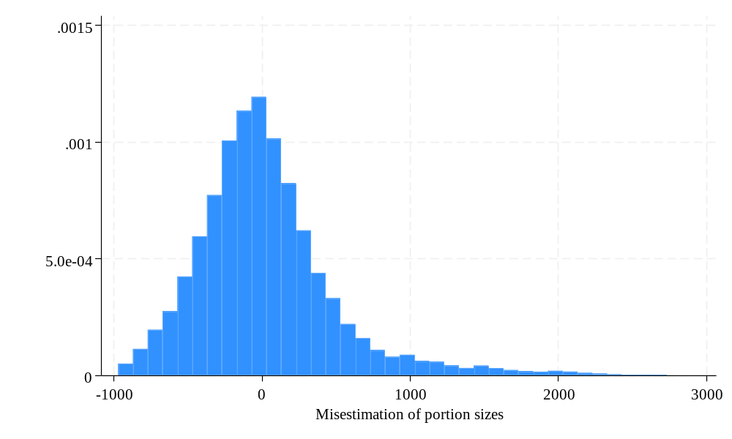
Figure S7 Histogram of Misestimation for all portion sizes
Notes: The figure displays a histogram of all calorie estimations in Study 4. Each participant provided eight estimates for each of the three meals.

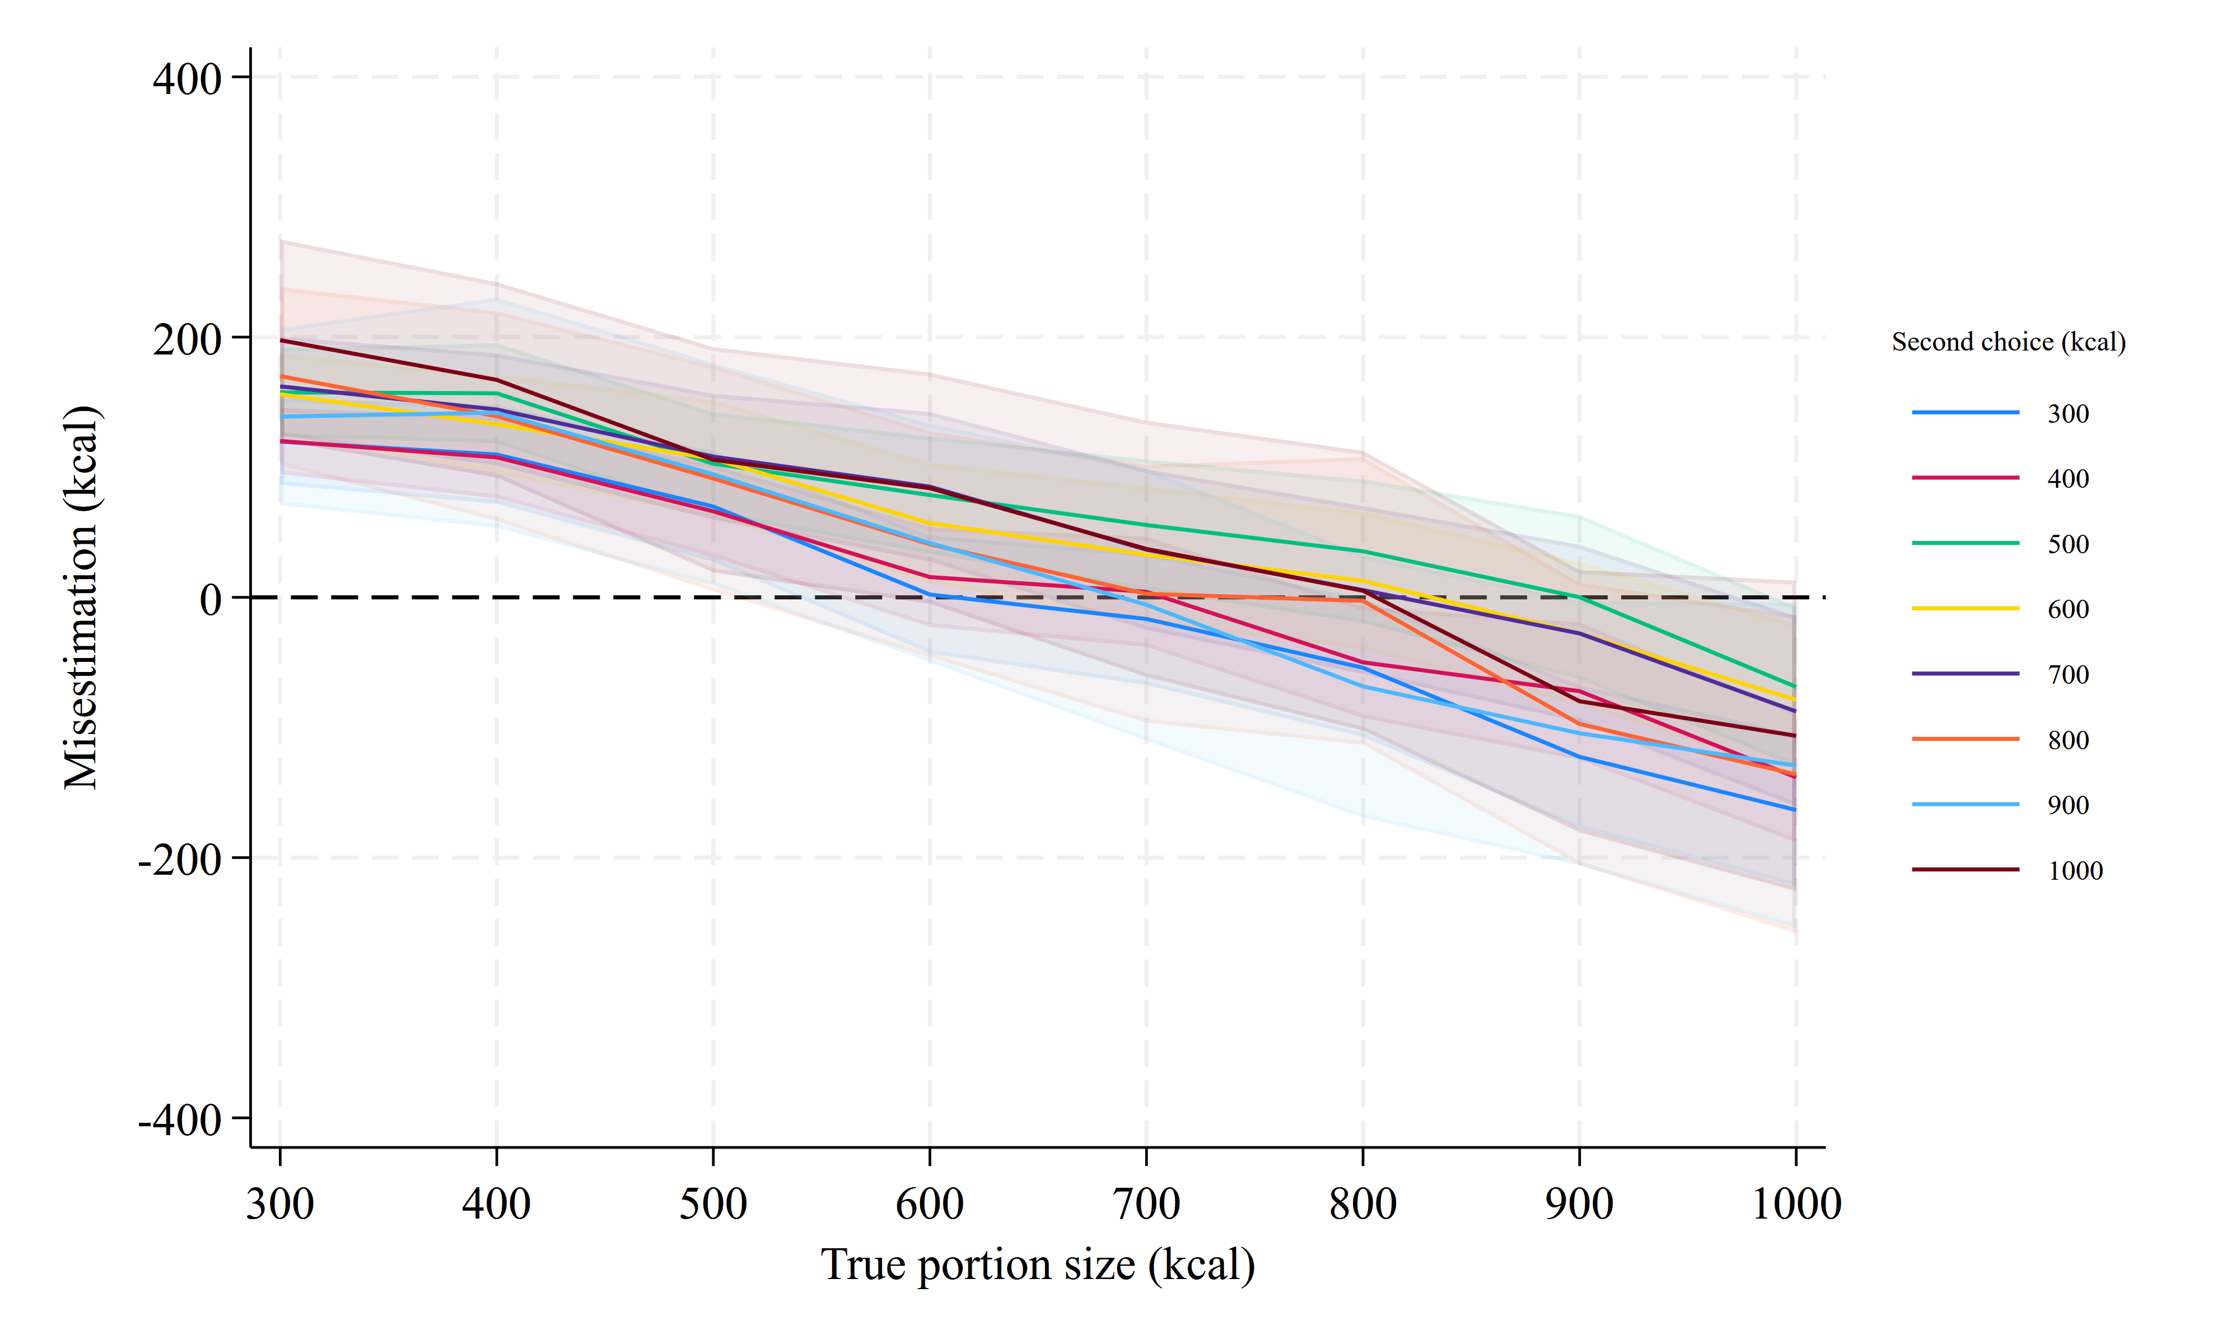
Figure S8 Estimation error by the second choice and Portion size
Notes: Coloured bars indicate the average estimation errors for each portion size (y-axis), grouped by people’s second choice. Shaded area indicates the 95% CIs

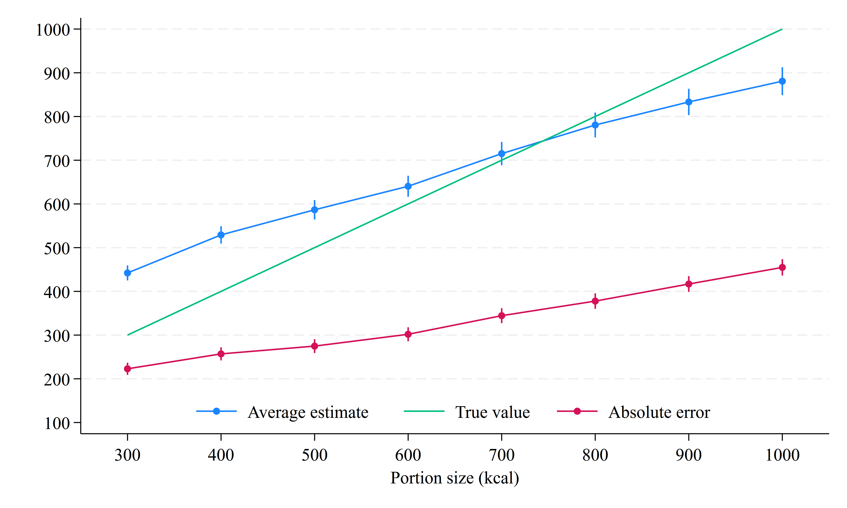
Figure S9 Estimation Error
Notes: The figure displays the relationship between the actual portion size and the average estimate (blue) and the average absolute error (red). Error bars indicate the 95% Cis

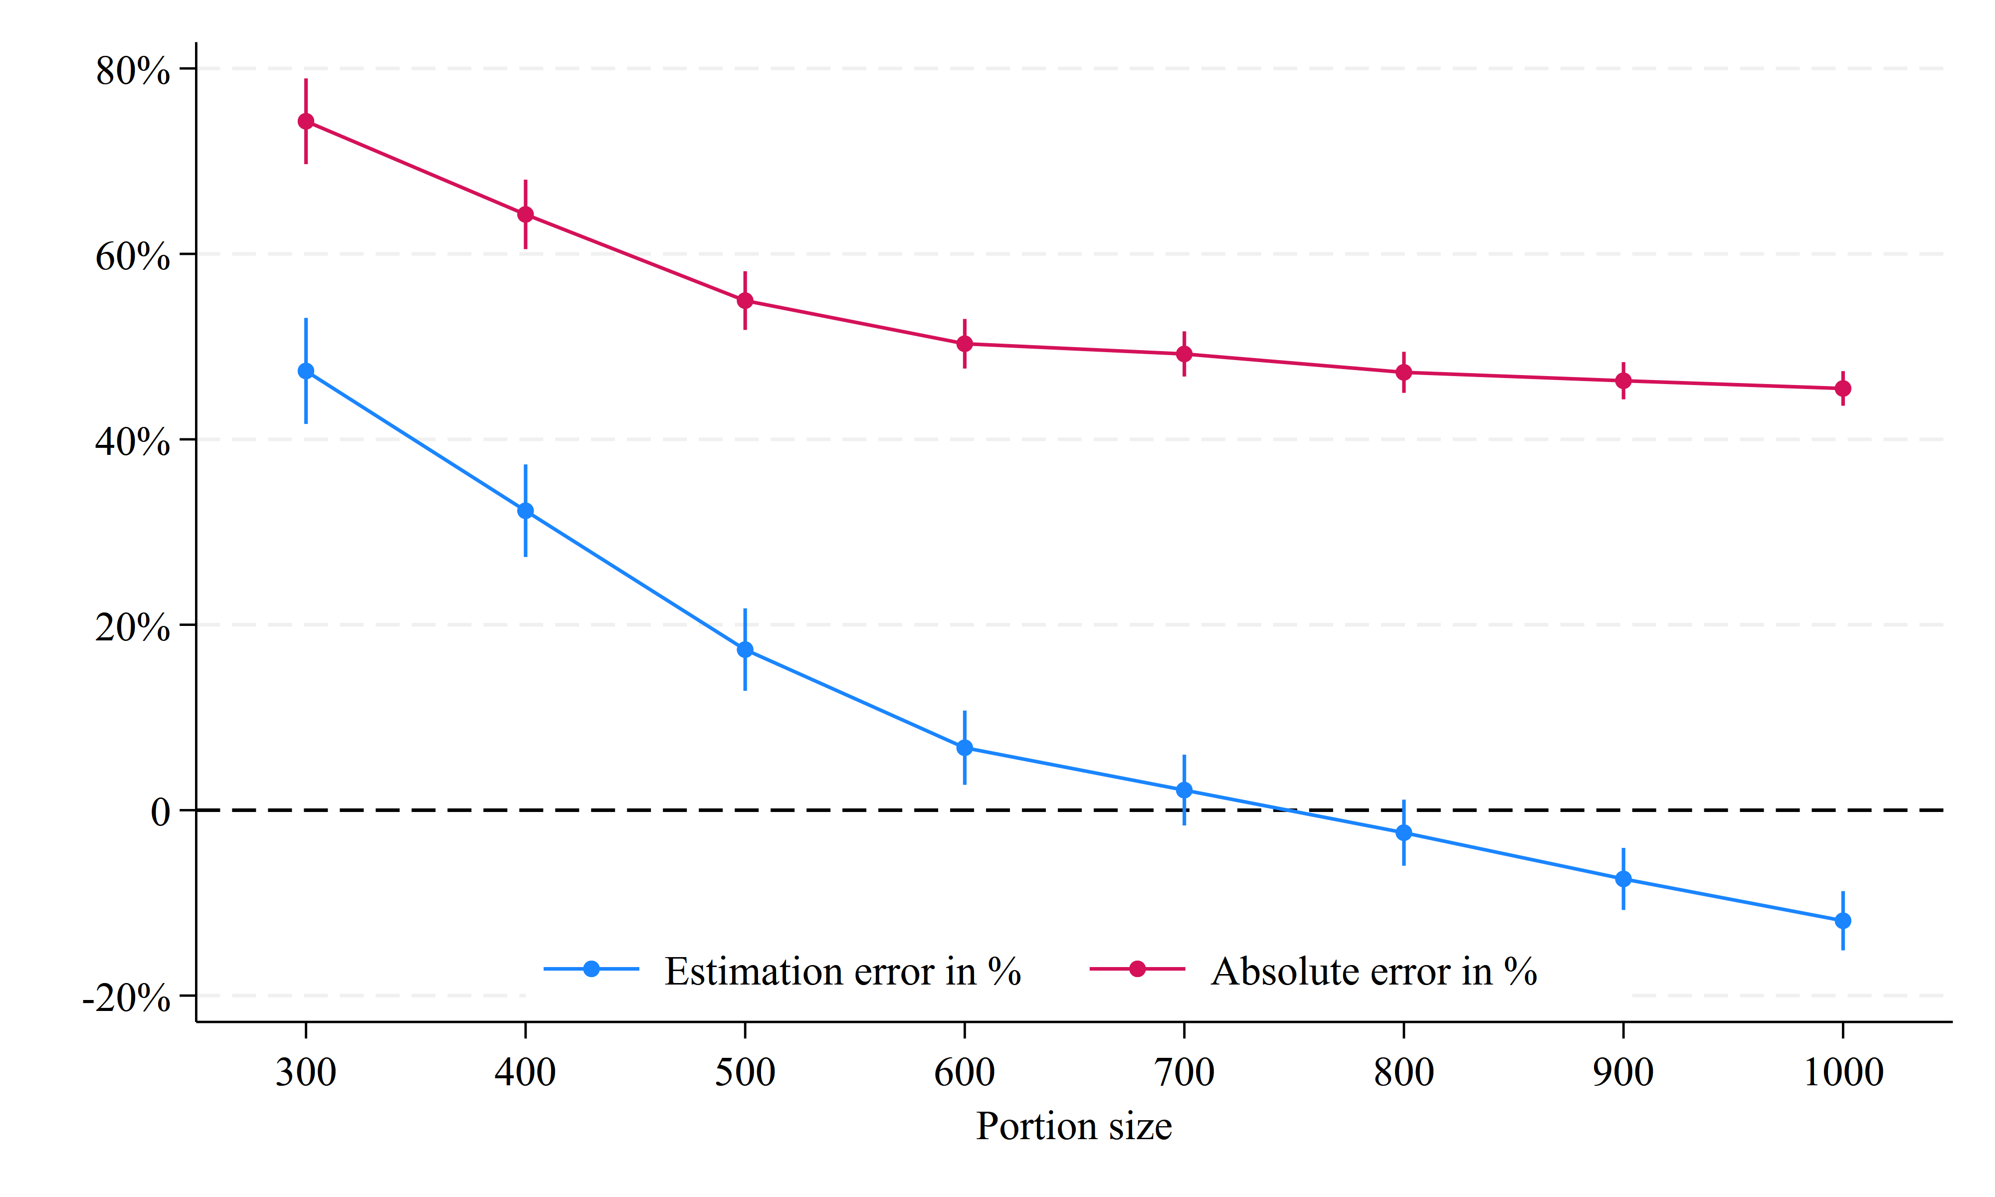
Figure S10 Percentage errors by portion size
Notes: The figure displays the average estimation error in percentage of the actual portion size. Error bars indicate the 95% CIs

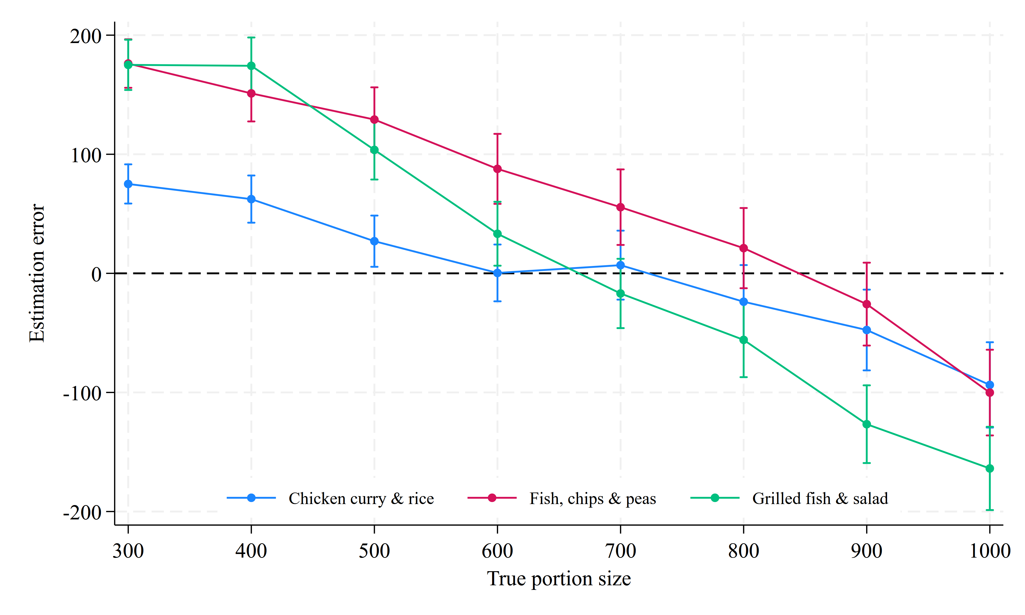
Figure S11 Estimation error by meal and portion size
Notes: The figure displays the average estimation based on portion sizes for each of the three meals. Error bars indicate the 95% CIs

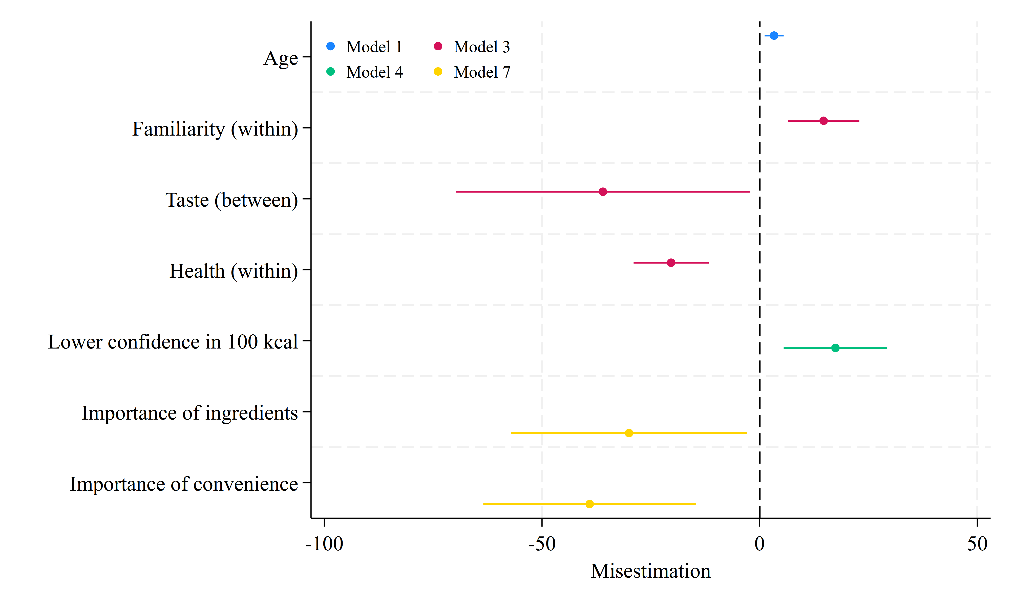
Figure S12 Determinants of Estimation errors
Notes: The figure displays regression results from different models indicated by colour. Error bars indicate the 95% CIs.

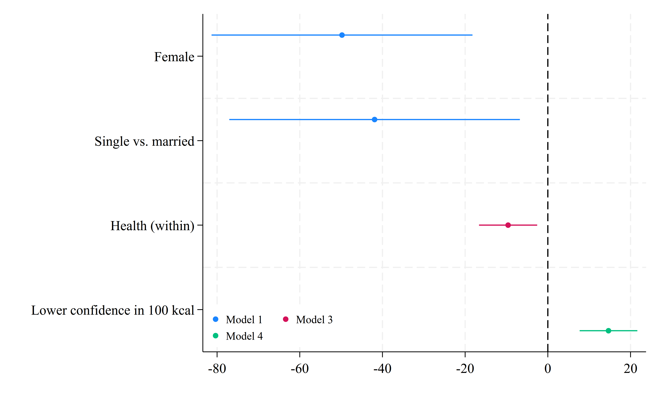
Figure S13 Determinants of Absolute Estimation errors
Notes: The figure displays regression results from different models indicated by colour. Model 2 did not yield any significant results. Error bars indicate the 95% CIs.
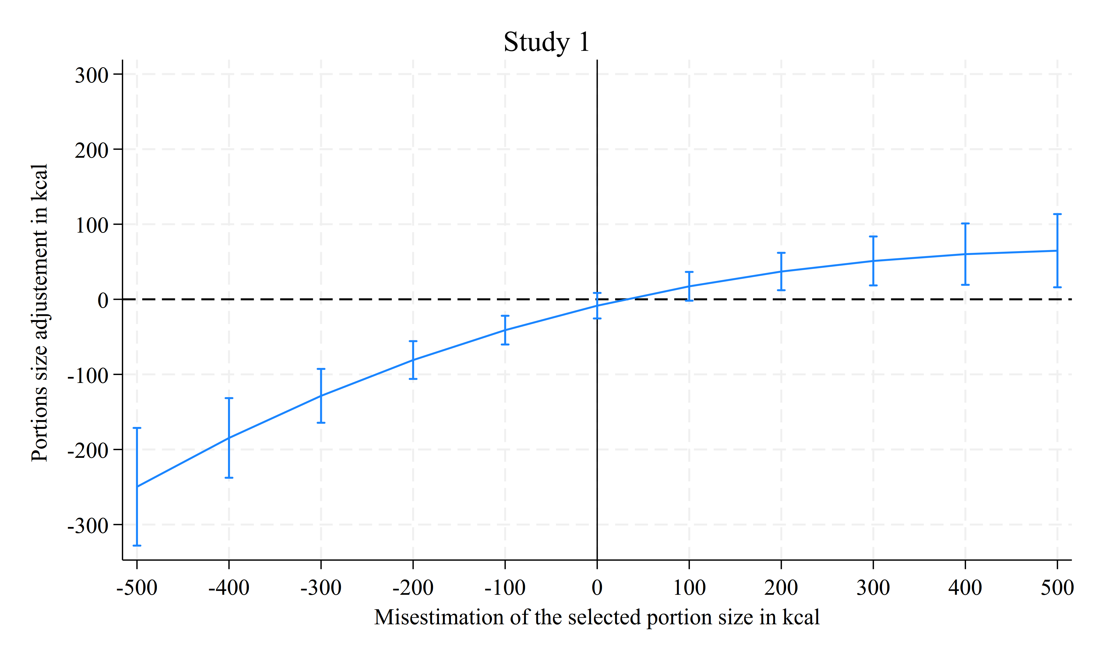 | 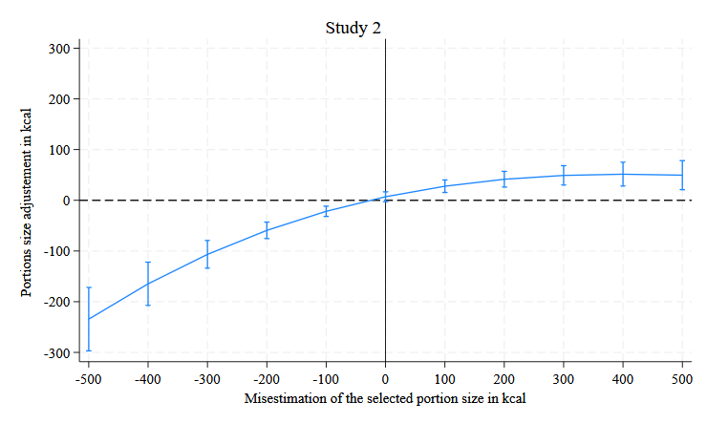
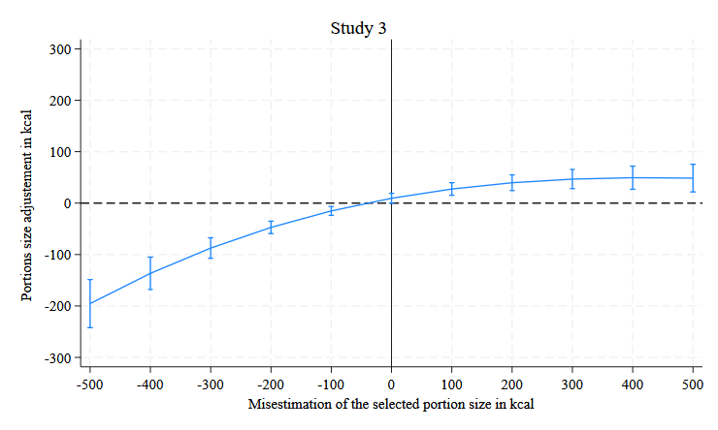 | 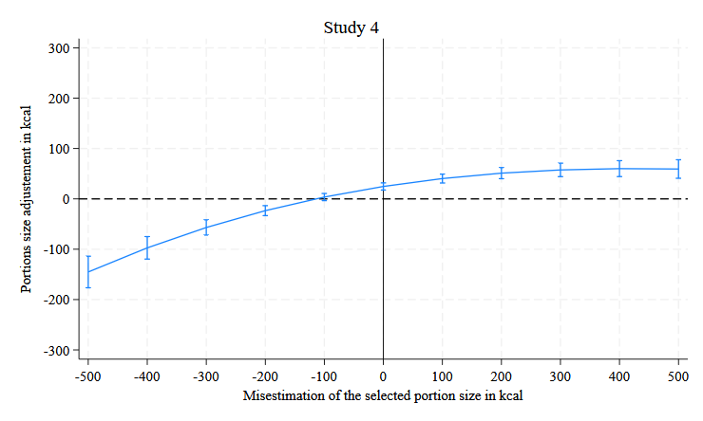
Figure s14 Portion size adjustment and Within-person misestimation across the four studies
Notes: For Studies 1-4, the figure displays the linear predictions from a fixed-effects regression that includes food type and individual fixed effects. The change between the first and second choices serves as the outcome, and the lines represent a third-order polynomial of the estimation error. The analysis pools over the experimental conditions in studies 2 and 3 as they are between-subject effects. Error bars reflect the 95% CIs.

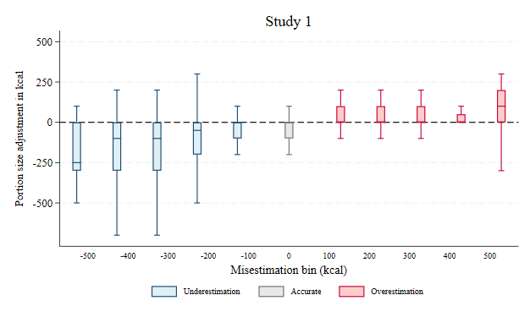 | 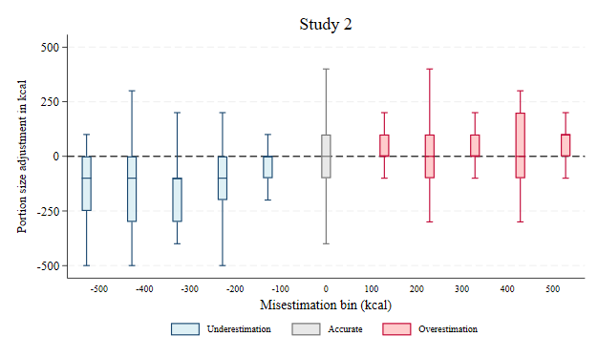
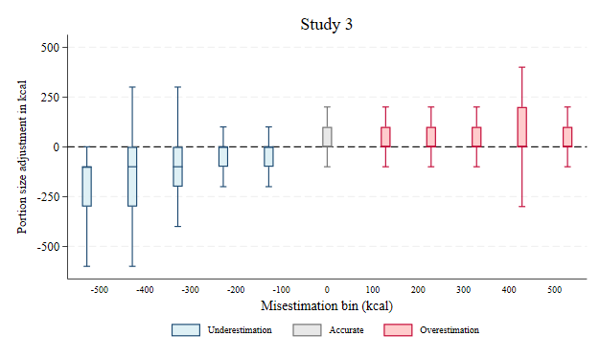 | 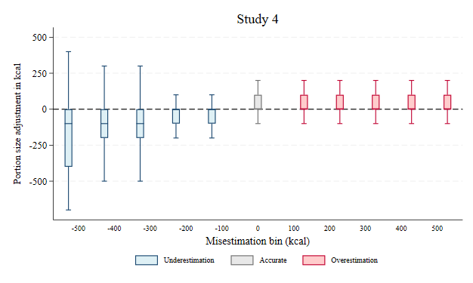
Figure S15. Portion-size adjustment by misestimation bin (Studies 1–4).

Notes: Boxes show the distribution of portion-size adjustments (second minus first choice, in kcal) within 100-kcal misestimation bins centred on the labelled value; negative bins indicate underestimation (blue), positive bins overestimation (red), and the 0-bin estimates accurate to within ±50 kcal (grey). Boxes span the interquartile range with the median marked; whiskers extend to adjacent values; outside values are omitted for readability. The outermost bins (±400, ±500) contain few observations. The figure displays raw data similar to Figure 3.

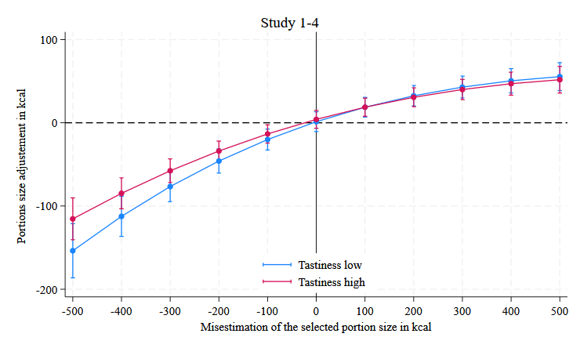
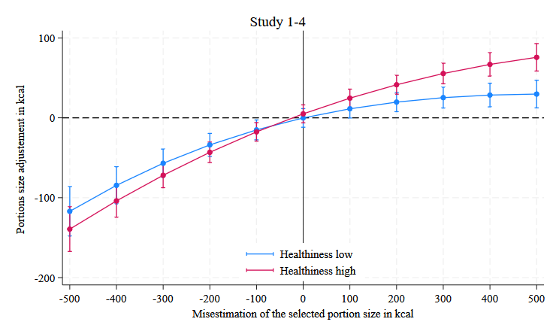
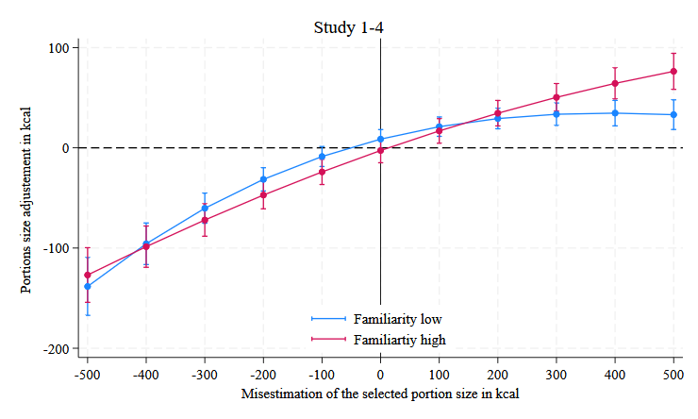
Figure S16 Moderation analysis by food ratings
Notes: The figures display the results of an OLS regression for the change in portion size selection between the first and second portions, based on the misestimation of the portion size selected in the first choice. The lines represent a third-order polynomial of the estimation error. Moderators are measured on a 5-point Likert scale, with low values assigned a rating of 1 and high values assigned a rating of 5. The analysis pools over the experimental conditions in Studies 2 and 3. The regression includes fixed effects for study samples, food types, and experimental conditions. Error bars reflect the 95% CIs.
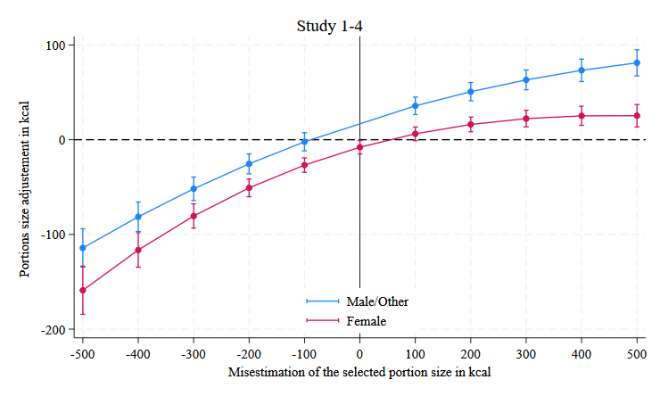
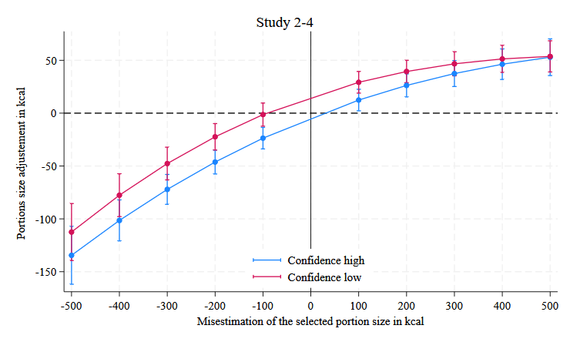
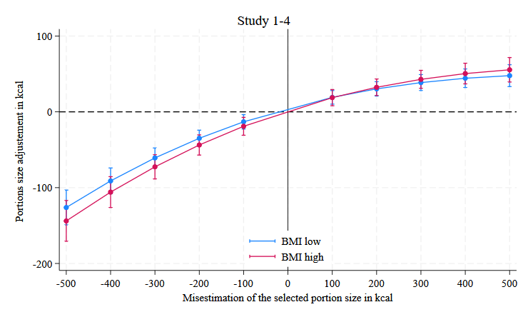
Figure S17 MODERATION ANALYSIS BY Gender, Confidence, and BMI
Notes: The figures display the results of an OLS regression for the change in portion size selection between the first and second portions, based on the misestimation of the portion size selected in the first choice. The lines represent a third-order polynomial of the estimation error. Moderators are plotted as follows: Confidence low = 600 kcal, high = 100 kcal, BMI low = 20, high = 35. The analysis pools over the experimental conditions in Studies 2 and 3. The regression includes fixed effects for study samples, food types, and experimental conditions. Error bars reflect the 95% CIs.

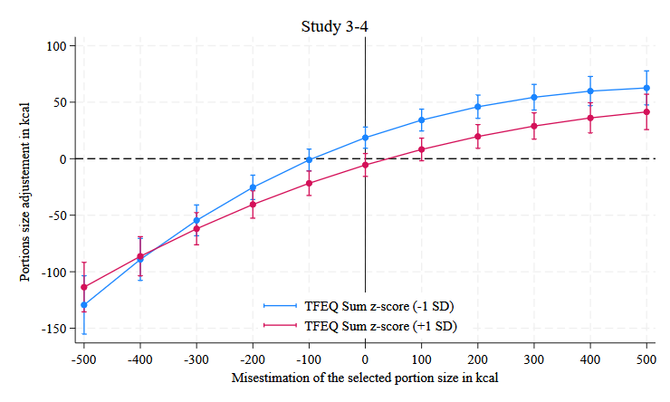
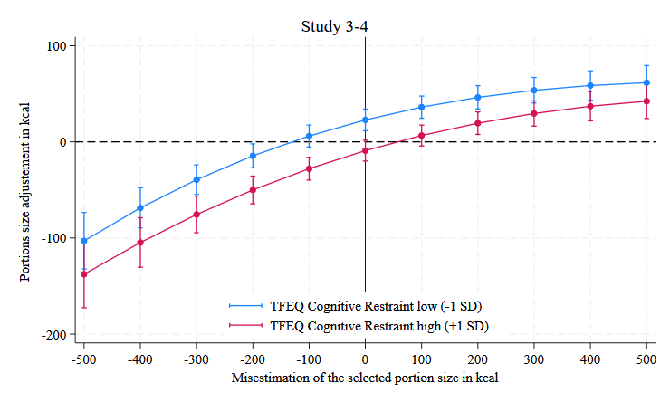
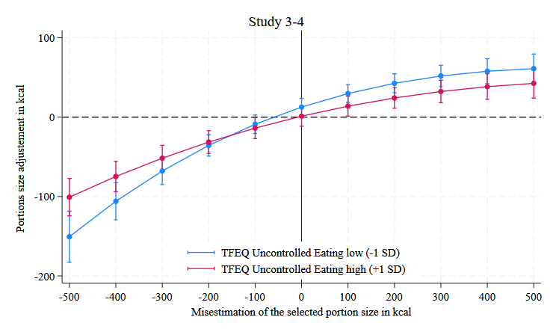
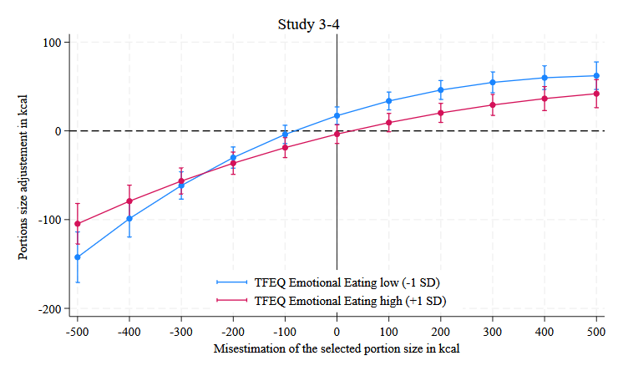
Figure S18 MODERATION ANALYSIS BY Three-factor eating questionnaire
Notes: The figures display the results of an OLS regression for the change in portion size selection between the first and second portions, based on the misestimation of the portion size selected in the first choice. The lines represent a third-order polynomial of the estimation error. Moderators are z-scores plotted as low = -1 SD and high = +1 SD. The analysis pools over the experimental conditions in Studies 2 and 3. The regression includes fixed effects for study samples, food types, and experimental conditions. Error bars reflect the 95% CIs.

Supplementary References

Cappelleri, J. C., Bushmakin, A. G., Gerber, R. A., Leidy, N. K., Sexton, C. C., Lowe, M. R., & Karlsson, J. (2009). Psychometric analysis of the Three-Factor Eating Questionnaire-R21: Results from a large diverse sample of obese and non-obese participants. International Journal of Obesity, 33(6), 611–620. https://doi.org/10.1038/ijo.2009.74
Herman, C. P., & Polivy, J. (1975). Anxiety, restraint, and eating behavior. Journal of Abnormal Psychology, 84(6), 666.
Pula, K., Parks, C. D., & Ross, C. F. (2014). Regulatory focus and food choice motives. Prevention orientation associated with mood, convenience, and familiarity. Appetite, 78, 15–22. https://doi.org/10.1016/j.appet.2014.02.015
Vandegrift, D., Yavas, A., & Brown, P. M. (2007). Incentive effects and overcrowding in tournaments: An experimental analysis. Experimental Economics, 10(4), 345–368. https://doi.org/10.1007/s10683-006-9138-9

