The Ideological Orientation of
Academic Social Science Research 1960 – 2024

SUPPLEMENTARY INFORMATION

Exhibit S1: Analyzed Journals by Discipline

Anthropology
------------
American Anthropologist
American Ethnologist
American Journal of Physical Anthropology
American Journal of Sociology
Anthropological Forum
Anthropological Journal of European Cultures
Anthropological Theory
Anthropology & Education Quarterly
Anthropology & Humanism
Anthropology Now
Anthropology Today
Anthropology and Medicine
Anthropology of Consciousness
Anthropology of Work Review
Anthropology of the Contemporary Middle East and Central Eurasia
Cultural Anthropology
Cultural Studies
Current Anthropology
Diaspora A Journal of Transnational Studies
Ethnography
European Journal of Cultural Studies
Field Methods
Human Ecology
International Journal of Anthropology
International Journal of Cultural Studies
International Social Science Journal
Journal of Anthropological Archaeology
Journal of Anthropological Research
Journal of Comparative Family Studies
Journal of Cultural Geography
Journal of Ethnic and Migration Studies
Journal of Ethnobiology
Journal of Human Evolution
Journal of Political Ecology
Journal of Rural Studies
Journal of Social Archaeology
Journal of the Royal Anthropological Institute
Journal of the Society for the Anthropology of Europe
Medical Anthropology Quarterly
PoLAR Political and Legal Anthropology Review
Social Anthropology
The American Indian Quarterly
The Journal of Latin American and Caribbean Anthropology
The Journal of Modern African Studies
The Journal of Peasant Studies
The Sociological Review
Transcultural Psychiatry
Visual Anthropology
Visual Studies
Women s Studies International Forum

Communications
--------------
Annals of the International Communication Association
Asian Journal of Communication
Communication Culture and Critique
Communication Education
Communication Monographs
Communication Quarterly
Communication Reports
Communication Research
Communication Research Reports
Communication Studies
Communication Theory
Communication and Critical/Cultural Studies
Corporate Communications An International Journal
Critical Studies in Media Communication
Digital Journalism
Discourse Context & Media
First Monday
Health Communication
Human Communication Research
International Journal of Online Marketing
International Journal of Strategic Communication
International journal of communication
Journal of Advertising
Journal of Applied Communication Research
Journal of Broadcasting & Electronic Media
Journal of Communication
Journal of Communication Inquiry
Journal of Communication Management
Journal of Computer-Mediated Communication
Journal of Family Communication
Journal of Health Communication
Journal of Information Technology & Politics
Journal of Interactive Advertising
Journal of Media Ethics
Journal of Media and Communication Studies
Journal of Radio & Audio Media
Journal of Visual Communication and Image Representation
Journalism & Mass Communication Quarterly
Journalism Practice
Journalism Studies
Language & Communication
Mass Communication & Society
Media Culture & Society
Media Psychology
New Media & Society
Southern Communication Journal
Studies in Applied Linguistics and TESOL
The Communication Review
The Information Society
The International Journal on Media Management
Visual Communication

Criminology
-----------
Crime Prevention and Community Safety
Crime Science
Crime and Justice
Criminal Justice Review
Criminal Justice and Behavior
Criminology
European Journal of Criminology
International Journal of Comparative and Applied Criminal Justice
Journal of Contemporary Criminal Justice
Journal of Crime and Justice
Journal of Criminal Justice
Journal of Criminal Psychology
Journal of Criminology and Criminal Law
Journal of Quantitative Criminology
Journal of Research in Crime and Delinquency
Justice Quarterly
Policing-an International Journal of Police Strategies & Management
Victims & Offenders

Economics
---------
American Economic Review
Contemporary Economic Policy
Eastern Economic Journal
Econometric Reviews
Econometrica
Economic Modelling
Economic Policy
Economic Systems
Economics Letters
European Economic Review
Health Economics
International Economic Review
International Review of Economics & Finance
Journal Economic History
Journal of Business and Economic Statistics
Journal of Development Economics
Journal of Economic Behavior & Organization
Journal of Economic Dynamics and Control
Journal of Economic Education
Journal of Economic Issues
Journal of Economic Theory
Journal of Economics
Journal of Environmental Economics and Management
Journal of Health Economics
Journal of Institutional Economics
Journal of International Economics
Journal of Labor Economics
Journal of Macroeconomics
Journal of Monetary Economics
Journal of Political Economy
Journal of Risk and Uncertainty
Letters in Spatial and Resource Sciences
National Tax Journal
Public Choice
Regional Science and Urban Economics
Review of Development Economics
Southern Economic Journal
The Journal of Economic Perspectives
The Quarterly Journal of Economics
The Review of Economic Studies
The Review of Economics and Statistics
World Development

Ethnic Studies
--------------
American Journal of Sociology
American studies
Critical Ethnic Studies
Ethnic and Racial Studies
Ethnic studies review
Ethnicities
Gothic Studies
ISLE Interdisciplinary Studies in Literature and Environment
Journal of Asian American Studies
Journal of Ethnic and Migration Studies
Journal of Hispanic Higher Education
Journal of International and Global Studies
Journal of Multicultural Counseling and Development
Journal of indigenous studies
Latino Studies
Race & Class
Race Ethnicity and Education
The Journal of Race Ethnicity and Politics
The international journal of critical pedagogy

Gender Studies
--------------
Feminism & Psychology
Feminist Studies
Feminist Theory
Gender & History
Gender & Society
Gender Place & Culture
Gender Studies
Gender Technology and Development
Gender Work and Organization
Gender and Education
International Journal of Transgender Health
Journal of Family Issues
Journal of Gay & Lesbian Social Services
Journal of Gender Studies
Journal of Gender and Power
Journal of LGBT Youth
Journal of Lesbian Studies
Journal of women's history
Men and Masculinities
Sex Roles
Sexuality Research and Social Policy
Sexuality and Gender Studies Journal
The Journal of Men s Studies
Women s Studies
Women s Studies International Forum
The journal of gender, race, and justice

Political Science
-----------------
American Journal of Political Science
American Political Science Review
Asian Journal of Political Science
British Journal of Political Science
Comparative Political Studies
Comparative Politics
Critical Review
Democratization
Electoral Studies
European Journal of Political Research
European Political Science Review
Governance
International Organization
International Security
Journal of Conflict Resolution
Journal of European Public Policy
Journal of Peace Research
Journal of Political Economy
Journal of Political Science
Legislative Studies Quarterly
New Political Science
Perspectives on Politics
Political Analysis
Political Behavior
Political Communication
Political Psychology
Political Research Quarterly
Political Science Quarterly
Political Studies
Political Theory
Politics & Gender
Public Choice
Public Opinion Quarterly
Quarterly Journal of Political Science
Research & Politics
Review of International Political Economy
Security Studies
Social Science Quarterly
The Journal of Politics
World Politics

Psychology
----------
Adolescence
American Journal of Orthopsychiatry
American Journal of Psychology
Behavior Research Methods
Cognition
Cognitive Psychology
Cognitive Therapy and Research
Contemporary Clinical Trials
Developmental Psychology
Emotion
Emotion Review
Health Psychology
International Journal of Behavioral Medicine
International Journal of Psychology
Journal of Abnormal Psychology
Journal of Applied Psychology
Journal of Child Psychology and Psychiatry
Journal of Clinical Psychology
Journal of Cognitive Neuroscience
Journal of Consulting and Clinical Psychology
Journal of Educational Psychology
Journal of Educational and Behavioral Statistics
Journal of Experiential Education
Journal of Experimental Psychology General
Journal of Experimental Social Psychology
Journal of Family Psychology
Journal of Health Psychology
Journal of Humanistic Psychology
Journal of Occupational Health Psychology
Journal of Personality Assessment
Journal of Personality and Social Psychology
Journal of Psychopathology and Behavioral Assessment
Journal of the History of the Behavioral Sciences
Memory & Cognition
Neuropsychology
Neuropsychology Review
Personality and Social Psychology Review
Psychological Assessment
Psychological Bulletin
Psychological Methods
Psychological Review
Psychological Science
Psychology of Addictive Behaviors
Psychology of Women Quarterly
Social Psychological and Personality Science
The Counseling Psychologist
Transgender Health

Public Administration
---------------------
Administration & Society
Administrative Science Quarterly
American Journal of Public Health
International Journal of Public Administration
International Journal of Public Administration in the Digital Age
International Journal of Public Sector Management
International Review of Administrative Sciences
Journal of Management Studies
Journal of Policy Analysis and Management
Journal of Public Administration Research and Theory
Journal of Public Affairs
Journal of Urban Affairs
Nonprofit Management and Leadership
Organization Studies
Perspectives on Public Management and Governance
Policy Studies Journal
Public Administration
Public Administration Quarterly
Public Administration Review
Public Budgeting &amp Finance
Public Management Review
Public Organization Review
Public Performance & Management Review
Public Policy and Administration
Review of Public Personnel Administration
The American Review of Public Administration
Urban Affairs Review

Public Health
-------------
American Journal of Preventive Medicine
American Journal of Public Health
BMC Public Health
Critical Public Health
European Journal of Public Health
Global Health Action
Global Public Health
Health & Place
Health Affairs
Health Promotion International
International Journal for Equity in Health
International Journal of Epidemiology
International Journal of Public Health
Journal of Community Health
Journal of Public Health
Journal of Public Health Management and Practice
Journal of Public Health Policy
Journal of epidemiology and community health
Preventive Medicine
Public Health
Public Health Ethics
Public Health Nutrition
Public Health Reports
Social Science & Medicine

Sociology
---------
American Journal of Community Psychology
American Journal of Sociology
American Sociological Review
Critical Sociology
Cultural Sociology
European Sociological Review
Feminist Theory
International Journal of Comparative Sociology
International Journal of Sociology
Journal for the Theory of Social Behaviour
Journal of Family Issues
Journal of Marriage and Family
Journal of Social Issues
Journal of Sociology
Journal of international women's studies
Qualitative Sociology
Research in Social Stratification and Mobility
Review of Sociology
Social Forces
Social Problems
Social Psychology Quarterly
Social Science Research
Sociological Methods & Research
Sociological Perspectives
Sociological Quarterly
Sociology Compass
Sociology of Education
Sociology of Health & Illness
Sociology of Race and Ethnicity
Sociology of Religion
Socius Sociological Research for a Dynamic World
The Sociological Review
Theory and Society

Exhibit S2: Definition and Anchors for Political Stance Scores with Rationales and Confidence
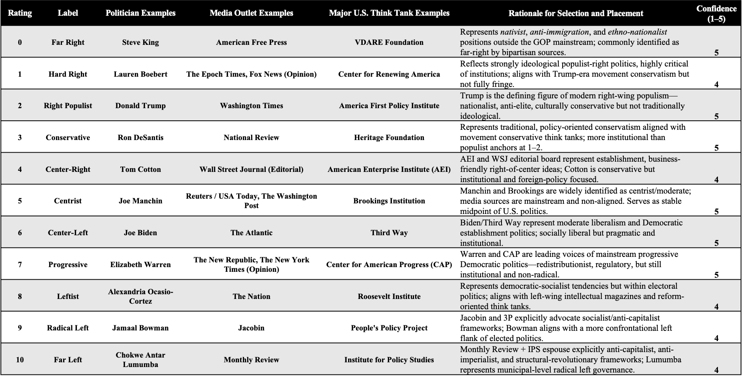

Exhibit S3: GPT-4o System Instructions and Full Prompt
System Instructions:
"You are a politically neutral assistant. Your task is to rate academic abstracts based on political orientation.\n"
"When a prompt instructs you to use the 0–10 political spectrum, use the following U.S.-based definitions as of the year 2025:\n"
"0 = Far Right (Steve King, VDARE), "
"1 = Hard Right (Lauren Boebert), "
"2 = Right Populist (Donald Trump), "
"3 = Conservative (Ron DeSantis, National Review), "
"4 = Center-Right (Tom Cotton, AEI), "
"5 = Centrist (Joe Manchin, Reuters), "
"6 = Center-Left (Joe Biden, The Atlantic), "
"7 = Progressive (Elizabeth Warren, NYT Opinion), "
"8 = Leftist (AOC, The Nation), "
"9 = Radical Left (Jamaal Bowman, Jacobin), "
"10 = Far Left (Chokwe Lumumba, Institute for Policy Studies).\n"
"Only use this 2025 scale when explicitly asked."
)
completion = client.chat.completions.create(
model=gpt-4o,
messages=[
{"role": "system", "content": scale_guide},
{"role": "user", "content": prompt}
]
temperature=0,
top_p=1

Full Prompt:
Answer the following questions. For each, return only:

Answer: [your answer]
Confidence: [0–100]

Do not repeat the questions or provide any explanations. Just list five answer–confidence pairs in this exact format.

1. Is the abstract directly relevant to any political or social debates in the United States in 2025?
Answer with 'yes' or 'no'.

2. Based on the fixed 2025 U.S. political spectrum defined in your system instructions, where would you place the position taken in the abstract?
Answer with an integer from 0 (far right) to 10 (far left) using the 2025 anchor definitions.

3. According to the same 2025 political spectrum, would accepting the content of the abstract as true generally align with the political right or the political left in the United States?
Answer with 'right' or 'left'.

4. On the 2025 U.S. political spectrum, where would the abstract fall with respect to economic issues?
Answer with an integer from 0 (far right) to 10 (far left).

5. On the 2025 U.S. political spectrum, where would the abstract fall with respect to social or cultural issues?
Answer with an integer from 0 (far right) to 10 (far left).
Exhibit S4: Discipline Weighting Calculations
Corpus definition
All stance estimates were computed from a universe of works drawn from the February 27, 2025 OpenAlex snapshot. Records were retained if they satisfy the following criteria:
(1) item type is journal article,
(2) English-language record,
(3) publication year between 1960 and 2024 (inclusive),
(4) a deposited abstract is present (non-null),
(5) the associated journal has at least one discipline assignment as defined below.
Works without abstracts were excluded from stance estimation and from all bootstrap procedures.
Journal-to-discipline mapping
Discipline assignments were derived from OpenAlex x_concepts metadata at the journal level. A journal was assigned to a discipline if any of its concept labels match a predefined social-science domain (e.g., sociology, economics, political science, psychology, gender studies, anthropology). Matching was string-based and case-insensitive. A journal may have mapped to multiple disciplines, and each work inherited all discipline labels associated with its journal. No normalization or fractional weighting was applied at the mapping stage.
Discipline-level stance estimates
Discipline-level stance values were computed from LLM scores assigned to abstracts. If a journal mapped to k disciplines, each abstract from that journal was assigned a weight of 1/k when computing discipline-level estimates. For each discipline–year cell, the stance value was the weighted mean of abstract-level stance scores using these 1/k weights. This fractional weighting was used only in the calculation of discipline–year stance estimates. Discipline–year cells with fewer than 50 effective papers after fractional assignment were excluded from all discipline-level time series.
Annual discipline proportions
Discipline proportions were calculated from a separate universe of works assembled from the same OpenAlex snapshot, using the same inclusion criteria except for the requirement that an abstract be deposited. For sizing purposes, articles were retained whether or not an abstract was available. For each calendar year, the number of qualifying works associated with each discipline was counted. If a journal mapped to multiple disciplines, each work was counted in each mapped discipline with no fractional division. Annual discipline proportions were the ratio of a discipline’s count to the total count of qualifying works across all disciplines in that year. These annual proportions are shown in SI Figure S1. These annual proportions are used only to weight discipline-level stance estimates when constructing the aggregate time series shown in Figures 6 and 7 and robustness analyses; they do not modify stance scores or discipline-specific trajectories.
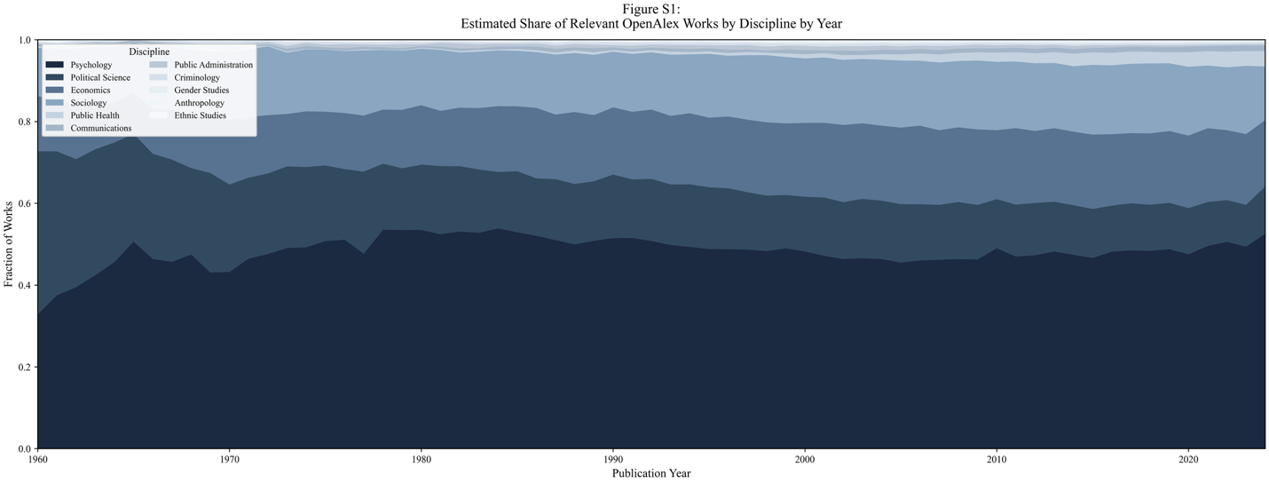
Aggregate annual series
For specifications that combine disciplines, the yearly aggregate stance was computed by multiplying each discipline’s stance estimate by its corresponding discipline proportion and summing across disciplines. Discipline-specific series did not use this aggregation step.
Bootstrap resampling and smoothing
Uncertainty was assessed by bootstrap resampling at the abstract level. Resampling was performed independently within each discipline–year cell. Each bootstrap replicate followed these steps:
- sample abstracts with replacement within each discipline–year cell,
- recompute discipline–year stance estimates using the same 1/k weighting,
- if using the aggregate series, multiply recomputed discipline means by the fixed annual proportions and sum across disciplines,
- smooth the resulting annual series using the LOWESS configuration employed in the analysis (span = 0.20, no robust iterations).
Confidence bands
A total of 500 bootstrap replicates were generated. After smoothing, for each year the 2.5th and 97.5th percentiles of the replicate values were taken across bootstraps. These percentiles defined the confidence interval band. Annual discipline proportions remained fixed for all bootstrap iterations and were not resampled.

Exhibit S5: Analysis of Papers With and Without US Authors
Results are displayed for all papers, papers with at least one author affiliated with a US institution (‘US-Only’), and papers with no author associated with any US institution.
