Supplement S1

Model Extensions and Robustness Analyses

Supplement S1 — Model Extensions and Robustness Analyses
The primary model (main text §3.3) uses a single latent-risk term, a two-component additive lethality (λ_any + λ_viol·r_i), and a single behavioral-attenuation scalar ψ. The sensitivity extensions summarized in §4.4 of the main text generalize each of these; their full setup and results are reported here. Each extension reduces to the primary specification at identity parameter values. The three extensions answering concerns on decomposed risk, institutional lethality, and decomposed offsets are summarized graphically in Figure S1.

S1.1 Decomposed risk vector (r_sel, r_enc, r_leth)
To assess whether the avertogenic effect depends on the assumption that selection, encounter, and lethality risks share a common latent factor, we re-implement the model with a three-dimensional risk vector (rsel,i, renc,i, rleth,i) governing selection, encounter intensity, and per-encounter lethality, respectively, with a Gaussian copula on the standard-normal latent scale specifying the pairwise dependence among the three components. Each component preserves the same marginal mixture distribution defined in §3.3.1, so the calibration of α is unchanged. The central specification corresponds to perfect correlation (rsel,i = renc,i = rleth,i), reducing to the single-r model used throughout the primary results.
We consider four alternative dependence structures alongside the central perfect-correlation case: weakening only the selection–lethality coupling (ρsel,leth = 0.3, ρsel,enc = ρenc,leth = 0.7); weakening only selection–encounter (ρsel,enc = 0.3, others = 0.7); weakening only encounter–lethality (ρenc,leth = 0.3, others = 0.7); and all weak (all ρ = 0.3). At Δ𝛼 = 0.5, mean avertogenic deaths range from 36.7 (weak ρenc,leth) to 42.0 (weak ρsel,leth), compared to 35.5 in the central specification. Weakening any cross-correlation modestly increases the estimate. The mechanism is that the marginal-released cohort under the central α-calibration is concentrated near rsel ≈ 0.2 (the low-class peak of the mixture); under decoupling, those individuals’ rleth is drawn from the full marginal distribution rather than co-varying with their low rsel, so a fraction inherit high-class rleth and contribute disproportionately to lethality. The single-r specification is therefore conservative with respect to this dimension of model uncertainty.
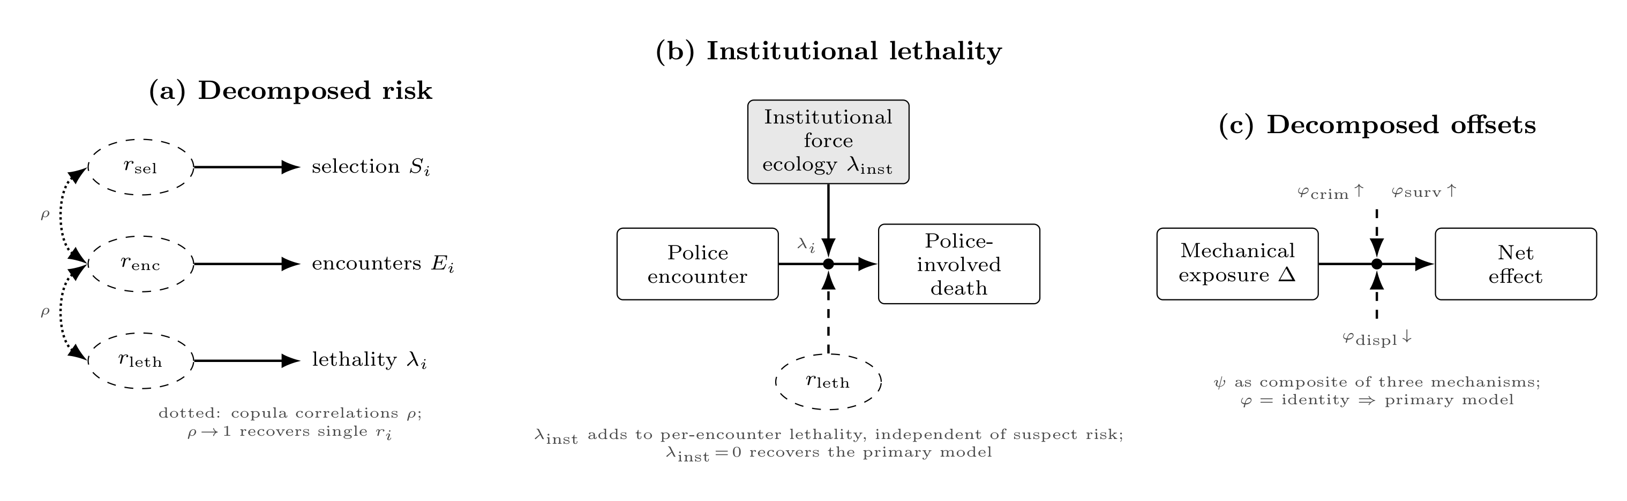
Figure S1. Model extensions used in the sensitivity analyses. Each panel depicts an extension of the primary specification that reduces to it at identity parameter values. (a) Decomposed risk: latent risk r_i is split into three correlated components (r_sel, r_enc, and r_leth) governing incarceration selection, encounter intensity, and per-encounter lethality, respectively; dotted arcs denote latent correlations on the Gaussian-copula scale, and ρ → 1 recovers the single-r_i specification (S1.1). (b) Institutional lethality: an additive per-encounter term λ_inst captures contributions to lethal force that are independent of suspect risk (e.g., the responding agency’s force ecology), so that λ_i = λ_any + λ_viol·r_leth + λ_inst; λ_inst = 0 recovers the primary model (S1.4). (c) Decomposed offsets: the behavioral attenuation ψ is decomposed into three mechanistic scalars: displacement (φ_displ), criminogenic amplification (φ_crim), and surveillance-driven encounter amplification (φ_surv), acting on the marginal-released cohort; φ = identity recovers the primary model (S1.5).

S1.2 Risk-targeted decarceration policy
The risk-neutral logistic intercept shift used throughout the primary grid is one of several plausible models of how decarceration policies operate. Sentencing reform, diversion programs, and early-release initiatives in practice target individuals near sentencing thresholds, drawing the marginal released population from the lower tail of the risk distribution (at least, in theory). We implement two risk-targeted counterfactuals: (i) a continuous variant in which the policy shift is δi = Δ𝛼 · g(ri) with g(ri) = exp(−κ · ri), normalized so the cohort-average shift equals Δ𝛼; and (ii) a ranked-release variant that releases the lowest-r individuals among those who would be incarcerated under baseline, matching the count of marginal-released under the risk-neutral policy at the same Δ𝛼. At Δ𝛼 = 0.5, mean avertogenic deaths fall from 35.5 (risk-neutral) to 28.1 (continuous targeting, κ = 2.5) to 13.6 (ranked release). The pattern is monotonic with respect to (assumed accurate) targeting strength. The avertogenic effect persists, but more aggressive low-risk targeting attenuates it because the marginally released cohort is progressively drawn from lower-risk subpopulations than under risk-neutral release.

S1.3 Force-funnel test: λ_viol = 0
We test whether the avertogenic effect depends on the assumption that per-encounter lethality is coupled to individual risk by setting λviol = 0. Under this specification, per-encounter lethality is constant at λany = 5 × 10−5 regardless of suspect characteristics, and the avertogenic mechanism operates entirely through differential time at risk and the elevated-encounter V mechanism. At Δ𝛼 = 0.5, mean avertogenic deaths fall from 35.5 (central λviol = 4 × 10−4) to 18.1 (λviol = 1 × 10−4) to 11.9 (λviol = 0). The effect persists even with no individual-risk lethality coupling, indicating that the encounter-rate channel alone supports the qualitative claim.

S1.4 Institutional lethality and concurrent reform
We add an institutional per-encounter lethality term λinst that enters lethality additively,
$$λ_{i}=λ_{\text{any}}+λ_{\text{viol}}⋅r_{i}+λ_{\text{inst}},$$
constant across individuals, capturing contributions from force-toolkit availability, de-escalation training, and tactical posture (Neil et al., 2025; Stoughton et al., 2021); it may differ between baseline and policy regimes. We anchor λinst,base = 7.5 × 10−6, exactly 15% of λany = 5 × 10−5. The choice of fraction is exploratory rather than empirically derived: institutional contributions to per-encounter lethality cannot be cleanly separated from suspect and situational factors in available data. Under a concurrent reform scenario (e.g., revised force-toolkit availability, de-escalation training, tactical posture) in which λinst falls by 30% under the policy regime, institutional reform offsets part of the avertogenic effect: at Δ𝛼 = 0.5 the net avertogenic effect falls from 35.5 to 20.2 deaths over the cohort horizon. Under a lower-offset scenario (15% reduction in λinst), the net effect at Δ𝛼 = 0.5 is 28.6. Institutional reform partially offsets the avertogenic effect of decarceration but does not reverse it under defensible parameter values.

S1.5 Decomposed behavioral mechanisms (φ_displ, φ_crim, φ_surv)
The behavioral attenuation parameter ψ aggregates distinct mechanisms that may push in different directions (§3.3.5). We decompose ψ into three mechanistic scalars, each calibrated so that its identity value reproduces the central specification:
- φdispl ∈ [0, 1] (displacement): the fraction of the marginal-released cohort’s encounters that occur in the community rather than being absorbed by other actors. φdispl = 1 (identity) means no displacement; φdispl = 0.85 corresponds to 15% displacement; φdispl = 0.75 to 25%.
- φcrim ≥ 0 (criminogenic amplification): the proportional increase in rleth for currently-incarcerated individuals attributable to incarceration itself. φcrim = 0 (identity) means no amplification; φcrim = 0.30 means rleth is 30% higher for that subset.
- φsurv ≥ 0 (surveillance-driven encounter amplification): the proportional increase in encounter intensity for the marginal-released cohort under the policy regime relative to baseline. φsurv = 0 (identity) means no amplification; φsurv = 0.30 corresponds to 30%; φsurv = 0.50 to 50%.
The central specification (φdispl = 1, φcrim = 0, φsurv = 0) reproduces the primary results. Activating each mechanism individually at Δ𝛼 = 0.5 and otherwise central parameters yields, relative to the central 35.5 expected deaths: φdispl = 0.85 → 15.1; φdispl = 0.75 → 1.4; φcrim = 0.30 → 15.6; φsurv = 0.30 → 76.5; φsurv = 0.50 → 104.1. Displacement and criminogenic amplification reduce the avertogenic effect; surveillance amplification raises it. Under simultaneous moderate values of all three (φdispl = 0.85, φcrim = 0.30, φsurv = 0.30), the net effect at Δ𝛼 = 0.5 is 29.9, slightly below the central 35.5, indicating partial cancellation. The decomposition shows that the ψ scalar summarizes a balance of mechanisms with opposing directional contributions, none of which dominates at moderate parameter values.

