ELECTRONIC APPENDIXES

A1 – Data
Three data sources have been used to create our dataset:
1) The first is the ASIA database of the Italian National Statistical Office (ISTAT), which contains information on the structural characteristics of the population of Italian companies. From this source we retrieved information related to the industrial sector, the number of employees and the date of birth for the population of Italian business firms over the period of 2000-2011. Due to the data availability of the other relevant data sources (see Table 1), we restricted the period of interest to 2000-2008. Moreover, building upon other firm-level studies (Geroski et al., 2010; Mata and Portugal, 2002; Coad and Rao, 2011), we considered a firm to have ceased operation if absent from the records for three consecutive years.
2) Our second source of data refers to balance sheet information, obtained from the Bureau van Dijk AIDA database for the period of 2000-2008 and is used to retrieve the: investments in tangible assets, investments in intangible assets and market shares.
3) Finally, following previous studies in the analysis of eco-innovations (see, among the others, Lotti & Marin, 2013; Marin, 2014), we relied on the Worldwide Patent Statistical Database (PATSTAT) to retrieve patent data information for the names of the assignees, filing dates and technological classes.

A2 – Methodology
In general, the distribution of growth rates at the firm level is recognised to be highly non-linear and considerably heavy-tailed. Thus a quantile approach could provide more robust and efficient alternatives to OLS when the error term is non-normal, and in the presence of outliers and fat-tails.
Our empirical setting is not an exemption from the pattern outlined above. The distribution of growth rates (defined in Section 3.3) reveals this non-normality nature, showing a kurtosis well above the accepted threshold value of three (our null hypothesis of a kurtosis equal to zero is rejected at the 99% confidence level).
Further support for this pattern is provided by Figure A1 and Figure A2. Figure A1 illustrates that growth rates for our sample of companies is exponentially distributed (Stanley et al., 1996), therefore showing a tent-shape distribution (Bottazzi and Secchi, 2003). Figure A2, plotting the quantiles of the growth variable against the quantiles of a normal distribution, shows that growth rates deviate from a normal distribution both at the upper and lower tails.
The quantile approach is then motivated in order to overcome the distributional issues discussed above.
[FIGURE A1 ABOUT HERE]
[FIGURE A2 ABOUT HERE]

A3 - Variables
Dependent variable: Growth_{it}.
Following previous contributions (Coad and Rao, 2006; Coad, 2010), the growth rate of employees has been calculated as the difference between the logarithm of employees in year t and the logarithm of employees in year t-1. To remove common time trends for firms operating in the same sector (e.g., inflation, business cycles, etc.), we normalised growth rates, subtracting for each year the sectoral mean growth rate at the 2-digit NACE (Rev. 1.1) codes (Bottazzi et al., 2011; Coad and Rao, 2010). We also run the estimates using non-normalised growth rates and growth rates normalised to 4-digit NACE (Rev. 1.1) industry codes. All attempts (available from the authors upon request) yield results that are not qualitatively different from those presented here.
Independent variables: Pat Green_{it-1} and Pat Nongreen_{i,t-1}
Following Marin and Lotti (2016), green patents are identified by relying on two sources: the classification provided by the OECD (2015) project on “Environmental Policy and Technological Innovation” (ENV-TECH); the IPC Green Inventory, launched by the World Organisation for Intellectual Property (WIPO). Both ENV-TECH and IPC Green Inventory define a list of technological classes that correspond to environmentally sound technologies. In our analysis, we define as green patent every patent with at least one technological class, which is included in the OECD or WIPO classifications. The WIPO classification may include classes of green technologies that are too broad and that require to be addressed. In this last respect, following Marin and Lotti (2016), we exclude IPC Green Inventory falling into the four technological realms. IPC Green Inventory classes related to “biofuel” in fact include many non-environmental technologies. Patents related to “agriculture and forestry” are excluded because of our focus on manufacturing firms. The “Administrative, regulatory and design aspects” macro-category includes sub-categories which are too general and not necessarily related to environmental technologies. Patents related to “nuclear power generation” are excluded because Italy opted out from nuclear energy production in the aftermath of the Chernobyl disaster. In addition, some nuclear activities may in fact be harmful for the environment. In brief, the approach we follow is aimed at reducing the risk of having false negatives when identifying green patents. Table A2 lists all the classes that identify green patents.
[TABLE A2 ABOUT HERE]
Both Pat Green and Pat Nongreen have been calculated as stocks. In particular, we followed the literature and computed all of the stock variables for the period of 2000-2008 using the perpetual inventory method formula, K_{t} = K_{t−1}(1 − δ) + P_{t}, where K_{t-1} is the stock of patents at year t-1, δ is the depreciation rate assumed constant at 15% (Blundell et al., 1995; Hall, 1993), and P_{t} is the number of new patents in year t. More precisely, patent stocks have been computed using information for the whole period for which patent data are available (1977-2008).
Control variables
Inv Tang_{i,t-1} (Inv Intang_{i,t-1}) is calculated as the yearly net acquisition of tangible (intangible) assets plus the amortisation (Grazzi et al., 2015). Investments are deflated by adopting the ratio of current prices to chained-linked prices (reference year 2005) at the higher level of disaggregation, as provided by the Italian National Institute of Statistics (ISTAT) at the NACE 1.1 2-digit industrial level. Investment indicators are measured in thousands of euros, and like the number of employees (Emp_{t-1}), they are log transformed (plus 1).
Herfindahl index_{jt} is the sum of the square of the turnover shares of firms operating in (at 2-digit NACE Rev. 1.1 codes) industry j at time t.

Table A1. t-test comparison between sample (N=30,670) and population (N= 5,787,897)
Variable | Mean difference
Growth | -0.003
Emp | 0.612***
Age | 2.744***
Emp and Age variables are log transformed.
*P<0.1, **P<0.05, ***P<0.01.

Table A2. Technological classes for environmental patents
 | Description | IPC/ECLA Class
General environmental management | Air pollution abatement | BO1D46, B01D47, B01D49, B01D50, B01D51, B01D53/34-72, B03C3, C10L10/02, C10L10/06, C21B7/22, C21C5/38, F01N3, F01N5, F01N7, F01N9, F23B80, F23C9, F23G7/06, F23J15, F27B1/18
General environmental management | Water pollution abatement | B63J4, C02F, C05F7, C09K3/32, E02B15/04-06, E02B15/10, E03B3, E03C1/12, E03F
General environmental management | Solid waste collection | E01H15, B65F
General environmental management | Material recovery, recycling and re-use | A23K1806-10, A43B1/12, A43B21/14, B03B9/06, B22F8, B29B7/66, B29B17, B30B9/32, B62D67, B65H73, B65D65/46, C03B1/02, C03C6/02, C03C6/08, C04B7/24-30, C04B11/26, C04B18/04-10, C04B33/132, C08J11, C09K11/01, C10M175, C22B7, C22B19/28-30, C22B25/06, D01G11, D21B1/08-10, D21B1/32, D21C5/02, D21H17/01, H01B15/00, H01J9/52, H01M6/52, H01M10/54
General environmental management | Fertilizers from waste | C05F1, C05F5, C05F7, C05F9, C05F17
General environmental management | Incineration and energy recovery | C10L5/46-48, F23G5, F23G7
General environmental management | Waste management n.e.c. | B09B, C10G1/10, A61L11
General environmental management | Soil remediation | B09C
General environmental management | Environmental monitoring | F01N11, G08B21/12-14
Energy generation from renewable and non-fossil sources | Wind energy | Y02E10/7
Energy generation from renewable and non-fossil sources | Solar thermal energy | Y02E10/4
Energy generation from renewable and non-fossil sources | Solar photovoltaic (PV) energy | Y02E10/5
Energy generation from renewable and non-fossil sources | Solar thermal-PV hybrids | Y02E10/6
Energy generation from renewable and non-fossil sources | Geothermal energy | Y02E10/1
Energy generation from renewable and non-fossil sources | Marine energy | Y02E10/3
Energy generation from renewable and non-fossil sources | Hydro energy | Y02E10/2
Energy generation from renewable and non-fossil sources | Biofuels | Y02E50/1
Energy generation from renewable and non-fossil sources | Fuel from waste | Y02E50/3
Combustion technologies with mitigation potential | Technologies for improved output efficiency (combined combustion) | Y02E20/1
Combustion technologies with mitigation potential | Technologies for improved input efficiency | Y02E20/03
Climate change mitigation | CO2 capture or storage | Y02C10
Climate change mitigation | Capture or disposal of greenhouse gases other than CO2 | Y02C20
Potential or indirect contribution to emissions mitigation | Energy storage | Y02E60/1
Potential or indirect contribution to emissions mitigation | Hydrogen technology | Y02E60/3
Potential or indirect contribution to emissions mitigation | Fuel cells | Y02E60/5
Emissions abatement and fuel efficiency in transportation | Integrated emissions control | F02B47/06, F02M3/02-055, F02M23, F02M25, F02M67, F01N9, F02D41, F02D43, F02D45, F01N11, G01M15/10, F02M39-71, F02P5, F02M27, F02M31/02-18
Emissions abatement and fuel efficiency in transportation | Post-combustion emissions control | F01M13/02-04, F01N5, F02B47/08-10, F02D21/06-10, F02M25/07, F01N11, G01M15/10, F01N3/26, B01D53/92, B01D53/94, B01D53/96, B01J23/38-46, F01N3/08-34, B01D41, B01D46, F01N3/01, F01N3/02-035, B60, B62D
Emissions abatement and fuel efficiency in transportation | Technologies specific to propulsion usin electric motor | B60K1, B60L7/10-20, B60L11, B60L15, B60R16/033, B60R16/04, B60S5/06, B60W10/08, B60W10/26, B60W10/28, B60K16, B60L8
Emissions abatement and fuel efficiency in transportation | Technologies specific to hybrid propulsion | B60K6, B60W20
Emissions abatement and fuel efficiency in transportation | Fuel efficiency-improving vehicle design | B62D35/00, B62D37/02, B60C23/00, B60T1/10, B60G13/14, B60K31/00, B60W30/10-20
Energy efficiency in buildings and lighting | Insulation | E04B1/62, 04B1/74-78, 04B1/88, E06B3/66-677, E06B3/24
Energy efficiency in buildings and lighting | Heating | F24D3/08, F24D3/18, F24D5/12, F24D11/02, F24D15/04, F24D17/02, F24F12, F25B29, F25B30
Energy efficiency in buildings and lighting | Lighting | H01J61, H05B33

Figure A1. Growth rates distribution (years 2001, 2005, 2008)
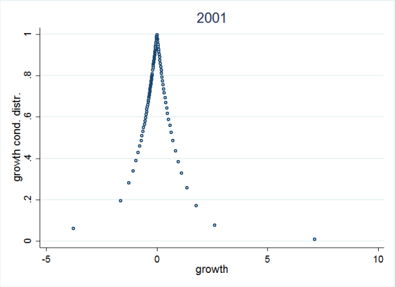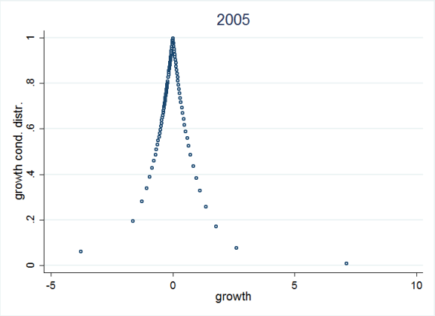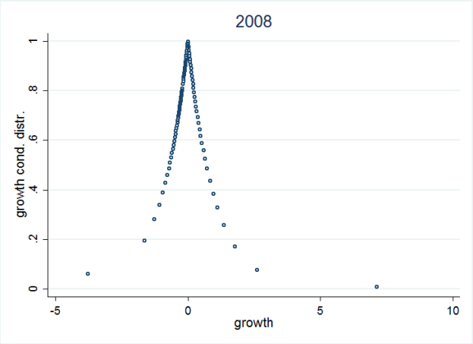
Non displayed years show very similar patterns; graphs are available upon request to the authors

Figure A2. Quantile-normal plot of Growth variable (years 2001, 2005, 2008)
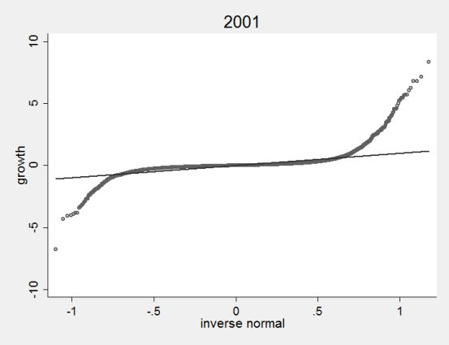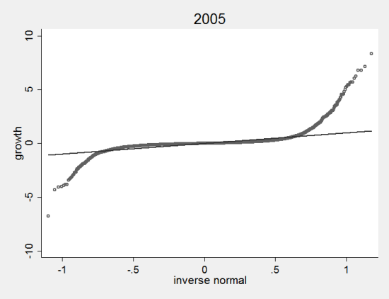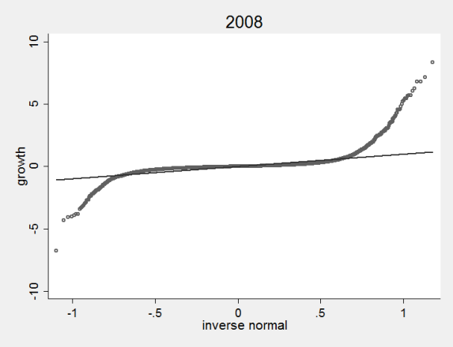
Non displayed years show very similar patterns; graphs are available upon request to the authors

Figure A3. Additional effect of green technologies compared to non green technologies by quantiles (quantiles 50th, 75th, 90th respectively)

