Appendix A
This section presents the questions regarding perceived growth barriers, as presented in the Situations and Conditions of Enterprises questionnaire.
Table A1. Questions regarding growth barriers. Situation and Conditions of Enterprises 2014.
Question: How big of a barrier would you say that the following factors constitute toward business development and growth?  Check one on each row.  a) Competition from other firms . . . . . . . . . . . . . . . . . . .  b) Product demand . . . . . . . . . . . . . . . . . . . . . . . . . . . . .  c) Profitability . . . . . . . . . . . . . . . . . . . . . . . . . . . . . . . . .  d) Access to loans and credits . . . . . . . . . . . . . . . . . . . . .  e) Access to external financing . . . . . . . . . . . . . . . . . . . .  f) Access to suitable personnel . . . . . . . . . . . . . . . . . . . .  g) Access to infrastructure (e.g., transport systems,  telecommunications, broadband) . . . . . . . . . . . . . . . . . .  h) Capacity of current premises, equipment, etc. . . . . . .  i) Own time for the business core activities  and strategic questions . . . . . . . . . . . . . . . . . . . . . . . . . .  j) Laws and regulations . . . . . . . . . . . . . . . . . . . . . . . . . | No barrier | Moderate barrier | Significant barrier
Notes: Minor changes have been made to certain questions over the years. However, no changes have been made to the questions studied in this paper.

Appendix B
Table B1. Previous empirical research on perceived growth barriers.
Study | Period | Country or countries | Sample size | Firm size^{Ψ} | Sampling method | Empirical method | Outcome variable(s)^{Φ} | Focus | Results
Levy (1993) | 1980/1990 | Tanzania and Sri Lanka | 57 | All sizes | Personal interviews | Descriptive | Five point Likert scale | General growth barriers | Top managers perceive access to and cost of finance to be a growth barrier
Hay and Kamshad (1994) | 1993 | UK | 408 | 0-249 | Mail survey | Descriptive | Binary | Managerial capacity | Insufficient managerial capacity is a common growth barrier
Bryson et al. (1997) | 1991 | UK | 2,028 | 1-500 | Mail survey | Descriptive | Ten point Likert scale | General growth barriers | Availability and cost of finance is generally perceived to be a growth barrier
McCormick et al. (1997) | 1989 | Kenya | 40 | 4-49 | Personal interviews | Qualitative | Interview response | General growth barriers | Weak demand, poor financial system and lack of suitable premises are perceived as growth barriers
Bohatá and Mládek (1999) | 1997 | Czech Republic | 100 | > 5 | Personal interviews | Descriptive | Five point Likert scale | General firm characteristics | Excess tax burden, access to credit and price of credit are perceived as growth barriers
Orser et al. (2000) | 1994/1995 | Canada | 1,004 | < 100 | Telephone interviews | Probit regression | Binary | Top management characteristics | Female top managers and managers in older and smaller firms are more likely to face growth barriers
Bartlett and Bukvič (2001) | 2000 | Slovenia | 173 | 2-249 | Personal interviews | OLS regression | Firm growth | Firm growth | Perceived growth barriers regarding bureaucracy, taxes and cost of credit is negatively associated with firm growth
Hashi (2001) | 1997 | Albania | 50 | < 200 | Mail survey | OLS regression | Firm growth | General growth barriers | Firms that face financial and institutional growth barriers exhibit lower employment and asset growth
Ačevska (2002) | 2000 | Macedonia | 300 | 0-249 | Mail survey | Descriptive | Five point Likert scale | General growth barriers | High taxes, low availability of loans, high labor costs, lack of liquidity and poor institutions are commonly perceived as growth barriers
Harris (2002) | Not specified | UK | 6 | 25-100 | Personal interviews | Qualitative analysis | Interview response | Regulation | Regulation is generally perceived as a growth barrier
Table B1. Continued. Previous empirical research on perceived growth barriers.
Study | Period | Country or countries | Sample size | Firm size^{Ψ} | Sampling method | Empirical method | Outcome variable(s)^{Φ} | Focus | Results
Mambula (2002) | Not specified | Nigeria | 32 | Not specified | Personal interviews | Descriptive | Binary | General growth barriers | Lack of finance, poor infrastructure and difficulty attaining factor inputs are commonly perceived as growth barriers
Sleuwaegen and Goedhuys (2002) | 1995-1996 | Côte d’Ivoire | 185 | All sizes | Personal interviews | Descriptive | Three point Likert scale | Firm size | Top managers perceive access to finance, insufficient market conditions, access to infrastructure and regulations to be growth barriers
Trulsson (2002) | 1999 | Three countries | 54 | 5-60 | Personal interviews | Descriptive | Three point Likert scale | General growth barriers | Top managers perceived access to finance to be a growth barrier
Fielden et al. (2003) | Not specified | UK | 99 | All firm sizes | Personal interviews | Qualitative | Interview response | Top management characteristics | Female top managers perceived negative attitudes and gender stereotypes to constitute growth barriers
Lechner and Dowling (2003) | 1998/1999 | Germany | 10 | All firm sizes | Personal interviews | Qualitative analysis | Interview response | Firm networks | Networking capacity constitutes a growth barrier for firms
Morrison et al. (2003) | Not specified | Australia | 20 | 5-49 | Personal interviews | Qualitative analysis | Interview response | General growth barriers | Institutions matter for firm growth
Moy and Luk (2003) | 1998-1999 | Hong Kong | 200 | < 200 | Mail survey | Discriminant analysis | Seven point Likert scale | Firm development | Perceptions of growth barriers are carried over the lifecycle of firms
Pissarides et al. (2003) | 1995 | Russia and Bulgaria | 437 | $≤$ 200 | Personal interviews | Multinomial logit | Binary | General growth barriers | Top managers perceive access to finance to be a significant growth barrier
Aidis (2005) | 2000 | Lithuania | 332 | 0-49 | Mail survey | Multinomial logit | Six point Likert scale | General growth barriers | The perceptions of different growth barriers within firms are correlated
Beck et al. (2005) | 1999-2000 | 54 countries | 4,255 | > 5 | Personal interviews | Random effects | Four point Likert scale | Firm size | Owners of smaller firms experience more financial constraints to growth
Rankin (2006) | 1998 | South Africa | 325 | < 40 | Personal interviews | Probit regression | Binary | General growth barriers | Firms with lower costs are less likely to face growth barriers
Krasniqi (2007) | 2002 | Kosova | 178 | 0-249 | Personal interviews | OLS regression | Firm growth | Firm growth | Top managers of fast growing firms are less likely to experience growth barriers
Table B1. Continued. Previous empirical research on perceived growth barriers.
Study | Period | Country or countries | Sample size | Firm size^{Ψ} | Sampling method | Empirical method | Outcome variable(s)^{Φ} | Focus | Results
Okpara and Wynn (2007) | 2006 | Nigeria | 396 | Not specified | Mail survey | Correlation | Five point Likert scale | Top management characteristics | Top managers who perceive themselves as successful are less likely to face growth barriers
Reddy (2007) | 2003/2004 | Fiji | 240 | Not specified | Personal interviews | Descriptive | Five point Likert scale | General growth barriers | Top managers perceive a lack of financial security, experience and financial knowledge to be growth barriers
Ayyagari et al. (2008) | 1999/2000 | 80 countries | 79 | > 4 | Mail survey | OLS regression | Firm growth | General growth barriers | Firm growth is negatively associated with a perceived lack of finance
Hassanien and Adly (2008) | 2005 | Egypt | 15 | < 50 | Mail survey | Descriptive | Binary | Access to finance | A majority of top managers perceive access to finance to be a growth barrier
Robson and Obeng (2008) | 2002-2005 | Ghana | 500 | 4-50 | Mail survey | Ordered logit | Six point Likert scale | General firm characteristics | Ownership, firm growth and R&D spending affect perceptions of growth barriers
Carter et al. (2009) | 2005 | UK | 16,779 | 0-249 | Mail survey | OLS regression | Five point Likert scale | Institutions | Top managers who rate their firm’s competitiveness highly are more likely to face growth barriers
Harvie et al. (2010) | 2009 | 8 countries | 912 | 1-199 | Mail survey | Descriptive | Five point Likert scale | General growth barriers | Top managers perceive product and price regulations to be growth barriers
Irwin and Scott (2010) | Not specified | UK | 400 | 0-249 | Telephone interviews | Descriptive | Binary | Top management characteristics | Top managers with low education and/or from ethnic minorities are more likely perceive finance as a growth barrier
Olawale and Garwe (2010) | Not specified | South Africa | 361 | 1-200 | Mail survey | Descriptive | Five point Likert scale | Young firms | Top managers generally perceive a lack of access to finance to be a growth barrier
Doern (2011) | 2005 | Russia | 27 | 10-99 | Personal interviews | Qualitative approach | Interview response | General growth barriers | Perceived growth barriers reduce growth intentions and postpone growth realization
Table B1. Continued. Previous empirical research on perceived growth barriers.
Study | Period | Country or countries | Sample size | Firm size^{Ψ} | Sampling method | Empirical method | Outcome variable(s)^{Φ} | Focus | Results
Hashi and Krasniqi (2011) | 2002, 2005 | 6 countries | 2,100 | 2-250 | Mail survey | OLS regression | Firm growth | Institutions | Laggard economy firms face greater growth barriers relating to tax burden, corruption and organized crime
Ishengoma and Kappel (2011) | 2003 | Uganda | 105 | < 20 | Personal interviews | Probit/logit | Sales growth | General growth barriers | Perceived limited access to markets is negatively associated with sales growth
Okpara (2011) | 2007 | Nigeria | 211 | Not specified | Mail survey | Probit regression | Binary | Firm exit | Top managers perceive access to finance and infrastructure to be growth barriers
Syed Shah et al. (2011) | 2010 | Malaysia | 170 | < 150 | Mail survey | Factor analysis | Five point Likert scale | General firm characteristics | Top managers perceive access to finance and the poor quality of institutions as growth barriers
(Muneeb et al. 2012) | Not specified | Pakistan | 158 | 0-250 | Personal interview | Descriptive | Five point Likert scale | General growth barriers | Perceived growth barriers are negatively correlated with firm growth
Athanasouli et al. (2012) | 2005 | Greece | 546 | All firm sizes | Personal interviews | Descriptive | Three point Likert scale | Corruption | Top managers of quarrying firms are more likely than others to perceive corruption as a growth barrier
Burger et al. (2012) | 2010 | Kenya and Ghana | 600 | All firm sizes | Mail survey | Descriptive | Binary | General growth barriers | Health providers found lack of access to finance to be a growth barrier
Coad and Tamvada (2012) | 2002-2003 | India | Approx. 85,000 | All firm sizes | Mail survey | Probit | Binary | General growth barriers | Top managers of older and larger firms are less likely to face growth barriers relating to demand and managerial problems
Gill and Biger (2012) | Not specified | Canada | 219 | < 150 | Telephone interviews | OLS regression | Firm performance | General firm characteristics | Top managers of fast growing firms are more likely to face growth barriers
Xheneti and Bartlett (2012) | 2004 | Albania | 110 | > 5 | Personal interviews | Factor analysis | Binary | Institutions | Employment regulations and insufficient institutions are commonly perceived as growth barriers
Table B1. Continued. Previous empirical research on perceived growth barriers.
Study | Period | Country or countries | Sample size | Firm size^{Ψ} | Sampling method | Empirical method | Outcome variable(s)^{Φ} | Focus | Results
Hessels and Parker (2013) | 2003 | 18 countries | 7,673 | 0-249 | Telephone interviews | OLS regresssion | Employment growth | Trade | Firms which trade and face demand constraints exhibit lower sales growth
Lee and Cowling (2013) | 2007-2008 | UK | 7,670 | 0-249 | Telephone interviews | Probit regression | Binary | Firm demographics | Firm characteristics account for most variation in perceived growth barriers across regions
Afraz et al. (2014) | Not specified | Pakistan | 24 | Not specified | Personal interviews | Qualitative approach | Interview response | General growth barriers | Top managers perceive poor institutions to be a growth barrier
Alrabeei and Kasi (2014) | Not specified | Bahrain | 200 | 11-250 | Personal interviews | Descriptive | Binary | General growth barriers | Top managers perceive a lack of qualified human resources, finance and competition to constitute growth barriers
Das and Das (2014) | 2002, 2006 | India | 1,908 | > 5 | Personal interviews | Factor analysis | Binary | General growth barriers | Top managers perceive a lack of access to finance, as well as cost of finance to constitute growth barriers
Rehman (2014) | 2012 | Pakistan | 69 | 1-500 | Personal interviews | OLS regression | Labor productivity | General growth barriers | Firms whose top managers report a lack of appropriate labor exhibit lower labor productivity
Lee (2014) | 2007/2008, 2010 | UK | 4,858 | 0-249 | Telephone interviews | Probit regression | Binary | High growth firms | Top managers of high growth firms are more likely to experience growth barriers
Lee and Drever (2014) | 2012 | UK | 3,684 | 0-249 | Telephone interviews | Probit regression | Binary | Firm demographics | Top managers in deprived areas are more likely to perceive finance as a growth barrier
Chinomona and Maziriri (2015) | Not specified | South Africa | 30 | All firm sizes | Personal interviews | Qualitative approach | Interview response | Top management characteristics | Female top managers perceive a lack of finance to be a growth barrier
Lee and Cowling (2015) | 2006/2007, 2007/2008 | UK | 12,188 | 0-249 | Telephone interviews | Probit regression | Binary | Firm demographics | Top managers of urban and rural firms experience different growth barriers
Nikolic et al. (2015) | 2009-2010 | Serbia | 3,500 | 0-249 | Mail survey | Descriptive | Binary | Innovation | Poor institutions constitute a commonly perceived growth barrier among top managers
Table B1. Continued. Previous empirical research on perceived growth barriers.
Study | Period | Country or countries | Sample size | Firm size^{Ψ} | Sampling method | Empirical method | Outcome variable(s)^{Φ} | Focus | Results
Villanger (2015) | 2009 | Nepal | 291 | All firm sizes | Personal interviews | Descriptive | Binary | General growth barriers | Lack of capital is the most commonly cited growth barrier
Reppen (2015) | 2012-2014 | 8 countries | 6,917 | 5-99 | Personal interviews | OLS regression | Sales growth | Infrastructure | Firms whose top managers consider their access to infrastructure to be good exhibit higher sales growth
Baporikar et al. (2016) | Not specified | Nambia | 2 | Not specified | Personal interviews | Qualitative analysis | Interview response | General growth barriers | Fighting, stealing and tax-levels were perceived as growth barriers
Lekhanya and Visser (2016) | Not specified | South Africa | 127 | All firm sizes | Mail survey | Descriptive | Five point Likert scale | General growth barriers | Low local demand and poor infrastructure were perceived as growth barriers.
Wang (2016) | 2006-2014 | 119 countries | 73,000 | < 100 | Personal interviews | Probit regression | Binary | Growth barriers in developing countries | High growth SMEs are more likely to perceive financing as a growth barrier. Larger SMEs are less likely to perceive finance and competition as growth barriers.
Galati et al. (2017) | Not specified | Italy | 15 | All firm sizes | Mail survey | Forecasting and simulation | 12 point Likert scale | General growth barriers | Top managers perceive a lack of human resources to be a growth barrier
Krešić et al. (2017) | 2012-2014 | 7 countries | 1,800 | All firm sizes | Personal interviews | Descriptive | Four point Likert scale | General growth barriers | Top managers perceive competition from the informal sector to be the most pressing barrier to growth
Shibia and Barako (2017) | 2008 | Kenya | 2,536 | < 50 | Mail survey | OLS regression | Firm growth | General growth barriers | Negative perceptions of fairness, cost and efficiency of the judicial system is associated with lower firm growth
Davies et al. (2018) | Not specified | Western Europe | 10 | Not specified | Personal interviews | Qualitative analysis | Interview response | Firm growth | Social enterprise barriers are found to be based on value differences, business models and institutional norms
Drinkwater et al. (2018) | 2010/2011 | 12 countries | 1,846 | > 5 | Personal interviews | Ordered probit | 4 point Likert scale | General growth barriers | Lack of educated personnel, access to finance and crime, theft and disorder are the most commonly cited growth barriers
Lee and Luca (2018) | 2006-2015 | 135 countries | 120,000 | > 5 | Personal interviews | Ordinal logit | 4 point Likert scale | Access to finance | Inhabitants of large cities are less likely than others to perceive financing as a constraint
Notes:
^{Ψ} Firm size refers to the number of employees.
^{Φ} Outcome variables refer to perceived growth barriers unless specified otherwise.

Appendix C
Figure C1. Number of observations, by firm size. For 2011, 2014 and 2017.
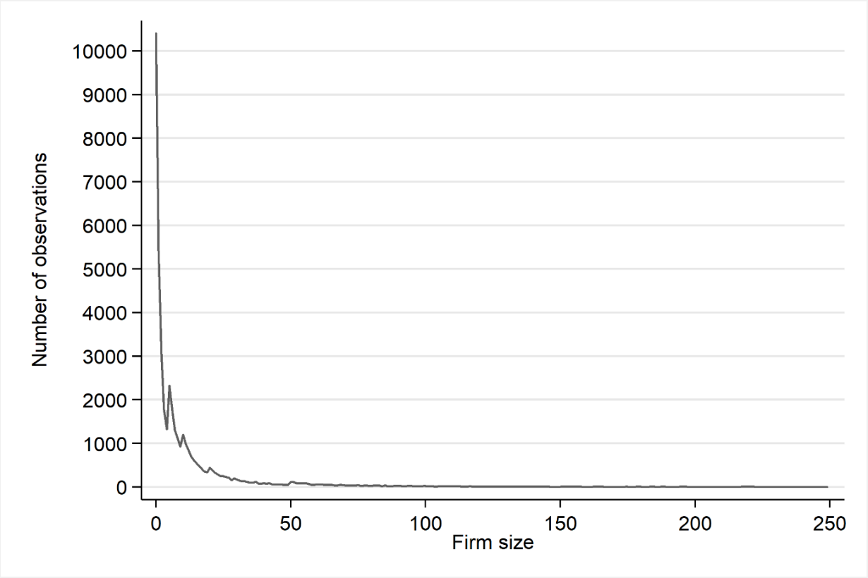
Notes: Number of observations (sum) per firm size. Observations concern the years 2011, 2014 and 2017.

Figure C2. Number of responses, versus non-responses, across questions and firm size. For 2011, 2014 and 2017.
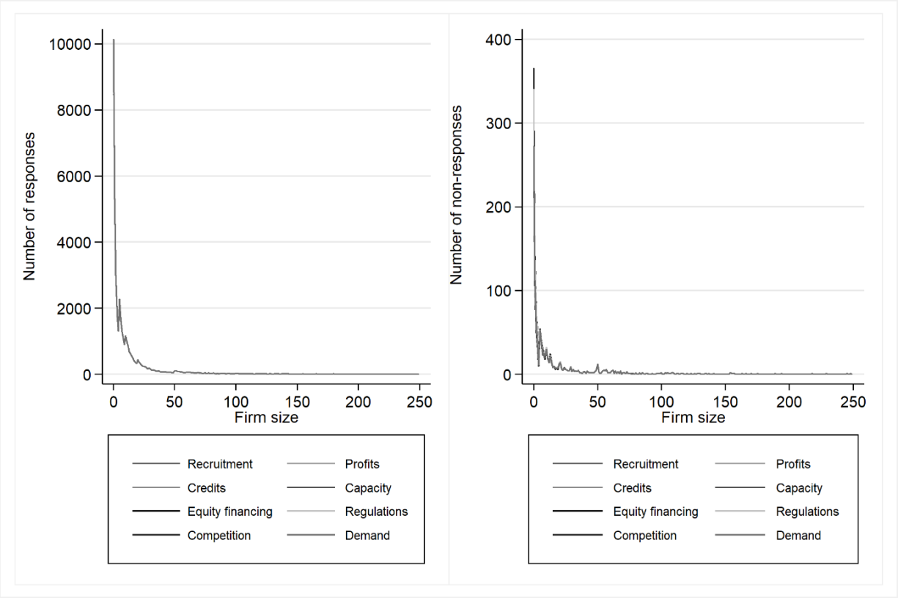
Notes: Number of responses and non-responses per growth barriers and firm size. Observations concern the years 2011, 2014 and 2017. Questions concerning competition, demand and profits were only asked in 2011 and 2014.

Table C3. Response rates across size groups. All growth barriers. For 2011, 2014 and 2017.
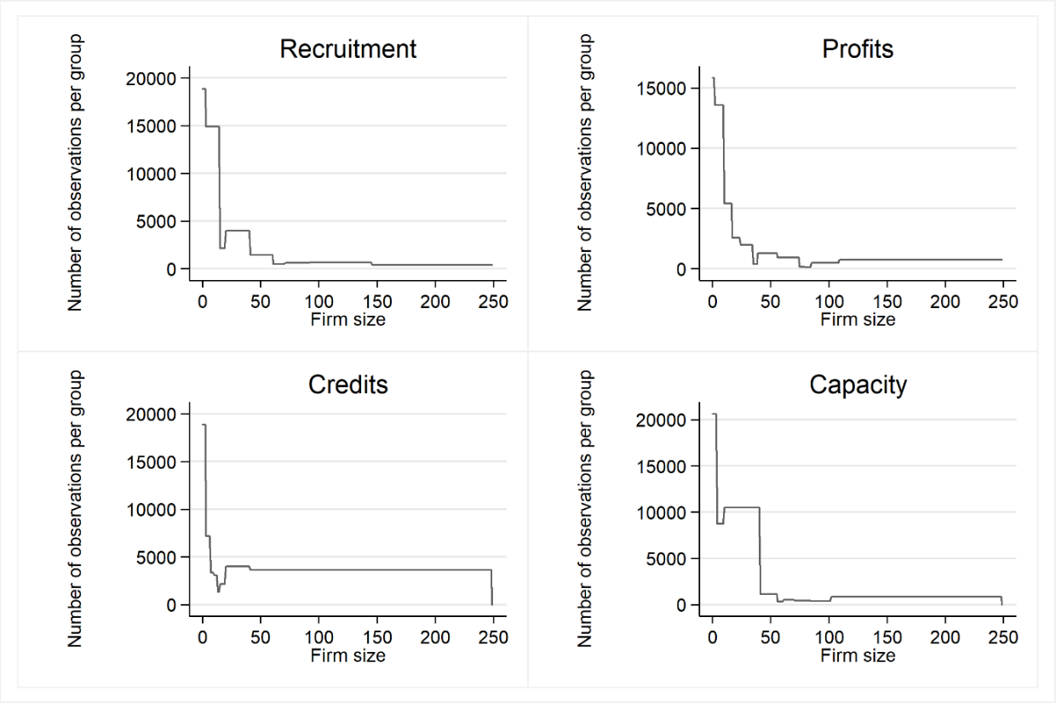
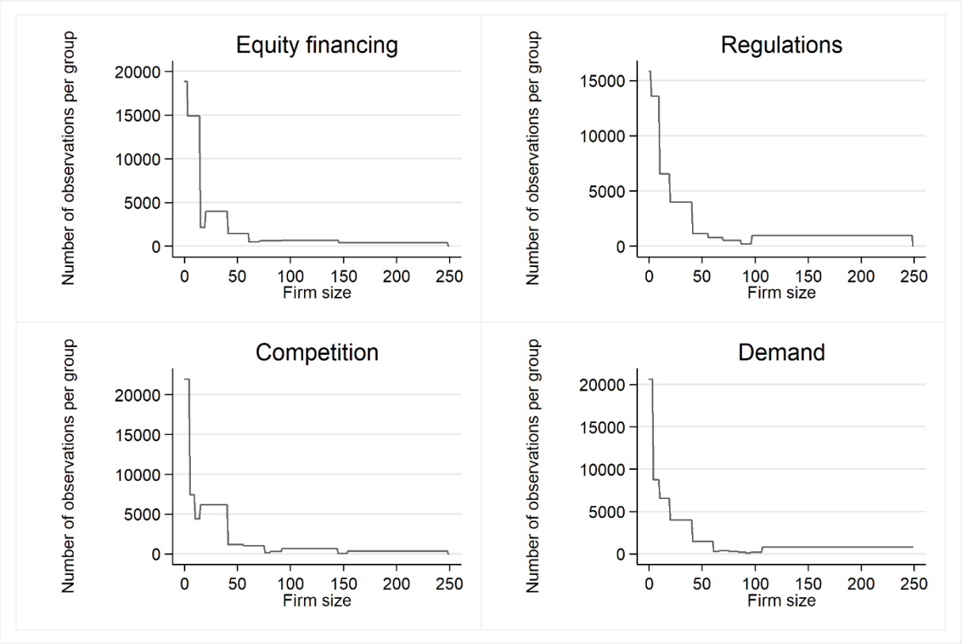
Notes: Firm size groups are determined following the developed identification strategy. Questions regarding competition, demand and profits were only asked in 2011 and 2014.

Appendix D

/* Example STATA code to replicate the analysis of Karlsson (2020).
----------------------------------------------------------------------------------
The approach described in Karlsson (2020) consists of four steps:
----------------------------------------------------------------------------------

1. Estimating Kernel densities across firm size.
2. Running stepwise OLS regression across consecutive firm sizes, i.e., 0, 0-1, 0-2, 0-3, …, 0-249 employees.
3. Evaluating the fit of each group based on adjusted R2, weighted by the Kernel density of the largest firm size in each group. In practice, this is equal to the density of the highest included Kernel bandwidth.
4. Select highest ranking (best fitting) group in terms of weighted adjusted R2, insert it into the model and repeat until groups have been fitted for all firm sizes. In order to reduce the number of small groups, models are also restricted so that they do not fit more than one entire group within a single Kernel bandwidth.

For the sake of brevity, only the first two iterations of Step 3. and 4. are presented, whereas they can be generalized to K number of iterations. The presented steps are currently stacked. However, with some finessing, the code may be generalized using nested forvalues loops.

----------------------------------------------------------------------------------
The following example presupposes the existence of three variables in the data.
The data itself is contained within a dataset labeled "dataset.dta":
----------------------------------------------------------------------------------

1. size – This is the continuous variable that we seek to divide into groups. For the context of this example, this constitutes firm size in terms of number of employees, ranging from 0-249.

2. DEP_VAR – This denotes the dependent variable that we seek to fit firm size to.

3. INDEP_VAR – This denotes the independent variable(s) that are included in regressions, in excess of firm size.
----------------------------------------------------------------------------------
*/

// First, we sort firm sizes and estimate Kernel densities using the Epanechnikov function.

use "dataset.dta", clear
sort size
kdensity size, generate(kernel_density density_estimate) nograph

/* This generates two variables:

1. kernel_density – which denotes the points where each Kernel density is estimated
2. density_estimate – which denotes the density weight itself

*/

// Next, let’s set up a macro to denote the number of bandwidths (this will help to generalize the forvalues loops).

qui sum density_estimate
gen bandwidths=r(sum_w)
global bandwidths=bandwidths
drop bandwidths

/* Next, we assign a bandwidth to each firm size. This is done by locating the start and end points of each bandwidth, where membership is assigned to all firm sizes located between these two points */

qui forvalues i=1/$bandwidths {
gen bandwidth_`i'_start=.
replace bandwidth_`i'_start=kernel_density if `i'==_n

// Maximization function used to generate a scalar across obs.
egen max=max(bandwidth_`i'_start)
replace bandwidth_`i'_start=max
drop max

gen bandwidth_`i'_end=.
replace bandwidth_`i'_end=kernel_density[_n+1] if `i'==_n

// Maximization function used to generate a scalar across obs.
egen max=max(bandwidth_`i'_end)
replace bandwidth_`i'_end=max
drop max

gen bandwidth_`i'_weight=.
replace bandwidth_`i'_weight=density_estimate if `i'==_n

// Maximization function used to generate a scalar across obs.
egen max=max(bandwidth_`i'_weight)
replace bandwidth_`i'_weight=max
drop max
}

/* Lastly, we assign Kernel density weights to all firm sizes based on Kernel bandwidths. This will be our weighting variable */

gen kweight=.
qui forvalues i=1/$bandwidths {
if `i'==1 {
qui replace kweight= bandwidth_`i'_weight if size>= bandwidth_`i'_start & size<= bandwidth_`i'_end
}
if `i'>1 {
qui replace kweight= bandwidth_`i'_weight if size> bandwidth_`i'_start & size<= bandwidth_`i'_end
}
}

keep size kweight

// For the weighting matrix, we only need one value per firm size.

gen d=0
by size: replace d=_n
keep if d==1
keep size kweight
rename size size2
save "kernel.dta", replace

// The weighting matrix has now been constructed.

/* ---------------------------------------------------------------------
-------------- STARTING STEPWISE OLS REGRESSIONS -----------------------
------------------------------------------------------------------------ */

/* --------------------------------------------------------------------

In this step, we perform 250 regressions involving dummy variables for each consecutive firm size group, starting from 0 employees. The results of each regression is exported to a .csv file. Once completed, the output is retrieved from the .csv file and merged with the original dataset.

Lastly, the weighting matrix constructed in the previous step is used to weight the output based on the density of the largest firm size of each group, i.e., the highest included Kernel bandwidth.

--------------------------------------------------------------------- */

/*-------------------------------------------------------
------------------------ RUN ONE ------------------------
---------------------------------------------------------*/

// First, let’s set up a macro for the boundaries of the loops (highest value of continuous var).

use "dataset.dta", clear

qui sum size
gen loop_end=r(max)
global loop_end=loop_end

// Now, let’s generate 250 dummy variables and conduct the first set of 250 stepwise regressions:

forvalues i=0/$loop_end {

qui gen cutoff_`i'=0
qui replace cutoff_`i'=1 if size>=0 & size<=`i'
qui reg DEP_VAR cutoff_`i' INDEP_VAR
eststo est1

// Saving the adj. R2 of each regression in a .csv file

if `i'==1 {
qui esttab est1 using "run_1_ DEP_VAR_output.csv", nostar keep(cutoff_`i') replace stats(r2_a) mtitles("Cutoff ends at `i'")
}
if `i'>1 & `i'<=$loop_end {
qui esttab est1 using "run_1_DEP_VAR_output.csv", nostar keep(cutoff_`i') append stats(r2_a) mtitles("Cutoff ends at `i'")
}
estimates clear
}
drop cutoff_*

// Retrieving all cutoff points and their corresponding R2, merging it with the original data

use "dataset.dta", clear
qui import delimited "run_1_DEP_VAR_output.csv", clear
qui gen DEP_VAR_end_1=.
qui tostring DEP_VAR_end_1, replace
qui replace DEP_VAR_end_1=substr(v1,10,length(v1)-10) if substr(v1,3,6)=="cutoff"
qui replace DEP_VAR_end_1=DEP_VAR_end_1[_n-2] if DEP_VAR_end_1=="." & substr(v1,3,2)=="r2"
qui replace DEP_VAR_end_1="." if substr(v1,3,6)=="cutoff"
qui drop if DEP_VAR_end_1=="."
qui gen size=DEP_VAR_end_1
qui gen r2=.
qui tostring r2, replace
qui replace r2=substr(v2,3,length(v2)-3)
qui destring r2, replace
qui destring DEP_VAR_end_1, replace
qui gen size2= DEP_VAR_end_1
qui drop v1 v2

// Merging with the weighting dataset

merge 1:1 size2 using "kernel.dta", nogen

// Finally, we weight the adjusted R2 with the Kernel density weight of the largest firm size included in each group.

gen r2_weighted=r2*kweight
qui gsort -r2_weighted
qui drop if _n!=1 // Selecting the highest ranking class
qui drop r2
qui gen cutoff=1
qui gen DEP_VAR_kweight1=kweight
drop size* *kweight kweight
gen size2=DEP_VAR_end_1

// Save cutoff limit
qui save "DEP_VAR_output_1.dta", replace

/*-------------------------------------------------------
------------------------ RUN TWO ------------------------
---------------------------------------------------------*/

use "dataset.dta", clear
qui append using "DEP_VAR_output_1.dta"
qui egen c2=max(DEP_VAR_end_1)
qui replace DEP_VAR_end_1=c2
qui drop c2
qui gen DEP_VAR_end_1_dummy=0
qui replace DEP_VAR_end_1_dummy=1 if size>=0 & size<=DEP_VAR_end_1

/* Running all regressions again, now including a dummy for the group selected in the first stage. In practice, the algorithm will still run all 249 regressions, although estimates for already established groups will be omitted due to collinearity. With some finessing, however, the code could be made more efficient by only running the necessary regressions. */

forvalues i=0/$loop_end {
qui gen cutoff_`i'=0
qui replace cutoff_`i'=1 if size>DEP_VAR_end_1 & size<=`i'
qui reg DEP_VAR DEP_VAR_end_1_dummy cutoff_`i' INDEP_VAR
eststo est1

if `i'==1 {
qui esttab est1 using "run_2_DEP_VAR_output.csv", keep(cutoff_`i') nostar replace stats(r2_a) mtitles("Cutoff ends at `i'")
}
if `i'>1 & `i'<=$loop_end {
qui esttab est1 using "run_2_DEP_VAR_output.csv", keep(cutoff_`i') nostar append stats(r2_a) mtitles("Cutoff ends at `i'")
}
estimates clear
}
drop cutoff_*

// Retrieving results and merging with the original dataset

use "dataset.dta", clear

qui import delimited "run_2_DEP_VAR_output.csv", clear
qui gen DEP_VAR_end_2=.
qui tostring DEP_VAR_end_2, replace
qui replace DEP_VAR_end_2=substr(v1,10,length(v1)-10) if substr(v1,3,6)=="cutoff"
qui replace DEP_VAR_end_2=DEP_VAR_end_2[_n-2] if DEP_VAR_end_2=="." & substr(v1,3,2)=="r2"
qui replace DEP_VAR_end_2="." if substr(v1,3,6)=="cutoff"
gen se=.
tostring se, replace
replace se=substr(v1,3,6) if substr(v1,3,6)=="cutoff"
replace se=substr(v2,4,length(v2)-5) if se[_n-1]=="cutoff"
replace se="." if se=="cutoff"
replace se=se[_n-1] if substr(v1,3,2)=="r2"
replace se="." if substr(v1,3,2)!="r2"
gen beta=.
tostring beta, replace
replace beta=substr(v2,3,length(v2)-3) if substr(v1,3,6)=="cutoff"
replace beta=beta[_n-2] if substr(v1,3,2)=="r2"
replace beta="." if substr(v1,3,2)!="r2"
replace beta="." if beta=="0"
destring se, replace
destring beta, replace
qui drop if DEP_VAR_end_2=="."
qui gen r2=.
qui tostring r2, replace
qui replace r2=substr(v2,3,length(v2)-3)
qui destring r2, replace
qui destring DEP_VAR_end_2, replace
qui drop v1 v2
append using "DEP_VAR_output_1.dta"

// Using max module to create scalar of first cutoff
egen s=max(DEP_VAR_end_1)
replace DEP_VAR_end_1=s
drop s
drop size2
qui gen size2=DEP_VAR_end_2

// Merging with the weighting dataset
merge 1:1 size2 using "kernel.dta", nogen

// Merging results with the output of the previous run
merge 1:1 size2 using "DEP_VAR_output_1.dta", nogen

// Next, we first apply the weights
egen c=max(DEP_VAR_kweight1)
replace DEP_VAR_kweight1=c
drop c
drop r2_weighted
gen r2_weighted=r2*kweight

// Next, we impose the restriction that the new cutoff must be larger than the previous one
drop if DEP_VAR_end_2<=DEP_VAR_end_1
drop cutoff DEP_VAR_end_1

// Lastly, we impose the restriction that the new endpoint cannot be in the same Kernel bandwidth as the previous endpoint. In practice, this means that their Kernel density weight cannot be identical.

drop if kweight==DEP_VAR_kweight1

// In some cases, we will find that two or more adjacent firm sizes give the same weighted R2. In these cases, we select the shortest interval span. In this, we reduce the risk of colluding findings.

qui gsort -r2_weighted
qui drop if _n!=1 // Selecting the highest ranking class
qui gen cutoff=2
qui gen DEP_VAR_kweight2=kweight
append using "DEP_VAR_output_1.dta"
replace DEP_VAR_end_1=DEP_VAR_end_2 if DEP_VAR_end_1==.
drop size* *kweight kweight
gen size2=DEP_VAR_end_2
qui save "DEP_VAR_output_2.dta", replace

References
Ačevska, B. (2002). Entrepreneurship under difficult circumstances: factors hindering SME growth in the Republic of Macedonia. South-East Europe Review for Labour and Social Affairs, Special Issue "Republic of Macedonia", pp.109–122.
Adan Guyo Shibia, Dulacha Galgallo Barako, (2017) Determinants of micro and small enterprises growth in Kenya. Journal of Small Business and Enterprise Development, 24(1):105–118.
Afraz, N., Hussain, S., & Khan, U. (2014). Barriers to the Growth of Small Firms in Pakistan: A Qualitative Assessment of Selected Light Engineering Industries. The Lahore Journal of Economics, 19, 135–176.
Alison Morrison, John Breen, Shameem Ali, (2003) Small Business Growth: Intention, Ability, and Opportunity. Journal of Small Business Management ,41(4),417–425.
Alrabeei, H., & Kasi, B. (2014). Barriers to Growth: Key Challenges Facing Bahraini Small and Medium Enterprises. Arabian Journal of Business and Management, Review, 4(3),45–62.
Anyadike-Danes, M., Bjuggren, C-M., Gottschalk, S., Hölzl, W., Johansson, D., Maliranta, M., & Myrann, A. (2015). An international cohort comparison of size effects on job growth. Small Business Economics, 44(4), 821–844.
Athanasouli, D., Goujard, A., & Sklias, P. (2012). Corruption and Firm Performance: Evidence from Greek Firms. International Journal of Economic Sciences and Applied Research, 5(2), 43–67.
Ayyagari, M., Demirgüç-Kunt, A., & Maksimovic, V. (2008). How Important Are Financing Constraints? The Role of Finance in the Business Environment. The World Bank Economic Review, 22 (3):483–516.
Baporikar, N., Nambira, G., & Gomxos, G. (2016). Exploring factors hindering SMEs’ growth: evidence from Nambia. Journal of Science and Technology Policy Management ,7(2),190–211.
Bartlett, W., & Bukvič, V. (2001). Barriers to SME Growth in Slovenia. MOCT-MOST: Economic Policy in Transitional Economies, 11(2), 177–195.
Besnik A. & Krasniqi. (2011). Barriers to entrepreneurship and sme growth in transition: The case of kosova. Journal of Developmental Entrepreneurship, 12 01), 71–94.
Bohatá, M., & Mládek, Jan. (1999). The development of the czech sme sector. Journal of Business Venturing, 14 (5-6),461–473.
Bryon, J., Keeble, D., & Wood, P. (1997). The Creation and Growth of Small Business Service Firms in Post-Industrial Britain. Small Business Economics, 9(4), 345-360.
Burger, N. E., Kopf, D., Spreng, C. P., Yoong, J., Sood, N., & Noor, A. M. (2012). Healthy Firms: Constraints to Growth among Private Health Sector Facilities in Ghana and Kenya. PLoS ONE, 7(2), e27885.
Carter, S., Mason, C., & Tagg, S. (2009). Perceptions and Experience of Employment Regulation in UK Small Firms. Environment and Planning C: Government and Policy, 27(2), 263-278.
Chinomona, E., &Maziriri, E. T. (2015). Women In Action: Challenges Facing Women Entrepreneurs In The Gauteng Province Of South Africa. International Business & Economics Research Journal (IBER), 14(6), 835.
Das, S. S., & Das, A. (2013). India shining? A two-wave study of business constraints upon micro and small manufacturing firms in India. International Small Business Journal: Researching Entrepreneurship, 32(2), 180–203.
Davies, I. A., Haugh, H., & Chambers, L. (2018). Barriers to Social Enterprise Growth. Journal of Small Business Management, 57(4),1616–1636.
Doern, R.(2011). Understanding how perceived barriers influence growth intentions and behaviours. International Journal of Entrepreneurial Behavior & Research, 17(5),488–514.
Drinkwater, S., Lashley, J., & Robinson, C. (2018). Barriers to enterprise development in the Caribbean. Entrepreneurship & Regional Development 30 (9-10), 942–963.
European Commission (2013). Entrepreneurship and innovation programme EIP performance report. Brussels: European Commission.
Fielden, S. L., Davidson, M. J. & Dawe, A. J., & Makin, P. J. (2003). Factors inhibiting the economic growth of female owned small businesses in North West England. Journal of Small Business and Enterprise Development ,10(2), 152–166.
Galati, F., Bigliardi, B., Petroni, A., & Marolla, G. (2016). Which factors are perceived as obstacles for the growth of Italian academic spin-offs?. Technology Analysis & Strategic Management, 29(1), 84–104.
Gill. A., & Biger, N. (2012). Barriers to small business growth in Canada. Journal of Small Business and Enterprise Development,19(4),656–668.
Hashi, I. (2001). Financial and Institutional Barriers to SME Growth in Albania. Results of an Enterprise Survey. Economic Policy in Transitional Economies, 11(3), 221–238.
Hashi, I., & Krasniqi, B. A. (2011). Entrepreneurship and SME growth: evidence from advanced and laggard transition economies. International Journal of Entrepreneurial Behavior & Research, 17 (5),456–487.
Hassanien, A., & Adly, S. (2008). Issues facing small Egyptian construction firms: the financing barrier. Journal of Small Business and Entrepreneurship, 21(3), 363–376.
Harris, L. (2002). Small firm responses to employment regulation. Journal of Small Business and Enterprise Development ,9 (3),296–306.
Harvie, C., Dionisius, N., & Sothea, O. (2010). Constraints to growth and firm characteristic determinants of SME participation in production networks. Integratingsmall and medium enterprises (SMEs) into the more integrated East Asia, pp. 68.
Hay, M., & Kamshad, K. (1994). Small Firm Growth: Intentions, Implementation and Impediments. Business Strategy Review, 5 (3), 49–68.
Hessels, J., & Parker, S. C. (2013). Constraints, internationalization and growth: A cross-country analysis of European SMEs. Journal of World Business, 48(1), 137–148.
Irwin, D., & Scott, J. M. (2010). Barriers faced by SMEs in raising bank finance. International Journal of Entrepreneurial Behavior & Research, 16(3), 245–259.
Ishengoma, E. K., & Kappel, R. (2011). Business Environment and Growth Potential of Micro and Small Manufacturing Enterprises in Uganda. African Development Review, 23(3), 352–365.
Krešić, A., Milatović, J., & Sanfey, P. (2017). Firm performance and obstacles to doing business in the Western Balkans: Evidence from the BEEPS. Working paper No. 200. London: European Bank for Reconstruction and Development.
Lechner, C., & Dowling, M. (2003). Firm networks: external relationships as sources for the growth and competitiveness of entrepreneurial firms. Entrepreneurship & Regional Development,15(1), 1–26.
Lee, L., & Drever, E.(2014) Do SMEs in deprived areas find it harder to access finance? Evidence from the UK Small Business Survey. Entrepreneurship & Regional Development, 26(3-4),337–356.
Lee, N., & Luca, D. (2019). The big-city bias in access to finance: evidence from firm perceptions in almost 100 countries. Journal of Economic Geography, 19(1), 199–224.
Lee, N., & Cowling, M. (2012). Place, sorting effects and barriers to enterprise in deprived areas: Different problems or different firms?. International Small Business Journal: Researching Entrepreneurship, 31(8), 914–937.
Lekhanya, M., & Visser, K. (2016). Critical Environmental Dynamics: Barriers Restraining Business Growth in Rural Areas of Southern region of KwaZulu-Natal province. Problems and Perspectives in Management, 14(4), 33–40.
Mambula, C. (2002). Perceptions of SME Growth Constraints in Nigeria. Journal of Small Business Management, 40(1), 58–65.
McCormick, D., Kinyanjui, M. N., & Ongile, G. (1997). Growth and barriers to growth among Nairobi's small and medium-sized garment producers. World Development, 25(7), 095–1110.
Moy, J. W., & Luk,V. W. M. (2003). The Life Cycle Model as a Framework for Understanding Barriers to SME Growth in Hong Kong. Asia Pacific Business Review, 10(2), 199–220.
Muneeb, A., Ejaz, A., Muhamad, K., & Gulam, M. (2012). New Determination of Factors Affecting the Growth of Small and Medium Sized Enterprises in Pakistan. Interdisciplinary Journal of Contemporary Research in Business, 4(6) 513–530.
Nikolic, M., Despotovic, D., & Cvetanovic, D. (2015). Barriers to innovation in SMEs in the Republic of Serbia. Ekonomika, 61(4), 89–96.
Olawale, F., & Garwe, D. (2010). Obstacles to the growth of new SMEs in South Africa: A principal component analysis approach. African Journal of Business Management, 4(5), 729–738.
Pissarides, F., Singer, M., & Svejnar, J. (2003). Objectives and constraints of entrepreneurs: evidence from small and medium size enterprises in Russia and Bulgaria. Journal of Comparative Economics, 31(3), 503–531.
Rankin, N. (2006). "The Regulatory Environment and SMMEs. Evidence from South African Firm Level Data," Working Papers 06113. Cape Town: University of Cape Town, Development Policy Research Unit.
Reddy, M. (2007). Small Business in Small Economies: Constraints and Opportunities for Growth. Social and Economic Studies, 56(1/2), 304–321.
Rehman, N. (2014). Obstacles to the Growth of Small Software Firms in Islamabad. Indian Journal of Commerce and Management Studies, 5(2), 47–52.
Reppen, S. (2015). Finding obstacles to growth: Is infrastructure a binding constraint on african light-manufacturing firms? International Journal of Economics and Financial Issues, 5(3), 820–832.
Ruta Aidis, (2005). Institutional Barriers to Small- and Medium-Sized Enterprise Operations in Transition Countries. Small Business Economics, 25(4),305–317.
Shah, S. A., Fauzi, M. J., Che, Z. S., & Domil, A. (2011). Assessing Barriers of Growth of Food Processing SMIs in Malaysia: A Factor Analysis. International Business Research, 4(1), 252–259.
Sleuwaegen, L., & Goedhuys, M. (2002). Growth of firms in developing countries, evidence from Côte d'Ivoire. Journal of Development Economics, 68 (1):117–135.
Swedish Agency for Economic and Regional Growth. (2014). Företagens villkor och verklighet 2014 (the situation and condition of enterprises 2014). Stockholm: Agency for Economic and Regional Growth.
Trulsson, P. (2002). Constraints of growth-oriented enterprises in the Southern and Eastern African region. Journal of Developmental Entrepreneurship, 7(3), 331–339.
Villanger, E. (2015). Entrepreneurial Abilities and Barriers to Microenterprise Growth: A Case Study in Nepal. The Journal of Entrepreneurship, 24(2), 115–147.
Xheneti, M., & Bartlett, W. (2012). Institutional constraints and SME growth in post‐communist Albania. Journal of Small Business and Enterprise Development, 19(4),607–626.

