Supplementary Information (SI) (Electronic Supplementary Material)

Appendix A: Basic characteristics of the variables
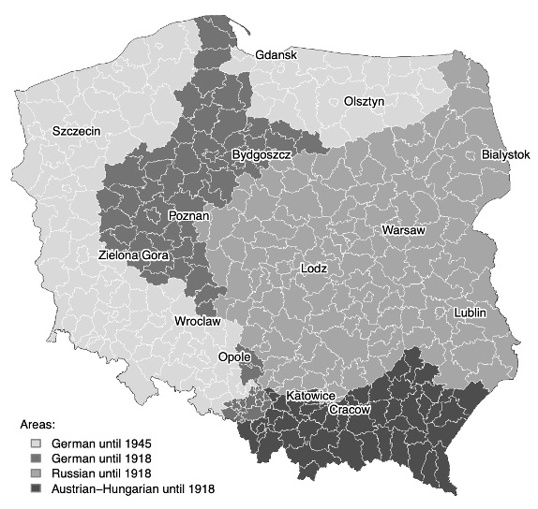
Fig. A.1 Affiliation of current counties of Poland to Prussia, Russia and Austria-Hungary between 1815 and 1945

Table A.1 Summary of the main variables of interest, the two groups of control variables, and dummy variables with definitions and sources
Variable | Definition | Source
Main variables of interest
Current start-up rate | The share of new private businesses of the years 2003–2019 (without people running individual farms in agriculture) in the total workforce (employed and unemployed) in the economy, including agriculture in 2011 | Local Data Bank of the Central Statistical Office of Poland for numerator; National Population Census from 2011 for denominator
Historical self-employment rate | The share of self-employed (both employing and not employing additional workers but without helping family members) in the economic active regional population 1921 (for Polish part) and 1925 (for former German part). Homeworkers and self-employed in agriculture, forestry, fishery, gas, water, electricity, and public services are not considered in the number of self-employed. | Statistik des Deutschen Reichs (1927) for the German part; (GUS 1927) for the Polish part
Historical self-employment in knowledge-intensive manufacturing industries | Number of self-employed (both employing and not employing additional workers but without helping family members) in knowledge-intensive manufacturing industries^{a)} in the 1920s over economically active persons in the region. | Statistik des Deutschen Reichs (1927) for the German part; (GUS 1927) for the Polish part
Control variables for the pre-War period of the 1920s
Workforce density | Number of economically active population per square kilometer | As historical self-employment rate
Distance to nearest university | Distance measured in km to the nearest county with the state or private university that existed in the 1920s (distance to the same county is equal to zero) | For Germany: Deutsche Hochschulstatistik (1929); for Poland GUS (1923, p. 292).
Distance to nearest coalfield | Distance measured in km to the nearest county with a coalfield (distance to the same county is equal to zero) | Atlas Chatel & Dollfus (1931)
Share of manufacturing | The share of people working in manufacturing industries in the total number of economically active persons (including agriculture) in 1921 (for Poland) and in 1925 (for Germany) | As historical self-employment rate
Control variables for the most recent years
Share of indigenous population | Population of the year 1950 that lived in the same NUTS2 region in 1939 over total population of 1950 | Special issues of census from 3rd of December 1950 concerning place of residence in August 1939 (GUS 1955)
Share of migrants Russia | Number of repatriates from the formerly Polish area that became Russian after World War II (mostly from Kresy) over total population of year 1950 | Special issues of census from 3rd of December 1950 concerning place of residence in August 1939 (GUS 1955)
Share of migrants from central Poland | Number of migrants from regions that were Polish before and after 1945 over total population of year 1950 | Special issues of census from 3rd of December 1950 concerning place of residence in August 1939 (GUS 1955)
Share of migrants other | Number of repatriates and re-emigrants from other countries (especially Germany and France) in the total population of 1950 | Special issues of census from 3rd of December 1950 concerning place of residence in August 1939 (GUS 1955)
Distance to current German border | Distance measured in km to the nearest county with the current German border (distance to the same county is equal to zero) | Current maps
Variables for regional political heritage
German until 1945 | Value of 1 if county belonged to Germany until 1945; 0 otherwise | Historical maps
German until 1918 | Value of 1 if county belonged to Prussia until 1918; 0 otherwise | Historical maps
Austrian until 1918 | Value of 1 if county belonged to Austria-Hungary until 1918; 0 otherwise | Historical maps
Russian until 1918 | Value of 1 if county belonged to Russia until 1918; 0 otherwise | Historical maps
Note: a) Industries classified as knowledge-intensive are as follow: manufacture of machinery and electro-technical equipment; manufacture of basic precious metals, watches and clocks and precision instruments; manufacture of chemicals and chemical products.

Table A.2 Descriptive statistics for pre-1945 German and pre-1945 Polish areas
Variable | Polish until 1945 |  |  |  |  | German until 1945
Variable | N | Mean | Standard Deviation | Minimum | Maximum | N | Mean | Standard Deviation | Minimum | Maximum
Current start-up rate in 2003-2019 | 244 | 1.57 | 0.385 | 0.93 | 4.362 | 113 | 1.89 | 0.435 | 1.031 | 3.29
Current start-up rate in 2012-2019 | 244 | 1.668 | 0.409 | 1.004 | 4.205 | 113 | 1.951 | 0.485 | 1.041 | 3.834
Self-employment rate in knowledge-intensive manufacturing in the 1920s | 228 | 0.063 | 0.064 | 0.006 | 0.466 | 100 | 0.172 | 0.085 | 0.034 | 0.468
Self-employment rate in other than knowledge-intensive manufacturing industries in the 1920s (excluding agriculture) | 228 | 6.134 | 2.802 | 1.698 | 20.597 | 100 | 6.682 | 1.889 | 3.948 | 12.240
Self-employment rate in non-knowledge-intensive manufacturing in the 1920s | 228 | 3.181 | 1.176 | 0.824 | 8.691 | 100 | 3.216 | 0.635 | 2.053 | 4.784
Workforce density | 228 | 61.379 | 102.161 | 9.179 | 907.787 | 100 | 70.007 | 124.929 | 4.338 | 1001.85
Share of manufacturing in the 1920s | 228 | 8.465 | 6.636 | 1.824 | 53.487 | 100 | 19.886 | 11.17 | 4.762 | 52.249
Distance to nearest university (km) | 244 | 80.718 | 54.781 | 0 | 273.749 | 113 | 156.734 | 55.288 | 19.232 | 257.023
Distance to nearest coalfield (km) | 244 | 144.359 | 103.54 | 0 | 469.801 | 113 | 109.128 | 116.838 | 0 | 422.498
Share of indigenous population | 244 | 89.954 | 6.386 | 52.658 | 96.04 | 113 | 16.614 | 18.75 | 2.715 | 65.395
Share of migrants from Kresy | 244 | 3.142 | 1.961 | 1.008 | 12.831 | 113 | 27.231 | 8.51 | 11.351 | 41.125
Share of migrants from other countries | 244 | 0.325 | 0.296 | 0.067 | 2.132 | 113 | 2.4 | 1.629 | 0.359 | 4.964

Table A.3 Correlation matrix between main variables of interest and control variables
 |  | 2 | 3 | 4 | 5 | 6 | 7 | 8 | 9 | 10 | 11 | 12
1 | Current start-up rate in 2003-2019 | 0.976*** | 0.557*** | 0.411*** | 0.318*** | 0.313*** | 0.488*** | 0.308*** | –0.443*** | –0.457*** | 0.366*** | 0.328***
2 | Current start-up rate in 2012-2019 |  | 0.474*** | 0.346*** | 0.251*** | 0.288*** | 0.419*** | 0.272*** | –0.392*** | –0.402*** | 0.317*** | 0.295***
3 | Self-employment rates in knowledge-intensive manufacturing in the 1920s |  |  | 0.746*** | 0.609*** | 0.569*** | 0.826*** | 0.255*** | –0.518*** | –0.615*** | 0.618*** | 0.606***
4 | Self-employment rates in other than knowledge-intensive manufacturing industries in the 1920s (excluding agriculture) |  |  |  | 0.924*** | 0.629*** | 0.642*** | –0.101* | –0.209*** | –0.143*** | 0.128** | 0.176***
5 | Self-employment rates in non-knowledge-intensive manufacturing in the 1920s |  |  |  |  | 0.437*** | 0.547*** | –0.125** | –0.261*** | –0.072 | 0.054 | 0.125**
6 | Workforce density |  |  |  |  |  | 0.514*** | –0.114** | –0.040 | –0.051 | 0.044 | 0.133**
7 | Share of manufacturing in the 1920s |  |  |  |  |  |  | 0.146*** | –0.538*** | –0.562*** | 0.597*** | 0.625***
8 | Distance to nearest university |  |  |  |  |  |  |  | –0.140*** | –0.599*** | 0.490*** | 0.276***
9 | Distance to nearest coalfield |  |  |  |  |  |  |  |  | 0.617*** | –0.652*** | –0.664***
10 | Share of indigenous population |  |  |  |  |  |  |  |  |  | –0.940*** | –0.763***
11 | Share of migrants from Kresy |  |  |  |  |  |  |  |  |  |  | 0.843***
12 | Share of migrants from other countries

Appendix B: Full tables and additional analyses for main findings
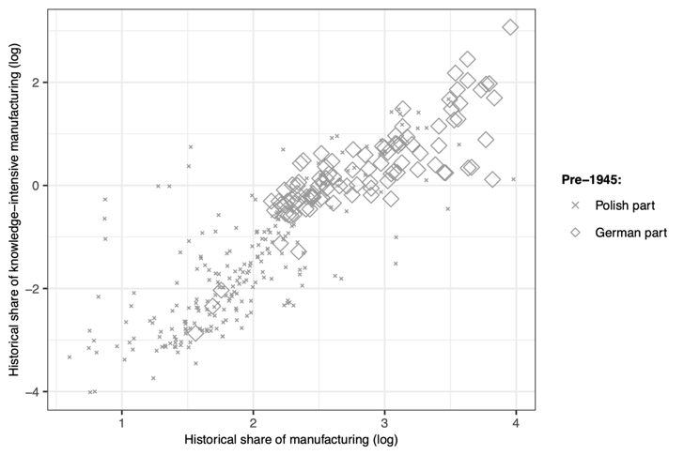
Fig. B.1 Scatter plot between the historical share of manufacturing and the historical share of knowledge-intensive manufacturing in total workforce

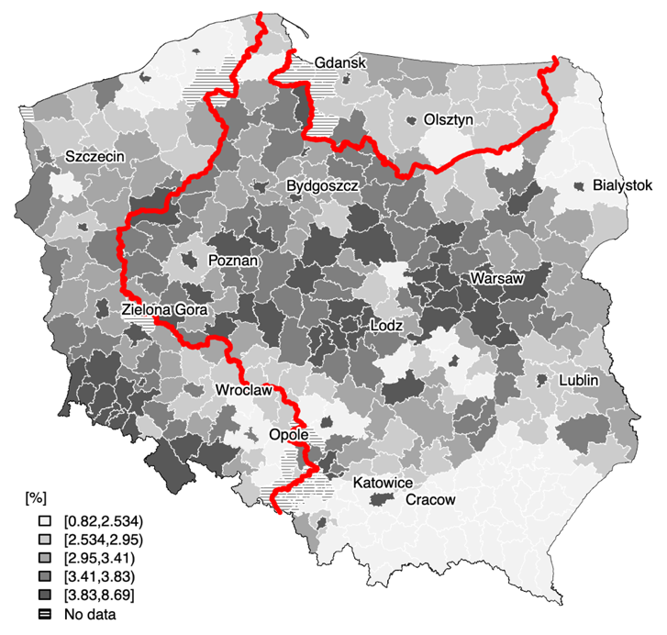
Fig. B.2 Self-employment in non-knowledge-intensive manufacturing industries per total workforce in the 1920s
Note: the bold line represents the border between the pre-1945-German and Polish territory.

(a) | (c)
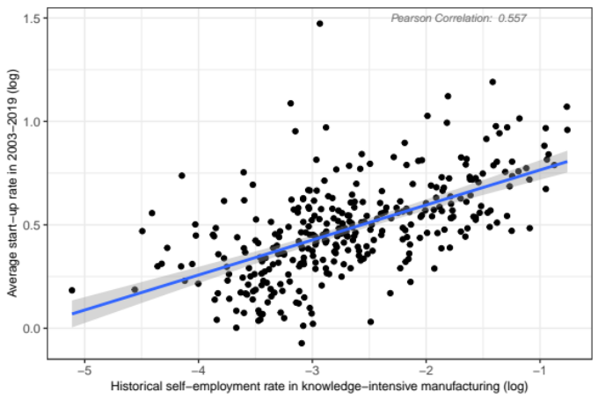 | 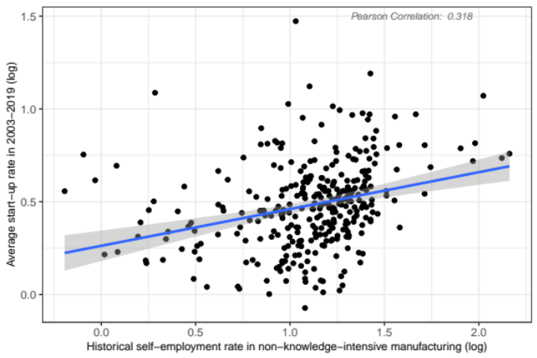
(b)
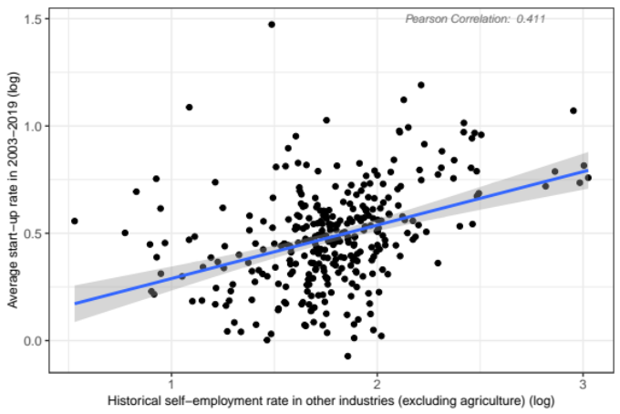
Fig. B.3 Scatter plot between the average start-up rate (log) in 2003–2019 and historical self-employment rates in knowledge-intensive manufacturing industries (a) other than knowledge-intensive industries excluding agriculture (b) non-knowledge-intensive manufacturing industries (c) per total workforce

Table B.1 (full Table 1) Differences in start-up rates across Polish counties 2003–2019: The role of historical entrepreneurship in knowledge-intensive industries
 | I | II | III | IV | V | VI
Historical self-employment in knowledge-intensive industries | 0.169*** | 0.114*** | 0.095*** | 0.114*** | 0.109*** | 0.126***
Historical self-employment in knowledge-intensive industries | (0.013) | (0.028) | (0.027) | (0.028) | (0.027) | (0.031)
Area belonged to Germany until 1945  (yes=1) |  | –0.065* | –0.204*** | –1.127*** | –4.524*** | –4.914***
Area belonged to Germany until 1945  (yes=1) |  | (0.036) | (0.057) | (0.313) | (0.895) | (0.949)
Area belonged to Russia until 1918  (yes=1) |  | –0.128*** | –0.143*** | –0.124*** | –0.084** | –0.078**
Area belonged to Russia until 1918  (yes=1) |  | (0.032) | (0.038) | (0.033) | (0.039) | (0.040)
Area belonged to Austro-Hungary until 1918  (yes=1) |  | 0.102** | 0.066 | 0.095* | 0.137*** | 0.146***
Area belonged to Austro-Hungary until 1918  (yes=1) |  | (0.051) | (0.050) | (0.056) | (0.053) | (0.053)
Workforce density |  | –0.026 | –0.016 | –0.041 | –0.023 | –0.028
Workforce density |  | (0.020) | (0.020) | (0.027) | (0.025) | (0.025)
Share of employed in manufacturing |  | 0.130*** | 0.099*** | 0.119*** | 0.068* | 0.054
Share of employed in manufacturing |  | (0.035) | (0.034) | (0.038) | (0.038) | (0.039)
Distance to the nearest university |  | –0.033** | –0.045*** | –0.046*** | –0.050*** | –0.051***
Distance to the nearest university |  | (0.014) | (0.014) | (0.016) | (0.015) | (0.015)
Distance to the nearest coal field |  | 0.037*** | 0.044*** | 0.029*** | 0.039*** | 0.038***
Distance to the nearest coal field |  | (0.008) | (0.008) | (0.011) | (0.011) | (0.011)
Share of indigenous people |  |  | –0.095*** |  | –0.994*** | –1.000***
Share of indigenous people |  |  | (0.021) |  | (0.161) | (0.161)
Share of immigrants from Russia |  |  | –0.048** |  | –0.083*** | –0.086***
Share of immigrants from Russia |  |  | (0.022) |  | (0.024) | (0.024)
Share of immigrants from other countries |  |  | 0.036* |  | 0.038* | 0.040*
Share of immigrants from other countries |  |  | (0.019) |  | (0.022) | (0.022)
Historical self-employment in knowledge-intensive industries x area belonged to Germany until 1945 (yes=1) |  |  |  |  |  | –0.083
 |  |  |  |  |  | (0.047)
Workforce density x area belonged to Germany until 1945 (yes=1) |  |  |  | 0.059 | 0.067 | (0.068)
 |  |  |  | (0.044) | (0.043) | 0.088*
Share of employed in manufacturing x area belonged to Germany until 1945 (yes=1) |  |  |  | –0.062 | –0.080 | –0.050
 |  |  |  | (0.073) | (0.076) | (0.080)
Distance to the nearest university x area belonged to Germany until 1945 (yes=1) |  |  |  | 0.213*** | 0.117* | 0.118*
 |  |  |  | (0.064) | (0.064) | (0.064)
Distance to the nearest coal field x area belonged to Germany until 1945 (yes=1) |  |  |  | –0.009 | –0.015 | –0.012
 |  |  |  | (0.018) | (0.017) | (0.018)
Share of indigenous people x area belonged to Germany until 1945 (yes=1) |  |  |  |  | 0.894*** | 0.891***
 |  |  |  |  | (0.163) | (0.163)
Share of immigrants from Russia x area belonged to Germany until 1945 (yes=1) |  |  |  |  | –0.036 | –0.023
 |  |  |  |  | (0.106) | (0.106)
Share of immigrants from other countries x area belonged to Germany until 1945 (yes=1) |  |  |  |  | –0.015 | –0.014
 |  |  |  |  | (0.046) | (0.045)
Constant | 0.935*** | 0.638*** | 1.168*** | 0.809*** | 5.378*** | 5.507***
Constant | (0.036) | (0.175) | (0.193) | (0.209) | (0.767) | (0.774)
Number of observations | 328 | 328 | 328 | 328 | 328 | 328
R² | 0.346 | 0.442 | 0.502 | 0.466 | 0.566 | 0.568
Adjusted R² | 0.344 | 0.428 | 0.485 | 0.445 | 0.540 | 0.541
Notes: The dependent variable is the average start-up rate (log) in 2003–2019. Number of observations is N=328. Pre-war controls are workforce density, the share in employed in the manufacturing, the distance to universities and the distance to coal mines. Migration controls following WWII include the share of indigenous people, immigrants from Russia, and immigrants from other countries. In all models, we include a dummy variable that controls whether a region was part of Austria before 1918 and a dummy variable that controls whether a region was part of Russia before 1918 (reference group: regions that belonged to Prussia before 1918). All independent variables except dummies are in logs. Constant is not shown for brevity. Robust standard errors are shown in parentheses. ***Statistically significant at the 1% level; **statistically significant at the 5% level, *statistically significant at the 10% level.
Table B.2 (full Table 2): Differences in start-up rates across Polish counties 2003–2019: The role of historical entrepreneurship in other than knowledge-intensive industries (excluding self-employment in agriculture)
 | I | II | III | IV | V | VI
Historical self-employment in other than knowledge-intensive industries | 0.249*** | 0.074 | 0.057 | 0.059 | 0.033 | –0.063
 | (0.033) | (0.058) | (0.056) | (0.059) | (0.057) | (0.067)
Area belonged to Germany until 1945  (yes=1) |  | –0.020 | –0.194*** | –1.016*** | –4.126*** | –4.357***
Area belonged to Germany until 1945  (yes=1) |  | (0.038) | (0.060) | (0.320) | (0.911) | (0.907)
Area belonged to Russia until 1918  (yes=1) |  | –0.167*** | –0.175*** | –0.164*** | –0.124*** | –0.126***
Area belonged to Russia until 1918  (yes=1) |  | (0.032) | (0.038) | (0.032) | (0.039) | (0.038)
Area belonged to Austro-Hungary until 1918  (yes=1) |  | 0.079 | 0.044 | 0.064 | 0.097* | 0.060
Area belonged to Austro-Hungary until 1918  (yes=1) |  | (0.055) | (0.054) | (0.060) | (0.057) | (0.058)
Workforce density |  | –0.014 | –0.005 | –0.020 | 0.001 | 0.019
Workforce density |  | (0.021) | (0.020) | (0.029) | (0.027) | (0.027)
Share of employed in manufacturing |  | 0.185*** | 0.144*** | 0.183*** | 0.143*** | 0.181***
Share of employed in manufacturing |  | (0.035) | (0.035) | (0.039) | (0.038) | (0.041)
Distance to the nearest university |  | –0.030** | –0.044*** | –0.041** | –0.044*** | –0.044***
Distance to the nearest university |  | (0.015) | (0.014) | (0.016) | (0.015) | (0.015)
Distance to the nearest coal field |  | 0.040*** | 0.046*** | 0.034*** | 0.040*** | 0.041***
Distance to the nearest coal field |  | (0.008) | (0.009) | (0.011) | (0.011) | (0.011)
Share of indigenous people |  |  |  | –0.105*** |  | –0.951***
Share of indigenous people |  |  | (0.021) |  | (0.165) | (0.163)
Share of immigrants from Russia |  |  | –0.043* |  | –0.069*** | –0.064***
Share of immigrants from Russia |  |  | (0.022) |  | (0.025) | (0.025)
Share of immigrants from other countries |  |  | 0.033* |  | 0.025 | 0.015
Share of immigrants from other countries |  |  | (0.020) |  | (0.023) | (0.023)
Historical self-employment in other than knowledge-intensive industries x area belonged to Germany until 1945 (yes=1) |  |  |  |  |  | 0.319***
 |  |  |  |  |  | (0.123)
Workforce density x area belonged to Germany until 1945 (yes=1) |  |  |  | 0.050 | 0.065 | 0.019
 |  |  |  | (0.045) | (0.045) | (0.048)
Share of employed in manufacturing x area belonged to Germany until 1945 (yes=1) |  |  |  | –0.081 | –0.133* | –0.210**
 |  |  |  | (0.074) | (0.078) | (0.082)
Distance to the nearest university x area belonged to Germany until 1945 (yes=1) |  |  |  | 0.218*** | 0.111* | 0.108*
 |  |  |  | (0.065) | (0.066) | (0.065)
Distance to the nearest coal field x area belonged to Germany until 1945 (yes=1) |  |  |  | –0.011 | –0.012 | –0.018
 |  |  |  | (0.018) | (0.018) | (0.018)
Share of indigenous people x area belonged to Germany until 1945 (yes=1) |  |  |  |  | 0.838*** | 0.861***
 |  |  |  |  | (0.167) | (0.166)
Share of immigrants from Russia x area belonged to Germany until 1945 (yes=1) |  |  |  |  | –0.034 | –0.045
 |  |  |  |  | (0.108) | (0.108)
Share of immigrants from other countries x area belonged to Germany until 1945 (yes=1) |  |  |  |  | 0.004 | 0.017
 |  |  |  |  | (0.047) | (0.046)
Constant | 0.040 | 0.015 | 0.698*** | 0.144 | 4.524*** | 4.577***
Constant | (0.060) | (0.113) | (0.161) | (0.139) | (0.757) | (0.750)
Number of observations | 328 | 328 | 328 | 328 | 328 | 328
R² | 0.146 | 0.416 | 0.484 | 0.439 | 0.544 | 0.553
Adjusted R² | 0.143 | 0.401 | 0.466 | 0.418 | 0.517 | 0.526
Notes: As in Table B.1.

Table B.3 (full Table 3): Differences in start-up rates across Polish counties 2003–2019: The role of historical entrepreneurship in non-knowledge-intensive manufacturing industries
 | I | II | III | IV | V | VI
Historical self-employment in non-knowledge-intensive manufacturing industries | 0.198*** | –0.026 | –0.033 | –0.056 | –0.074 | –0.124
 | (0.036) | (0.065) | (0.062) | (0.068) | (0.064) | (0.078)
Area belonged to Germany until 1945  (yes=1) |  | –0.040 | –0.219*** | –1.013*** | –4.193*** | –4.191***
Area belonged to Germany until 1945  (yes=1) |  | (0.042) | (0.061) | (0.320) | (0.912) | (0.912)
Area belonged to Russia until 1918  (yes=1) |  | –0.164*** | –0.177*** | –0.163*** | –0.132*** | –0.137***
Area belonged to Russia until 1918  (yes=1) |  | (0.032) | (0.038) | (0.032) | (0.039) | (0.039)
Area belonged to Austro-Hungary until 1918  (yes=1) |  | 0.042 | 0.007 | 0.013 | 0.043 | 0.016
Area belonged to Austro-Hungary until 1918  (yes=1) |  | (0.060) | (0.059) | (0.066) | (0.063) | (0.067)
Workforce density |  | –0.005 | 0.003 | –0.004 | 0.015 | 0.020
Workforce density |  | (0.020) | (0.019) | (0.027) | (0.025) | (0.026)
Share of employed in manufacturing |  | 0.221*** | 0.176*** | 0.225*** | 0.184*** | 0.204***
Share of employed in manufacturing |  | (0.037) | (0.036) | (0.041) | (0.040) | (0.043)
Distance to the nearest university |  | –0.033** | –0.047*** | –0.041** | –0.043*** | –0.043***
Distance to the nearest university |  | (0.015) | (0.014) | (0.016) | (0.015) | (0.015)
Distance to the nearest coal field |  | 0.044*** | 0.049*** | 0.038*** | 0.041*** | 0.042***
Distance to the nearest coal field |  | (0.008) | (0.009) | (0.011) | (0.011) | (0.011)
Share of indigenous people |  |  | –0.110*** |  | –0.967*** | –0.976***
Share of indigenous people |  |  | (0.021) |  | (0.165) | (0.165)
Share of immigrants from Russia |  |  | –0.041* |  | –0.068*** | –0.068***
Share of immigrants from Russia |  |  | (0.022) |  | (0.025) | (0.025)
Share of immigrants from other countries |  |  | 0.027 |  | 0.014 | 0.010
Share of immigrants from other countries |  |  | (0.020) |  | (0.023) | (0.023)
Historical self-employment in non-knowledge-intensive manufacturing industries x area belonged to Germany until 1945 (yes=1) |  |  |  |  |  | 0.159
 |  |  |  |  |  | (0.139)
Workforce density x area belonged to Germany until 1945 (yes=1) |  |  |  | 0.039 | 0.054 | 0.051
 |  |  |  | (0.046) | (0.045) | (0.045)
Share of employed in manufacturing x area belonged to Germany until 1945 (yes=1) |  |  |  | –0.092 | –0.151* | –0.197**
 |  |  |  | (0.074) | (0.077) | (0.086)
Distance to the nearest university x area belonged to Germany until 1945 (yes=1) |  |  |  | 0.227*** | 0.118* | 0.107
 |  |  |  | (0.065) | (0.066) | (0.067)
Distance to the nearest coal field x area belonged to Germany until 1945 (yes=1) |  |  |  | –0.014 | –0.012 | –0.014
 |  |  |  | (0.018) | (0.018) | (0.018)
Share of indigenous people x area belonged to Germany until 1945 (yes=1) |  |  |  |  | 0.853*** | 0.861***
 |  |  |  |  | (0.167) | (0.167)
Share of immigrants from Russia x area belonged to Germany until 1945 (yes=1) |  |  |  |  | –0.029 | –0.037
 |  |  |  |  | (0.108) | (0.109)
Share of immigrants from other countries x area belonged to Germany until 1945 (yes=1) |  |  |  |  | 0.017 | 0.018
 |  |  |  |  | (0.047) | (0.047)
Constant | 0.263*** | 0.071 | 0.766*** | 0.161 | 4.593*** | 4.628***
Constant | (0.042) | (0.110) | (0.157) | (0.138) | (0.756) | (0.757)
Number of observations | 328 | 328 | 328 | 328 | 328 | 328
R² | 0.085 | 0.413 | 0.483 | 0.439 | 0.545 | 0.547
Adjusted R² | 0.082 | 0.398 | 0.465 | 0.417 | 0.519 | 0.519
Notes: As in Table B.1.

Table B.4 Differences in start-up rates across Polish counties 2003–2019: The role of historical entrepreneurship in general
 | I | II | III | IV | V | VI
Historical self-employment in general (outside agriculture) | 0.252*** | 0.077 | 0.058 | 0.063 | 0.036 | –0.056
Historical self-employment in general (outside agriculture) | (0.033) | (0.057) | (0.056) | (0.059) | (0.057) | (0.067)
Area belonged to Germany until 1945  (yes=1) |  | –0.020 | –0.193*** | –1.017*** | –4.128*** | –4.351***
Area belonged to Germany until 1945  (yes=1) |  | (0.037) | (0.060) | (0.320) | (0.911) | (0.908)
Area belonged to Russia until 1918  (yes=1) |  | –0.167*** | –0.175*** | –0.164*** | –0.124*** | –0.126***
Area belonged to Russia until 1918  (yes=1) |  | (0.032) | (0.038) | (0.032) | (0.039) | (0.039)
Area belonged to Austro-Hungary until 1918  (yes=1) |  | 0.080 | 0.044 | 0.066 | 0.098* | 0.062
Area belonged to Austro-Hungary until 1918  (yes=1) |  | (0.054) | (0.054) | (0.060) | (0.057) | (0.058)
Workforce density |  | –0.015 | –0.005 | –0.021 | 0.0002 | 0.018
Workforce density |  | (0.021) | (0.020) | (0.029) | (0.027) | (0.028)
Share of employed in manufacturing |  | 0.184*** | 0.143*** | 0.181*** | 0.142*** | 0.178***
Share of employed in manufacturing |  | (0.036) | (0.035) | (0.039) | (0.038) | (0.041)
Distance to the nearest university |  | –0.030** | –0.044*** | –0.041** | –0.044*** | –0.044***
Distance to the nearest university |  | (0.015) | (0.014) | (0.016) | (0.015) | (0.015)
Distance to the nearest coal field |  | 0.040*** | 0.046*** | 0.034*** | 0.040*** | 0.041***
Distance to the nearest coal field |  | (0.008) | (0.009) | (0.011) | (0.011) | (0.011)
Share of indigenous people |  |  | –0.105*** |  | –0.951*** | –0.960***
Share of indigenous people |  |  | (0.021) |  | (0.165) | (0.163)
Share of immigrants from Russia |  |  | –0.043* |  | –0.069*** | –0.065***
Share of immigrants from Russia |  |  | (0.022) |  | (0.025) | (0.025)
Share of immigrants from other countries |  |  | 0.033* |  | 0.026 | 0.015
Share of immigrants from other countries |  |  | (0.020) |  | (0.023) | (0.023)
Historical self-employment in knowledge-intensive industries x area belonged to Germany until 1945 (yes=1) |  |  |  |  |  | 0.309**
 |  |  |  |  |  | (0.123)
Workforce density x area belonged to Germany until 1945 (yes=1) |  |  |  |  |  | 0.020
 |  |  |  |  |  | (0.048)
Share of employed in manufacturing x area belonged to Germany until 1945 (yes=1) |  |  |  | –0.081 | –0.133* | –0.208**
 |  |  |  | (0.074) | (0.078) | (0.082)
Distance to the nearest university x area belonged to Germany until 1945 (yes=1) |  |  |  | 0.217*** | 0.111* | 0.109*
 |  |  |  | (0.065) | (0.066) | (0.065)
Distance to the nearest coal field x area belonged to Germany until 1945 (yes=1) |  |  |  | –0.011 | –0.012 | –0.018
 |  |  |  | (0.018) | (0.018) | (0.018)
Share of indigenous people x area belonged to Germany until 1945 (yes=1) |  |  |  |  | 0.838*** | 0.861***
 |  |  |  |  | (0.167) | (0.166)
Share of immigrants from Russia x area belonged to Germany until 1945 (yes=1) |  |  |  |  | –0.034 | –0.045
 |  |  |  |  | (0.108) | (0.108)
Share of immigrants from other countries x area belonged to Germany until 1945 (yes=1) |  |  |  |  | 0.004 | 0.016
 |  |  |  |  | (0.047) | (0.047)
Constant | 0.031 | 0.013 | 0.697*** | 0.143 | 4.523*** | 4.572***
Constant | (0.060) | (0.112) | (0.161) | (0.139) | (0.757) | (0.751)
Number of observations | 328 | 328 | 328 | 328 | 328 | 328
R2 | 0.153 | 0.416 | 0.485 | 0.440 | 0.544 | 0.553
Adjusted R2 | 0.150 | 0.401 | 0.467 | 0.418 | 0.517 | 0.525
Notes: As in Table B.1.

Table B.5 Differences in start-up rates across Polish counties 2012–2019: The role of historical entrepreneurship in knowledge-intensive industries
 | I | II | III | IV | V | VI
Historical self-employment in knowledge-intensive industries | 0.138*** | 0.081*** | 0.057** | 0.085*** | 0.074** | 0.089***
Historical self-employment in knowledge-intensive industries | (0.014) | (0.030) | (0.029) | (0.030) | (0.029) | (0.033)
Area belonged to Germany until 1945  (yes=1) |  | –0.053 | –0.236*** | –1.261*** | –4.954*** | –5.315***
Area belonged to Germany until 1945  (yes=1) |  | (0.039) | (0.060) | (0.337) | (0.961) | (1.020)
Area belonged to Russia until 1918  (yes=1) |  | –0.130*** | –0.132*** | –0.129*** | –0.085** | –0.079*
Area belonged to Russia until 1918  (yes=1) |  | (0.035) | (0.041) | (0.035) | (0.042) | (0.042)
Area belonged to Austro-Hungary until 1918  (yes=1) |  | 0.110** | 0.076 | 0.098 | 0.141** | 0.148***
Area belonged to Austro-Hungary until 1918  (yes=1) |  | (0.055) | (0.053) | (0.060) | (0.056) | (0.057)
Workforce density |  | –0.020 | –0.010 | –0.038 | –0.018 | –0.023
Workforce density |  | (0.022) | (0.021) | (0.029) | (0.027) | (0.027)
Share of employed in manufacturing |  | 0.129*** | 0.094*** | 0.104** | 0.056 | 0.043
Share of employed in manufacturing |  | (0.037) | (0.036) | (0.041) | (0.040) | (0.042)
Distance to the nearest university |  | –0.042*** | –0.057*** | –0.061*** | –0.064*** | –0.065***
Distance to the nearest university |  | (0.015) | (0.015) | (0.017) | (0.016) | (0.016)
Distance to the nearest coal field |  | 0.039*** | 0.049*** | 0.032*** | 0.041*** | 0.041***
Distance to the nearest coal field |  | (0.009) | (0.009) | (0.012) | (0.012) | (0.012)
Share of indigenous people |  |  | –0.105*** |  | –1.041*** | –1.046***
Share of indigenous people |  |  | (0.022) |  | (0.173) | (0.173)
Share of immigrants from Russia |  |  | –0.040* |  | –0.080*** | –0.083***
Share of immigrants from Russia |  |  | (0.024) |  | (0.026) | (0.026)
Share of immigrants from other countries |  |  | 0.046** |  | 0.038 | 0.040*
Share of immigrants from other countries |  |  | (0.020) |  | (0.023) | (0.024)
Historical self-employment in knowledge-intensive industries x area belonged to Germany until 1945 (yes=1) |  |  |  |  |  | –0.077
 |  |  |  |  |  | (0.073)
Workforce density x area belonged to Germany until 1945 (yes=1) |  |  |  | 0.047 | 0.052 | 0.071
 |  |  |  | (0.047) | (0.047) | (0.050)
Share of employed in manufacturing x area belonged to Germany until 1945 (yes=1) |  |  |  | –0.008 | –0.045 | –0.016
 |  |  |  | (0.078) | (0.082) | (0.086)
Distance to the nearest university x area belonged to Germany until 1945 (yes=1) |  |  |  | 0.222*** | 0.138** | 0.139**
 |  |  |  | (0.068) | (0.069) | (0.069)
Distance to the nearest coal field x area belonged to Germany until 1945 (yes=1) |  |  |  | –0.007 | –0.007 | –0.004
 |  |  |  | (0.019) | (0.019) | (0.019)
Share of indigenous people x area belonged to Germany until 1945 (yes=1) |  |  |  |  | 0.952*** | 0.949***
 |  |  |  |  | (0.175) | (0.175)
Share of immigrants from Russia x area belonged to Germany until 1945 (yes=1) |  |  |  |  | –0.033 | –0.021
 |  |  |  |  | (0.114) | (0.114)
Share of immigrants from other countries x area belonged to Germany until 1945 (yes=1) |  |  |  |  | 0.027 | 0.028
 |  |  |  |  | (0.049) | (0.049)
Constant | 0.903*** | 0.610*** | 1.178*** | 0.854*** | 5.591*** | 5.710***
Constant | (0.039) | (0.188) | (0.205) | (0.224) | (0.823) | (0.831)
Number of observations | 328 | 328 | 328 | 328 | 328 | 328
R² | 0.235 | 0.346 | 0.426 | 0.373 | 0.491 | 0.493
Adjusted R² | 0.232 | 0.330 | 0.406 | 0.349 | 0.461 | 0.461
Notes: The dependent variable is the average start-up rate (log) in 2012–2019. Other notes are given in Table B.1.

