Online Appendix
Appendix A: Descriptive statistics for the treated and control firms

Panel A: Eligible and non-eligible firms
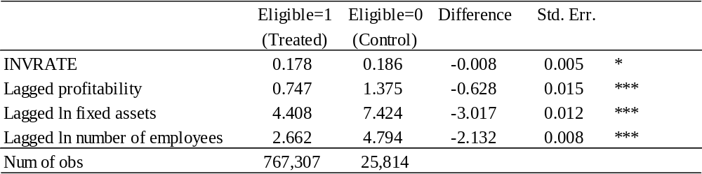

Panel B: 2014 users and non-eligible firms
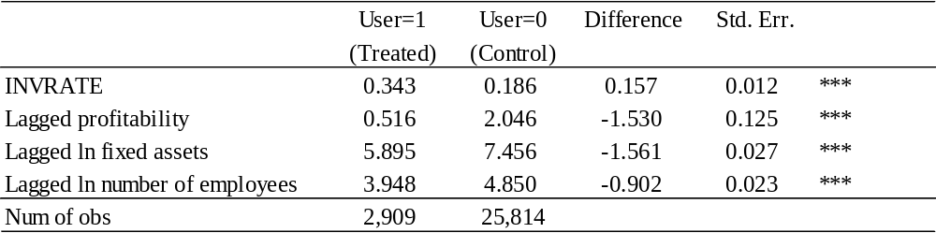

Panel C: 2015 users and non-eligible firms
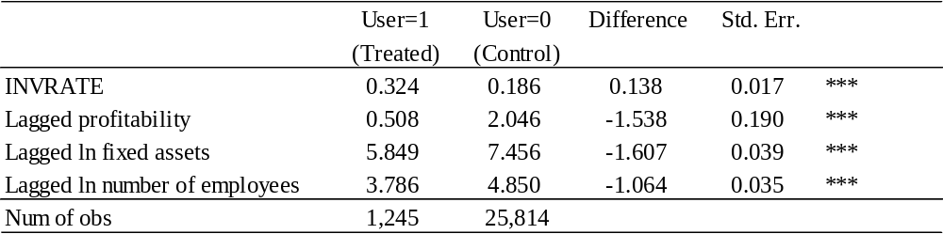
Notes: INVRATE is defined as investment divided by the lagged tangible fixed assets. Eligible is a dummy that takes one if firm i is eligible to use the SME tax incentive and zero otherwise. User is a dummy variable that takes one if firm i first used the tax incentive in 2014 (or 2015) and zero if it is not eligible to use the tax incentive. Profitability is the operating profit divided by the tangible fixed assets. The null hypothesis that the difference between Eligible (User)=1 and Eligible (User)=0 is zero is tested. ***, **, and * indicates statistical significance at the 1%, 5%, and 10% level respectively.

Appendix B: Treatment effect of the tax incentive on investment rate in each year: the results from using first use as the treatment.

Panel A: 2016 users
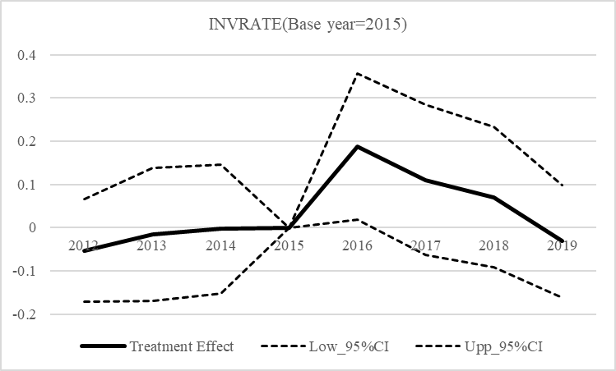

Panel B: 2017 users
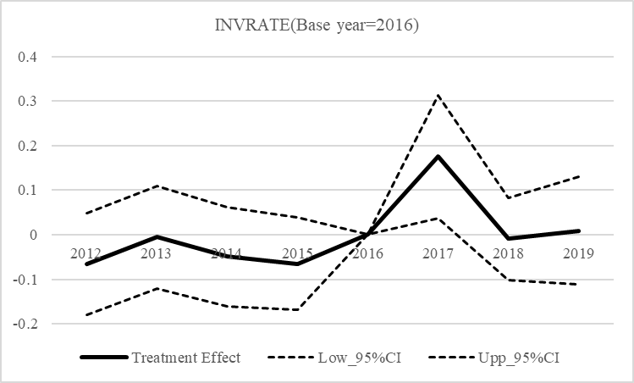

Panel C: 2018 users
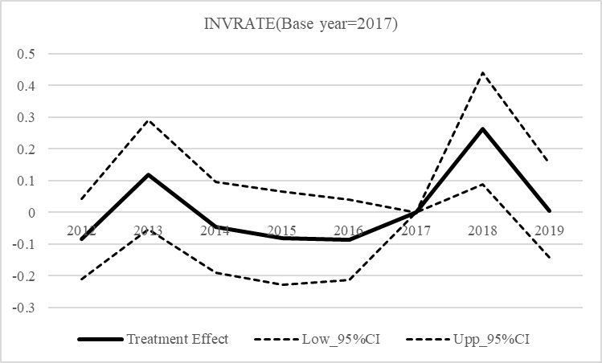

Panel D: 2019 users
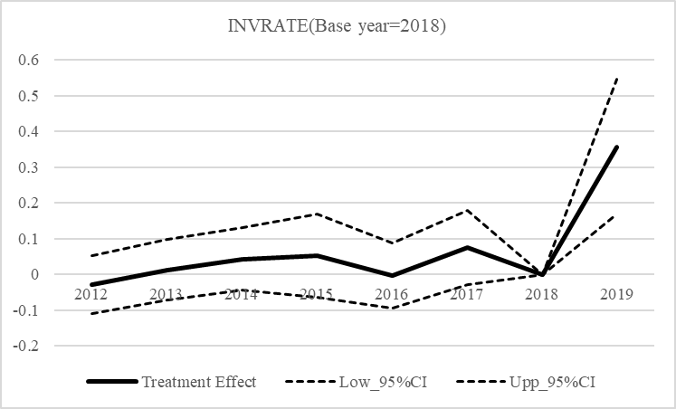
Notes: Treatment group consists of firms that first used the tax incentive in 2016 in Panel A, 2017 in Panel B, 2018 in Panel C, and 2019 in Panel D. We estimate the treatment effect of the tax incentive on investment rate for each year using Equation (2).

Appendix C: GMM estimation for first-differenced model

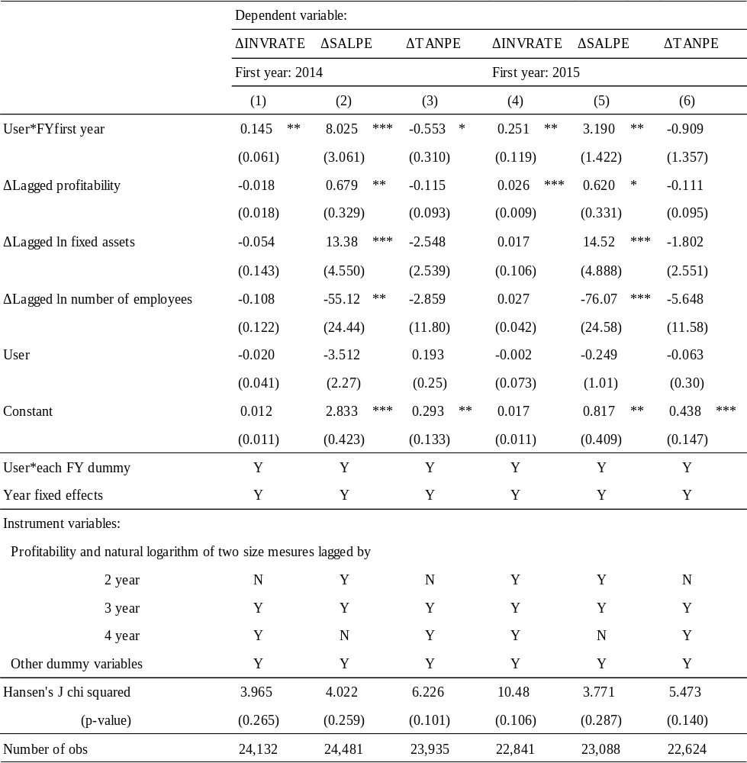
Notes: Treatment group consists of the firms that first used the tax incentive either in 2014 or 2015. INVRATE is defined as investment divided by the lagged tangible fixed assets. SALPE and TANPE represent sales per employee and tangible fixed assets per employee, respectively. User is a dummy variable that takes one if firm i first used the tax incentive in 2014 (or 2015) and zero if it is not eligible to use the tax incentive. FYfirst year is a dummy variable that takes one if fiscal year t is 2014 in columns (1) to (3) and 2015 in columns (4) to (6) while it is zero otherwise. Profitability is the operating profit divided by the tangible fixed assets. ***, **, and * indicate statistical significance at the 1%, 5%, and 10% levels, respectively. Clustered robust standard errors are in the parentheses.

Appendix D: Heterogeneous treatment effects on labor productivity that depend on financial constraints

Panel A1: Short-run effects for 2014 users
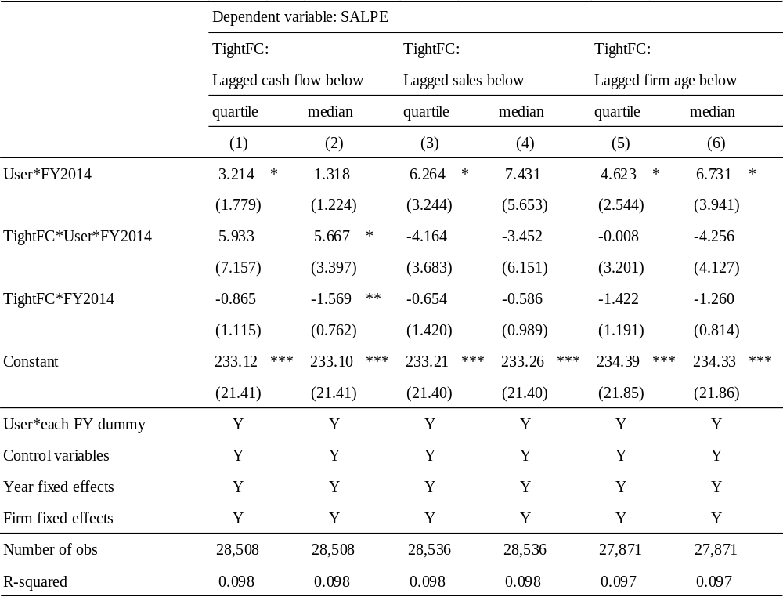

Panel A2: Short-run effects for 2015 users
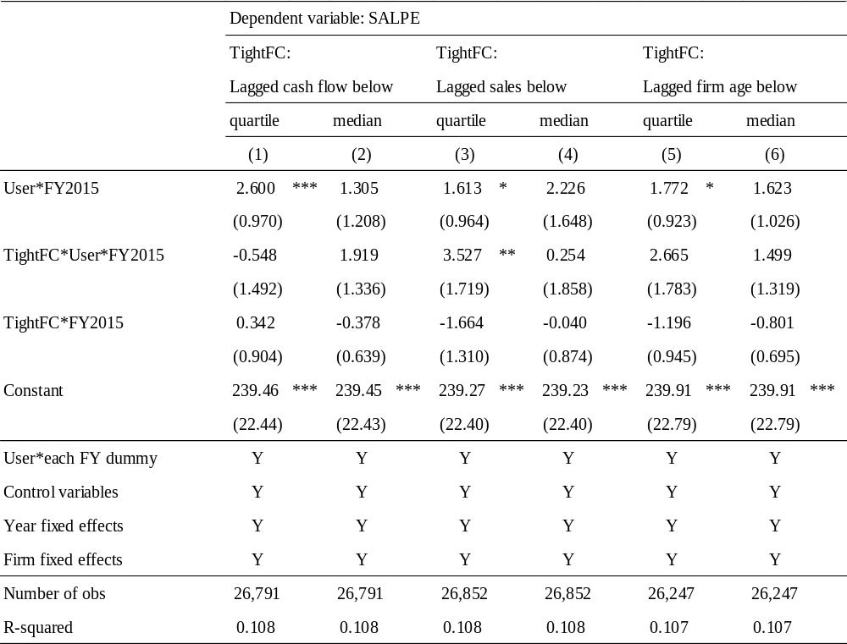

Panel B1: Long-run effects for 2014 users
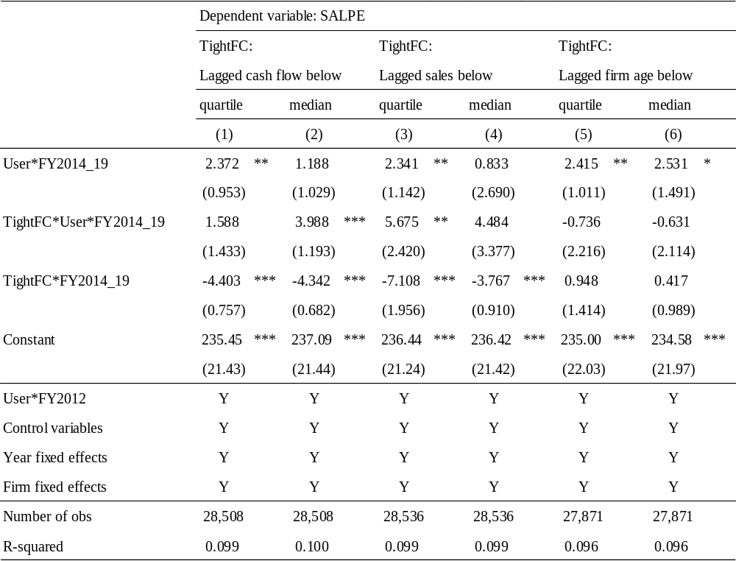

Panel B2: Long-run effects for 2015 users
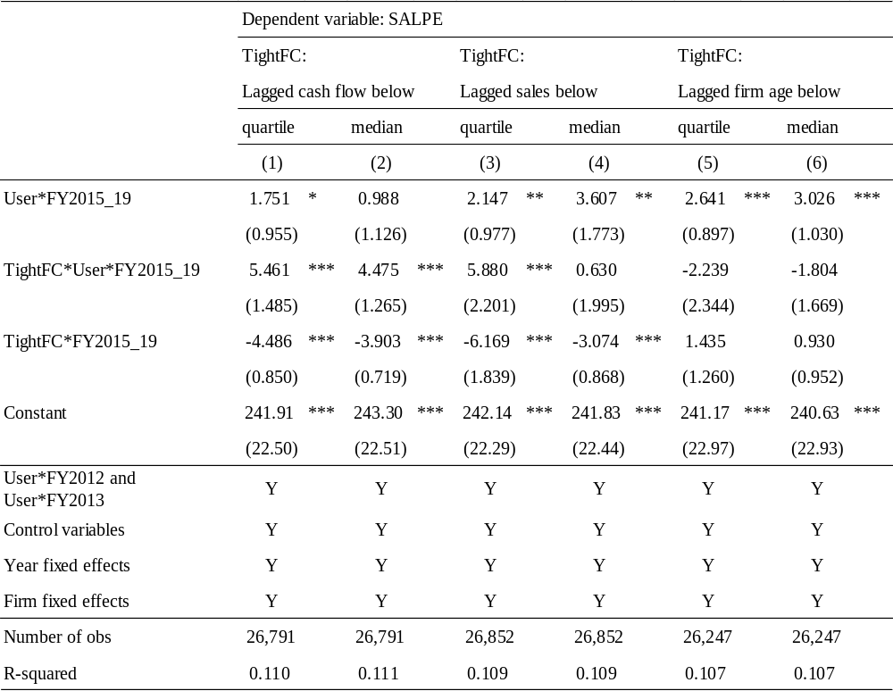
Notes: Treatment groups consist of the firms that first used the tax incentive in 2014 in Panels A1 and B1 and 2015 in Panels A2 and B2. SALPE is sales per employees. User is a dummy variable that takes one if firm i first used the tax incentive in 2014 (or 2015) and zero if it is not eligible to use the tax incentive. FY2014 is a dummy that takes one if year t is fiscal year 2014 and zero otherwise. FY2014_19 is a dummy that takes one if year t is between fiscal year 2014 and 2019 and zero otherwise. FY2015 and FY2015_19 are similarly defined. TightFC is a dummy that takes one if the proxy for a financial constraint is less than the threshold of each year and zero otherwise. Cash flow is defined as the sum of operating profit and depreciation. Firm age is defined as difference between the present year t and the founding year of the firm. Control variables are the lagged operating profit divided by the lagged tangible fixed assets, the lagged natural logarithm of one plus fixed assets, and the lagged natural logarithm of one plus number of employees. ***, **, and * indicate statistical significance at the 1%, 5%, and 10% levels respectively. Clustered robust standard errors are in parentheses.

