GRAPH A. NETWORK EMBEDDEDNESS - BARCELONA
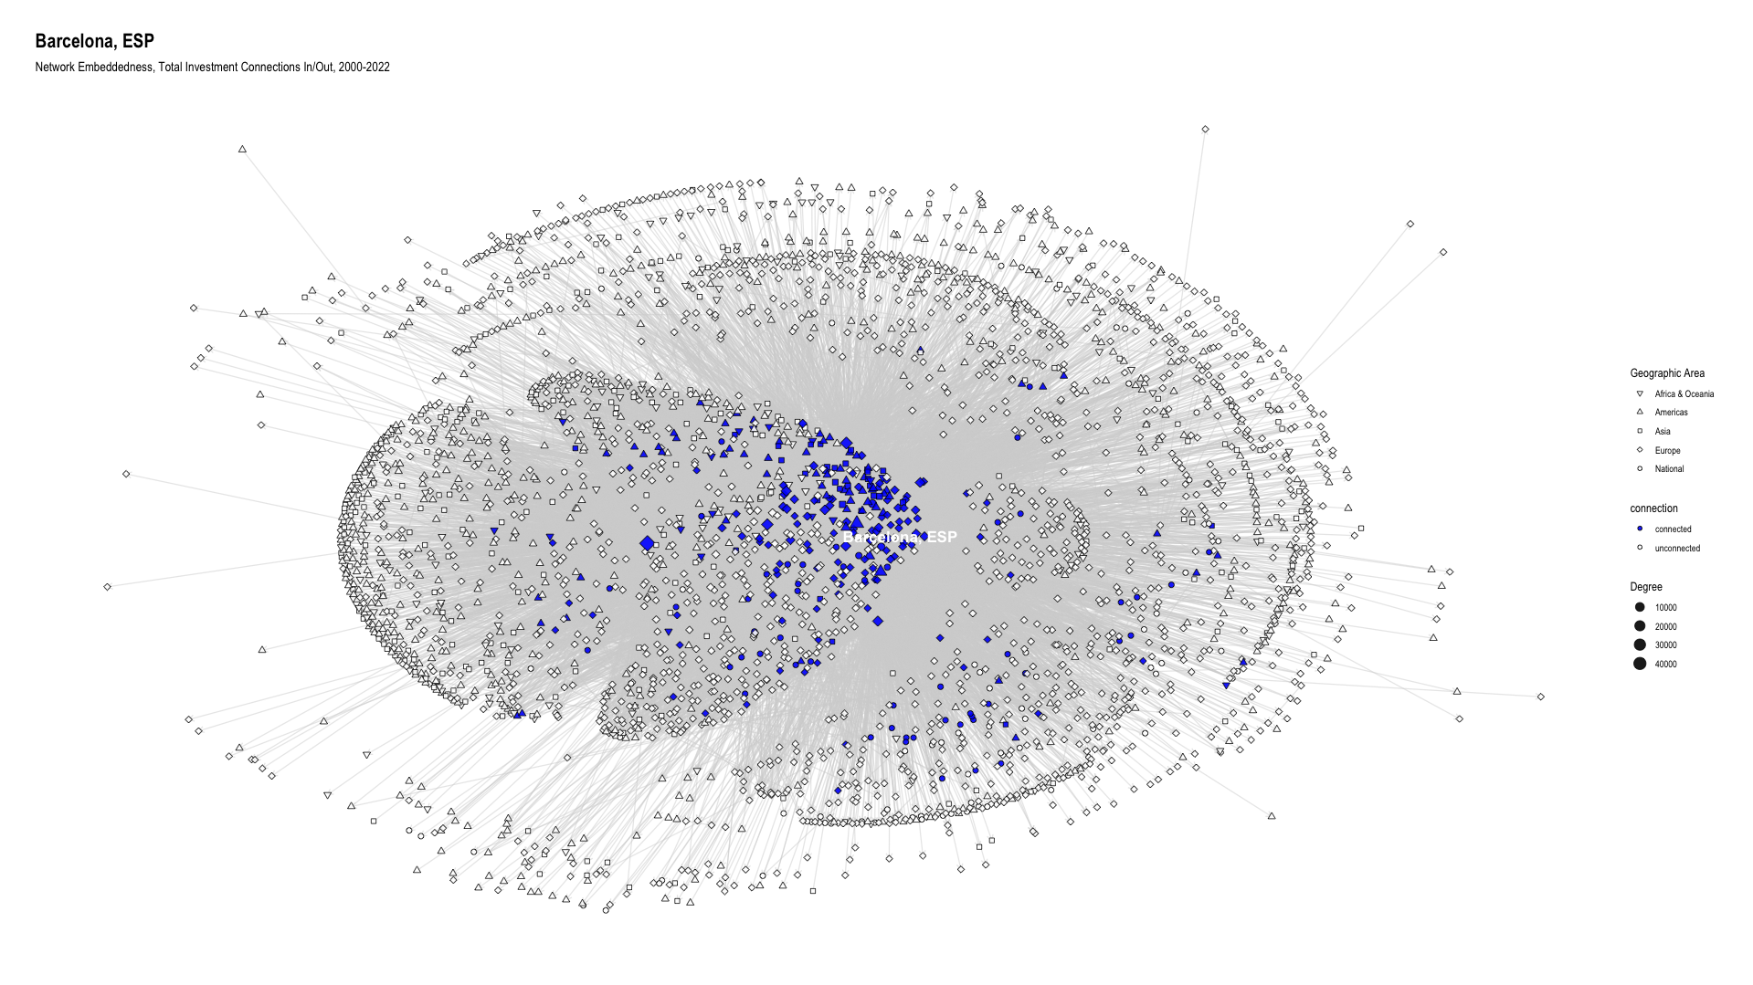

GRAPH B. NETWORK EMBEDDEDNESS - BERLIN
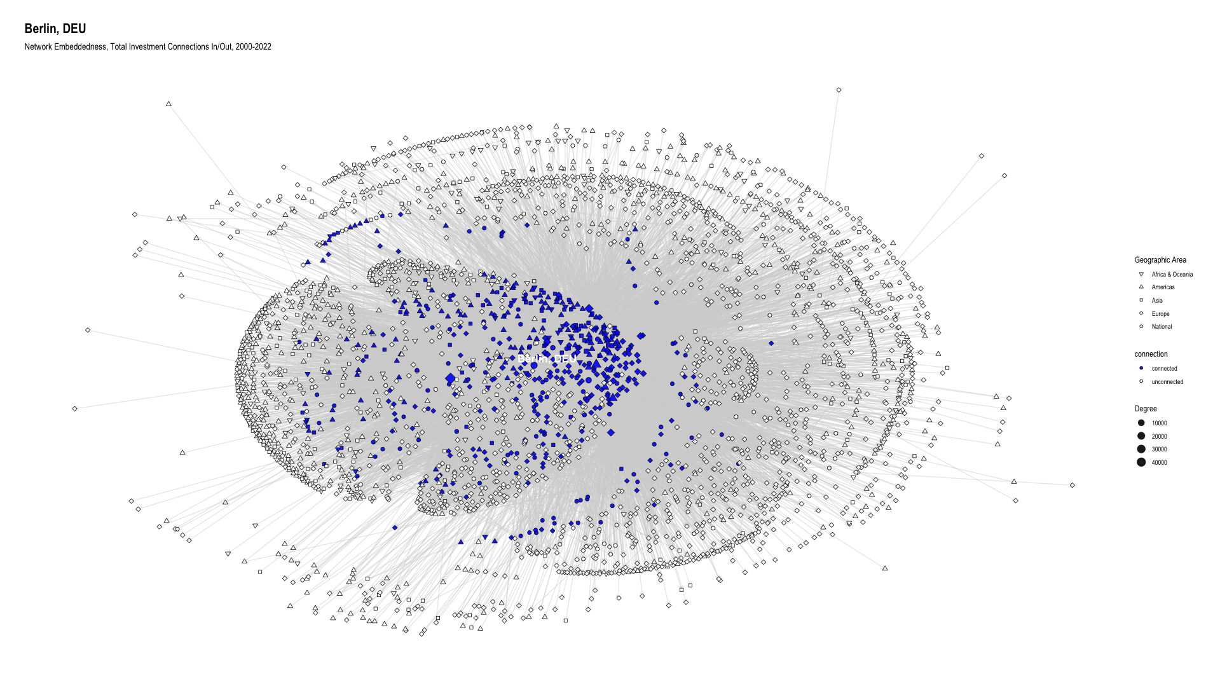

GRAPH C. NETWORK EMBEDDEDNESS - KRAKOW
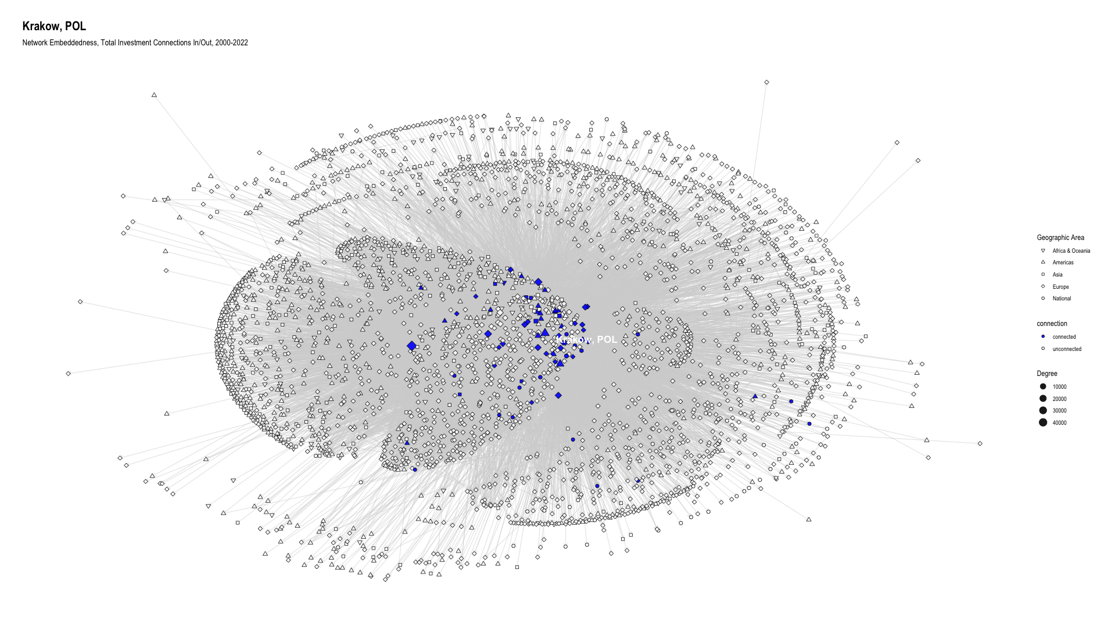

GRAPH D. NETWORK EMBEDDEDNESS - LONDON
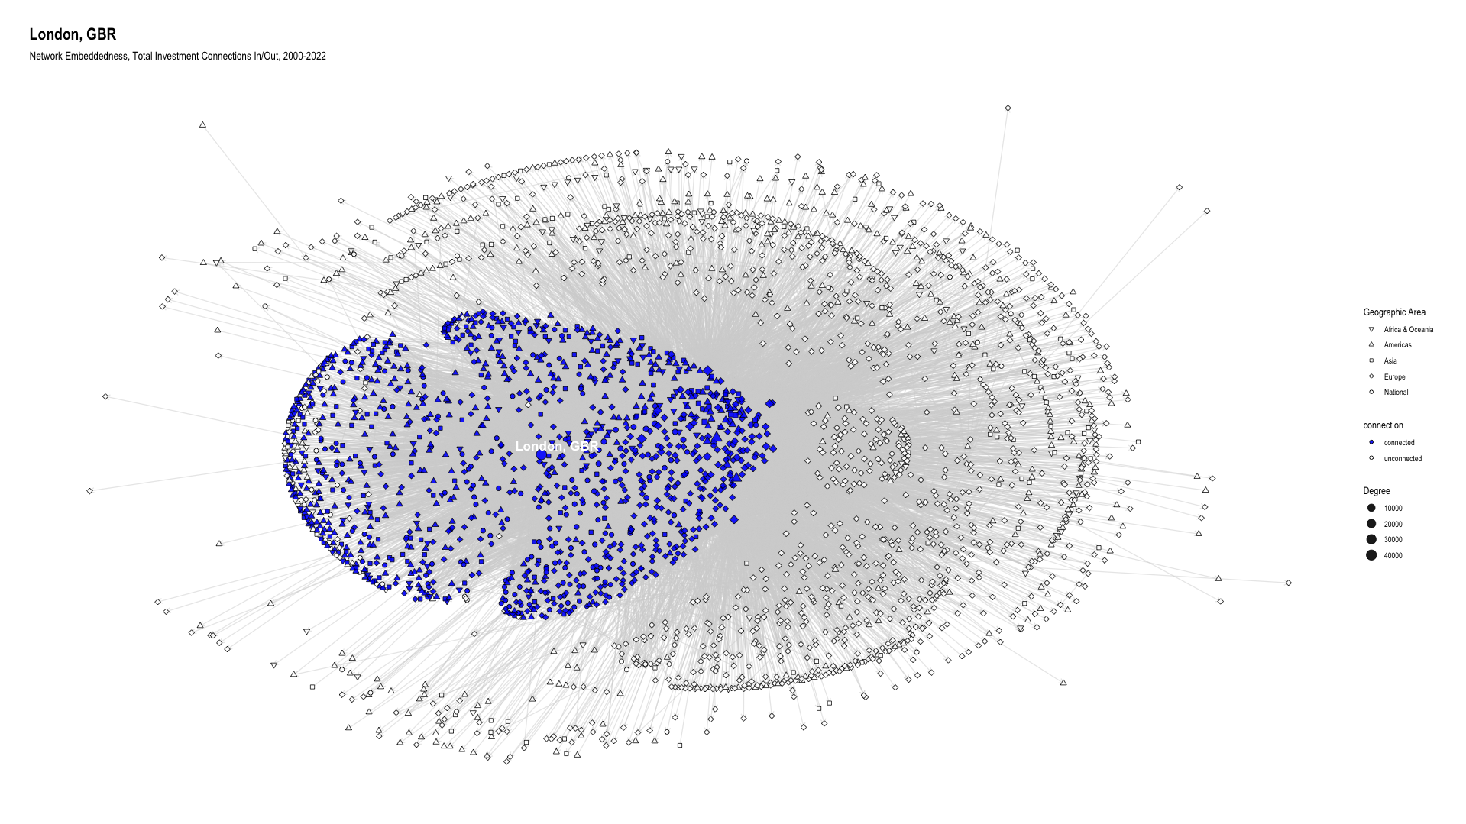

GRAPH E. NETWORK EMBEDDEDNESS - PARIS
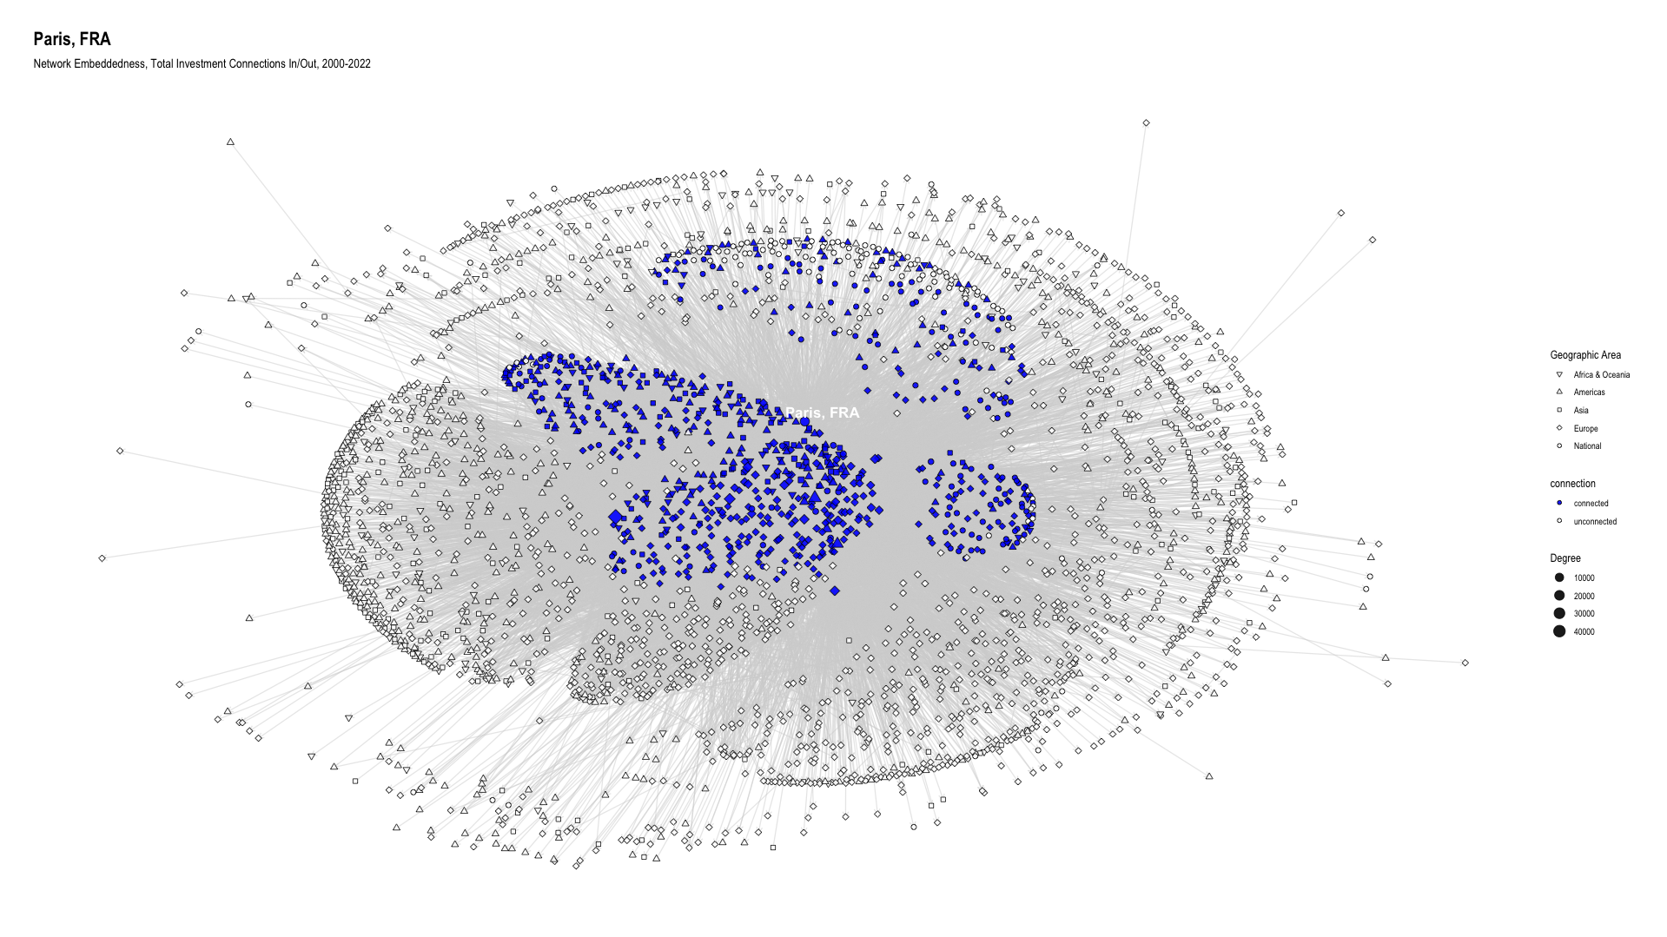

GRAPH F. NETWORK EMBEDDEDNESS - STOCKHOLM
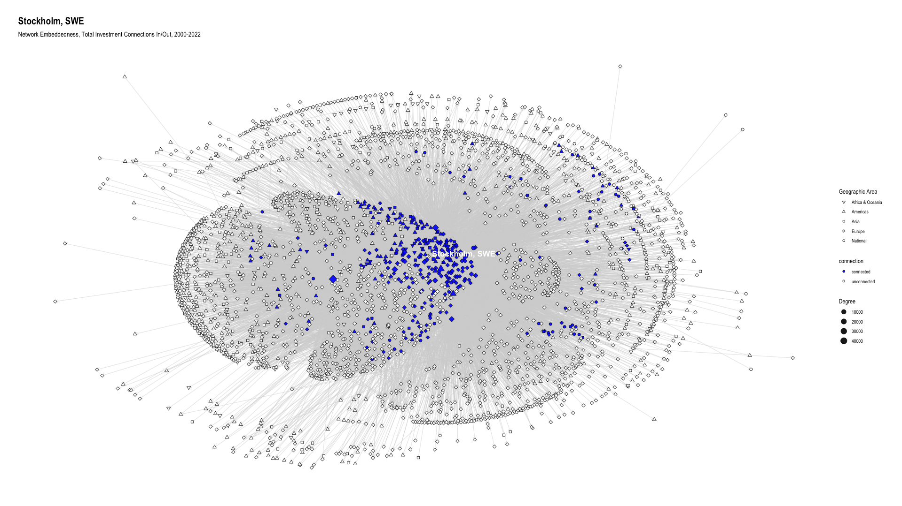

GRAPH G. TWO-DIMENSIONAL CLUSTER VISUALIZATIONS
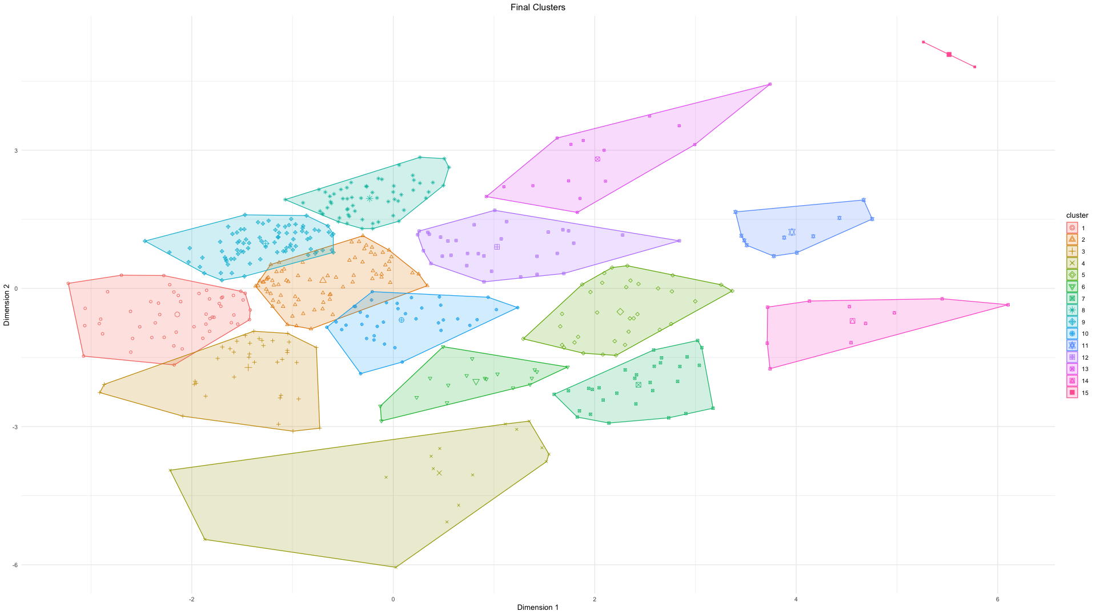

GRAPH H. TWO-DIMENSIONAL CLUSTER VISUALIZATIONS WITH SELECTED EE LABELS
